Project
Management
Process

[Version No.1.0]
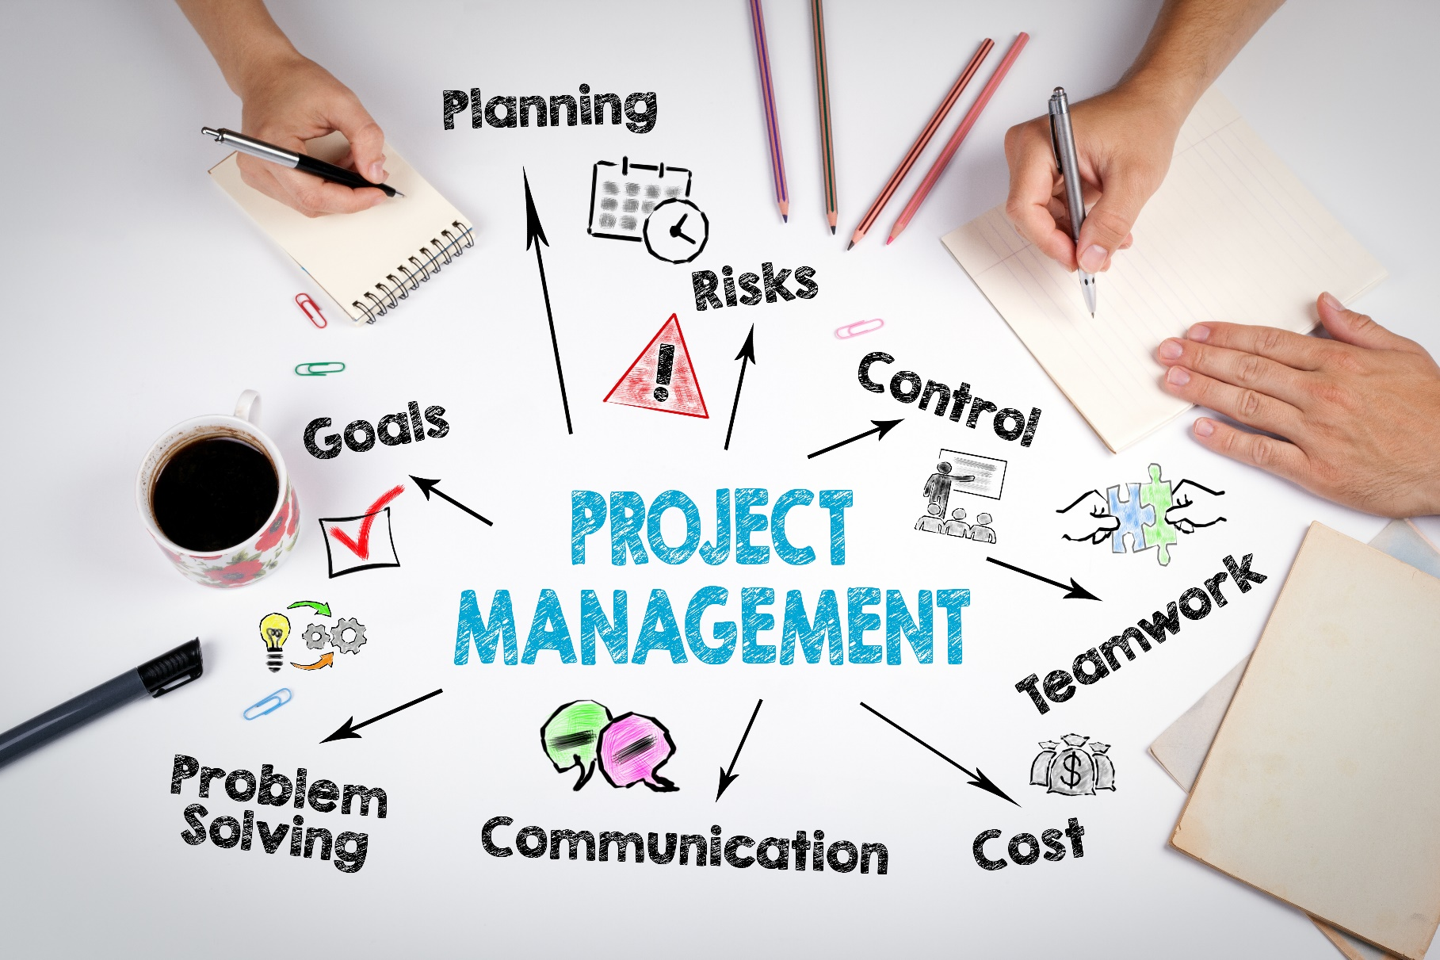
31 - Dec - 2023
dormakaba MENA internal document | Project 1 – S4S: Re-evaluate processes and KPI in various operational areas.

Table of contents
Introduction 3
Project Management General Overview 4
Project Initiation Process 5
Project Planning Process 6
Project Execution Process 7
Subcontracting Process 8
Project Monitoring and Control Process 8
Project Closing Process 10
Escalation Matrix and KPIs 11

Introduction
Documenting the complete project management process can have a significant positive impact on both the team and the organization as a whole. The scope of documenting the process includes capturing all the steps, activities, and interactions involved in the planning, execution, monitoring, and closing of projects. This can encompass various stages such as project initiation, planning, execution, monitoring and controlling, and project closure.
Scope
Effective project management is crucial for any business to ensure successful project delivery, meet stakeholder expectations, and optimize resource utilization. This document outlines the guidelines and procedures for determining project objectives, timelines, resource allocation, and risk management within dormakaba MENA.

By following these guidelines, we aim to strike a balance between achieving project goals and minimizing risks, resulting in improved project outcomes and cost savings.
Benefits:
- Clarity and Transparency:
To have a clear and transparent view of how projects progress through various stages. This will identify bottlenecks, inefficiencies, and areas for improvement.
- Standardization:
To ensure consistent practices, reducing complexity and errors.
- Training and Onboarding:
Staff members can quickly understand their roles, responsibilities, and overall workflow, leading to faster integration, productivity, and resource allocation.
- Risk Management:
By identifying potential points of failure or disruption, the department can develop contingency plans to minimize the impact of unforeseen events.
- Performance Measurement:
This data-driven approach helps monitor efficiency (KPIs), track progress, and make informed decisions for process optimization.
- Continuous Improvement:
A benchmark for continuous improvement. The department can identify areas for enhancement and implement changes effectively.
- Compliance and Auditing:
Well-documented logistics processes aid compliance with regulations and industry standards, streamlining audits.
- Scalability:
Enabling efficient handling of increased workload and complexity.

Project Management General Overview
The flow diagram illustrates the comprehensive processes encompassed in Project Management. Each block in the diagram is further elucidated in detail within this document.
Process flow chart ID: PP-M-PP-01
Document Ref.: PM-LOG -07
Issue No.: 1
Rev.: 0
Issuance Date: 20 June 2024
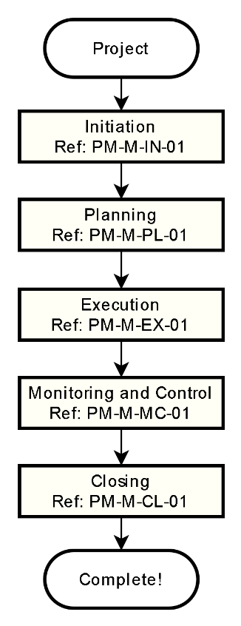
All Abbreviations
LPO - Local Purchase Order
PO - Purchase Order
OA/OC - Order Acceptance/Confirmation
LC - Letter of Credit
HO - Handover
KO - Kick-off
DLP - Defect Liability Period
BG - Bank Guarantee

Responsible
■ Project Management process

Project Initiation Process
The process is designed to guarantee the control and monitoring of project initiation activities, contributing to effective project management, and ensuring stakeholder satisfaction.
Process flow chart ID: PM-M-IN-01
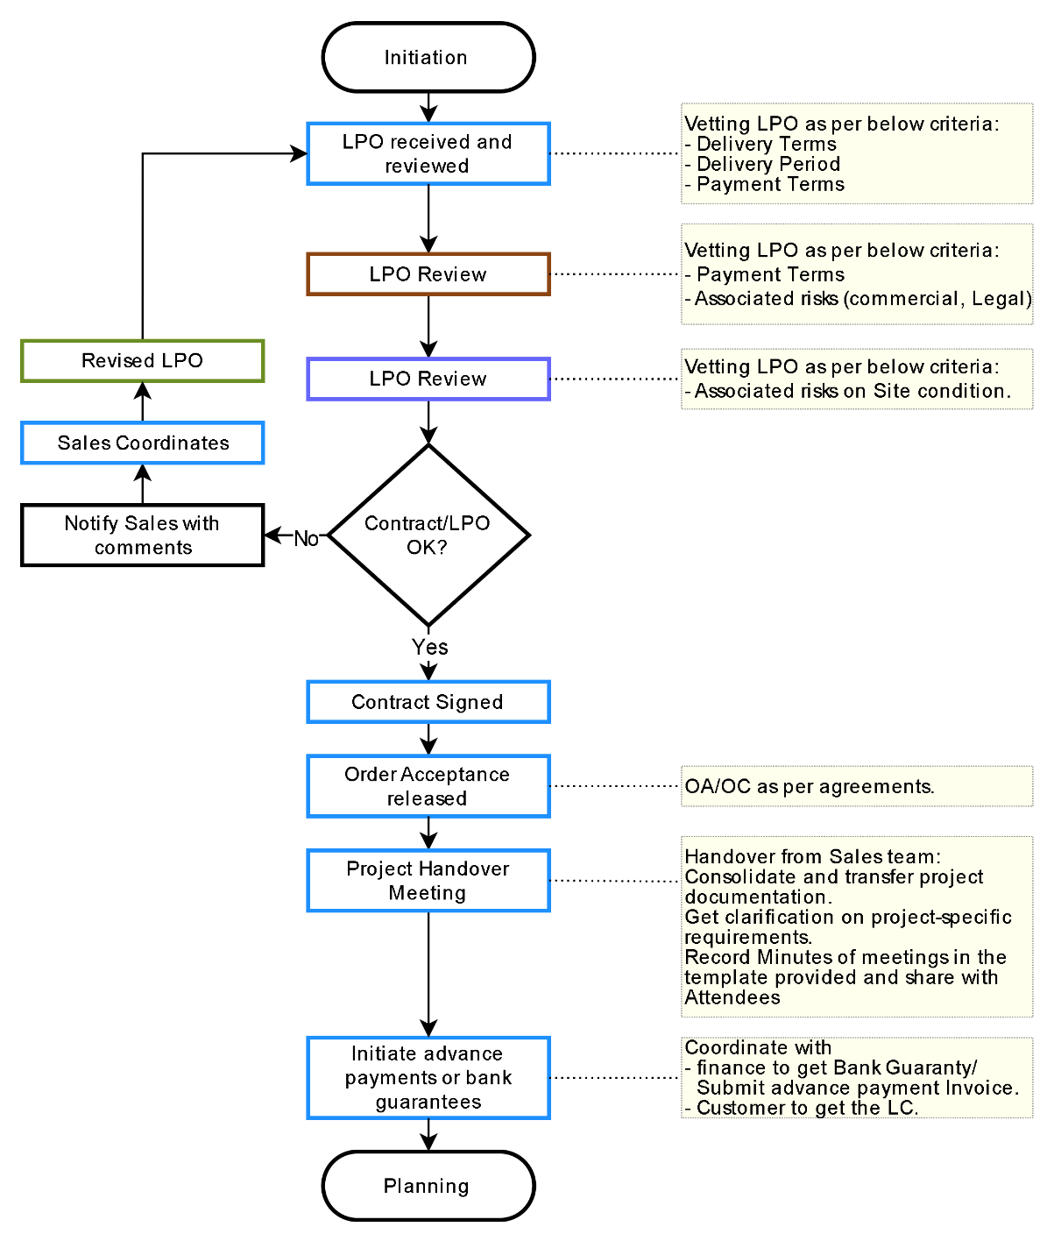
Document Ref.: PM-LOG -07
Issue No.: 1
Rev.: 0
Issuance Date: 20 June 2024
Responsible
■ Customer/Client
■ Sales Team
■ Finance
■ Project management
All Abbreviations
LPO - Local Purchase Order
PO - Purchase Order
OA/OC - Order Acceptance/Confirmation
LC - Letter of Credit

Project Planning Process
The process is designed to guarantee the control and monitoring of project planning activities, contributing to effective project management, and ensuring stakeholder satisfaction.
Process flow chart ID: PM-M-IN-01
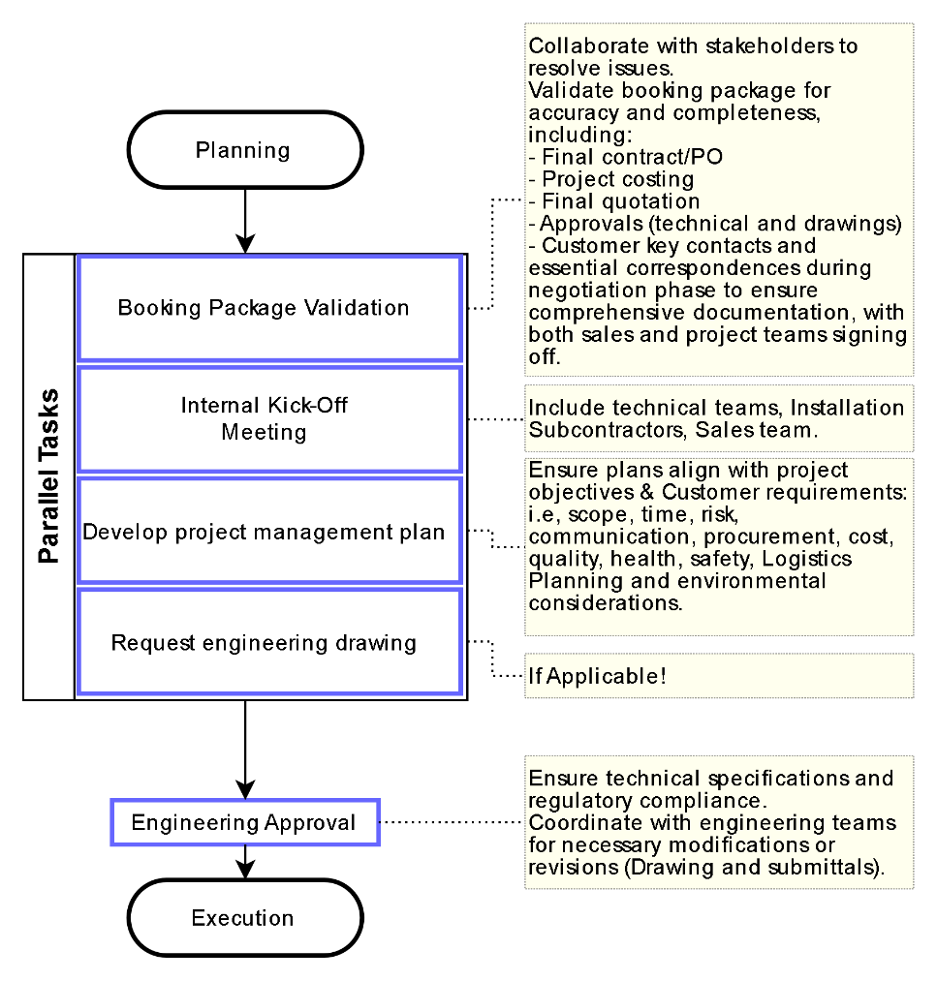
Document Ref.: PM-LOG -07
Issue No.: 1
Rev.: 0
Issuance Date: 20 June 2024
Responsible
■ Customer/Client
■ Sales Team
■ Finance
■ Project management
All Abbreviations
PO - Purchase Order
KO - Kick-off

Project Execution Process
The process is designed to guarantee the control and monitoring of project execution activities, contributing to effective project management, and ensuring stakeholder satisfaction.
Process flow chart ID: PM-M-IN-01
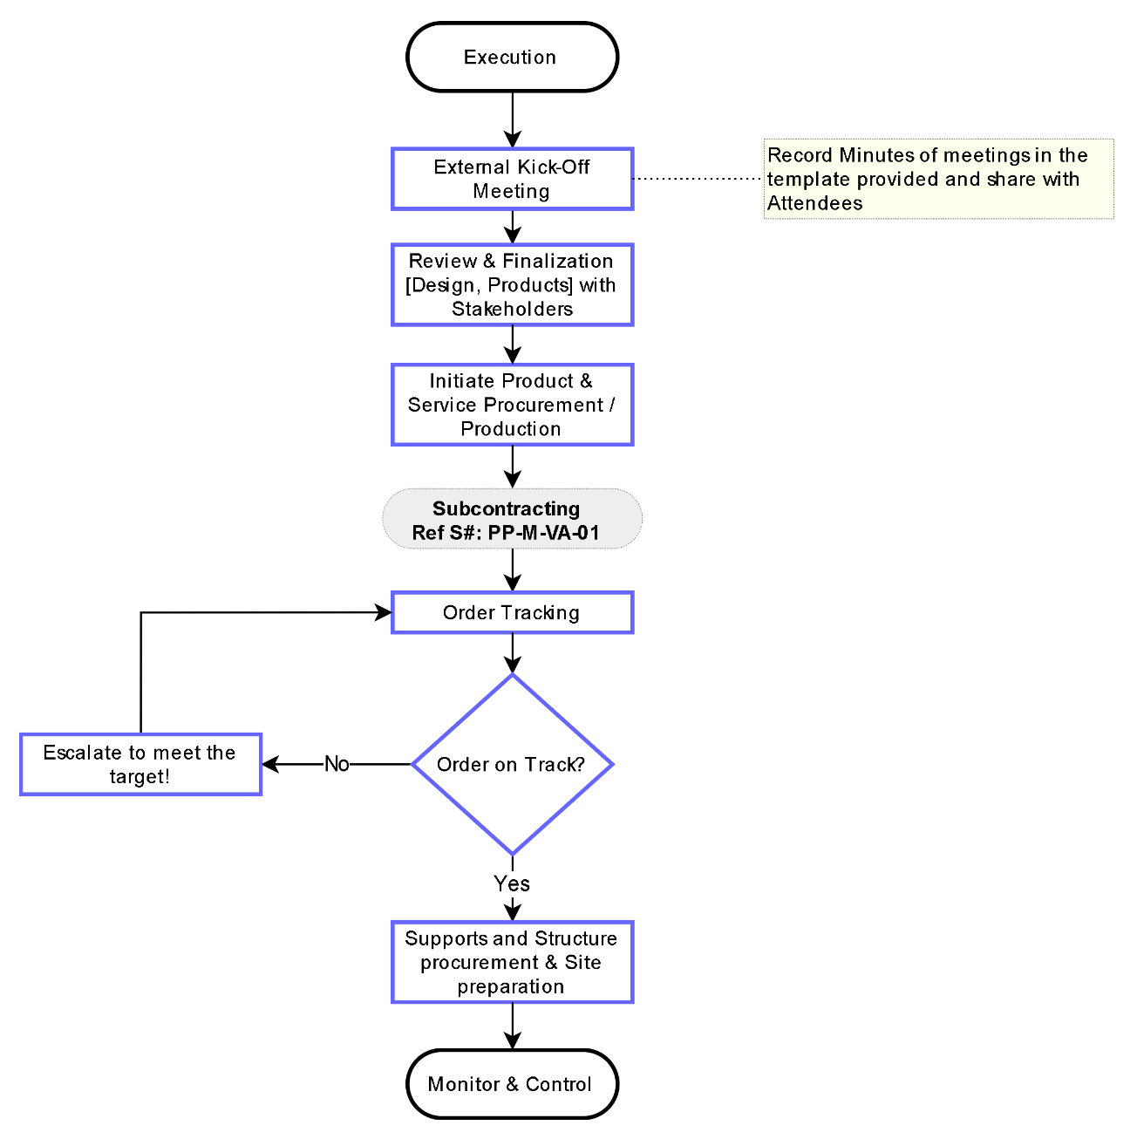
Document Ref.: PM-LOG -07
Issue No.: 1
Rev.: 0
Issuance Date: 20 June 2024
Responsible
■ Customer/Client
■ Sales Team
■ Finance
■ Project management

Subcontracting Process
The process of subcontracting involves soliciting three quotes and assessing whether the installation task should be assigned to a subcontractor or handled by an internal team, Process is applicable for Service/Installation/Projects.
Process flow chart ID: PP-M-SC-01
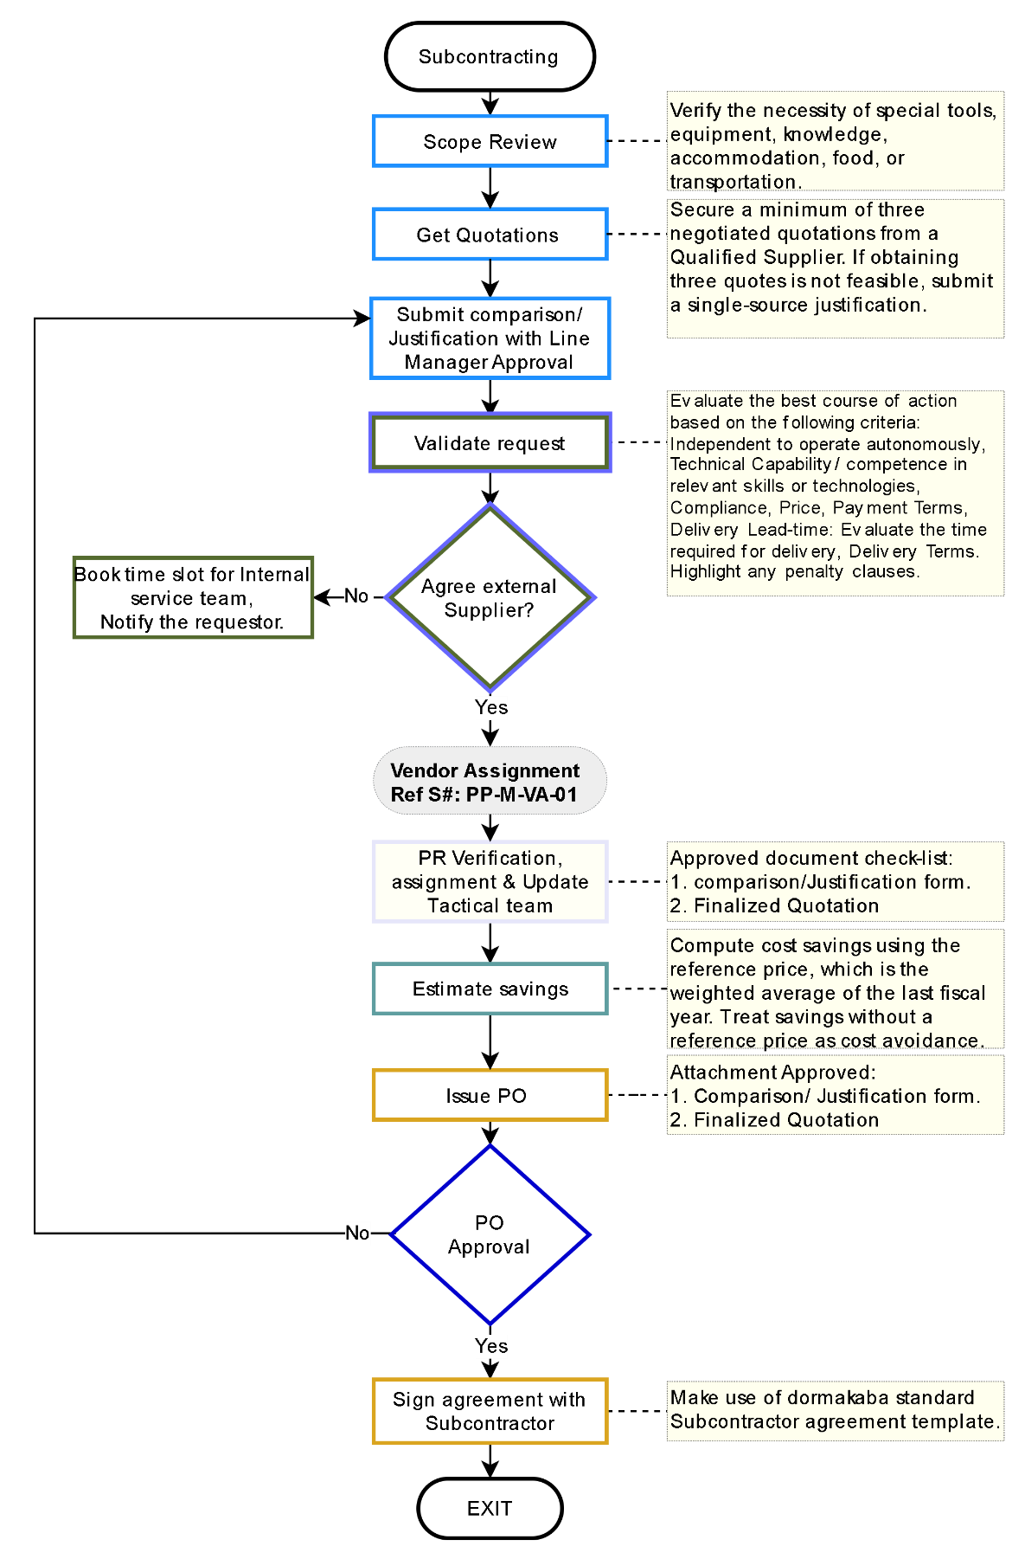
Responsible
■ Sales
■ Service/Installation Manager
■ Procurement Head
■ Tactical Team
■ Material Planning Team
■ Project management

Project Monitoring and Control Process
Vendor Qualification
Abbreviation
PO - Purchase Order
PR - Purchase Requisition
STO - Stock to Order
PTO - Purchase to Order
Document Ref.: PP-LOG -07
Issue No.: 1
Rev.: 0
Issuance Date: 20 Nov 2023
The process is designed to guarantee the control and monitoring of project monitoring and control activities, contributing to effective project management, and ensuring stakeholder satisfaction.
Process flow chart ID: PM-M-IN-01
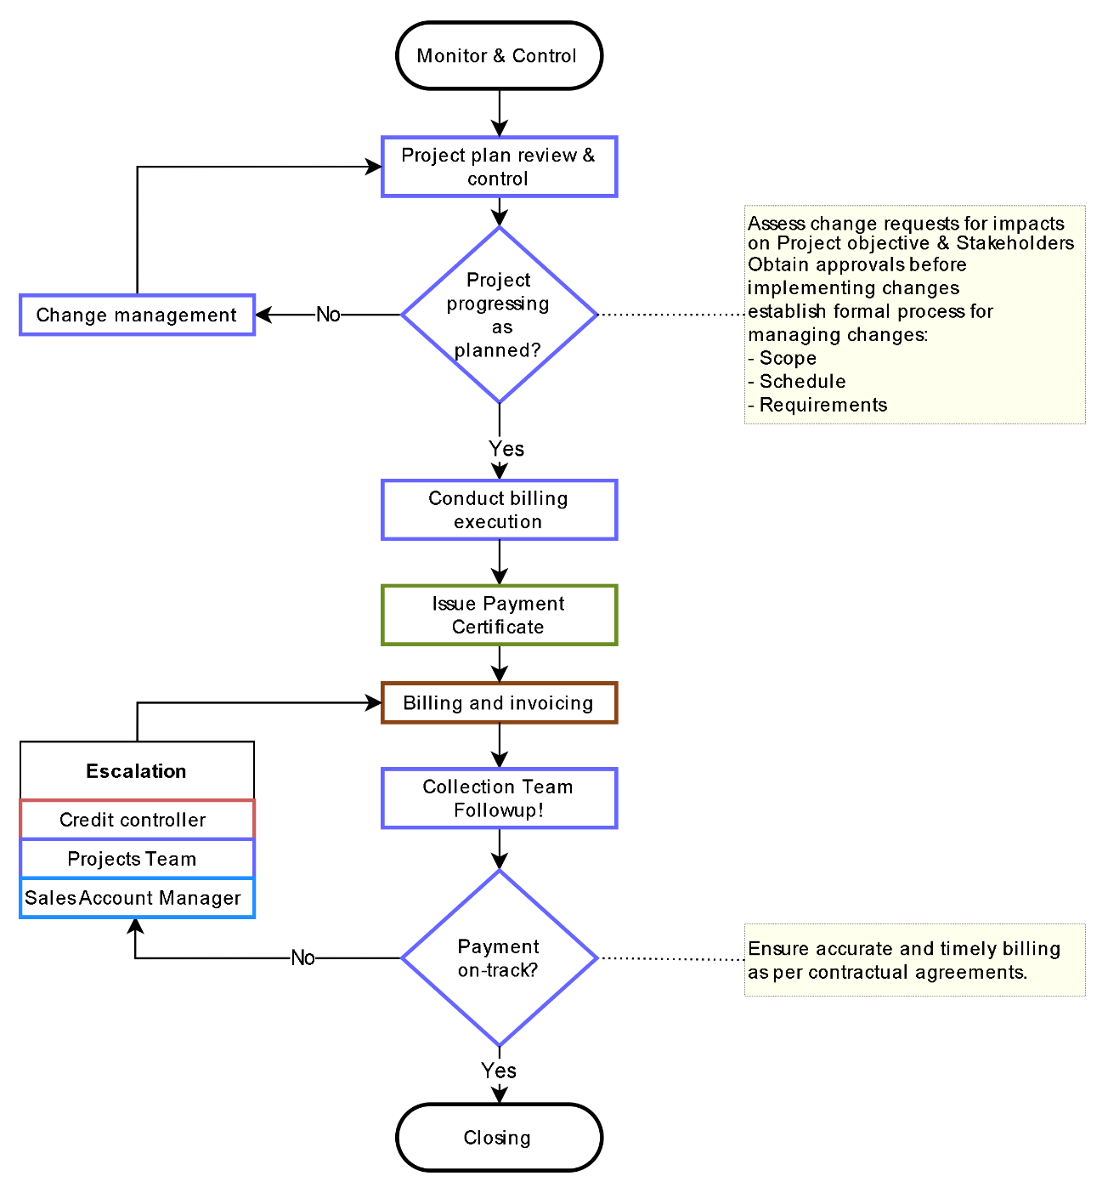
Document Ref.: PM-LOG -07
Issue No.: 1
Rev.: 0
Issuance Date: 20 June 2024
Responsible
■ Customer/Client
■ Sales Team
■ Finance
■ Credit control
■ Project management

Project Closing Process
The process is designed to guarantee the control and monitoring of project closing activities, contributing to effective project management, and ensuring stakeholder satisfaction.
Process flow chart ID: PM-M-IN-01
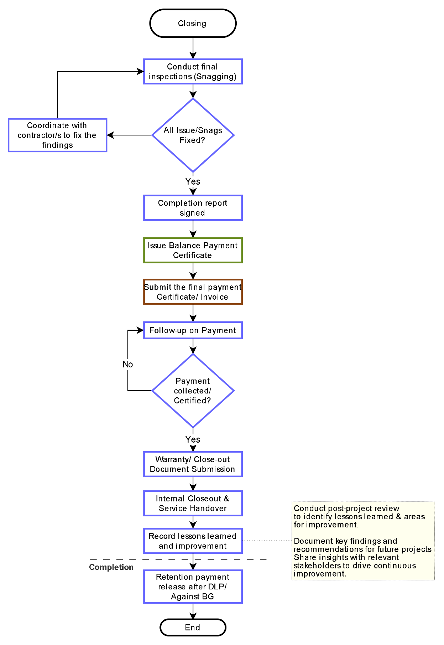
Document Ref.: PM-LOG -07
Issue No.: 1
Rev.: 0
Issuance Date: 20 June 2024
Responsible
■ Customer/Client
■ Sales Team
■ Finance
■ Project management
All Abbreviations
LC - Letter of Credit
HO - Handover
KO - Kick-off
DLP - Defect Liability Period
BG - Bank Guarantee

Escalation Matrix and KPIs
To be Updated!
Escalation Matrix
Stage | Task / Reminder to | Time Period | Escalation (by Customer Service)
Level 0 | PR + PO + OC | Process Turn Around Time  2 days | No Escalation if done in time
Level 0 | Goods Shipment | + Agreed lead time day  to be added to above TAT | No Escalation if done in time
Level 1 | Supervisor | +1 day  after the Process agreed TAT | - Reminder.  - Copy to Manager.
Level 2 | Procurement head | +1 day  after the Process agreed TAT | - Reminder.  - Copy-1 (Escalation) to Department Head.  - Copy-2 (For Information) concerned Sales and Sales support Manager.
Level 3 | Department Head | +1 day  after the Process agreed TAT | - Reminder.  - Copy-1 (Escalation) to SVP.  - Copy-2 (For Information) concerned Sales, Sales Support Manager, and Market Lead.

Note:
- Labelling 500+ will vary TAT as per the agreed term between CS, WH & Logistics

KPIs (Line Manager to manage)
- Turnaround time for each process:
- Inbound: 1 day
- PICK + PACK + Labelling + Documentation + Dispatch:
- 2 days – UAE
- 3 days – OMN/BHR
- 4 days - EXP/KWT/QAT
- Keep Stock quantity updated in the System.
- SAP Up to date with Weight, COO and HS-code time of GR
- Rate of return.
- Picking Accuracy.
- Others as per the line manager's decision.

dormakaba Gulf FZE
Jebel Ali South,
Dubai, United Arab Emirates
T: +971 4 8020 000
www.dormakaba.com/mea

