Logistics,
Warehouse
Process
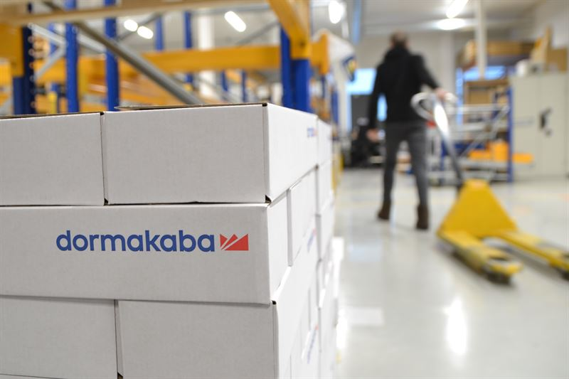
[Version No.2.1]
31 - Dec - 2023
dormakaba MENA internal document | Project 1 – S4S: Re-evaluate processes and KPI in various operational areas.
31 - Dec - 2023
dormakaba MENA internal document | Project 1 – S4S: Re-evaluate processes and KPI in various operational areas.
Table of contents
Introduction 3
Logistics and Warehouse General Overview 4
Material Inbound Process 5
Fragile Handling Process 6
Quality Assurance & Control Check Process – UAE & EXP 7
Quality Assurance & Control Check Process – KSA 8
Material Pick & Pack Process – UAE & EXP 9
Material Pick & Pack Process – KSA 10
Shipping Documentation Process – UAE & EXP 11
Shipping Documentation Process – KSA 12
Material Dispatch Process – UAE & EXP 13
Material Dispatch Process – KSA 14
Inventory Audit Process – UAE & EXP 15
Inventory Audit Process – KSA 16
Stock Correction Process 17
Scrap Disposal Process 18
19
Escalation Matrix and KPIs 20

Introduction
Documenting the complete logistics process can have a significant positive impact on both the department and the organization as a whole. The scope of documenting the logistics process includes capturing all the steps, activities, and interactions involved in the movement of goods and services from the point of origin to the final destination. This can encompass various stages such as procurement, transportation, warehousing, inventory management, order fulfilment, and distribution.
Scope
This document encompasses the process brief and flowchart for key Logistics and Warehousing procedures, along with the inclusion of an Escalation Matrix and Key Performance Indicators (KPIs). It has been collaboratively developed with guidance from team members and Subject Matter Specialists. Through a thorough analysis of existing processes and the subsequent integration of enhancements, this document reflects an optimized approach to these operations.
Benefits:
- Clarity and Transparency:
To have a clear and transparent view of how materials and products flow through the supply chain. This will identify bottlenecks, inefficiencies, and areas for improvement.
- Standardization:
To ensure consistent practices, reducing complexity and errors.
- Training and Onboarding:
Staff members can quickly understand their roles, responsibilities, and the overall workflow, leading to faster integration, productivity, and resource allocation.
- Risk Management:
By identifying potential points of failure or disruption, the department can develop contingency plans to minimize the impact of unforeseen events.
- Performance Measurement:
This data-driven approach helps monitor efficiency (KPIs), track progress, and make informed decisions for process optimization.
- Continuous Improvement:
A benchmark for continuous improvement. The department can identify areas for enhancement and implement changes effectively.
- Compliance and Auditing:
Well-documented logistics processes aid compliance with regulations and industry standards, streamlining audits.
- Scalability:
Enabling efficient handling of increased workload and complexity.

Logistics and Warehouse General Overview
The flow diagram illustrates the comprehensive processes encompassed in Logistics and Warehouse. Each block in the diagram is further elucidated in detail within this document.
Process flow chart ID: WL-M-WL-01

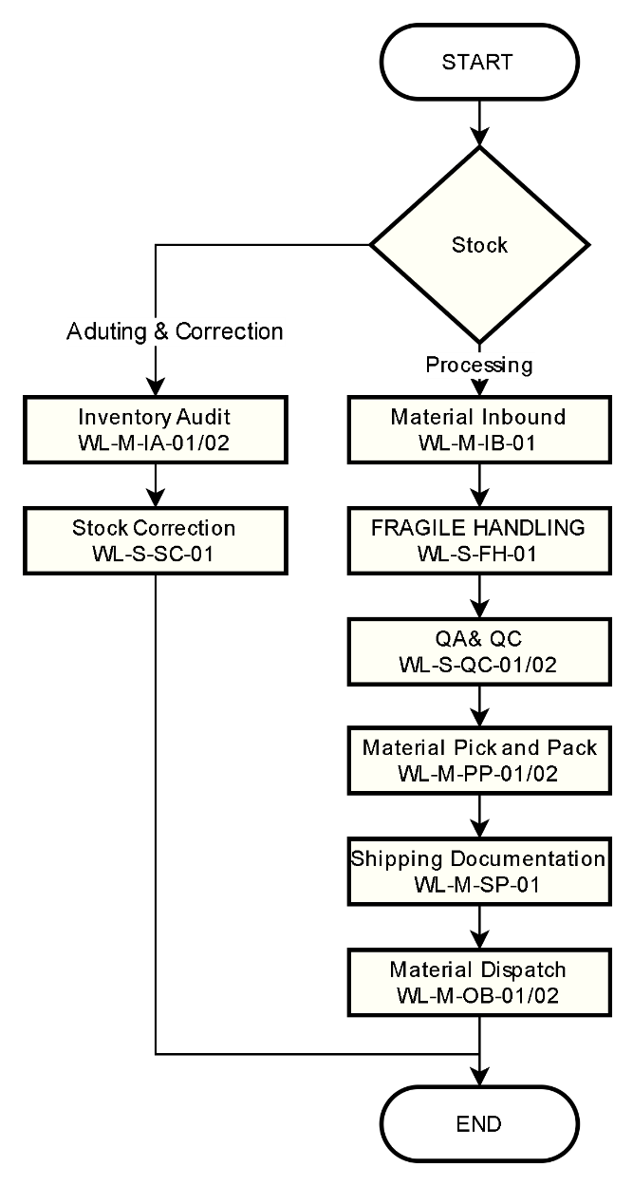
Responsible:
■ Procurement & Planning

Document Ref.: WL-LOG -01
Issue No.: 1
Rev.: 0
Issuance Date: 01 JUL 2024
All Abbreviations
PO - Purchase Order
PR - Purchase Requisition
NASA - New Authorization
for Supplier Acquisition
IAP - Investment Application
BDM - Business Development Manager
PM - Product Manager
PMM - Product Marketing Manager
CH - Competency Hub
NDA - Nondisclosure agreement
STO - Stock to Order
PTO - Purchase to Order
SMI - Slow-Moving Initiative

Material Inbound Process
It is the process of receiving materials or goods from external sources, such as suppliers/vendors or customer returns, into an organization's inventory or production facility. This process is crucial to the overall supply chain and logistics operations. The term "inbound" typically refers to the movement of materials coming into the organization.
Process flow chart ID: WL-M-IB-01

Responsible:
■ Purchase
■ Logistics
■ Warehouse

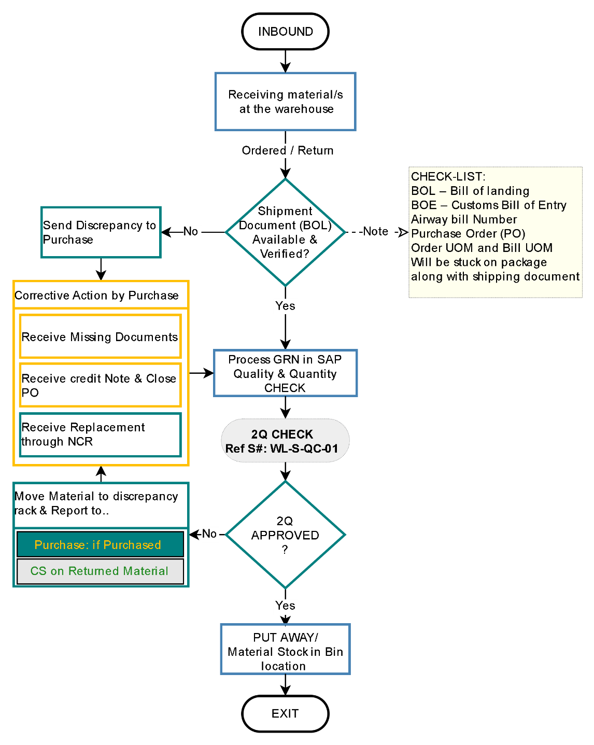
Document Ref.: WL-LOG -02
Issue No.: 1
Rev.: 0
Issuance Date: 01 JUL 2024

Fragile Handling Process
Document Ref.: WL-LOG -03
Issue No.: 1
Rev.: 0
Issuance Date: 01 JUL 2024
The Fragile material inspection involves the careful examination of delicate or easily breakable items to ensure they are undamaged and properly packaged. It aims to prevent any potential damage during transportation or handling by identifying and addressing any vulnerabilities in the items or their packaging.
Process flow chart ID: WL-S-FH-01

Responsible:
■ Logistics
■ Warehouse

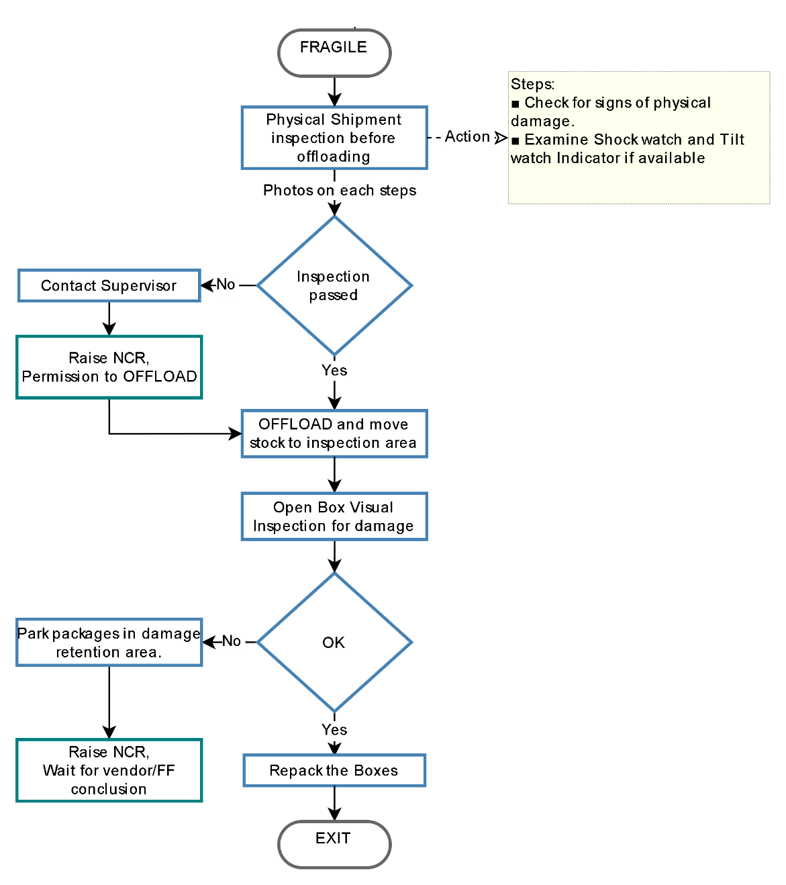

Quality Assurance & Control Check Process – UAE & EXP
The Material Quality Assurance (QA) and Quality Control (QC) are essential processes in manufacturing and supply chain management that ensure the materials used in production meet specific quality standards and requirements. While QA and QC are related, they have distinct roles within the overall quality management framework.
Process flow chart ID: WL-S-QC-01

Responsible:
■ Logistics
■ Warehouse

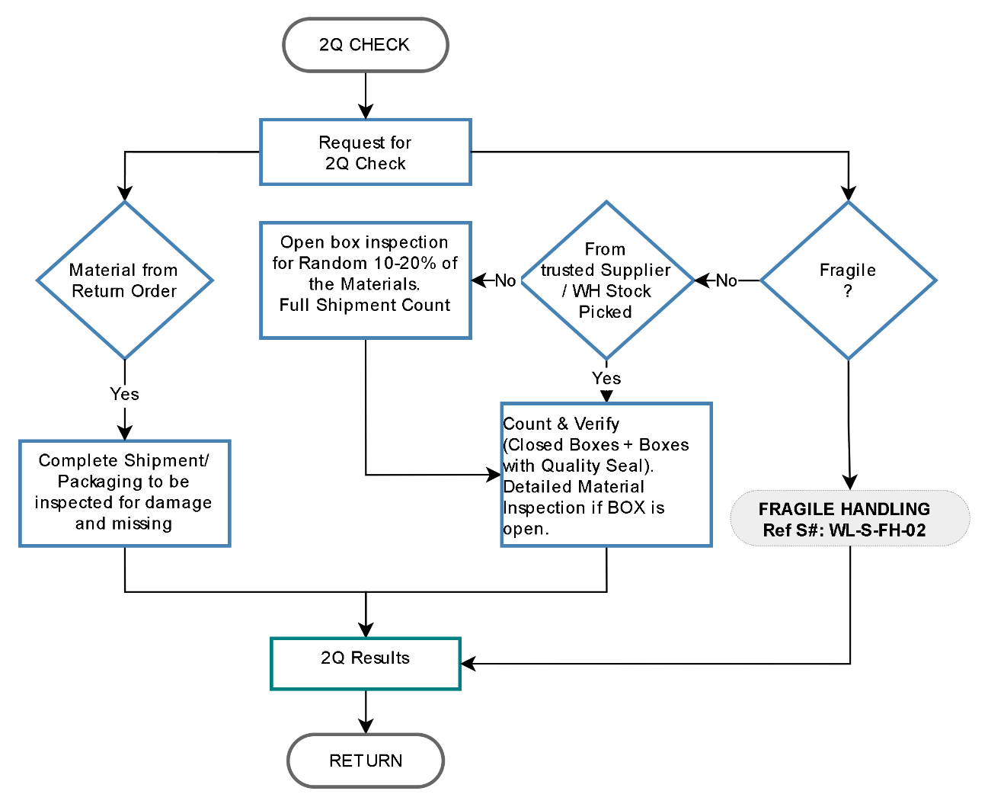
Document Ref.: WL-LOG -04
Issue No.: 1
Rev.: 0
Issuance Date: 01 JUL 2024

Quality Assurance & Control Check Process – KSA
The Material Quality Assurance (QA) and Quality Control (QC) are essential processes in manufacturing and supply chain management that ensure the materials used in production meet specific quality standards and requirements. While QA and QC are related, they have distinct roles within the overall quality management framework.
Process flow chart ID: WL-S-QC-02

Responsible:
■ Logistics
■ Warehouse

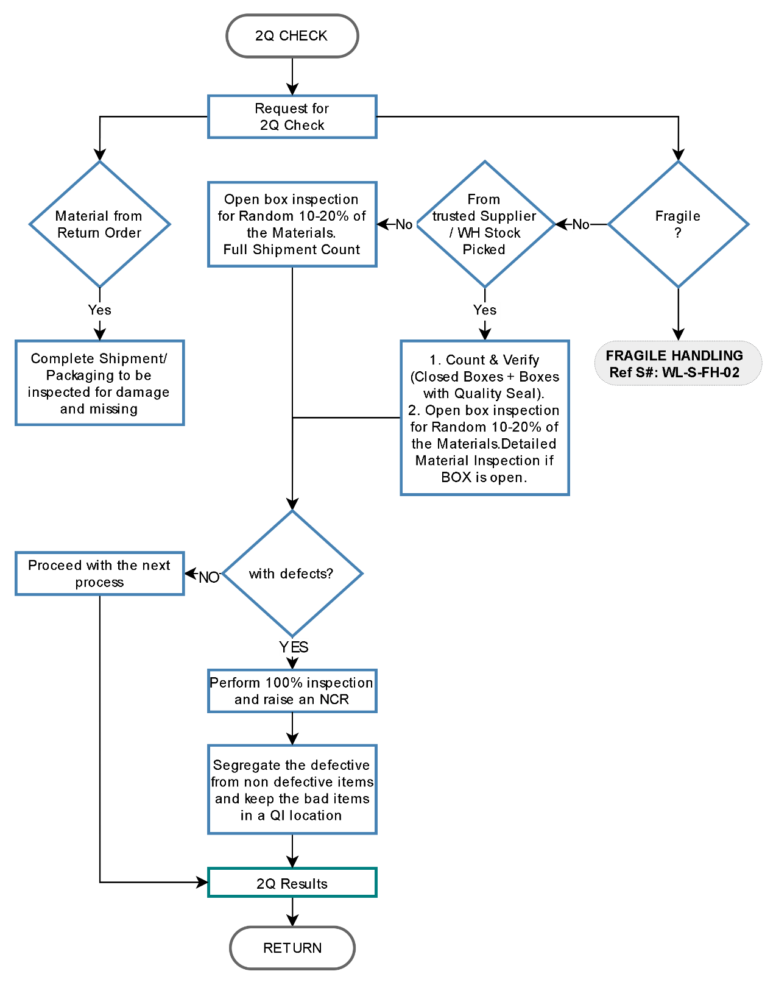
Document Ref.: WL-LOG -05
Issue No.: 1
Rev.: 0
Issuance Date: 01 JUL 2024

Material Pick & Pack Process – UAE & EXP
The process involves selecting and gathering the required materials or products from a storage location and then packing them appropriately for shipment or use, ensuring accuracy, efficiency, and adhering to specified procedures or quality standards.
Process flow chart ID: PP-M-PQ-01

Responsible:
■ Logistics
■ Warehouse

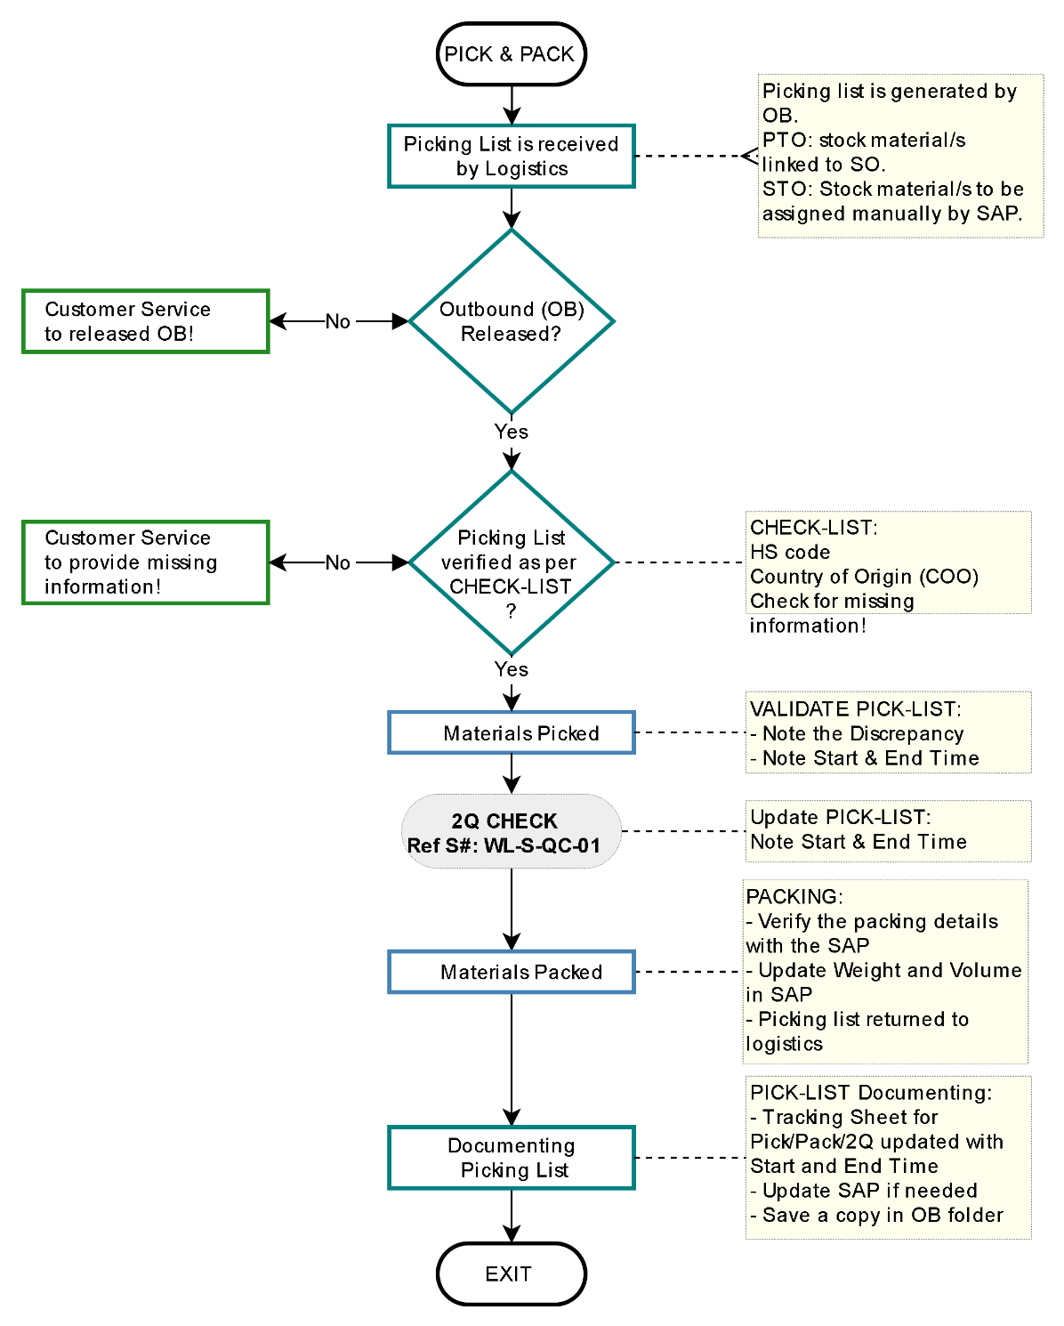
Document Ref.: WL-LOG -06
Issue No.: 1
Rev.: 0
Issuance Date: 01 JUL 2024

Material Pick & Pack Process – KSA
The process involves selecting and gathering the required materials or products from a storage location and then packing them appropriately for shipment or use, ensuring accuracy, efficiency, and adhering to specified procedures or quality standards.
Process flow chart ID: PP-M-PQ-02

Responsible:
■ Logistics
■ Warehouse

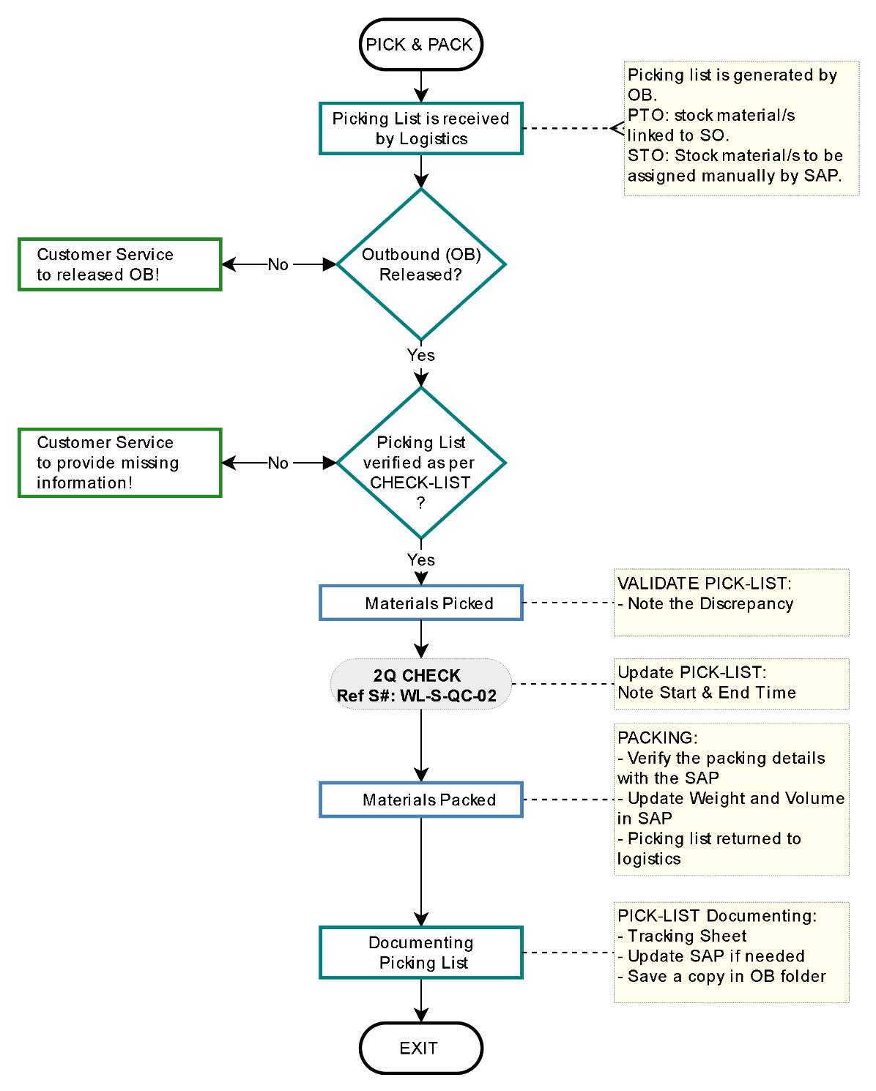
Document Ref.: WL-LOG -07
Issue No.: 1
Rev.: 0
Issuance Date: 01 JUL 2024

Shipping Documentation Process – UAE & EXP
The shipping document process is a series of steps and documentation involved in preparing, organizing, and executing the shipment of goods from one location to another. This process is a critical component of logistics and supply chain management, as it ensures that goods are properly packaged, labelled, and documented for transportation and delivery.
Process flow chart ID: WL-M-SP-01

Responsible:
■ Customer Service
■ Logistics
■ Warehouse

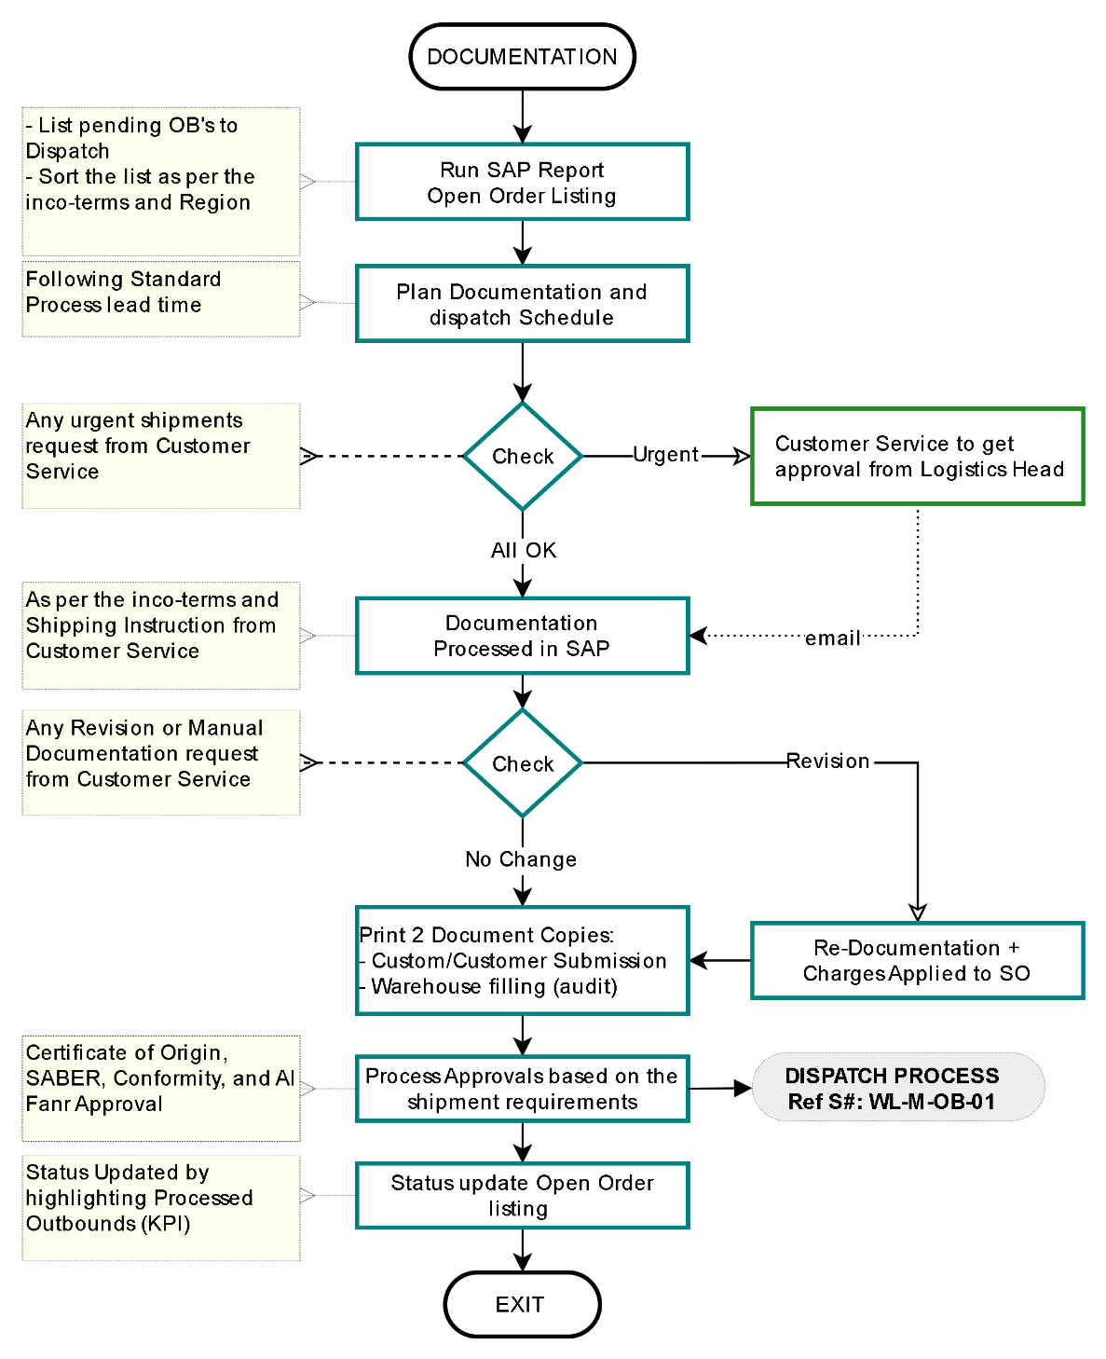
Document Ref.: WL-LOG -08
Issue No.: 1
Rev.: 0
Issuance Date: 01 JUL 2024

Shipping Documentation Process – KSA
The shipping document process is a series of steps and documentation involved in preparing, organizing, and executing the shipment of goods from one location to another. This process is a critical component of logistics and supply chain management, as it ensures that goods are properly packaged, labelled, and documented for transportation and delivery.
Process flow chart ID: WL-M-SP-01

Responsible:
■ Customer Service
■ Logistics
■ Warehouse

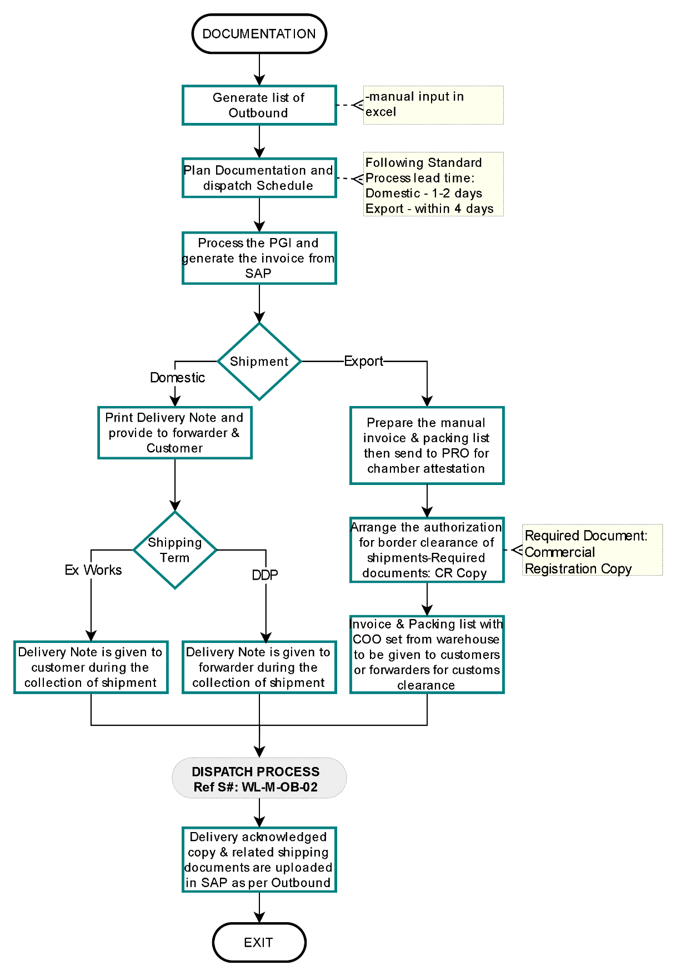
Document Ref.: WL-LOG -09
Issue No.: 1
Rev.: 0
Issuance Date: 01 JUL 2024

Material Dispatch Process – UAE & EXP
The movement of goods, materials, or information from an organization's internal operations to external entities, such as customers, distributors, or other partners. In the context of logistics and supply chain management, outbound processes involve activities related to packaging, labelling, and delivering products to their intended recipients.
Process flow chart ID: WL-M-OB-01

Responsible:
■ Freight Forwarder
■ Customer
■ Customer Service
■ Logistics
■ Warehouse

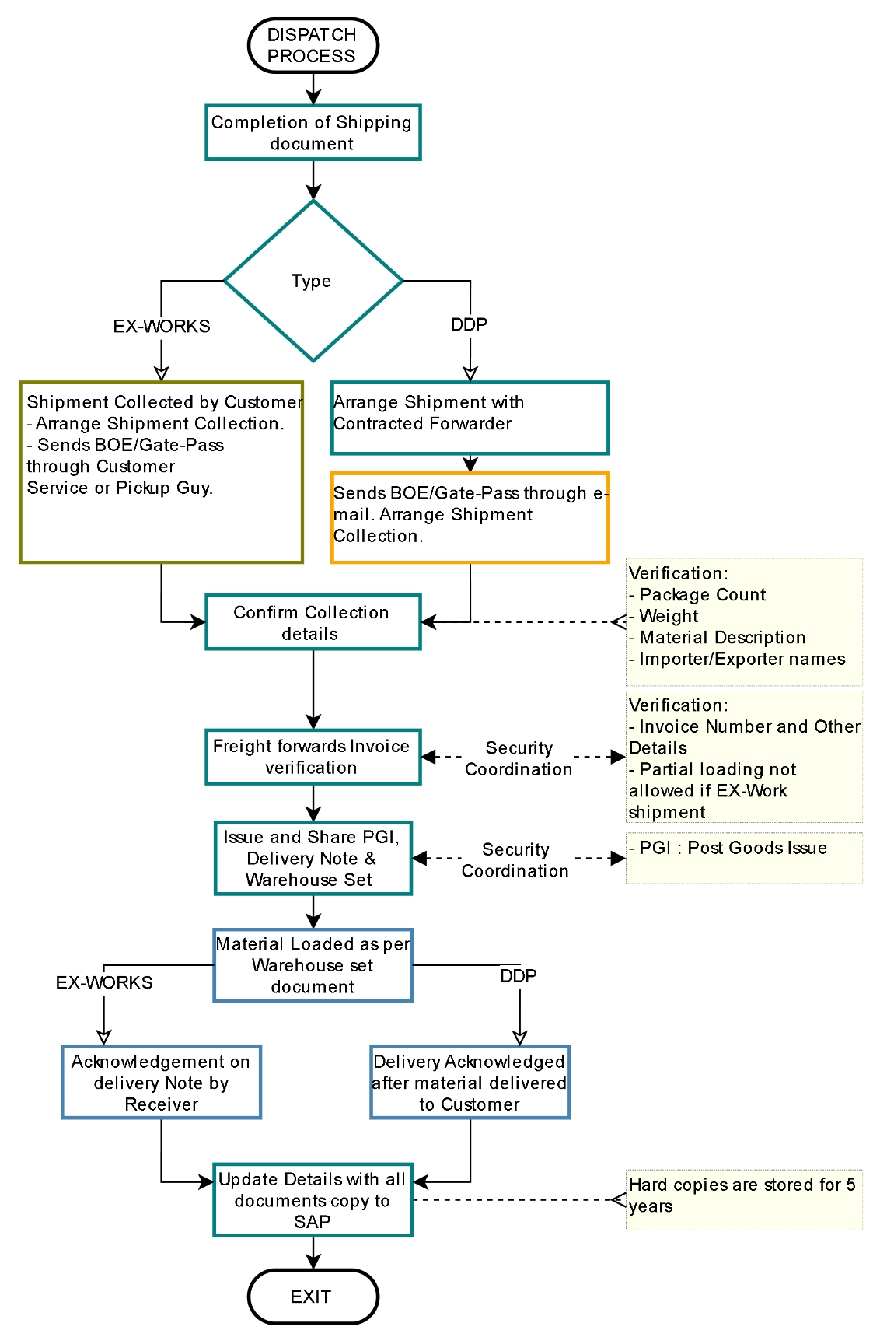
Document Ref.: WL-LOG -10
Issue No.: 1
Rev.: 0
Issuance Date: 01 JUL 2024

Material Dispatch Process – KSA
The movement of goods, materials, or information from an organization's internal operations to external entities, such as customers, distributors, or other partners. In the context of logistics and supply chain management, outbound processes involve activities related to packaging, labelling, and delivering products to their intended recipients.
Process flow chart ID: WL-M-OB-02

Responsible:
■ Freight Forwarder
■ Customer
■ Customer Service
■ Logistics
■ Warehouse

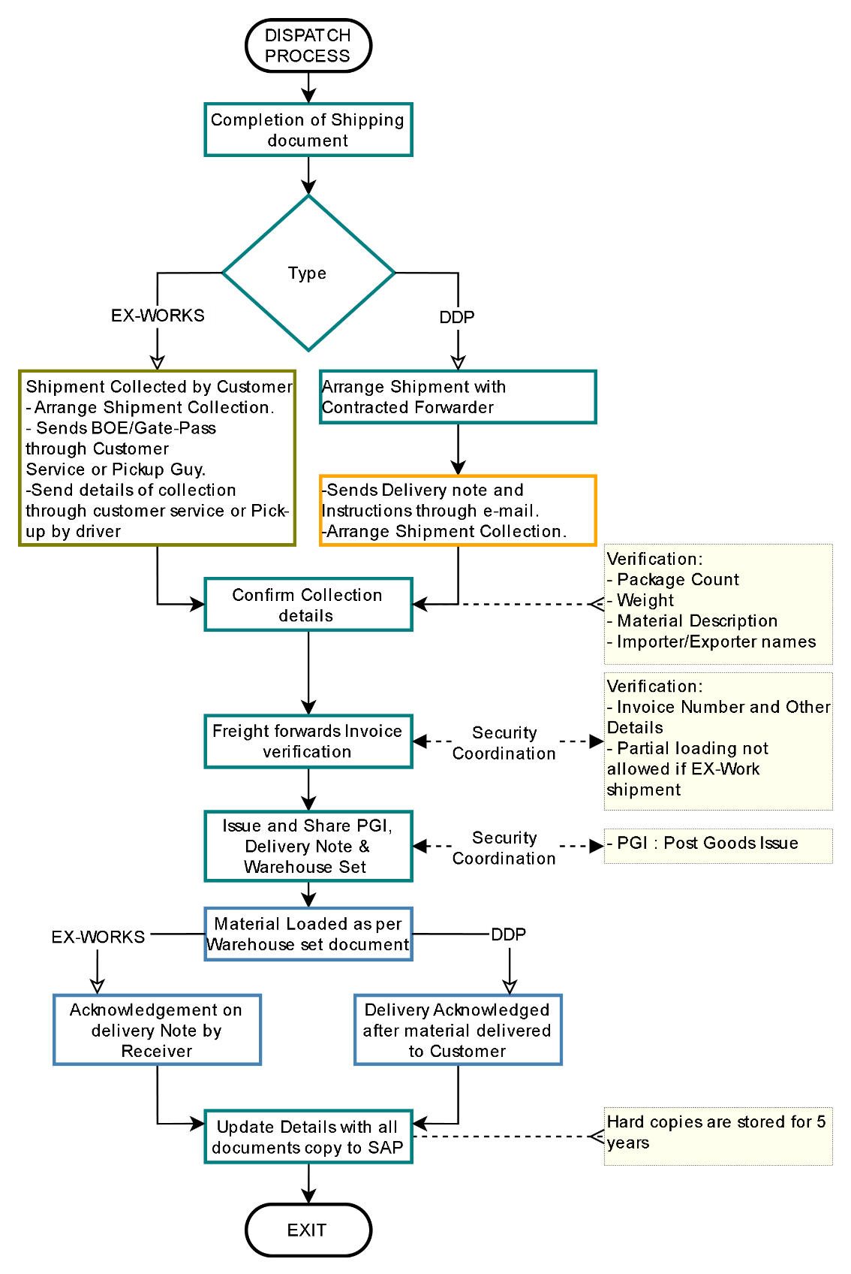
Document Ref.: WL-LOG -11
Issue No.: 1
Rev.: 0
Issuance Date: 01 JUL 2024

Inventory Audit Process – UAE & EXP
The annual inventory or stock audit is a routine procedure conducted by either internal or external auditors. Its primary objective is to verify and confirm the accuracy, comprehensiveness, and reliability of the stock levels and valuations as reported in the company's financial statements.
Process flow chart ID: WL-M-IA-01

Responsible:
■ Purchase
■ Customer Service
■ Logistics
■ Warehouse.
■ Financial Controller

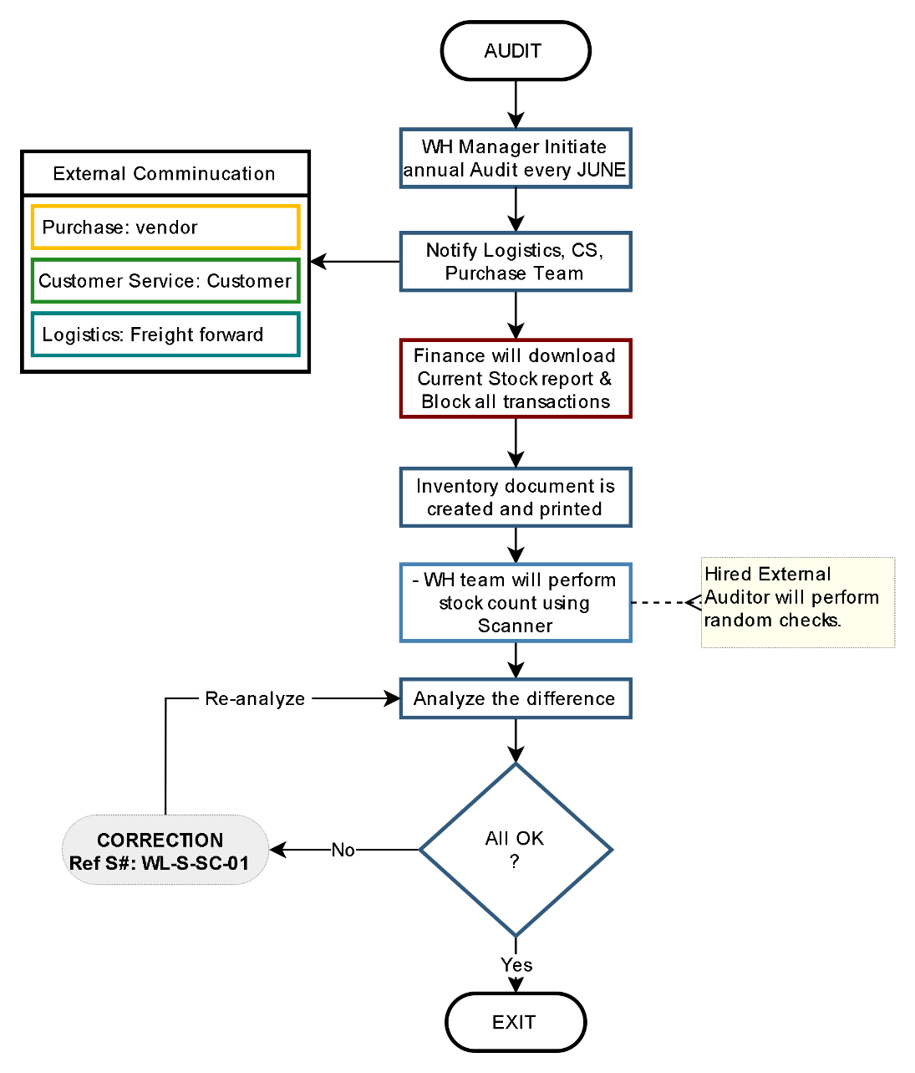

Document Ref.: WL-LOG -12
Issue No.: 1
Rev.: 0
Issuance Date: 01 JUL 2024

Inventory Audit Process – KSA
The annual inventory or stock audit is a routine procedure conducted by either internal or external auditors. Its primary objective is to verify and confirm the accuracy, comprehensiveness, and reliability of the stock levels and valuations as reported in the company's financial statements.
Process flow chart ID: WL-M-IA-02

Responsible:
■ Purchase
■ Customer Service
■ Logistics
■ Warehouse.
■ Financial Controller

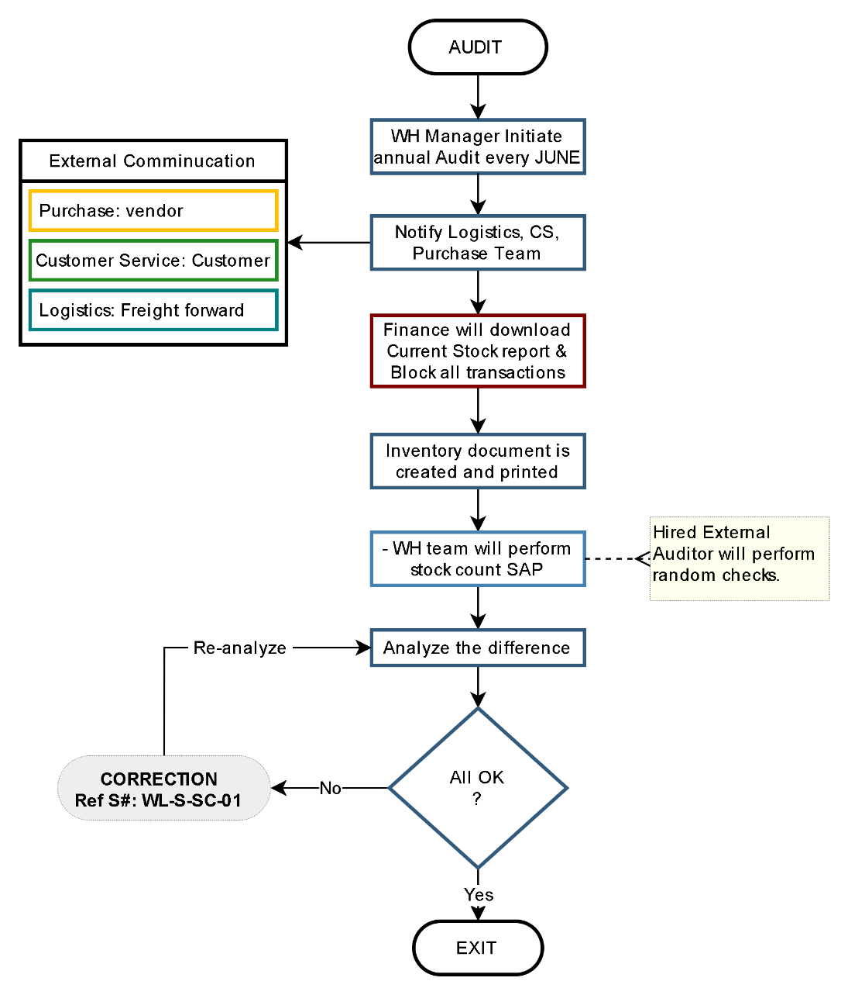

Document Ref.: WL-LOG -13
Issue No.: 1
Rev.: 0
Issuance Date: 01 JUL 2024

Stock Correction Process
Inspect the physical stock and ensure that SAP records are updated to accurately reflect the quantity and price in accordance with the approvals provided by the financial controller.
Process flow chart ID: WL-S-SC-01

Responsible:
■ Financial Controller
■ Warehouse.

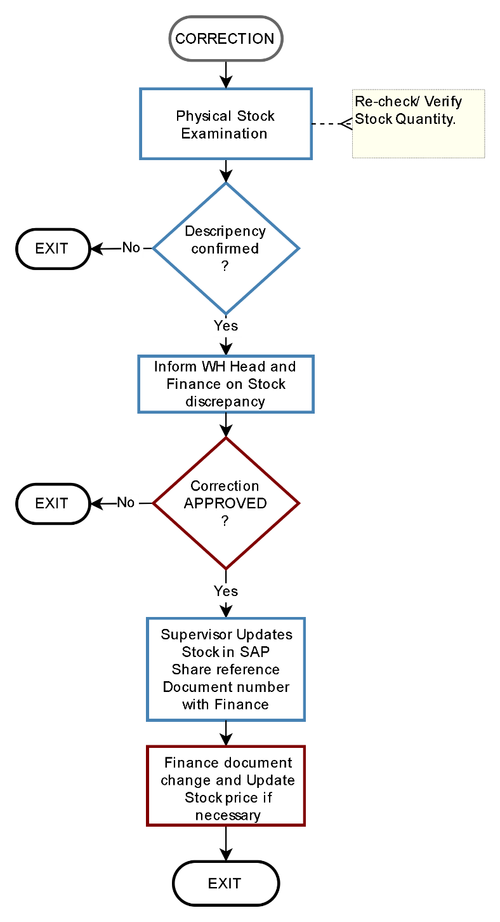
Document Ref.: WL-LOG -14
Issue No.: 1
Rev.: 0
Issuance Date: 01 JUL 2024

Scrap Disposal Process
The process begins with the initiation of a complete scrapping procedure, triggered by the Scrap Bin for product scrap, non-compliant products, or a scrapping request from the Finance department.
Process flow chart ID: WL-S-SC-01

Responsible:
■ Financial Controller
■ Warehouse
■ Scrap Vendor
■ Strategic Team – Purchase

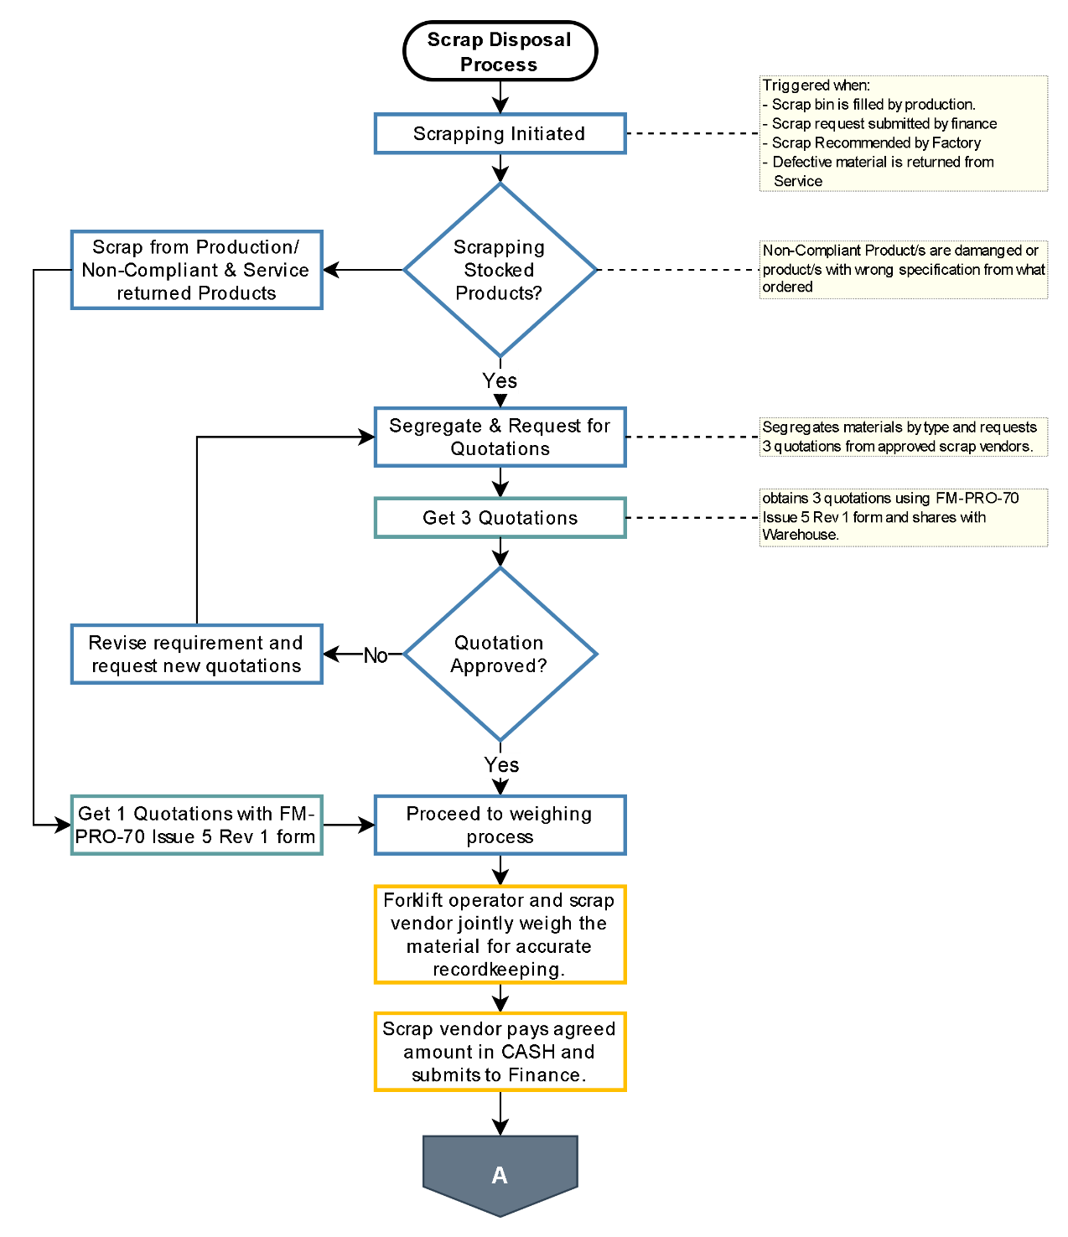
Document Ref.: WL-LOG -14
Issue No.: 1
Rev.: 0
Issuance Date: 01 JUL 2024
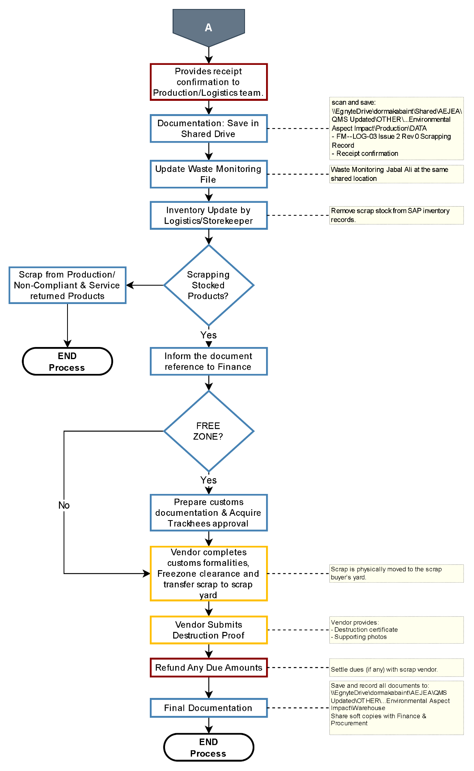

Escalation Matrix and KPIs
Escalation Matrix
Stage | Task / Reminder to | Time Period | Escalation (by Customer Service)
Level 0 | PICK + PACK +  Labelling + Documentation + Dispatch. | Process Turn Around Time  2 days - UAE  3 days - OMN/BHR  4 days - EXP/KWT/QAT | No Escalation if done in time
Level 0 | Documentation revision | + 1 day  to be added to above TAT | No Escalation if done in time
Level 1 | Logistics Supervisor | +1 day  after the Process agreed TAT | - Reminder.  - Copy to Manager.
Level 2 | Logistics Manager | +1 day  after the Process agreed TAT | - Reminder.  - Copy-1 (Escalation) to Department Head.  - Copy-2 (For Information) concerned Sales and Sales support Manager.
Level 3 | Department Head | +1 day  after the Process agreed TAT | - Reminder.  - Copy-1 (Escalation) to SVP.  - Copy-2 (For Information) concerned Sales, Sales Support Manager, and Market Lead.

Note:
- Labelling 500+ will vary TAT as per agreed term between CS, WH & Logistics
- for KSA SABER process TAT will change and if not registered the TAT will extend (depending on availability of required documents).

KPIs (Line Manager to manage)
- Turn around time for each process:
  - Inbound: 1 day
  - PICK + PACK + Labelling + Documentation + Dispatch:
    - 2 days – UAE
    - 3 days – OMN/BHR
    - 4 days - EXP/KWT/QAT
- Keep Stock quantity updated in System.
- SAP Up-to date with Weight, COO and HS-code time of GR
- Rate of return.
- Picking Accuracy.
- Others as per line manager decision.


dormakaba Gulf FZE
Jebel Ali South,
Dubai, United Arab Emirates
T: +971 4 8020 000
www.dormakaba.com/mea

