Supply Chain
Process

Handbook
[Version No.1.0]
Table of contents
31 - Dec - 2023
dormakaba MENA internal document | Project 1 – S4S: Re-evaluate processes and KPI in various operational areas.
Introduction 3
Project Management General Overview 4
Project Initiation Process 5
Project Planning Process 6
Project Execution Process 7
Subcontracting Process 8
Project Monitoring and Control Process 8
Project Closing Process 10
Escalation Matrix and KPIs 11

Introduction
The Supply Chain at dormakaba MEA forms the backbone of our operational excellence framework.
It connects every business function—from customer order intake through planning, procurement, production, logistics, installation, and after-sales service—into a single, coordinated process designed to deliver customer satisfaction, cost efficiency, and sustainable growth.
Purpose:
This handbook establishes a standardized, end-to-end approach for managing all supply-chain processes within dormakaba MEA.
It defines clear ownership, control mechanisms, and performance indicators across departments to ensure:
- Transparent communication and accountability.
- Reliable material availability and on-time delivery.
- Continuous process improvement through data-driven insights.
- Alignment with regional compliance, audit, and corporate governance standards.
Scope:

The scope of this handbook covers all activities within the dormakaba MEA Supply Chain:

- Sales Support – Enquiry, quotation, and order confirmation.
- Material Requirement Planning (MRP) – Demand validation and PR generation.
- Procurement – Purchase-order creation, vendor coordination, and expedition.
- Production – Fabrication, assembly, and replenishment planning.
- Logistics & Warehouse – Inbound, QA/QC, outbound, stock accuracy, and freight.
- Project Management – Planning, execution, and project close-out.
- Service & Installation – AMC renewal, breakdown response, commissioning, and warranty.
- Finance & Accounts – Customer creation, invoicing, and financial control.
- Operational Excellence (OPEX / Automation) – Process digitization and KPI monitoring.
All processes are governed by dormakaba’ s global quality standards and regional management policies, ensuring a consistent operating model across markets (UAE, KSA, Export, and Africa).
Objectives:
- Deliver the right product, in the right quantity, at the right time, to the right customer, every time.
- Balance inventory investment with service-level performance to optimize working capital.
- Strengthening collaboration between Sales, Operations, and Finance through unified data and shared KPIs.
- Eliminate process redundancy by aligning handovers and automating repetitive tasks.
- Support continuous improvement, transparency, and scalability for future business growth.

Benefits of an Integrated Supply Chain
The Supply Chain at dormakaba MEA forms the backbone of our operational excellence framework.
It connects every business function—from customer order intake through planning, procurement, production, logistics, installation, and after-sales service—into a single, coordinated process designed to deliver customer satisfaction, cost efficiency, and sustainable growth.
Purpose:

This handbook

Production Costing Process
To ensure accurate material and process costing linked to BOM headers before production and invoicing.
Process flow chart ID: FI-M-PC-01
Document Ref.: PM-LOG -07
Issue No.: 1
Rev.: 0
Issuance Date: 20 June 2024
All Abbreviations
LPO - Local Purchase Order
PO - Purchase Order
OA/OC - Order Acceptance/Confirmation
LC - Letter of Credit
HO - Handover
KO - Kick-off
DLP - Defect Liability Period
BG - Bank Guarantee

Responsible
■ Project Management process

Project Initiation Process
The process is designed to guarantee the control and monitoring of project initiation activities, contributing to effective project management, and ensuring stakeholder satisfaction.
Process flow chart ID: PM-M-IN-01
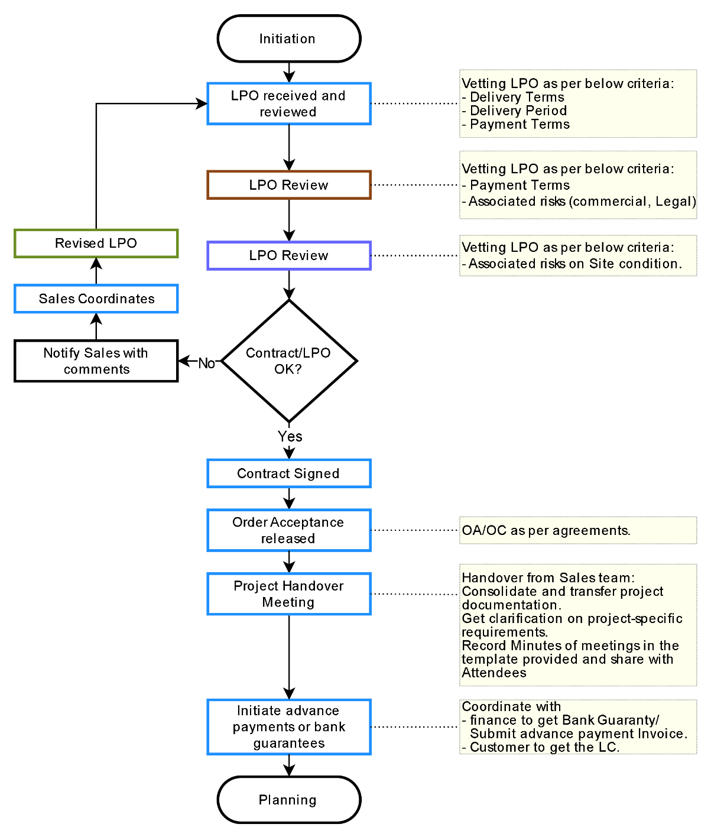
Document Ref.: PM-LOG -07
Issue No.: 1
Rev.: 0
Issuance Date: 20 June 2024
Responsible
■ Customer/Client
■ Sales Team
■ Finance
■ Project management
All Abbreviations
LPO - Local Purchase Order
PO - Purchase Order
OA/OC - Order Acceptance/Confirmation
LC - Letter of Credit

Project Planning Process
The process is designed to guarantee the control and monitoring of project planning activities, contributing to effective project management, and ensuring stakeholder satisfaction.
Process flow chart ID: PM-M-IN-01
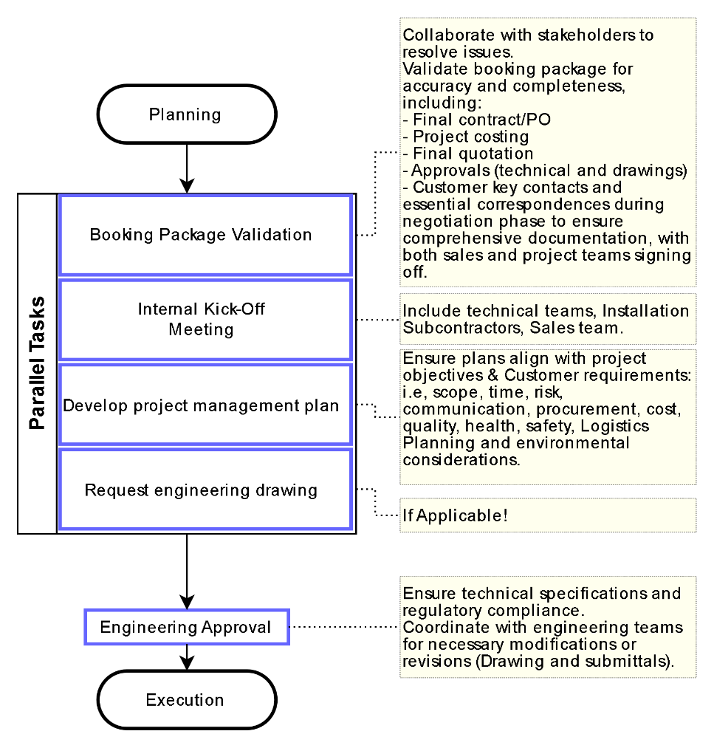
Document Ref.: PM-LOG -07
Issue No.: 1
Rev.: 0
Issuance Date: 20 June 2024
Responsible
■ Customer/Client
■ Sales Team
■ Finance
■ Project management
All Abbreviations
PO - Purchase Order
KO - Kick-off

Project Execution Process
The process is designed to guarantee the control and monitoring of project execution activities, contributing to effective project management, and ensuring stakeholder satisfaction.
Process flow chart ID: PM-M-IN-01
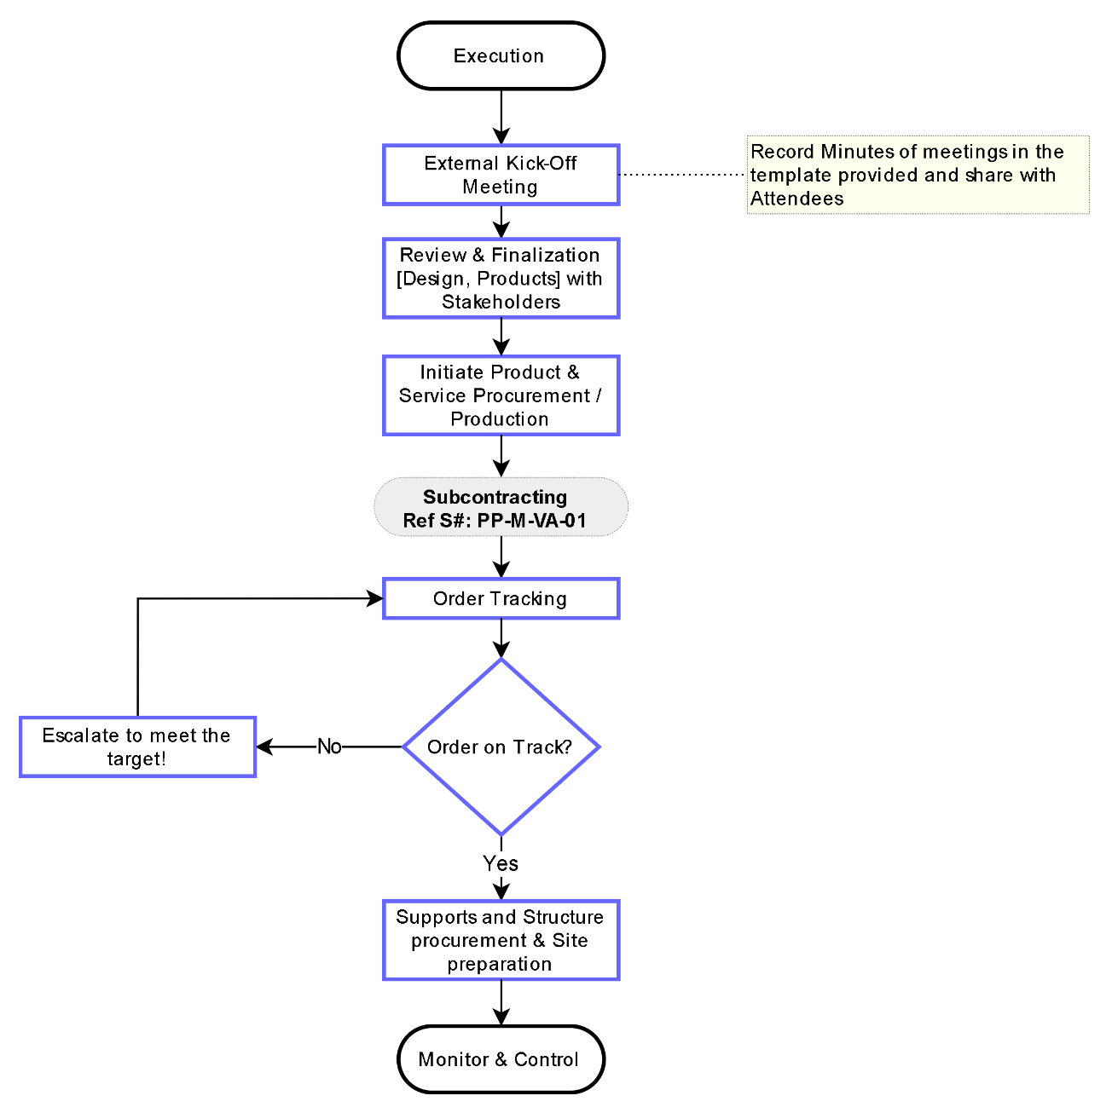
Document Ref.: PM-LOG -07
Issue No.: 1
Rev.: 0
Issuance Date: 20 June 2024
Responsible
■ Customer/Client
■ Sales Team
■ Finance
■ Project management

Subcontracting Process
The process of subcontracting involves soliciting three quotes and assessing whether the installation task should be assigned to a subcontractor or handled by an internal team, Process is applicable for Service/Installation/Projects.
Process flow chart ID: PP-M-SC-01
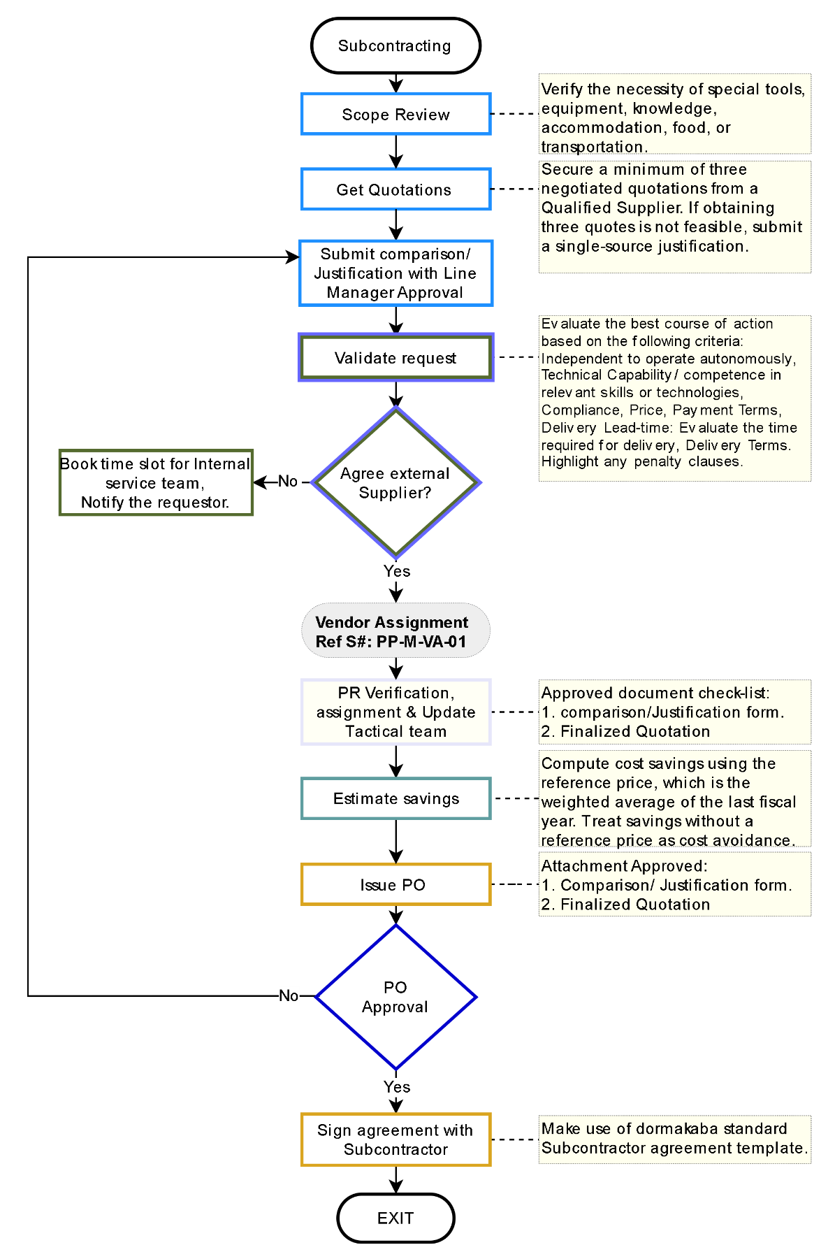
Responsible
■ Sales
■ Service/Installation Manager
■ Procurement Head
■ Tactical Team
■ Material Planning Team
■ Project management

Project Monitoring and Control Process
Vendor Qualification
Abbreviation
PO - Purchase Order
PR - Purchase Requisition
STO - Stock to Order
PTO - Purchase to Order
Document Ref.: PP-LOG -07
Issue No.: 1
Rev.: 0
Issuance Date: 20 Nov 2023
The process is designed to guarantee the control and monitoring of project monitoring and control activities, contributing to effective project management, and ensuring stakeholder satisfaction.
Process flow chart ID: PM-M-IN-01
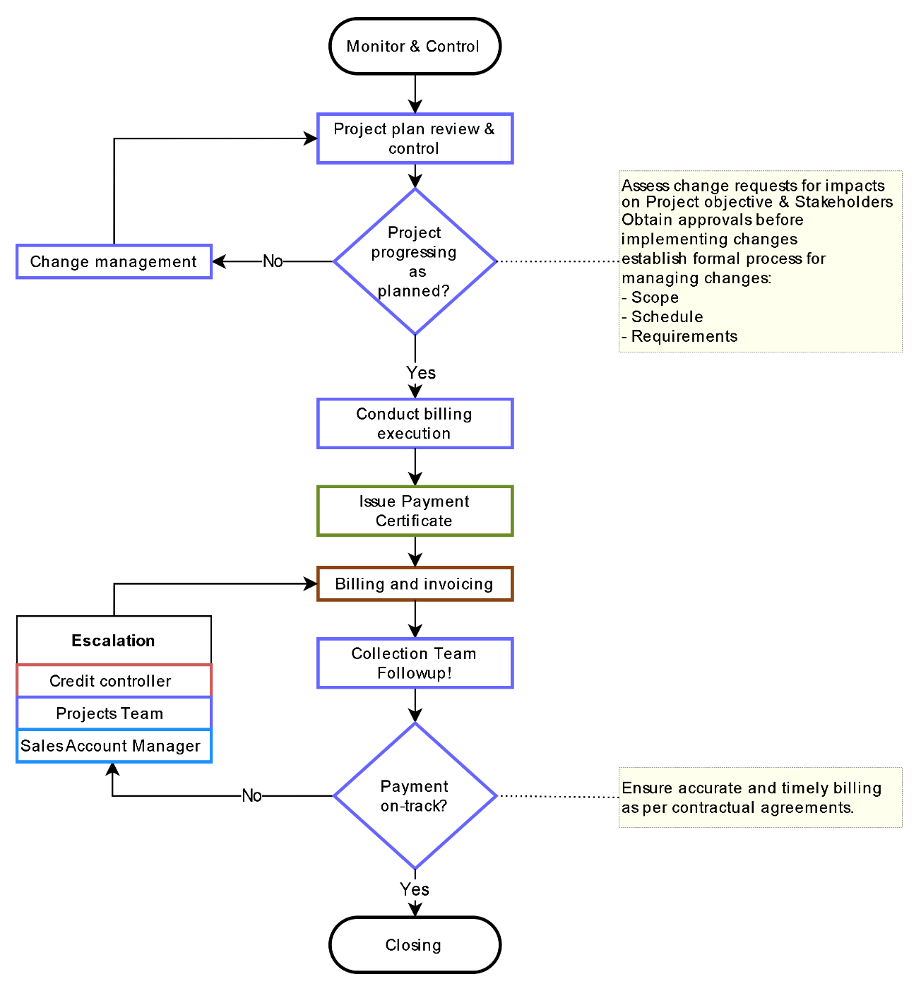
Document Ref.: PM-LOG -07
Issue No.: 1
Rev.: 0
Issuance Date: 20 June 2024
Responsible
■ Customer/Client
■ Sales Team
■ Finance
■ Credit control
■ Project management

Project Closing Process
The process is designed to guarantee the control and monitoring of project closing activities, contributing to effective project management, and ensuring stakeholder satisfaction.
Process flow chart ID: PM-M-IN-01
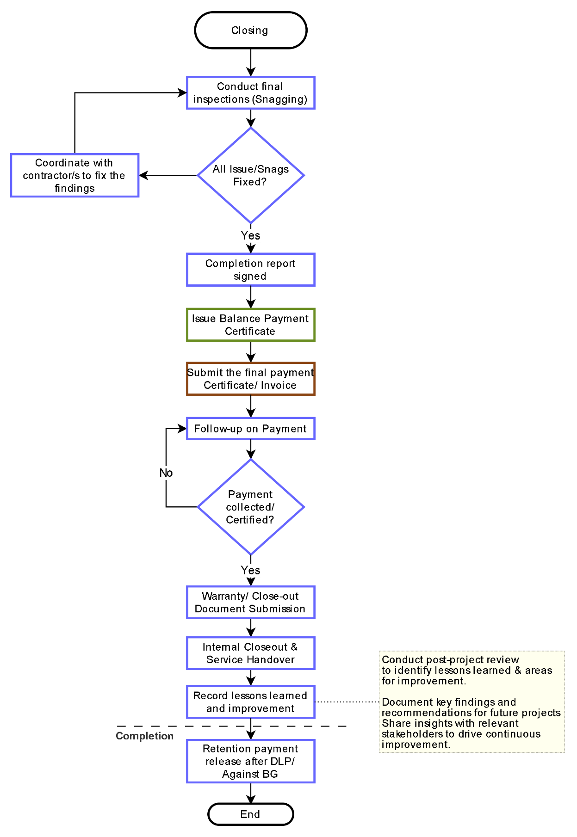
Document Ref.: PM-LOG -07
Issue No.: 1
Rev.: 0
Issuance Date: 20 June 2024
Responsible
■ Customer/Client
■ Sales Team
■ Finance
■ Project management
All Abbreviations
LC - Letter of Credit
HO - Handover
KO - Kick-off
DLP - Defect Liability Period
BG - Bank Guarantee

Escalation Matrix and KPIs
To be Updated!
Escalation Matrix
Stage | Task / Reminder to | Time Period | Escalation (by Customer Service)
Level 0 | PR + PO + OC | Process Turn Around Time  2 days | No Escalation if done in time
Level 0 | Goods Shipment | + Agreed lead time day  to be added to above TAT | No Escalation if done in time
Level 1 | Supervisor | +1 day  after the Process agreed TAT | - Reminder.  - Copy to Manager.
Level 2 | Procurement head | +1 day  after the Process agreed TAT | - Reminder.  - Copy-1 (Escalation) to Department Head.  - Copy-2 (For Information) concerned Sales and Sales support Manager.
Level 3 | Department Head | +1 day  after the Process agreed TAT | - Reminder.  - Copy-1 (Escalation) to SVP.  - Copy-2 (For Information) concerned Sales, Sales Support Manager, and Market Lead.

Note:
- Labelling 500+ will vary TAT as per the agreed term between CS, WH & Logistics

KPIs (Line Manager to manage)
- Turnaround time for each process:
- Inbound: 1 day
- PICK + PACK + Labelling + Documentation + Dispatch:
- 2 days – UAE
- 3 days – OMN/BHR
- 4 days - EXP/KWT/QAT
- Keep Stock quantity updated in the System.
- SAP Up to date with Weight, COO and HS-code time of GR
- Rate of return.
- Picking Accuracy.
- Others as per the line manager's decision.

dormakaba Gulf FZE
Jebel Ali South,
Dubai, United Arab Emirates
T: +971 4 8020 000
www.dormakaba.com/mea

