Spring

a)

<bean id=*"a"* class=*"firstProject.A"*>

</bean>

<bean id=*"b"* class=*"firstProject.B"*>

</bean>

<bean id=*"c"* class=*"firstProject.B"*>

</bean>

Ans : three different singleton beans

Parent (singleton) + child (singleton) => Parent (singleton) + child (singleton)

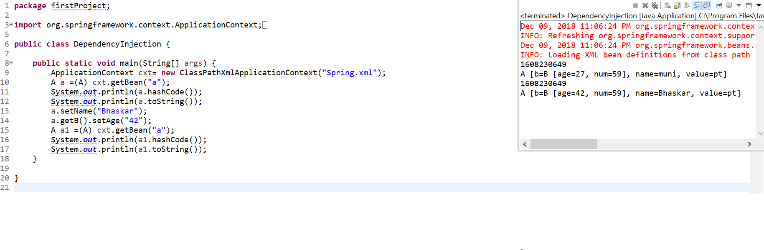

Parent (singleton) + child (prototype) => Parent (singleton) + child (singleton)

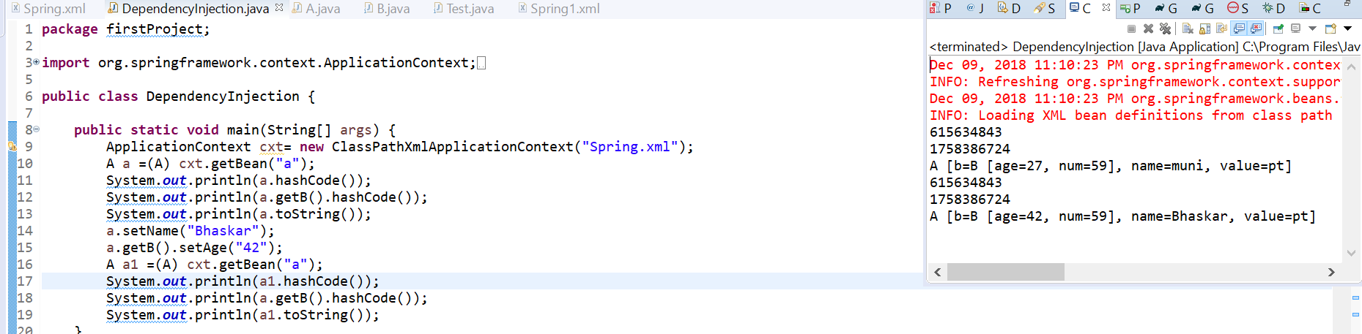

Parent (prototype) + child (singleton) => Parent (prototype) + child (singleton)

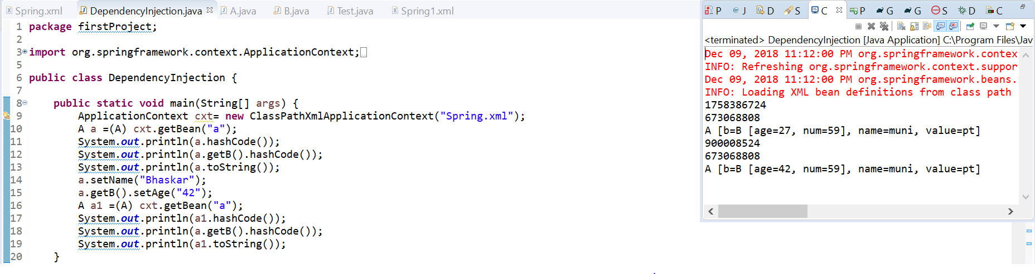

Parent (prototype) + child (prototype) => Parent (prototype) + child (prototype)

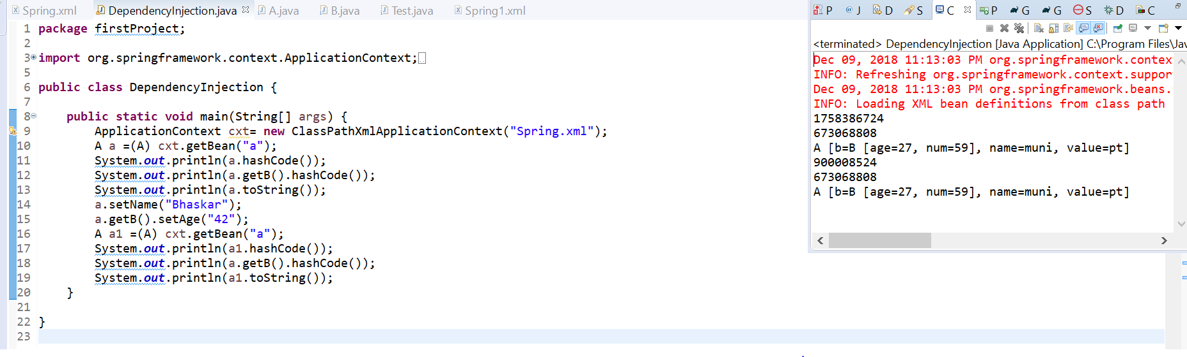

Spring1.xml is parent which contains spring .xml imported. If both xml have same beanid what happens

Ans: parent xml overrides child