Online survey system

Software Engineering Project Documentation
Submitted By
Department : Computer Science and Engineering
Institution : Annamacharya Institute of Technology and Sciences, Tirupati
Academic Year : 2023–2027
ACKNOWLEDGEMENT :
I sincerely thank my project guide, faculty members, and the Department of Computer Science and Engineering for their valuable guidance and support throughout this project. I am grateful to my teammates, friends, and family for their encouragement and cooperation. Their continuous support and motivation played a significant role in the successful completion of the Online Survey System with Analysis project.

TABLE OF CONTENTS :
- Abstract
- Introduction
- Problem Statement
- Project Objectives
- Technology Stack
- System Architecture
- Database Design
- Functional Features
- User Interface Design
- Deployment Details
- Challenges Faced
- Real-World Applications
- Future Enhancements
- Conclusion
- References

1.ABSTRACT
Many organizations and educational institutions still rely on manual or basic online methods for collecting feedback. Managing responses, analyzing data, and generating reports can be time-consuming. This project addresses these challenges by providing a centralized platform for survey creation, response collection, and automated analysis.

2. INTRODUCTION
Social Networks The Online Survey System with Analysis is a web-based application developed to simplify survey creation, response collection, and data analysis. The system allows administrators to design and manage surveys while enabling users to participate through an easy-to-use interface. Collected responses are stored securely and analyzed automatically to generate meaningful insights and reports. This platform reduces manual effort, improves data accuracy, and supports better decision-making for educational institutions, businesses, and research organizations.

3. Problem Statement:
Manual survey management is time-consuming and prone to errors. There is a need for an automated system that simplifies survey creation, response collection, and data analysis while providing accurate and meaningful insights for decision-making.

4. PROJECT OBJECTIVES
The primary objectives of this project are:
- Create and manage online surveys.
- Collect user responses efficiently.
- Store survey data securely in a database.
- Generate statistical analysis and reports.
- Provide a user-friendly interface.
- Reduce manual effort in survey management.
- Improve decision-making through data insights.

5. TECHNOLOGY STACK USED
Component | Technology Used
Frontend | HTML, CSS, Bootstrap
Backend | Python Flask
Database | MySQL
Version Control | Git & GitHub
Deployment | Render

6. SYSTEM ARCHITECTURE
The Online Survey System follows a three-tier architecture consisting of the presentation layer, application layer, and database layer. The presentation layer provides the user interface for survey creation and participation. The application layer handles business logic, survey processing, and analysis generation. The database layer stores survey details, questions, user information, and responses. This architecture ensures scalability, maintainability, and efficient data management.

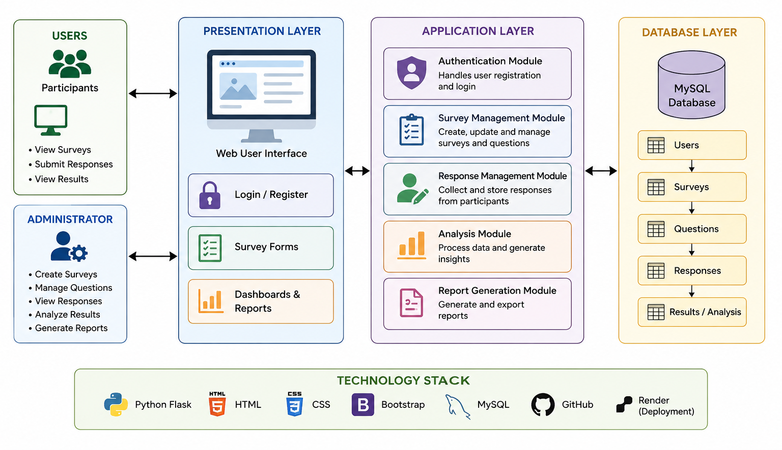
7. Database Design
The database consists of multiple tables that manage survey operations.
Users Table:
Stores user credentials and profile information.
Surveys Table:
Stores survey titles, descriptions, and creation details.
Questions Table:
Stores survey questions and associated options.
Responses Table:
Stores user responses submitted for surveys.
The database design ensures proper organization and secure storage of information.

8. Functional Features
The Online Survey System provides the following features:
• User Registration and Login
• Survey Creation and Management
• Response Submission
• Survey Monitoring
• Data Storage and Retrieval
• Automated Analysis and Reporting
• User-Friendly Dashboard
These features help streamline the complete survey process.

9.USER INTERFACE DESIGN
The user interface is designed to be simple and easy to navigate.
Home Page:
Provides access to surveys and authentication options.
Login and Registration Page:
Allows secure user authentication.
Admin Dashboard:
Enables survey creation, editing, and report viewing.
Survey Form Page:
Allows participants to answer survey questions.
Analysis Dashboard:
Displays survey statistics and reports for administrators.

10.Deployment Details
The application is deployed using the Render cloud platform. Deployment allows users to access the application through a web browser without local installation.
Deployment Benefits:
• Easy accessibility
• Centralized management
• Continuous availability
• Simplified maintenance
The source code is maintained using GitHub for version control and project management.

11. Challenges Faced
Several challenges were encountered during project development:
• Database connectivity and configuration issues.
• Designing an intuitive user interface.
• Managing survey data efficiently.
• Generating meaningful analytical reports.
• Deploying the application on a cloud platform.
These challenges were resolved through testing, debugging, and optimization.

12.. Real-World Applications
The Online Survey System can be used in various domains:
• Educational Institutions for student feedback.
• Businesses for customer satisfaction surveys.
• Organizations for employee engagement surveys.
• Research Centers for data collection.
• Market Research Companies for consumer analysis.
The system provides valuable insights that support informed decision-making.

13. Future Enhancements
The project can be enhanced with additional features such as:
• Mobile Application Support
• Real-Time Notifications
• AI-Based Data Analysis
• Advanced Data Visualization
• Multi-Language Support
• Export Reports in PDF and Excel Formats
• Enhanced Security Features
These improvements will increase usability and functionality.
14. Conclusion
The Online Survey System with Analysis successfully automates survey creation, response collection, and data analysis. The system provides a reliable and efficient platform for gathering feedback and generating insights. Its user-friendly interface, secure database management, and analytical capabilities make it a valuable tool for organizations, educational institutions, and researchers.

15. References
• Flask Official Documentation
• MySQL Documentation
• Bootstrap Documentation
• HTML and CSS Documentation (MDN)
• GitHub Documentation
• Render Deployment Documentation

