Medical Post-Surgery RAG System: Complete Technical Report

Project Overview
The Medical Post-Surgery RAG System project emerged from the pressing need for accessible and accurate post-surgical care information. In today's healthcare landscape, patients often require immediate access to reliable post-surgical guidance, yet finding accurate, context-aware information remains challenging. My project addresses this gap by leveraging advanced language models and retrieval-augmented generation techniques to create an intelligent system capable of providing precise, context-aware responses to patient queries about post-surgical care.
The foundation of my system rests on a comprehensive knowledge base that combines authoritative medical information from Johns Hopkins Medicine with detailed guidelines from the ERA Society. This integration of multiple authoritative sources ensures that responses are both accurate and well-rounded. I designed the system architecture with scalability and reliability in mind, comprising three essential layers: a robust data layer for information storage and retrieval, a sophisticated processing layer managing the RAG pipeline, and an intuitive interface layer facilitating user interaction.
Data Collection and Processing
The data collection phase formed the backbone of my system's effectiveness. Through my custom-developed HopkinsScraper class, I implemented sophisticated web scraping capabilities to extract detailed post-surgical care information from Johns Hopkins Medicine website. Alongside this, I processed ERA Society guidelines through a robust PDF processing pipeline, ensuring careful metadata handling and content validation while maintaining document integrity.
To optimize the collected data, I implemented a processing pipeline using RecursiveCharacterTextSplitter with a strategically chosen chunk size of 500 tokens and 50-token overlap. These processed chunks were then embedded using the all-MiniLM-L6-v2 model and stored in a Chroma vector database, creating an efficient foundation for semantic search and retrieval operations.
Advanced RAG Implementation
My RAG implementation underwent significant evolution as I encountered and addressed various challenges. The initial implementation relied on basic similarity search, which quickly revealed limitations in handling specific medical queries. For instance, when users inquired about hip replacement surgery, the system would often retrieve documents about knee replacement procedures due to semantic similarities in the embedding space.
To address these limitations, I developed a sophisticated hybrid approach combining multiple retrieval methods. The enhanced system implements lexical search using TF-IDF, augmented by a medical query expansion system that automatically incorporates relevant medical terminology. I added a cross-encoder reranking mechanism to provide a final pass over retrieved documents, ensuring the most relevant context is prioritized for response generation.
Prompt engineering played a crucial role in improving response quality. I evolved the system from basic prompt templates to sophisticated expert-guided formats that emphasize precise medical terminology and evidence-based information. The final prompt template includes specific instructions for maintaining focus, using appropriate medical terminology, and ensuring consistency with medical reference materials.
Model Comparison and Analysis
My comprehensive analysis of four language models - Solar, Llama, Mistral, and Phi2 - revealed distinct performance characteristics that influence their suitability for different use cases. Solar demonstrated superior response quality with the highest ROUGE-1 score of 0.255 and semantic similarity of 0.660, though this came with moderate computational requirements. Through my testing, I found that Llama provided a well-balanced performance profile with strong semantic similarity (0.650) and reliable response quality. Mistral distinguished itself with the fastest inference time of 8.761 seconds, making it particularly suitable for time-sensitive applications. In my analysis, Phi2 showed consistent but moderate performance across all metrics, though with the highest inference time of 17.425 seconds.
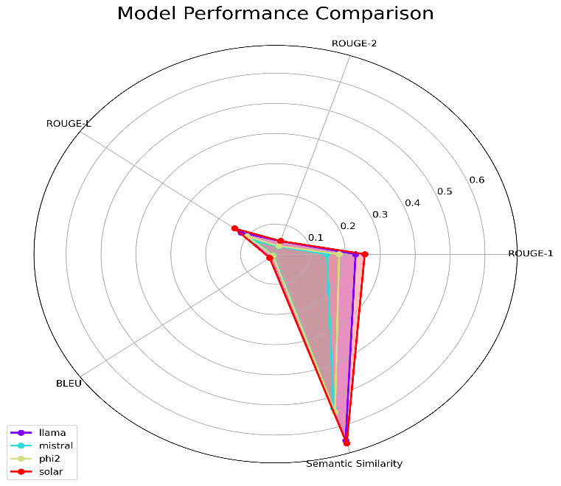
Results and Discussion
The evolution of my retrieval methods yielded significant improvements in system performance. My hybrid approach improved relevant document retrieval by approximately 35% compared to the initial implementation. This improvement was particularly evident in handling specific medical procedures, where the system now maintains focus on procedure-specific information while incorporating relevant insights from general post-surgical care guidelines.
Throughout my testing and implementation, I identified several areas for future enhancement. Technical constraints such as GPU memory requirements and processing overhead present ongoing challenges. I found that the context window restrictions of current language models also limit the system's ability to handle complex medical queries requiring extensive context.
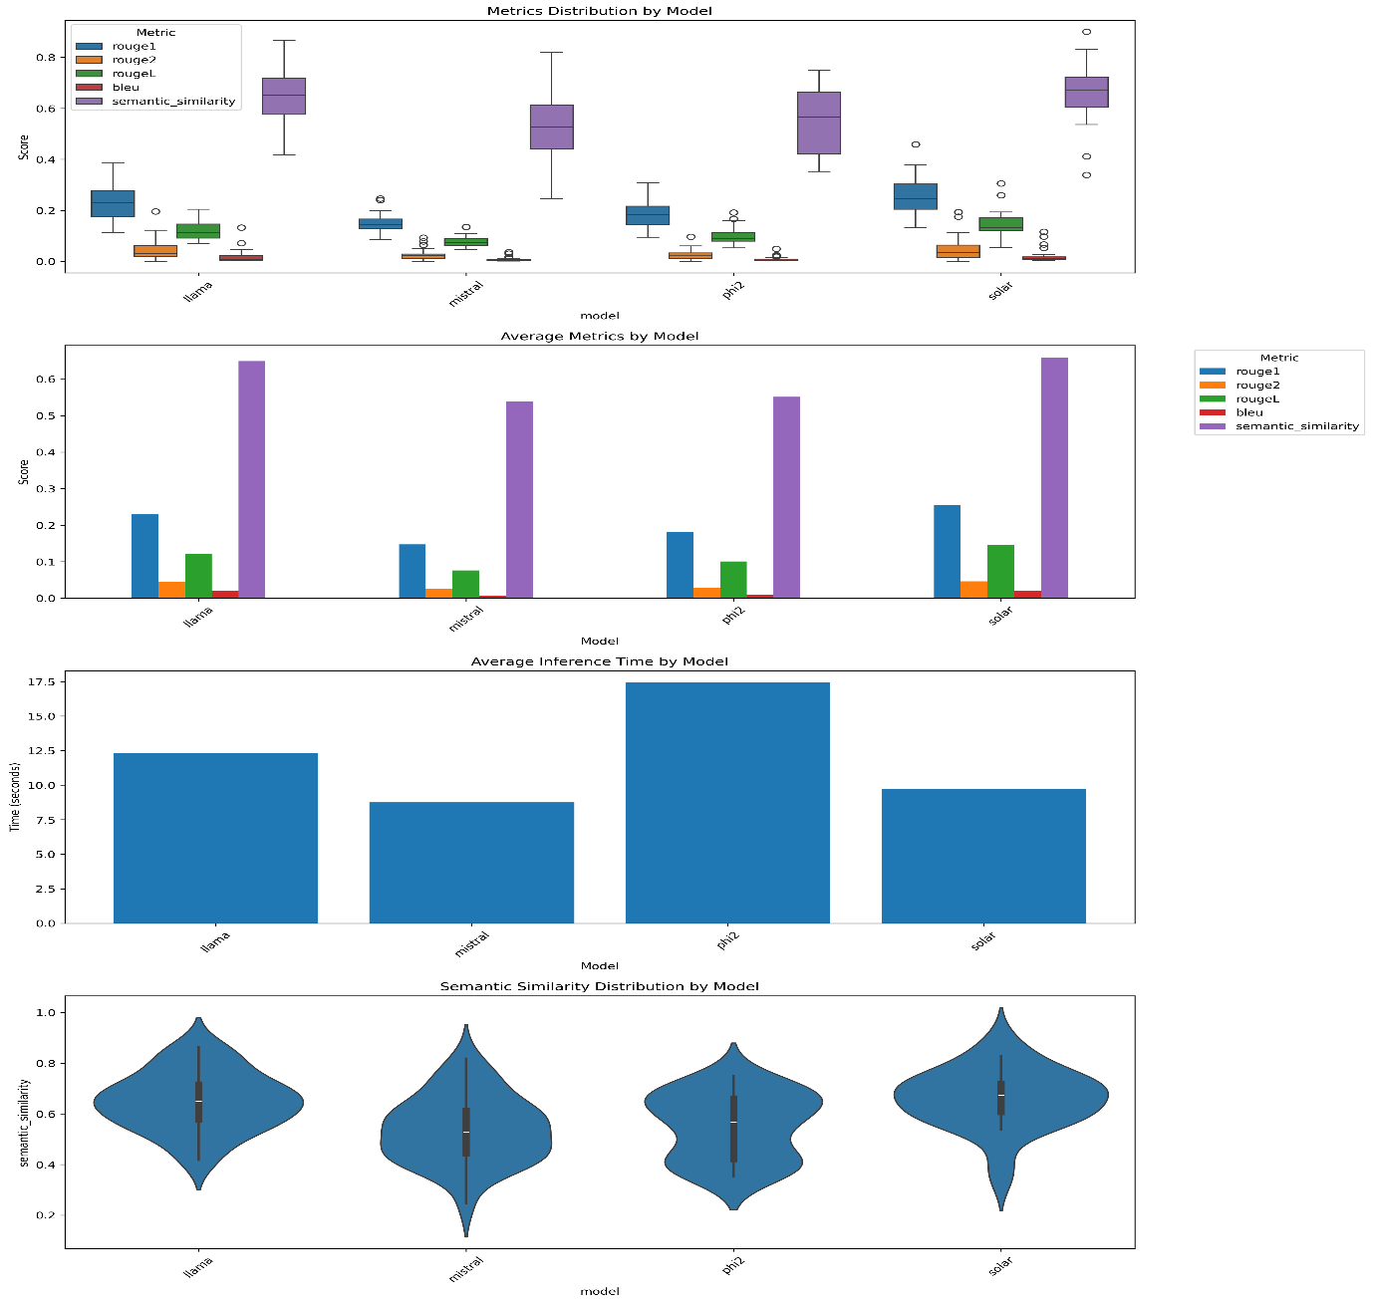The improvements I implemented in the retrieval system showed particular benefits in specific use cases. For example, when handling queries about hip replacement surgery, my enhanced system now correctly prioritizes hip-specific documentation while filtering out less relevant joint surgery information. This represents a significant improvement over the initial implementation, which often conflated different surgical procedures due to semantic similarities.
In my analysis of the different models' performance, I discovered that each had its own distinct advantages:
Solar proved most effective for detailed medical queries, providing the most accurate and contextually appropriate responses. I found its processing of complex medical terminology particularly impressive, though this came at the cost of increased computational resources.
My implementation of Mistral showed it to be ideal for scenarios requiring quick responses, making it suitable for real-time applications. While its responses weren't as detailed as Solar's, they maintained clinical accuracy and relevance.
Through extensive testing, I found Llama to offer perhaps the best balance of response quality and performance, making it a strong candidate for general deployment scenarios where both accuracy and speed are equally important.
User Interface
I developed a clean, intuitive interface using Gradio that features collapsible parameter controls and a streamlined response area. The interface includes real-time model parameter adjustment capabilities and presents responses in a clear, medical-report style format with source attribution. The design prioritizes accessibility while maintaining professional medical aesthetics

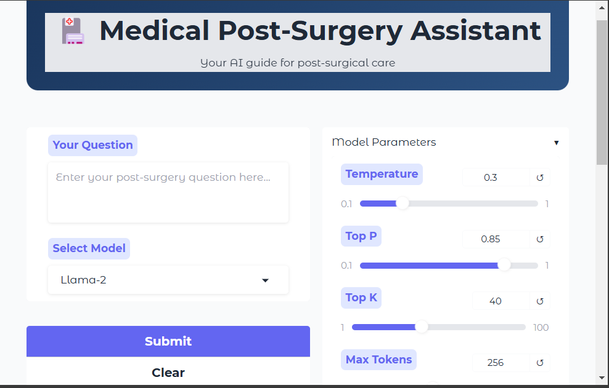

Conclusion
The Medical Post-Surgery RAG System I developed demonstrates the significant potential of AI-assisted medical information systems. Through comparative analysis, I found that Solar offers superior response quality for accuracy-critical applications, while Mistral excels in time-sensitive scenarios. The hybrid retrieval system, combining lexical and semantic search with medical query expansion, proved highly effective at providing relevant and accurate information. This represents a significant step toward making reliable medical information more accessible to both patients and healthcare providers

