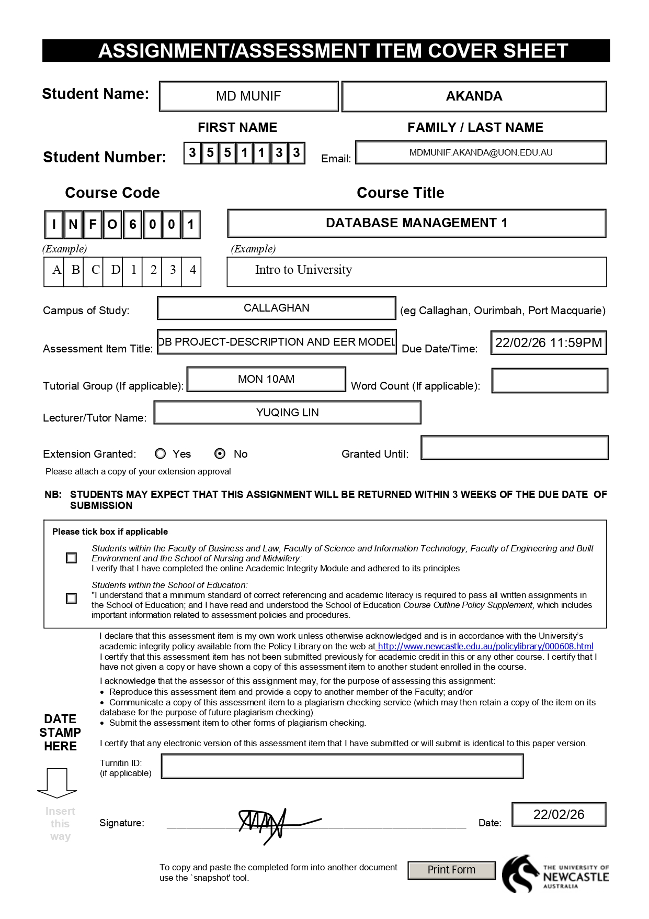
INFO6001 T1 2025
Assignment 1
Project: Database design of UNIE Library System
Table of Contents
Preface 2
Part 1: Requirements 3
Data Requirements 3
Transaction Requirements 7
Business Rules 8
Part 2: EER Model 9
Data Dictionary 11
Entity 11
Relationships 12
Attributes: 13
Summary 18

Preface

The conceptual design of the UNIE Library System was developed using an Enhanced Entity-Relationship (EER) approach to capture resources, borrowing processes, membership management, and copy tracking within a consistent structure.

Core entities such as Item, Copy, Member, and Loan were first identified. Specialization was introduced to reflect domain differences that could not be represented effectively through a single entity structure.

Item was categorised into Book, Journal, and OnlineDatabase. Similarly, Copy was divided into PhysicalCopy and DigitalCopy. These generalisations were modelled as total and disjoint to prevent classification overlap, ensuring each instance is represented with clear semantic meaning.

The model also incorporates operational constraints observed in real library environments (Elmasri & Navathe, 2016). MembershipType and Privilege is used to control borrowing eligibility. HoldRequest is used to represent reservation behaviour. Resource procurement and collection expansion are handled through AcquisitionRequest to reflect acquisition workflows. Composite and multivalued attributes were introduced selectively to improve accuracy.

Overall, the model prioritises clarity, extensibility, and realistic constraint representation across physical and digital resource management contexts.

Part 1: Requirements

Data Requirements

Catalogue Services
Item
An Item in the UNIE library could be of various types such as Book, Journal, and Online Database. When an Item is created, information recorded includes a unique item number, title, publisher, author (up to 10), year, description, notes, and subject. Additional information is recorded based on the item type as:
- Book: edition, contents, summary, ISBN
- Journal: frequency, abbreviated title, main series, ISSN
- Online Database: contents, release date
An Item can have zero or more copies. Each Copy of an Item has a unique accession number with information on date added and cost. A Copy of an Item can be either a Physical Copy or a Digital Copy.
- Physical Copy: contains a barcode and status (available, on loan, on hold, damaged, withdrawn, lost).
- Digital Copy: contains URL, format, access period, size, and units of size.
Collection
A collection represents a physical grouping of resources within the library that helps users locate physical items. Each PhysicalCopy belongs to a single collection describing its campus and storage location.
Attributes include:
- collectionID (Primary Key)
- collectionName
- physicalLocation (Composite Attribute):
  - campus
  - building
  - shelf
Member
A member represents a user of the UNIE library who can borrow/loan physical items and place hold request. The system will store information such as personal details, contact details, and membership status to enable borrowing, notifications, and access control.
Attributes include:
- memberID (Primary Key)
- PIN
- name
- memberAddress (composite attribute)
  - street
  - city
  - postcode
- email
- contactNumber
- dateJoined
- dateOfBirth
- membershipStatus
- membershipExpirationDate

MemberType
MemberType represents a classification of library members such as student, staff, or external user. This is used to determine a member’s borrowing privileges, renewal and loan limits, and any restrictions that apply to a member.
Attributes include:
- memberTypeID (Primary Key)
- typeName
- description
- additionalInformation

Privilege
Privilege defines borrowing and hold restrictions that apply to members based on their MemberType and the Collection of items that are being accessed. Privileges specify limits such as loan period, maximum items that can be borrowed, and maximum holds that are allowed.
Attributes include:
- PrivilegeID (Primary Key)
- privilegeName
- loanPeriod
- maxRenewals
- maxBorrowLimit
- maxHoldLimit
Loan
A Loan represents the borrowing of a physicalCopy of an Item by a member. This entity records current and past transactions including loan dates, due dates and loan status.
Attributes include:
- loanID (Primary Key)
- dateLoaned
- dueDate
- loanStatus
- renewalCount
HoldRequest
A HoldRequest will represent a reservation requested by a Member for an currently unavailable Item. HoldRequest are processed in a first in first out (FIFO) order.
Attributes include:
- holdRequestID (Primary Key)
- holdRequestDateTime
- holdStatus
- comments
AcquisitionRequest
An AccquisitonRequest represents a suggestion submitted by member to acquire a new item. Requests are reviewed by library management and may be approved or rejected.
Attributes include:
- accquisitonRequestID (Primary Key)
- requestedTitle
- requestedAuthor
- requestedDate
- requestStatus
- additionalComments

Transaction Requirements
Data Manipulation
The following data manipulation operations describe the core create, update, and removal activities required to maintain the integrity and accuracy of the UNIE Library System database.
- Insert, update, and delete Item records (Book, Journal, OnlineDatabase).
- Insert, update, and delete CopyOfItem records (PhysicalCopy and DigitalCopy).
- Insert and maintain Collection records and update the location of PhysicalCopies.
- Register a new Member and assign a PIN.
- Update Member details such as address, contact information, and membership status.
- Create and maintain MemberType records.
- Create and update Privilege rules for MemberTypes and Collections.
- Issue a Loan when a Member borrows a PhysicalCopy.
- Renew a Loan and update the dueDate and renewalCount.
- Close a Loan when a PhysicalCopy is returned and update its status.
- Create and cancel HoldRequests for unavailable Items.
- Submit and manage AcquisitionRequests.

Queries
The system must support a range of search and retrieval operations that enable efficient discovery of library resources and member activities.
- Search Items by title, author, subject, or publisher.
- Filter catalogue search results by subtype (Book, Journal, OnlineDatabase).
- Display all copies of an Item and indicate availability.
- Show the physical location (Collection) of a PhysicalCopy.
- List all current Loans for a Member with due dates and status.
- Identify overdue Loans.
- Display the HoldRequest queue for an Item ordered by requestDateTime.
- List Holds ready for pickup or nearing expiry.
- Generate a report of frequently borrowed Items.
- List AcquisitionRequests by status.

Business Rules
The following business rules define the operational constraints and policies governing resource management, borrowing activities, membership control, and reservation handling within the UNIE Library System.
Catalogue Rules
- An Item must belong to exactly one subtype: Book, Journal, or OnlineDatabase.
- Each Item is uniquely identified by itemNo.
- An Item may have zero or more copies.
- Each CopyOfItem must belong to exactly one Item.
- A CopyOfItem must be either a PhysicalCopy or a DigitalCopy.
- A PhysicalCopy has a status indicating availability (available, on loan, on hold, damaged, withdrawn, lost).
Circulation and Membership Rules
- Only registered Members can borrow PhysicalCopies.
- Each Member must belong to exactly one MemberType.
- Borrowing limits and renewal limits are determined by Privilege rules.
- A Loan must reference one Member and one PhysicalCopy.
- A PhysicalCopy cannot be loaned to more than one Member at the same time.
- Loan renewals are limited by maxRenewals.
Hold Rules
- Members can place HoldRequests on Items that are currently unavailable.
- HoldRequests are processed in FIFO order based on requestDateTime.
- When a PhysicalCopy becomes available, the next HoldRequest may be fulfilled and the member notified.
- If a held item is not collected within a defined pickup period, the HoldRequest expires.
- A Member’s maximum number of holds is controlled by Privilege rules.
Acquisition Rules
- Members may submit AcquisitionRequests for new Items.
- AcquisitionRequests must be reviewed and either approved or rejected.
- The status of each AcquisitionRequest must be recorded.

Part 2: EER Model

The following Enhanced Entity-Relationship (EER) diagram illustrates the conceptual design of the UNIE Library System. It includes resource classification, copy management, membership, and circulation processes.
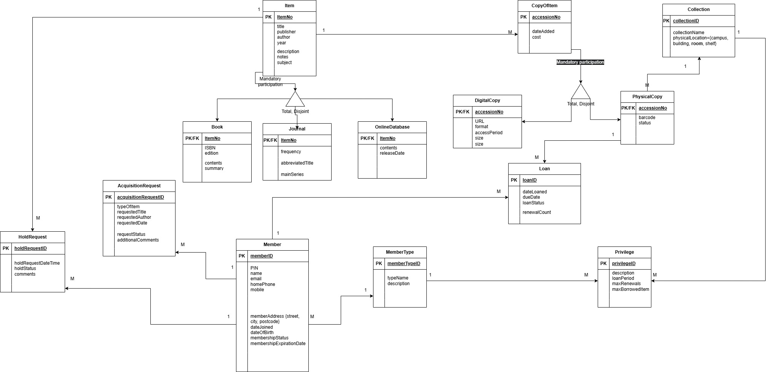
Figure 1: EER diagram representing the UNIE Library System.

Data Dictionary

Entity
The following table documents all entities in the EER model, including superclass and subclass entities.
Entity Name | Description | Aliases | Occurrences
Item | Central superclass representing any library resource catalogued by the UNIE library. | Resource | One per distinct library resource (itemNo).
Book | Subclass of Item representing a monographic publication. | Monograph | One per book title.
Journal | Subclass of Item representing a serial academic publication. | Periodical | One per journal title.
OnlineDatabase | Subclass of Item representing a digital subscription resource with no physical copies. | e-Database | One per database subscription.
CopyOfItem | Superclass representing an individual instance of an Item owned by the library. | Item Instance | One per copy accession record.
PhysicalCopy | Subclass of CopyOfItem representing a tangible library item that can be borrowed. | Physical Item | One per physical copy.
DigitalCopy | Subclass of CopyOfItem representing an electronic version of an Item. | e-Copy | One per digital copy.
Collection | Logical grouping used to organise PhysicalCopies within the library. | Library Collection | One per collection category.
Member | Registered user of the library who can borrow and request items. | Library Member | One per registered member.
MemberType | Classification defining borrowing privileges for members. | Membership Category | One per membership category.
Privilege | Borrowing and holding rules associated with a membership category. | Borrowing Rules | One per privilege rule set.
Loan | Record of a PhysicalCopy being borrowed by a Member. | Borrowing Record | One per borrowing transaction.
HoldRequest | Reservation placed by a Member for an unavailable Item. | Reservation | One per hold request.
AcquisitionRequest | Request submitted by a Member to add a new Item to the library. | Purchase Request | One per acquisition request.

Relationships
The following sections further document the relationships and attributes that support the entities defined above.
Entity Name | Multiplicity | Relationship | Multiplicity | Entity Name
Item | 1 | has | 0..* | CopyOfItem
Item | Mandatory | Generalisation (Total, Disjoint) | Mandatory | Book
Item | Mandatory | Generalisation (Total, Disjoint) | Mandatory | Journal
Item | Mandatory | Generalisation (Total, Disjoint) | Mandatory | OnlineDatabase
CopyOfItem | Mandatory | Generalisation (Total, Disjoint) | Mandatory | PhysicalCopy
CopyOfItem | Mandatory | Generalisation (Total, Disjoint) | Mandatory | DigitalCopy
PhysicalCopy |  | located in | 1 | Collection
  0..*
PhysicalCopy | 1 | loaned in | 0..* | Loan
Member | 1 | borrows | 0..* | Loan
Member | 1 | places | 0..* | HoldRequest
Item | 1 | requested in | 0..* | HoldRequest
Member | 1 | submits | 0..* | AcquisitionRequest
Member | 0..* | belongs to | 1 | MemberType
MemberType | 1 | assigned | 0..* | Privilege

Attributes:
Entity | Attributes | Description | Data Type & Length | Nulls | Multi-valued | Derived | Default
Item | itemNo | Unique item identifier (PK) | CHAR(10) | N | N | N | —
Item | title | Title of the item | VARCHAR(200) | N | N | N | —
Item | publisher | Publisher name | VARCHAR(200) | Y | N | N | —
Item | author | Author(s) (max 10) | VARCHAR(200) | Y | Y | N | —
Item | year | Publication year | CHAR(4) | Y | N | N | —
Item | description | Item description | VARCHAR(500) | Y | N | N | —
Item | notes | Notes about the item | VARCHAR(300) | Y | N | N | —
Item | subject | Subject classification | VARCHAR(100) | Y | N | N | —

Entity | Attributes | Description | Data Type & Length | Nulls | Multi-valued | Derived | Default
Book | itemNo | PK/FK referencing Item.itemNo | CHAR(10) | N | N | N | —
Book | ISBN | Book ISBN | CHAR(13) | Y | N | N | —
Book | edition | Edition info | VARCHAR(20) | Y | N | N | —
Book | contents | Table of contents / contents | VARCHAR(500) | Y | N | N | —
Book | summary | Book summary | VARCHAR(500) | Y | N | N | —

Entity | Attributes | Description | Data Type & Length | Nulls | Multi-valued | Derived | Default
Journal | itemNo | PK/FK referencing Item.itemNo | CHAR(10) | N | N | N | —
Journal | frequency | Publication frequency | VARCHAR(50) | Y | N | N | —
Journal | abbreviatedTitle | Abbreviated journal title | VARCHAR(100) | Y | N | N | —
Journal | mainSeries | Main series name | VARCHAR(100) | Y | N | N | —

Entity | Attributes | Description | Data Type & Length | Nulls | Multi-valued | Derived | Default
OnlineDatabase | itemNo | PK/FK referencing Item.itemNo | CHAR(10) | N | N | N | —
OnlineDatabase | contents | Database contents/description | VARCHAR(500) | Y | N | N | —
OnlineDatabase | releaseDate | Release date | DATE | Y | N | N | —

Entity | Attributes | Description | Data Type & Length | Nulls | Multi-valued | Derived | Default
CopyOfItem | accessionNo | Unique copy identifier (PK) | CHAR(15) | N | N | N | —
CopyOfItem | dateAdded | Date the copy was added | DATE | N | N | N | —
CopyOfItem | cost | Cost of this copy | DECIMAL(8,2) | Y | N | N | —

Entity | Attributes | Description | Data Type & Length | Nulls | Multi-valued | Derived | Default
PhysicalCopy | accessionNo | PK/FK referencing CopyOfItem.accessionNo | CHAR(15) | N | N | N | —
PhysicalCopy | barcode | Physical barcode identifier | VARCHAR(20) | N | N | N | —
PhysicalCopy | status | Availability status | VARCHAR(20) | N | N | N | Available

Entity | Attributes | Description | Data Type & Length | Nulls | Multi-valued | Derived | Default
DigitalCopy | accessionNo | PK/FK referencing CopyOfItem.accessionNo | CHAR(15) | N | N | N | —
DigitalCopy | URL | Link to digital resource | VARCHAR(300) | N | N | N | —
DigitalCopy | format | File/resource format (e.g., PDF, HTML) | VARCHAR(20) | Y | N | N | —
DigitalCopy | accessPeriod | Access period/term | VARCHAR(50) | Y | N | N | —
DigitalCopy | size | Size value | DECIMAL(10,2) | Y | N | N | —
DigitalCopy | unitOfSize | Unit of size (MB/GB) | VARCHAR(10) | Y | N | N | —

Entity | Attributes | Description | Data Type & Length | Nulls | Multi-valued | Derived | Default
Collection | collectionID | Unique collection identifier (PK) | CHAR(10) | N | N | N | —
Collection | collectionName | Name of collection | VARCHAR(100) | N | N | N | —
Collection | physicalLocation | Composite location string (campus/building/room/shelf) | VARCHAR(200) | Y | N | N | —

Entity | Attributes | Description | Data Type & Length | Nulls | Multi-valued | Derived | Default
Member | memberID | Unique member identifier (PK) | CHAR(10) | N | N | N | —
Member | PIN | Member PIN | CHAR(4) | N | N | N | —
Member | name | Full name | VARCHAR(100) | N | N | N | —
Member | email | Email address | VARCHAR(150) | N | N | N | —
Member | homePhone | Home phone number | VARCHAR(20) | Y | N | N | —
Member | mobile | Mobile phone number | VARCHAR(20) | Y | N | N | —
Member | memberAddress | Composite address (street/city/postcode) | VARCHAR(200) | Y | N | N | —
Member | dateJoined | Date joined | DATE | N | N | N | —
Member | dateOfBirth | Date of birth | DATE | Y | N | N | —
Member | membershipStatus | Status (active/expired/suspended etc.) | VARCHAR(20) | N | N | N | Active
Member | membershipExpirationDate | Expiry date | DATE | Y | N | N | —

Entity | Attributes | Description | Data Type & Length | Nulls | Multi-valued | Derived | Default
Privilege | privilegeID | Privilege identifier (PK) | CHAR(10) | N | N | N | —
Privilege | description | Privilege description | VARCHAR(200) | Y | N | N | —
Privilege | loanPeriod | Standard loan period (days) | INT | N | N | N | —
Privilege | maxRenewals | Max renewals allowed | INT | N | N | N | 0
Privilege | maxBorrowLimit | Max physical items borrowable | INT | N | N | N | —
Privilege | maxHoldLimit | Max holds allowed | INT | N | N | N | —

Entity | Attributes | Description | Data Type & Length | Nulls | Multi-valued | Derived | Default
Loan | loanID | Unique loan identifier (PK) | CHAR(12) | N | N | N | —
Loan | dateLoaned | Date loan started | DATE | N | N | N | —
Loan | dueDate | Due date | DATE | N | N | N | —
Loan | loanStatus | Status (open/closed/overdue) | VARCHAR(20) | N | N | N | Open
Loan | renewalCount | Number of renewals used | INT | N | N | N | 0

Entity | Attributes | Description | Data Type & Length | Nulls | Multi-valued | Derived | Default
HoldRequest | holdRequestID | Unique hold request identifier (PK) | CHAR(12) | N | N | N | —
HoldRequest | holdRequestDateTime | Date/time hold was placed | DATETIME | N | N | N | —
HoldRequest | holdStatus | Status (pending/notified/fulfilled/cancelled/expired) | VARCHAR(20) | N | N | N | Pending
HoldRequest | comments | Optional comments | VARCHAR(300) | Y | N | N | —

Entity | Attributes | Description | Data Type & Length |  | Nulls | Multi-valued | Derived | Default
AcquisitionRequest | acquisitionRequestID | Unique acquisition request id (PK) | CHAR(12) |  | N | N | N | —
AcquisitionRequest | typeOfItem | Requested item type | VARCHAR(30) |  | Y | N | N | —
AcquisitionRequest | requestedTitle | Title requested | VARCHAR(200) |  | N | N | N | —
AcquisitionRequest | requestedAuthor | Author requested | VARCHAR(200) |  | Y | N | N | —
AcquisitionRequest | requestedDate | Date requested | DATE |  | N | N | N | —
AcquisitionRequest | requestStatus | Status (submitted/approved/rejected) | VARCHAR(20) |  | N | N | N | Submitted
AcquisitionRequest | additionalComments | Extra notes | VARCHAR(300) |  | Y | N | N | —

Summary
The developed EER model captures the core structure of the UNIE Library System. The model integrates resource classification, copy management, membership control, and borrowing activities within a unified conceptual framework. The introduction of specialisation enabled the model to separate resource and copy variations.
Key relationships were defined to mirror real library behaviour. This includes the dependency between Items and Copies, borrowing processes represented through Loan, and reservation handling through HoldRequest. Borrowing eligibility and usage restrictions are enforced through MembershipType and Privilege. This allows policy constraints to be expressed directly at the conceptual level rather than deferred to implementation stages.
The accompanying data dictionary strengthens the model by explicitly defining entities, attributes, and relationships, ensuring consistency between the conceptual diagram and its documentation. Design decisions prioritised structural clarity and constraint representation while maintaining flexibility for future extensions such as fine management or notification support.
Overall, the conceptual model establishes a consistent foundation which supports physical and digital resource management. The model provides a stable basis for subsequent logical database design and implementation.

References
- Elmasri, R., & Navathe, S. B. (2016). Fundamentals of database systems (7th ed.). Pearson.

