1. Arithmetic operation is mathematical operator in programming to complete calculation, there are addition (+), subtraction (-), multiplication (*) and division (/).
2. Data type word or String is a variable have information in several characters likes word or sentence.

Data type character is a variable have information in single character.

1. 113
2. 2
3. 3566GoldenStreetMiami
4. Flaky test is a test that uis observed to both pass and fail with the same code
5. For testing Ajax/javascript using Selenium WebDriver with five methods, there are
6. Thread.Sleep()
7. Implicit Wait()
8. Explicit Wait()
9. WebdriverWait
10. FluentWait
11. To test captcha on website page with two test, there are positive and negative test.

Positive test, input right chrachter 🡪 Expected Result is success to enter the application.

Negative test, input with wrong character uppercase and lowercase, in example different between I(I uppercase), l(L lowercase) 🡪 sometime user can not differentiate it. wrong number number, with spasi and punctuation (ex: ?; !; @; /; +; ect). Expected result is show notification “captcha code does not macth”.

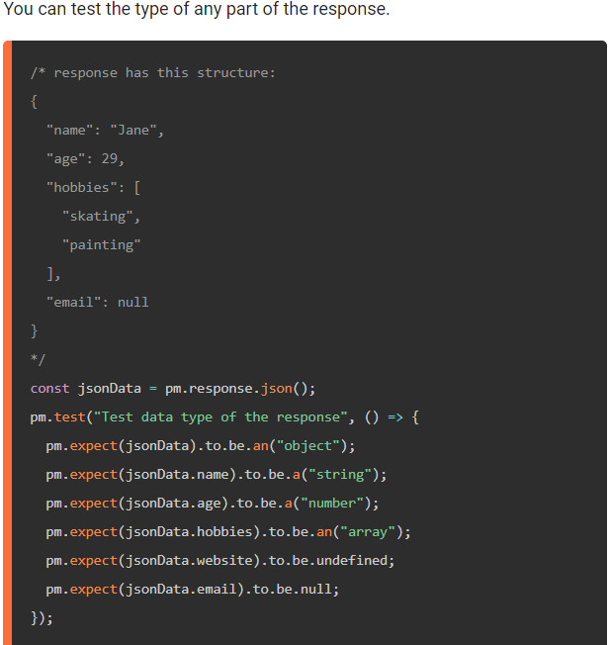

|  |  |  |  |  |
| --- | --- | --- | --- | --- |
| Test Case | Command | Target | Value | Status |
| Registration |  |  |  |  |
|  |  |  |  |  |
|  |  |  |  |  |
|  |  |  |  |  |
|  |  |  |  |  |
|  |  |  |  |  |
|  |  |  |  |  |