**Test-1: Creating a new Book**

**Output: Book created successfully**

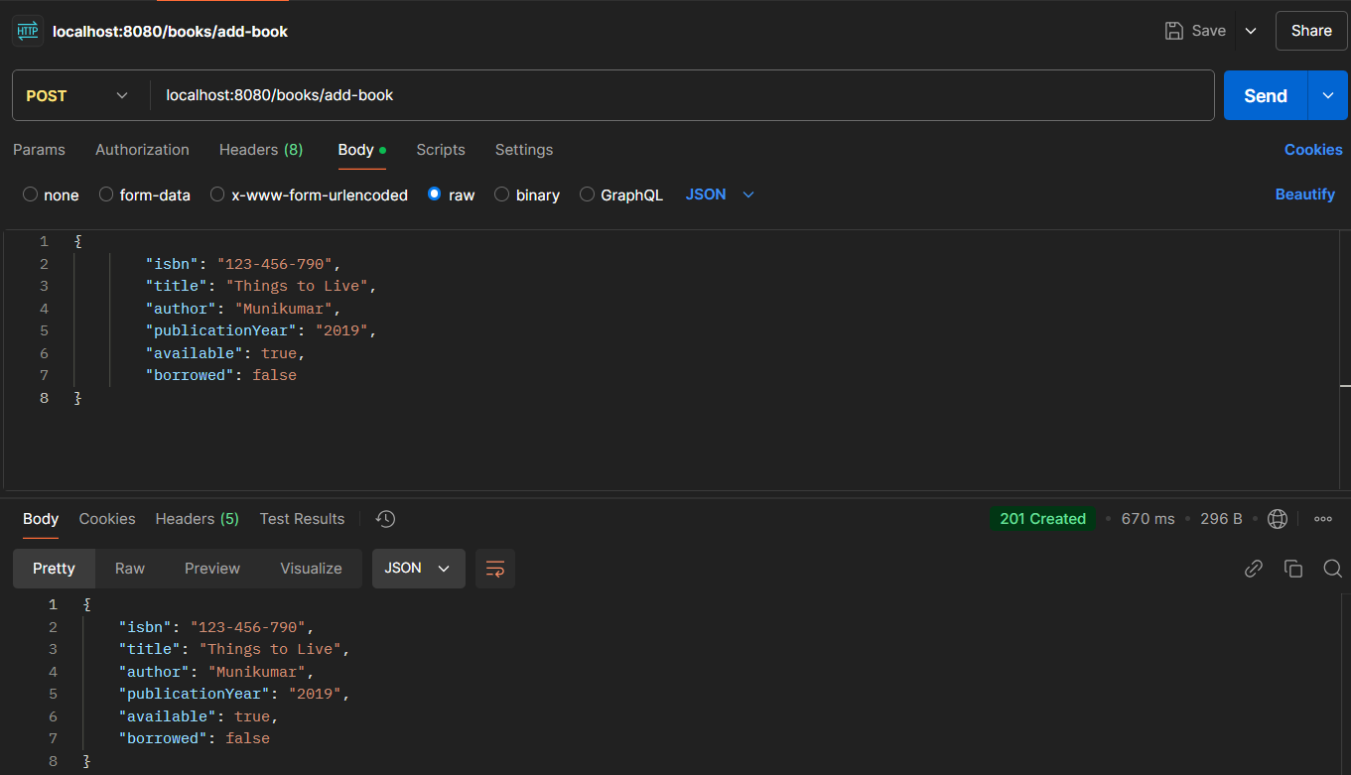

**Test-2: Creating another Book with existing isbn**

**Output: Book with this isbn already exists**

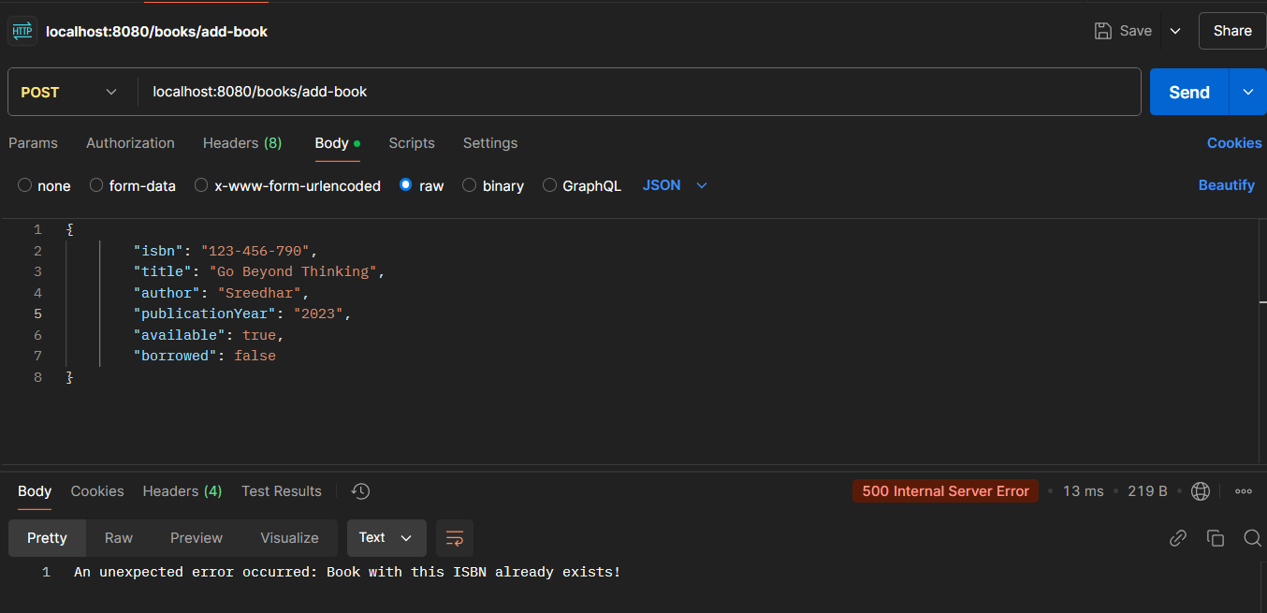

**Test-3: Creating a new Book without isbn**

**Output: The isbn must not be null**

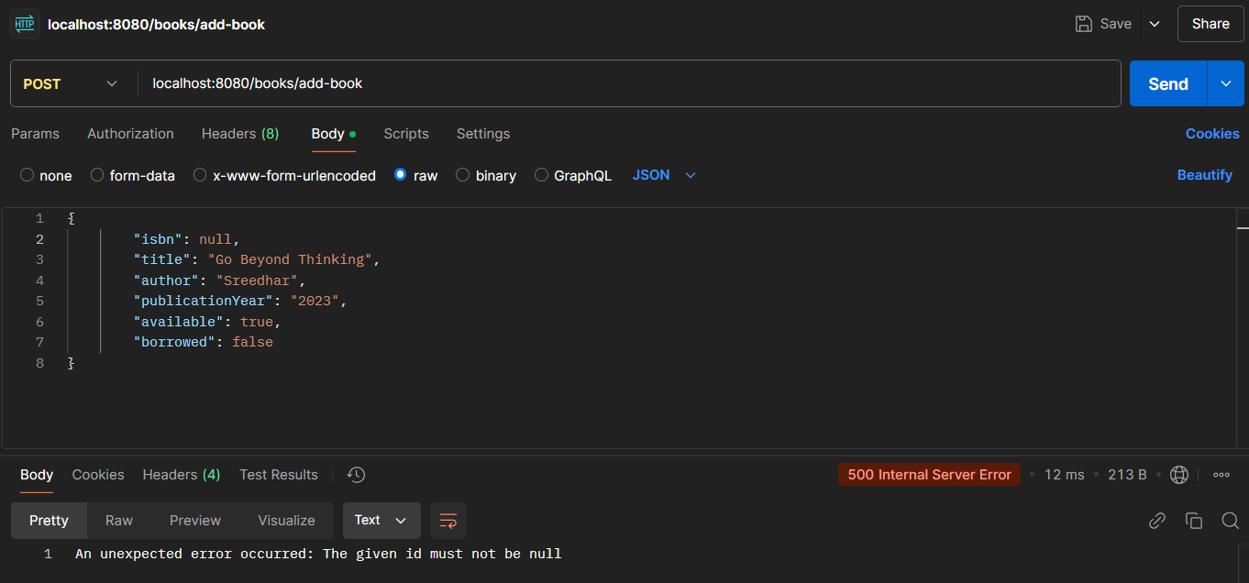

**Test-4: Creating a new Book without author name**

**Output: Author name cannot be empty**

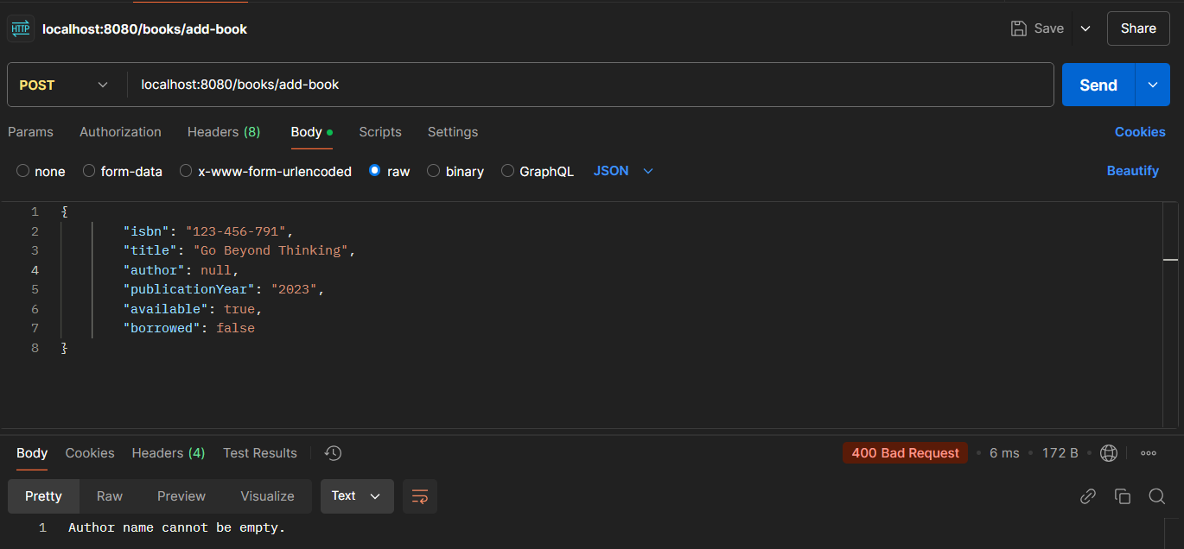

**Test-5: Creating a new Book without title**

**Output: Book title cannot be empty**

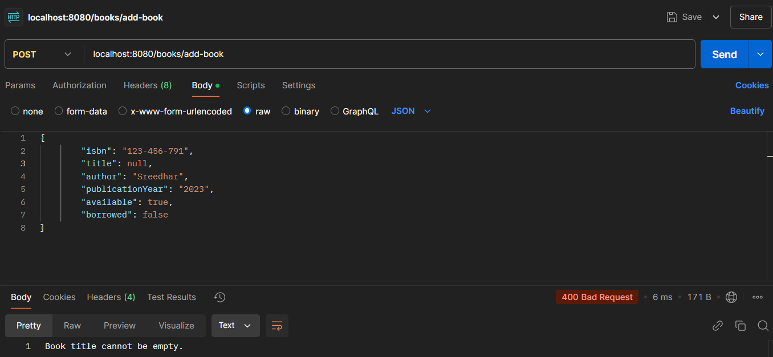

**Test-6: View available books in library**

**Output: Getting only the books whose status is available**

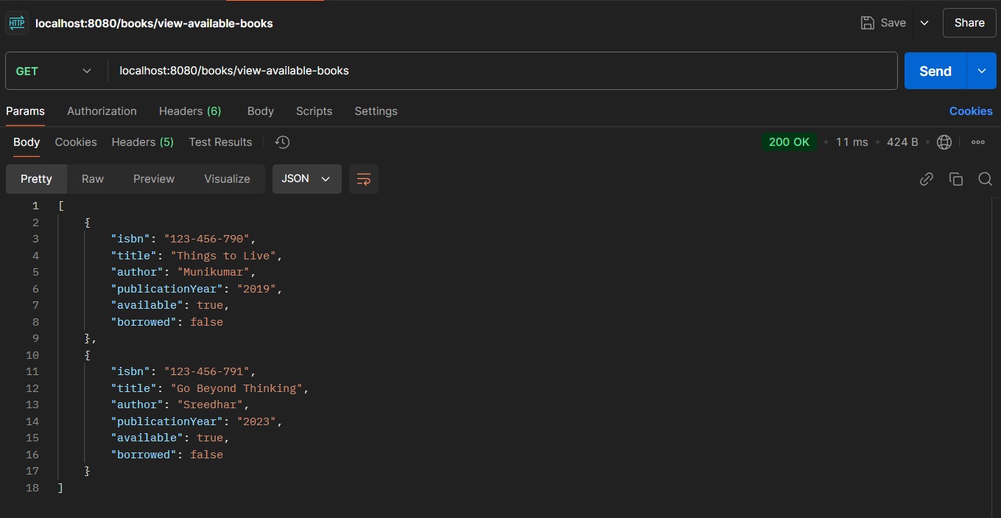

**Test-7: Borrow a book from library**

**Output: Successfully borrowed the book with given isbn**

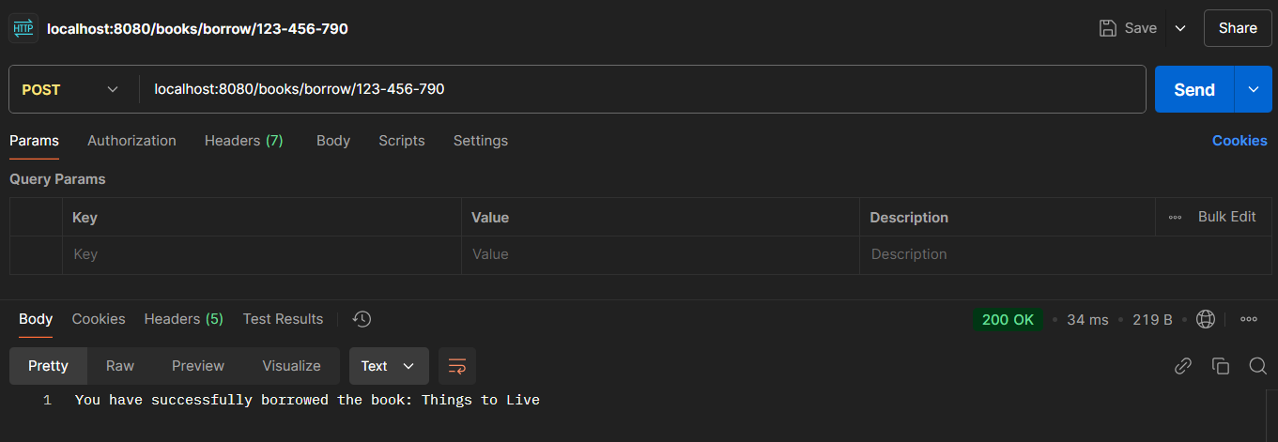

**Test-8: Borrow a book from library with wrong isbn**

**Output: Book not found!**

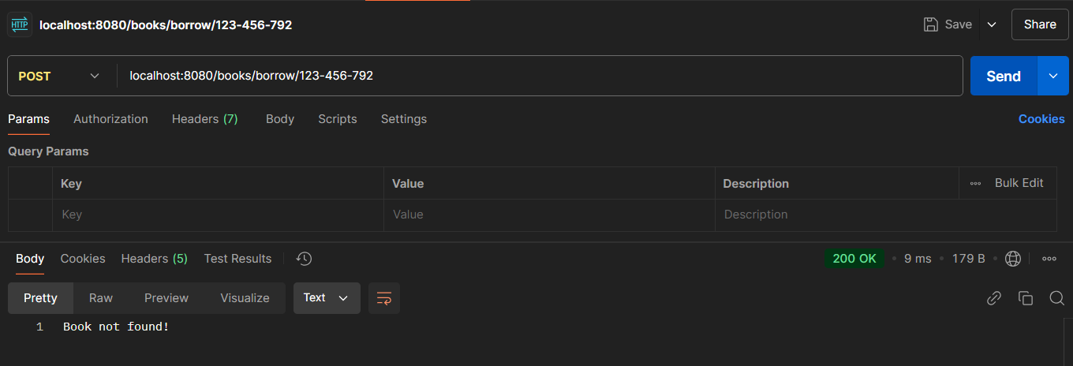

**Test-9: Trying to borrow a book that is already borrowed**

**Output: Sorry, this book is already borrowed.**

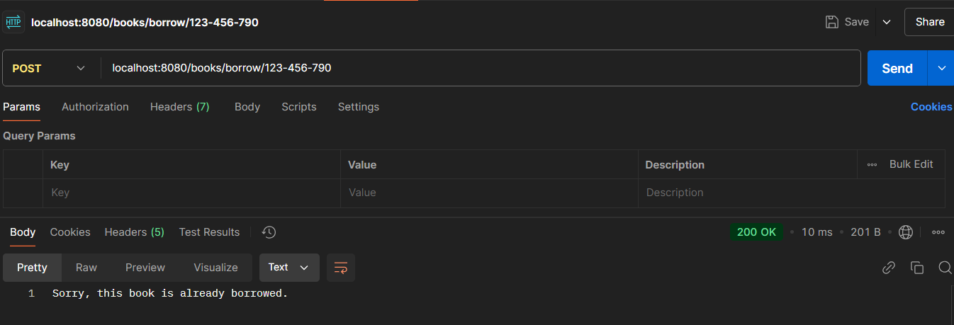

**Test-10: Return the book that is borrowed**

**Output: Successfully returned the book**

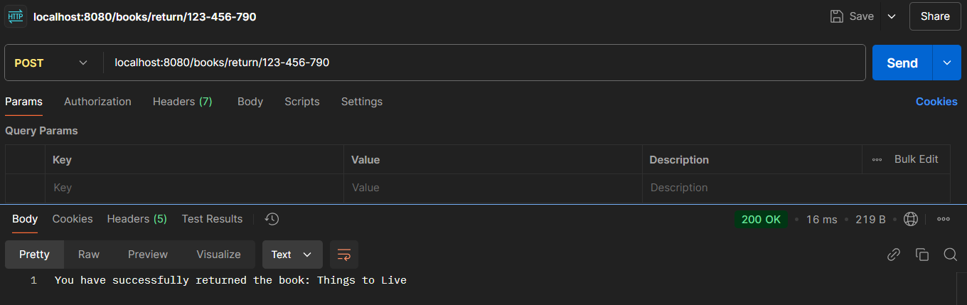

**Test-11: Return the book that is not borrowed**

**Output: This book was not borrowed.**

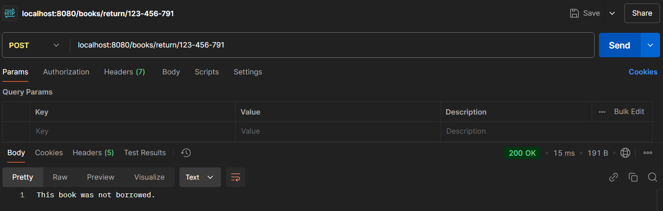

**Test-12: Return the book that is not in library**

**Output: Book not found**

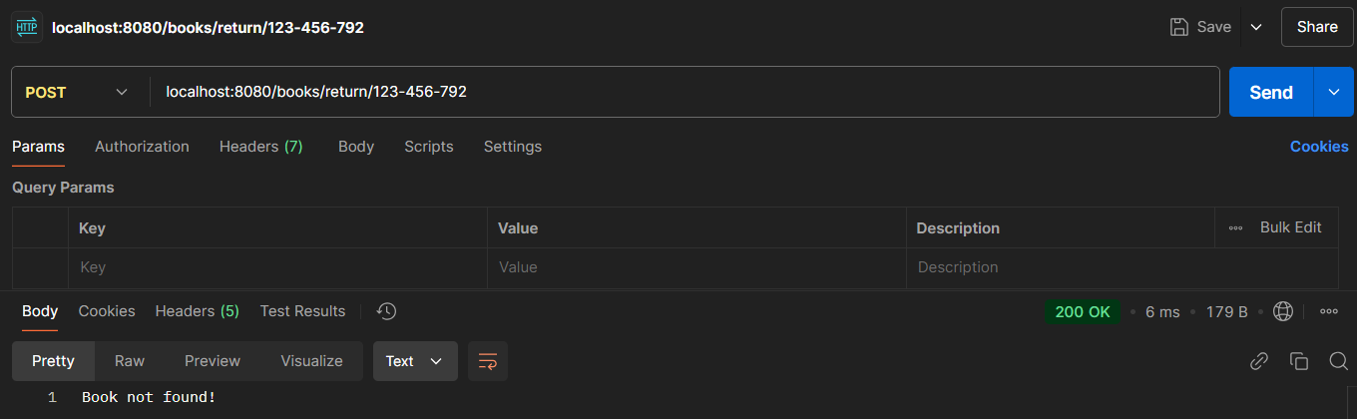

**Test-13: Update the details of the book with isbn**

**Output: Details updated successfully**

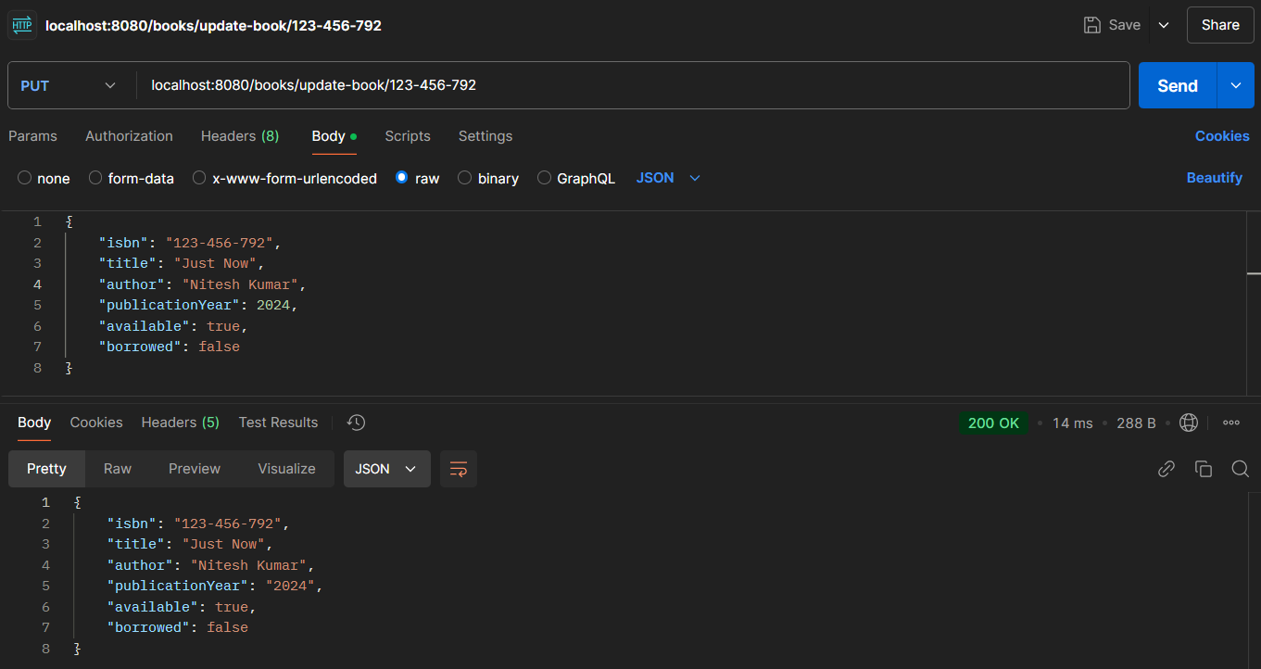

**Test-14: Update the details of the book with isbn that is not in library**

**Output: Book not found with given isbn**

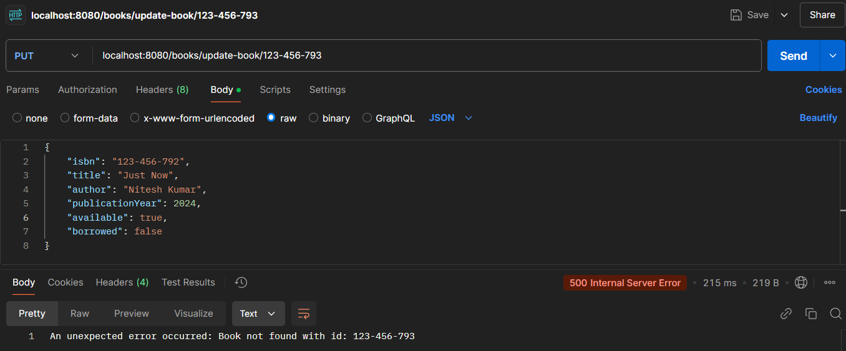

**Test-15: Delete the book from library**

**Output: successfully deleted the book**

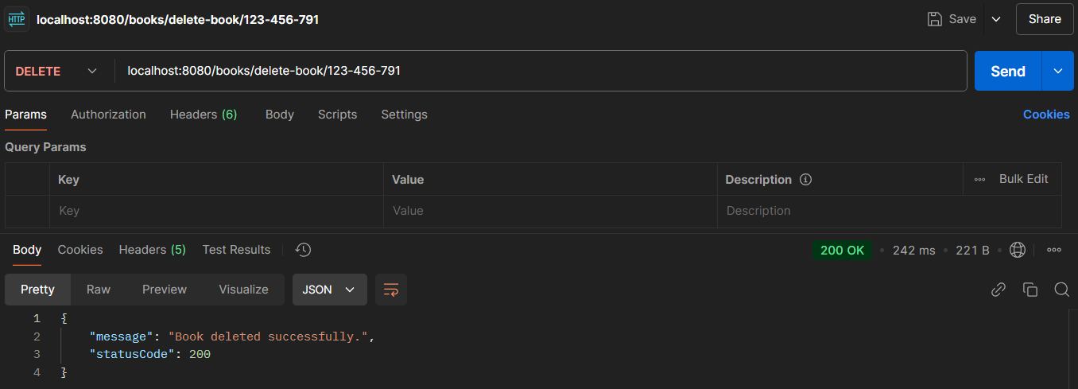

**Test-16: Delete the book that is not there in library**

**Output: Book not found**

