SIMATS ENGINEERING

ASSESSMENT TOOL 1: CONCEPT MAPPING
Course Name: Cloud Computing and Big Data Analytics
Course Code: CSA1508
Course Outcome Covered: CO1 - Apply cloud computing technologies including hardware-software evolution, virtualization, web services, and service models to develop cloud-based solutions. (BL2)
Assessment Tool Weightage: 20%
Dave's Taxonomy: Imitation (Level 1)
Question Count: 4
Total Marks: 50

Code of Conduct
I P.MuniLokesh (192372181)(Name / Reg No) certify that this submission is my original work and that I have adhered to the guidelines specified for this assessment.
I understand that any violation of academic integrity rules will result in disciplinary action.
Signature of the student: P.MuniLokesh

Assignment Reference Details
Expected Concept Nodes:
- Elasticity, scalability, resource pooling, on-demand access, measured service
- Virtual machine, hypervisor, abstraction, API, SOAP, REST, provider, consumer
- Infrastructure layer, platform layer, application layer, shared responsibility
Permitted Tools:
draw.io / diagrams.net, Lucidchart, MindMeister, Miro, Canva, PowerPoint, Google Drawings, or equivalent diagramming tool.
Procedure for Preparing the Digital Concept Map:
- Open https://app.diagrams.net/ or the desktop version of draw.io / diagrams.net
- Choose Device, Google Drive, or OneDrive as the save location
- Create a blank diagram named CSA15_CO1_AT1_RegisterNumber_Concept_Map.drawio
- Place the concept map title at the center or as a clearly visible anchor node
- Add major cloud nodes: cloud definition, cloud evolution, cloud architecture, service models, deployment models, virtualization, web services, SOAP, REST, APIs, elasticity, scalability, resource pooling, measured service, and emerging paradigms
- Connect nodes with labeled arrows such as uses, depends on, enables, scales through, communicates through, belongs to, supports, provides, consumes, or controls
- Use colors meaningfully: one color for service models, one for cloud characteristics, one for API/web-service concepts, and one for concept-map-title-specific elements
- Export the final diagram as PNG or PDF, and keep the editable .drawio source file
- Paste the exported diagram image in the DOCX under Task 1
- Upload the DOCX, exported PNG/PDF, and .drawio file to Google Classroom
GitHub and Google Classroom Submission:
- Create a repository named CSA15_CO1_AT<Number>_<RegisterNumber>
- Upload editable source files, exported PDF/PNG evidence, screenshots, and a short README
- Keep filenames professional and include the register number where appropriate
- Submit only the GitHub repository link in Google Classroom before the deadline
- Ensure the repository is accessible to the faculty evaluator during assessment
Implementation Note:
Faculty may evaluate the submitted evidence digitally using repository inspection, diagram quality, oral explanation, and CO-aligned rubric scoring. The focus is on technical understanding, cloud design reasoning, and hands-on evidence rather than routine written work.

Concept Mapping Rubric
Criteria | Weight | Level 4 - Exemplary | Level 3 - Proficient | Level 2 - Developing | Level 1 - Beginning
Concept Identification | 25% | All major concepts are accurately identified | Most concepts are identified correctly | Limited concepts are identified | Essential concepts are missing
Relationship Mapping | 25% | Links between concepts are accurate and meaningful | Most links are correct | Some links are weak or unclear | Relationships are mostly incorrect
Hierarchy and Organization | 20% | Excellent structure with clear hierarchy | Mostly organized with minor issues | Basic structure with weak hierarchy | No logical organization
Technical Relevance | 20% | Map strongly reflects cloud course content | Mostly aligned to topic | Partially aligned to topic | Weak alignment to topic
Visual Clarity | 10% | Neat, readable, and easy to interpret | Generally readable | Somewhat cluttered | Poorly presented

Concept Map 1: Cloud Computing Fundamentals
This concept map presents the definition, essential characteristics, benefits, and limitations of cloud computing as a single connected structure.
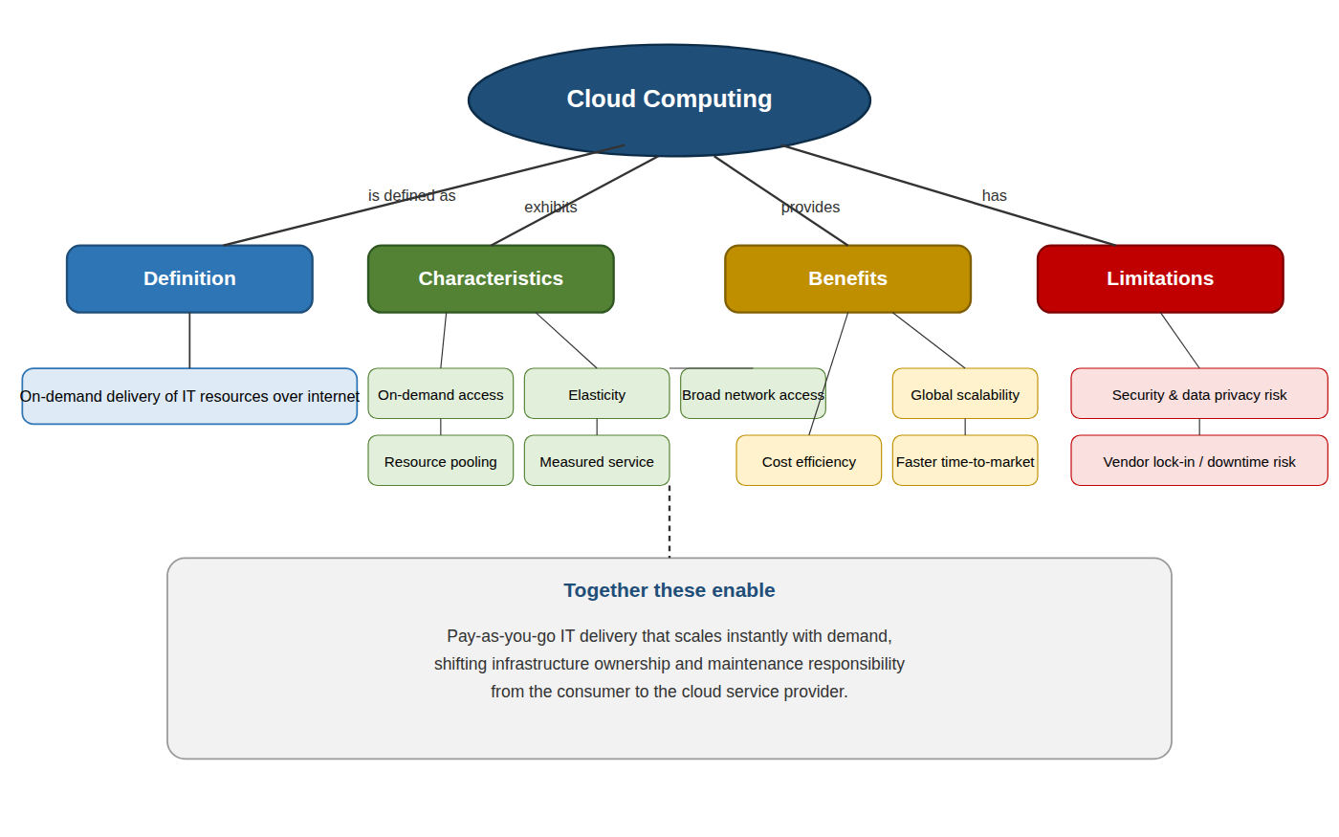
Figure 1. Concept map of cloud computing fundamentals showing definition, characteristics, benefits, and limitations.
Cloud computing is the on-demand delivery of IT resources (compute, storage, networking, and software) over the internet, with pricing based on usage rather than upfront hardware investment. It is built on five widely recognized characteristics: on-demand self-service, broad network access, resource pooling, rapid elasticity, and measured service. These characteristics jointly produce major benefits such as cost efficiency, global scalability, and faster time-to-market, but they also introduce limitations including security and data-privacy risk, potential vendor lock-in, and dependency on network availability.

Concept Map 2: Evolution of Cloud Computing
This concept map connects hardware evolution, internet/software evolution, distributed systems, and service delivery to show how cloud computing emerged.
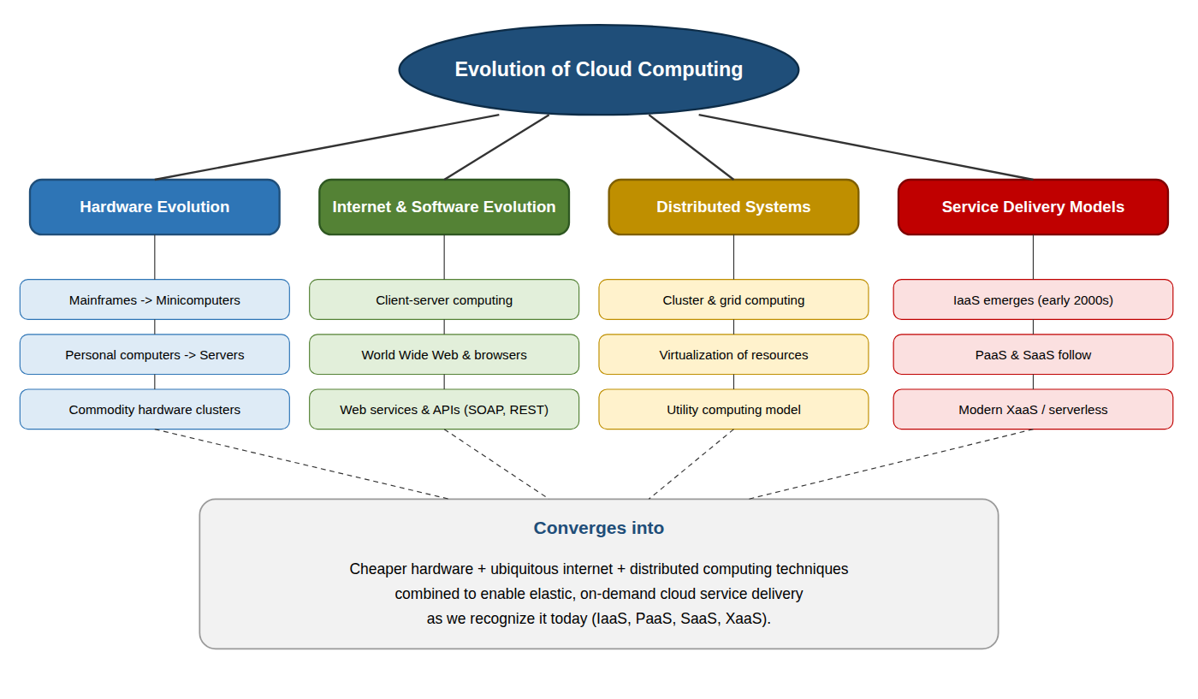
Figure 2. Concept map linking hardware evolution, internet/software evolution, distributed systems, and service delivery.
Cloud computing did not appear as a single invention; it is the convergence of four parallel trends. Hardware evolved from expensive mainframes to cheap, commoditized servers that could be clustered together. In parallel, internet and software evolution moved from client-server computing to the web, and eventually to standardized web services (SOAP, REST) that let applications talk to each other over HTTP. Distributed systems research contributed grid computing, virtualization, and the utility-computing billing model. Together, these strands converged into modern service delivery: first IaaS, then PaaS and SaaS, and now serverless/XaaS models.

Concept Map 3: Service Models
This concept map maps IaaS, PaaS, SaaS, and XaaS against provider and consumer responsibilities.
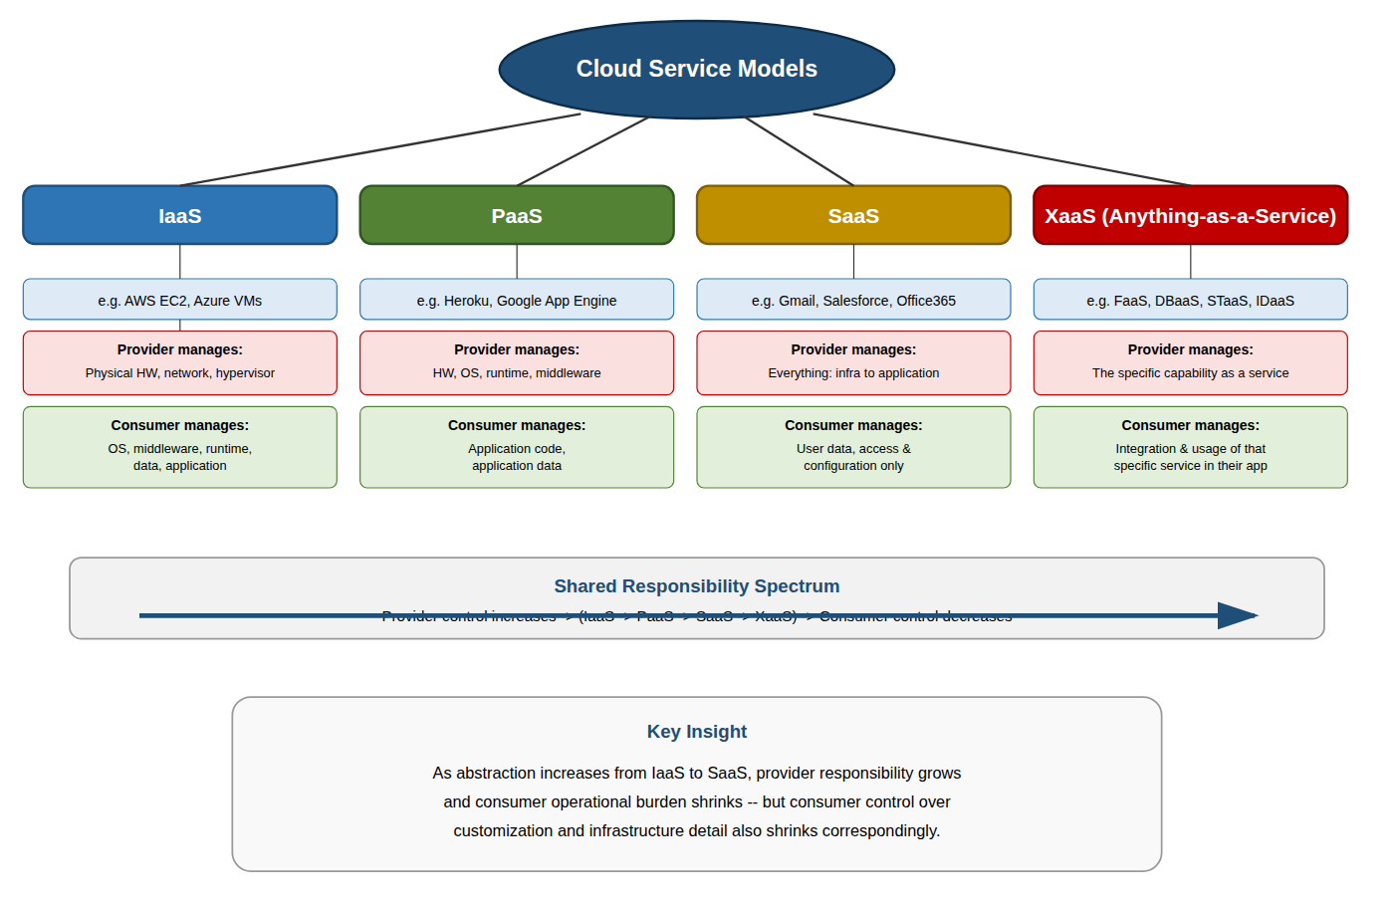
Figure 3. Concept map of IaaS, PaaS, SaaS, and XaaS with the shared-responsibility spectrum.
The four service models sit on a spectrum of increasing abstraction. In IaaS, the provider is responsible only for physical hardware, networking, and the hypervisor, while the consumer manages the OS, middleware, runtime, and application. In PaaS, the provider additionally manages the OS and runtime, leaving the consumer responsible only for application code and data. In SaaS, the provider manages the entire stack and the consumer only manages user data and configuration. XaaS extends this same responsibility-shifting logic to specialized services such as FaaS, DBaaS, storage-as-a-service, and identity-as-a-service, where the provider owns the specific capability and the consumer is responsible only for integrating and using it correctly.

Concept Map 4: Virtualization and Web Services as Enablers of Cloud
This concept map shows how virtualization and web services jointly enable cloud deployment and scalability.
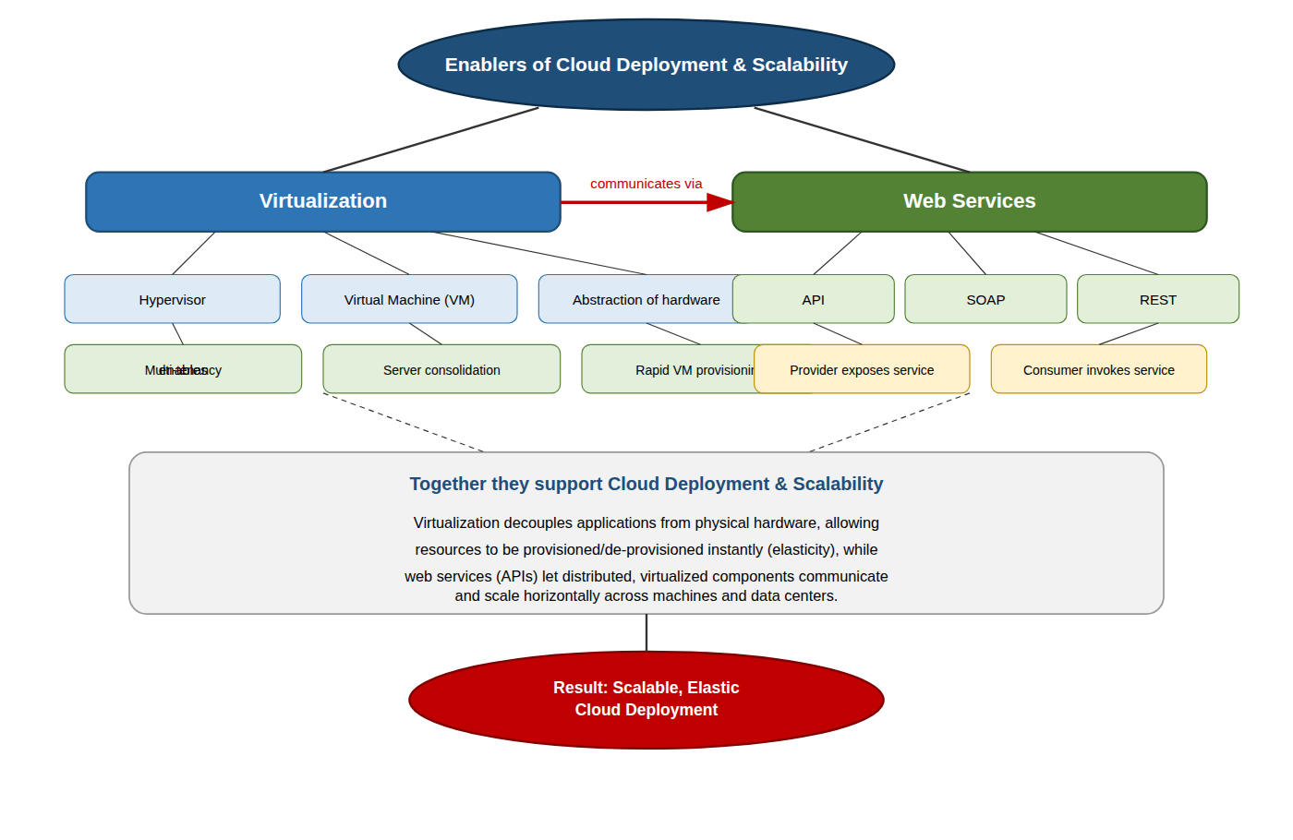
Figure 4. Concept map showing virtualization and web services as enablers of cloud deployment and scalability.
Virtualization uses a hypervisor to abstract physical hardware into virtual machines, enabling multi-tenancy, server consolidation, and rapid provisioning of compute capacity on demand. Web services, exposed through APIs using SOAP or REST, let virtualized and distributed components communicate over standard protocols regardless of their underlying implementation. Together, these two concepts let a cloud platform provision new capacity instantly (elasticity) while allowing distributed services to discover and call one another reliably (interoperability) - the combination that makes elastic, scalable cloud deployment possible.

Task 1: Concept Map (Project-Specific)
Project used for this assessment: Cloud Food Delivery Platform - a web and mobile application connecting customers, restaurants, and delivery agents, with order management, payments, and real-time delivery tracking.
The master concept map below connects the cloud ecosystem, cloud actors, service models, deployment models, virtualization, web services, REST/SOAP APIs, scalability, and elasticity specifically to this project.
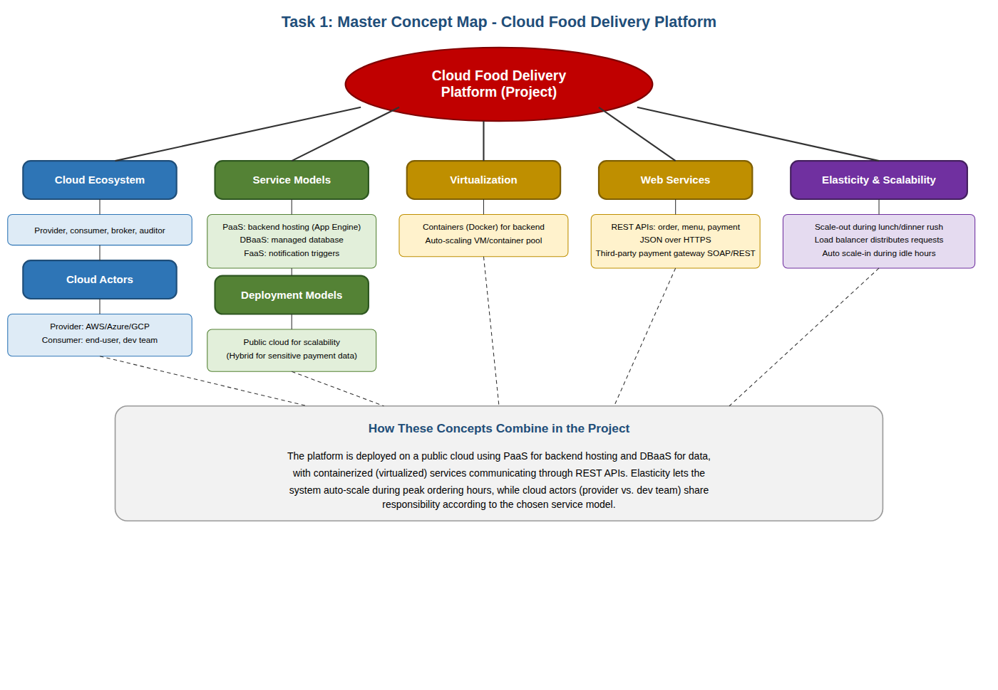
Figure 5. Master project concept map for the Cloud Food Delivery Platform.

Task 2A: Service Model Responsibility Matrix
The matrix below compares SaaS, PaaS, IaaS, FaaS/serverless, database-as-a-service, storage-as-a-service, identity-as-a-service, and monitoring/logging for the Cloud Food Delivery Platform, showing what is managed by the provider versus the application team, and why that split fits the project.
Service Category | Example (this project) | Managed by Provider | Managed by App Team | Why this split fits the project
IaaS | AWS EC2 (rarely used directly) | Physical servers, network, hypervisor, storage hardware | OS patching, backend runtime, security groups | Project uses managed PaaS instead, so raw IaaS is only a fallback for custom compute needs
PaaS | AWS Elastic Beanstalk / Google App Engine | OS, runtime, middleware, scaling infrastructure | Application code, business logic (order processing) | Team wants to focus on delivery features, not server management, so PaaS reduces operational overhead
SaaS | Google Workspace / Slack (internal use) | Entire software stack | User accounts, data entered into the tool | Used only for internal team collaboration, not part of the customer-facing product
FaaS / Serverless | AWS Lambda for order-status triggers | Server provisioning, runtime, automatic scaling | Function code and event trigger configuration | Order-status and notification events are short bursts of work, ideal for pay-per-execution billing
Database-as-a-Service | Amazon RDS / Firebase Firestore | Database engine, patching, backups, replication | Schema design, queries, indexing strategy | Order and menu data needs high availability without the team managing DB servers manually
Storage-as-a-Service | Amazon S3 / Google Cloud Storage | Physical storage, durability, redundancy | Bucket policies, file naming, access control | Menu images and receipts need durable, cheap storage that scales without capacity planning
Identity-as-a-Service | Auth0 / Firebase Authentication | Identity infrastructure, token issuance, MFA | Role definitions, login UI, session handling | Secure login (customers, restaurants, delivery agents) is critical and best delegated to a specialist provider
Monitoring / Logging | AWS CloudWatch / Datadog | Log storage, dashboards, alerting infrastructure | Defining alert thresholds, reviewing logs | Real-time visibility into order-processing errors and scaling events is essential for reliability

Task 2B: Cloud Service Decision Matrix
Project modules are mapped below to the most relevant cloud services, with justification for each choice rather than forcing every possible service into the design.
Project Module | Chosen Cloud Service | Justification
Authentication | Firebase Authentication (IDaaS) | Provides ready-made secure login, MFA, and social sign-in without building custom auth infrastructure
Frontend Hosting | AWS Amplify / Vercel | Global CDN-backed static hosting gives fast page loads for customers across regions
Backend / API Layer | AWS Elastic Beanstalk (PaaS) | Auto-scaling backend removes the need to manually provision servers during demand spikes
Database | Amazon RDS (PostgreSQL, DBaaS) | Relational data (orders, restaurants, users) needs consistency and managed backups
Object Storage | Amazon S3 | Cost-effective, durable storage for menu images and generated receipts/invoices
Analytics / Logging | AWS CloudWatch + Amazon QuickSight | Tracks order volume trends and surfaces operational errors in near real time
Notification | AWS SNS / Firebase Cloud Messaging | Push and SMS order-status alerts need a scalable, low-latency delivery service
AI / Python Module | AWS Lambda (Python) + SageMaker (optional) | Delivery-time prediction model runs as an event-triggered function, avoiding idle server cost
Security | AWS IAM + Security Groups | Enforces least-privilege access between services inside the security boundary
CI/CD | GitHub Actions | Automates build, test, and deployment on every commit, reducing manual release effort
Backup | AWS Backup (RDS snapshots + S3 versioning) | Automated, scheduled backups protect against data loss without manual intervention
Monitoring | AWS CloudWatch Alarms | Automatically alerts the team when latency, error rate, or scaling thresholds are breached

Task 3: API Flow, Elasticity, and Scalability Design
The diagram below shows the request flow for the Cloud Food Delivery Platform: user app, API gateway/backend service, authentication, compute layer, database, object storage, analytics/logging, monitoring, security boundaries, and scaling points.
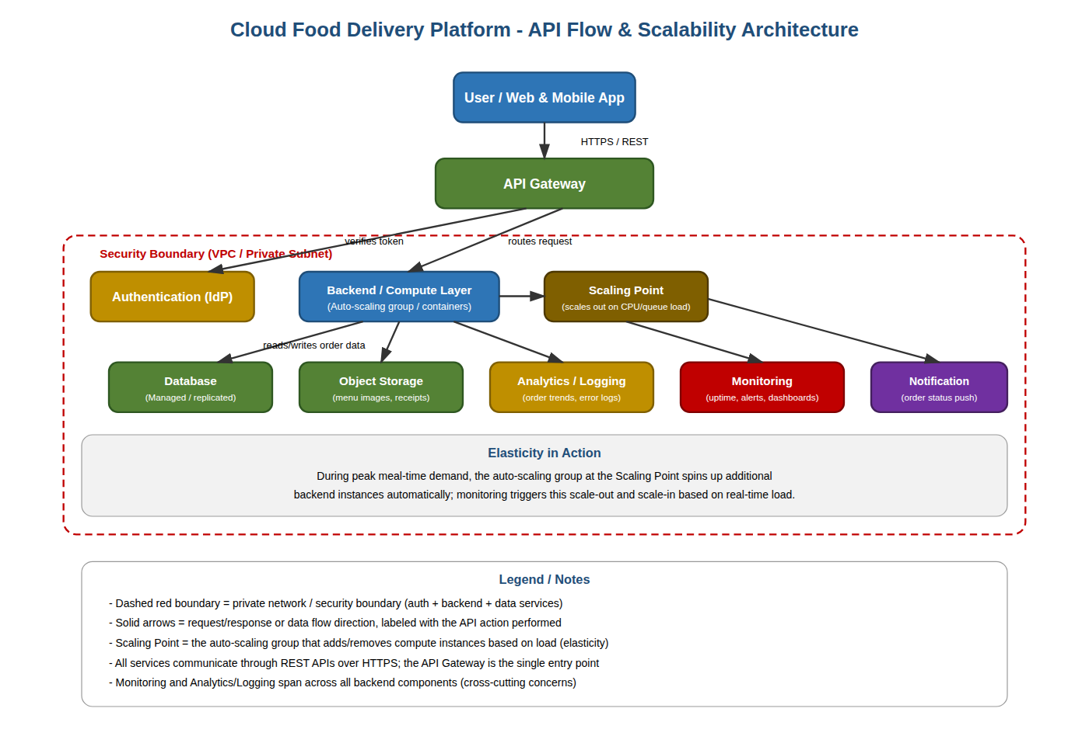
Figure 6. Cloud architecture and API flow diagram with elasticity and scalability points for the Food Delivery Platform.
A customer request first reaches the API Gateway, which is the single entry point over HTTPS. The gateway forwards the request into the security boundary, where it is first verified by the Authentication service (IDaaS) before reaching the Backend/Compute Layer. The compute layer sits behind a Scaling Point - an auto-scaling group that adds or removes instances based on CPU and queue load, particularly during lunch and dinner rush hours. From there, requests read/write to the managed Database, retrieve or store files in Object Storage, and are recorded by Analytics/Logging and Monitoring, which span all backend components as cross-cutting concerns. Order-status changes are pushed to customers through the Notification service.

Task 4: Technical Justification
The concept maps, matrices, and architecture diagram together demonstrate CO1 by showing not just what cloud technologies exist, but why each was chosen for this project.
Service model selection: The platform uses PaaS (Elastic Beanstalk) for the backend and DBaaS (Amazon RDS) for data, so the team can focus on order-processing logic instead of server administration. FaaS is used only for short, event-driven work like notifications, since paying per invocation is cheaper than running a dedicated server for infrequent triggers. This selective mixing - rather than defaulting to one model - shows applied understanding of the service-model trade-offs mapped in Concept Map 3.
Role of APIs: REST APIs, exposed through a single API Gateway, connect the frontend to backend services and let the payment gateway integrate without tightly coupling the codebase to one provider. This reflects Concept Map 4's principle that web services let distributed, virtualized components interoperate over standard protocols.
Elasticity: The auto-scaling group at the Scaling Point (Task 3) expands capacity automatically during demand spikes and contracts during idle periods, directly implementing the elasticity characteristic from Concept Map 1 - the project pays only for resources it actually uses.
Scalability and virtualization/managed compute choice: Backend services run in containers rather than on dedicated servers, allowing multiple services to share hardware and provision within seconds. Combined with the load balancer routing traffic across instances, this gives the system horizontal scalability without manual server provisioning - the same virtualization principle mapped in Concept Map 4.
Cloud responsibility boundaries: Task 2A shows that as the project moves toward higher-abstraction services (PaaS, DBaaS, IDaaS), the provider absorbs more operational responsibility (patching, scaling infrastructure, backups), leaving the application team responsible only for business logic, schema design, and configuration. This shared-responsibility shift is what makes it feasible for a small team to run a scalable, secure platform without managing physical infrastructure.

Reflection Questions
1. Evaluate the effectiveness of your concept map in representing cloud computing principles. Which design decisions most strongly support your solution, and why?
The master concept map (Task 1) is effective because it does not treat cloud concepts in isolation - it routes every branch (service models, deployment models, virtualization, web services, elasticity) back to a concrete project decision. The strongest design choice was color-coding each category consistently across all maps, which makes the shared-responsibility pattern (Concept Map 3) immediately recognizable when it reappears in the project-specific matrix (Task 2A).
2. Analyze how scalability, elasticity, and resource management influence the architecture shown in your concept map. What challenges could arise if these capabilities were absent?
Scalability and elasticity are what allow the Scaling Point in Task 3 to add backend instances automatically during peak ordering hours and remove them afterward. Without elasticity, the team would need to permanently provision for peak load, wasting money during off-peak hours, or under-provision and risk slow responses and failed orders during rush periods - directly harming customer trust in a food-delivery context where speed matters.
3. Justify the selection of the APIs, web services, or cloud services included in your concept map. How do they contribute to the overall functionality and efficiency of the system?
REST APIs were chosen over SOAP for internal services because REST is lighter weight and easier to scale horizontally behind a load balancer, which suits the high volume of short order/menu requests. Firebase/Auth0 for identity was chosen so authentication logic (password hashing, MFA, session tokens) does not have to be built and secured in-house, reducing both development time and security risk.
4. Critically examine the relationships between the components in your concept map. How do these interactions improve reliability, performance, or user experience?
The relationship between the Scaling Point and Monitoring is central: Monitoring supplies the load metrics that trigger scaling decisions, forming a feedback loop that keeps performance stable without manual intervention. Similarly, routing all traffic through a single API Gateway improves reliability because authentication, rate-limiting, and logging can be enforced consistently in one place rather than duplicated across every backend service.
5. Reflect on the process of developing your concept map. How has creating and analyzing the map changed your understanding of cloud computing architecture, and what improvements would you make if you were redesigning it?
Building the maps made the shared-responsibility spectrum concrete rather than abstract - seeing IaaS, PaaS, SaaS, and XaaS side by side clarified why the project deliberately avoids raw IaaS wherever possible. If redesigning, a future iteration would add a explicit disaster-recovery/multi-region branch, since the current map focuses on day-to-day elasticity but does not yet capture cross-region failover for business continuity.

README (For GitHub Repository)
Title: CSA15_CO1_AT1 - Cloud Food Delivery Platform - Concept Mapping
Tools Used: draw.io / diagrams.net (or equivalent), Microsoft Word
Repository Structure:
- /diagrams - editable .drawio source files for Concept Maps 1-4, Task 1 master map, and Task 3 architecture diagram
- /exports - PNG/PDF exports of all diagrams
- /matrices - Task 2A Service Model Responsibility Matrix and Task 2B Cloud Service Decision Matrix
- /docs - this assessment Word document (CSA15_CO1_AT1_RegisterNumber_Concept_Map.docx)
- README.md - this file
CO1 Reflection:
This assessment required mapping cloud computing fundamentals, its historical evolution, the four service models, and the enabling roles of virtualization and web services, then applying all of it to a real project architecture. Completing it demonstrated CO1 by requiring concrete justification - not just definitions - for every service model, deployment choice, and scaling mechanism used in the Cloud Food Delivery Platform.

Digital Evidence Checklist
- Editable diagram source file(s) (.drawio) and exported PNG/PDF for all concept maps
- Completed Service Model Responsibility Matrix (Task 2A)
- Completed Cloud Service Decision Matrix (Task 2B)
- Architecture / API flow diagram exported as PNG/PDF (Task 3)
- README file with title, tools used, repository structure, and CO1 reflection
- GitHub repository link submitted via Google Classroom before the deadline

