**BANGLADESH UNIVERSITY OF ENGINEERING AND TECHNOLOGY**

**BUET**

**Department of Electrical and Electronic Engineering**

**EEE 316 Project Report  
Group-5**

**Topic:** Single-Phase Sine Wave Inverter

**Date of Submission:** 25-02-2022

**Submitted by:**

Sheikh Munim Hussain

Md. Jahidul Hoq Emon

Shafin Shadman Ahmed

Azazul Islam

**Student ID:**

S201706008

S201706017

S201706020

S201706033

**Department:** EEE, **Section:** A (A1)

**Level:** 3, **Term:** II

# **Introduction:**

A DC-AC converter is an important part of today’s electronics devices. It converts DC voltage into AC voltage. Generally, a DC-AC converter is used in Solar Cell circuitry if stored DC voltage is required to convert into AC grid voltage and grid frequency. Again, in AC-AC converters, a DC-AC converter is sometimes used to change the frequency of input AC voltage.

In this project, we used full bridge inverter circuit to convert DC voltage into AC voltage. We used 12V DC voltage for hardware setup and for software setup we used 15V DC input. In another set of software setup, we used varying input signal which at last created a 20V P-P AC output sinusoid voltage.

We used a step-up transformer to increase the voltage level. For hardware setup, we got 116V peak AC voltage. In software setup we got 220V Peak AC voltage.

This project met the general specification of an inverter. An inverter converts DC voltage to an AC voltage. In most cases, the input DC voltages are usually lower while the output AC voltages are equal to grid supply voltage of either 120 volts or 240 volts. In this project we took input voltage as 5-15V range and got output as 220V AC which is equal to our grid voltage.

# **Objectives:**

The main objectives of our project are:

1. To implement a DC-AC inverter that converts lower input DC voltages into higher output AC voltages.  
2. To implement the inverter in MATLAB Simulink that gives us the ideal output.  
3. To verify the hardware output voltage from the MATLAB Simulink output.  
4. To implement an inverter that gives a constant peak output AC voltage irrespective of the input DC voltage level.

# **Hardware Setup:**

In hardware design, we used different hardware modules to design the inverter. We used Arduino Nano to produce gate pulses for the MOSFETs. This gate pulses are fed to MOSFET’s that turn on and off alternatively using ground isolation circuits.

Then we used 4 MOSFET’s as turn on and off switching. All the MOSFET’s are power MOSFET’s that has a higher current voltage rating than the general MOSFET’s we use in electronics circuits.

We used feedback diode for further safety in case our output becomes a highly inductive load.

**Figure: Schematic Diagram of Full Bridge Inverter**

We then used a centre-tapped transformer of 12V ~ 3000mA rating whose output voltage is 220V at 50Hz. This transformer is a step-up type and it is used to increase the AC voltage peak value which satisfies the general criteria of an inverter.

**Figure: Hardware Setup for our Project**

The equipments used in this hardware setup are listed below:

1. Arduino Nano: 1 Piece
2. BD136 (p-n-p Transistor): 2 Pieces
3. IRF3205 (MOSFET): 4 Pieces
4. Transformer (Centre-tapped 12V, 3000mA ~ 220 V at 50 Hz): 1 Piece
5. Resistors:

10 kΩ: 2 Pieces

1 kΩ: 2 Pieces

100 Ω: 1 Piece

1. Capacitors

Ratings: a) 2.2 µF ~ 400V

b) 470 µF

c) 2200 µF

1. Jumper Wires
2. Breadboard: 1 Piece
3. Crocodile Clips
4. Oscilloscope
5. DC Source etc.

# **Output of Hardware Setup with Discussion:**

After we generated AC signal, we observed it on oscilloscope. As our laboratory oscilloscope is not capable of showing 220V Peak voltages, we used voltage divider circuit to get output voltage shape.

**Figure: Stepped Downed Output Voltage using Voltage Divider**

From the output voltage waveform, we can see that output voltage is not a pure sinusoid. This happened due to 2 reasons. The reasons behind this distortion are explained one by one:

**1. Low Output Capacitor Value:** The capacitor value we used in the filter circuit was very small of 0.1 µF range. For getting the higher frequency components clearly filtered out, we need capacitors of about 100 or 1000 µF range. So, for using smaller capacitor value, we didn’t get the pure sine wave, rather we got the distorted sine wave that was shown in the previous figure.

**2. Lower Switching Frequency:** In the setup, we used the switching frequency 1600 Hz using Arduino. Almost 10000 Hz is required to get better sine wave in the transition region from positive to negative and the peak value points. For better sine waves, we need to increase the switching frequency.

So, we can see that, using larger capacitors and higher switching frequency, we could get better sine wave that was our main objective.

# **The Single-Phase Full Bridge Inverter Circuit:**

A full-bridge inverter circuit converts a DC input signal into an AC signal. For a DC input voltage source, the output obtained is AC voltage. In a full-bridge inverter, the output voltage has its maximum amplitude comparable to the input voltage.

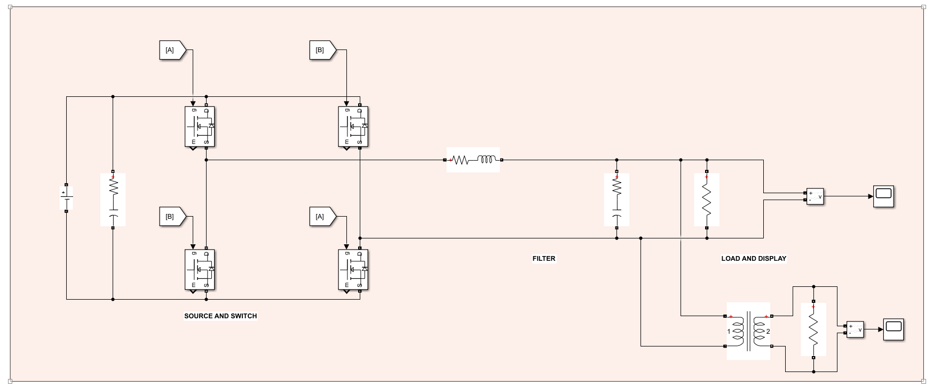

***Figure: The Single-Phase Full-Bridge Inverter Circuit***

In this project, the full-bridge inverter circuit plays a pivotal role in generating sinusoidal waves. The components used in this circuit are at first described, and then the work process is mentioned.

**Components of the Full Bridge Inverter Circuit:**

|  |  |
| --- | --- |
| ***Figure: DC Voltage Source*** | **DC Voltage Source:** A DC voltage source is a necessary component of this circuit since it will be used to generate the output AC voltage. Depending on the magnitude of the DC voltage, the amplitude of the AC voltage may vary. |

|  |  |
| --- | --- |
| ***Figure: DC Link Capacitor*** | **DC Link Capacitors:** In an inverter circuit, sometimes some changes or spikes may be generated in the input due to feedback to the input voltage source. This type of sudden changes can cause unexpected changes in output and also can harm the DC voltage source. A DC link capacitor mitigates the sudden changes in voltage and keeps the input voltage constant. |

**Switches:** There are switches made of transistor-like elements which control the output voltage flow. The switches may be made of IGBT’s or MOSFET’s with diodes; in this experiment, switches made of MOSFET’s are used. Since a single-phase full-bridge inverter is being made, four switches are used.

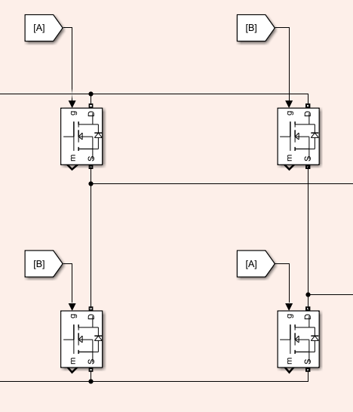

***Figure: Switches to Implement Single-Phase Full-Bridge Operation***

The switches work based on gate pulses. If the switch gets a gate pulse, it becomes on; if there is no gate pulse, the switch turns off. The switches on the alternate positions need to be turned on to conduct the input voltage as either the positive or the negative half-cycle. If the switches on the same row are turned on, the output will be zero. To ensure that this never happens, the gate pulses are given on the alternate switches.

|  |  |
| --- | --- |
| ***Figure: RLC Filter Impedance*** | **RLC Filter Impedance:** While generating AC voltage, harmonics may generate which hampers the quality of the generated AC voltage signal. An RLC filter removes all the unnecessary harmonics and maintains the fundamental frequency of the output voltage as expected. |

|  |  |
| --- | --- |
| ***Figure: Load Resistance and Voltage Measurement Mask*** | **Load Resistance:** A load resistance is essential to visualize the output voltage obtained from the circuit. The two ends of the resistor are connected to a scope to see the output, and a resistance is a suitable element for this. In simulation, a voltage measuring mask is used to ensure that only the voltage is measured. |

|  |  |
| --- | --- |
| ***Figure: Scope*** | **Scope:** A scope helps us to see the output obtained from the circuit. The scope in Simulink is very similar to the real-life oscilloscopes used in laboratories to observe various wave-shapes. |

|  |  |
| --- | --- |
| ***Figure: Transformer*** | **Transformer:** It may often happen that the output voltage from the inverter circuit due to the input DC source is not enough to meet the requirements. In practical situations, a larger voltage is often needed. So, a step-up transformer is used to increase the output voltage to the amount as desired. |

**Implementing the Full Bridge Inverter Circuit:**

**1. Generating DC Voltage:** A DC voltage source of 15 V is at first used to generate a DC voltage. To prevent any spike or other abnormality which may affect the DC voltage, a DC Link Capacitor is used. The capacitor has a value of 500 μF, which is coupled with a 50 mΩ in series.

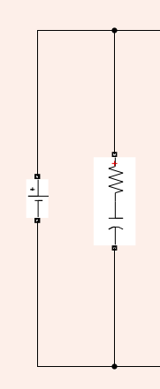

***Figure: DC Voltage Generation***

**2. Switching:** After the DC voltage is generated, switching is done to convert it into AC voltage. As described earlier, the switches on the alternate sides need to be turned on to get AC voltage. If the gate pulse A is activated, the switches getting the pulse A will turn on, while the other switches will be off since they are not getting gate pulses. The turned-on switches will allow the positive half cycle of the AC voltage to be generated and propagated to the output through the load resistance.



***Figure: Switching being performed; there is no scope to get a zero output.***

Similarly, if the gate pulse B is activated, the switches getting the pulse B will turn on, while the other switches will be off since they are not getting gate pulses. The turned-on switches will allow the negative half cycle of the AC voltage to be generated and propagated to the output through the load resistance.

**3. Filtering and Output Display:** After the AC voltage is generated from switching actions, it is quite natural that some harmonics will remain. The RLC filter removes all such harmonics to give an almost smooth output with a stable fundamental frequency. Since a real-life inductor has some built-in resistance, the inductor used has a resistance in series in this simulation. The inductor has a value of 150 μH, while the resistance is 1.5 mΩ. The main resistor and the capacitor are themselves connected in series, but they are together placed in parallel to the inductor. The capacitance is 220 μF and the resistance is 5 mΩ.

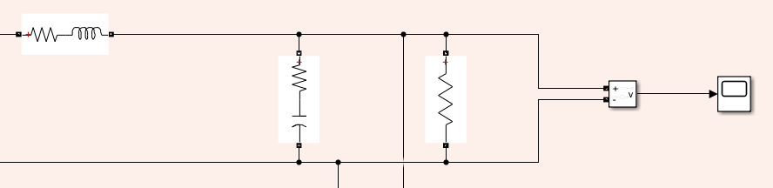

***Figure: Filtering unnecessary harmonics and reading the output voltage***

To show the output, a resistor of 10 Ω is connected in parallel to the circuit and the ends are connected to an oscilloscope so that the output is visible.

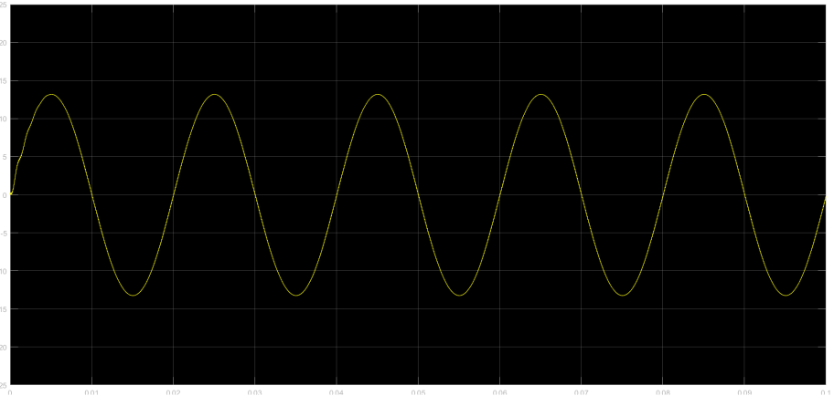

***Figure: Output obtained from the full-bridge inverter***

It is seen that the output is a bit less, at 13 V. This reduction is due to a modulation index of 0.9 being used while generating gate signals. Although the line losses are not seen in simulations, in real life these losses would play some role and so the output would be lesser.

**4. Getting the Desired Output:** It is seen that the output generated is much less than the desired voltage of 220 V. So, a step-up transformer having turns ratio 13:220 is used to get the output voltage similar to the desired voltage.

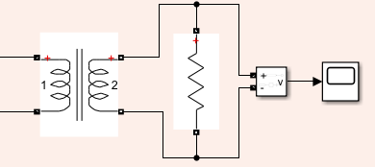

***Figure: Using a step-up transformer to get the desired output***

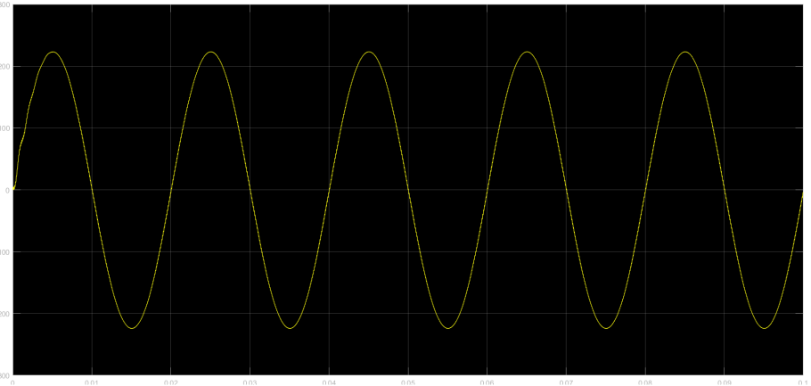

***Figure: Output obtained after a transformer is used.***

Now it is seen that the output voltage matches the expectations. The output is near-perfect due to line losses not being taken into account by the simulation. In real life situations the output would be less than 220 V. It is to be noted that the output voltage of 220 V is obtained for a DC input of 15 V; if the DC voltage is varied, the AC voltage amplitude will vary, which will be discussed later.

**Gate Pulse Generation:**

The gate pulses used to turn the switches on need to be generated from some circuit block. In the gate pulse generation block, a triangular wave is compared with a sinusoidal wave to generate pulsating waves which are then transferred to the gates of the MOSFET’s to drive them. The amplitude of sine wave was varied to observe the cases of under-modulation, normal modulation and over modulation.

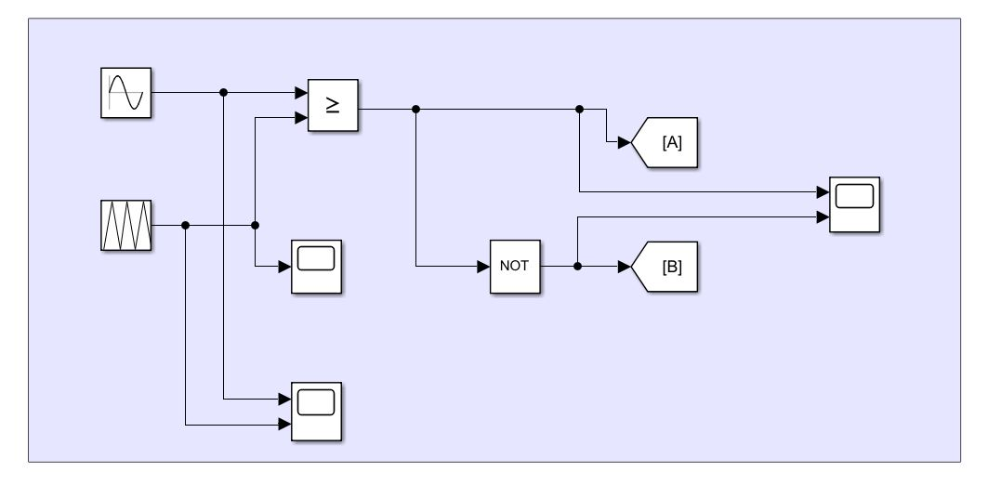

***Figure: Gate Pulse Generation Block***

From the generation block, we can see that comparator was used to compare between the triangular wave and sinusoidal wave. Thus, we got pulsating waves, which is a discontinuous DC wave since the maximum value is 1 and the minimum value is 0. Then we made an inverted output by using NOT gate and the blocks named A and B are used to send the desired outputs to the gates.

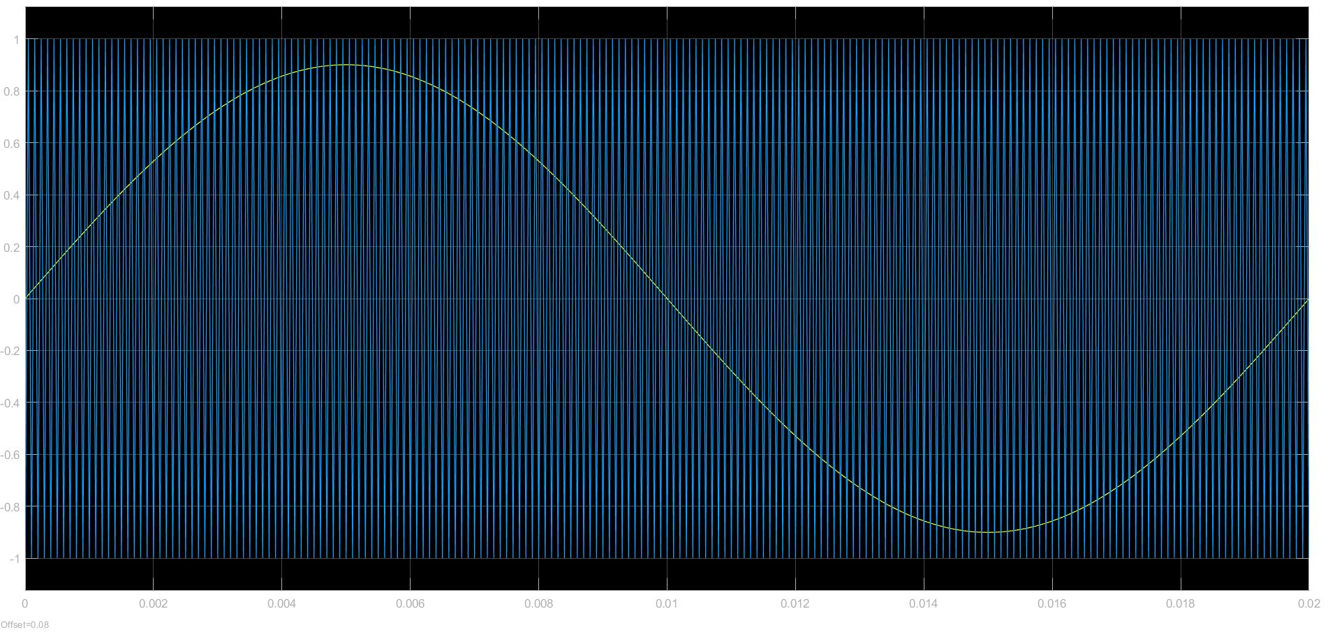

***Figure: Sinusoidal and Triangular Waves, Inputs to the Comparator***

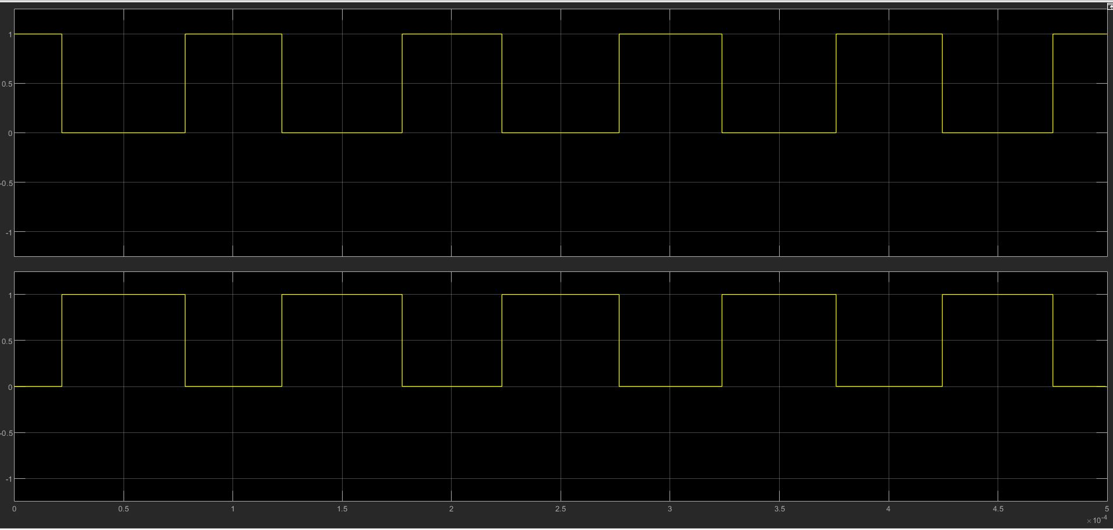

***Figure: Gate Pulses, Outputs of the Comparator***

**Problems with the Existing Simulation:**

So far in our full bridge inverter, there was no type of feedback system from the output. Thus the output was highly dependent on modulation index and supply dc voltage. For example, let us consider two different supply voltages 10 V and 20 V with a modulation index of 0.9. If we analyse the output voltage:

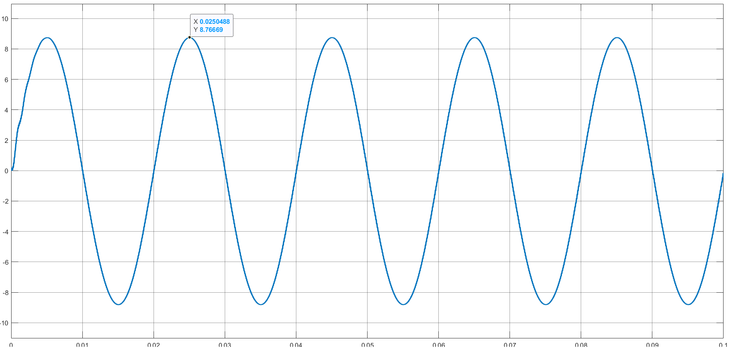

***Figure: Inverter Output Voltage for 10 V Supply***

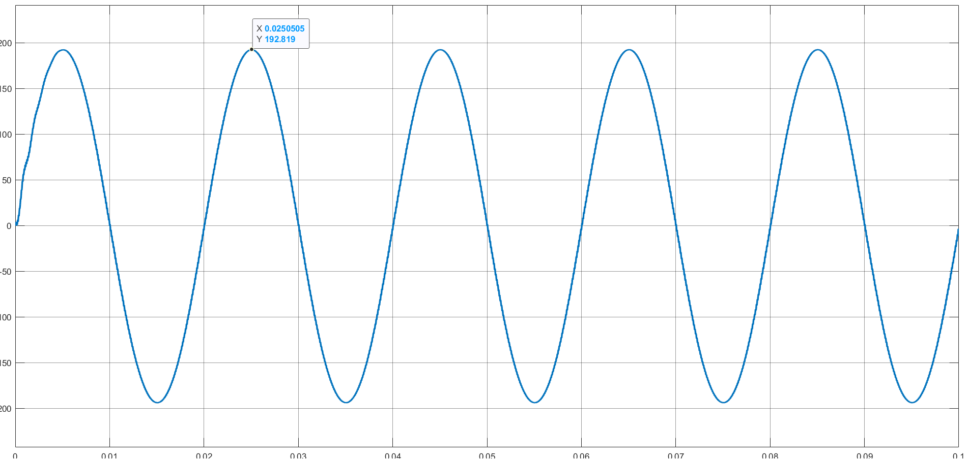

***Figure: 10/220 Step-Up Transformer Output for 10 V Supply***

It can be seen that the output from the inverter decreased considerably. Since the step-up transformer has a fixed ratio, the output voltage will be found following this ratio. Due to the less value of the output voltage from the inverter, the transformer output will also be considerably lesser.

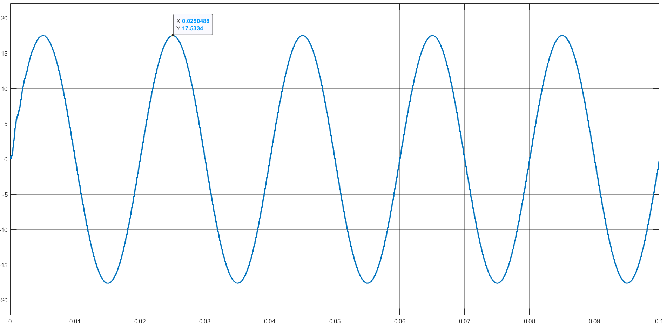

***Figure: Inverter Output Voltage for 20 V Supply***

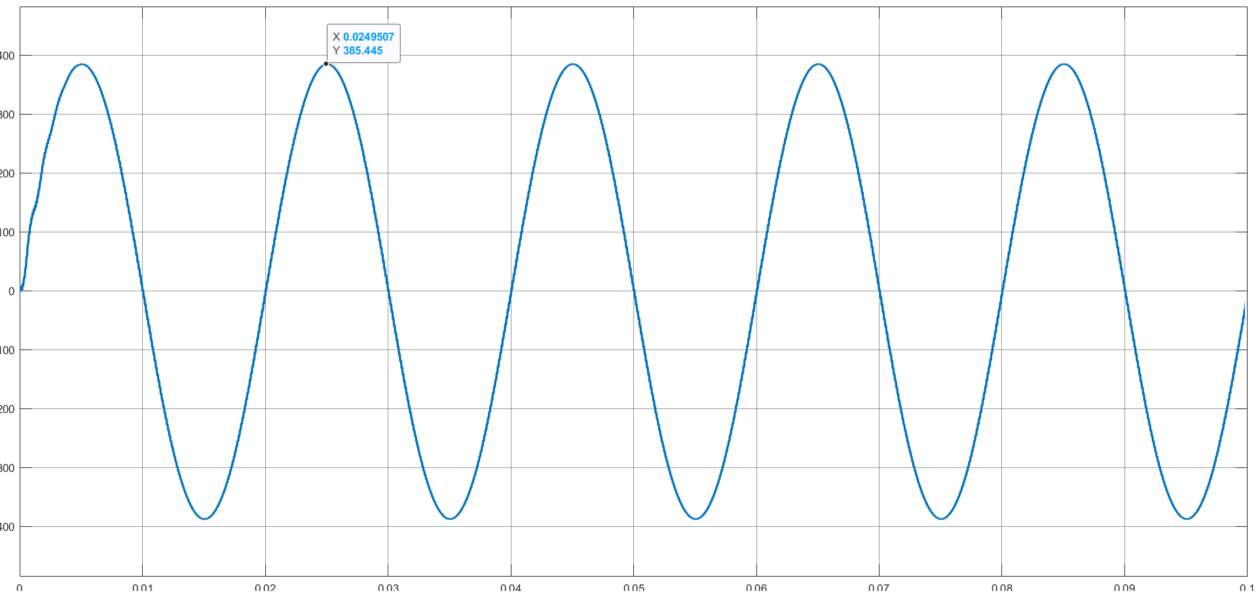

***Figure: 10/220 Step-Up Transformer Output for 20 V Supply***

Here, it can be seen that the output from the inverter increased considerably. Since the step-up transformer has a fixed ratio, the output voltage will be found following this ratio as before. Due to the greater value of the output voltage from the inverter, the transformer output will also be considerably lesser.

So, by now, it is obvious that just a simple change in the supply is causing a huge change in the output. Here, one solution could be to change the winding ratio every time we are using a different input. But it is not suitable in real life to opt for a different turn ratio every time any variation appears in the input supply; it is actually impossible. To check such changes, a feedback control from the input can be used so that despite variations in input, there can be an output which is stable for almost all the time. By using such a feedback control, the output can be protected from abrupt variations in input.

**PI Controller, a Possible Solution:**

In control system, PI controller is included to nullify steady state error. In short, it compares the output with a reference expected value. Then the difference or the error is fed through the PI controller and the reference signal for the gate pulse generation is tweaked to get the expected output from the inverter.

**Parameter Calculation**

For our PI controller, we consider time constant = 200 µs

Now, the capacitor that we have used in the filter has an capacitance, C = 220 µF and resistance, R = 5 mΩ

Thus, proportional constant, and integral constant,

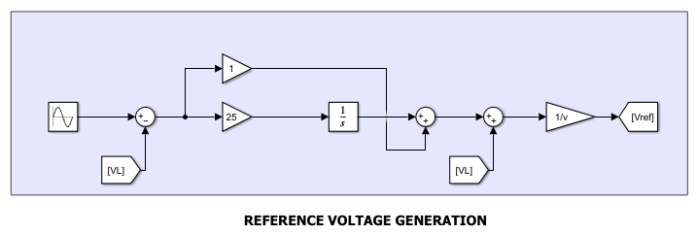

***Figure: PI Controller***

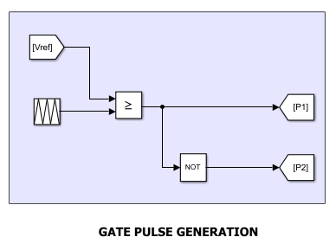

***Figure: Generation of Gate Pulses from changer Vref***

A reference sinusoidal voltage of 10 V was used which can be provided from the grid through a step-down transformer. It ensures that the output obtained through the transformer will not change, and at the same time abrupt changes in the values of DC input can be mitigated.

**Analysis**

Now let us again consider two different input voltages, 15 V and 20 V and see how the problems encountered previously are handled by the PI controller.

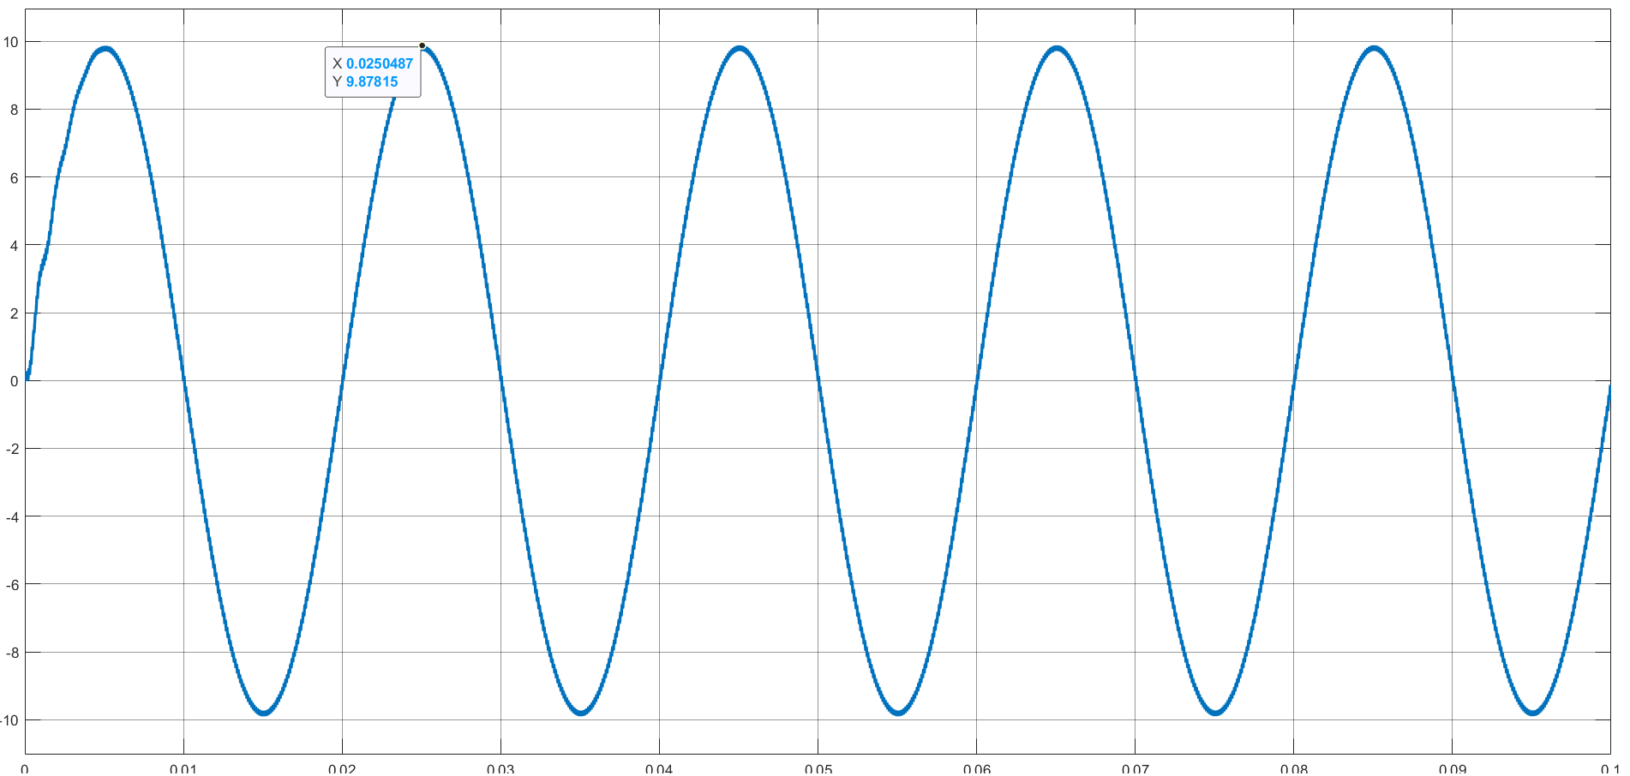

***Figure: Inverter Output Voltage for 15 V Supply***

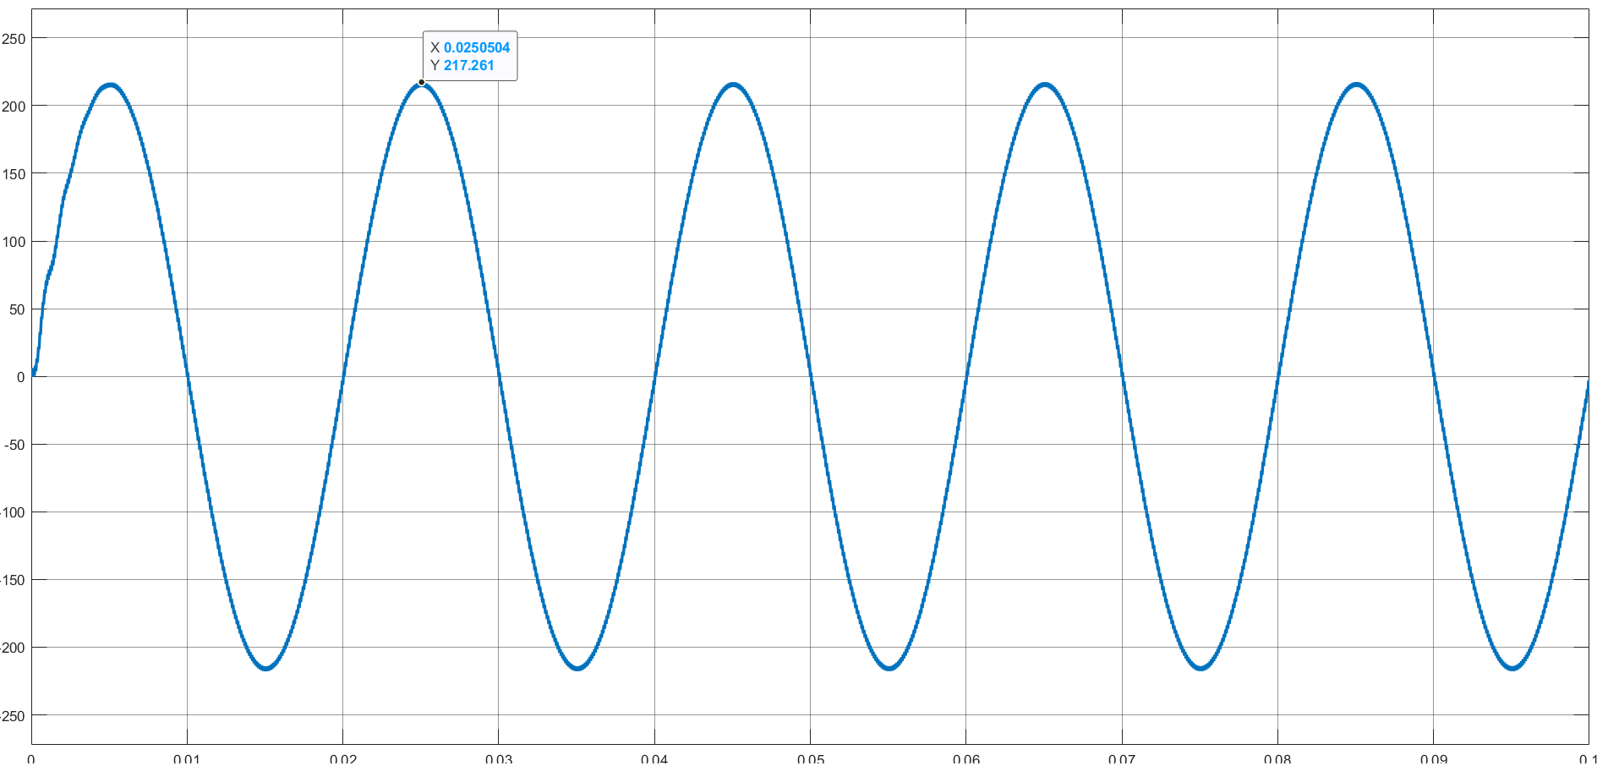

***Figure: 10/220 Step-Up Transformer Output for 15 V Supply***

It can be seen that the output from the inverter is now at almost 10 V. Since the step-up transformer has a fixed ratio, the output voltage will be found following this ratio. Although 15 V was given, the PI controller managed to reduce the error and brought it close to 10 V. So, the output is close to 220 V as expected.

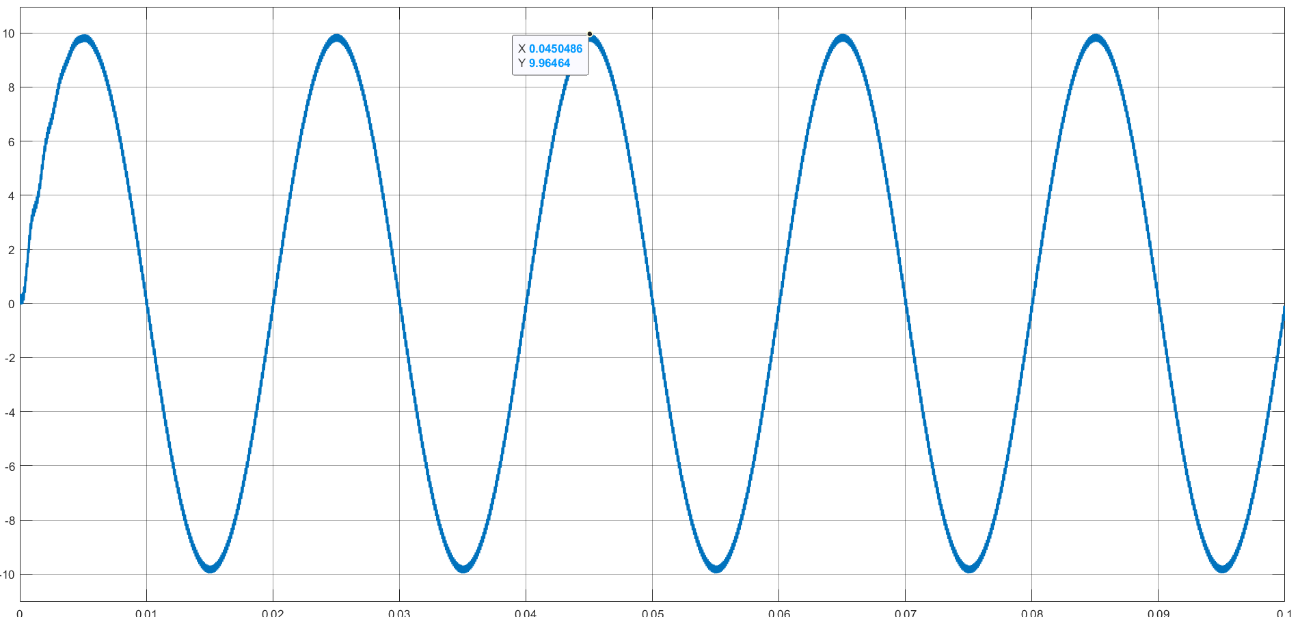

***Figure: Inverter Output Voltage for 20 V Supply***

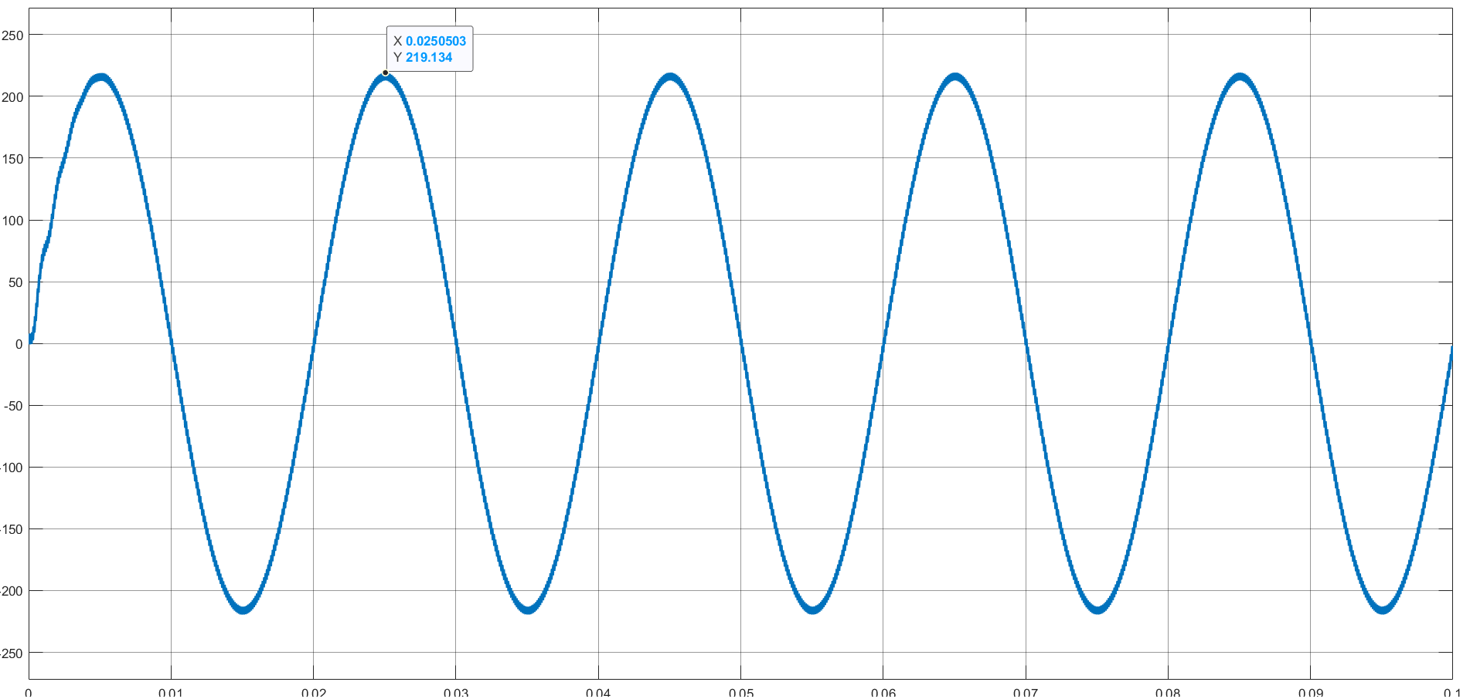

***Figure: 10/220 Step-Up Transformer Output for 20 V Supply***

Here too, it can be seen that the output from the inverter is now at almost 10 V. Since the step-up transformer has a fixed ratio, the output voltage will be found following this ratio. Although 20 V was given, the PI controller managed to reduce the error and brought it close to 10 V. So, the output is close to 220 V as expected.

So, in both cases with the same transformer winding ratio, the inverter generates a fixed output of 220 V. The PI controller controls the change in DC input voltage and ensures a constant output AC voltage having peak amplitude of almost 220 V. Although the ripple increases due to pursuing a different PWM technique than SPWM, the fundamental frequency and the overall wave shape is maintained accurately. A slightly better filter could easily ameliorate the ripples in the output waveform.

**Limitations and Possible Improvements:**

Since the project was partially done in hardware and later completed in software, we faced some limitations. However, these limitations can be addressed by some improvements which will make the inverter better and more usable.

1. Similar to voltage PI controller, a current PI controller could be added to get more robust and harmonic-free output. It may happen that due to loads being unchecked, more current may be used up, which will damage the whole circuitry. A current PI controller can help to check the current flow throughout the circuit and make the circuit open if the current flow is above a specified value.

2. Though the power rating of the simulated inverter wasn’t that high and a voltage stabilizer was implemented, in real-life scenario a short circuit condition could appear in an inverter. Thus a circuit breaker could be added for protecting the circuit from damages.

3. A perfect hardware implementation could display different features more elegantly.

**Discussions:**

To maintain a fixed sinusoidal supply to the load is important in power system, since AC systems are commonplace in the daily lives of people. Besides, in renewable power technology, motor drives, UPS, induction heating and in different other sectors, inverter is essential to provide an AC power conversion from DC supply.

In this project we tried to implement a single phase sine wave inverter. Though initially, the work was initiated in hardware, but later due to transition to online classes, a simulation circuit was generated along with the uncompleted hardware. SPWM technique was mainly used to generate the gate pulses though effects of over-modulation and under-modulation were analysed. Finally to provide stability, a voltage controller was added which makes the output fixed to a 220 V sinusoidal output. With the improvements discussed earlier, the single phase inverter can be made usable for different real-life applications.

______________________________________