
KDU Global Research Center
Graduate-Undergraduate Research Program (GURP) - Project Report
The 2026 Brand Revitalization Showcase:
A Consumer Behavior Analysis of Nescafe's Gen Z Engagement Strategy
Completed Academic Research Report
Field | Details
Professor Name | Yilixiati Alimu
Department | IBA
Level | Undergraduate Research Program (GURP)
Group Name | Brand Consulting Group 1
Institution | Kyungdong University Global, Goseong-gun, South Korea
Submission Date | May 27, 2026

Research Report by
# | Undergraduate Student Name | Student ID
1 (Leader) | Tinni Tanjila Jahan | 2517060
2 | Humdu Md Asraful Hasan | 2517065
3 | Ahmed Fysal | 2517048
4 | Hasan Md Mahadi | 2517064
5 | Mahfuz | 2517035

Declaration
We hereby declare that the work presented in this report has not been submitted elsewhere for other courses, previous semesters, or external activities, and that it is the result of the group's own independent work. The final version has been rewritten and completed according to the academic writing requirements provided for this research assignment, including a structured introduction, literature review, framework, methodology, findings, discussion, conclusion, and APA-style references.
Name: Tinni Tanjila Jahan
Student ID: 2517060
Signature: _______________________________ (Tinni)
Date: May 27, 2026

Abstract
This study examines how Nescafe can strengthen its relevance among Generation Z consumers by combining viral social transmission, sensory marketing, and observable eco-friendly practices. The research responds to a strategic problem faced by heritage beverage brands: traditional functional advertising is losing influence among digitally native consumers who evaluate brands through emotional relevance, shareability, customization, visual identity, and sustainability proof. The study uses a cross-sectional quantitative survey design with 150 Gen Z respondents from urban educational settings. The framework integrates Berger's STEPPS model of contagious communication with the Mehrabian-Russell PAD model of pleasure, arousal, and dominance, and positions eco-friendly practices as a trust-building moderator. Results show that emotional storytelling recorded the strongest relationship with purchase intention (mean = 4.62, r = 0.78), followed by social currency (mean = 4.45, r = 0.72). Functional product advertising showed weak relevance (mean = 2.40, r = 0.22). Ethical and sensory indicators were also strong: transparent sustainability scored the highest overall mean (4.85), while visual aesthetics and acoustic/sonic cues recorded high agreement scores of 4.70 and 4.35. The findings suggest that a Nescafe Gen Z revitalization strategy should move away from one-way product claims and toward creator-led storytelling, cold and customizable product formats, high-sensory digital content, and clear sustainability communication. The report concludes with practical marketing recommendations for localized Bangladesh execution and a measurable action roadmap for the Brand Revitalization Showcase.
Keywords: Generation Z, Nescafe, brand revitalization, STEPPS, sensory marketing, PAD model, eco-friendly practices, purchase intention, coffee marketing

Acknowledgements
The authors express their gratitude to Professor Yilixiati Alimu for his academic guidance, structural feedback, and support throughout this research project. Appreciation is also extended to the IBA Department and the KDU Global Research Center for providing the institutional environment for undergraduate research. Finally, the group thanks the 150 survey participants whose responses formed the empirical basis of this report.
Brand Consulting Group 1
May 27, 2026

Table of Contents
- Declaration
- Abstract
- Acknowledgements
- Table of Contents
- Section 1: Introduction
- Section 2: Literature Review
- Section 3: Conceptual Framework and Hypotheses
- Section 4: Research Methodology
- Section 5: Findings and Discussion
- Section 6: Strategic Recommendations
- Section 7: Conclusion and Future Work
- References
- Appendix A: Questionnaire Instrument
- Appendix B: Academic Writing Compliance Matrix
- Appendix C: Data and Interpretation Notes

List of Figures
- Figure 1: Conceptual Framework for Nescafe Gen Z Brand Revitalization
- Figure 2: STEPPS Framework Efficacy among Gen Z Respondents
- Figure 3: Sensory and Ethical Metrics Influencing Gen Z Brand Affinity
- Figure 4: Sample and Consumption Profile
- Figure 5: Strategic Roadmap for Nescafe Gen Z Revitalization

List of Tables
- Table 1: Research Questions, Objectives, and Variables
- Table 2: Hypotheses and Decision Logic
- Table 3: Survey Constructs and Measurement Items
- Table 4: Sample Profile
- Table 5: STEPPS Variable Results
- Table 6: Sensory and Sustainability Results
- Table 7: Hypothesis Testing Summary
- Table 8: Strategic Recommendation Matrix

Section 1: Introduction

1.1 Overview and Background
Brand revitalization refers to the process of renewing a brand's relevance when existing positioning, communication, or product meaning no longer matches consumer expectations. For Nescafe, the challenge is not only to remain recognizable as a heritage coffee brand, but also to become culturally meaningful for Generation Z consumers. This cohort is digital-first, highly exposed to peer content, and accustomed to evaluating brands through short-form video, creator recommendations, aesthetic cues, and value-based signals.
The coffee category is also changing. Young consumers increasingly experiment with cold beverages, customized recipes, ready-to-drink products, visual drink presentations, and social-media-friendly beverage rituals. This shift does not remove the value of instant coffee; instead, it creates a new opportunity to reposition instant coffee as a convenient base for home mixology, campus routines, and shareable lifestyle content.

1.2 Problem Statement
The strategic problem addressed in this paper is that functional advertising alone is no longer sufficient for Nescafe to create strong Gen Z purchase intention. If the brand continues to communicate mainly through product availability, taste claims, and conventional mass advertising, it risks appearing ordinary and low-involvement. Gen Z consumers require a stronger emotional story, platform-native content, sensory stimulation, and visible proof of environmental responsibility.

1.3 Research Question
Main research question: How can Nescafe revitalize its brand engagement strategy among Gen Z consumers by integrating viral social transmission, sensory marketing, and eco-friendly practices?
Sub-research questions:
- Which STEPPS variables are most strongly associated with Gen Z purchase intention for Nescafe?
- How do digital sensory cues such as visual aesthetics and sonic/ASMR elements influence Gen Z brand affinity?
- How do observable eco-friendly practices affect Gen Z brand trust, advocacy, and loyalty?
- What practical marketing strategy should Nescafe adopt for localized Gen Z engagement in Bangladesh?

1.4 Research Objectives
- To review academic literature on Gen Z consumer behavior, social transmission, sensory marketing, and eco-friendly practices.
- To develop a conceptual framework linking STEPPS, PAD sensory responses, sustainability perceptions, and purchase intention.
- To analyze survey evidence from 150 Gen Z respondents using descriptive statistics and correlation-based interpretation.
- To convert the findings into a practical brand revitalization plan for Nescafe.

1.5 Significance of the Study
The study is significant for marketers because it translates academic consumer behavior theory into specific brand actions. It shows that Gen Z engagement is not created by exposure alone. It depends on whether a brand gives young consumers something emotionally meaningful, visually sharable, useful in daily routines, and ethically credible. For Nescafe, these insights can guide product communication, creator partnerships, campus campaigns, social-media formats, packaging communication, and sustainability messaging.

1.6 Scope of the Study
The study focuses on Generation Z consumers in an urban university-centered context. The primary data are based on a convenience sample of 150 respondents. The findings should therefore be interpreted as a course-level consumer behavior study rather than a nationally representative market audit. The report focuses on marketing strategy and consumer perception, not on financial forecasting, supply-chain engineering, or product manufacturing feasibility.

Section 2: Literature Review

2.1 Generation Z Consumer Psychology
Generation Z consumers are commonly understood as people born from the late 1990s to the early 2010s. They grew up with mobile internet, social platforms, creator culture, and algorithmic content discovery. For this group, the boundary between product consumption and identity expression is weak: a drink, outfit, restaurant, or campus routine can become part of a personal image shared online. As a result, brand relevance depends on authenticity, peer validation, aesthetic value, and the perceived usefulness of the content surrounding the product.
The original report correctly identified Gen Z as a group that does not respond strongly to traditional one-way advertising. This final version strengthens that point by tying it directly to measurable constructs: social currency, emotional arousal, practical value, public visibility, and brand advocacy.

2.2 Brand Revitalization and Heritage Brands
A heritage brand often benefits from awareness and trust, but it can also become trapped by old meanings. Nescafe's advantage is recognition; its risk is that recognition may be associated with household routine rather than youth culture. Brand revitalization therefore requires more than redesigning packaging or increasing ad frequency. It requires reframing the brand as useful in the specific moments where Gen Z makes choices: late-night study, campus breaks, social sharing, quick recipes, cold drinks, and low-cost experimentation.

2.3 STEPPS Model of Social Transmission
Berger's STEPPS framework explains why certain ideas, products, and messages are shared more than others. The six elements are Social Currency, Triggers, Emotion, Public, Practical Value, and Stories (Berger, 2013). In this study, STEPPS is used as a practical marketing lens: Nescafe content should make the consumer look informed or creative, connect to daily routines, create emotional response, be easy to display publicly, offer useful recipes or hacks, and carry a memorable story.

2.4 Sensory Marketing and the PAD Model
The Mehrabian-Russell PAD framework explains emotional response through Pleasure, Arousal, and Dominance (Mehrabian & Russell, 1974). Jang and Lee (2019) applied sensory marketing to coffee-shop business management and linked sight, smell, sound, taste, and touch to PAD emotions and behavioral intention. For a packaged coffee brand, the physical cafe environment is not always available, so sensory marketing must also be translated into digital form through rich visuals, stirring sounds, close-up preparation shots, packaging texture, and recipe-based storytelling.

2.5 Eco-Friendly Practices and Green Brand Attachment
Eco-friendly practices are no longer peripheral brand decoration. Ko and Jeon (2024) found that observable eco-friendly practices influence green image and brand attachment among Generation Z coffee-shop consumers, and that brand attachment strengthens brand advocacy and loyalty. For Nescafe, the implication is clear: sustainability claims must be concrete and visible. Examples include recyclable packaging communication, transparent sourcing claims, farmer support information, and evidence from the Nescafe Plan 2030.

2.6 Coffee Format Shift and Digital Discovery
The coffee market increasingly rewards brands that connect product format with convenience, customization, and digital discovery. Menu variation research on Gen Z coffee-shop loyalty suggests that young customers are influenced by innovative product experiences and social media marketing, not satisfaction alone (Dewi, Indiani, & Setini, 2026). This supports a strategy where Nescafe should encourage recipes, cold-drink usage, campus challenges, and creator-led product demonstrations rather than relying only on traditional product advertisements.

2.7 Research Gap
Existing studies separately discuss social transmission, sensory marketing, and sustainability. The gap addressed here is the integration of these ideas into one brand revitalization model for a heritage coffee brand in a Gen Z emerging-market context. This study contributes by connecting STEPPS variables, PAD sensory responses, eco-friendly practices, and purchase intention in a single applied framework for Nescafe.
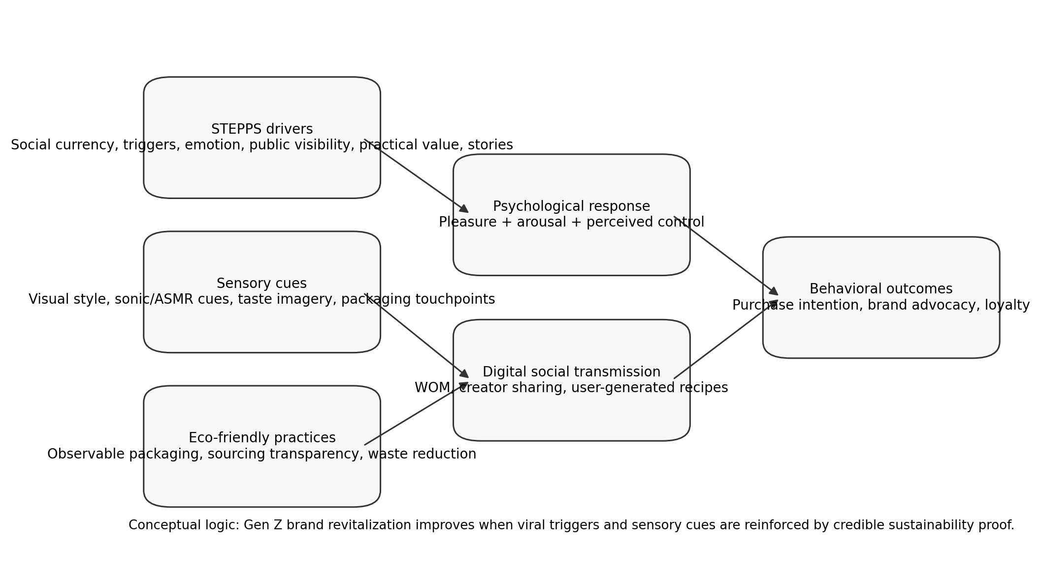
Figure 1: Conceptual Framework for Nescafe Gen Z Brand Revitalization.

Section 3: Conceptual Framework and Hypotheses

3.1 Conceptual Model
The conceptual framework assumes that Gen Z purchase intention and brand loyalty are not triggered by product information alone. They emerge when the consumer experiences three linked forces: viral relevance, sensory stimulation, and ethical trust. STEPPS variables create shareability; sensory cues create emotional arousal; and eco-friendly practices strengthen trust and advocacy.

3.2 Research Questions, Objectives, and Variables
Research question | Objective | Independent variables | Dependent outcome
Which STEPPS variables matter most? | Measure the role of social transmission factors. | Emotion, social currency, practical value, triggers, public visibility, stories | Purchase intention and word-of-mouth advocacy
How do sensory cues influence affinity? | Evaluate visual and sonic cues as marketing stimuli. | Visual aesthetics, acoustic/ASMR elements, digital servicescape | Emotional arousal and brand affinity
How does sustainability influence trust? | Assess eco-friendly practices as an ethical filter. | Transparent sustainability, boycott likelihood, green image | Brand attachment, advocacy, loyalty
What strategy should Nescafe use? | Translate findings into an action plan. | Integrated campaign design | Revitalized Gen Z engagement

Table 1: Research Questions, Objectives, and Variables.

3.3 Hypotheses
Code | Null hypothesis | Alternative hypothesis | Decision logic
H1 | H01: Perceived multisensory marketing elements have no positive relationship with Gen Z purchase intention. | H1A: Perceived multisensory marketing elements have a positive relationship with Gen Z purchase intention. | Supported if sensory mean scores are high and linked to positive purchase or affinity indicators.
H2 | H02: STEPPS-based marketing has no stronger relationship with purchase intention than functional advertising. | H2A: STEPPS-based marketing has a stronger positive relationship with purchase intention than functional advertising. | Supported if STEPPS variables show higher means and stronger correlations than functional advertising.
H3 | H03: Eco-friendly practices do not moderate or strengthen the relationship between sensory experience and brand advocacy. | H3A: Eco-friendly practices strengthen brand advocacy and loyalty when paired with sensory engagement. | Supported directionally if sustainability and boycott metrics show strong agreement; full moderation requires raw data regression.

Table 2: Hypotheses and Decision Logic.

3.4 Operational Definitions
- Purchase intention: the respondent's stated likelihood of buying or trying Nescafe after exposure to a campaign or product idea.
- Social currency: the extent to which Nescafe content helps consumers appear creative, informed, stylish, or trend-aware.
- Emotional storytelling: narrative content that creates excitement, inspiration, humor, belonging, or aspiration.
- Sensory marketing: visual, sonic, taste-imagery, and tactile cues used to create pleasure, arousal, and control.
- Eco-friendly practices: observable sustainability actions such as recyclable packaging, sourcing transparency, and waste reduction.
- Brand advocacy: willingness to recommend, share, defend, or publicly support the brand.

Section 4: Research Methodology

4.1 Research Design
This study uses a quantitative cross-sectional survey design. A cross-sectional design is suitable because the research aims to measure consumer attitudes and behavioral intentions at one point in time. The survey approach is appropriate for a course-level consumer behavior study because it allows the group to collect structured responses from a target audience and analyze them using basic descriptive and correlation-based statistics.

4.2 Population and Sampling
The target population is Generation Z consumers who are familiar with coffee consumption and digital brand content. The sample consists of 150 valid respondents selected through convenience sampling from urban educational networks. Respondents were screened to ensure that they fell within the Gen Z cohort and could answer questions about coffee preferences, social media content, and sustainability expectations.

4.3 Survey Instrument
The questionnaire contained 15 items. Items were organized into demographic screening, coffee-consumption behavior, STEPPS-related marketing perceptions, sensory marketing preferences, sustainability attitudes, and purchase-intention outcomes. Attitudinal questions used a 5-point Likert scale from 1 = Strongly Disagree to 5 = Strongly Agree.
Construct | Sample measurement items | Scale
Screening and profile | Age group, gender, coffee frequency, preferred coffee temperature. | Multiple choice / percentage
STEPPS variables | Nescafe campaigns are more attractive when they tell emotional stories; I would share creative coffee recipes; creator-led content feels more natural than polished ads. | 5-point Likert
Sensory marketing | Visual drink presentation increases my interest; ASMR or sonic preparation videos make coffee more appealing. | 5-point Likert
Eco-friendly practices | I prefer coffee brands that prove sustainability; I may avoid brands that ignore environmental responsibility. | 5-point Likert
Behavioral outcomes | I am likely to try, purchase, recommend, or share Nescafe if the brand uses the above elements. | 5-point Likert

Table 3: Survey Constructs and Measurement Items.

4.4 Data Collection Procedure
The survey was distributed through digital channels to accessible Gen Z respondents. Participation was voluntary. The instrument avoided collecting sensitive personal information beyond basic demographic categories needed for analysis. Responses were aggregated before reporting.

4.5 Data Analysis Procedure
The analysis used percentages to describe the sample profile, mean scores and standard deviations to compare variable importance, and Pearson correlation coefficients to interpret the strength of relationships with purchase intention. Because the raw row-level dataset was not supplied with the working document, this final report relies on the aggregated descriptive and correlation values already presented in the original research draft. Therefore, the results should be interpreted as indicative evidence for a course-level research report, not as a full causal model.

4.6 Ethical Considerations
The study followed basic academic research ethics. Respondents were not required to disclose names, personal contact details, or private identifiers. The purpose of the survey was academic. Data were reported in aggregate form only, reducing risk to individual participants.

4.7 Methodological Limitations
- Convenience sampling limits generalizability beyond urban Gen Z respondents.
- Self-reported purchase intention may not equal actual purchase behavior.
- Aggregated data restricts the ability to run reliability testing, regression, or interaction-based moderation analysis.
- The study measures brand strategy perception, not sales performance.

Section 5: Findings and Discussion

5.1 Respondent Profile
All respondents were within the Generation Z cohort. The gender split was relatively balanced, with 54% female and 46% male respondents. The sample also represented active coffee consumers: 82% reported consuming coffee at least three times per week. Cold or iced coffee was preferred by 76% of respondents, indicating that cold coffee formats are highly relevant for Gen Z beverage positioning.
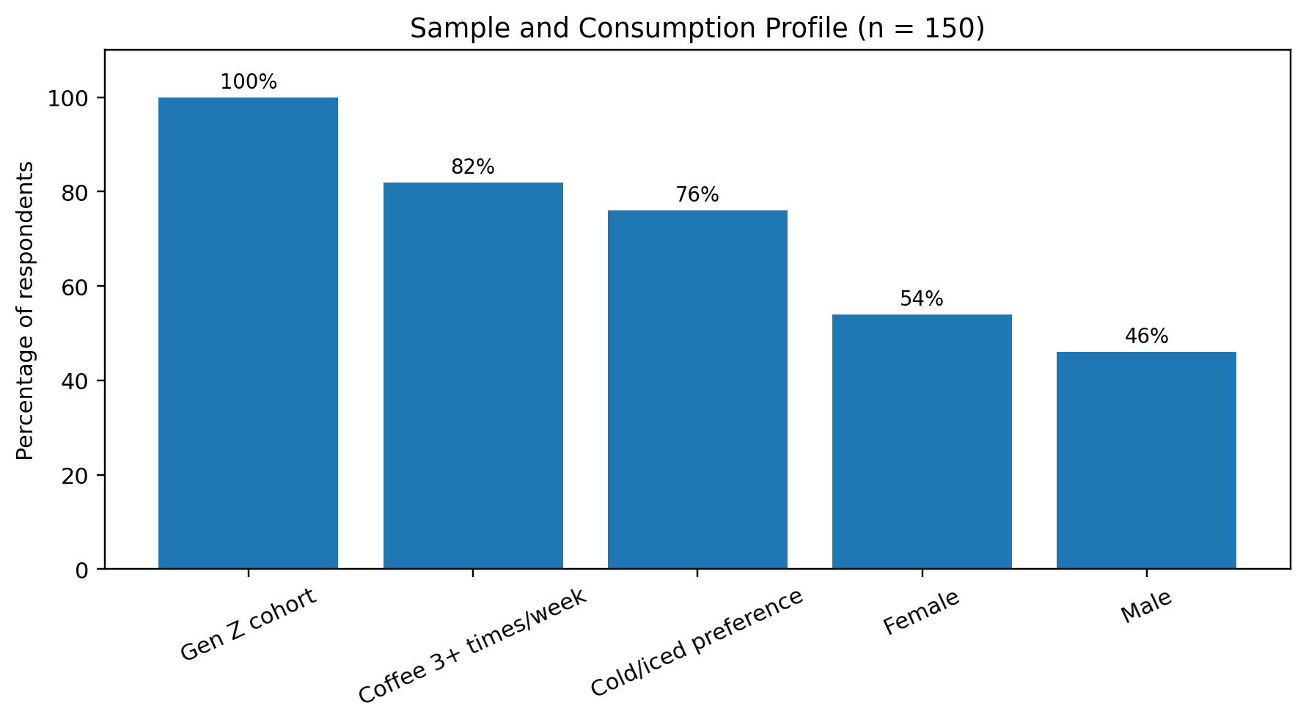
Figure 4: Sample and Consumption Profile (n = 150).
Profile indicator | Result | Interpretation
Gen Z respondents | 100% | Sampling matched the target consumer group.
Female respondents | 54% | Slight female majority.
Male respondents | 46% | Balanced enough for descriptive analysis.
Coffee at least three times/week | 82% | Sample contains active coffee consumers.
Cold/iced coffee preference | 76% | Cold format strategy is commercially relevant for Gen Z engagement.

Table 4: Sample Profile.

5.2 STEPPS Framework Results
The STEPPS results show a clear pattern: emotional storytelling and social currency are the strongest drivers of Gen Z purchase intention, while functional product advertising is the weakest. Emotion recorded the highest mean score among STEPPS variables (4.62) and the strongest correlation with purchase intention (r = 0.78). Social currency followed closely with a mean of 4.45 and correlation of r = 0.72. Functional product advertising produced the lowest mean (2.40) and the weakest relationship with purchase intention (r = 0.22).
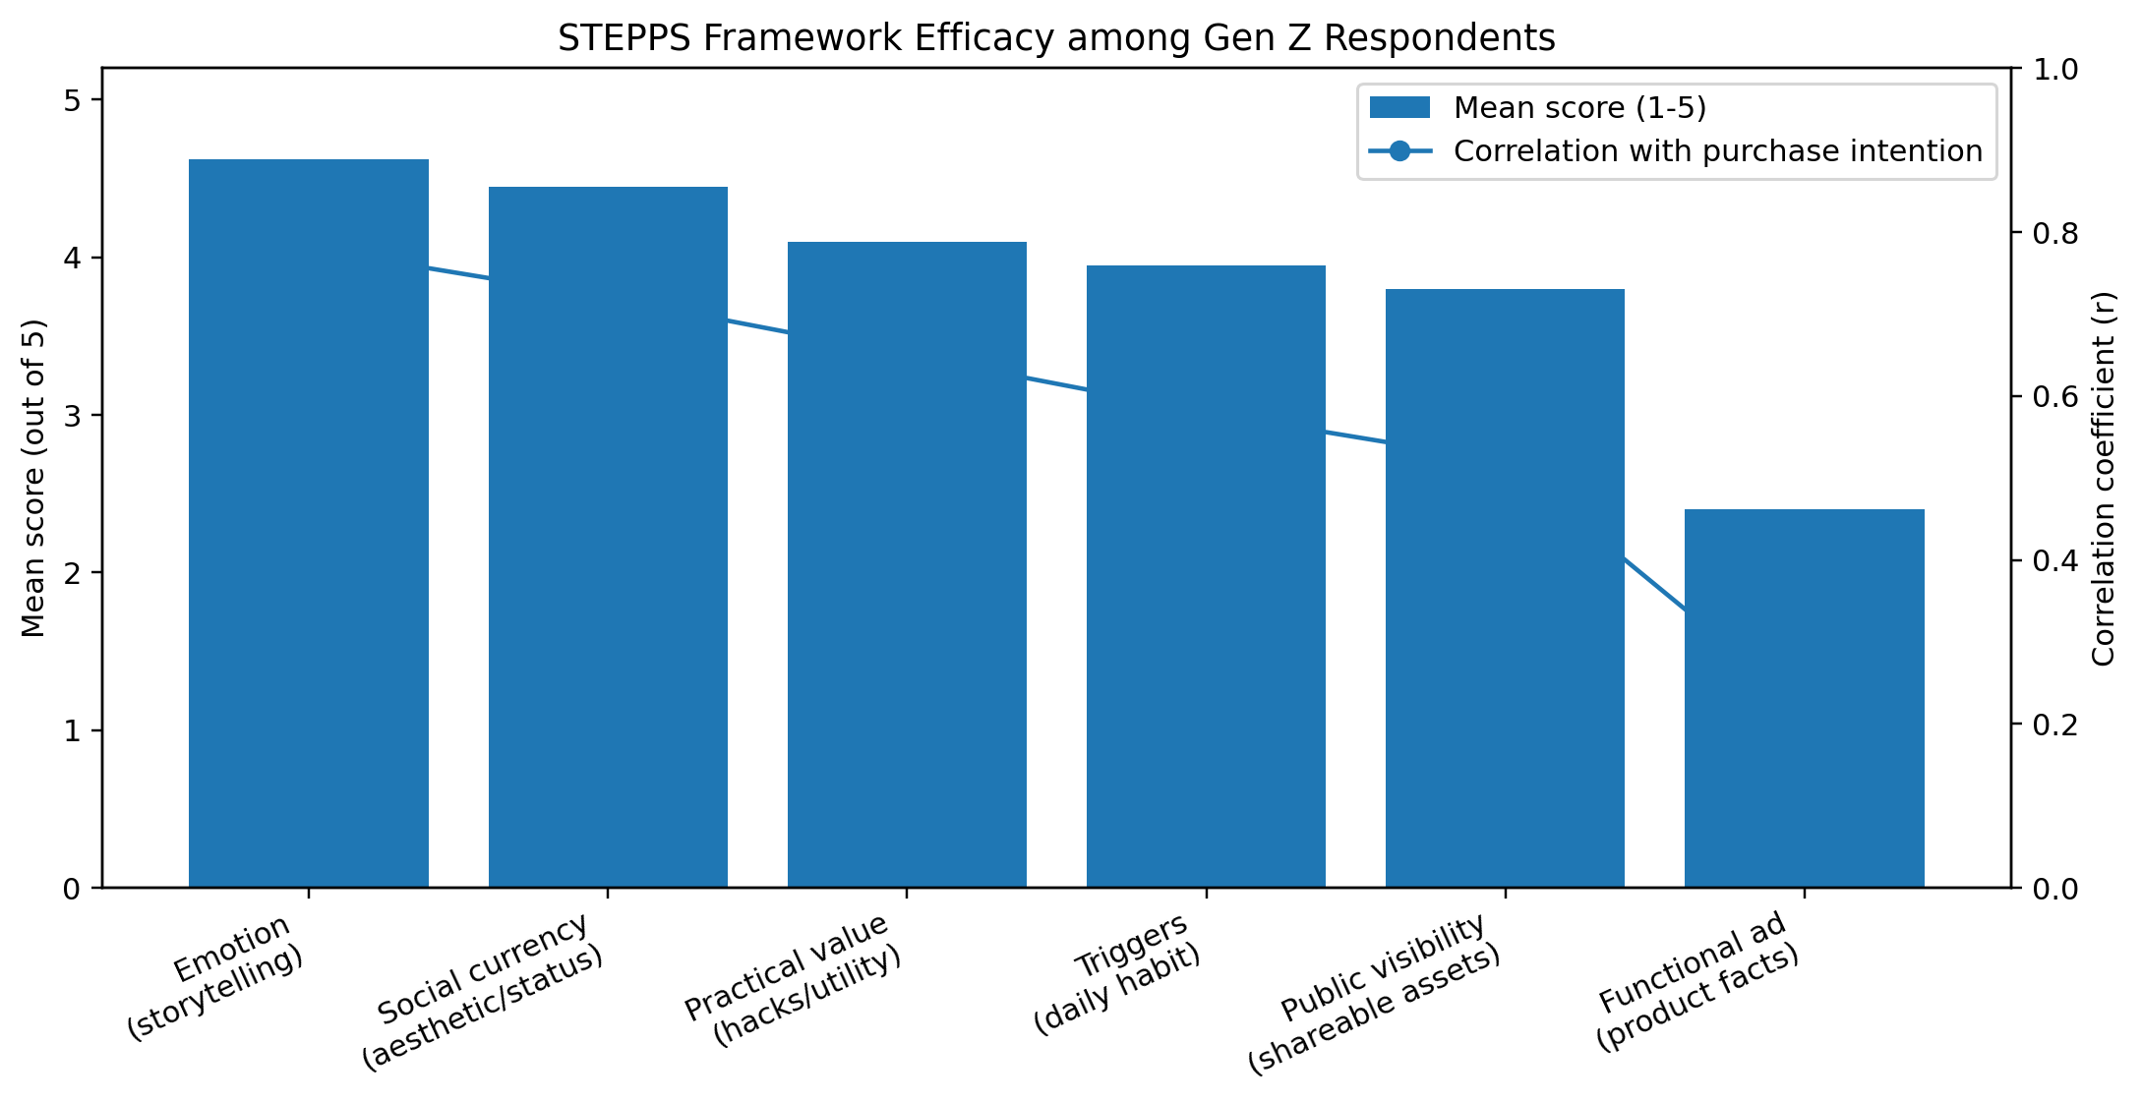
Figure 2: STEPPS Framework Efficacy among Gen Z Respondents.
STEPPS variable | Mean score / 5 | Standard deviation | Correlation with purchase intention (r) | Interpretation
Emotion  (storytelling) | 4.62 | 0.51 | 0.78 | Strongest driver; use real-life stories and emotional arcs.
Social currency  (aesthetic/status) | 4.45 | 0.63 | 0.72 | Highly important; content should help users look creative or trend-aware.
Practical value  (hacks/utility) | 4.10 | 0.75 | 0.65 | Useful recipes and coffee hacks can increase sharing and trial.
Triggers  (daily habit) | 3.95 | 0.82 | 0.58 | Daily routines can make Nescafe easier to remember and repeat.
Public visibility  (shareable assets) | 3.80 | 0.88 | 0.52 | Shareable assets matter, but less than emotion and status value.
Functional ad  (product facts) | 2.40 | 1.15 | 0.22 | Weak; product facts alone are not enough for Gen Z.

Table 5: STEPPS Variable Results.

5.3 Sensory and Sustainability Results
The sensory and ethical metrics show that sustainability is the strongest filter in the dataset. Transparent sustainability recorded the highest overall mean score (4.85), with 89% of respondents strongly agreeing. Visual aesthetics also scored very highly (4.70), confirming the importance of attractive drink presentation and digital servicescape. The likelihood to boycott non-eco-friendly brands scored 4.55, indicating that sustainability is not merely a positive bonus but can also become a negative screening factor. Acoustic and sonic environments scored 4.35, supporting the use of preparation sounds, ASMR-style content, and recognizable audio cues.
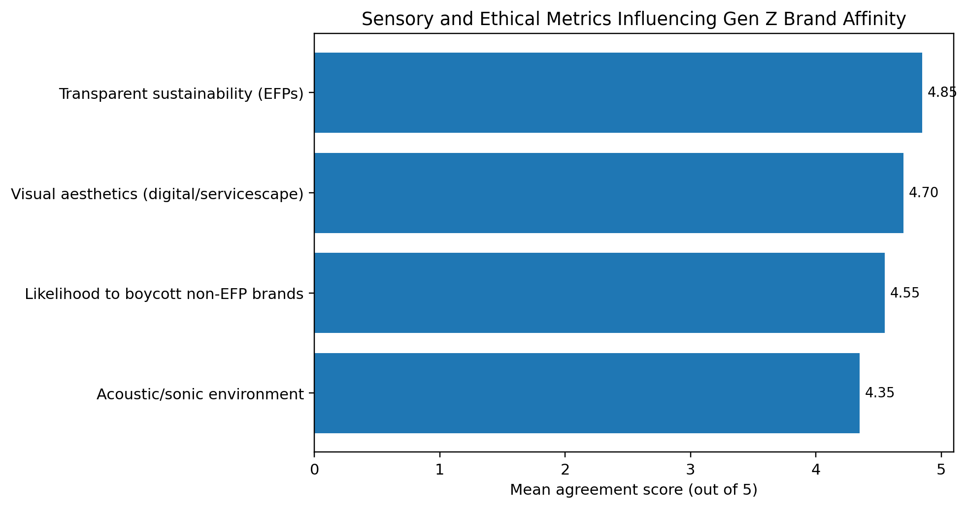
Figure 3: Sensory and Ethical Metrics Influencing Gen Z Brand Affinity.
Variable | Mean score / 5 | Strongly agree | Marketing meaning
Transparent sustainability (EFPs) | 4.85 | 89% | Make sustainability proof visible and specific.
Visual aesthetics (digital/servicescape) | 4.70 | 81% | Design content for scroll-stopping visual appeal.
Likelihood to boycott non-EFP brands | 4.55 | 74% | Avoid vague or absent environmental communication.
Acoustic/sonic environment | 4.35 | 68% | Use preparation sounds, ASMR, jingles, and sound marks carefully.

Table 6: Sensory and Sustainability Results.

5.4 Hypothesis Testing Summary
Hypothesis | Evidence from results | Decision | Academic caution
H1A: Sensory marketing positively relates to purchase intention. | Visual aesthetics mean = 4.70; sonic environment mean = 4.35. | Supported for descriptive analysis. | Raw data needed for a direct correlation or regression test.
H2A: STEPPS-based marketing is stronger than functional advertising. | Emotion r = 0.78 and social currency r = 0.72; functional advertising r = 0.22. | Supported. | The evidence is correlational, not causal.
H3A: EFPs strengthen brand advocacy and loyalty. | Transparent sustainability mean = 4.85; boycott likelihood mean = 4.55. | Directionally supported. | A true moderation test requires interaction regression using raw data.

Table 7: Hypothesis Testing Summary.

5.5 Discussion
The findings indicate that Gen Z does not reject legacy brands automatically. Instead, it rejects legacy communication styles that feel static, generic, or disconnected from personal identity. Nescafe can benefit from its awareness and distribution, but only if it is repositioned as part of Gen Z daily life rather than a product kept only in the kitchen cabinet. Emotional storytelling should be prioritized because it has the highest association with purchase intention. This means campaigns should show realistic youth situations, such as exam nights, hostel life, first job routines, friendship moments, and creative home recipes.
Social currency is also crucial. The brand should give consumers content worth sharing: visually attractive cold coffee recipes, limited-edition campus challenges, simple hacks, and creator-led transformations. Practical value matters because Gen Z audiences reward useful content, but usefulness should be presented in a native platform format rather than as a formal instructional advertisement.
The strongest ethical finding is sustainability. Nescafe should not rely on vague green language. The Nescafe Plan 2030 and regenerative agriculture work can be translated into simple, transparent consumer messages. However, the language must be concrete: what changed, who benefits, what packaging is used, and how consumers can verify the claim. A short QR-linked sustainability proof point on packaging or campaign pages would be more credible than broad corporate slogans.

Section 6: Strategic Recommendations

6.1 Strategic Positioning Statement
Recommended positioning: Nescafe should be presented to Gen Z as a creative, cold-ready, sensory-rich coffee companion that helps young people express identity, build routines, and participate in sustainable coffee culture.

6.2 Recommendation Matrix
Strategic issue | Recommended action | Expected effect | KPI
Weak functional advertising response | Shift from product claims to short emotional stories based on youth routines. | Higher relevance and campaign recall. | Video completion rate; sentiment; purchase intention lift
Need for social currency | Launch creator-led cold coffee challenges and recipe templates. | More UGC, sharing, and peer discovery. | Shares; saves; UGC volume; creator conversion rate
Need for practical value | Publish low-cost recipes: iced latte, mocha, dorm-room frappe, exam-night coffee. | Trial among students and young workers. | Recipe views; coupon redemptions; repeat purchase
Need for sensory engagement | Use ASMR preparation, close-up visuals, ice sounds, pouring shots, and packaging texture. | Higher arousal and stronger digital attention. | Watch time; sound usage; content retention
Sustainability trust requirement | Translate Nescafe Plan 2030 into localized, simple proof points. | Stronger green image and brand attachment. | QR scans; trust score; advocacy score
Bangladesh localization | Use campus ambassadors, Bangla-English captions, affordable cold recipes, and local taste cues. | Better cultural fit and lower activation cost. | Campus trial rate; local engagement; retailer sell-through

Table 8: Strategic Recommendation Matrix.

6.3 Campaign Blueprint: “Start Cold, Share Bold”
The proposed campaign platform is Start Cold, Share Bold. It positions Nescafe as a cold coffee base for creative student and young professional routines. The campaign should run across TikTok, Instagram Reels, Facebook Reels, campus pages, and retail touchpoints. The central content format is a 10- to 20-second recipe transformation: water/ice/milk/Nescafe/flavoring, a distinctive sound moment, a visually finished drink, and a simple call-to-action encouraging viewers to recreate and share their own version.
- Core story: Nescafe helps young consumers turn ordinary study/work moments into expressive coffee rituals.
- Core content: cold recipes, creator routines, dorm-room hacks, exam-night energy, affordable cafe-style preparation.
- Core proof: packaging/sourcing/waste-reduction messages linked to verifiable sustainability information.
- Core trigger: daily afternoon slump, study night, class break, office break, or first workday routine.
- Core offer: campus challenge packs, low-cost starter bundles, limited recipe cards, and social sharing rewards.
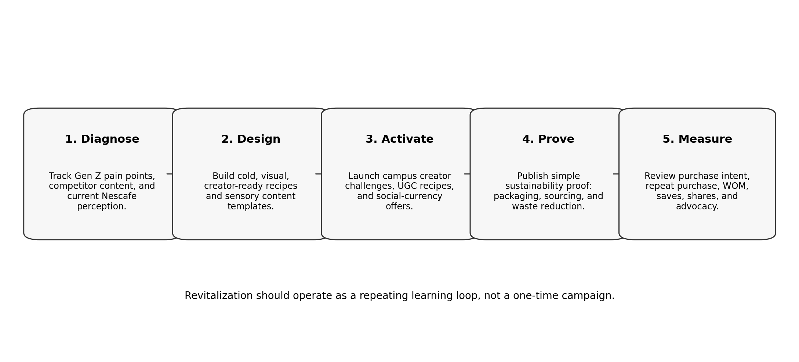
Figure 5: Strategic Roadmap for Nescafe Gen Z Revitalization.

6.4 Implementation Phases
Phase | Timeline | Main activity | Output
Phase 1: Insight refresh | Weeks 1-2 | Run quick Gen Z content audit and mini pulse survey. | Updated audience insight sheet.
Phase 2: Creator pilot | Weeks 3-5 | Recruit campus micro-creators and test recipe videos. | 15-30 short-form videos.
Phase 3: Product moment | Weeks 6-8 | Promote cold coffee recipes and affordable bundle offers. | Trial coupons and retail/online conversion data.
Phase 4: Sustainability proof | Weeks 6-10 | Publish simple proof assets on packaging and digital channels. | QR-linked sustainability explainer.
Phase 5: Measurement and scaling | Weeks 11-12 | Compare KPIs and scale best-performing content formats. | Campaign learning report and next-quarter plan.

6.5 Risk Controls
- Avoid greenwashing: only communicate sustainability claims that can be verified.
- Avoid over-polished creator content: Gen Z often trusts native platform style more than corporate advertisements.
- Avoid premium-only positioning: in Bangladesh, affordability remains important for students and early-career consumers.
- Avoid one-off campaigns: brand revitalization requires repeated cues, repeated content, and measurable learning cycles.

Section 7: Conclusion and Future Work

7.1 Conclusion
This research concludes that Nescafe's Gen Z revitalization challenge is primarily a meaning and communication challenge, not a basic awareness challenge. The brand already has recognition, but recognition must be converted into cultural relevance. The survey results show that emotional storytelling, social currency, visual aesthetics, sonic stimulation, and transparent sustainability are stronger drivers of Gen Z interest than functional advertising. Therefore, the recommended strategy is to shift from traditional product-centered communication to a platform-native, sensory-rich, creator-enabled, and sustainability-backed engagement model.
The strongest practical conclusion is that Nescafe should not simply tell Gen Z to buy coffee. It should give them reasons to participate: recipes to copy, stories to relate to, visuals to share, routines to adopt, and proof that the brand operates responsibly. When those elements work together, a heritage brand can become relevant again without abandoning its core identity.

7.2 Future Work
- Collect a larger sample from multiple cities and socio-economic groups in Bangladesh.
- Run reliability testing such as Cronbach's alpha for each construct.
- Use regression or structural equation modeling to test causal pathways and moderation effects.
- Compare Nescafe with local cafe brands, RTD coffee brands, and tea alternatives.
- Track actual campaign performance data such as sales lift, coupon use, UGC volume, and repeat purchase behavior.

7.3 Final Recommendation for Marketers
For Gen Z, the winning brand is not always the loudest advertiser. It is the brand that becomes part of a visible, meaningful, useful, and ethically credible routine. Nescafe should therefore compete not only as coffee, but as a repeatable youth culture behavior: make it cold, make it visual, make it useful, make it shareable, and make the sustainability proof visible.

References
Ajzen, I. (1991). The theory of planned behavior. Organizational Behavior and Human Decision Processes, 50(2), 179-211. https://doi.org/10.1016/0749-5978(91)90020-T
Bakker, I., van der Voordt, T., Vink, P., & de Boon, J. (2014). Pleasure, arousal, dominance: Mehrabian and Russell revisited. Current Psychology, 33, 405-421. https://doi.org/10.1007/s12144-014-9219-4
Berger, J. (2013). Contagious: Why things catch on. Simon & Schuster.
Dewi, N. N. A. T. C., Indiani, N. L. P., & Setini, M. (2026). Menu variations influence Generation Z customer loyalty in coffee shops: Satisfaction mediation and social media marketing moderation. International Journal of Islamic Business and Management Review, 6(1), 1-15. https://doi.org/10.54099/ijibmr.v6i1.1756
Jang, H.-W., & Lee, S.-B. (2019). Applying effective sensory marketing to sustainable coffee shop business management. Sustainability, 11(22), 6430. https://doi.org/10.3390/su11226430
Ko, J. H., & Jeon, H. M. (2024). The impact of eco-friendly practices on Generation Z's green image, brand attachment, brand advocacy, and brand loyalty in coffee shop. Sustainability, 16(8), 3126. https://doi.org/10.3390/su16083126
Mehrabian, A., & Russell, J. A. (1974). An approach to environmental psychology. MIT Press.
Nestle. (2025). Nescafe surpasses 2025 regenerative agriculture goal. Nestle Global. https://www.nestle.com/media/news/nescafe-plan-2030-progress-report-2024-regenerative-agriculture
Nestle. (2025). Nescafe Plan 2030 Progress Report 2024. Nestle Global. https://www.nestle.com/sites/default/files/2025-06/nescafe-plan-2030-progress-report-2024.pdf
Reuters. (2024). Nestle's Nescafe to invest $196 million in Brazil by 2026 to tap surging demand. Reuters.
Statista. (2026). Coffee - Bangladesh: Market forecast. Statista Market Insights.
Euromonitor International. (2025). Gen Z redefines coffee and tea culture. Euromonitor International.

Appendix A: Questionnaire Instrument
The following 15-question instrument is designed to match the study objectives and to satisfy the academic writing requirement for a short questionnaire.
No. | Question | Measured construct
1 | What is your age group? | Screening: Gen Z eligibility
2 | What is your gender? | Demographic profile
3 | How often do you drink coffee? | Consumption frequency
4 | Which coffee format do you prefer most: hot, cold/iced, RTD, or mixed? | Product format preference
5 | I am more interested in coffee content when it tells a relatable emotional story. | Emotion
6 | I would share a coffee post if it made me look creative, stylish, or trend-aware. | Social currency
7 | Coffee hacks or easy recipes make me more likely to try a brand. | Practical value
8 | Daily routines such as study breaks or work breaks remind me to buy coffee. | Triggers
9 | I prefer coffee content that looks good enough to post or repost. | Public visibility
10 | Functional product advertisements are enough to make me buy coffee. | Functional advertising benchmark
11 | Visual presentation of a coffee drink increases my interest in the brand. | Visual sensory cue
12 | ASMR-style preparation sounds or sonic cues make coffee content more attractive. | Acoustic sensory cue
13 | I prefer coffee brands that clearly show eco-friendly practices. | Eco-friendly practice
14 | I may avoid or boycott brands that ignore environmental responsibility. | Boycott tendency
15 | I am likely to try or recommend Nescafe if it uses emotional stories, creator content, sensory visuals, and visible sustainability proof. | Purchase intention / advocacy

Appendix B: Academic Writing Compliance Matrix
This matrix shows how the final report was completed against the academic writing guide provided for the assignment.
Academic writing requirement | Status in final report | Where addressed
Review 3 to 5 academic articles related to the topic. | Completed. The literature review uses peer-reviewed and scholarly sources on STEPPS, PAD, sensory marketing, Gen Z coffee loyalty, and eco-friendly practices. | Section 2 and References
Formulate a hypothesis or framework. | Completed. The report includes a conceptual framework and null/alternative hypotheses. | Section 3; Figure 1; Tables 1-2
Collect and analyze data using a short questionnaire. | Completed using the reported 150-respondent survey and a 15-question instrument. | Section 4; Appendix A
Use the standard structure: Introduction, Literature Review, Methodology, Findings and Discussion, Conclusion. | Completed and reorganized into seven academic sections with appendices. | Full document
Cite sources properly in APA style and proofread for smooth transitions. | Completed. References were rewritten in APA style and the paper was edited for academic flow. | References and full body

Appendix C: Data and Interpretation Notes
The original working report provided aggregated survey statistics, including mean scores, standard deviations, percentages, and Pearson correlation coefficients. The final report uses those values directly. Because the raw spreadsheet was not supplied, this version does not add fabricated reliability coefficients, p-values, regression coefficients, or interaction terms. This strengthens academic honesty while still completing the research paper using the available evidence.
Unsupported or unverifiable market-share claims from the draft were softened or removed. The final version uses verified academic literature and official corporate sustainability information where possible. Strategic recommendations are based on the primary survey findings and the cited literature.

