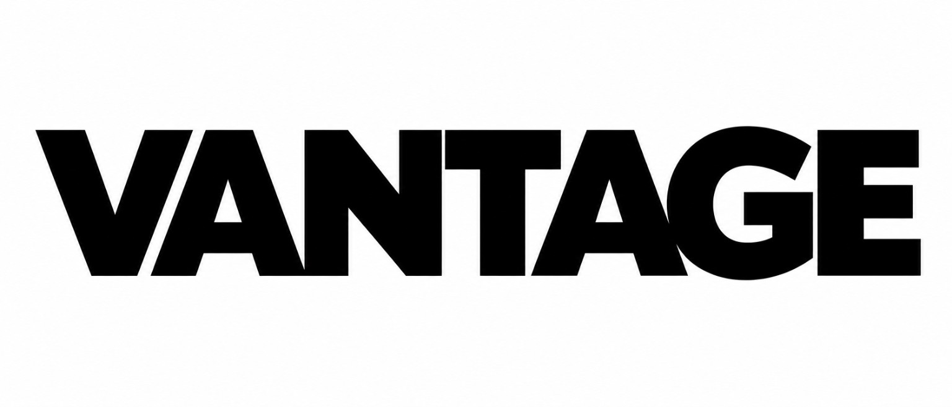  See further. Stay protected. | Prepared by VANTAGE  Document Code: VANTAGE-GR-002 | Version: 0.1 | Status: DRAFT  Folder: 06_DELIVERY_TEMPLATES | Date: 27 May 2026  Keystone Consultancy | munimhasibul10@gmail.com | +8801941646278

1-PAGE GAP REPORT TEMPLATE
Executive readiness summary after a Free Gap Scan. Built for internal management review and conversion into a paid VANTAGE support package.
Document Title | 1-Page Gap Report Template | Document Code | VANTAGE-GR-002
Version | 0.1 | Status | DRAFT
Prepared by | VANTAGE | Operated by | Keystone Consultancy
FACTORY SUMMARY  Factory name  Location  Management contact  Workforce approx.  Key buyers / targets  Scan date  SCAN SCOPE  [ ] HR policy / handbook [ ] Wage & attendance  [ ] Worker files [ ] OSH / safety records  [ ] RSC / CAP readiness [ ] Subcontractor file  [ ] Bond / customs file [ ] Buyer CoC mapping  MISSING / EXPIRED DOCUMENT SUMMARY  Document / file Status Due  1. [ ] Missing [ ] Expired  2. [ ] Missing [ ] Expired  3. [ ] Missing [ ] Expired | EXECUTIVE READINESS SCORE  SCORE ___ / 100 BAND [ ] Green [ ] Amber [ ] Red  CONFIDENCE [ ] Strong [ ] Partial [ ] Limited MANAGEMENT PRIORITY [ ] Immediate [ ] 30 days [ ] Monitor  CRITICAL READINESS RISKS  Label Risk summary Action owner  Critical 1. Owner / action  Critical 2. Owner / action  Critical 3. Owner / action  HIGH-PRIORITY READINESS ISSUES  Label Issue summary Next evidence  High 1. Evidence needed  High 2. Evidence needed  High 3. Evidence needed | RECOMMENDED IMPROVEMENTS  # Improvement area Target date  1 Immediate management action  2 Document cleanup / file structure  3 Policy / procedure update  4 Evidence tracker / owner matrix  RECOMMENDED PAID NEXT STEP  [ ] Labour Compliance Sprint - document update and remediation support  [ ] Monthly Compliance Support - ongoing document currency and management review  [ ] Subcontractor Due Diligence Report - subcontractor evidence and risk summary  [ ] Bond License Protector - reconciliation-support and anomaly summary  LEGAL-SAFE DISCLAIMER  VANTAGE provides audit-preparation support, readiness review, gap analysis, document review, documentation-readiness support, remediation support and internal risk review only. VANTAGE does not act as a regulated assurance provider, legal adviser, inspection body, buyer representative or public authority. Findings depend on the accuracy, completeness and authenticity of information provided by the Client. Safety, OSH, CAP, payroll, attendance, production and wage-ledger records may require specialist review where risk indicators are identified.  Acknowledgment: VANTAGE rep ____________________ Factory rep ____________________ Date ____________

