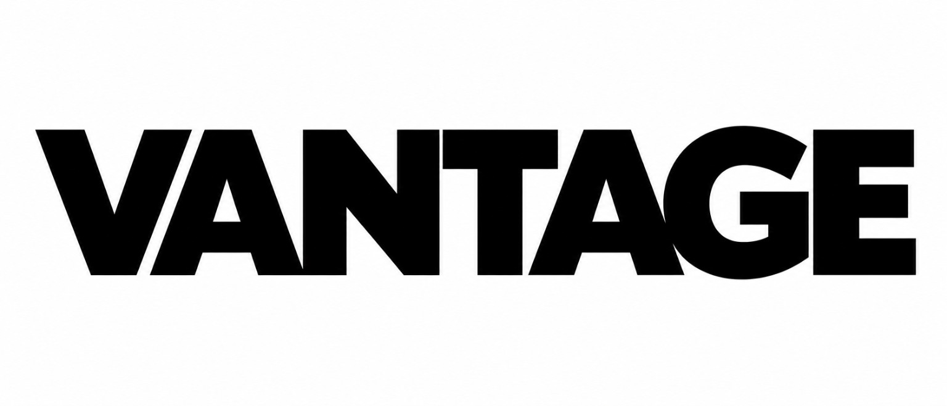  See further. Stay protected. | Prepared by VANTAGE  Operated by Keystone Consultancy  munimhasibul10@gmail.com | +8801941646278  govantage.vercel.app

FREE FACTORY GAP SCAN FORM
Preliminary readiness intake for Bangladesh RMG export factories. Designed for sales lead capture, document readiness review, and internal remediation planning.
Document Title | Free Factory Gap Scan Form
Document Code | VANTAGE-FGS-FORM-001
Version | 1.0
Status | Ready for Client Intake
Date | 27 May 2026
Prepared by | VANTAGE
Operated by | Keystone Consultancy
Folder Classification | 03_SALES_LEAD_CAPTURE
Use this form to run a limited, no-charge readiness scan. The output is a preliminary internal snapshot only. It does not create legal advice, buyer acceptance, regulator acceptance, or third-party assurance.

1. Factory information
Factory legal name
Factory address / location
Contact person and designation
Phone / WhatsApp / email
Total workforce approx.
Main product category
Key export markets
Target buyer review / key buyers
2. Scan scope requested
[ ] General compliance documents | [ ] Labour law / HR policy file | [ ] Wage and attendance records
[ ] Worker file readiness | [ ] OSH and safety records | [ ] RSC / CAP readiness
[ ] Subcontractor due diligence | [ ] Bond / customs reconciliation | [ ] Buyer code-of-conduct mapping
[ ] Monthly maintenance support | [ ] Other: ______________________

3. Core document readiness tracker
Status options: Available / Missing / Expired / Incomplete / Not applicable. VANTAGE notes should record only observable document status and gaps, not accusations or legal conclusions.

Document area | Status | Expiry / period | VANTAGE notes
Trade licence and factory licence file
DIFE-related registration or correspondence
Fire safety licence / fire service file
Environmental clearance file
Buyer code-of-conduct file
Previous third-party review reports
Previous corrective action plan file
Policy manual / employee handbook
Document expiry tracker
Management responsibility matrix
4. OSH, safety and CAP-readiness snapshot
Safety area | Available? | Risk band | Notes / next evidence needed
Building / structural safety file
Electrical safety records
Boiler / compressor records, if applicable
Fire drill and evacuation records
First aid / medical room records
Machine safety and PPE training records
Accident / incident register
RSC or buyer corrective-action evidence file

5. HR, wage, attendance and worker-file snapshot
For the free scan, request masked samples where possible. Avoid collecting worker names, NID numbers, union-sensitive information, personal grievance identities, bank details or MFS numbers unless a signed data-control arrangement is in place.

Record area | Status | Sample period | Gap / action note
Current worker list
Appointment letter / service book sample
Worker personal-file checklist
Attendance records - last 3 months
Overtime records - last 3 months
Wage sheets - last 3 months
Payment proof, bank or MFS sample
Leave, maternity and termination records
Participation / safety committee records
Grievance log and resolution proof
Training attendance and photo evidence log
6. Production, subcontractor and bond-readiness snapshot
Record area | Status | Period / batch | Notes / missing evidence
Buyer tech-pack / internal work-order file
Cutting register and production records
QC records and shipment file
Subcontractor list and authorization records
Subcontractor wage / safety documents where available
LC, Bill of Entry and UD records if applicable
Stock, wastage and reconciliation records

7. Priority gap identification
Use neutral language. Record the gap, affected document area, business consequence, and next evidence requested. Do not write conclusions about wrongdoing without formal review and supporting proof.

Priority band | Gap / variance observed | Affected area | Next evidence requested | Target date
Critical
High
Medium
Monitor
8. VANTAGE scan notes
Overall readiness band | [ ] Green [ ] Amber [ ] Red [ ] Not enough evidence
Top 3 immediate gaps | 1.  2.  3.
Documents requested after scan
Management contact for follow-up
Suggested paid support package
Quoted proposal needed? | [ ] Yes [ ] No [ ] Management decision pending
9. Recommended next step
[ ] Labour law / HR policy document update sprint | [ ] Wage and attendance review
[ ] Worker-file cleanup sprint | [ ] RSC / CAP support file preparation
[ ] Subcontractor due-diligence pack | [ ] Bond licence reconciliation support
[ ] Monthly compliance documentation maintenance | [ ] Buyer questionnaire response support

10. Legal safety, data protection and integrity notice
Scope limit | VANTAGE provides document readiness review, gap analysis and remediation-support planning under Keystone Consultancy. This free scan is based only on documents, access and explanations provided by the client. It is for internal management use unless separately reviewed before external sharing.
Structural safety, OSH and legal currency | This scan records whether client-provided safety and OSH documents appear available, current and internally consistent. VANTAGE does not perform engineering, fire, electrical, boiler, structural or regulator inspections. Urgent hazards should be escalated to competent professionals and the relevant process. Current law, buyer requirements, RSC/DIFE communications and competent advice must be checked before external use.
Worker anonymity and data protection | Worker names, NID numbers, union-sensitive information, grievance identities, bank details and MFS numbers should be masked or excluded from the free scan unless a signed data-control arrangement exists. Any worker-sensitive note should use codes, restricted access and the minimum data needed for the stated purpose.
Data integrity and double-books protection | The client must not submit altered, incomplete or parallel records for this scan. If VANTAGE later receives inconsistent payroll, attendance, overtime, production, wage-ledger or corrective-action records, the scan notes may be amended or withdrawn and further work may require a separate data-integrity review.
No outcome guarantee | VANTAGE does not guarantee buyer acceptance, regulator acceptance, commercial outcome, corrective-action closure or readiness result. Any management decision remains the client’s responsibility.
11. Acknowledgement
Factory management acknowledges that this free scan is a limited readiness intake. VANTAGE will rely on the documents and explanations provided and may request additional evidence before issuing any paid proposal or management summary.
______________________________  VANTAGE representative | ______________________________  Factory representative
Name / designation: __________________________ | Name / designation: __________________________
Date: __________________________ | Date: __________________________

