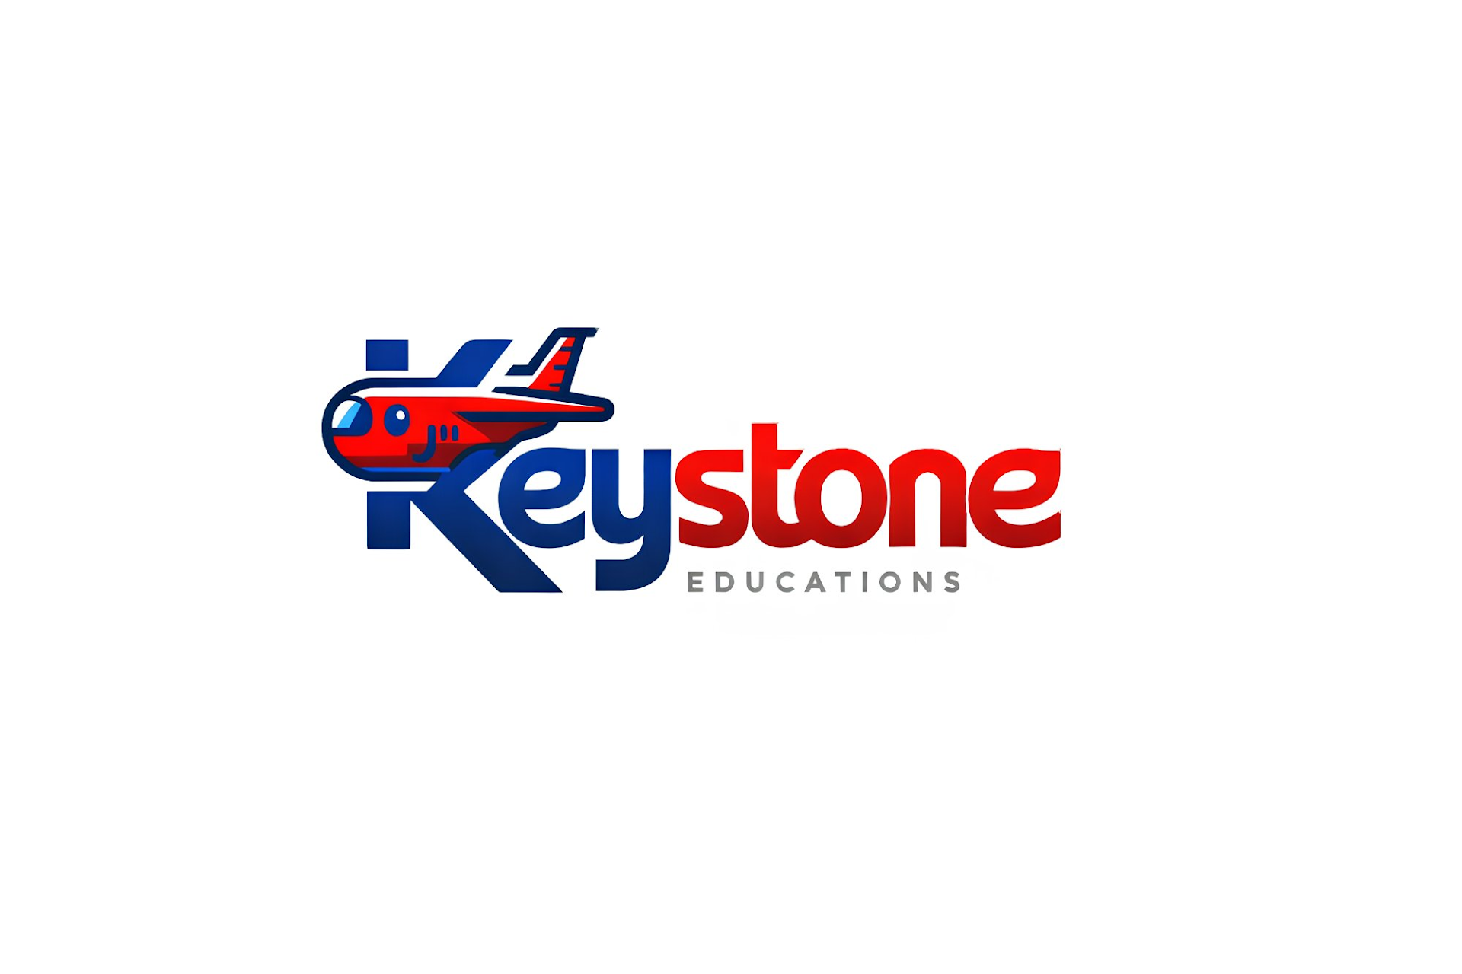 | 
STUDY IN SOUTH KOREA 🇰🇷
Kyungdong University (KDU Global) — Student Admission & Intake Flyer
🔥 WHY CHOOSE KYUNGDONG UNIVERSITY GLOBAL?
✅ 95%+ Visa Success Ratio for international applicants via streamlined processing.
✅ 100% English-Medium Undergraduate Programs (No Korean language test required for entry!).
✅ Generous Scholarships: Up to 30% – 50% tuition waivers automatically awarded.
✅ Affordable Tuition & Housing: High-quality European & Asian standard education at low cost.
✅ Legal Part-Time Work: Up to 20-25 hrs/week during semesters & UNLIMITED during vacations.
✅ High Employment Rate: Post-graduation D-10 job seeker visa & E-7 work visa pathways.
❓ TOP QUESTIONS STUDENTS ASK (AND THE ANSWERS)
👉 1. When is the next semester / intake for KDU Global?
• Bachelor's Degree Programs: The next primary intake is Spring (March Intake). Applications open in October and close in December/January.
• EAP & KLP Preparatory Programs: Operates on 4 terms per year (March, June, September, December). The Winter Term starts in DECEMBER! Applications close in Oct–Nov.
👉 2. Can I apply for the next semester right now?
• YES! Applications are currently OPEN for the December Winter Intake (Language & EAP prep) and pre-admissions are active for the March Spring Intake (Bachelor's degree).
👉 3. How much will it cost for the next semester?
• Language Program (EAP/KLP): ~USD $1,200 – $1,500 per term.
• Bachelor's Degree Tuition: ~USD $2,000 – $3,500 per semester (BEFORE scholarships).
• Scholarships: Up to 30% – 50%+ tuition reduction automatically awarded based on your GPA/IELTS!
• On-Campus Hostel: ~USD $600 – $800 per semester (includes air conditioning, Wi-Fi, modern facilities).
👉 4. What language test score do I need?
• EAP Pathway: IELTS 5.0 floor (accepts IELTS 5.0 – 6.0).
• Bachelor Direct Entry: IELTS 5.5 / 6.0+ or TOEFL iBT 71+.
• Korean Track: TOPIK Level 3+.
👉 5. Can I work part-time while studying in South Korea?
• ABSOLUTELY! D-2 and D-4 visa holders can legally work part-time up to 20–25 hours per week during study semesters and UNLIMITED hours during summer and winter vacations.
👉 6. What is the Visa Success Ratio?
• Over 95% Visa Success Rate! KDU applications submitted with verified documents have one of the highest approval records at the South Korean Embassy.
📋 ADMISSION REQUIREMENTS & BANK DOCUMENTS
Requirement Item | Official Standard & Rules
Academic Qualification | HSC / A-Levels / High School Diploma (Min GPA 3.0 out of 5.0). Maximum 3-year study gap allowed.
English Proficiency | IELTS 5.0 for EAP pathway; IELTS 5.5 / 6.0+ for direct Bachelor's degree entry.
Bank Statement | Minimum USD $16,000 balance in a 6-month active savings account (Applicant's or Parent's name).
Document Verification | e-Apostille via MoFA Dhaka on academic certificates + Praava Health TB test certificate.
📞 APPLY TODAY WITH KEYSTONE EDUCATION CONSULTANCY
Hotline: +880 1941-646278 | Website: www.keystoneeducations.com
Head Office & Narsingdi Branch | Korea Student Advisory Desk

