CHEF

# Intro

1. Chef is an Infrastructure configuration management tool.
2. Chef is a configuration management tool for dealing with machine setup on physical servers, virtual machines and in the cloud. Many companies use Chef software to control and manage their infrastructure including Facebook, Etsy, Cheezburger, and Indiegogo.
3. But what does that really mean?
   1. Configuration management is all about trying to ensure that the files and software you are expecting to be on a machine are present, configured correctly, and working as intended.
   2. When you have only a single machine this is fairly simple. When you have five or ten servers, it is still possible to do this manually, but it may take all day. However, when your infrastructure scales up into the thousands we need a better way of doing things.
4. Chef can do documentation.
5. Infrastructure as code
   1. Chef helps solve this problem by treating infrastructure as code. Rather than manually changing anything, the machine setup is described in a Chef recipe.
   2. Collections of recipes are stored in a cookbook. One cookbook should relate to a single task, but can have a number of different server configurations involved (for example a web application with a database, will have two recipes, one for each part, stored together in a cookbook).
   3. There is a Chef server which stores each of these cookbooks and as a new chef client node checks in with the server, recipes are sent to tell the node how to configure itself.
   4. The client will then check in every now and again to make sure that no changes have occurred, and nothing needs to change. If it does, then the client deals with it. Patches and updates can be rolled out over your entire infrastructure by changing the recipe. No need to interact with each machine individually.

### Chef configuration

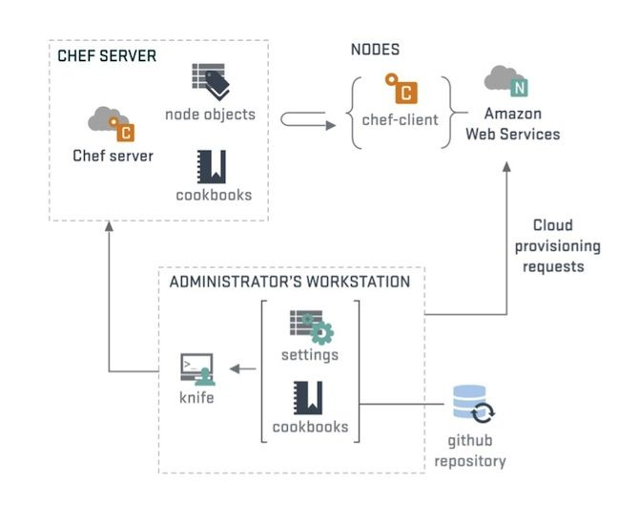

Streams

1. Programming
2. Admin

Programming:

How to start programming in CHEF?

Install CHEFDK - Chef’s Knife Plugin Architecture and the Chef Developer Kit (Chef DK)

WINDOWS –MSI _EXE

CENTOS -> rpm –ivh filename.rpm

How to verify?

Chef –v

How to write a recipe?

* first.rb

Recipe

INGRED (RESOURCES) + HOW (ACTION)

File CREATE + MDIFY +DELETE

DIRECTORY CREATE + UPDATE +DELETE

Package Install + REMOVE +UPDATE

Services INSTALL + REMOVE + UPDATE

[Chef](https://www.upguard.com/articles/hosted-chef-vs.-puppet-enterprise) is a tool for automation, provisioning and configuration management. The platform is made up of the following components:

**Chef Server** - the main hub where Chef propagates and stores system configuration information and policies (i.e., recipes and cookbooks). The Chef management console is the web user interface for Chef Server.

**Chef Client** - installed on every node being managed, the Chef Client performs configuration tasks on the local machine.

**Workstation** - allows designated workstations to author/test/maintain cookbooks and upload them to Chef Server. Workstations are also used when utilizing the Chef Development kit package.

**Chef Analytics** - a platform that provides actions and run history, real-time reporting, and notifications around Chef automation activities.

**Chef Supermarket** - an open source directory of community-contributed cookbooks

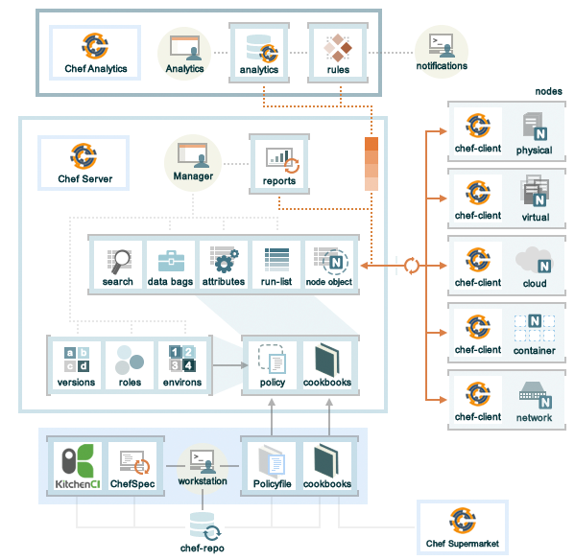

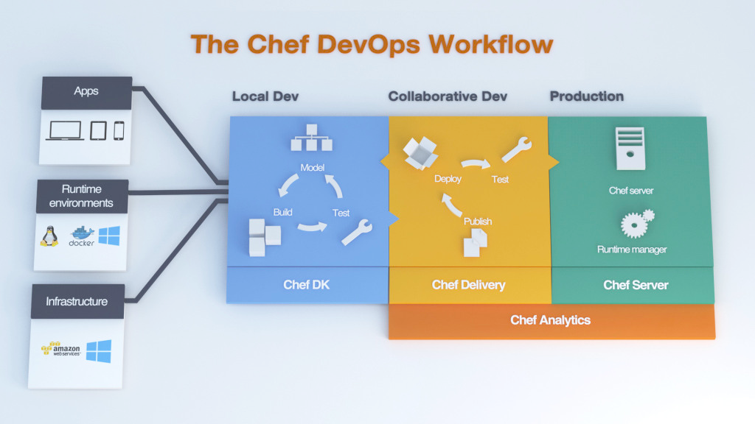

[Chef](https://www.upguard.com/articles/docker-chef) Delivery’s automated testing and continuous integration/delivery tools augment the platform with new features such as a shared workflow pipeline, collaboration capabilities, and enhanced analytics—as well as new ecosystem integrations with AWS, Azure, and Docker, to name a few. Though these enhancements are no doubt a boon to Chef’s developer community, Chef’s aspirations arguably have little to do with becoming a developer-centric automation tool and more with building a comprehensive platform for DevOps pipeline management.

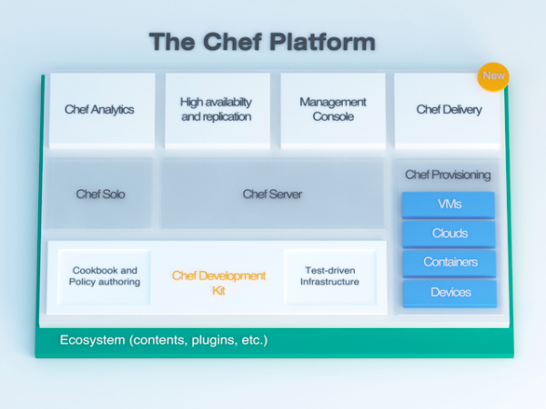

The Chef Platform with Chef Delivery. Source: Chef.

**Improved Security with Chef Vault**

Customer and/or community customizations quite often become so widespread and integral that they find their way into bonafide product releases. This is certainly the case with Chef Vault, a project started by [Nordstrom](https://github.com/Nordstrom/chef-vault) to improve upon the platform’s inherent security mechanisms. Chef can natively store sensitive data (e.g., SSL certificate keys, database passwords) in encrypted “data bags”—repositories of key/value pairs—for secure and easy access. Management of these data bags, however, is a tedious and error-prone process. Chef Vault provides an additional layer of security that enables easier management of these encrypted data bags.

Recipe –

Chef client – understand the file MANIFEST.

Roles in chef –

Chef server –

Tempalte -

To configure the knife need to n

How to create Cookbook?

Chef cookbook generate first

Metadata – info about author

Knife is command to connect from the chef server

The process to call node is “BootStrap”

Adminstration:

1. Create a Role
2. Assigning the cookbook
3. Bootstrap a node with ROLES
4. Run the ROLES

Knife bootstrap –run –lidt “role[client1]” –sudo hostname

Chef-solo – can use instead of chef server.

GSH

POSHChef