Muni Mohith Reddy Kamireddy (munimohithreddy@gmail.com)

1.

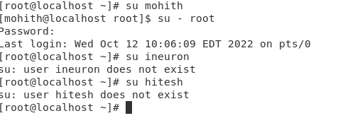

We could see the error that user does not exist, so it does not give access to non-existing users.

Only existing users can login and do operations.

2.

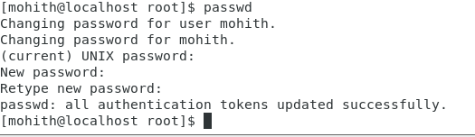

We could see it asks for new password and password confirmations, later all the authentication tokens are updated.

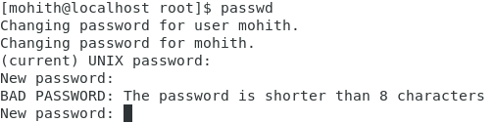

I tried updating password to 1234 but it says it is shorter than 8 characters, so password should have minimum 8 characters



There should be some password to user account

3.

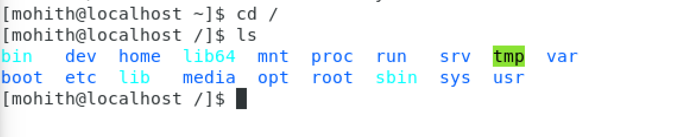

We got all system files

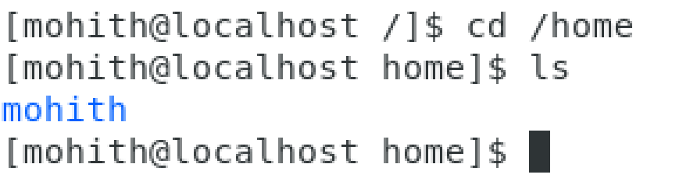

Home directory indicates the current user directory

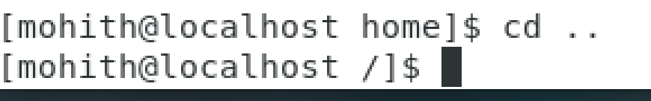

We will move one directory backward

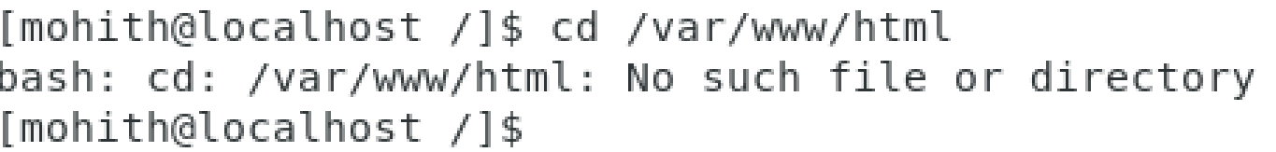

Since there is no such directory we get no such file output

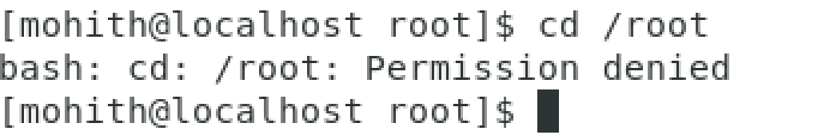

We get error as we are in user, if we change to root user we don’t get any error

4.

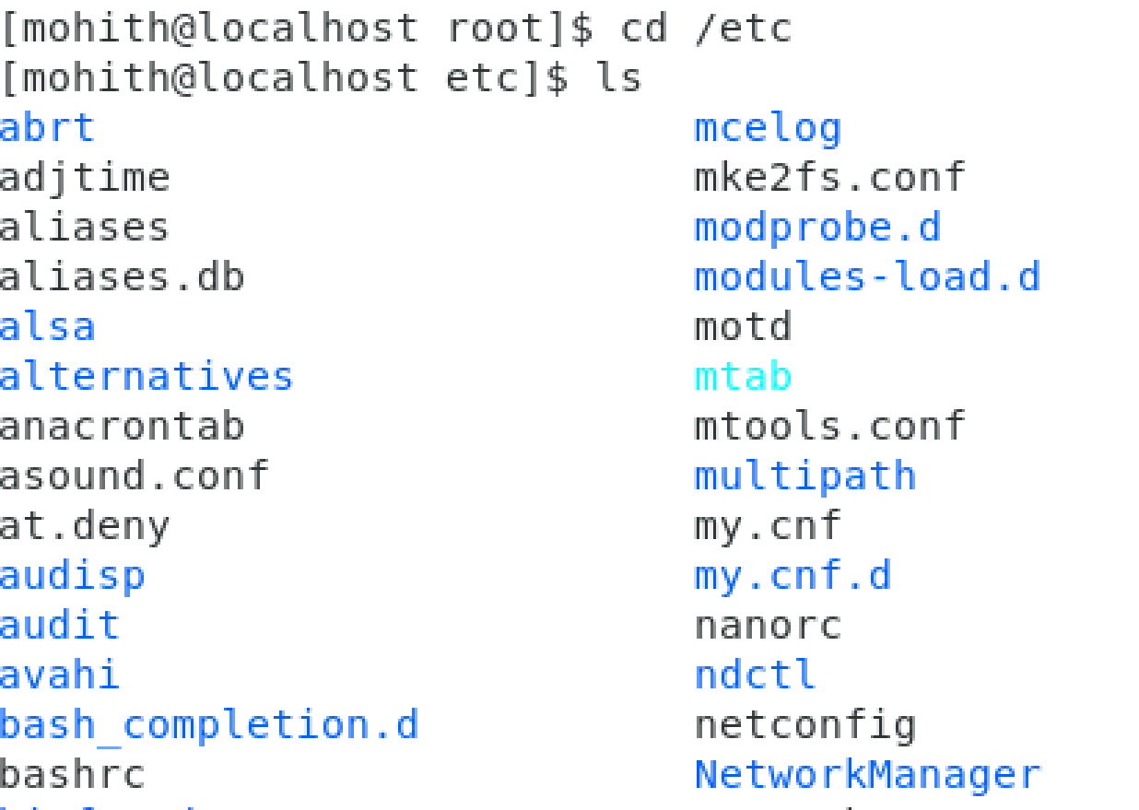

I could see many system configuration files

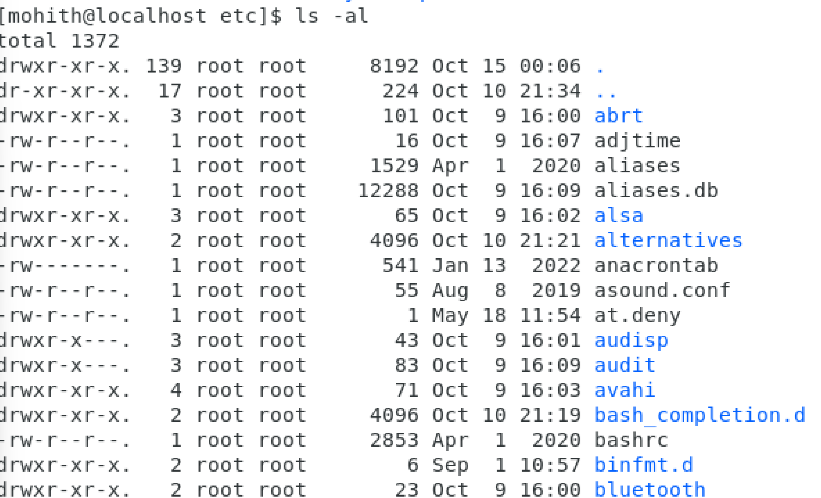

I could see permissions given for the above files

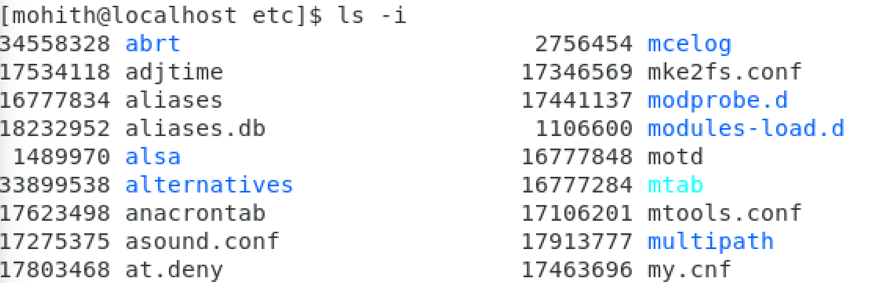

5.

