Name: Jane P. Balboa

Program: BS in Computer Science with specialization in Software Engineering

Year Level: 4th

School: FEU – IT

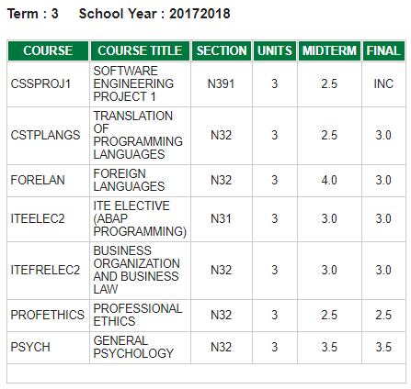

Term Average: 54 / 18 = **3.0** (excluding INC)

August 22, 2018

Dear Ms. Carmen,

I would like to apologize for having an incomplete grade in my thesis subject. It is due to the signed document by the panelists that must be submitted to my adviser. The panelists kept on delaying the schedule of appointment due to their unexpected meetings and my adviser has been transferred to another branch of the school which makes the communication a bit complicated. The completion of the incomplete is on progress already and the estimated date for it to be completed will be on August 29, 2018.

Thank you very much for your kind consideration.

Sincerely,

Jane P. Balboa

BSCSSE, FEU-IT