**FULL NAME: GABRIELLE KAYE DAGAANG-SATERA**

**PROPOSAL #1**

**Problem Overview:**

Henry has a small perfume business he established online. As a small business owner who aims to grow his business, he wants to increase his online presence by making a portfolio and an official platform where his prospects can shop.

**Proposed Solution:**

* To create a business website.

**Project title:**

ARÔMEscents by Henry

**Project Objectives:**

* To create a platform where his prospects can browse the client’s products
* To design the platform that will also serve as the client’s product portfolio.

**Target Users/Audience:**

Young men and women ages from 18-55, who love great aesthetics, with an interest in chic, classic and arousing perfumes.

**Introduction:**

Henry is a college student who loves perfumes. Wearing a good scent makes him feel good and boosts his self esteem as he tackles his days as a student and a part-time design associate. It gives him confidence to face meetings and classes, knowing he smells great.

As a scent enthusiast, he decided to share his love of scents by creating his own line of perfumes. By making a business website, Henry hopes to increase his reach and engagement targeting students and young professionals alike.

**SITE MAP**

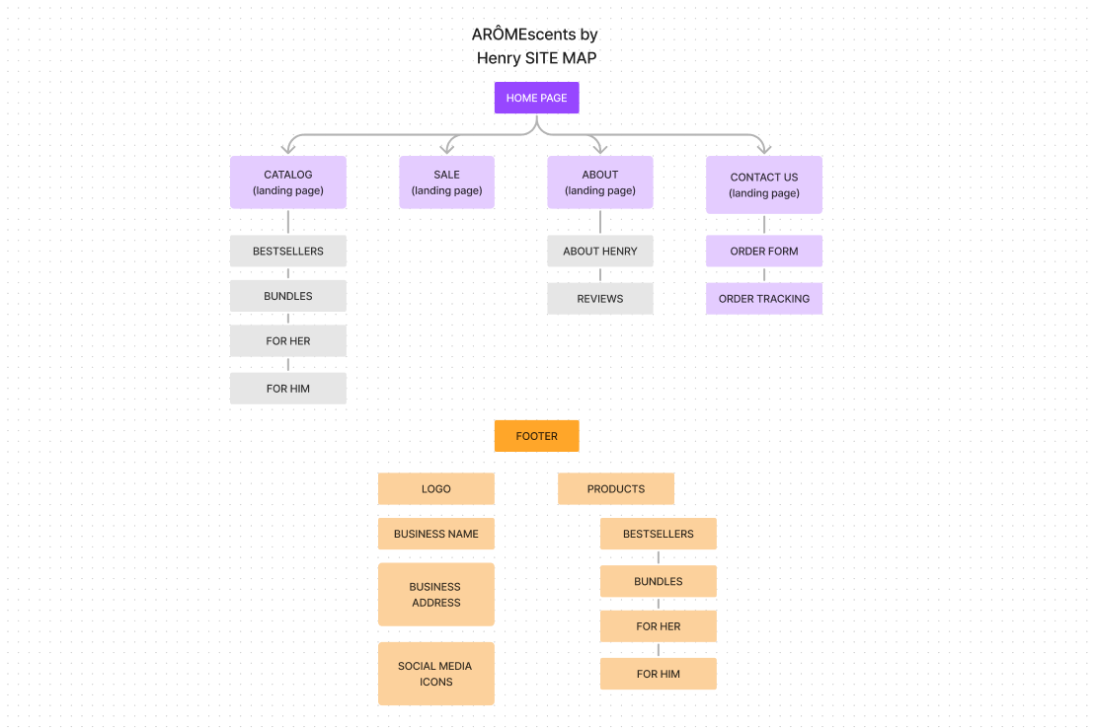

**PROPOSAL #2**

**Problem Overview:**

Cagayan de Oro is a fast-progressing urbanized city, with 4 universities and 6 major colleges, inviting students from all over Mindanao. With this in mind, many students need a place to live during the course of their studies. Being a complete stranger to the place, most have no idea where to find an affordable rent that caters their budget and lifestyle and resources where they can get their material needs such as carenderias, groceries, and farmers markets.

**Proposed Solution:**

* To create a website directory.

**Project title:**

PLACE-A-STUDENT CDO

**Project Objectives:**

* To create a directory where upcoming students of Cagayan de Oro can browse student-friendly rent nearby their prospective universities and colleges.
* A centralized platform where place holders can advertise their rentable places with distinct categories like budget bracket, gender specific, nearby resources and traffic routes to universities and colleges.

**Target Users/Audience:**

* Upcoming college students that will live in Cagayan de Oro

**Introduction:**

Going to college is a milestone. It is an educational training ground towards becoming a professional and as an independent individual. Many students make their way to cities away from their hometowns to pursue their preferred course and university.

Building a website directory which centralizes information about student-friendly rentable spaces within Cagayan de Oro aims to help upcoming students find living spaces to make it convenient for them in deciding where to live, assess the safety of the environment, and manage their budget before transferring to the actual place.

**SITE MAP**

