PROJECT REPORT
Resume Screening System
Explainable screening of PDF resumes against role-specific skills, using rule-based matching and TF-IDF similarity
Submitted by
Amudala Muni Parash
B.Tech, Computer Science and Engineering (AI & ML)
September 2026

Contents
1. Abstract
2. Introduction
3. Approach and Design Decisions
4. System Architecture
5. Methodology
6. Role Profiles
7. Implementation
8. Testing and Evaluation
9. Deployment
10. Limitations and Future Work
11. Conclusion
Appendix A. Project Structure
Appendix B. Example API Call

1. Abstract
Recruiters receive far more resumes than they can read closely, and most of the first-pass work is checking whether a candidate has the skills a role needs. This project builds a web application that automates that first pass. A user uploads a PDF resume and chooses a target role. The system extracts the text, finds the role's required skills and keywords, estimates experience and education, and returns a score out of 100 with a decision (Shortlisted, Needs review or Not shortlisted) and a plain-language explanation.
No training dataset is used. Each role is defined by a default profile of must-have skills, good-to-have skills and keywords stored in a JSON file. The score combines deterministic skill matching with a TF-IDF cosine-similarity signal, so every point of the score can be traced to something in the resume. The system handles single-column and two-column layouts and falls back to OCR for scanned resumes.
The application is a FastAPI service with a browser interface that shows the resume as a marked-up document, highlighting matched skills and striking through missing ones. It is packaged with Docker, includes a Render deployment blueprint and a GitHub Actions pipeline, and ships with 29 automated tests, sample resumes and an evaluation script.

2. Introduction

2.1 Problem statement
Manual resume screening is slow, inconsistent between reviewers, and hard to justify afterwards. Many commercial applicant tracking systems return an opaque score with no explanation, which makes it difficult for a recruiter to trust the result or for a candidate to understand it. The problem addressed here is to screen a single PDF resume against a chosen job role, quickly and with reasons a person can check.

2.2 Objectives
- Accept a PDF resume and a role, and return a score, a decision and the evidence behind them.
- Work without a labelled dataset, using default skills and keywords per role that anyone can edit.
- Read real-world PDFs: multi-page, two-column, and scanned resumes.
- Explain every result: which requirements were found, which are missing, and how each part of the score was earned.
- Provide a clean web interface and a documented REST API.
- Be deployable with a single Docker command or a Render blueprint, with tests and CI.

2.3 Scope
The system screens one role at a time, supports English-language PDF resumes, and ships with five role profiles: Data Analyst, Data Scientist, Machine Learning Engineer, Python Backend Developer and Frontend Developer. New roles are added by editing a JSON file. The score is a screening aid to support a human reviewer. It is not intended to make hiring decisions on its own.

3. Approach and Design Decisions

3.1 Why not a trained classifier
A supervised model (for example logistic regression or a neural network over resume embeddings) needs many resumes labelled by recruiters for each role. That data was not available, and resumes are personal data that should not be collected casually. A model trained on a small or borrowed dataset would also carry the biases of its labels and would be hard to explain. Since the requirement was to screen against default skills and keywords rather than a dataset, a rules-first design fits the problem.

3.2 Hybrid: rules plus TF-IDF
The core signal is deterministic: does the resume contain the skills the role requires, and where does it mention them? On top of this, a TF-IDF cosine similarity between the resume and the role description adds a softer measure of overall topical fit, for example catching a candidate who describes relevant work in different words. TF-IDF is fitted once on the role documents, so there is nothing to train on resumes.

3.3 Explainability as a design goal
Every component of the score has a fixed maximum and is shown in the interface, together with the reasons for the decision. Skills are highlighted in the resume text so the reviewer can verify each match in seconds. The decision uses both the total score and the share of must-have skills found, so a resume cannot be shortlisted on a high total while missing most core requirements.

3.4 Configuration over code
Roles, skill aliases, weights and thresholds all live in data/roles.json and are validated when the application starts (for example, weights must add up to 1.0). This lets a non-programmer tune the screener, and it keeps all the tuning knobs in one place.

4. System Architecture
The system is a pipeline of small modules, each with one job. The FastAPI layer receives the upload, the Screener orchestrates the pipeline, and the result is returned as JSON for the web interface to render.
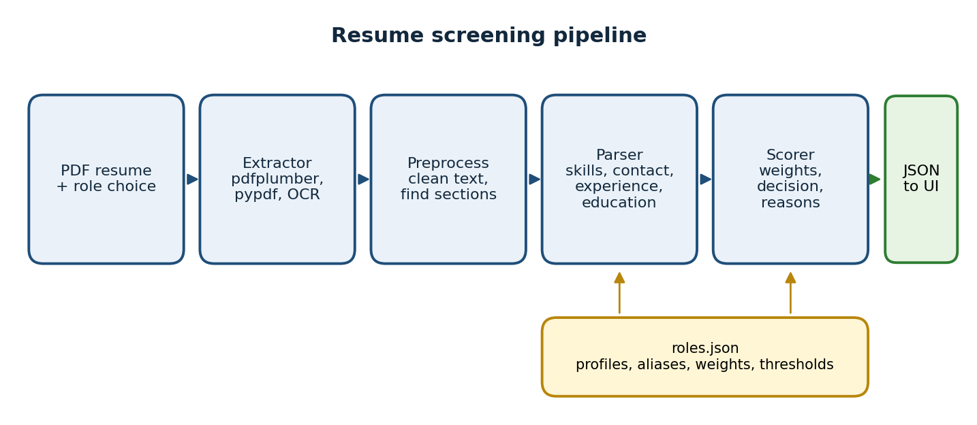
Figure 1. Resume screening pipeline

4.1 Technology stack
Layer | Technology
Language | Python 3.12
PDF text extraction | pdfplumber (primary), pypdf (fallback)
OCR for scanned PDFs | Tesseract through pytesseract (optional)
Text similarity | scikit-learn TfidfVectorizer, cosine similarity
Backend | FastAPI, Uvicorn, python-multipart
Frontend | HTML, CSS and vanilla JavaScript (no framework, no build step)
Packaging and deployment | Docker, Render blueprint, GitHub Actions
Testing | unittest and pytest, reportlab for sample PDFs, httpx for API tests

4.2 Modules
Module | Responsibility
app/config.py | Runtime settings with environment-variable overrides (upload size, page limit, OCR switch, and so on).
app/roles.py | Loads and validates role profiles, aliases and scoring rules from JSON.
app/extractor.py | PDF to text: validation, column-aware reading, pypdf fallback, OCR fallback, safe error messages.
app/preprocess.py | Text cleaning (unicode, bullets, dashes, broken glyphs) and section detection.
app/parser.py | Skill matcher, contact details, experience estimation, education level.
app/scorer.py | Screener class: evaluates requirements, computes the weighted score, decision, reasons and warnings; single and batch screening.
app/main.py | FastAPI endpoints, upload validation, security headers.
app/static/ | Web interface (index.html, style.css, app.js).

5. Methodology

5.1 Text extraction
The extractor tries three strategies and uses the first that yields enough text (at least 200 characters by default).
- pdfplumber with a column-aware reader. Many resume templates use two columns, and reading line by line across the page interleaves unrelated content. The reader looks for a vertical empty strip (gutter) at least 10 points wide with a meaningful share of words on each side, and if found reads the left column and then the right column. A full-width header above the columns is kept first.
- pypdf as a fallback for files pdfplumber struggles with.
- OCR for scanned, image-only resumes: pages are rendered to images and read with Tesseract. A warning is attached to the result because OCR text can contain errors.
Before any of this, the file is validated. Empty files, non-PDFs, damaged files, password-protected files and files with no pages are rejected with a user-safe message, and the page count is capped (10 by default) so an oversized file cannot tie up the server.

5.2 Preprocessing and sections
Cleaning normalises unicode, bullet characters and dash variants and repairs (cid:N) glyph placeholders produced by some PDF fonts. The text is then split into sections (Summary, Skills, Experience, Projects, Education, Certifications, Other) by matching headings against an alias dictionary such as "Technical Skills" or "Work History". Knowing where a skill appears matters for scoring.

5.3 Skill matching
Each skill is matched with a regular expression using word boundaries plus a list of aliases from roles.json. This handles cases that naive substring search gets wrong: "C++" is matched literally, "sklearn" counts for scikit-learn, and "SQL" is not matched inside "NoSQL" or "MongoDB". A requirement can be written as a list, such as ["Power BI", "Tableau"], meaning any one of the options satisfies it.
Each matched skill is also classified by evidence: demonstrated (it appears in experience, projects or certifications), listed (it appears only in the skills or summary section), or mentioned (found elsewhere, or the resume has no detectable headings). Skills that are only listed receive 80% credit, which rewards candidates who show how they used a skill without ignoring those who simply list it.

5.4 Experience and education
Experience is estimated by parsing date ranges such as "Jan 2024 - Present" or "Oct 2025 - March 2026", merging overlapping ranges so concurrent jobs are not double counted, and ignoring dates inside the education section. If no ranges are found, a statement such as "4+ years of experience" is used as a fallback. The experience ratio is the years found divided by the years the role asks for, capped at 1.
Education is detected as a level: 1 diploma, 2 bachelor's, 3 master's, 4 PhD, with 0 meaning none detected. A candidate at or above the required level gets full marks, one level below gets half, and otherwise zero.

5.5 Text similarity
A TF-IDF vectoriser (English stop words removed, unigrams and bigrams, sublinear term frequency) is fitted once on the role documents, each built from the role title, description and skill lists. The resume is transformed with the same vectoriser and compared with its role by cosine similarity. If the user pastes a job description, it is appended to the role document for that request. Raw cosine similarity between a resume and a short description is naturally low, so the value is rescaled: a similarity of 0.45 or more earns full marks for this component.

5.6 Scoring
The final score is a weighted sum. Each component produces a ratio between 0 and 1 that is multiplied by its weight.
Component | Weight | Ratio used
Must-have skills | 45 | Credit of requirements found divided by the number of requirements
Good-to-have skills | 15 | Same, over the good-to-have list
Role keywords | 10 | Same, over the keyword list
Text similarity | 10 | TF-IDF cosine similarity divided by 0.45, capped at 1
Experience | 10 | Years found divided by years required, capped at 1
Education | 10 | 1 if level met, 0.5 if one level below, else 0

5.7 Decision rules
Decision | Condition
Shortlisted | Score is at least 70 and at least 70% of must-have requirements are found
Needs review | Score is at least 50 and at least 50% of must-have requirements are found
Not shortlisted | Anything else
The coverage condition prevents a resume from passing on the strength of other components while missing most of the core skills. These thresholds were calibrated on the sample resumes (see Section 8) and can be changed in roles.json.

5.8 Reasons and warnings
Alongside the score, the system produces plain-language reasons (for example "Matches 5 of 6 must-have requirements" and "Missing must-have: Statistics") and warnings when the result may be unreliable: very little text, no standard headings, no degree detected, text recovered by OCR, or possible keyword stuffing, meaning one skill repeated 12 or more times.

6. Role Profiles
Each role has a description used for text similarity, must-have skills (worth the most), good-to-have skills, keywords, a minimum experience and a minimum education level. Skills separated by a slash are "any of" groups. The default must-have skills shipped with the project are shown below; the full lists, including good-to-have skills and keywords, are in data/roles.json.
Role | Must-have skills | Min. exp.
Data Analyst | SQL, Excel, Power BI / Tableau, Data Visualization, Statistics | 0 yrs
Data Scientist | Python, SQL, Machine Learning, Statistics, Pandas, scikit-learn | 0 yrs
Machine Learning Engineer | Python, Machine Learning, Deep Learning, TensorFlow / PyTorch, Model Deployment, Docker, Git | 1 yr
Python Backend Developer | Python, FastAPI / Django / Flask, REST API, SQL, Git | 1 yr
Frontend Developer | HTML, CSS, JavaScript, React / Vue / Angular, Git, Responsive Design | 0 yrs

The aliases section of the same file maps about 80 skills to their common spellings, for example scikit-learn to sklearn, Power BI to powerbi, and Kubernetes to k8s.

7. Implementation

7.1 REST API
Method | Path | Purpose
GET | / | Serves the web interface
GET | /health | Health check used by Docker and Render
GET | /api/roles | Lists roles with their default skills and keywords
POST | /api/screen | Screens one PDF: form fields file, role, optional job_description
POST | /api/screen/batch | Screens up to 20 PDFs for one role and returns them ranked, best first
Errors use standard status codes: 404 for an unknown role, 413 for a file over the size limit (5 MB by default), 415 for a non-PDF upload, and 422 for a PDF that cannot be read. Endpoints are ordinary synchronous functions so FastAPI runs them in a thread pool, which keeps CPU-bound PDF parsing from blocking the event loop.

7.2 Web interface
The interface has a role selector that previews the role's must-have skills, drag-and-drop PDF upload, and an optional job-description box. Results appear as a marked-up copy of the resume with matched skills highlighted and missing skills struck through, a score breakdown with progress bars, the reasons list, candidate facts (name, email, experience, education) and any warnings. The layout is responsive, and on narrow screens the score table restructures into stacked rows.
Resume text is untrusted input. The interface builds every element with textContent rather than innerHTML, so text inside a resume cannot inject markup or scripts.

7.3 Security and privacy
- Resumes are processed in memory; their contents are never written to disk or to the logs (only failure tracebacks are logged).
- Upload type and size are checked before parsing; page count is capped.
- Responses carry a Content-Security-Policy, X-Frame-Options, X-Content-Type-Options and Referrer-Policy header.
- The Docker container runs as a non-root user.
- Error messages returned to users are fixed, safe strings and do not expose internals.
Because resumes contain personal information, a production deployment should add HTTPS (provided by Render), authentication if the tool is not public, and a written policy for how long any data is retained. The shipped version retains none.

8. Testing and Evaluation

8.1 Automated tests
The suite has 29 tests, run with pytest or unittest. They cover extraction (single-column, two-column column order, bad files, OCR fallback), the parser (aliases, word boundaries, "C++", experience date ranges, overlap merging, education levels, contact details), the screener (strong match, unrelated resume, same resume against different roles, any-of requirements, partial credit for listed-only skills, keyword stuffing, effect of a job description, batch ranking, unknown role), configuration validation, and the API (status codes, security headers, batch ranking).

8.2 Sample resumes and calibration
Five fictional resumes were generated with reportlab: a strong data scientist, a data-analyst fresher, a frontend developer, a two-column ML engineer resume, and a scanned (image-only) version of the data-scientist resume to exercise OCR. Each was screened against several roles. Weights and thresholds were tuned until matched roles were shortlisted and mismatched roles were not.
Resume | Role | Score | Must-haves | Decision
Strong data scientist | Data Scientist | 90.5 | 6 / 6 | Shortlisted
Strong data scientist | ML Engineer | 73.7 | 7 / 7 | Shortlisted
Strong data scientist | Data Analyst | 49.7 | 2 / 5 | Not shortlisted
Analyst fresher | Data Analyst | 82.3 | 5 / 5 | Shortlisted
Analyst fresher | Data Scientist | 46.2 | 3 / 6 | Not shortlisted
Frontend developer | Frontend Developer | 80.2 | 6 / 6 | Shortlisted
Frontend developer | Data Scientist | 17.0 | 0 / 6 | Not shortlisted
Two-column ML engineer | ML Engineer | 85.3 | 7 / 7 | Shortlisted
Two-column ML engineer | Data Scientist | 56.0 | 3 / 6 | Needs review
Two-column ML engineer | Backend Developer | 63.2 | 4 / 5 | Needs review
Scanned data scientist (OCR) | Data Scientist | 90.5 | 6 / 6 | Shortlisted
Table 1. Screening results on the sample resumes
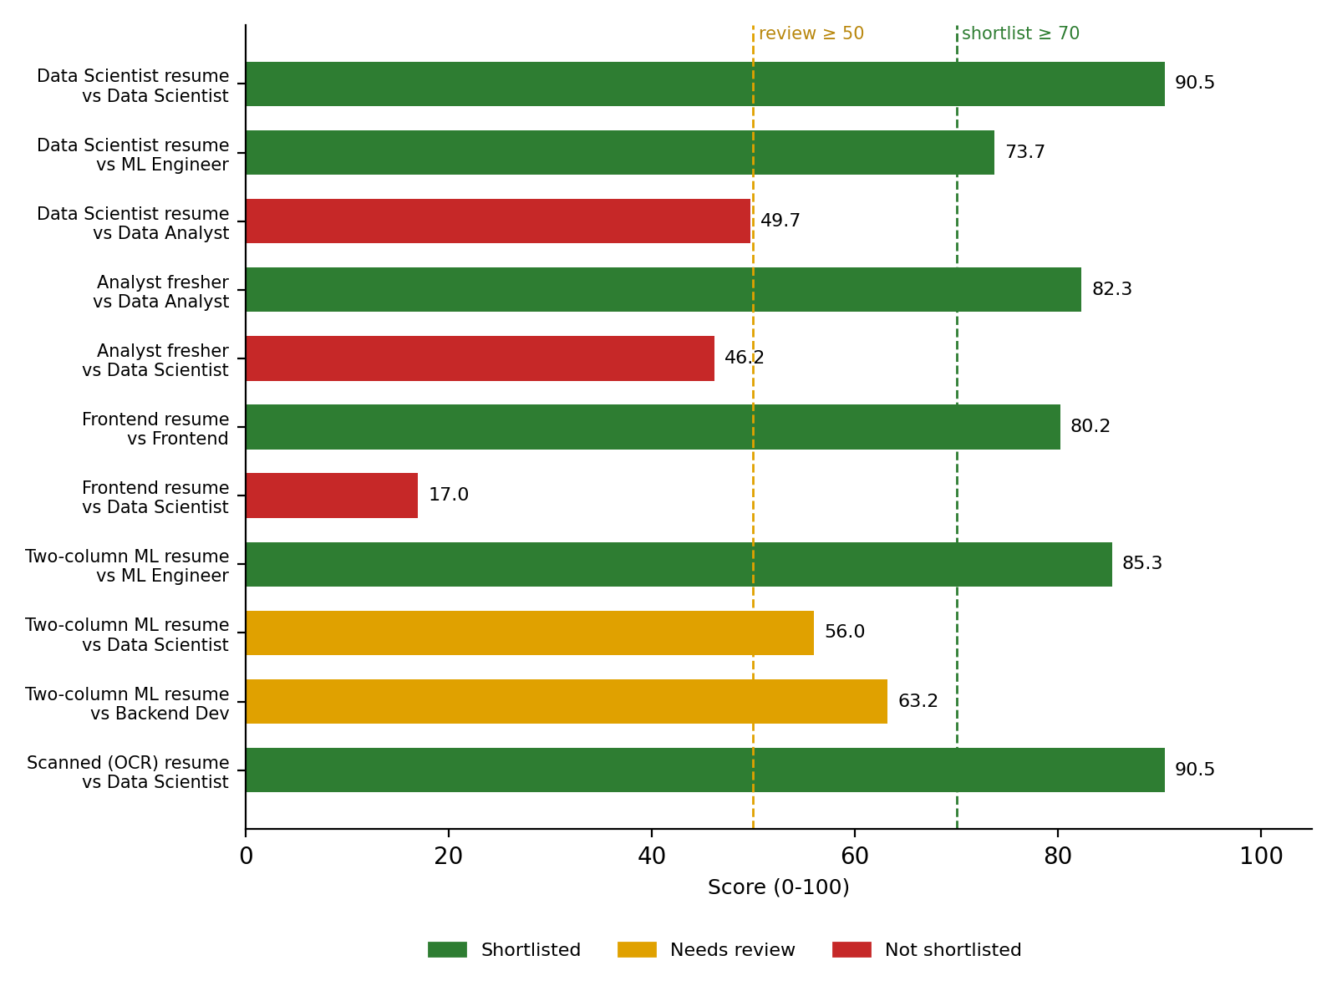
Figure 2. Scores by resume and role, with the shortlist and review thresholds
The results show the intended behaviour: a resume scores 80 or higher for its own role and far lower for unrelated roles, adjacent roles fall in between (a data-science resume scores 73.7 for ML engineering), and the two-column resume scores 85.3 for its role, which shows the column reader works. The scanned version scores exactly the same as its text twin, so OCR did not lose any matched skill on this clean, synthetic scan.

8.3 Evaluation harness
scripts/evaluate.py compares the screener with human labels in a CSV (filename, role, label) and reports accuracy, precision, recall and F1 under a strict rule (only Shortlisted counts as a pass) and a lenient rule (Shortlisted and Needs review count), a confusion matrix, ROC-AUC of the raw score, and a threshold sweep. It also lists every disagreement with the human label.
On the bundled 8-row label file, all metrics are 1.00 and ROC-AUC is 1.00, and thresholds from 50 to 80 give perfect precision and recall. This is a smoke test that shows the harness works, not evidence of real-world accuracy: the thresholds were tuned on these same resumes and the examples are deliberately clear-cut. A meaningful evaluation needs at least 100 real resumes labelled by recruiters, ideally split so that thresholds are tuned on one part and measured on another.

8.4 Performance
Measured end to end on the development machine, a text-based resume takes roughly 30 to 90 ms, while a scanned resume takes about 2.5 seconds because OCR renders and reads every page. Both are comfortable for an interactive tool. Batch requests process files one after another.

8.5 Verification status
The five API tests need FastAPI and httpx and were skipped in the build sandbox, which had no package installation. In their place, the real endpoint handlers in app/main.py were exercised through a minimal FastAPI stand-in (health, successful screen, unknown role, wrong type, corrupt PDF, oversized file, batch ranking), and the real web interface was driven with a headless browser at desktop and mobile widths, including the error path. Running pip install -r requirements-dev.txt followed by pytest on a normal machine executes all 29 tests against real FastAPI. The Docker image and the Render deployment are configured but were not built or launched in the sandbox, so the first docker build should be treated as the final check.

9. Deployment

9.1 Local
python -m venv .venv && source .venv/bin/activate
pip install -r requirements.txt
uvicorn app.main:app --reload
# open http://127.0.0.1:8000 (API docs at /docs)

9.2 Docker
The Dockerfile uses python:3.12-slim, installs Tesseract (skippable with a build argument), runs as a non-root user, includes a health check, and starts Uvicorn on the port given by the PORT environment variable so it works on Render, Railway and Cloud Run.
docker build -t resume-screener .
docker run -p 8000:8000 resume-screener

# smaller image without OCR
docker build --build-arg WITH_OCR=0 -t resume-screener .
docker run -p 8000:8000 -e OCR_ENABLED=false resume-screener

9.3 Render
- Push the project to a GitHub repository.
- In Render choose New, then Blueprint, and select the repository. render.yaml defines a Docker web service with /health as its health check.
- Open the URL Render assigns. On the free plan the service sleeps when idle, so the first request after a pause is slow.

9.4 Continuous integration
The GitHub Actions workflow runs the test suite (with Tesseract installed so the OCR test runs), then builds the Docker image, starts it, and polls /health until it responds. A failing test or a container that does not start fails the build.

9.5 Configuration
Variable | Default | Meaning
MAX_UPLOAD_MB | 5 | Largest accepted PDF
MAX_PAGES | 10 | Pages read per resume
MAX_BATCH_FILES | 20 | Files per batch request
OCR_ENABLED | true | Use Tesseract for scanned PDFs
MIN_TEXT_CHARS | 200 | Below this many characters a PDF is treated as scanned
ROLES_PATH | data/roles.json | Use a different roles file
LOG_LEVEL | INFO | Logging level

10. Limitations and Future Work

10.1 Limitations
- Matching depends on skill names and aliases. A skill described without its usual name can be missed until an alias is added.
- Skill presence is not skill depth. A resume that mentions Python once and one that shows years of Python work both match, apart from the listed-versus-demonstrated distinction.
- Experience comes from date ranges and can be wrong for unusual formats.
- Resumes with tables, text boxes, icons or heavy graphics can scramble reading order.
- OCR quality depends on scan quality, and scanned resumes are slower.
- English only, and thresholds are calibrated on a few synthetic resumes rather than real recruiter judgements.
- Rule-based screening can encode the biases of whoever writes the profiles. A person should review every result, especially Needs review, and the tool should not be the sole basis for rejecting a candidate.

10.2 Future work
- Collect 100 or more recruiter-labelled resumes per role, evaluate properly, and tune weights and thresholds on a held-out split.
- Add sentence-embedding similarity (for example a small transformer model) alongside TF-IDF to catch paraphrased skills.
- Learn weights with a simple model such as logistic regression once labelled data exists, while keeping the rule-based explanation.
- Support DOCX resumes, more languages and a larger skills taxonomy.
- Add a role editor in the interface, so profiles can be changed without editing JSON.
- Add authentication, rate limiting and an audit trail for multi-user deployments.

11. Conclusion
The project delivers a working, explainable resume screener that needs no training data. By combining word-boundary skill matching, evidence of where skills appear, experience and education checks, and TF-IDF similarity, it produces a score and decision that a recruiter can verify in seconds. It reads two-column and scanned PDFs, exposes a documented API and web interface, validates its own configuration, and ships with tests, a deployment recipe and an evaluation harness. Its main open task is measurement on real, recruiter-labelled resumes, and the design (profiles in JSON, all numbers configurable) makes that tuning straightforward.

Appendix A. Project Structure
resume-screener/
app/ config, roles, extractor, preprocess,
parser, scorer, main, static/ (web UI)
data/roles.json role profiles, aliases, scoring rules
tests/ test_pipeline.py (29 tests)
scripts/ make_sample_resumes.py, evaluate.py
samples/ fictional resumes and toy labels.csv
Dockerfile, render.yaml, .github/workflows/ci.yml
requirements.txt, requirements-dev.txt, pytest.ini
README.md

Appendix B. Example API Call
curl -F "file=@samples/strong_data_scientist.pdf" \
-F "role=data_scientist" http://127.0.0.1:8000/api/screen

# response (abridged)
{
"role": {"id": "data_scientist"},
"score": 90.5,
"decision": "Shortlisted",
"summary": {"must_have_matched": 6, "must_have_total": 6},
"breakdown": [{"label": "Must-have skills", "earned": 45.0}, ...],
"reasons": ["Matches 6 of 6 must-have requirements...", ...],
"warnings": []
}

