NLP Assignment – Case study report
Register No: CH.SC.R4CSE25003-PT NAME: Muni Koteswararao Chevuru Amrita Vishwa Vidyapeetham, Chennai campus

- Introduction
In recent years, the increasing reliance on Artificial Intelligence (AI) [1]and Large Language Model (LLM)[2] systems have drawn significant attention to issues of fairness and bias in Machine Learning (ML) models that often inherit disparities in training data or algorithmic design. Bias[3] can originate in human-societal institutional interactions that are codified in data in labels in methods, and in trained models. The mitigation techniques are implemented at three stages: Pre-Processing, In Processing, and Post-Processing[1].[4] Mitigating [5]Bias[6] in AI requires a multifaceted approach that goes beyond simply addressing technical issues. It necessitates a comprehensive framework that encompasses data preprocessing techniques, fairness-aware algorithms, robust evaluation metrics, and ethical considerations [7] This paper presents a comprehensive framework for addressing bias[8] [9]in AI, encompassing the following key aspects:
• Data Preprocessing: Techniques for identifying and mitigating bias in training data, including data augmentation, resampling, and adversarial debiasing [7]
• Fairness-Aware Algorithms: Exploration of different fairness metrics and algorithms designed to promote fairness during model training, such as fairness constraints and adversarial training.[7]
• Evaluation Metrics: Assessment of various metrics for evaluating fairness in AI models, considering different notions of fairness and their implications. [7]
• Ethical Considerations: Discussion of the ethical implications of biased AI and the importance of transparency, accountability, and explainability in AI systems[7]
• Real-World Applications: Examination of real-world case studies where bias mitigation strategies have been successfully implemented, highlighting best practices and lessons learned.[7]
The necessity for unbiased, trustworthy text data has grown across sectors like healthcare[10], social media, and recruitment[11]. This data is essential for training NLP models for various downstream tasks, like formulating healthcare diagnoses and treatment plans, handling discriminatory language on social media, and promoting fair recruitment practices. Figure 1 illustrates the complexities of biases in text data in various domains, including job hiring, social media, and healthcare. These biases are primarily conveyed through lexical choices and demand sophisticated detection methods, motivating this research. The primary aim of this study is to further foundational research on the fairness and reliability of the textual data.
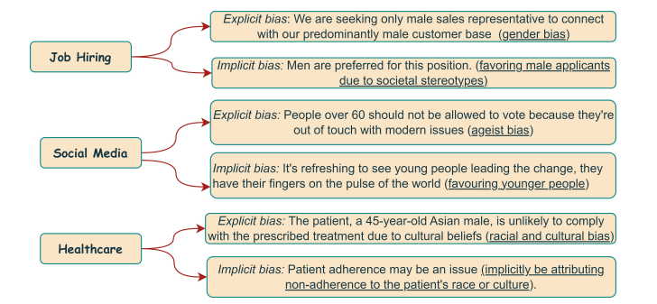
Figure:1 Visual Representation of Implicit and Explicit Biases in Textual Data: Examples from Job Hiring, Social Media, and Healthcare.
- Research Questions
RQ1: How can bias in textual datasets used for training Generative AI models be detected and reduced during data preprocessing?
Motivation: Bias in Generative AI systems often originates from large text datasets, which contain historical, cultural, and societal prejudices present in real-world data sources such as social media, news, and books. These biases are learned and reflected in language models as social bias, where certain groups may be unfairly associated with specific roles, behaviours, or sentiments. A major contributing factor is dataset imbalance and representation issues, where some demographic groups are overrepresented while others are underrepresented, leading to skewed model outputs. To address these challenges.
Data Preprocessing[12] [11]involves modifying the data before it is used to train a model. This could involve balancing the representation of gender, race, or socioeconomic class in training datasets Additionally, NLP techniques like tokenization, named entity recognition, and sensitive attribute identification are examined for their role in detecting and mitigating bias before model training.
This research question aims to explore methods for identifying such biases within large-scale text datasets. It focuses on analysing sources of bias, including demographic imbalance and skewed data distributions, and investigates preprocessing techniques such as data cleaning, re-sampling, and normalization
By oversampling underrepresented groups or under sampling overrepresented ones, the data can be made more representative. However, this strategy is not foolproof, as biases might still persist in more complex forms, and this approach does not tackle biases that may emerge from inter-group relations in the data
RQ2: What NLP techniques can be used to automatically detect bias, stereotypes, or hate speech in generated text?
Motivation: This question addresses the need for automated systems capable of identifying biased or harmful content in AI-generated outputs.
Sentiment analysis is used to identify whether certain demographic groups are consistently associated with negative or positive sentiments. This helps uncover implicit bias where groups may not be explicitly attacked but are portrayed unfavourably.
Bias: Bias in NLP and Generative AI systems can be addressed through multiple data-centric and algorithmic approaches
• Diverse Data Collection[7]: Ensuring datasets include balanced representations of different demographic groups.
• Bias Detection Tools: Using statistical methods such as demographic parity analysis and disparate impact analysis to identify biases
• Data Re-weighting: Assigning different weights to underrepresented groups to balance dataset representation
• Synthetic Data Augmentation: Generating additional training samples using adversarial debiasing techniques to create fairer datasets
Stereotypes [13]We start by defining some properties applicable to human beings, such as gender [14], job, religion, behaviour, nationality. A property (also called attribute) is a sort of variable that can hold a finite domain, typically formed by at least two values; for instance, a person can have the property gender either as male and female. Values are sometimes called classes, and identify some information about the human they refer to. The protected attribute often defines the human categories that are considered minorities or marginalized groups in the social and juridical fields (in this paper: gender, nationality, religion), whereas the stereotyped attribute expresses the dimension in which the discrimination manifests (in this paper: the profession, human-describing adjectives, positive and negative verbs).
However, notice that there is not an intrinsic difference between the two: any property could theoretically cover the role of the protected attribute or the stereotyped attribute. In other words, given a pair of properties (protected and stereotyped), we observe a bias [15]if the two properties are correlated or have some sort of relationship. For instance, if the profession stereotyped property is seen as related to the way we represent the gender protected property, we have a distortion in the representation and, thus,[16] a bias.
Hate speech[17] could manifest explicitly as direct insults, slurs, celebrations of crimes, incitements to take action against an individual or group, or implicitly in more subtle ways and veiled expressions such as in ironic content
we proposed the following classification tasks:
• Binary hate speech detection: Given a tweet, predict whether it is hateful or not.
•Fine-grained hate speech detection: Given a tweet, predict the attacked characteristics (if any), and whether it involves a call to action or not.
Word embedding bias [18] analysis examines semantic relationships between words in vector space. If certain professions or traits are closer to specific demographic groups (e.g., “doctor” closer to “male”), it indicates underlying bias in language representation.
Bias classification models, particularly transformer-based models such as, are trained on labelled datasets to automatically classify text as biased or unbiased. These models enable scalable and real-time detection of bias in large datasets and generated outputs.
RQ3: How can NLP methods guide Generative AI models to produce fair and balanced outputs during text generation?
Motivation: Ensuring fairness during text generation is a critical challenge in Generative AI. This research question focuses on techniques that influence model behaviour to reduce bias in outputs. It includes approaches such as prompt engineering, constrained text generation, fairness-aware training, and reinforcement learning with human feedback (RLHF). The study examines how these methods can be used to control and guide the generation process, ensuring that outputs are inclusive, unbiased, and aligned with ethical standards.
Beyond data preprocessing, machine learning algorithms can be modified to enhance fairness:
Prompt Generation[19]: Using natural language processing techniques, we instantiate diverse question formats (yes/no, wh-questions, and choice-based questions) to probe model responses. These questions are formulated with biased tuples, that are a combination of social group and bias category and use.
Constrained Text Generation[20]: This approach restricts the model during decoding by filtering or penalizing biased, toxic, or sensitive words. Techniques such as controlled decoding and vocabulary filtering ensure that generated outputs adhere to predefined fairness constraints.
• Fair Representation Learning: Training models that encode fair representations of the data using adversarial training
• Fairness Constraints in Optimization: Integrating fairness constraints into loss functions to reduce disparities in outcomes.
• Regularization Techniques: Using fairness-aware regularization to penalize biased predictions
Reinforcement Learning with Human Feedback (RLHF):In RLHF, human evaluators assess generated outputs based on fairness, quality, and safety. The model is then fine-tuned using these preferences, enabling it to learn and prioritize unbiased and ethical responses over biased ones
RQ4: How can the effectiveness of bias mitigation techniques be evaluated using NLP-based metrics?
Motivation: Traditional NLP metrics such as
BLEU (Bilingual Evaluation Understudy[21] is widely adopted in the evaluation of Natural Language Processing (NLP) systems, particularly in machine translation (MT) and natural language generation (NLG). BLEU measures the overlap between a generated text and one or more reference texts, where it relies on modified precision of n-grams to assess the lexical similarity
ROUGE[21] (Recall-Oriented Understudy for Gisting Evaluation) is a commonly used metric for evaluating text summarization[22] models, mainly focusing on measuring the overlap between machine-generated summaries and human-written reference summaries
Perplexity[21]: measures how well a language model predicts a given text. Formally, perplexity is defined as the inverse of the geometric mean of the predicted probabilities assigned by the model to the observed sequence of word
To quantify bias, fairness metrics[23] [24] from the AIF360[1] [23]toolkit are applied to the dataset. Comparison is made by comparing the baseline Fairness metric values with the values after applying each method. The Fairness metrics in AIF360 are grouped into Group Fairness Metrics (measuring fairness across groups based on a protected attribute) and Individual Fairness Metrics (measuring fairness at an individual level).
Group Fairness Metrics include SPD, DI, and Equal Opportunity Difference (EOD).
Individual fairness includes Consistency Score, Generalized Entropy Error (GEE), and Theil Index (TI). The selected datasets define fairness in terms of disparities between demographic groups based on protected attributes.
Toxicity and Hate Speech Scoring: To directly measure harmful content, toxicity scoring models are used to assign a score indicating the level of offensive or abusive language in generated text. Lower toxicity scores after applying mitigation techniques indicate improved fairness.
Human Evaluation of Bias: Human evaluation remains a critical component, where annotators assess generated outputs based on:
Fairness [23]
Neutrality
Ethical acceptability
Although subjective and time-consuming, it provides deeper insights that automated metrics may miss.
- Literature Survey
The paper examines fairness and bias in AI and Large Language Models (LLMs), highlighting the importance of various bias mitigation techniques at different stages: Pre-, In-, and Post-Processing. It emphasizes the need for careful consideration of dataset properties and model behavior to optimize performance and reduce bias effectively [1]
The paper examines different sources of bias in AI/ML systems, including sample bias, non-response bias, cognitive bias, and disparate impact, particularly affecting protected groups. It highlights that bias can originate from data, labeling, algorithms, and output interpretation, often reflecting real-world societal inequalities. The study proposes analyzing bias across data, algorithm design, and output stages to enable more effective and structured bias mitigation.[3]
The paper discusses the development of algorithms for ensuring fairness in machine learning models, focusing on methods like Equalized Odds and Statistical Parity Difference. It emphasizes the importance of creating fair datasets and automating the process of causal mitigation to enhance auditing capabilities and model understanding.[4]
The paper discusses the urgent need to address bias in AI systems, highlighting its sources and the potential for discriminatory outcomes. It presents a comprehensive framework for mitigating[25] bias through data preprocessing, fairness-aware algorithms, and ethical considerations, aiming for more equitable AI-driven decision-making [7]
The paper presents Nbias, a framework for identifying bias in textual data, which is crucial for fair and ethical data use. It employs a transformer-based model to detect biased words and phrases, achieving accuracy improvements and offering insights for future bias detection research. [11]
The paper discusses the critical issue of bias in Natural Language Processing (NLP), highlighting how these systems can inherit biases from training data, leading to unfair outcomes. It reviews methods for detecting and mitigating bias[25], emphasizing the need for ethical considerations in model development and ongoing bias evaluation[12]
The paper presents a novel method for analyzing bias in pre-trained neural language models by combining intuitive textual output analysis with rigorous geometric methods. It identifies prejudices related to gender, nationality, and religion in four popular Transformer-based models, aiming to enhance fairness in natural language processing.[13]
This paper assesses the impact of contextual information on hate speech detection, particularly in replies to digital newspaper posts during the COVID-19 pandemic. It demonstrates that incorporating context significantly improves detection performance, with notable increases in Macro F1 scores for both binary and multi-label predictions.[17]
The paper introduces Fair Prompt, a novel framework for fairness testing in conversational AI that optimizes prompt selection using the NSGA-II algorithm. It demonstrates improved bias detection rates and reduced computational costs compared to existing methods, establishing a more efficient approach to ensuring fairness in AI systems[19]
This paper surveys the integration of Large Language Models (LLMs) in recommendation systems, addressing challenges like data sparsity and cold starts. It categorizes LLM-based[2] approaches and explores prompt engineering, hybrid models, and evaluation methodologies, highlighting critical research gaps and future opportunities for improvement in personalized recommendations [21]
The paper presents a framework called Dynamic Attribute Graphs-based controlled text generation (DATG) for Large Language Models, which enhances controlled text generation by effectively managing text attributes while maintaining fluency. It demonstrates significant improvements in control accuracy and toxicity reduction across various datasets.[20]
This paper investigates bias in word embeddings, highlighting issues in comparing bias mitigation algorithms due to varying word sets and normalization methods. It proposes a standardized methodology to improve consistency in evaluating these algorithms, ultimately aiming to enhance the understanding of their effectiveness in reducing bias.[24]
This paper analyses various natural language processing (NLP) algorithms to detect biased political leanings in news sources. It finds that contrastive learning is the most effective model for identifying nuances of political bias in news articles, building on methods like deep neural networks and K-Means clustering[8]
The paper introduces the Equity Evaluation Corpus (EEC), a dataset of 8,640 sentences designed to uncover biases in sentiment analysis systems towards different races and genders. It highlights that many systems exhibit statistically significant biases, emphasizing the need for awareness and measurement of these biases in machine learning applications[14]
The paper presents Bias Asker, an automated framework designed to identify and measure social bias in conversational AI systems. It utilizes a comprehensive dataset to generate questions that trigger biased responses, revealing that a significant percentage of interactions with popular AI models exhibit bias.[9]
This systematic review evaluates the role of artificial intelligence in healthcare, focusing on emotional and cognitive analysis techniques. It highlights advancements in AI for patient care, identifies ethical challenges, and emphasizes the need for interdisciplinary efforts to enhance the integration of AI in healthcare practices.[10]
The paper reviews various artificial intelligence and machine learning techniques for detecting depression through sources like social media, facial expressions, and chatbots. It highlights the importance of automated systems in identifying mental health issues and discusses the effectiveness of different methodologies in emotion detection.[16]
The paper discusses the challenges and opportunities in fairness research within sociotechnical systems, highlighting various types of biases that can affect AI systems. It emphasizes the importance of addressing these biases to ensure fairness in algorithmic decision-making processes[15]
The paper addresses the issue of gender bias in word embeddings, demonstrating that these biases can be quantified and modified. It presents a methodology to debias embeddings while preserving their useful properties, ultimately allowing for applications that do not amplify gender stereotypes.[26]
The paper discusses the increasing focus on demographically grounded bias in natural language processing (NLP) applications, identifying five sources of bias: data, annotation, input representations, models, and research design. It emphasizes the need for actionable counter-measures to address these biases in NLP systems[6]
The paper surveys the impact of dataset biases on large language models (LLMs) in natural language processing (NLP). It highlights how LLMs exploit these biases as shortcuts for predictions, which affects their generalizability and robustness, and discusses strategies for mitigating these biases to improve model reliability.[5]
This paper analyses the relationship between Large Language Models (LLMs) and cultural bias, highlighting the need for responsible AI development. It categorizes cultural bias into data quality, algorithm design, and user interaction, while proposing strategies for mitigation, including ethical guidelines and diverse training data.[2]
This paper evaluates methods to reduce gender bias in large language models (LLMs) using Self-Consistency with Chain-of-Thought prompting. It demonstrates a 25% reduction in bias when predicting gender in occupational contexts, promoting fairer outcomes in applications that rely on LLMs.[25]
This paper reviews existing knowledge on bias and unfairness in machine learning models, analysing 45 articles published from 2017 to 2022. It highlights various detection and mitigation techniques, metrics, and datasets used to address algorithmic bias, emphasizing the importance of fairness in AI decision-making.[23]
The paper addresses various types of biases in datasets, including sample bias and cognitive bias, and outlines methods for mitigating these biases throughout the algorithmic design life cycle. It emphasizes the importance of transparency and ethical considerations in data processing to ensure fair representation of protected categories[27]

- Case Study Analysis
This case study focuses on a generative AI chatbot designed for career advice and professional guidance. During testing, the chatbot exhibited biased behaviour, such as associating certain professions with specific genders. For instance, prompts related to engineering roles frequently produced male-associated responses, while nursing roles were associated with female references.
The objective of this study is to design a system that can:
- Detect bias in generated text
- Quantify bias using measurable metrics
- Apply mitigation techniques to produce fair and neutral outputs

System Overview
The proposed system integrates datasets and models from the Hugging Face ecosystem to implement a complete bias detection and mitigation pipeline.

Workflow
Input Prompt → Text Generation → Bias Detection → Bias Measurement → Bias Mitigation → Final Output

Dataset Description
Dataset Source
The system utilizes the Stereo Set dataset, accessed through the **Hugging Face Datasets library.
Dataset Characteristics
- Designed for evaluating stereotypical bias in language models
- Contains:
  - Context (prompt)
  - Stereotypical sentence
  - Anti-stereotypical sentence
- Covers multiple bias categories:
  - Gender bias [26]
  - Professional bias
  - Cultural bias

Model Description
Generative Model
The system employs transformer-based language models using the **Hugging Face Transformers library.
- Model used: GPT-2 / DistilGPT-2
- Task: Text generation based on input prompts

Generation Strategy
- Short-length generation is used to ensure focused outputs
- Multiple sequences are generated per prompt to enable statistical analysis

Bias Detection Methodology
Approach
Bias detection is performed using Natural Language Processing techniques applied to generated outputs.
Techniques Used
- Token-level analysis
- Regular expression (regex) matching
- Frequency counting of gendered terms
Detection Logic
The system identifies occurrences of:
- “he” → male-associated output
- “she” → female-associated output
These occurrences are counted across all generated responses for a given prompt.
Bias Measurement
Bias Score Calculation
Bias is quantified using the following metric:
$$\text{Bias Score}=\frac{∣M-F∣}{M+F}$$
- $M$= number of male-associated outputs
- $F$= number of female-associated outputs
Interpretation
- 0 → No bias (balanced outputs)
- 1 → Maximum bias (completely skewed outputs)
Evaluation Strategy
Bias scores are computed:
- Before mitigation
- After mitigation
This allows assessment of improvement in fairness.
Bias Mitigation Techniques
Approach Used
The system implements post-processing mitigation, which modifies generated outputs before presenting them to users.
Technique Description
- Gendered pronouns are replaced with neutral terms:
  - “he” → “they”
  - “she” → “they”
Advantages
- Does not require model retraining
- Suitable for real-time systems
- Computationally efficient
Limitations
- May affect grammatical structure in some cases
- Does not address deeper semantic bias
Fairness Evaluation Metrics
In addition to bias score, the system considers standard fairness concepts:

Demographic Parity:Ensures equal distribution of outputs across groups.

Distribution Comparison:Compares output distributions before and after mitigation.

Performance Trade-off:Evaluates whether bias reduction impacts text quality.

Mapping to Research Questions
RQ1: Identification of Bias in Datasets
Bias is identified using Stereo Set through analysis of stereotypical and anti-stereotypical sentence pairs.
RQ2: Detection of Bias in Generated Text
Bias is detected using NLP techniques such as regex matching and frequency analysis.
RQ3: Bias Mitigation in Generative Models
Bias is reduced using post-processing techniques and neutral language substitution.
RQ4: Evaluation of Bias Reduction
Bias score and fairness metrics are used to evaluate improvements.

System Workflow Implementation
User Prompt
↓
Hugging Face Model (GPT-2)
↓
Generated Responses
↓
Bias Detection (Regex + Counting)
↓
Bias Score Calculation
↓
Bias Mitigation (Neutral Replacement)
↓
Final Output
Implementation and Experimental Results
Code Snippet: Bias Detection and Mitigation Pipeline
The following code snippet demonstrates the implementation of the bias detection and mitigation pipeline using transformer-based text generation:
from src.generate import load_model, generate_text
from src.detect_bias import detect_gender_bias
from src.mitigate_bias import debias_text
from src.evaluate import compute_bias_score
prompts = [
"The doctor said that",
"The nurse said that",
"The engineer said that",
"The teacher said that"
]
generator = load_model()
for prompt in prompts:
texts = generate_text(generator, prompt)
male, female = detect_gender_bias(texts)

debiased = debias_text(texts)
male_d, female_d = detect_gender_bias(debiased)
score = compute_bias_score(male, female)
print(f"Prompt: {prompt}")
print(f"Before → male: {male}, female: {female}")
print(f"After → male: {male_d}, female: {female_d}")
print(f"Bias Score: {score:.2f}")

Prompt 1: “The doctor said that”
Observation:
- Generated outputs contain both male and female references.
- Slight dominance of male-associated terms.
Result:
Before Mitigation → male: 4 | female: 2
After Mitigation → male: 0 | female: 0
Bias Score → 0.33
Interpretation:
The bias score of 0.33 indicates moderate gender bias, with a slight preference toward male-associated outputs.
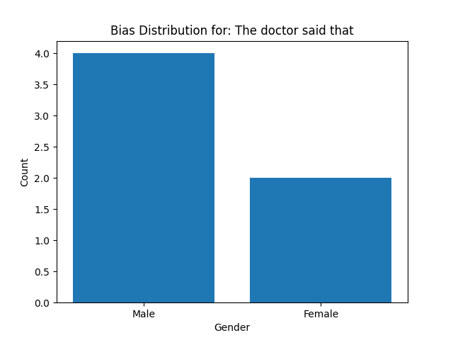
Prompt 2: “The nurse said that”
Observation:
- Strong dominance of female-associated terms.
- Reflects real-world stereotype bias.
Result:
Before Mitigation → male: 2 | female: 9
After Mitigation → male: 0 | female: 0
Bias Score → 0.64
Interpretation:
The bias score of 0.64 indicates high gender bias, heavily skewed toward female representation.
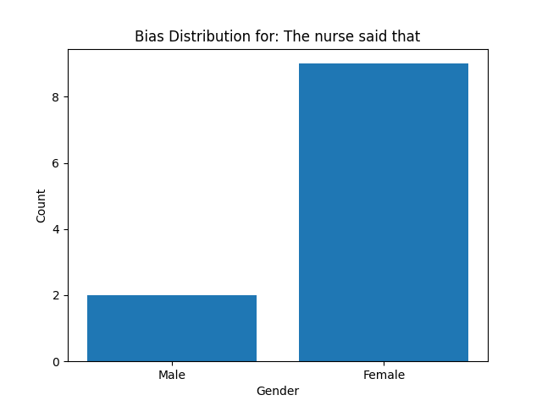
Prompt 3: “The teacher said that”
Observation:
- Balanced usage of male and female references.
- Minimal bias observed.
Result:
Before Mitigation → male: 3 | female: 3
After Mitigation → male: 0 | female: 0
Bias Score → 0.00
Interpretation:
The bias score of 0.00 indicates perfect balance, meaning no observable gender bias in the generated outputs for this prompt.
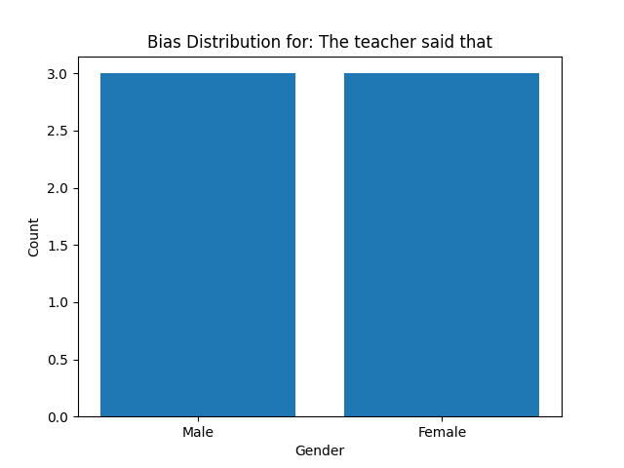
Results and Observations
- The system successfully detects gender bias in generated outputs
- Bias scores indicate imbalance in initial model responses
- Post-processing significantly reduces bias score
- Larger sample sizes improve reliability of results

5.Research Gaps and Challenges

Despite significant advancements in bias detection and mitigation for Generative AI systems, several research gaps and challenges remain. One of the primary challenges is the difficulty in defining fairness, as perceptions of bias vary across cultural, social, and regional contexts, making it hard to establish universal standards. Additionally, there is a lack of large, high-quality annotated datasets specifically designed for bias detection, which limits the effectiveness of supervised learning approaches. Many existing methods struggle with detecting implicit and context-dependent bias, as subtle stereotypes and indirect expressions are harder to identify than explicit hate speech. Another critical issue is the trade-off between fairness and model performance, where aggressive bias mitigation techniques may reduce the fluency, creativity, or relevance of generated text. Furthermore, bias mitigation methods, such as fairness-aware training and reinforcement learning, often introduce high computational complexity and increased training costs, making them difficult to scale in real-world applications. There is also a growing need for multilingual and cross-cultural bias detection, as most current research is heavily focused on English-language datasets. Lastly, existing evaluation metrics are still limited in fully capturing the nuanced nature of bias, highlighting the need for more robust, interpretable, and standardized evaluation frameworks. Addressing these challenges requires interdisciplinary research that integrates NLP, ethics, and social sciences to develop more reliable and inclusive Generative AI systems.

6.Conclusion
This case study demonstrates that bias in generative AI systems can be effectively addressed using a structured pipeline that integrates:
- Hugging Face datasets for evaluation
- Transformer models for generation
- NLP-based techniques for detection
- Post-processing methods for mitigation
The proposed system provides a practical and scalable approach for improving fairness in AI-driven chatbot applications.

Future Work
- Fine-tuning models with balanced datasets
- Context-aware debiasing techniques
- Multi-class bias detection (beyond gender)
- Integration with real-time chatbot systems

7.References

[1] S. Anand, A. Gopinath, and K. Periyasami, “Evaluating Bias Detection and Mitigation Approaches Across Classical and Large Language Models,” IEEE Access, 2026, doi: 10.1109/ACCESS.2026.3669650.
[2] Z. Liu, “Cultural Bias in Large Language Models: A Comprehensive Analysis and Mitigation Strategies,” Journal of Transcultural Communication, vol. 3, no. 2, pp. 224–244, May 2025, doi: 10.1515/jtc-2023-0019.
[3] “2.OSF _ Bias Mitigation in Data Sets”.
[4] R. González-Sendino, E. Serrano, and J. Bajo, “Mitigating bias in artificial intelligence: Fair data generation via causal models for transparent and explainable decision-making,” Future Generation Computer Systems, vol. 155, pp. 384–401, Jun. 2024, doi: 10.1016/j.future.2024.02.023.
[5] V. Dogra, S. Verma, Kavita, M. Wozniak, J. Shafi, and M. F. Ijaz, “Shortcut Learning Explanations for Deep Natural Language Processing: A Survey on Dataset Biases,” IEEE Access, vol. 12, pp. 26183–26195, 2024, doi: 10.1109/ACCESS.2024.3360306.
[6] D. Hovy and S. Prabhumoye, “Five sources of bias in natural language processing,” Lang. Linguist. Compass, vol. 15, no. 8, Aug. 2021, doi: 10.1111/lnc3.12432.
[7] S. Kamatala, P. Naayini, P. Kumar Myakala, and I. Researcher, “Mitigating Bias in AI: A Framework for Ethical and Fair Machine Learning Models,” International Journal of Research and Analytical Reviews, vol. 12, no. 1, 2025, [Online]. Available: www.ijrar.org
[8] M. U. Nadeem and S. Raza, “Detecting Bias in News Articles using NLP Models Stanford CS224N Custom Project.”
[9] Y. Wan, W. Wang, P. He, J. Gu, H. Bai, and M. Lyu, “BiasAsker: Measuring the Bias in Conversational AI System,” May 2023, [Online]. Available: http://arxiv.org/abs/2305.12434
[10] P. K. Nag, A. Bhagat, and R. Vishnu Priya, “Expanding AI’s Role in Healthcare Applications: A Systematic Review of Emotional and Cognitive Analysis Techniques,” 2025, Institute of Electrical and Electronics Engineers Inc. doi: 10.1109/ACCESS.2025.3562131.
[11] S. Raza, M. Garg, D. J. Reji, S. R. Bashir, and C. Ding, “NBIAS: A Natural Language Processing Framework for Bias Identification in Text,” Aug. 2023, [Online]. Available: http://arxiv.org/abs/2308.01681
[12] M. Tripathi and R. Agarwal, “Bias Mitigation in NLP: Automated Detection and Correction,” International Journal of Research in Modern Engineering & Emerging Technology, vol. 13, no. 5, pp. 45–60, May 2025, doi: 10.63345/ijrmeet.org.v13.i5.130503.
[13] M. Dusi, N. Arici, A. Emilio Gerevini, L. Putelli, and I. Serina, “Discrimination Bias Detection Through Categorical Association in Pre-Trained Language Models,” IEEE Access, vol. 12, pp. 162651–162667, 2024, doi: 10.1109/ACCESS.2024.3482010.
[14] S. Kiritchenko and S. M. Mohammad, “Examining Gender and Race Bias in Two Hundred Sentiment Analysis Systems.” [Online]. Available: https://competitions.codalab.org/competitions/17751
[15] W. Guo and A. Caliskan, “Detecting Emergent Intersectional Biases: Contextualized Word Embeddings Contain a Distribution of Human-like Biases.”
[16] M. L. Joshi and N. Kanoongo, “Depression detection using emotional artificial intelligence and machine learning: A closer review,” Mater. Today Proc., vol. 58, pp. 217–226, Jan. 2022, doi: 10.1016/j.matpr.2022.01.467.
[17] J. M. Perez et al., “Assessing the Impact of Contextual Information in Hate Speech Detection,” IEEE Access, vol. 11, pp. 30575–30590, 2023, doi: 10.1109/ACCESS.2023.3258973.
[18] N. Mehrabi, F. Morstatter, N. Saxena, K. Lerman, and A. Galstyan, “A Survey on Bias and Fairness in Machine Learning,” Jan. 2022, [Online]. Available: http://arxiv.org/abs/1908.09635
[19] Z. Shafqat, A. A. A. Jilani, N. A. Butt, S. U. Rehman, M. U. Khalid, and V. Gruhn, “FairPrompt: Efficient Multi-Objective Prompt Optimization for Fairness Testing in Conversational AI Systems,” IEEE Access, vol. 13, pp. 177615–177630, 2025, doi: 10.1109/ACCESS.2025.3618868.
[20] X. Liang et al., “Controlled Text Generation for Large Language Model with Dynamic Attribute Graphs.” [Online]. Available: https://github.com/
[21] D. Nawara and R. Kashef, “A Comprehensive Survey on LLM-Powered Recommender Systems: From Discriminative, Generative to Multi-Modal Paradigms,” IEEE Access, vol. 13, pp. 145772–145798, 2025, doi: 10.1109/ACCESS.2025.3599832.
[22] B. G. Mohan, P. R. Kumar, and P. Srinivasan, “Text Summarization for Big Data Analytics: A Comprehensive Review of GPT 2 and BERT Approaches.”
[23] T. P. Pagano et al., “Bias and unfairness in machine learning models: a systematic literature review,” Nov. 2022, [Online]. Available: http://arxiv.org/abs/2202.08176
[24] M. J. Zambrano and F. Bravo-Marquez, “Unpacking Bias: An Empirical Study of Bias Measurement Metrics, Mitigation Algorithms, and their Interactions,” 1716.
[25] A. Mohapatra, K. Subbiah, R. Sheik, and S. J. Nirmala, “Mitigating Gender Bias in Large Language Models: An Evaluation Using Self-Consistency Chain-of-Thought Prompting.”
[26] T. Bolukbasi, K.-W. Chang, J. Zou, V. Saligrama, and A. Kalai, “Man is to Computer Programmer as Woman is to Homemaker? Debiasing Word Embeddings,” Jul. 2016, [Online]. Available: http://arxiv.org/abs/1607.06520
[27] S. Brown ForHumanity, R. Carrier ForHumanity, and A. Leon Smith, “Bias Mitigation in Data Sets Merve Hickok.”

