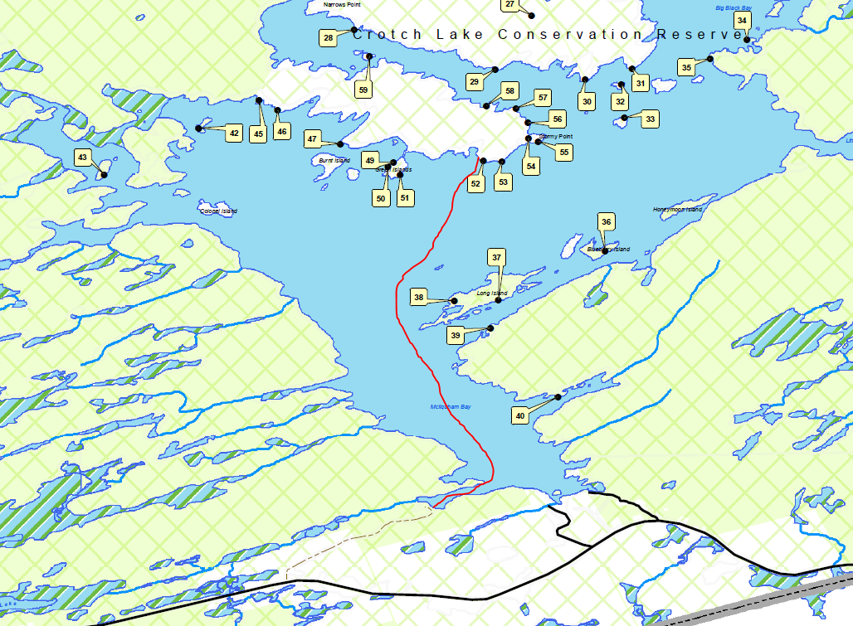

This is where we put in. Follow the signs for public access. It is just after tumblehome lodge. Turn right off of Ardock Rd.