MUNISH KUMAR

+91 9315373911

[munishrathour11@gmail.com](mailto:munishrathour11@gmail.com)

https://[www.linkedin.com/in/munish-kumar-8a376918b](http://www.linkedin.com/in/munish-kumar-8a376918b)

# Summary

Forward-thinking Java Developer with **4.7**+ years of experience. Offering extensive knowledge of Spring,Springboot,Web-Services,Micro-Services, Hibernate, Angular, much more. Successful at developing web application and integration of new technologies with java at Production. Through these qualities, I have confidence in my ability to facilitate positivechange and collective effort for any organisation.

# Skills

* Highly proficient with Java, JEE, Spring, Web-services,Micro-services,Hibernate, Spring boot, Documentum.
* Databases : MySQL, Oracle,Sqllite, DQL(Documentum Query Language)
* WebTechnologies: Jsp,Servlet,Html5, Css,Jquery, Ajax,Web Services(Rest Web Service)
* Java Tool : Jasper Report,JUNIT.
* Repository : SVN Repository,Git.
* Web Servers : Apache Tomcat.
* Good organizational skills, with an ability to work both independently and collaboratively.

**Experience**

* **SENIOR SOFTWARE DEVELOPER(Java**)- 09/2021 to PRESENT R-Systems,Noida.
* **SOFTWARE DEVELOPER**- 04/2018 to 09/2021 CostaCloud- An

Appolo Computers Pvt Ltd, Nehru Place, Delhi.

## Training &Internship

* + 8 Months of Training in Java at Ducat India, sector 16 – Noida

## Education

* **RAYAT BAHRA INSTITUTE OF ENGINEERING AND NANO TECHNOLOGY**,- HOSHIARPUR(PUNJAB) Bachelor’s of Technology with Computer Science And Engineering.(2016).
* **GOLDENSEN.SEC.SCHOOL**,GURDASPUR(PUNJAB) Science(2012).
  + **GOLDEN SEN.SEC.SCHOOL**, GURDASPUR(PUNJAB) Matriculation(2010).

**PROJECTS DETAILS**

### Project: PAPERLESS

* + - **Client: Indian Navy**

### Role: Team Member(Java Developer).

* + - **Description:**

The purpose of the navy paperless office is to develop a work environment, in which we can create digital file and DAK (letter,Note,Fax). We can send File and DAK to one department to another department. This Application provide transparency, Digital Signature and different feature to user to customize documents. Traditional offices have paper-based filing systems. It is time consuming process to store and manage those files. Paperless office eliminates all those problem and make information sharing easier, keep information more secure.

### Responsibilities:

Responsible to manage inbox page.

Responsible for creating different type of report using jasper report. Example – Inbox Item report, File Monitor Report, Overdue File report using Jasper Report etc.

Responsible for managing groups and user and Role.

Also responsible to generate excel file using by apache poi api. Rest Service using spring mvc for sending file from onedepartment to another department.

### Servers: Apache Tomcat

* + - **Project: Capture Application**

### Client: Indian Navy

* + - **Role: Team Member(Java Developer).**

### Description:

Capture Application is a Java web service and web application for upload,viewing and download of documents, using OpenText Documentum.

### Responsibilities:

Analyze the scenario and understand the requirements. Get Approval of planned technical task details.

Create directory in documentum repository using DFC. Upload files in created Validation of JSON data.

Write the service as per requirements using REST JAX Web- Services. Test the complete service using RestFul web service.

Retrieve response in JSON format. As per our requirement expectations. Solving the Issues in Production which is raised by Customer.

### Servers: Apache Tomcat

### Project: Cubs Lendlease

### Client: Podium(U.K)

* **Role: Create Java Web Services.**

### Description:The purpose of this project cubs vendor to design and construct customer interior and external houses,apartment according to requirement.

### To customize dimensions of room,bed room,bathroom etc. using web services.

### Responsibilities:

### Analyze the scenario and understand the requirements.

### Create Vendor Module,Apartment Module,Customor Order and Solver Module using Api.

### Test the complete services using JUNIT.

### 

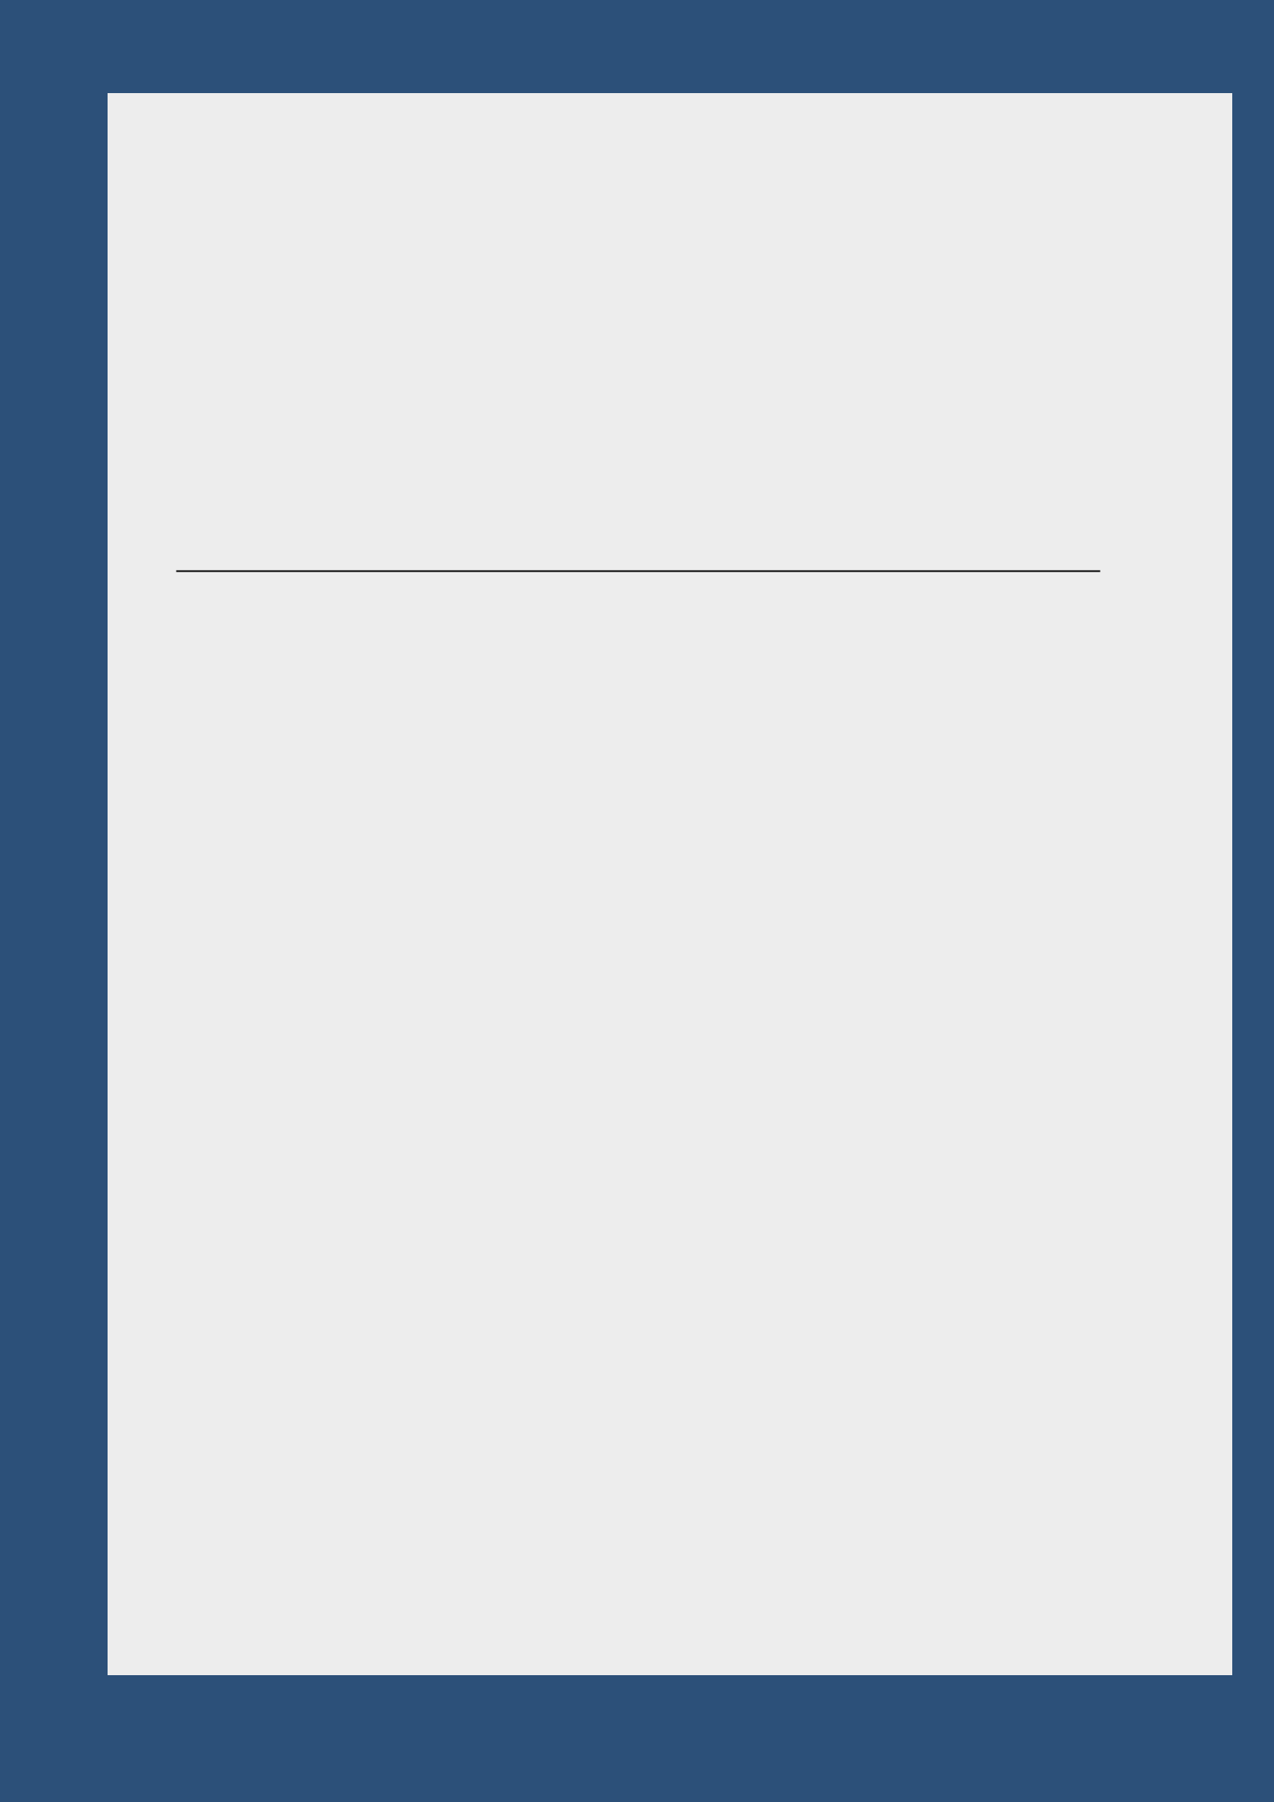

### Project: Eoffice (Andriod/IOS)

**Technology: Flutter-Dart(Google Language)**

**Client: RECL([Rural Electrification Corporation Limited)](https://www.recindia.nic.in/)**

### Role: Create Eoffice App Description :

This is a inhouse project where the Confidential Document were shared between higher chain of employees to lower chain of employees and vice versa.

### Responsibilities:

Responsible to create Inbox,Outbox,Comment Widget using Flutterwidget for frontened Application view.

For Backened using Dart Api to fetch data from Web Services(Rest Api).

### Project:Egovernance Eoffice Client: IAF (Indian Air Force)

**Role: Team Member (Java Developer).**

**Description:** The purpose of the IAF paperless office is to develop a work environment, in which we can create digital file and DAK (letter, Note, Fax). We can send File and DAK to one department to another department. This Application provide transparency, Digital Signature and different feature to user to customize documents. Traditional offices have paper-based filing systems. It is time consuming process to store and manage those files.Paperless office eliminates all those problem and make information sharing easier, keep information more secure.

### Responsibilities:

Responsible to create iaf department,section and user utility.Responsible to manage inbox page.

Responsible for creating different type of report using jasper report. Example – Inbox Item report, file Monitor Report, OverdueFile report using Jasper Report etc.

Responsible for managing groups and user and Role.

Also responsible to generate excel file using by apache poiapi. Rest Service using spring mvc for sending file from one department to another department.

Implement the Interactive Guided Tours for the projectusing jquery. File and Daak monitor ,Export inboxTask

Also working on File Transfer **web services** from one server to another server

### Servers: Apache Tomcat