**Title:** **Spatiotemporal Analysis of Public Sentiment on Low-Carbon Energy Sources**

**Authors:** Munish Kumara,b and Caleb Chia We Keata

**Affiliations:** aSingapore University of Social Sciences, School of Business, Clementi Rd, #463号, Singapore 599494

bWood Mackenzie, 1 Marina Blvd, Singapore 018989

Corresponding author. Email: munishkumar001@suss.edu.sg

**Abstract:** There is now irrefutable evidence that mankind’s anthropogenic activities are the largest contributor to greenhouse gas (GHG) emissions, whether it comes from the burning of fossil fuels or from chemical waste and plastic use. While the goal is for public policy and businesses to lead the way in reducing GHG emissions, interestingly, the pressure to undertake such reform appears to come from increasing grass-root environmentalism such as (a) public willingness to change consumption behaviours after seeing and experiencing abnormal environmental and weather-related phenomenon, (b) activist green investors who feel the need to ensure their investments provide socially responsible returns and (c) debate and discourse on social media threads about the responsibility we have towards future generations in climate related matters. Citizen environmentalism is particularly powerful when harnessed via social media, as the latter democratises the delivery of information and reduces complexities in information to something easily digestible by the majority. This study analyses public perception towards low-carbon energy (LCE) sources in two key population centres, namely the United States and Europe, by analysing data found in the social media platform, Twitter. Data was collected and analysed over a one-year period (from 2021 to 2022) to evaluate public sentiment and gain deeper insight into discussions surrounding LCE sources. We have observed that spikes in tweet volume corresponded to significant real-world events which social media users could directly link to the impact these events would have on the adoption of LCE sources. We also conducted sentiment analysis using an unsupervised, lexicon-based model (VADER), which showed that the public sentiment towards LCE sources is largely positive in both regions. We then extracted frequent keywords in positive, neutral, and negative tweets to better understand which topics resonate more strongly with the public. In the United States, the word ‘climate’ was used a lot in positive discussions surrounding President Joe Biden’s climate and energy bill and how it can drive decarbonisation. In Europe, the word ‘price’ appeared frequently in negative tweets with discussions on the energy crisis and high gas prices. Tweets with ‘price’ also showed discontent with prices for green energy adoption and users being unable to adopt low-carbon energy sources as a result. We also provided a comprehensive overview of the geographical variation in public sentiment across states and countries. We found that the sentiment in certain states and countries are more positive than others. This allowed us to introduce and compare socioeconomic factors such as the demographics in the state/country, political affiliations, GDP, renewable energy consumption, and how they may cause differing sentiments towards LCE sources. This study provides information that can be potentially used by policymakers, environmental activist groups, and international organisations like the United Nations to design better adoption strategies and low-carbon emission policies or initiatives.

**One-Sentence Summary:** Sentiment analysis of public perception regarding low carbon energy adoption and use

**Keywords (minimum 6):** low-carbon, Twitter, sentiment, data science, analysis, VADER, GHG, emissions

# Introduction

Climate change has been one of the most pressing issues in recent decades, sparking contentious debates as growing emphasis is placed on protecting and restoring our planet from man-made activities [1]. Our actions this last century have been responsible for almost all of the increase in reported amounts of greenhouse gases (GHG) in the atmosphere, which is the leading cause of global warming and various tumultuous weather-related phenomenon. Most notably, the burning of fossil fuels (coal, oil, and natural gas) produces the greenhouse gases carbon dioxide (CO2), methane (CH4) and nitrous oxide (N2O). According to a report by the United States (US) Environmental Protection Agency (EPA), the burning of fossil fuels for transport and electricity generation was the largest contributing source of greenhouse gas emissions, with up to 3.11 million metric tons of CO2 equivalent being produced in 2020 [2].

As growing emphasis is being placed on protecting our environment, many studies have been conducted to continually assess efforts towards attaining sustainable development goals. Such studies often provide quantitative data and measures that corporations, governments, and environmental groups can potentially rely on to evaluate their progress within the broad umbrella of sustainability – ranging from pollution reduction to better managing natural resources.

A mitigation for the burning of fossil fuels is the adoption of low-carbon energy (LCE) alternatives. LCE is the collective term applied to renewable, green, and clean energy sources (Figure 1), which we will consider collectively in this work.

1. Green energy is energy that is renewable, produced from natural sources, has a zero-emissions profile and provides the highest environmental benefit. As an example, solar and wind energy are natural and renewable, do not harm the environment, and do not directly emit any GHGs, thus are classified as green energy.
2. Often used interchangeably with green energy, renewable energy is also produced from natural sources that replenish at a rate faster than they would otherwise be consumed [3]. Unlike green energy, however, it may not be totally green. As an example, geothermal power plants may not be considered ‘green’ energy, particularly if there is pollution associated with discharge of water, gases and/or soil subsidence to the local environment. However, in general, the benefits of renewable energy outweigh the associated downside.
3. Clean energy comes from sources which generate some pollution, chemical contaminants, or greenhouse gases during its production. These are also not necessarily renewable or may still negatively impact the environment. CH4 from biogenic sources like manure, household waste, or organic matter is an example of clean energy. Nuclear energy is another example, as it requires mining, extraction, and long-term radioactive waste storage.

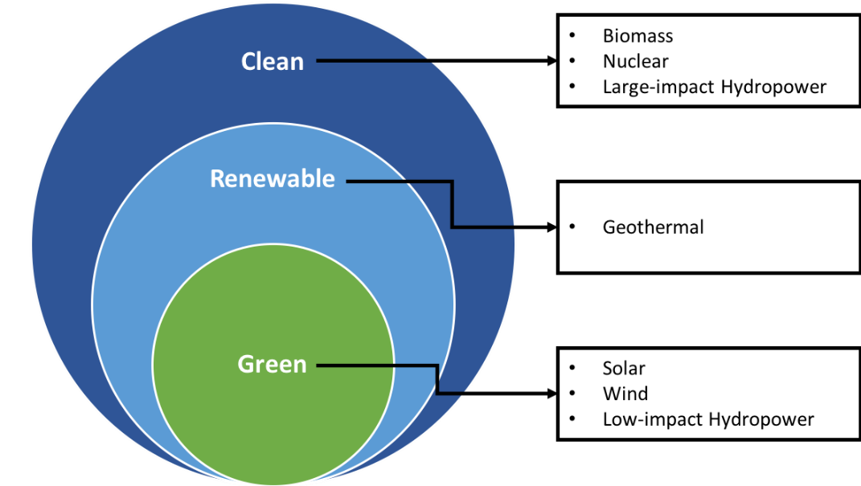

**Figure 1:**Low-Carbon Energy Sources

Research conducted by others has found that successful implementation of GHG mitigation is highly dependent on the public’s cooperativeness, activism, and involvement in forcing changes to energy production and consumption behaviours [4, 5]. Thus, any popularly-held view regarding the development benefit and/or burden of LCE holds significant insights which can influence decision making by corporations, governments, policymakers, and international organisations like the UN.

We will be primarily focusing on the US and Europe in this study given the sheer volume of activity, discourse, and debate going on in these regions, with continual advocation for a reduction in carbon emissions and attempts by lobbyists and environmentalists to influence policy, either via (a) “active means” such as legislative or legal challenges, or via (b) “passive means” such as through influencing others using social media, advertisements and articles in the media. An example of the former is when Shell was taken to court by the environmental group, Friends of the Earth, alongside six other activist groups and more than 17,000 Dutch citizens in 2019. This legal challenge resulted in a landmark ruling which requires Shell to reduce its carbon emissions by 45% by 2030, from its 2019 levels. This case is just one instance where groups of individuals band together to share a louder collective voice and are thus able to force policy-makers and businesses to move towards environmental sustainability [5].

With the ability to reach multitudes at the click of a button, sites like Reddit, Instagram, Tik-Tok and Twitter provide bite-size chucks of information to a readily available audience. The advent of social media has in fact changed how we consume and digest data. Studies have shown that audiences rely on social media to communicate, maintain and form relationships, access and spread information, debate and form opinions, and essentially formulate decisions [6, 7]. Hence, the power of persuasion using “passive means” such as advertising, debate and discourse via social media is very powerful indeed, and policy-makers and businesses cannot afford to ignore its collective power.

In this body of work, we will demonstrate that social media (in this case, Twitter) can act as a very powerful “soft” influencer by acting as a sort of social barometer to quantify how LCE is being perceived by the general public. Twitter data from US and Europe will be analysed to understand how public perceptions, areas of interests and concerns related to LCE change over time. Through spatiotemporal analysis, we can uncover meaningful insights on how LCE is viewed by the “online generation” and whether these sentiments change over time as real-world events unfold.

# Literature Review

## Twitter as the Data Source

Our choice of Twitter as the data source was based on a review of work done by previous researchers in this field, as well as Twitter having less restrictions for accessing published tweets. We considered two other platforms, Facebook and Reddit, but eliminated them as choices because of the settings of private and semi-private groups and profiles, which limited access to data on both platforms. Our own review of the literature has also found that Twitter is a fairly open communication platform that favours opinion sharing and is useful for the extraction of factors from public opinion [8]. Twitter allows users to group published tweets on topics through hashtags (represented by ‘#’) which facilitates relevant discussions surrounding a given topic. Tweet replies and retweets with a hashtag can also be visualised together, which allows users with common interests to communicate easily and allows researchers to easily identify discussions surrounding the topic of interest. For instance, Reyes-Menendez et al. (2018) looked into the hashtag ‘#WorldEnvironmentDay’ to identify economic, social, cultural, and environmental factors related to public health and environmental sustainability that most concerned Twitter users [8].

Twitter’s search algorithm is advanced; search of specific keywords returns tweets containing these words and potentially other related queries as well. Kim et al. (2021), for instance, used Twitter data to examine public sentiment towards solar energy in the United States (US) [9]. Ballestar et al. (2020) analysed tweets with the words “sustainability” or “sustainable” to investigate how these terms were used on social media, the content it entailed and the extent of which social media perceptions were aligned with scientific discourse [10]. The focus of his research was not necessarily on LCE or any particular renewable energy type.

Twitter has another interesting feature related to georeferencing, where geotagged tweets contain geographical coordinates, like longitude and latitude, as well as timestamps, which researchers can utilise for both spatial analysis as well as determination of temporal effects related to topics of interest. Like Ballestar et al. (2020), Dahal et al. (2019) did not focus on any one energy source. Rather, the work utilised timestamp and geographic coordinate information to analyse climate change discussions over time between tweets originating from users of various countries [11]. Zhang et al. (2022) analysed people’s perceptions of GHG emissions and reactions and views towards mitigation policies from the US, Australia, and Europe.

## Sentiment Analysis

Sentiment analysis (SA) is being increasingly utilised to identify the polarity and intensity of sentiments, or emotions, expressed primarily as blocks of texts [4]. Typically, it is used as a marketing analytics tool to evaluate how consumers’ feel about a particular product and/or services, but by its very nature, SA is non-specific and can be applied to any topic where ‘emotions’ are present. Polarity and intensity are classified and interpreted through the use of Machine Learning (ML) models. SA can also help to identify socio-economic, cultural, and political factors for improvement, and empower important decision-making. Furthermore, SA can aid in comparing and contrasting the nature of topic discussions.

As mentioned earlier, Reyes-Menendez et al. (2018) was interested in identifying key factors related to public health and environmental sustainability. They trained a Support Vector Machine (SVM) algorithm to classify a sample of tweets and identify topics with negative sentiment. Their study identified that most users were concerned about water and air pollution, massive industrialisation, climate change, deforestation, displacement of communities, and diminishing biodiversity.

The study by Kim et al. (2021) on sentiment towards US solar energy use utilised a “Robustly optimised Bidirectional Encoder Representations from Transformers pre-training Approach (RoBERTa)” classification model. They found that public sentiment was more positive in the Northeast US region and which tend to be more “democrat-leaning”. States that had a more mature solar market and consumer-friendly net metering policies also had more positive public sentiment [9]. This study showed how political views can be extracted and analysed with SA.

Zhang et al. (2022), in analysing perceptions of GHG emissions from the US, Australia, and Europe, used a supervised machine learning lexicon-based SA method, with a look-up table of sentiment words mapped to specific values. A distribution of overall sentiment was plotted, followed by a breakdown into satisfaction, expressed in preferences for energy resources from these countries. The study first concluded that one’s origin was a determinant in energy source preference. Secondly, there is no global “one-size” fits all solution, thus challenging policymakers to design solutions that fit the energy needs of their countries citizens, while simultaneously adhering to multilateral global standards like the Global Reporting Initiative (GRI) Sustainability Reporting Standards, which include environmental reporting in the GRI 300 series [4, 12].

Dahal et al. (2019) and Ballestar et al. (2020) applied “Valence Aware Dictionary and sEntiment Reasoner (VADER)”, a rule-based model capable of handling a variety of content, and returning sentiment polarity. Dahal et al. (2019), for instance, compared the change in sentiment pertaining to climate change between different countries over time. The analysis showed that overall sentiments were negative, predominantly because of demeaning terms used in heated discussions and negative responses towards current events, especially when users are reacting to political or extreme weather events [11].

Ballestar et al. (2020), who investigated terms “sustainability” or “sustainable” on social media, determined that ~85% of tweets about sustainability were either positive or neutral. Their research also identified topics linked to sustainability for positive and negative sentiments. Ballestar et al. (2020) found that the word ‘new’ was highly linked to positive sentiments, and negative sentiments were highly associated with ‘climate crisis’ [10].

All earlier studies confirmed that analysing sentiments expressed through tweets can help identify cultural, economic, social, and environmental factors that users were concerned about. The use of SA is thus geared towards assisting in decision making within organisations, policy & strategy development and driving environment-related financial initiatives like funds, investments, taxes and subsidies [9, 4].

## Challenges with Twitter Based Sentiment Analysis

The main limitation of using Twitter is fundamentally related to the risk of bias and poor data representation, be it from (a) profile or demographics, (b) seasonality and (c) emotion.

First, there may be biases in the collected data, given the platform demographics where the vast majority of users are younger and (usually) more politically liberal. Closely connected to this is internet penetration. In regions where this tends to be lower, selection bias is inherent, and it is reasonable to assume that the less educated, lower income, or older population will be under-represented. There is also no consideration for gender or ethnicity with this form of data collection (although this can sometimes be guessed), which can be both a good and bad thing. The positive side is that researchers are blind to the input data and thus, have no inherent selection bias. The negative is that biases already present in the data with respect to gender and ethnicity cannot be identified. Finally, there is a bias towards people who tend to be more active/vocal on social media. The antecedent to this is if parties hold views but do not feel the need to express their sentiments for fear of reprisal, what is often the issue of “the silent majority or minority” [9, 4]. A researcher’s own linguistic shortcomings also creates some form of ‘linguistic bias’, in that only data collected in English can be examined. Dahal et al. (2019), for instance, was forced to classify non-English tweets as ‘neutral’, while Ballestar et al. (2020) deliberately limited his sample set to only English tweets. While a way to overcome this is via a translation algorithm or adopting a supervised SA technique that can handle multiple languages, this is beyond the scope of this paper.

Reyes-Menendez et al. (2018) and Ballestar et al. (2020) noted issues related to the time aspect of the data. Both pointed to using a different sample of tweets from a different time period to validate their findings and ensure conclusions remain stable. Ballestar et al. (2020) also indicated that there could be more depth in their analysis by understanding how discussions evolve over time and through a geospatial view of the discussions [10, 8].

Kim et al. (2021) highlighted that the RoBERTa model was insufficient in capturing fine-grained emotions such as frustration, fear, sarcasm, etc. Likewise, Reyes-Menendez et al. (2018) acknowledged that ironies and sarcasm posed a challenge as the SVM algorithm tended to classify such tweets as neutral. Zhang et al. (2022) acknowledged a limitation in their methodology having only focused on the text, excluding symbols that could provide additional related information. All these studies suggested that such emotions can be better captured using some other ML algorithms customised for such uses.

# Scope and Methods

We aim to complement the previous work mentioned above, by utilising Twitter data to analyse public sentiment towards LCE sources. We are interested in identifying the social, economic, and political trends present, as well as potential opportunities for improvement. Our work will utilise a large data set with 17,256 points of data, and primarily focus on US and Europe (primarily due to our own linguistic shortcomings). While there is not much we can do regarding the biases present when utilising Twitter data alone, we will be analysing geospatial and temporal factors which were identified as shortcomings in previous work. Lastly, we will apply VADER in our work, which is probably most suited to capture fine-grained emotions. We note that the use of VADER is fairly novel and has not been applied to a topic of this nature to date.

## Data Collection

For data pertaining to LCE sources, we scrapped tweets that contained key phrases ‘renewable energy’, ‘clean energy’, and ‘green energy’, as well as tweets with the hashtags ‘#renewableenergy’, ‘#cleanenergy’, and ‘#greenenergy’, limiting our query to only tweets in English, and from countries/states in Europe and the US. Tweets were collected over a one year time period from June 1, 2021, to June 1, 2022. We found that having larger datasets than this became cumbersome to handle computationally (in terms of CPU cycle time and memory requirements). All scraped tweets were geotagged and contained location data. We ran unique realisations of the search query, as shown in Table 1, generating 6 different datasets. Table 2 shows the fields present in each dataset and Table 3 shows a sample of tweets in one of the datasets.

**Table 1:** Twitter Query Searches

|  |  |
| --- | --- |
| **Keywords searched** | **Location** |
| (renewable energy) OR (#renewableenergy) | USA |
| (clean energy) OR (#cleanenergy) | USA |
| (green energy) OR (#greenenergy) | USA |
| (renewable energy) OR (#renewableenergy) | Europe |
| (clean energy) OR (#cleanenergy) | Europe |
| (green energy) OR (#greenenergy) | Europe |

**Table 2:** Field Present in dataset

|  |  |
| --- | --- |
| **Field Name** | **Interpretation** |
| date_time | Date and time that the tweet was posted |
| content | Tweet content |
| hashtags | The hashtags in the tweet (if any) |
| language | Tweet language |
| user_location | User’s location |
| coord | Geographical coordinates where the tweet was posted |
| place | Country and city where the tweet was posted |

**Table 3:** Example of Scraped Tweet

|  |  |  |  |  |  |
| --- | --- | --- | --- | --- | --- |
| **date_time** | **content** | **language** | **user_location** | **coord** | **place** |
| 2021-06-01 02:57:52+00:00 | Water is infinite. Energy to access it can be renewable. Land is abundant. Every single argument against golf makes zero sense. | en | Anaheim, CA | Coordinates(longitude=-118.017789, latitude=33.788913) | Place(fullName='Anaheim, CA', name='Anaheim', type='city', country='United States', countryCode='US') |
| 2022-05-31 23:33:57+00:00 | @DebHaalandNM announces two new renewable energy initiatives at NV Energy on Tuesday afternoon, including new renewable energy offices that will streamline permitting for projects. Story coming. https://t.co/5bg8X49Mq2 | en | Las Vegas, NV | Coordinates(longitude=-115.384091, latitude=36.129459) | Place(fullName='Las Vegas, NV', name='Las Vegas', type='city', country='United States', countryCode='US') |

## Removing Duplicates

We merged the scrapped data sets such that we ended with two main master datasets, one containing tweets from Europe and the other from the US. We next computationally scanned for duplicate tweets i.e. tweets which contained more than one instance of the searched keywords. For example, there might be a tweet that contains both phrases ‘renewable energy’ and ‘clean energy’ and would show up twice. We determined that there was a total of 960 duplicates, which had to be removed from the dataset. Table 4 shows the breakdown of tweets after removing duplicates in the dataset. Our final data set comprised of 17,256 unique tweets.

**Table 4:** Breakdown of tweets post duplicate removal

|  |  |  |  |  |
| --- | --- | --- | --- | --- |
| **Tweet Key Word** | **US** | | **Europe** | |
| **Absolute** | **Percentage** | **Absolute** | **Percentage** |
| Renewable Energy | 3,439 | 32.6% | 3,524 | 52.6% |
| Clean Energy | 5,093 | 48.2% | 991 | 14.8% |
| Green Energy | 2,027 | 19.2% | 2,182 | 32.6% |
| Total | 10,559 | 100% | 6,697 | 100% |

## Regularising Tweet Texts

Tweets can often contain metadata/non-text-based information that has no value to the analysis and, therefore, can be removed. Such things include the mentioning of other users (‘@user’), quoted retweets (‘RT: …’), URLs, or unwanted characters such as HTML ampersand formatting (&amp;), which may affect SA down the line. Care must be taken, however, to ensure that not all metadata is treated similarly. For instance, emojis and emoticons were useful in SA algorithms such as VADER (which we will utilise in this work), which can handle and provide a score for emojis and emoticons. Likewise, punctuations and capitalisations were not changed as VADER is able to process emphasis through punctuations or capitalisations when generating a sentiment score. For instance, VADER treats capitalisation and exclamation points as sentiment amplifiers, scaling the positive or negative polarity of the text [11]. Hashtags are another example if users use words with hashtags as part of their text-based communication. A ‘Regular Expression’ library was used in Python to check if a tweet contained certain patterns in its text, which could be replaced or removed accordingly. Table 5 shows the specific expressions that were searched and the outcome applied to them, while Table 6 shows an example of a tweet before and after it was regularised.

**Table 5:** Regular Expression search pattern and outcome applied

|  |  |  |
| --- | --- | --- |
| **Purpose of Regular Expression** | **Text pattern to search** | **Outcome** |
| Search for quoted retweets | RT @[\w]*: | Remove |
| Search for mentioned users | (@[A-Za-z0-9_]+) | Remove |
| Search for URLs | https?://[A-Za-z0-9./]* | Remove |
| Search for HTML ampersand formatting | &amp; | Replace with ‘and’ |
| Search for whitespaces | ‘ ‘ | Remove |

**Table 6:** Tweet content before and after regularisation

|  |  |
| --- | --- |
| **Tweet content before regularisation** | **Tweet content after regularisation** |
| ‘TONIGHT: There are only a few hours left to pass a comprehensive #climate bill that prioritizes equity, jobs, &amp; justice! @DonHarmonIL, @RepChrisWelch - nearly 50 legislators won’t vote for an energy bill without a #FossilFreeFuture. #CleanEnergy #twill https://t.co/Z0D6yooaTw’ | ‘TONIGHT: There are only a few hours left to pass a comprehensive #climate bill that prioritizes equity, jobs, and justice! , - nearly 50 legislators won’t vote for an energy bill without a #FossilFreeFuture. #CleanEnergy #twill’ |

## Cleaning Location Data

An analysis of collected tweets determined that the field ‘user_location’ is unreliable as it sometimes contains metadata that can be falsified or nonsensical, fundamentally because it is a user defined field and not one that is automatically determined. For instance, several users entered ‘user_location’ information like ‘Planet Earth’ or ‘I am lost’ as their profile location.

The only verified fields are those labelled ‘coord’ and ‘place’, which provide accurate geotagging according to the location where the tweet originated. These fields tended to be complete and also did not contain spurious or nonsensical data. Hence, we will use the data from the two fields of ‘coord’ and ‘place’ for the geospatial analysis, and discard ‘user_location’ information.

We also note that because Europe is an amalgamation of countries, while the US is an amalgamation of states, data must be separated and analysed differently in each case. Table 7**:** Output after extracting city and state from US data shows an example of the output of extracting the city and state, with the ‘place’ column reflecting the original scraped data. It is evident that some city and states from the original ‘place’ column are incorrect. In this example, Delaware was wrongly categorised as the city and USA was wrongly categorised as the state. Our review of the data found 1,457 such instances of this occurring. These were manually corrected and/or removed.

**Table 7:** Output after extracting city and state from US data

|  |  |  |  |
| --- | --- | --- | --- |
| **place** | **city_state** | **state** | **Edited** |
| Place(fullName='Houston, TX', name='Houston', type='city', country='United States', countryCode='US') | Houston, TX | TX | No |
| Place(fullName='Delaware, USA', name='Delaware', type='admin', country='United States', countryCode='US') | Delaware, USA | USA | Yes |

The same method was used on Europe tweet data, but we focused instead on making sure the country was correctly represented. We found 41 instances of mislabelling – far fewer than the US data set. In this case, as we could not verify the location accurately, we instead opted to remove the spurious data. Table 8 shows the output after extracting the country and country code from tweets in Europe.

**Table 8:** Output after extracting country and country code from Europe data

|  |  |  |  |
| --- | --- | --- | --- |
| **place** | **country** | **country_code** | **Removed** |
| Place(fullName='Wexford, Ireland', name='Wexford', type='city', country='Ireland', countryCode='IE') | Ireland | IE | No |
| Place(fullName='United States', name='United States', type='country', country='United States', countryCode='US') | United States | US | Yes |

# Sentiment Analysis using Valence Aware Dictionary for Sentiment Reasoning (VADER)

The method of SA applied in this study is “Valence Aware Dictionary for Sentiment Reasoning (VADER)” – an unsupervised, lexicon and heuristic based model to classify tweet sentiments. VADER is computationally efficient compared to building and training a new supervised SA model [10].

VADER works by mapping lexical features (i.e. words), labelled according to their semantic orientation, returning a metric score for the sentiment of the tweet. It not only returns if a tweet is positive or negative, but also how positive or how negative the tweet’s sentiment is – also known as sentiment polarity. VADER handles more than 7,000 items and their associated sentiments, and the quality of these measures were validated by humans before adding them to VADER’s sentiment lexicon library [10].

VADER is specifically attuned to handle sentiments expressed in social media content and it was found in prior studies to even outperform individual human reviewers. VADER is also able to factor in emojis, punctuations, capitalisations, and repeated words via heuristics, making it ideal for use with Twitter data [13]. Table 9 provides an illustration of how the score generated by VADER varies according to different emotional cues commonly used in social media content.

**Table 9:** Example of VADER score for different emotional cues

|  |  |
| --- | --- |
| **Example: Positive** | **VADER compound score** |
| I love how renewable energy is becoming more accessible and affordable for everyone. | 0.7430 |
| I love how renewable energy is becoming more accessible and affordable for everyone! | 0.7644 |
| I LOVE how renewable energy is becoming more accessible and affordable for everyone! | 0.8087 |
| I LOVE LOVE LOVE how renewable energy is becoming more accessible and affordable for everyone! | 0.9595 |
| **Example: Negative** | **VADER compound score** |
| I'm so sad that our earth is literally dying | -0.5256 |
| I'm so sad that our earth is literally dying :( | -0.7425 |
| I'm so sad that our earth is literally dying! :( | -0.7639 |
| I'm SO SAD that our earth is literally dying! :( | -0.8422 |

We illustrate how VADER produces its compounded score with the schematic shown in Figure 2**:**. First, VADER examines the lexical features in a tweet, i.e., the words that are present, to determine a preliminary score, before applying five different rules according to grammatical conventions and general syntactic to modify that score [10, 11] . The rules treat capitalisations and exclamation points as sentiment amplifiers, which scale the polarity of positivity/negativity, and are able to handle negations (e.g. the word “not”) as well as contrastive conjunctions (e.g. the word “but”) [11]. Each tweet is given three unique probability values i.e. P(Negative), P(Neutral), and P(Positive). Next, the model then generates a ‘compound score’ as a final sentiment score for a given tweet, calculated by summing the valence scores of each word in the lexicon (which have been adjusted according to rules). Valence scores are score assigned to the word under consideration by means of observation and experiences rather than pure logic. Finally, the ‘compound score’ is normalised to between -1 (most extreme negative) to +1 (most extreme positive).

The likelihood of erroneous classifications (false negatives and/or false positives) is handled by increasing the threshold for what is identified as neutral. While the score for a ‘neutral’ tweet is typically between –0.05 to 0.05, we expanded this range to between –0.25 to 0.25, with the view that the sentiment score of a tweet being close to a 0 threshold is highly unlikely. The only other instance where a neutral sentiment score of 0 is applied is when non-English words are present in the parsed text. As VADER is lexographic, it utilises a dictionary containing only English words, and if it is unable to identify new entities that are not in the existing lexicon, it defaults to this value.

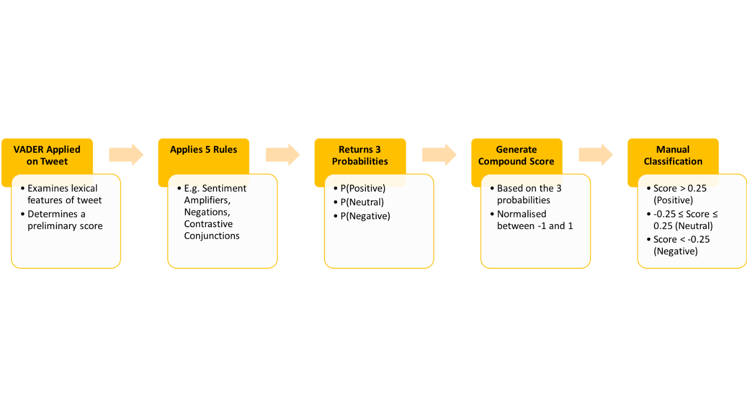

**Figure 2:**VADER process and sentiment classification

To determine VADER’s effectiveness, we created a small test subset of specifically curated data, where there were clear negative, neutral and positive sentiments associated with each statement. We then determined the scores for each sentiment, the final compound score, and finally the overall sentiment classification. The results are given in Table 10. It can be seen from the results that while Tweet #1 had the highest neutral score, it was still correctly classified as negative, because VADER was able to correctly identify the impact and perceived intensity of sentiment present in the statement via heuristic-based rules. In this case, the insinuation being that the user was ignorant and not well read on the facts of the discussion. For Tweet #2, once again, the neutral sentiment was scored the highest, and the compound score despite being negative, is correctly classified as neutral because it falls within our defined neutral threshold of –0.25 to 0.25. Tweet #3 again had the highest neutral score but via heuristic-based rules, the capitalisation presents in the statement likely influenced the polarity of the compound score.

**Table 10:** Example of VADER output and sentiment classification

|  |  |  |  |  |  |  |
| --- | --- | --- | --- | --- | --- | --- |
| **No.** | **Tweets from Dataset** | **Negative** | **Neutral** | **Positive** | **Compound** | **Sentiment** |
| 1 | Do a little reading. Abbot is opposed to green energy and doing his best to kill it. And loss of power was mostly a failure of gas and nuclear plants. | 0.248 | 0.601 | 0.151 | -0.6124 | Negative |
| 2 | Water is infinite. Energy to access it can be renewable. Land is abundant. Every single argument against golf makes zero sense. | 0.106 | 0.805 | 0.089 | -0.1027 | Neutral |
| 3 | WE NEED A MANHATTEN PROJECT TO CLEAN UP PLASTICS. TO ME IT REPRESENTS OUR GREATEST GREEN ENERGY PROBLEM. PLASTICS ARE FOUND IN OUR SEA LIFE, SOME PLACES IT HAS EFFECTED CURRENTS, AND TEMPERATURES. | 0.066 | 0.713 | 0.221 | 0.7430 | Positive |

# Results and Discussion

## Tweet Distribution in the US

Before performing a deep dive into the SA demonstrated by the data, we firstly need to holistically view the data and identify key features/events of significance that may potentially result in us misinterpreting the results later. Shown in Table 11 and Figure 3 is the tweet volume distribution for topics which discuss clean, green, and renewable energy within the US for the one-year period from June 1, 2021, to June 1, 2022, split monthly. We note a significant spike in tweet volume around in March 2022, lasting till the end of the analysis period, primarily related to the intensification of the Russia-Ukraine war. Russia is a major player in global energy markets as the world’s largest gas exporter and one of the largest oil exporters as a member of OPEC+. The war sparked lively discussions around possible spikes in energy prices, potential shortfalls of fossil fuel exports from Russia and its implications, and by extension, discussions into the need to diversify energy sources and/or types of alternative energy sources like renewable, clean, and green energy likely picked up.

**Table 11:** Tweet Volume Distribution

| **Month** | **Clean Energy** | **Proportion of Monthly Tweets** | **Green Energy** | **Proportion of Monthly Tweets** | **Renewable Energy** | **Proportion of Monthly Tweets** | **Monthly Total** |
| --- | --- | --- | --- | --- | --- | --- | --- |
| Jun 2021 | 354 | 45.38% | 162 | 20.77% | 264 | 33.85% | 780 |
| Jul 2021 | 338 | 47.47% | 138 | 19.38% | 236 | 33.15% | 712 |
| Aug 2021 | 359 | 51.58% | 113 | 16.24% | 224 | 32.18% | 696 |
| Sep 2021 | 431 | 53.74% | 138 | 17.21% | 233 | 29.05% | 802 |
| Oct 2021 | 587 | 56.44% | 148 | 14.23% | 305 | 29.33% | 1,040 |
| Nov 2021 | 468 | 48.95% | 198 | 20.71% | 290 | 30.33% | 956 |
| Dec 2021 | 358 | 51.14% | 117 | 16.71% | 225 | 32.14% | 700 |
| Jan 2022 | 263 | 51.87% | 76 | 14.99% | 168 | 33.14% | 507 |
| Feb 2022 | 280 | 41.85% | 133 | 19.88% | 256 | 38.27% | 669 |
| Mar 2022 | 550 | 37.70% | 391 | 26.80% | 518 | 35.50% | 1,459 |
| Apr 2022 | 567 | 48.88% | 243 | 20.95% | 350 | 30.17% | 1,160 |
| May 2022 | 538 | 49.91% | 170 | 15.77% | 370 | 34.32% | 1,078 |
| **Total** | **5,093** |  | **2,027** |  | **3,439** |  | **10,559** |

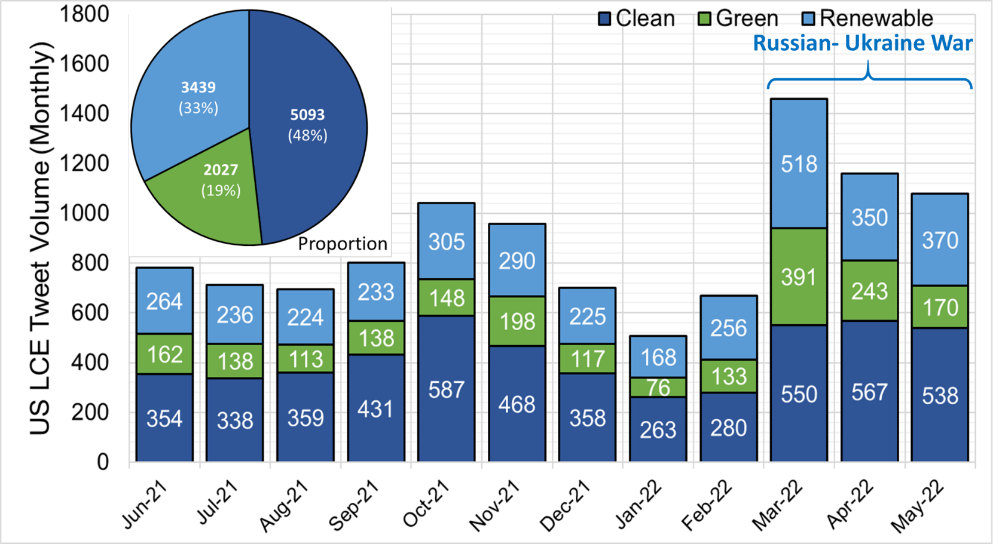

**Figure 3:** Tweet volume discussing LCE within the US

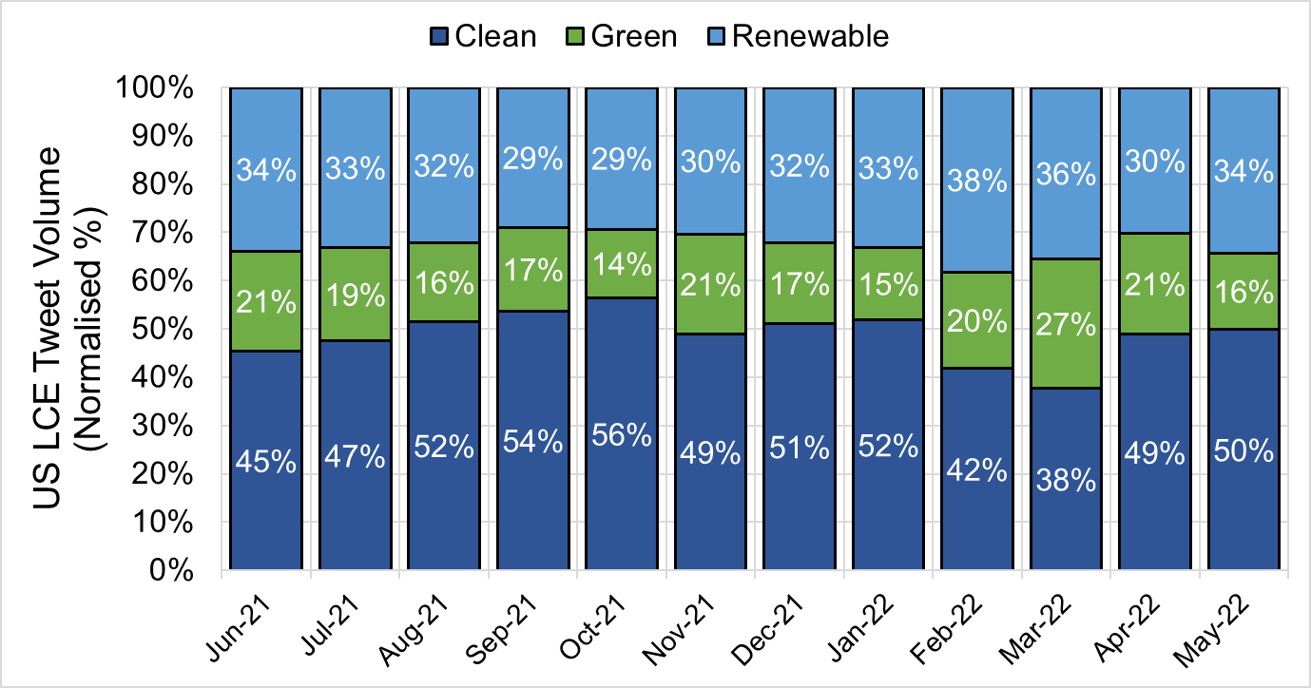

**Figure 4:** Normalised tweet volume discussing LCE within the US

We next show a breakdown of the tweet distribution by state (Table 12), plotting the results on a choropleth for easy visualisation (Figure 5). California (shaded in dark purple) contributed the highest volume over the period, making up 13.17% of all US tweets. Overall, the top 5 states are given in Table 12.

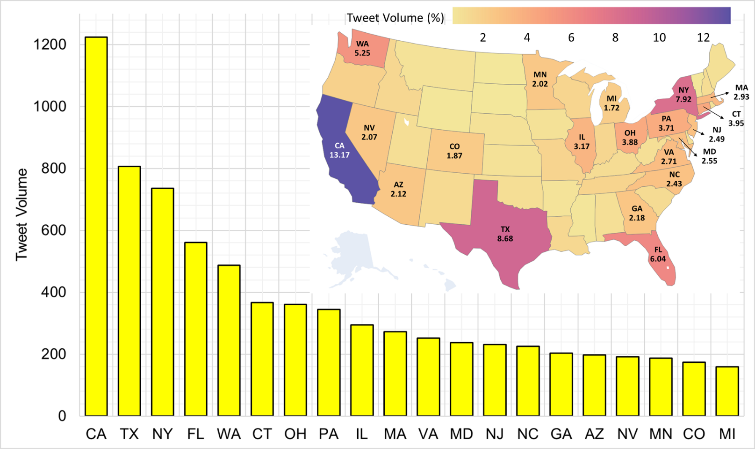

**Figure 5:** Tweet volume by US state (top 20)

**Table 12:** Top 5 states in the US, ranked by tweet volume

|  |  |  |
| --- | --- | --- |
| **State** | **Proportion (%)** | **Absolute** |
| California | 13.17 | 1,224 |
| Texas | 8.68 | 807 |
| New York | 7.92 | 736 |
| Florida | 6.04 | 561 |
| Washington | 5.24 | 488 |

## Tweet Distribution in Europe

Figure 6 and Figure 7 shows the monthly distribution of LCE tweets in Europe through the same one year period. 2 events stand out quite clearly. The first was during the the period of October-November 2021, when the UN Climate Change Conference in Glasgow (COP26) took place. We similarly note spikes in March to May 2022, in relation to the Russina-Ukrainian war.

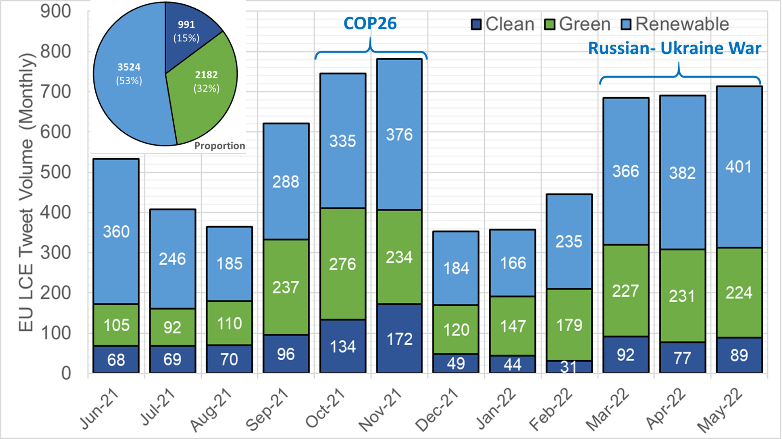

**Figure 6:** Tweet volume discussing LCE within Europe

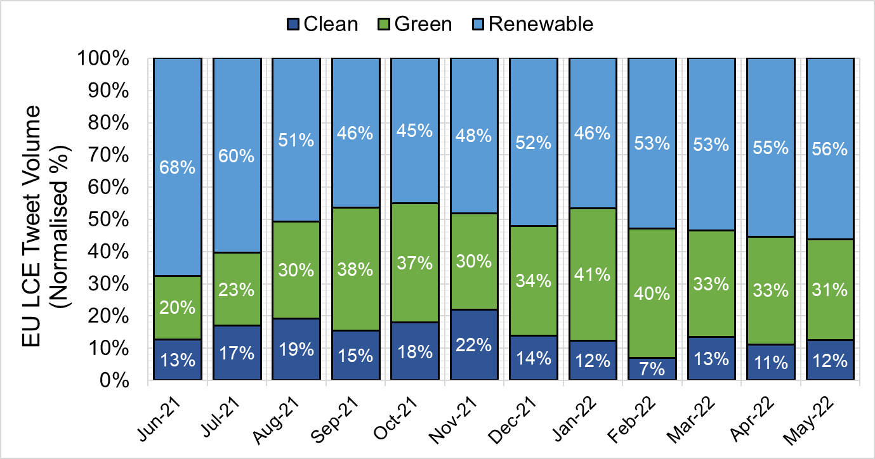

**Figure 7:** Normalised tweet volume discussing LCE within Europe

As was done for the US, tweet volume for Europe was analysed by country, with

Table **13** revealing the top five countries by tweet majority. Tweets from the United Kingdom made up most of the volume of Europe tweets (>50%). However, there are far fewer tweets from the other major countries in Europe, primarily because of language. Users in the United Kingdom and Ireland are primarily English speakers, while Europe is very linguistically diverse. Our method of scraping has unfortunately omitted tweets in other major European languages such as German, French, and Spanish.

**Table 13:** Top 5 countries in Europe, ranked by tweet volume

|  |  |  |
| --- | --- | --- |
| **Country** | **Proportion (%)** | **Absolute** |
| United Kingdom | 55.07 | 3,665 |
| Ireland | 19.50 | 1,298 |
| Germany | 3.94 | 262 |
| France | 2.52 | 168 |
| Belgium | 2.28 | 152 |

## Sentiment Proportion

We observe from Figure 8 that most tweets tend to portray a positive sentiment at 76.1% of all scrapped tweets, while 14.7% were classified as neutral, and 9.2% as negative.

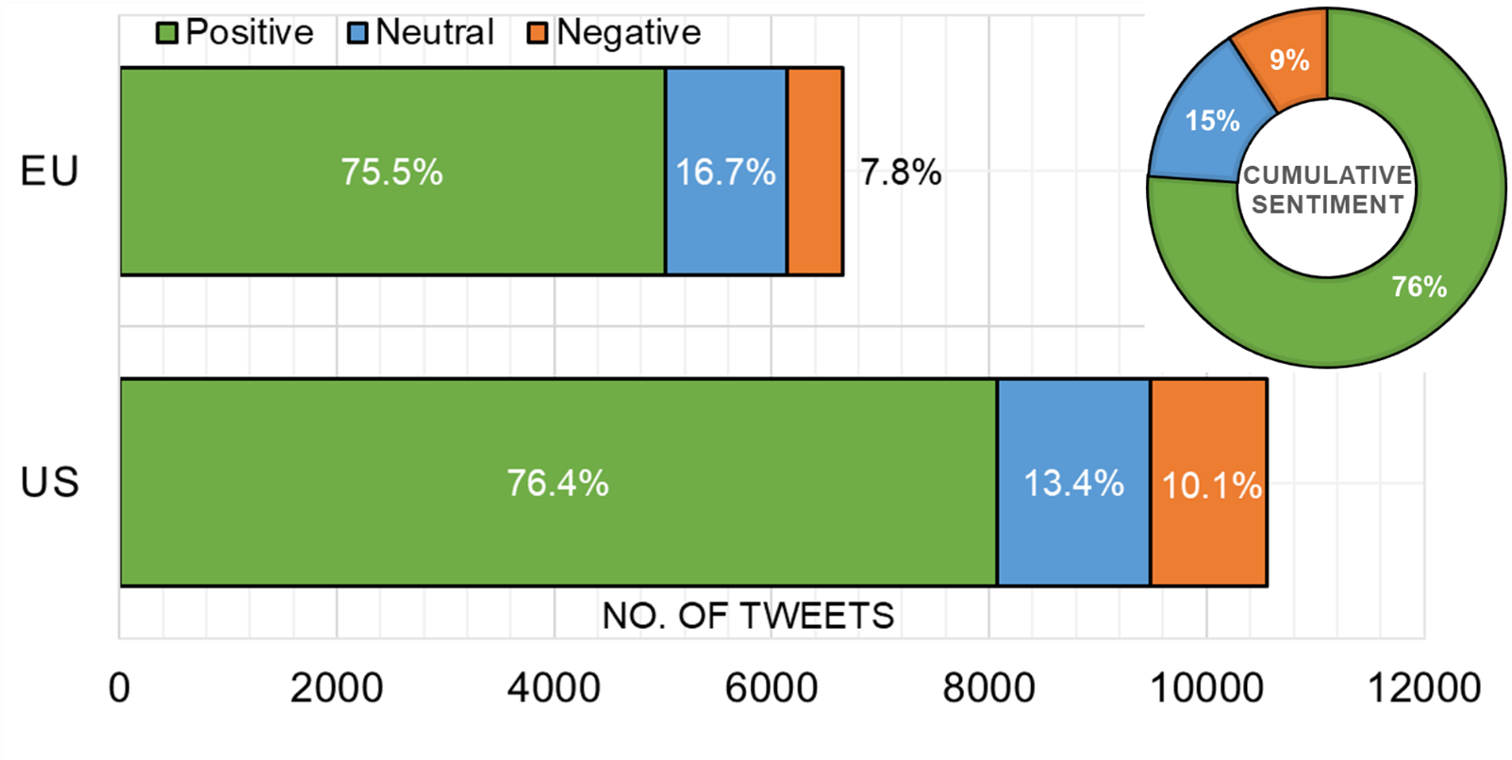

**Figure 8:** Sentiment proportion in the US and in Europe (the inset is the cumulative proportion for of all tweets)

The breakdown of sentiment proportion in the US and in Europe is shown in **Error! Reference source not found.**. We note that the proportion of positive tweets in both regions is similar (76.4% in the US and 75.5% in Europe), which indicates that users view this topic as important and worthy of pursuit. Interestingly, Europe has a larger proportion of neutral tweets as compared to the US; while the US had a larger proportion of negative tweets as compared to Europe.

The wealth of data allows us to perform a deep dive into the exact sentiments driving positive, neutral and negative views. We breakdown the associated text bodies into a series of keywords which was often mentioned. We remove default “stop-words” along with other words that can bias our interpretation, like ‘clean’, ‘green’, ‘renewable’, ‘energy’, ‘cleanenergy’, ‘greenenergy’, and ‘renewableenergy’. We use a word cloud approach to visualise the ten most frequent words (Figure 9) with which we shortlist the top five most commonly occurring words.



**Figure 9:** Word Cloud – US positive tweets

### Positive Sentiment Towards Low Carbon Energy Sources - US

Our review of the data reveals that the most frequent word is ‘solar’, where users were engaging in discourse regarding the benefits solar brings and raising awareness about the feasibility of solar energy as a viable alternative energy source. We observed that tweets covered a spectrum of topics and scales. There were users which discussed adoption of solar at an individual level, such as installing solar panels, while there were others that wanted discussions to be broader and have further reaching consequences, such as at federal and state level, including discussions garnering support for petitions for legislators to make solar energy affordable and easily accessible. For example, one user tweeted “Join me in telling our legislators that everyone deserves access to clean, affordable solar energy! SIGN HERE:”.

An interesting topic which appeared was how crypto mining processes are increasingly using LCE sources. For example, one user tweeted “Completely in agreement that Bitcoin fights climate change. It incentivizes renewable energy production and helps make grids more efficient.”. Another user tweeted “Based on studies from Cambridge University and CoinShares, 39% to 77% of energy used by $BTC miners comes from renewable sources. That’s more than any industry as a whole. It’s also more than powerhouse countries like the U.S., U.K., and Germany! #crypto #Bitcoin”.

The second most populous words were ‘climate’ and ‘fuel’, with each appearing 707 times. This is likely due to President Joe Biden’s positive messaging regarding climate and energy bills and how LCE can positively drive decarbonisation. This uptick is also likely bolstered by the US’s re-involvement in climate pacts post the Trump administration. For example, one user tweeted “Joe Biden’s proposed budget includes $192 million in new funding for this agency to do more research on climate change and clean energy projects related to ag. This is critical for the industry.”.

We also observed a series of tweets advocating positive climate actions and a move away from oil and other pollutive fossil fuels. With the word ‘fuel’, most were users sharing their opinions on using fossil fuels compared to LCE in anthropogenic activities. There were also tweets discussing fuel prices and inflation, which is in line with the findings present in Figure 3 regarding the Russia-Ukraine war. For example, one user tweeted “Long term, the world is unquestionably better off in a mostly renewable energy powered planet. A) Inherently less inflationary (better for Global GDP Growth). B) Reduces OPEC+ nations geopolitical relevance (Russia ≠ leverage over Europe). Long term ambition, but important.”. Another tweet mentioned “Not running on gas and oil but educating voters about the cause of inflation being tied to Putin and gas company greed. These are great reasons to transition away from fossil fuels to clean energy in addition to combating the climate crisis.”.

**Table 14:** 5 most impactful words – US positive tweets

|  |  |  |
| --- | --- | --- |
| **Word** | **Frequency** | **Proportion (%)** |
| solar | 984 | 0.82% |
| climate | 707 | 0.59% |
| fuel | 707 | 0.59% |
| need | 692 | 0.58% |
| power | 639 | 0.53% |
| **Total Words (All Tweets)** | **120,091** | **100%** |

### Positive Sentiment Towards Low Carbon Energy Sources – Europe

Table 15 shows the 5 most frequent words for positive tweets in Europe. The most frequent word ‘solar’ appeared 1,115 times and was mainly used in tweets advocating the effectiveness of solar power and photovoltaic technology. Many users shared how much energy is being produced from solar panels they had installed. It was also discovered that the following words ‘Ireland’, ‘ClimateAction’, and ‘EnergyTransition’ were trending hashtags used in similar tweets. For instance, one user shared in a tweet saying, “Ikea and Rockefeller foundations in $10bn clean energy push hoping they can finance more than $10bn of small-scale renewable power projects to try to lift more than 1bn people out of #energypoverty via #EnergyTransition #Renewables #ClimateActionNow”. Another user tweeted using the same hashtags “Copper boom: how clean energy is driving a commodities supercycle. More #copper projects are needed for increasing demand of #windturbines and #ElectricVehicles via #EUGreenDeal #ClimateActionNow #EnergyTransition #electriccars #Timmermans”. This points to the effectiveness of Twitter in anchoring discussion topics among users with common interests through the use of hashtags.

**Table 15:** 5 most impactful words – Europe positive tweets

|  |  |  |
| --- | --- | --- |
| **Word** | **Frequency** | **Proportion (%)** |
| solar | 1,115 | 1.47% |
| Ireland | 802 | 1.06% |
| ClimateAction | 777 | 1.02% |
| EnergyTransition | 724 | 0.95% |
| home | 700 | 0.92% |
| **Total Words (All Tweets)** | **75,983** | **100%** |

### Neutral Sentiment Towards Low Carbon Energy Sources – US

A deeper look into tweets with neutral sentiment in the US (Table 16) uncovered that tweet mainly involved sharing facts and numbers for the various energy sources with no particular stance on the topics. For instance, the most frequent word ‘solar’ was mainly used in tweets that shared statistics. One user tweeted “The Taihang solar farm in China is built right into the local mountains and reduces 251,000 metric tons of carbon dioxide emissions every year #RenewableEnergy #solarenergy” and another user tweeted “With the commission of a new #solar facility today, will surpass 10,000 #megawatts of #RenewableEnergy. That’s the equivalent of 2.4 Million customers at peak production”. While it logically sounds like a good thing, VADER considers such statements of fact as being difficult to classify as either positive or negative.

The second most frequent word ‘oil’ however, involved more opinionated tweets but with no particularly strong positive/negative sentiment. This is likely due to the adjusted threshold where we expanded the range for neutral tweets from –0.05 to 0.05 to between –0.25 to 0.25, meaning that there are tweets that are slightly positive/negative, but do not have adequate polarity to be classified as a positive/negative tweet. Some examples that contain the word ‘oil’ are “Isn’t it ironic that the American oil companies that formed Aramco fight green energy use in America” and “It's time to build up clean energy so we don't have to deal with the dangers of transporting oil.”.

**Table 16:** 5 most frequent words – US neutral tweets

|  |  |  |
| --- | --- | --- |
| **Word** | **Frequency** | **Proportion (%)** |
| solar | 212 | 1.02% |
| oil | 147 | 0.71% |
| fuel | 130 | 0.63% |
| gas | 125 | 0.60% |
| climate | 122 | 0.59% |
| **Total Words (All Tweets)** | **20,746** | **100%** |

### Neutral Sentiment Towards Low Carbon Energy Sources - Europe

Likewise, the tweets mainly contained the sharing of facts and statistics or raising awareness for projects with no particularly polar emotional cues. The most frequent word from tweets with neutral sentiments in Europe was also ‘solar’ where users were mainly sharing facts rather than personal opinions (Table 17). One user tweeted “Icelandic communities are driving major #renewableenergy transformation in Grimsey under SMARTrenew, which aims to install #wind turbines, producing 30,000kWh a year with additional plans for a #solarpower plant to produce up to 10,000kWh per year.” This finding was consistent for the other frequent words found in neutral sentiment tweets in Europe. For instance, the second most populous word “Ireland” was used in tweets such as the following “Do you think that High demand and lack of supply would accelerate energy innovation in Ireland, especially for renewables? Therefore, increasing overall capacity on the grid. Would this act as an accelerant? Meet demand while keeping our 2030 emissions and renewable targets in mind”, where the tweet was not particularly skewed towards a positive or negative sentiment. While a logical human thinker may assign the nuances in the words to be either positive or negative, it is hard for a computational approach to do this.

**Table 17:** 5 most frequent words – Europe neutral tweets

|  |  |  |
| --- | --- | --- |
| **Word** | **Frequency** | **Proportion (%)** |
| solar | 241 | 1.47% |
| Ireland | 193 | 1.18% |
| home | 191 | 1.16% |
| ClimateAction | 186 | 1.13% |
| EnergyTransition | 182 | 1.11% |
| **Total Words (All Tweets)** | **16,412** | **100%** |

### Negative Sentiment Towards Low Carbon Energy Sources - US

Table 18 shows the 5 most frequent words for negative tweets in the US. The word ‘oil’ is the most frequent word with 153 appearances in US negative tweets. Tweets with ‘oil’ were largely surrounding the negative environmental repercussions caused by the operations of large oil companies and the ineffectiveness of mitigating policies. For example, one user tweeted “Big Oil’s green energy and carbon tax push is just smoke and mirrors. How they advocate may technically be legal, but these big oil companies are guilty of crimes against humanity.”. Furthermore, users were also advocating to transition away from oil. For instance, one user tweeted “This is so tragic! If this event doesn’t change the minds of those “on the fence” about clean energy I’m not sure what will. These oil companies are destroying our oceans and when they are no longer a viable habitat for the ocean creatures the earth will not be viable for us.”.

The second most populous word ‘need’ was used mainly to advocate the need to transition to low-carbon energy sources as seen in the following tweet referring to US Senator Joe Manchin saying “J Manchin, we need the green energy in the Biden infrastructure plan. You Joe are complicit in killing creation.”. Negative tweets in the US with the word ‘climate’ was mainly seen in discussions about the climate crisis. One user tweeted “Is anyone listening? We need to decarbonize immediately and sequester what is already in our atmosphere now or suffer the disastrous consequences of our inaction on climate. #ClimateCrisis #ClimateAction #climatesolutions #GreenNewDeal #renewableenergy”. Quoting another tweet which was also pointed at US Senator Joe Manchin on the climate crisis, the tweet mentioned “Hey Manchin, from the home front in WV, our skies are filled with smoke and poisonous particulate matter from climate change caused fires. We need green energy and union jobs”.

We would like to highlight something at this juncture – that while we refer to tweets as being “negative”, what we mean is that these tweets still advocate for transition to LCE; they are “negative” in tone or expression only. Such tweets highlight negative environmental impacts and advocate for more action to transition from oil. The “negativity” is therefore not against LCE sources necessarily but rather against the pace of change and lack of political will, that to “tweeters” is potentially exacerbating or accelerating the environmental decline.

**Table 18:** 5 most frequent words – US negative tweets

|  |  |  |
| --- | --- | --- |
| **Word** | **Frequency** | **Proportion (%)** |
| oil | 153 | 0.87% |
| need | 117 | 0.66% |
| climate | 116 | 0.66% |
| fuel | 109 | 0.62% |
| fossil | 102 | 0.58% |
| **Total Words (All Tweets)** | **17,682** | **100%** |

### Negative Sentiment Towards Low Carbon Energy Sources – Europe

For tweets in Europe with negative sentiments, Table 19 shows the five most frequent words. The word ‘gas’ is the most frequent word with 85 appearances. Tweets with the word ‘gas’ comprised various topics but was most commonly used in discussions around gas prices due to the energy crisis – which is also the reason for the fifth most frequent word, ‘price’. For instance, one user tweeted “Orkney is currently generating more renewable electricity than it is using according to live data, yet consumers here are being pushed further into fuel poverty by the price surge in the gas and electricity market. #orkney #energy”. The majority of discussions revolved around the gas price crisis and its impacts. Some users tweeted about the collapse of energy suppliers in the UK, such as Avro Energy and Green, which resulted from the increase in gas prices. One user tweeted “That #energy crisis - with the collapse of Avro Energy and Green seven energy companies have gone bust in six weeks. A total of over 1.5m households now forced to find a new supplier and pay hundreds of pounds more for their gas and electricity per year. It’s not even over yet”. Avro Energy, with 580,000 customers at the time, was the largest supplier to exit UK’s energy market in 2021, followed by Green, with 250,000 customers [14].

Numerous discussions surrounded the topic of the Russia-Ukraine war and the impact this will have on gas supply and demand, given that Russia is the largest gas exporter in the world. One user tweeted “Russia’s war should accelerate the green transition - #UkraineInvasion has laid bare the folly of maintaining fossil-fuelled energy systems that are no longer fit for purpose via #OlafScholz #RobertHabeck #FransTimmermans #ClimateActionNow #EUGreenDeal” and another user tweeted “Surely European countries need to reduce their reliance on Russian gas/oil, by heavily investing in renewable energy technologies. We need to stop this obsession with growing NATO too. What does it achieve? Besides putting us on the verge of war, that is.”

In response to the gas price crisis, users actively shared their opinions on alternative energy sources. For instance, one user tweeted “Energy prices will double in April. Doesn't that show the current energy system is broken? There is no future in fossil fuel energy, we must invest in long term, green, clean renewable alternatives. No more EU gas #greenwash #FridaysForFuture #ClimateStrike #UprootTheSystem”. Another user tweeted to advocate moving towards sustainable energy sources and to stop the development of ‘Cambo’ – referring to the Cambo oil and gas field to be developed offshore Shetland Islands, Scotland – saying “Hi the gas price crisis has shown us how vulnerable we are to our reliance on fossil fuels. The solution to this and the climate crisis are the same – sustainable renewable energy. Stop Cambo and focus on renewable energy #BorisStopCambo”. We also found that users were particularly vocal on government policies pertaining to energy, which they largely attribute to the cause of the energy crisis. One user tweeted “Our bills are high because of the government's (past and present) failure to make our country self-sufficient when it comes to energy. Failure to extract more of our own gas due to a ridiculous green agenda and green taxes are why our bills are so high”.

Almost all discussions with the word ‘fuel’, which appeared 60 times, was around the damaging effects of fossil fuel for energy and advocating for alternative low-carbon energy sources. Similarly, the word ‘need’ was largely used to discuss the importance of energy transition. The word ‘price’ also revealed some interesting tweets which largely blamed governments and policymakers for the energy crisis and skyrocketing prices. Tweets also showed discontent with prices for green energy adoption and users being unable to adopt low-carbon energy sources as a result.

Similar to negative tweets in the US, negative tweets in Europe were actually ‘positive’ for the transition to LCE sources as the negativity was mostly directed towards reliance on Russia, increasing gas prices, and policymakers’ decisions that continue to favour fossil fuels.

**Table 19:** 5 most frequent words – Europe negative tweets

|  |  |  |
| --- | --- | --- |
| **Word** | **Frequency** | **Proportion (%)** |
| gas | 85 | 0.95% |
| fuel | 60 | 0.67% |
| need | 59 | 0.66% |
| price | 54 | 0.60% |
| now | 52 | 0.58% |
| **Total Words (All Tweets)** | **8,978** | **100%** |

## Overall Differences in Sentiments – US and Europe

Positive tweets in the US covered more topics, such as crypto mining, Joe Biden’s climate and energy bills, and the Russia-Ukraine war. For Europe, discussions mostly focused on the benefits of LCE sources and developments in the transition towards LCE. Neutral tweets were similar in US and Europe, where tweets in this class mostly shared facts and statistics with no distinct emotional polarity. Negative tweets in the US contained users mainly condemning oil companies and advocating for the need for sustainable energy sources to curb the climate crisis. The majority of negative tweets in Europe involved user opinions on the gas price crisis, its impacts, potential causes, and potential solutions. Negative tweets in both the US and Europe involved discussions around policy making – suggesting the importance that users place on government decisions in LCE adoption.

## GDP (not Politics) as Tweet Sentiment Proxy

We were interested in understanding if socio-economic indicators could potentially explain some of the sentiments expressed by Twitter users. We had two postulates. The first was that political affiliation is potentially a proxy for expressed tweet sentiment, with more ‘right-wing’ states viewing LCE less favourably [15]. The second was that Gross Domestic Product (GDP) is correlatable to Tweet sentiments. The assumption is that the better off one’s economic state, the better educated and the more internet-savvy one becomes, and the more informed one would become (with greater access to information) regarding the merits (or demerits) of LCE.

### Understanding Sentiment Scores in the United States

We started our analysis by looking at the US data, at a state level. The score presented in Table 20 is the average sentiments of ‘Democrat’ versus ‘Republican’ states. We observed that all states had scores above 0 (i.e. ‘positive’), but with the state of South Dakota falling within the ‘neutral’ class. Tweets from ‘Democrat’ states had an average sentiment of 0.460, which is only slightly more positive than ‘Republican’ states with an average sentiment of 0.448. Given the relative similarity, we did not view political affiliation as having a significant impact on sentiments towards LCE sources within the US. We ran into great difficulty when applying a similar analysis to the data set from Europe; the sheer diversity of political affiliations across the various European nations made this analysis impossible. We therefore abandoned this line of enquiry and focused on GDP instead, which is a much more quantitative comparator (Table 21).

**Table 20:** Average sentiment by political landscape

|  |  |  |
| --- | --- | --- |
|  | **Blue States (Democratic)** | **Red States (Republican)** |
| **Average Sentiment** | 0.460 | 0.448 |

Breaking down the individual scores per state (Table 21), the state with the highest sentiment is Vermont, with a score of 0.754, while the state with the lowest sentiment is South Dakota with 0.201. In general, we observed that states with the highest sentiments have a higher GDP (exceptions being Vermont and Wyoming) of >US$100B, whereas states with the lowest sentiments generally have a lower GDP (Kansas is an exception at US$162B). We note that Vermont, with no fossil fuel industry, already produces almost 100% of its in-state electricity from renewable sources since 2021 [16]. The population is therefore already naturally well informed and understand LCE sources and the importance it plays, and hence the score is no surprise, despite the low GDP.

**Table 21:** GDP and Average Sentiment of top and bottom 5 states

|  |  |
| --- | --- |
| **Highest Sentiment** | **Lowest Sentiment** |
| |  |  |  | | --- | --- | --- | | **State** | **Average Sentiment** | **2021 Real GDP (Billions of [Chained] 2012 Dollars)[1]** | | Vermont | 0.754 | 30.547 | | Wyoming | 0.613 | 36.400 | | Arkansas | 0.591 | 123.347 | | Utah | 0.555 | 186.910 | | Oklahoma | 0.549 | 193.230 | | |  |  |  | | --- | --- | --- | | **State** | **Average Sentiment** | **2021 Real GDP (Billions of [Chained] 2012 Dollars)** | | South Dakota | 0.201 | 49.558 | | New Mexico | 0.313 | 93.625 | | Maine | 0.329 | 63.595 | | Kansas | 0.340 | 162.291 | | North Dakota | 0.349 | 53.804 | |

Utah, Oklahoma and Wyoming have high sentiment scores of >0.5. We view this as an interesting finding, as these states have a significant oil and gas industry. Production from Utah is primarily from the Uinta and Paradox Basin, while Oklahoma is home to large oil fields such as the Greater Anadarko Basin and the Woodford Shale, both of which hold billions of barrels of resources. Wyoming was the eighth-largest crude oil producer and the ninth-largest natural gas producing state in 2021, however, Wyoming’s wind power more than doubled from 2019 and provided 19% of its electricity generated in 2021 [17]. We think that such high sentiment scores stem from optimism about future developments i.e. positive tweets demonstrate both the residents’ and government’s commitment to sustainable economic growth. There might be a view that benefits like job creation, upskilling and future-proofing of residents, attracting investment to the region, and diversifying the economies are far more important than just relying on the oil and gas industry, which is often mercurial with economic growth tied strongly to the oil price at the time. Arkansas, Utah, and Oklahoma also have significant areas of untapped wilderness, and environmental concerns may be important to many residents. Positive sentiment could reflect a desire to protect the states’ natural environment and reduce carbon emissions. Another possibility could be the shift in public opinion and state governments promoting/incentivising LCE projects or implementing policies that require utilities to adopt LCE sources. For instance, Arkansas passed the Solar Access Act in 2019, which allows homeowners and businesses to install solar panels on their properties without interference from homeowners’ associations [18]. Such a policy signals the willingness of the state to encourage LCE sources.

For the states with the lowest sentiment scores and < US$100B in GDP, New Mexico and North Dakota are major oil-producing states. In 2021, New Mexico was the second largest crude oil producing state, producing 11.1% of crude oil in the US, and North Dakota was the third largest, producing 9.9% of US crude oil [19]. These states have a significant economic dependence on the oil and gas industry. This economic dependence coupled with the already lower GDPs may cause resistance towards transitioning to LCE, with the view that unknowns such as LCE can threaten the stability of the (already fragile) economy, and chase away oil companies who are major employers. South Dakota has, over the years, begun more ethanol production. In 2021, South Dakota was the fourth leading ethanol-producing state in the US [20]. While there are arguments that ethanol represents a “greener” form of transport fuel (falling into the biomass category), it can potentially produce significant amounts of CO2 if blended with gasoline for transport, and thus, not everyone is convinced it can correctly be described as LCE [21]. Kansas is another major oil-producing and oil-refining state, accounting for 1% of both US-proved crude oil reserves and total oil production [22]. It is also home to 13 ethanol plants with a combined production capacity of approximately 603 million gallons per year – making it the ninth-largest ethanol-producing state [22]. With the oil & gas and biofuels industry accounting for a significant portion of the state’s economy (both historically and currently), residents and policymakers may be more resistant to the idea of transitioning fully to LCE, as it could threaten existing industries and employment opportunities. Political factors may also be at play as the state’s Republican governor has expressed scepticism towards renewable energy and has sought to roll back environmental regulations [23]. However, we have observed that there is an ever-increasing trend towards more LCE “savviness” in the state of Kansas. We have determined, for instance, that coal consumption is being replaced by wind, with the latter becoming the largest energy source for electricity generation in 2019, and continued through 2021, where wind accounted for 25% of Kansas’s total net generation [22]. In the case of Maine, the state has relatively low levels of economic growth and job creation, ranking in the bottom ten of Forbes’ Best States for Business every year since its inaugural 2006 ranking [24]. Furthermore, Maine has a relatively conservative political climate, with a Republican senator and a history of supporting traditional industries like fishing, forestry, and paper production [25]. Together, these factors could make policymakers and residents more recalcitrant to the idea of transitioning to LCE sources, which may be seen as a threat to existing industries and the already challenged employment scenarios.

### Understanding Sentiment Scores in Europe

A similar analysis is done on Europe, with sentiments aggregated by country. Table 22 and Table 23 show the top 5 European countries with the highest and lowest sentiments respectively. Apart from the Republic of Slovenia, the average score of all European countries is greater than 0 as well. Based on the manual classification threshold from -0.25 to 0.25, the Republic of Slovenia, Isle of Man, and Turkey fall within the ‘neutral’ class. The country with the highest sentiment is Lithuania, with a score of 0.945, and the country with the lowest sentiment is the Republic of Slovenia, with a score of -0.084.

**Table 22:** Top 5 countries with highest sentiment

|  |  |  |  |
| --- | --- | --- | --- |
| **Country** | **Average Sentiment** | **2021 GDP (Billions of US Dollars)** | **2021 Renewable Energy Consumption (% of total final energy consumption)[2]** |
| Lithuania | 0.945 | 66.445 | 33.53 |
| Monaco | 0.858 | 8.596 | - |
| Moldova | 0.822 | 13.679 | 22.04 |
| Luxembourg | 0.787 | 85.506 | 16.45 |
| Republic of Belarus | 0.746 | 68.205 | 7.83 |

**Table 23:** Top 5 countries with lowest sentiment

|  |  |  |  |
| --- | --- | --- | --- |
| **Country** | **Average Sentiment** | **2021 GDP (Billions of US Dollars)** | **2021 Renewable Energy Consumption (% of total final energy consumption)** |
| Republic of Slovenia | -0.084 | 61.749 | 20.86 |
| Isle of Man | 0.039 | 7.315 | 1.90 |
| Turkey | 0.240 | 819.035 | 14.12 |
| Malta | 0.354 | 17.364 | 7.70 |
| Gibraltar | 0.372 | - | 0 |

In our analysis of reasons why Lithuania has scored so highly, we observed that there is significant “will”, both at the political and grassroot levels, to wean the economy off Russian natural gas [26]. The Lithuanian government has implemented policies and initiatives to expedite the green transition, by increasing the share of renewable energy in electricity generation and implementing energy efficiency measures. Lithuania also has great social awareness, with its people committed to addressing climate change and preventing further funding of the Russia-Ukraine war by supporting the purchase of gas. Likewise, Monaco has a strong commitment to sustainability and reducing its carbon footprint [27]. Monaco’s GDP is low at only 8.60 billion USD in 2021, primarily because Monaco has not levied personal income tax on its residents – individuals that stay longer than three months a year – since 1869 [28]. With a population of approximately 38,000, ~70% of the resident population are millionaires in 2022 [29]. We note that wealthy individuals may view sustainability as part of social responsibility, and also want clean and green environments to maintain their lifestyle, without any adverse effects on their health. The practicality of embracing LCE has to do with having limited natural resources; Monaco has to embrace technology, innovation and novel energy solutions in order to ensure the continued vitality of its tourism and business sectors [27]. Next, Moldova, ranked third in sentiment scores, lacks energy resources and is almost fully dependent on imports of fossil fuels and electricity [30]. 60% of its population live in energy poverty, spending more than 10% of their budgets on energy bills. Surging gas prices and the Russian-Ukraine war had placed significant pressures on Moldova’s public finances and the most vulnerable citizens’ ability to afford gas, particularly in winter. The high positive sentiments could be attributed to the citizens’ receptivity to transition towards LCE as a sustainable energy source, again to wean off Russian gas. Luxembourg, as a major financial centre with a well-developed investment industry, ranking among the top seven green financial centres in the world and top three in Europe [31], has set ambitious climate targets to reduce greenhouse gas emissions. Luxembourg adopted its climate law in December 2020, introducing a 55% emission reduction target for 2030 and a climate neutrality target for 2050 [32]. Achieving these targets will require a significant commitment to increase LCE adoption, which may have contributed to positive sentiment towards LCE. Belarus, ranking fifth in sentiment scores, is a landlocked country in Eastern Europe, bordered by Russia to the north and the east [33]. It also has the lowest renewable energy consumption in 2021 amongst the top five countries. Belarus has modest natural resources and relies on imports from Russia for its energy supply, which can be a source of economic and political instability [33]. The main priorities of Belarus’s energy strategy and policy are to provide sustainable and reliable energy for the national economy while improving financial stability and reducing dependence on energy imports [33]. Support for the country’s stand to reduce energy import reliance may be the reason for the high sentiments.

We now analyse the lowest scoring countries (Table 23). First, the Republic of Slovenia has the lowest sentiment score in Europe with a score of -0.084 (neutral sentiment class). Slovenia has a small energy sector and oil constitutes 45% of the main energy source [34]. A significant percentage of Slovenian households live in energy poverty resulting from low energy efficiency of buildings, high ownership rates, and low incomes, however, the country’s trends in energy policies are directed at maintaining the status quo as policymakers still do not fully appreciate the relevance of these areas for a sustainable transition. The direction placed by policymakers may influence the people’s sentiments towards LCE. Second on the list is The Isle of Man, which is a small island nation that has limited financial resources, with the lowest GDP amongst the countries in the table (USD7.315 billion). Isle of Man’s government introduced an “action plan” which includes a commitment to generate 75% of electricity from renewable sources by 2035 and bring carbon emissions to net zero by 2050 [35]. However, Table 23 shows that Isle of Man’s renewable energy consumption was only at 1.90%. Lower sentiments are related to a general sense of disillusionment, abandonment and nonchalance people feel, as they feel the government has not managed to increase the standard of living, so how will they achieve such an ambitious LCE target? Turkey, which has the third lowest sentiment score, has the highest GDP of all European countries in both Table 22 and Table 23. Yet, its renewable energy consumption only stands at 14.12% in 2021. Turkey is considered a net energy importer with rapidly growing energy demand [36]. It spends approximately $40 billion on importing energy resources like coal, oil, and natural gas [37]. Turkey’s energy policy focuses on the assurance of a reliable and sufficient energy supply under clean and economic terms and to support and orientate social developments and growth. A historical dependence on energy sources like oil, gas, and coal, land-locked infrastructure, and political deadlock (fractured opinions across differing political parties) may be a reason for the lower sentiments expressed in Turkey, where the status quo is preferred. Malta, which has the fourth lowest sentiment score, is a small island nation in the Mediterranean Sea with limited land area and a high population density and faces unique challenges when it comes to transitioning to LCE sources. Malta imports nearly all its energy and has not yet adopted LCE solutions beyond solar power [38]. The unique characteristics of Malta’s energy system and market include its small scale, the presence of a sole electricity distributor and supplier, the lack of natural gas and district heating and cooling networks, and the limited number and size of suppliers and market players, constraining the range of available measures to meet energy-saving obligations [38]. Malta faces unique challenges in transitioning to LCE sources, which may explain its low renewable energy consumption and lower sentiments. Likewise, Gibraltar also faces unique challenges as it has very little land area and a small population. Gibraltar’s energy mix is currently heavily reliant on oil and natural gas [39]. The lack of a robust renewable energy industry in the territory, due to its small size and limited resources, make it challenging for adopting LCE sources.

# Recommendations

The following are some recommendations for future work, given more time and resources. First would be the inclusion of other sources of data. Twitter users are primarily younger, politically liberal, and more environmentally “woke”, and this could possibly inflate the reported sentiment scores [9]. For future works, we can consider expanding data collections to include more platforms such as Facebook and Reddit. Based on the keywords we used to scrape the data, it may not sufficiently reflect users that have truly negative views on LCE. We can also consider finding and including more keywords to capture data where users are completely against LCE for future work. Secondly, data collected should have social and demographic attributes if possible. It may be worth considering adding conventional data collection methods in future works to have more details about participants and capture opinions of older populations with no access to the internet, although digitising and applying sentiment analysis methods to such work would also be significantly time consuming. Thirdly, we want to expand the work to include other languages besides English in our data pool. Translating tweets or adopting a supervised sentiment analysis technique that can handle multiple languages might be the way forward for this. Finally, we think a natural extension of this work is to carry out sentiment analysis across different time scales i.e. 1 year, 2 years, 5 years etc, to observe the changes in the behaviour towards LCE and the possible trends of change.

# Conclusion

The objective of this study is to analyse public sentiment towards LCE sources from a geospatial and temporal perspective, by using Twitter as a data source. The analysis is based on tweets collected from Europe and the US over a one-year period. We first conducted volume analysis where we found that spikes in tweet volume was in correspondence to significant real-world events such as the COP26 and the Russia-Ukraine war.

We then conducted sentiment analysis using VADER and found that public sentiment towards LCE sources in the US and Europe is positive overall. We generated frequent keywords derived from positive, neutral, and negative tweets, which suggested topics of high importance. In the US, the word ‘climate’ was used a lot in positive discussions surrounding President Joe Biden’s climate and energy bill, and how it can drive decarbonisation. In Europe, the word ‘price’ appeared frequently in negative tweets with discussions on high gas prices resulting from the energy crisis.

We than provided a comprehensive analysis of the geographical variation in public sentiment across states and countries. We observed that the sentiment in certain states and countries were more positive than others. This allowed us to introduce and compare socioeconomic factors such as political affiliations, GDP and renewable energy take-up rates, and linked these to the differing sentiment scores we observed. In the US, we found that GDP and the states’ economies had an effect on the polarity of positive sentiments towards LCE sources. In Europe, there was more polarity in the sentiments of different countries. As the countries in Europe are highly diverse, we found that their unique characteristics brought about unique concerns on the adoption of LCE in many of the European countries.

Lastly, this study provides empirical evidence that social media platforms like Twitter can be utilised to gain easy access to international, valuable, and real-time information. This is especially so when there is a lack of formal statistics or when it is impractical or costly to use conventional data collection methods.

# Acknowledgements

The authors would like to thank Emelyn Ng and Maria Irene Inggrid for peer review of the work.

# Nomenclature

|  |  |
| --- | --- |
| ANN | Artificial Neural Network |
| BIRCH | Balanced Iterative Reducing and Clustering using Hierarchies |
| BIC | Bayesian Information Criteria |
| GDP | Gross Domestic Product |
| LCE | Low-Carbon Energy |
| ML | Machine Learning |
| SA | Sentiment Analysis |
| UK | United Kingdom |
| UN | United Nations |
| US | United States |
| VADER | Valence Aware Dictionary and sEntiment Reasoner |

# Bibliography

|  |  |
| --- | --- |
| [1] | United Nations, “The UN Secretary-General speaks on the state of the planet,” https://www.un.org/en/climatechange/un-secretary-general-speaks-state-planet, New York, 2022. |
| [2] | United States Environmental Protection Agency, “Sources of Greenhouse Gas Emissions,” 20 Jul 2022. [Online]. Available: from https://www.epa.gov/ghgemissions/sources-greenhouse-gas-emissions. |
| [3] | United Nations., “What is renewable energy?,” 29 July 2022 . [Online]. Available: https://www.un.org/en/climatechange/what-is-renewable-energy. |
| [4] | Y. Zhang, M. Abbas and W. Iqbal, “Perceptions of GHG emissions and renewable energy sources in Europe, Australia and the USA.,” *Environmental Science and Pollution Research,* vol. 29, no. 4, p. 5971–5987, 2022. |
| [5] | C. Taylor, “Dutch court rules oil giant Shell must cut carbon emissions by 45% by 2030 in landmark case,” 26 May 2021. [Online]. Available: https://www.cnbc.com/2021/05/26/dutch-court-rules-oil-giant-shell-must-cut-carbon-emissions-by-45percent. |
| [6] | H. Shahbaznezhad, R. Dolan and M. Rashidirad, “The Role of Social Media Content Format and Platform in Users’ Engagement Behavior,” *American Marketing Association,* vol. 53, no. 1, pp. 47-65, 2022. |
| [7] | K. Jamil, L. Dunnan, R. F. Gul, M. U. Shehzad, S. Y. M. Gillani and F. H. Awan, “Role of Social Media Marketing Activities in Influencing Customer Intentions: A Perspective of a New Emerging Era,” *Frontiers in Psychology,* vol. 12, no. 808525, pp. 1-12, 2021. |
| [8] | A. Reyes-Menendez, J. R. Saura and Alvarez-Alonso, “Understanding #WorldEnvironmentDay User Opinions in Twitter: A Topic-Based Sentiment Analysis Approach,” *International Journal of Environmental Research and Public Health, 15(11), 2537. https:/,* 2018. |
| [9] | S. Y. Kim, K. Ganesan, P. Dickens and S. Panda, “Public Sentiment toward Solar Energy—Opinion Mining of Twitter Using a Transformer-Based Language Model,” *Sustainability,* vol. 13, no. 5, p. 2673, 2021. |
| [10] | M. T. Ballestar, M. Cuerdo-Mir and Freire-Rubio, “The Concept of Sustainability on Social Media: A Social Listening Approach,” *Sustainability,* vol. 12, no. 5, p. 2122, 2020. |
| [11] | B. Dahal, S. A. P. Kumar and Z. Li, “Topic modeling and sentiment analysis of global climate change tweets,” *Social Network Analysis and Mining,* vol. 9, no. 1, p. 24, 2019. |
| [12] | Global Sustainability Standards Board, “GRI 305: EMISSIONS 2016,” 2016. [Online]. Available: https://www.globalreporting.org/standards/media/1012/gri-305-emissions-2016.pdf. |
| [13] | C. J. Hutto and E. Gilbert, “VADER: A Parsimonious Rule-based Model for Sentiment Analysis of Social Media Text,” *Proceedings of the Eighth International AAAI Conference on Weblogs and Social Media,* pp. 216-225, 2014. |
| [14] | BBC News, “Avro Energy and Green go bust amid warning more to come,” 2021. [Online]. Available: https://www.bbc.com/news/business-58652083. [Accessed 2 February 2023]. |
| [15] | E. Nilsen, “Republicans voted ‘no’ on the climate bill. Their states will get billions of dollars from it anyway,” CNN, 2022. [Online]. Available: https://edition.cnn.com/2022/08/31/politics/republican-states-benefit-climate-law/index.html. |
| [16] | U.S. Energy Information Administration, “Vermont,” October 2022. [Online]. Available: https://www.eia.gov/state/?sid=VT. [Accessed 5 May 2023]. |
| [17] | U.S. Energy Information Administration, “Wyoming State Energy Profile,” April 2022. [Online]. Available: https://www.eia.gov/state/print.php?sid=WY. [Accessed 5 May 2023]. |
| [18] | Arkansas Senate, “Solar power growing in Arkansas, thanks to Act 464 of 2019,” November 2021. [Online]. Available: https://senate.arkansas.gov/senate-news/posts/2021/november/solar-power-growing-in-arkansas-thanks-to-act-464-of-2019/. [Accessed 5 May 2023]. |
| [19] | U.S. Energy Information Administration, “Oil and Petroleum Products Explained,” September 2022. [Online]. Available: https://www.eia.gov/energyexplained/oil-and-petroleum-products/where-our-oil-comes-from.php. |
| [20] | U.S. Energy Information Administration, “South Dakota State Energy Profile,” June 2022. [Online]. Available: https://www.eia.gov/state/print.php?sid=SD. [Accessed 5 May 2023]. |
| [21] | J. Hill, “The sobering truth about corn ethanol,” *Proceedings of the National Academy of Sciences,* vol. 119, no. 11, 2022. |
| [22] | U.S. Energy Information Administration, “Kansas State Energy Profile,” June 2022. [Online]. Available: https://www.eia.gov/state/print.php?sid=KS. [Accessed 5 May 2023]. |
| [23] | R. Kerber, “Kansas anti-ESG bill could cut pension returns $3.6 bln -analysis,” Reuters, March 2023. [Online]. Available: https://www.reuters.com/business/sustainable-business/kansas-anti-esg-bill-could-cut-pension-returns-36-bln-analysis-2023-03-08/. [Accessed 5 May 2023]. |
| [24] | Forbes, “Best States for Business 2019: Maine,” December 2019. [Online]. Available: https://www.forbes.com/places/me/?sh=52a1cbc831c8. [Accessed 5 May 2023]. |
| [25] | Maine Office of Business Development, “Key Industries,” [Online]. Available: https://www.maine.gov/decd/business-development/move/key-industries. [Accessed 5 May 2023]. |
| [26] | T. Navickas, “Lithuania sees renewable energy as a way out of Russian gas,” Sunly, July 2022. [Online]. Available: https://sunly.ee/lithuania-sees-renewable-energy-as-a-way-out-of-russian-gas/. [Accessed 6 May 2023]. |
| [27] | A.-M. D'Hauteserre, “Tourism, Development and Sustainability in Monaco: Comparing Discourses and Practices,” *Tourism Geographies,* vol. 7, no. 3, pp. 290-312, 2005. |
| [28] | C. Anthony, “Why Is Monaco Considered a Tax Haven?,” Investopedia, October 2022. [Online]. Available: https://www.investopedia.com/ask/answers/060316/why-monaco-considered-tax-haven.asp. [Accessed 5 May 2023]. |
| [29] | T. Hardingham-Gill, “What it’s really like to live in Monaco,” CNN, December 2022. [Online]. Available: https://edition.cnn.com/travel/article/what-its-like-to-live-in-monaco/index.html. [Accessed 5 May 2023]. |
| [30] | United Nations Development Programme, “Addressing the Impacts of the Energy Crisis in the Republic of Moldova,” [Online]. Available: https://www.undp.org/moldova/projects/addressing-impacts-energy-crisis-republic-moldova. [Accessed 5 May 2023]. |
| [31] | Luxembourg For Finance, “The Luxembourg Financial Centre,” [Online]. Available: https://www.luxembourgforfinance.com/en/financial-centre/the-luxembourg-financial-centre/. [Accessed 5 May 2023]. |
| [32] | L. Jensen, “Climate action in Luxembourg,” European Parliamentary Research Service, June 2021. [Online]. Available: https://www.europarl.europa.eu/RegData/etudes/BRIE/2021/690664/EPRS_BRI(2021)690664_EN.pdf. [Accessed 5 May 2023]. |
| [33] | International Energy Agency, “Belarus Energy Profile,” April 2020. [Online]. Available: https://www.iea.org/reports/belarus-energy-profile. [Accessed 5 May 2023]. |
| [34] | L. Živčič and T. Tkalec, “Slovenia: Focus on Energy Efficiency, Community Energy Projects and Energy Poverty,” *Energy Demand Challenges in Europe,* pp. 95-104, 2019. |
| [35] | BBC, “Isle of Man commits to 75% renewable electricity by 2035,” January 2020. [Online]. Available: https://www.bbc.com/news/world-europe-isle-of-man-51041719. [Accessed 5 May 2023]. |
| [36] | A. M. Kiliç, “Turkey’s Main Energy Sources and Importance of Usage in Energy Sector,” *Energy Exploration & Exploitation,* vol. 24, p. 1–18, 2006. |
| [37] | International Trade Administration, U.S. Department of Commerce, “Energy Resource Guide - Turkey - Renewable Energy,” 2021. [Online]. Available: https://www.trade.gov/energy-resource-guide-turkey-renewable-energy. [Accessed 5 May 2023]. |
| [38] | International Trade Administration, U.S. Department of Commerce, “Malta - Country Commercial Guide,” November 2021. [Online]. Available: https://www.trade.gov/country-commercial-guides/malta-energy. [Accessed 6 May 2023]. |
| [39] | International Energy Agency, “Gibraltar,” 2020. [Online]. Available: https://www.iea.org/countries/Gibraltar. [Accessed 6 May 2023]. |

1. GDP figures are taken from https://www.bea.gov/data/gdp/gdp-state
2. Renewable Energy Consumption figures are taken from: https://data.worldbank.org/indicator/EG.FEC.RNEW.ZS