## GEOHackathon Field Development Plan (FDP) Report

### Team ERCE

**1. Summary of recommendations**: This FDP demonstrates that 80 MW and 100 MW thermal output can be delivered to the D1 and D2 locations respectively, while minimising the levelized cost of heat (LCOH) over the lifetime of the project. Table 1 summarises the recommendations.

Table 1: Summary of Development Plan

|  |  |
| --- | --- |
| No of Existing Wells | 10 |
| No of New Wells | 6 |
| CAPEX (MM€) | 125 |
| OPEX (MM€) [20 years] | 212 |
| OPEX (MM€) [50 years] | 589 |
| Project Duration (yrs) | 50 |
| LCOH (€/MW) at end of life [20 years] | 13.8 |
| LCOH (€/MW) at end of life [50 years] | 11.5 |
| NPV (MM€) [20 years] | 2,542 |
| NPV (MM€) [50 years] | 1,578 |
| Total terawatt-hours over Project Lifetime (TW.hrs) | 9.3 |
| Avoided Fossil Fuel Emissions (Gtonne) | 0.02 |

**2. Background:** Two locations (D1, D2) have a demand of 80 MW and 100 MW thermal output respectively. Within the surrounding area of interests (AOI) measuring 12.5km by 12.5km, 12 pre-existing wells consist of three producers (P01 to P03), three injectors (I01 to I03), and six exploration wells (E01 to E06). The team was given a budget for data purchase of EUR120,000, with each well log or well test costing EUR10,000 and EUR15,000 respectively.

**3. Methodology:** The methodology used to create the FDP consists of the following steps, for which more details are provided in the respective sections:

1. Select well logs and tests for purchase
2. Interpret the static properties of the subsurface from data purchased
3. Fairway map to identify sweet spots to aid optimal placement of wells
4. Base case simulation of flow rates and doublets performance using DARTS
5. Reiterate for multiple scenarios on DARTS
6. Employ a Support Vector Classification Model to classify doublets to demand location
7. Building a Generalized Model for Economic Analysis
8. Perform polynomial linear regression to identify best development scenario

**3.1 Select well logs and tests for purchase:** Information from exploration wells was prioritised because these wells could be used to add to the FDP without incurring drilling costs. Data was purchased from all six exploration wells, with an even split of well test data (E02, E04, E06) supplying permeability measurements, and well log data (E01, E03, E05) supplying information on porosity.

The producers and injectors were considered in a separate pool from the exploration wells because they were already operating. Producers and injectors were treated as interchangeable, so only one well from each operating doublet was selected. In each operating doublet, the well with the smallest Euclidean distance from any demand location was selected, resulting in well logs purchased for I02, I03, and P01. An additional well test was purchased for P01, which was centrally located among the operating doublets.

More well logs were purchased as they were cheaper. The Kozeny-Carman equation was used to correlate evaluated porosity to permeability through the application of a correlation constant (b), assuming that reservoirs are composed of well-rounded, well-sorted grains, that the reservoirs are stacked but have little to no vertical anisotropy, and that flow takes place within low tortuosity, capillary-like tubes. b is calibrated from P01, where both well logs and tests were purchased.

**3.2 Interpretation of static properties:** Permeability was calculated from the well test data. From the well log data, only sonic logs were provided. The Wyllie equation was used to calculate porosity, and b was applied to convert porosity to permeability.

**3.3 Generate a fairway map:** A fairway-map was built from permeability and net thickness (where porosity ≤ 0.25 is assumed in sands). Evaluated values were normalised relative to net thickness and permeability in P01. The plotly graphic plotting library in Python was used for the fairway mapping (Figure 3), and the results of the fairway mapping indicated that the southwestern quadrant of the AOI offered the best subsurface conditions for drilling new wells.

**3.4 Base case simulation of flow rates and doublets performance using DARTS:** A “Base Case” was simulated in DARTS with only the three centrally located doublets (P01-P03, I01-I03) at a constant flow rate of 350 m3/day for a duration of 50 years. The distance between producer and injector is ~1300m. Clean up of the output file was automated by means of a Python script. The results of the base case indicated that at flow rates of 350 m3/day insufficient energy was generated and there was cold (water) front breakthrough within 40 years.

“Base Case 2” (P01-P03, I01-I03 and E01-E06) was next run, at the same rate of 350 m3/day to generate production profiles and lifetimes. The results of this simulation indicated that E01, E05, and E06 did not have sufficient permeability to reach the 350 m3/day flow rate. Conversely, E03 and E04 did not show any signs of cold (water) front breakthrough after 50 years was simulated, suggesting that flow rates for these wells should be increased. These results were consistent with conclusions from the fairway mapping in Section 3.3. Finally, “Base Case 2” indicated that the total energy demand of 180 MWth was not met, and that cold (water) front breakthrough occurred after approximately 20 to 30 years.

**3.5 Iteration for multiple scenarios on DARTS and Support Vector Classification (SVC):**

After simulation of the two base cases, an additional 31 scenarios were simulated with combinations of different variables. The variables tested on DARTS were:

1. Dropping two of the three poorest performing doublets (E01, E05, E06) in favour of drilling one new doublet in the high-graded southwestern quadrant fairway.
2. Optimising well locations by changing the distance *L* between producers and injectors, and by using exploration wells as either producers or injectors.
3. Increasing flow rates in doublets to constrain the rates that can be sustained by the permeability in each location.

These iterations were used to gather data on production profiles and doublet lifetimes associated with different selected variables. For each iteration, doublets were initially assigned to the closest demand location. Even though the total power generated reached 180 MWth, this simple separation resulted in oversupply to D1 and undersupply to D2. This can be attributed to the location of D2 further away from the fairway of favourable drilling locations to the southwest quadrant.

An SVC was used to assign doublets to demand locations (Figure 1). Each doublet was given a distance from D1, distance from D2, and a label of the nearest demand location. The SVC generated a linear plane to separate the doublets and assigned them to either D1 or D2. Doublets closest to the linear plane were identified as the support vectors and reassigned to satisfy demand at D2, even though the distance to D1 was shorter.

**3.6 Building a Generalized Model for Economic Analysis:** Results from the runs in section 3.5 were subsequently applied to CAPEX and OPEX estimates to generate a levelized cost (LCOH) and net present value (NPV) for each iteration and later used in a multilinear regression in section 3.7.

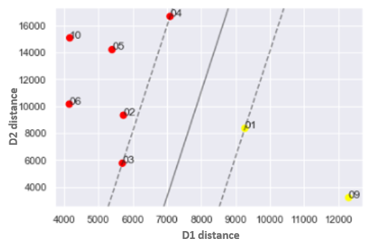

Figure 1: SVC to classify doublets to demand location

**3.7 Results and Final Development Plan Selection:** A polynomial regression function for all 31 runs was constructed between NPV for 50 years and average power produced per year (Figure 2). The team notes that to achieve 180 MW demand, NPV is ~ 2,542 MM€. Some of the cases do not adhere to the conservation of mass as the injected water is lower than the produced water. Filtering out these cases, the case with the highest NPV is case 36. This development plan for Run 36 is shown in Figure 3 and Figure 4.

The total energy produced over the 50-year period is shown in Figure 5. Run 36 produces more than demand in early years and drops below demand approximately after 40 years. The total power produced per year on average is 178 MWh. It has been demonstrated by changing the rate inputs, we are able to control the water produced and thus the demand. It is recommended to choke the well back or run the ESP at a lower speed to produce energy just enough to meet the demand. This would in turn be expected to push the cold front water breakthrough further out in time and meet the demand for 50 years.

The 31 DART runs were also used to generate a dataset consisting of DARTS inputs, the average generated power per year, NPV of the run and the LCOH at year 50. The dataset deliberately contained cases where demand is met in excess, not met at all or was partially achieved (to address cases of over or underfitting). It is assumed there will be no revenue for excess power produced and thus the NPV is expected to decrease as the excess power increases.

|  |  |
| --- | --- |
|  |  |
| Figure 2: NPV (MM€) versus average power per year | Figure 3: Development Plan showing bottomhole well locations on fairway map |
|  |  |
| Figure 4: Development Plan depicting surface facilities | Figure 5: Total System Power(MW) produced over time |

This dataset was normalised using minimum-maximum normalisation. A multivariant linear regressor was trained on 21 iterations and tested on 10 iterations, with the 70-30 split. Two linear regression models were trained with L2 (ridge) and L1 (lasso) regularisation respectively. The models were evaluated using mean absolute error (MAE), root mean square error (RMSE), and R2, with their performance shown in Table 2. Both models show similar performance.

Table 2: Performance of Ridge and Lasso Models

|  |  |  |  |
| --- | --- | --- | --- |
|  | MAE | RMSE | R2 |
| L2 Ridge | 45.4214 | 50.3494 | 0.88436 |
| L1 Lasso | 47.6576 | 47.6576 | 0.85305 |

Both models were tested against a blind holdout data set. The model was able to predict what rate reductions are required (assuming an arbitrary input location) to satisfy demand locations D1 and D2. In our hypothetical test at a random location, reducing the rates across all wells by 15% - 20% achieves this.

**4. Risking and Uncertainty:** Risks include (a) lack of or poor reservoir (unable to meet water rate), (b) premature breakthrough, (c) sand production and (d) frequent ESP failures.

Risks can be mitigated by (a) improved seismic mapping and well logging of reservoirs, (b) planning for workovers to replace ESPs and maintain flow rate, (c) reduce drawdown to prevent sand production and recompletion of well with sand screens.

**5. Conclusion:** Using techniques of machine learning, simulation and our understanding of static and dynamic properties, Team ERCE has demonstrated that our model is able to meet demand location requirements.

**Appendix 1: Greenhouse Gas (GHG) Emissions:**

The Team has also evaluated the total amount of greenhouse gases that can be offset by using geothermal energy generation; the assumption is that without geothermal, power is supplied by LNG. If the power station is coal-powered, then the GHG emissions would be far greater.

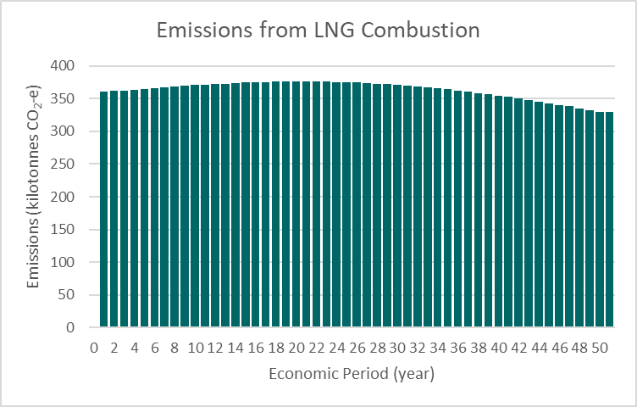

**Appendix 2: Change in LCOH formula**

After being informed of a change in the formula for calculation of LCOH, there was not enough time for the team to rerun the economics analysis due to standing work commitments. Nevertheless, the team did run 1 case on the above mentioned field development plan, to give a NPV of EUR 2542 MM€ at 20 years.

