Introduction-

Please take this tutorial with a grain-of-salt as I am certainly not a Python expert. My mom and I have been having fun lately trying in learning Power BI and we were having trouble getting it connected to Python, so I dedicated some time and figured it out. Hopefully this tutorial will be helpful to someone else trying to do the same thing!

Step 0- See what Microsoft has to say

The tutorial you are reading now is loosely based on [this tutorial by Microsoft](https://docs.microsoft.com/en-us/power-bi/desktop-python-scripts). If you, the reader, stumbled upon this medium article by searching the internet, definitely try to follow the Microsoft tutorial first — then check back here if you get stuck.

The first place I ran into problems was when I ran the command:

pip install pandas

Which resulted in the following error and blog article. Yikes.

The package setup script has attempted to modify files on your system that are not within the EasyInstall build area, and has been aborted.This package cannot be safely installed by EasyInstall, and may not support alternate installation locations even if you run its setup script by hand. Please inform the package's author and the EasyInstall maintainers to find out if a fix or workaround is available.ERROR: Command errored out with exit status 1: python setup.py egg_info Check the logs for full command output.

Step 1- Go to Pandas, wind up at Miniconda

My next step was to Google “how to install pandas python” which lead me to the [Pandas installation documentation](https://pandas.pydata.org/pandas-docs/stable/install.html). This page is weirdly laid out in that they tell you that you can install using Anaconda, but then the next section explains that its probably better to do so with **Miniconda**.

For this tutorial, we’ll use Miniconda to save hard-drive space. Go ahead and download/install the Python 3.7 Windows 10 Installer from the [Miniconda installer page](https://docs.conda.io/en/latest/miniconda.html).

Image for post

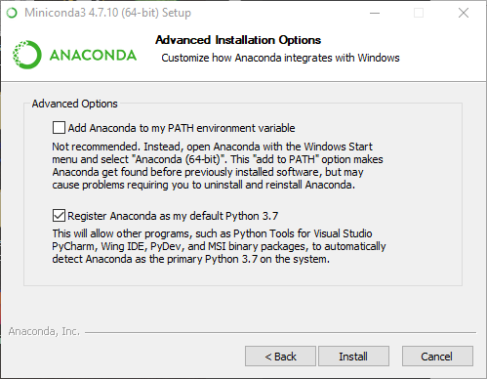

Miniconda installation settings

You can mostly just “next” your way through the installer, but as per the [windows installation instructions](https://docs.continuum.io/anaconda/install/windows/), make sure when you get to this screen(above), you check the boxes as shown.

Step 2- Configure Miniconda

Since Miniconda is not set up in the system PATH (on purpose), we’ll need to open up a command prompt with Anaconda/Miniconda already configured. I found my installation by using the Start menu and searching for Miniconda.

Image for post

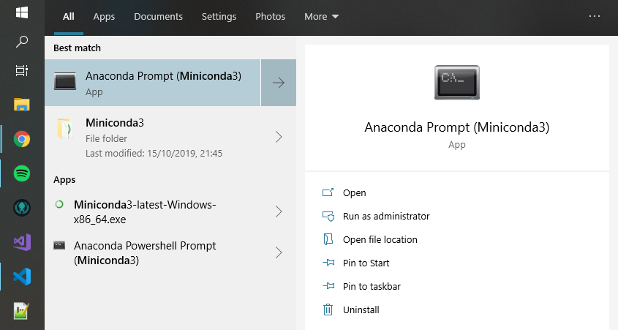

As of the time of the writing of this post, [Power BI has problems with Python 3.7 and higher](https://stackoverflow.com/questions/52885101/anaconda-in-windows-with-power-bi). So, the first thing you’ll want to do in this custom terminal is establish an environment with python 3.6 which can be done with this command:

conda create --name std_env python=3.6

Hit [return] to accept the [y]/n prompt.

The next command instructs our terminal session to use our newly created 3.6 environment:

conda activate std_env

Finally, we can run:

pip install pandas

And:

pip install matplotlib

Step 3- Configure Power BI

Open up Power BI and then go to File > Options and Settings > Options

Under the GLOBAL section go to subsection Scripting

Set the Detected Python Home Directories to Other

Set the Python home directory to:

C:\Users\[YourAccountNameGoesHere]\Miniconda3\envs\std_env

Image for post

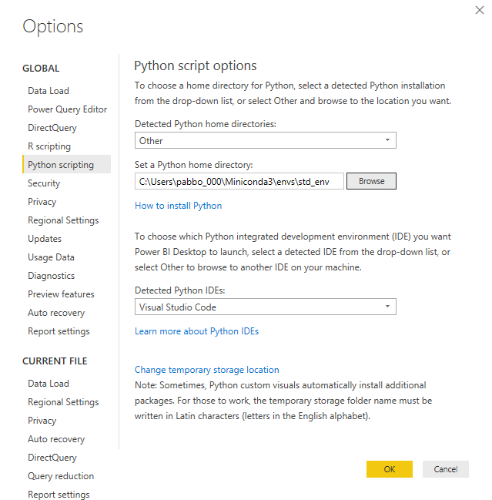

Here’s what mine looks like

Step 4- Test that things are working

Referencing the Microsoft tutorial from Step 0, click Get Data and then go to Other and select Python Script

Then paste in the following:

Power BI Python Sample Code

If everything went well, you should be able to see the results of the data frame from the python code in the Power BI navigator.

Image for post

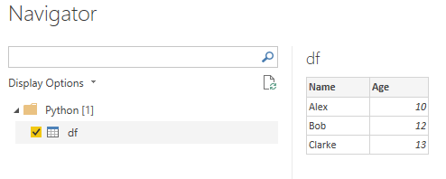

Power BI running Python code!

Step 5- Celebrate!

We now have Python as a data source in Power BI!

Happy reporting!