|  |  |
| --- | --- |
|  |  |

ANL488 BUSINESS ANALYTICS APPLIED PROJECT

**Project Proposal – Grading Form**

|  |  |  |  |
| --- | --- | --- | --- |
| Name of Student: | Choi Chi Min | PI: | H1870093 |
|  |  |  |  |
| Name of Supervisor: | Munish Kumar | PI: | M2090099 |
|  |  |  |  |
| Project Title: | Are The Top Greenhouse Gas Producing Countries and Industries on track to achieve Net Zero Emissions by 2050? | | |

|  |  |  |  |  |
| --- | --- | --- | --- | --- |
| **Course Learning**  **Outcomes** | **S/N** | **Component** | **Maximum**  **Marks** | **Score** |
| Discuss the business analytics problem. | 1. | ***Topic Formulation***: Clear description of the business/ research problem including appropriate project title; clear statement of the research question(s)/data mining objectives | 20 | 14 |
| Appraise relevant references to the selected business analytics project topic to form the Literature Review | 2. | ***Literature Review***: Relevant and adequately developed literature review | 20 | 14-6=8 |
| Apply appropriate business analytics techniques to the business analytics problem, including conducting business understanding, data understanding, data preparation, modeling, evaluation and deployment. | 3. | ***Data Understanding***:  Clear description of the data to be used to achieve stated research /data mining objectives | 20 | 16 |
| Evaluate the suitability of alternative business analytics methodologies for the project proposal. | 4. | ***Proposed Modeling***:  Appropriate description of the proposed modelling and schedule | 20 | 14 |
| Critique the impact of the project proposed.  Formulate a viable business analytics project proposal under individual supervision | 5. | ***Overall Presentation***:  Logical organisation of the project proposal; effective use of figures and tables; proper APA referencing | 20 | 15-6=7 |
|  |  | **TOTAL** | 100 | 7-12=61 |

|  |  |  |  |
| --- | --- | --- | --- |
| Signature: |  | Date: | 15022022 |

Notes to the marking of the ANL488 proposal:

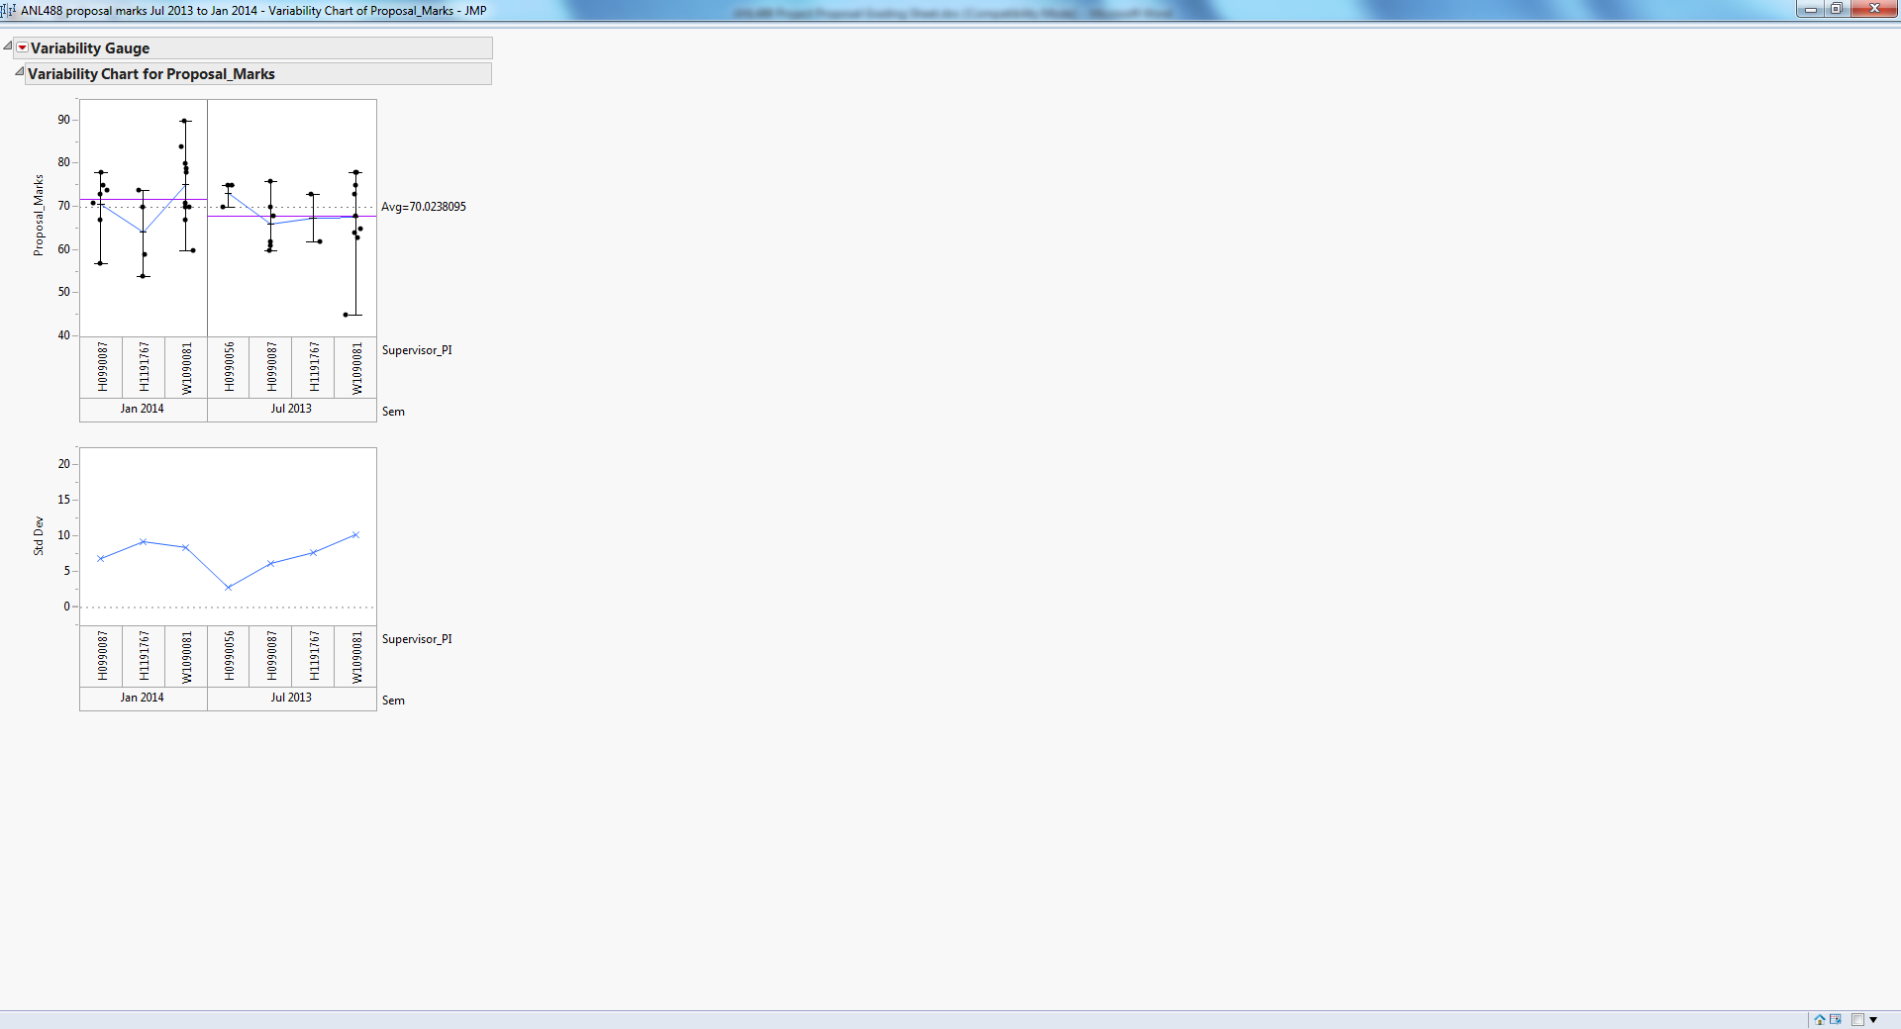

Markers whose mean is above or below the overall mean should aim to bring it more in line with the overall mean of 65.

For those students whose proposal is very general and vague and do not have complete chapters from the list below deserve a failing grade (below 40):

1. Introduction
2. Literature Review
3. Data Understanding and
4. Proposed Modelling and Evaluation.

Please bring to the Head of Programme’s attention if you are unsure.

When downloading the proposal for marking from the respective ANL488 T group in Canvas via Assignments -> PROPOSAL01, check those whose Similarity score is above 30%(see Figure 2 below) to see if there is plagiarism(look for 2 whole paragraphs that are copied wholesale without amendment). Please gather the evidence and put it in a word document and send it to the Head of Programme and Mechelle for their necessary action.

