

**ANL201 (Online)**

**Data Visualization for Business**

Tutor-Marked Assignment

**January 2021 Presentation**

**Submitted by:**

|  |  |
| --- | --- |
| **Name** | **PI No.** |
| **Muhammad Shafie Bin Pungut** | **H2070832** |

**Tutorial Group: ­­­­­­­­­­­­ TV T02**

**Instructor’s Name: Prof. Munish Kumar**

**Submission Date: 17/02/2021**

Content Page

Microsoft Mission Statement 3

Microsoft Vision Statement 3

Strategic Theme 4

Technology Breakthroughs and Progress 5

Trust 6

Environmental and Corporate Social Responsibility 6

Culture 7

Challenges in 4 Stages of Data Visualisation 7

Interesting Points 9

Increase in Revenue and Gross Margin 9

Decline in Phone Revenue 11

Acknowledgment 12

# Microsoft Mission Statement

In the Microsoft annual report 2019 indicated the mission of the company where it remain unchanged. Their objective is to have the utmost priority to ensure that each individuals and organisation feels empowered to accomplish more. Just from the mission statement, it can be categorised into three different components. Firstly it focuses on its empowerment, where it displays how their products can be useful for customer to utilise. For instance, the empowerment can be in a form of useful software from them like Microsoft office which can be useful for students, corporate employees and many more. For the second element, it focuses on every person and every organisation on the planet, which refers to their target audience. Not only does it involve the employees and current consumers of Microsoft, Microsoft is very inclusive to have a bigger target market. As for the last component, it focuses on delivering the message of achieving more. In other words, it is implying that the products and services that they offer will make it very easy for their consumers to achieve more. Generally, they are very flexible as they can aid small start-ups to ensure they are more productive, big corporates to be more innovative and ensure efficiency and effectiveness throughout different sectors with its platform and tools. Overall Microsoft ensures that with the opportunity that they have, they are responsible to assist everyone in the planet, including the planet itself to do better with the power of technology. By having such mission statement, it brings positive energy and high morale for people to have the right positive mindset to motivate themselves to aim for the best especially with their products and services that they offer.

# Microsoft Vision Statement

In comparison with the company’s mission where it define the business of Microsoft as well as its objective and the way to approach said target, a company vision generally implies the direction and desired state of the company in years and time to come. Generally, both mission and vision statement are usually blended to come up with the statement of Microsoft’s purposes, target and values. In the Microsoft’s annual report 2019 by the shareholder, it was not stated openly in terms of their vision but at the same time it provides an insight on the desired position Microsoft is going towards. From my perspective, I believe that Microsoft’s vision aligned with its mission where they aim to create and build technology that is innovative and at the same time accessible for their consumers to fit with everyone’s needs. I believe their intention is to reduces hurdles and aid people make the most of their capabilities by using their products. For instance, Microsoft is recognised for its ground breaking technology which is Microsoft Office that is used across most offices and schools due to of its low costs. This example shows that it is an innovation where it is readily accessible for consumers to explore and maximise their capability. From the annual report itself, I believe that Microsoft wish for everyone to embrace and be the next huge technology breakthrough from their consumers. Rather than just working and product platforms for the consumers, Microsoft is aiming to work alongside with them and to help partners and consumers form each individual digital capability. Their objective is to work hand in hand by innovating together, establishing new business opportunities and at the same time win their trust. They aim for their consumers and partners to become independent together with them and not just reliant on them. Despite the fact that the vision on the company’s desired future position clearly in the report, it is easy to comprehend that the company not only value their consumers but at the same time the growth of each individual with their digital capability. All in all, they are working towards a positive goal and objective which can be very motivating and enticing as a consumer’s perspective. I believe they wish to be at a state where they cover most business prospects including culture and environment to ensure they are at the right track in playing a huge part in making the world a better place especially with the use of their top-notch platform and tools.

# Strategic Theme

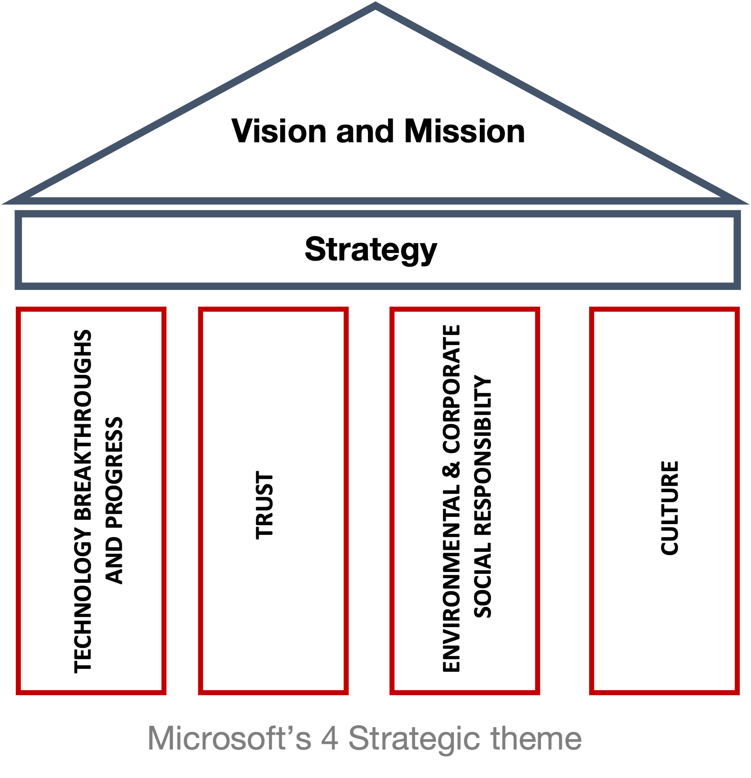

*Figure 1.1: Strategic Themes as Pillars Upholding Microsoft’s Vision and Mission*

To achieve its vision and mission, it is needed for company to have strategic themes to support it. Generally, Strategic themes refers as the main top-tier business strategies, which they have to do extremely well for them to attain its vision. In other words, the strategic themes integrated independent activities together, and concentrate on effort and resources of functional sectors that that are essentially important. These themes can be considered as the company’s pillar of excellence when they employ it to each segment of a company and at the same time define what are the main elements they can converge to attain their vision as a whole.   
  
In figure 1.1, it is an illustration of all the four strategic themes which is supporting Microsoft’s vision and statement. It consist of 4 different independent activities to uphold its vision and statement as described below.

## Technology Breakthroughs and Progress

For the first strategic theme, it covers the technology breakthroughs and progress. In this modern world, smart computing is rooted in the world almost everywhere and everything. In this age of intelligent cloud, it is influencing the innovation in time to come with its powerful systems which brings unimaginable positive experience and altering almost everything around people. In the line of Microsoft’s business, their innovation is to ensure the customers feels empowered and at the same time investing in the huge and rapid-growing markets to aid them with digital transformation in the long run.

In this particular strategic theme, Microsoft has 5 different range of products and tools to offer for their consumers with its embrace towards digital especially in this rapid growing technology and progress. The first one focuses on *Applications and Infrastructure* which Microsoft created a Microsoft application called Azure. Briefly, it is a cloud computing service to build, test, organise and handle applications and services via their own data centres. In fact with such invention, Microsoft has the most compliance certifications and datacentres areas as compared to any other cloud provider. Just by this, it would have helped the company to be able to stand out more than its competitors. Apart from that, Microsoft also focuses on *Data and AI* especially in this age where the volume of data is rapidly increasing on a daily basis. Microsoft offers the best wide-ranging cloud analytics with its limitless data and great analytic capabilities throughout their customers’ total data estate such as Azure Data Factory, SQL Data Warehouse as wells as Power BI. As for the third focus, it is the *Business Application* where it aids organisation to unleash their utmost ability by dividing data silos to connect consumers, products, people, and operations. A great example would be its Dynamic 365 where it allows any companies to build digital feedback loops which extract data from a system and apply it to enhance other outcomes which enables business to be AI-first. Another focus would be the fact that Microsoft wish to transform an organisation into a *modern workplace.* With their product like Microsoft Office 365, it empowers everyone in all sorts of background from small business to huge enterprises where it is integrated into one device to provide convenience. On top of that, Microsoft Teams is used around most organisations due to the fact that it brings everything together within a team into a simple and integrated positive user experience. The last focus would be *Gaming*, as they aim to pursue their extensive opportunity where they wish to transform the method of games distributed, played and observed. For instance, their Microsoft Game Stack combine their tools and services to inspire and encourage game developers.

## Trust

No doubt, Microsoft has been given expanding opportunity in this current times but it also comes with great responsibility. According to them, without having any trust which is their second strategic theme, none of their progress and achievements would be possible. Sharing success and prosperity is their commitment to gain trust with their consumers. Microsoft believes that consumers would desire to have an organisation with spending business model which affiliate to their success as a partner rather than just receiving products and services only for both parties to be a competitor. Their focus on trust is to ensure that consumers have utmost confidence in utilising their products and services itself. In this strategic theme, there are three area of focus to support this approach where their commitment is to offer tools and business frameworks for consumers to function hand in hand with the public sector to push for policy change. The first of the three focus would be privacy where they ensure the utmost priority to be responsible for its consumers privacy and data to be well protected. Secondly, it focuses on the cybersecurity where they aim to protect their consumers in this current “zero trust” nature. They analyse and ensure that their consumers are prevented from malware and phishing on daily basis. Lastly, they build responsible AI where they are motivated by the capability of AI to address society’s urgent challenges. For example of such focus would be their call for more considerate regulation for the use of facial recognition technology.

## Environmental and Corporate Social Responsibility

The third strategic theme focuses on importance of on the Environmental and their social responsibility as one of the biggest technological company. They aim to adopt a sustainable prospect created by technology to provide easy access of the advantages and opportunities. In fact, Microsoft has a leadership team who oversees the companies commitment towards environmental sustainability and at the same time organisations social responsibility. As a huge worldwide technology company, they believe the importance of joining focus to allow and accelerate digital transformation which may result in low carbon future thus heightening their commitment. Throughout the years, Microsoft manage to expand their work through resources which initiate spanning for such responsibility. For example, they rendered support and assistance for the non-profit sector. They work closely together to aid them accelerate their organisation with the help of technology.

## Culture

Lastly, Microsoft also pays attention of a healthy work environment and culture. Microsoft believes that their strength is due to their talented employees who work on a daily basis to gain trust from consumers and playing a vital role in the company’s success. They acknowledge the significance of prioritizing the welfare of the employees and their family members. The employees can enjoy industry-leading perks with their all sorts of enticing leaves. They are in the midst of closing the space between their adopted culture and the lived experience for each of their staff in the company. As a global technology company, they have well diverse consumers all around the world, thus they aim to make their work environment more diverse and inclusive. The aspire to create a positive workplace where everyone regardless of race, gender, background and etc to do their best work to achieve more. It is statistical proven that they are working towards it as the number of women corporate presidents has increased up to 152 percent. For instance, the company has also reinforce association between their growth mindset culture and their direction towards diversity and inclusion with the its introduction of science based, a global allyship program.

And this past year we strengthened the connection between our growth mindset culture and our approach to diversity and inclusion by introducing a science-based, global allyship program.

# Challenges in 4 Stages of Data Visualisation

Simply, Data Visualisation refers to the process of creating a visual representation of data. As stated by Ware (2013), the stages of data visualisation can be divided into 4 basic stages collectively with 3 feedback loops.

The first step refers to the Data Collection and Storage where it refers to obtaining and keeping data in the most systematic method in response to a given objective, or hypothesis. To develop methods to improve data collection practices, it is necessary for them to first classify barriers to ensure the data collection is consistent. Without a doubt containing consistent data is very crucial as it will aid to outline the similarity in data items and demographic information would be collated. In this case, Microsoft may have to deal with missing data especially when they have to deal with high volume and huge numbers in million when discussing with regards to revenue. Missing data may be caused by human error or system error which can reduce the statistical power a particular report status and can produce biased estimates and at the same time leading to worthless conclusion.

As for the second step, it refers to the data pre-processing. Data Pre-processing refers to the step where the data will be going through transformation or encoding to ensure that the machine can analyse it easily. Simply said, the characteristics of the data is easier to comprehend by the algorithm. Despite all that, I believe Microsoft definitely may face issues when processing consistent and quality data especially when dealing with collecting the effective interest rate and dividends globally. Without a doubt, not all countries have the same format in collecting their datasets like dates thus may lead to faults and negative effect in the data analysis and interpretations. The absence of a co-ordinated effort between different countries to standardise collating and habits implies that there may be substantial variation in how data is interpreted.   
  
As for the third data stage, it refers to the graphics engine. It simply refers to the display hardware and the graphic algorithms to create data visualisation on screen for well-defined overview. For Microsoft, where large amount data are continuously obtained for a variety of purposes it requires a high performance software and tools needed to display it accordingly. It is challenging for Microsoft as they are not able to provide real time data information for certain things, making it hard for consumers to make a real time decision based on the available data provided. Generally, most data visualization engine will only be able to generate data with limitation at a certain period and can handle only up to a certain level of data. Thus, the company has to come up with top notch engine or source for a better platform to ensure that their data is displayed timely and accurately.

The last stage of Data visualisation is the Human Visual and Cognitive Processing where it involves human perceptual and cognitive systems that are included in comprehending and visualising data. No doubt, comprehending the key elements of human perception and the cognitive process is a crucial part of creating outstanding data visualizations. The challenge that they may face is the interactive scalability. Having interactive data visualisation may aid readers to have deep insight to comprehend the dataset that is collected. However, Microsoft has a huge database on a daily basis where it will be rapidly growing, it may disrupt the fluent interaction which may have some technical issues in the long run.

All in all, the challenges faced in data visualisation may be inevitable to the extent that the data presented may be misinterpreted and misunderstood. However, when things are performed in the correct way, it will provide the ability and opportunity for readers to comprehend huge amount of data into meaningful insights to assist in decision making.

# Interesting Points

## Increase in Revenue and Gross Margin

Upon reading the entire Microsoft’s annual report 2019, I believe that the data that is provided by the company can be very overwhelming for readers which can increase the time required to process such information as a whole. They have included wide range sets of data from the revenue, gross margin, debt and others which can be meaningful as they provide transparency of the company’s performance with their consumers. Despite the overwhelming data in the report, I managed to convert those data into a more visually appealing to comprehend the trend better. The first interesting point which I find rather interesting is how well the company has done throughout the years just by looking at the two data sets of revenue and the gross margin which can be seen in figure 2.1.

*Figure 2.1: A Chart illustrating Microsoft Revenue & Gross Margin through the years*

To understand the graph better, it is essential to comprehend the difference between the two variables that we are using to observe and compare to see how well Microsoft is doing financially since 2015. In a financial perspective, an organisation’s gross margin is solely the difference between the revenue and cost of goods sold (COGS) which is divided by that revenue figure. Unlike gross profits, which are expressed as absolute dollar amounts, gross margins are expressed in percentage forms.

In terms of revenue, it refers to the money the organisation earns after subtracting the costs involved with production and selling cost. It is represented as a whole dollar amount, illustrating the revenue earned after deducting the costs of production.

For Gross margin, it illustrates how well the organisation is receiving revenue from the costs included in production of their products and services. In other words, the lower the margin, it shows that it is less effective the organisation’s management is in generating value for each dollar of cost.

With the help of data visualization in the graph, readers can infer and observe the trend better as seen in figure 2.1 where it clearly indicates the gradual improvement of the company’s revenue and gross margin. I find that this information is good for the company both variables can be used as an indicator of a company's financial health. With such result in 2019, it shows that they have achieved the highest revenue throughout the years especially in this digital age where consumers are embracing digital and the rise of technology.

In other words, their mission and vision seems to align with their performance where they are able to achieve such record by gaining more people to maximise their utmost potential with their especially by using their products and services throughout the years. Since Microsoft has a high gross margin, it usually means that they are at a more advantageous place as compared to their competitors as they have a bigger cushion to protect themselves in challenging times. An observation and recommendation would be if Microsoft going to maintain their hard work or even performing better, the sales for their products and services would surge high especially in this pandemic where everyone relies on technology. With the help of technology in this covid-19, it gives the opportunity and conveniences for consumers to work from home and using virtual meetings to perform their daily tasks. On top of that, Microsoft may consider including more graphs in the report to make it more appealing to indicate their revenue and gross margin to make it more convenient for readers to digest and analyse the trend throughout the years.

Overall, the increase of revenue and gross margin is an interesting point where it shows that the company is financially healthy thus building trust for consumers and investors. This is definitely beneficial for the company for its reputation as a global technology company and for the long run where more people are embracing digital and the company is readily available to render assistance and services for people to maximise their full potential.

## Decline in Phone Revenue

Despite the success and the surge in revenue for most of their products and services from the data provided in the annual report 2019, it was shown that under personal computing, Microsoft phone revenue has decreased by $525 million. Certainly, Microsoft's Windows Mobile software was one of the best mobile platforms back in the early 2000s. Unfortunately, the demand for Microsoft’s phone decline started with the growth of the Iphone’s with it is top notch operating software which Microsoft failed to compete with.

It is definitely an interesting point for me to highlight as it is the only decrease in revenue out of many things that is that they have garnered revenues through the years. Despite having a huge loss for mobile phones amounting to $525 million, it is till shown that revenue for personal computing generally increased in $3.0 billion or 8%. This implies that Microsoft is not heavily impacted by such loss due the revenues generated by other products like Windows commercial and Xbox software.

It is clearly stated that such information shows that it brings negative impact to the company as the sales are declining, thus since there is no market for their mobiles, there will not be any supply for mobile under Microsoft. Thus it implies that it is bad for the company as it shows that Microsoft is not able to produce mobile as good as the competitors despite being a global technology.

With regards to the recommendation, despite drastically redesigning Microsoft operating system and to the extent where they bought over Nokia's phone business, Windows for mobile never attained the characteristics or applications that Android and iPhone had. Windows phones are no longer supported. I believe Microsoft needs to ensure that they have top notch products and software that can be appropriate to meet the demand of the current market in order for them to stay in trend to ensure they are at same level of current competitors to avoid such losses all over again. They need to ensure that it matches the quality of the current competitors mobile before rolling out.

# Acknowledgment

Data collection challenges and improvements. (2020, October 19). Retrieved February 17, 2021, from https://www.vic.gov.au/victorian-family-violence-data-collection-framework/data-collection-challenges-and-improvements

Dolcourt, J. (2019, October 05). Microsoft isn't making another windows phone for one simple reason. Retrieved February 17, 2021, from https://www.cnet.com/news/microsoft-isnt-making-another-windows-phone-for-one-simple-reason/

Gregory, L. (2019, February 24). Microsoft's mission statement & vision statement (An Analysis). Retrieved February 17, 2021, from http://panmore.com/microsoft-corporation-vision-statement-mission-statement-analysis

Kang, H. (2013, May 24). The prevention and handling of the missing data. Retrieved February 17, 2021, from https://www.ncbi.nlm.nih.gov/pmc/articles/PMC3668100/

Microsoft annual Report 2019. (n.d.). Retrieved February 17, 2021, from https://www.microsoft.com/investor/reports/ar19/index.html

Pandey, P. (2020, July 29). Data preprocessing : Concepts. Retrieved February 17, 2021, from https://towardsdatascience.com/data-preprocessing-concepts-fa946d11c825