**BACHELOR OF SCIENCE**

**IN**

**BUSINESS ANALYTICS**



**SCHOOL OF BUSINESS**

**Tutor-Marked Assignment (TMA) for ANL201**

**Data Visualisation for Business**

By

Quek Shu Ting, Sheryl

W2071017

For

Mr Munish Kumar

Professor

17 February 2021

**Table of Contents**

**Question 1a** 3

**Question 1b** 4

**Question 1c** 5

**Question 1d** 7

**Question 1e** 9

**References** 11

# **Question 1a**

A Mission Statement is a motivational sentence that articulates the entity’s fundamental purpose and defines the existence of the business (Eric, 2021). Microsoft’s Mission Statement is to empower every person and every organization on the planet to achieve more. Its Mission Statement emphasizes on value preposition – how can the company’s products provide value to its customers. As pointed out in Microsoft’s 2019 Shareholder’s letter, “Our platforms and tools help make small businesses more productive, multinationals more competitive, non-profits more effective, and governments more efficient. They improve healthcare and education outcomes, amplify human ingenuity, and allow people everywhere to reach higher.” Microsoft achieves its mission by looking at three prerogatives:

* 1. Empowerment. For example, Microsoft empowers its customers by collaborating with them to help them build their own digital capability instead of being dependent.
  2. Microsoft specifies its customer segments in its Mission Statement, which involves small businesses, multinational corporations (MNCs), public sectors and individuals. For each customer segment, it offers a different benefit. For example, Microsoft offers productivity to small businesses, competitiveness to MNCs and efficiency to public sectors.
  3. Microsoft’s products benefit its customers in terms of achieving more. For instance, Microsoft’s commitment to providing solutions to foster deeper relationships with its customers instead of just selling its products.

# **Question 1b**

A Vision Statement is a sentence that succinctly describes the desired long-term outcome of an entity’s efforts. It is a mental image of the entity’s future state based on its aspirations (Eric, 2021). In my opinion, Microsoft’s vision for 2020 is to help advocate individuals and businesses to unlock its full potential in building their digital capability in the next era of technology. The CEO of Microsoft mentioned in the 2019 Shareholder’s letter “I believe the next big technology breakthroughs will come not only from technology companies like Microsoft, but from retailers, healthcare providers, and manufacturers, working in partnership with us. Every day, we work alongside our customers and partners to help them build their own digital capability — innovating with them, creating new businesses with them, and earning their trust. We want them to become independent with us, not dependent on us.” Microsoft has mentioned that its goal is to be an industry leader in several distinct areas of technology over the long-term. Microsoft wants to be there as a consultant for organisations by providing technological solutions such as application infrastructure, cloud computing, data and artificial intelligence (AI), business process, productivity and collaboration to its customers that will foster deeper partnerships. An example of how Microsoft achieved its vision is the tech intensity inspired collaboration with New York-based Mastercard to come up with new service to make the online shopping experience easier and more secure (Cupp, 2019).

# **Question 1c**

Strategic themes are the main, high-level business strategies, which an entity must excel to achieve its vision. These themes will affect the balanced scorecard perspectives – financial, customer, business internal process and learning and growth (Eric, 2021). Figure 1.1 illustrates the idea that the strategic themes are the foundation of the house which supports the vision and mission through each of the balanced scorecard perspective level.

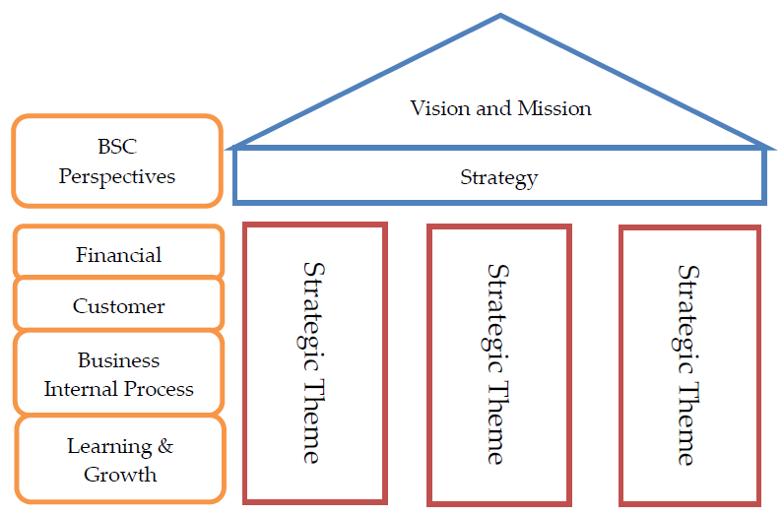

Figure 1.1

With reference to Microsoft’s 2019 Shareholders Letter, the strategic themes are:

1. **Reinvent** **productivity and business processes.** Microsoft has a diversified business model which entails Office, Microsoft Dynamics, LinkedIn and more. Its products help organisations to reinvent productivity and business processes. Especially amid a pandemic crisis, technology has never been more important in everyone’s lives. Microsoft Teams helps to speed up business processes by bringing people together virtually. Microsoft 365 has improved user experience; productivity is increased because one can access the same document on multiple devices. Microsoft helps organisations to digitize their business functions and aspire them to undergo digital transformation to drive their success. This strategic theme affects mainly customers.
2. **Build an intelligent cloud and intelligent edge platform.** Microsoft stated in its Annual Report that Microsoft continues to invest in datacentres and other hybrid and edge infrastructure to support its services and its cloud business benefits from three economies of scale, meaning that Microsoft can produce at a lower cost. Microsoft sees an opportunity to merge both physical and digital worlds as it will create a paradigm shift that will shape the next generation of computing. Microsoft also mentioned that they are adopting AI innovations from research to products and their innovations help developers to acquire AI knowledge through Azure Machine Learning Studio. Microsoft also stated that they have acquired GitHub, Inc. to empower every developer to succeed. This strategic theme affects mainly both its financial and business internal process perspective, with a brief on learning and growth for its customers.
3. **Create more personal computing.** Microsoft’s strategy to create more personal computing is through the use of Office, Windows, and devices to enhance the customer experience. Windows 10 is considered to be the most secure and productive operating system as it empowers users with AI-first interfaces like Cortana. A new device, Surface Hub 2S is another innovation which Microsoft has come up with to integrate Microsoft Teams, Windows, and Surface hardware to drive teamwork in organisations. Microsoft has also expanded its gaming products and services like Xbox consoles and Xbox Game Pass. This theme affects mainly customers.
4. **Taking responsibility in earning and sustaining trust of the customers and partners.** Microsoft instils privacy, cybersecurity and responsible AI in its products and services. It is logical for people to value privacy and protection of their personal sphere of life; people want to have control over who they want to share their information to. Microsoft ensures that while it increase the power of technology, personal data protection is not forsaken. With the current advancement of technology, hacking into data space is not rare, therefore, it is important to strengthen security when dealing with data. Stated in the Shareholders’ Letter, Microsoft is the only company that provides end-to-end security across its innovations. Lastly, Microsoft came up with two programs in their AI for Good initiative. Microsoft is committed to making sure AI tools are designed in a way that puts people first and in ways that warrants people’s trust. In general, it is a crucial strategy to gain trust before you have developed a fruitful relationship with another party. This theme affects the customers directly. Once trust is formed, it will be easier for Microsoft to collaborate and empower its customers.

In conclusion, each of the strategic themes above will result in the desired strategic outcomes that are measurable and attainable. Each theme contains strategic objectives which Microsoft will aim to achieve to transcend. When all themes are integrated as one, a tier-one strategy map is formed. Once the strategic results are achieved, the vision will be fulfilled. In this case, Microsoft emphasized “empowerment” in all of its strategic themes, focus on helping people across the world to gain digital capability; the themes are in alignment with Microsoft’s mission and vision.

# **Question 1d**

According to Ware (2013), the four basic stages consist of:

1. The collection and storage of data.
2. The pre-processing designed to transform data into something which one can understand.
3. The display hardware and the graphics algorithm that produces an image on the screen.
4. The human perceptual and cognitive system of the perceiver.

As seen in figure 1.2, the four stages are associated with three feedback loops: data gathering, data manipulation and data exploration (Eric, 2021).

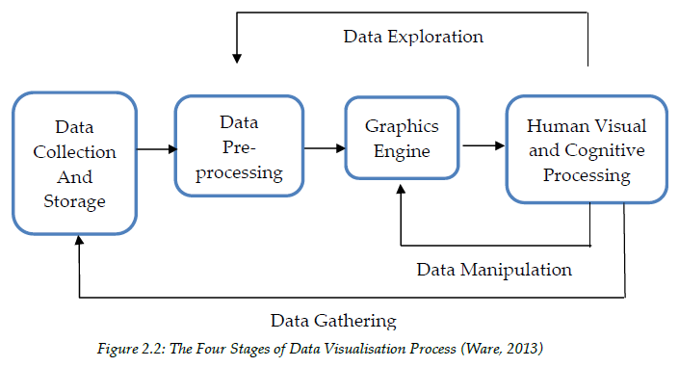

Figure 1.2

The challenge for stage one might be inconsistent data collection standards. The data presented in the Microsoft 2019 Annual Report might be taken from multiple data analyst and scientist, this might affect the standards and accuracy of the data collected. Also, different business functions might have different standards on the types of data collected. For example, the data collectors for Windows operating system are interested to find out whether its services have helped to increase productivity in organisations, while data collectors for the gaming are more interested to know whether the products have improved the gamers’ experience.

The challenge for stage two might be having unwanted data like outliers and redundant data. In the data collection stage, missing values, data inconsistency, etc. might exist. Hence, before passing the data to the graphic engine to transform data, the data collector should filter out irrelevant and redundant data or unreliable data. Another challenge is that since cleaning, selection and extraction of data are needed in the pre-processing stage, it is time-consuming for data analysts. Analysts need to perform this stage diligently as it may affect the outcomes of the final data interpreted by the graphics engine.

The challenge that might arise for stage three on the graphics engine is software diversity. Different business function departments might use different data analysis software to produce visuals. For instance, some may use SPSS, while others may use STATA or Tableau.

The challenge for stage four might be variation in the levels of data literacy. Most people are used to seeing the basic graphical presentation and might not be able to understand complex ones. However, some people will benefit more if complex visualisations are presented to them. Hence, it is difficult to match up to the wide-ranging presentation of data visualisation for all to understand. Another challenge is the visual representation of data. It is important to anticipate some of the potential challenges that data visualisation may pose to the reader and produce designs that take into considerations these issues. Microsoft’s Annual Report did not contain many graphical illustrations of data, this might affect people who prefer visuals instead of text. The whole point of data visualisation is to provide a visual experience, and a picture is worth more than a thousand words. Microsoft may consider presenting their report with some infographics. However, Microsoft did take into consideration for readers who might have colour-blind by using shapes instead of colours (Refer to Figure 1.3).

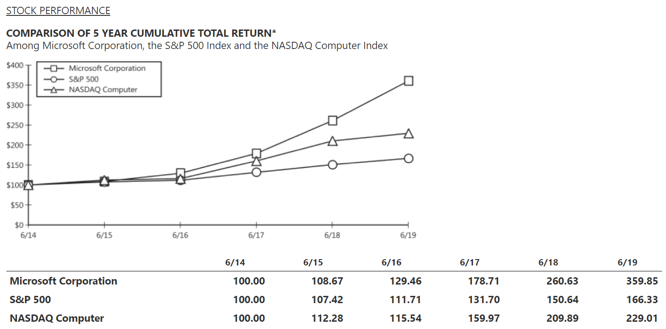

Figure 1.3

# **Question 1e**

The first interesting point that caught my eye is the gaming platform that Microsoft designed. In the past, gamers need to purchase physical game titles to insert into their Xbox consoles and cloud gaming is non-existent. The cost of video games in the 1990s cost about US$60 while today, one game can cost over US$80 for premium editions (Kharif & Mochizuki, 2020). Games data are not backed up in a cloud server, physical space is required to store the game titles and almost no possibility of recovery should the game title be corrupted. Most importantly, it is costly for gamers who want to play more games. If one game cost about $70, one will need $700 to purchase 10 different games, which is more than the console itself. And just like watching movies, one may get bored with certain games after completing the series and want to switch over to another game, more money would be spent. Therefore, I feel that it is a great idea that Microsoft came up with a Netflix-like subscription named Xbox Game Pass for gamers to access 100 games (Kharif & Mochizuki, 2020). It is fascinating to know about the new streaming technology, Project xCloud that enables gamers to play games in high-fidelity anywhere and anytime they want. Project xCloud uses Microsoft’s Azure datacentres’ hardware to stream gaming experiences remotely, and the games will be streamed to the gamers’ choice of device (Gurwin, 2021). As personal computing is becoming more in demand, I feel that it is beneficial for Microsoft to launch Project xCloud. Gamers who lack the hardware to play the games can now play on their mobile devices, this helps Microsoft to reach more customer segments. This project also helps Microsoft to increase its market share in the IOS and Android gaming industry and compete to be the market leader. This new reinvention of how games are played creates new gaming experiences to unite gamers. Despite the fierce competition with rivals like Nintendo and Sony, Microsoft’s gaming revenue managed to increase by 10% and grow its services by 19% (Microsoft 2019 Annual Report). In conclusion, it is fascinating to me how the gaming industry has evolved, and Microsoft is constantly reinventing gaming experience to stay relevant.

The next interesting point that stands out from the Annual Report is modern workplace with Microsoft 365. It is an integrated and secure experience for users to switch device seamlessly. Microsoft Teams has made meetings for inclusive with better interface like “together mode”, presentations are more accessible in PowerPoint, and emails are more relevant in Outlook. In the past, emails are sent and received, but Microsoft made use of AI to create better user experience by gathering these data into useful visualisations. For instance, the Workplace Analytics personally helped me by gather insights from Outlook backend data to track my working hours and number of emails to ensure I did not overwork. Another example is Microsoft’s AI Cortana has created a new experience for me by sending me reminders so that I would not miss out any important commitments and follow-ups. I feel that these new technological breakthroughs helped many people around the world to increase their work productivity and business processes. Microsoft has no doubt achieved its mission and vision to help every individual or organisations to gain their own digital capability. Microsoft Teams is core to its vision as stated in the annual report for the modern workplace and I feel that the creation of Microsoft Teams is an essential platform for Microsoft in today’s context. Due to Covid-19, physical meetings are not allowed when countries are in lockdown and even till date, they are discouraged. Microsoft Teams comes into play by connecting people across the world not only for business but also social purposes. The attributes of Microsoft heading into the direction of modern workplace is that paradigm shifts in the tech industry is inevitable, people prefer to work online and at the place of their choice if possible. Hence, by manipulating AI-backed tools and cloud intelligence, Microsoft can reach more customer segments around the world to gain more market share. Another point in relation to modern place is Microsoft Azure being the only cloud with limitless data and analytics capabilities, Microsoft might be able to compete with Amazon Web Services (holds 47.8% of market share in 2018) to dominate the cloud infrastructure oligopoly market (Jones, 2021).

# **References**

Eric, T. & Jess, T. (2021). *ANL201 Data Visualisation for Business (study guide).* Singapore University of Social Sciences.

Microsoft 2019 Annual Report. (2019). Microsoft. Retrieved from <https://www.microsoft.com/investor/reports/ar19/index.html>

Cupp, D. (2019). Microsoft’s resolution for 2020 is to empower tech intensity in its customers and partners | Transform. Retrieved from <https://news.microsoft.com/transform/microsofts-resolution-for-2020-is-to-empower-tech-intensity-in-its-customers-and-partners/>

Kharif, O., & Mochizuki, T. (2020). Video Game Prices Are Going Up for the First Time in 15 Years. *Bloomberg.* Retrieved from <https://www.bloomberg.com/news/articles/2020-11-09/game-prices-go-up-to-70-the-first-increase-in-15-years>

Gurwin, G. (2021). Microsoft xCloud: Everything we know about the streaming service. Retrieved from <https://www.digitaltrends.com/gaming/microsoft-xcloud-price-beta-release-date/>

Jones, E. (2021). Cloud Market Share – a Look at the Cloud Ecosystem in 2021. Retrieved from <https://kinsta.com/blog/cloud-market-share/>