ANL201 Data Visualisation for Business

Tutor-Marked Assignment January 2021 Presentation

Ho Hui Ming Darrell

K1970440

Submission Date: 17 February 2021

Q1a) Microsoft’s Mission statement is *“to empower every person and every organization on the planet to achieve more”.* Their aim is to allow their technology to assist and do good for the people and the planet; by providing *“platforms and tools”* to businesses, organisations and governments to enable them to be *more productive, competitive, effective and efficient*. This leads to *improvements in healthcare and education, augmenting initiative and encouraging creativity, enabling people to achieve more*. (Nadella, 2019)

Q1b) While Microsoft did not explicitly state their Vision statement, in my opinion, their vision for 2020 was to continue to innovate to allow their customers and partners to improve, while investing in emerging markets to *“help them digitally transform”*. (Nadella, 2019)

This can be seen in the actions that they have taken in 2019, in the fields of *Applications and Infrastructure, Data and AI, Business Applications, Modern Workplace and Gaming*.

In *Applications and Infrastructure*, they had acquired GitHub and the user base has grown, attracting more than 40 million developers while separately investing in building *“the most complete toolchain for developers”*. They have also attained *“more compliance certifications”* while they have strived *“to meet the requirements for maintain the security and integrity of classified workloads”*. (Nadella, 2019)

In *Data and AI*, they have invested in updating Azure and its related tools to make it more powerful while *improving its capabilities to streamline all processes, including building, training and development of models*. (Nadella, 2019)

In *Business Applications*, they launched the “Open Data Initiative” with Adobe and SAP to *“enable data to be exchanged and enriched across systems to provide unparalleled business insight”.* (Nadella, 2019)

In *Modern Workplace*, the work on Microsoft Teams has enabled entrance into *“new and underpenetrated markets”* and they have also released new Surface devices, with a *focus on productivity and creativity*. (Nadella, 2019)

In *Gaming*, they have provided game developers with the *tools and services that will allow them to develop games for fast growing mobile gaming space while continuing to develop for the more traditional PC and console gamers.* They have also *announced their game streaming technology “Project xCloud” that will enable gamers to play whenever and wherever they want, on any device*. (Nadella, 2019)

To summarise, a lot of their actions they have undertaken have been aimed towards improvement for their customers and partners, while also investing in markets that are emerging.

Q1c)

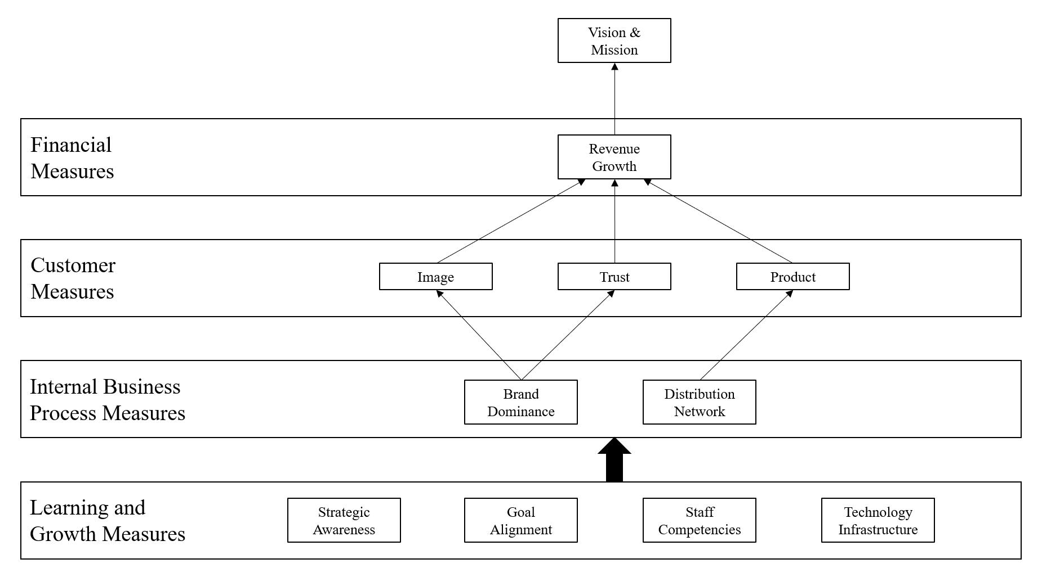

Figure 1: Strategy Map

Microsoft’s strategic themes fall into four main categories, namely *Learning and Growth Measures, Internal Business Process Measures, Customer Measures* and *Financial Measures*. (Tan, 2021)

1. Learning and Growth Measures
   1. Strategic Awareness: Ensuring all employees are aware of the organisation’s strategy.
   2. Goal Alignment: Ensuring all employees understand the organisation’s goals and are working towards achieving those goals.
   3. Staff Competencies: Ensuring all employees are trained and skilled for their tasks. The employees are not a cost but a resource to be treasured.
   4. Technology Infrastructure: Ensuring all employees have the required technology to perform their tasks at the optimal level.
2. Internal Business Process Measures
   1. Brand Dominance: To enable their products, platforms and tools to be used by everyone, especially industrial partners to achieve technological breakthroughs.
   2. Distribution Network: To enable their products, platforms and tools to be readily available to everyone, regardless of whether it is for personal or business use.
3. Customer Measures
   1. Image: For their brand to be synonymous when it comes to cloud computing, analytics, gaming and business software and hardware.
   2. Trust: To ensure customer trust when it comes to data privacy and security, ethical practices while maintaining environmental and corporate social responsibility
   3. Product: To put out a product that works, while meeting their customers’ needs.
4. Financial Measures
5. Revenue Growth: When all the strategic themes are met, the revenue for the organisation will grow.  
   (Tan, 2021)

Q1d) The four stages of the data visualisation process and challenges that may be faced:

1. Data Collection and Storage: Complexity of data and differences in data collection standards. While Microsoft is working to harmonise the programs and tools used, but there are still many tools in use currently which leads to fragmentation and different standards being used. This can lead to inconsistency in the way that data is collected. (Tan, 2021)
2. Data Pre-processing: Inconsistency and/or missing data in the data collected. While users are moving towards digitalisation and cloud computing and more data is collected, some historical data might not be so complete and there can be inconsistency or missing data in the data sets. This will lead to more time spent on data clean-up. (Tan, 2021)
3. Graphics Engine: The dashboards produced might not be displaying meaningful data. As more individuals and organisations move towards digitalisation and data visualisation, the dashboards and graphics they come up with might not be displaying meaningful data for the target audience. It could be due to lack of domain knowledge or unclear goals when coming up with the data visualisation. (Tan, 2021)
4. Human Visual and Cognitive Processing: Colours and symbols mean different things in different cultures. For example, the colour red might signify something that is not so good in Western culture, but it generally signifies something good in China. As globalisation grows, Microsoft and other companies that have international partners must be sensitive to cultural differences when coming up with data visualisation. (Tan, 2021)

Q1e) The two points that I find interesting are as follows:

1. The mention of the small, family-owned restaurant in Japan in their Annual Report, alongside a big organisation like Ford Motor Co.  
   I find this interesting because this report is going out to not only their shareholders but is also freely accessible to everyone, therefore this helps Microsoft show that they are serious about making their products and services available to everyone, regardless of the size of the business, as they mentioned in their mission statement *“to empower every person and every organization on the planet to achieve more”*. (Nadella, 2019)  
   This is good for the company because they are showing that they are striving to achieve their mission statement and are serious about it, which is good news for all their customers and partners, especially for the smaller companies and individual consumers.  
   My recommendation is for Microsoft to keep up the good work of striving towards their mission statement of empowering everyone to achieve more and to keep investing and innovating. This will help Microsoft maintain their good company image and allow customers to continue to build trust in them.
2. Their focus on gaming, for both game streaming technology and tools and services to assist game developers.  
   I find this interesting because gaming in general is a multi-billion-dollar company, and it has diverged from console and PC gaming, to include mobile gaming now. The gaming industry has been growing consistently the past few years, but mobile gaming has been emerging as a huge market that is very lucrative. This focus on gaming shows that Microsoft are investing more into gaming and are looking to be further involved in the gaming industry.  
   This is good for the company because there is a huge market for gaming and their game streaming technology will allow them to push their services to a large market which would definitely help with revenue growth. Their acquisition of game studios and the availability of their tools and services for game developers will allow more games to be developed, with potential revenue resulting from sales of first-party games or growth in their subscription services.  
   My recommendation for the company is to continue with the focus on gaming, as in this digital age there is a huge market available. Working adults have grown up around the emerging technology and gaming, while the negative stigma of gaming has virtually disappeared, there is spending power available for gaming hardware and software that can be tapped into. The children of today are growing up in a society where technology is everywhere, and more time is spent connected to the internet. The focus on gaming and the subsequent release of good products and services will certainly entice these potential customers and will be a help with revenue growth.

# References

Nadella, S. (2019, October 16). *Microsoft 2019 Annual Report - Shareholder Letter*. Retrieved from Microsoft: https://www.microsoft.com/investor/reports/ar19/index.html

Tan, J. (2021). *ANL201 Data Visualisation for Business Study Guide.* Singapore: Singapore University of Social Sciences.