

**ANL201**

**Data Visualisation for Business**

**Tutor-Marked Assignment 01**

**January 2021 Presentation**

**T02**

**Prepared by:**

Lee Si Min, Chermaine (B1610527)

**Submission Date:**

17 February 2021

**QUESTION 1A**

A mission statement defines the reason the company exists and the purpose it serves (Corporate Finance Institute, n.d.). Microsoft’s mission statement is “to empower every person and every organisation on the planet to achieve more”. We should note three key parts of the mission statement, firstly – “empowerment”, next – “every person and every organisation” and finally – “to achieve more”.

Empowerment means to have the “power, right, or authority to perform various acts or duties” (Merriam-Webster, n.d.). In his 2019 Shareholder Letter, CEO Satya Nadella mentioned that Microsoft wants its stakeholders to be independent with them, and not be dependent on them. It shows that Microsoft’s greater purpose is to not only provide new and innovative products and services to everyone throughout the world, but that it also enables them to have the power to push their own boundaries and capabilities through Microsoft. Its goal is to benefit its target market, which is everyone regardless of their background, to accomplish greater heights for themselves and for the world – from productivity of small & medium enterprises, efficacy of non-profit organisations, competitiveness of multinational corporations, efficiency of governments, to improving overall education and healthcare standards.

**QUESTION 1B**

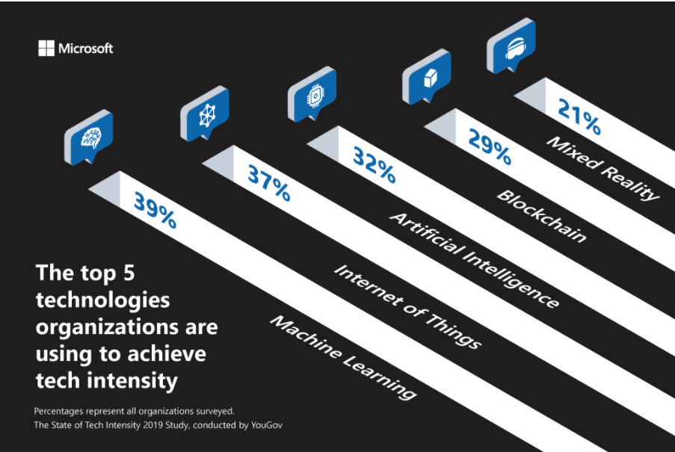

*Figure 1:* Microsoft’s illustration on the top five technologies used by organisations to achieve tech intensity (Microsoft, 2019)

Vision Statement

A vision statement defines the desired state that the company sees itself in the future, which could be five to ten years or even longer (Corporate Finance Institute, n.d.). In my opinion, Microsoft’s vision for 2020 would be to enable and increase tech intensity in its consumers to digitally transform, achieve their own competitive advantage and gain meaningful business insights through Microsoft’s array of innovative products and services. Microsoft wants to be at the forefront, leading and collaborating with its consumers and partners in adopting tech intensity through its trustable and sustainable solutions.

Explaining Tech Intensity

As mentioned in the Shareholder Letter, Microsoft wants its consumers and partners to be independent with them, and not be dependent on them. This is done through enabling tech intensity in them. CEO Nadella believes that future technology advances will not only come from big technology entities like Microsoft, but from any entity that uses existing digital capabilities to build their own proprietary digital solutions – this is tech intensity. In addition, these entities will not only create digital solutions for their own utilisation, but also to resolve issues for communities around the world (Cupp, 2019).

Evidence for Vision

Based on the State of Tech Intensity 2019 Study as shown in Figure 1, we can see that the top five technologies that entities are using to attain tech intensity is machine learning, Internet of Things (IoT), artificial intelligence (AI), blockchain and mixed reality. In this study of over 700 United States executives from 20 industries, there is a common consensus that there is a tremendous appetite for data in the 2020s; and using AI as well as machine learning to analyse data will help companies spot opportunities and overcome obstacles by revolutionizing their products and services. Therefore, Microsoft aims to help these companies pivot into this digital transformation and utilise these technologies.

Moving into the 2020s, every company will become a technology company by embracing tech intensity and designing their own digital solutions. Microsoft wants to be a leader in this new generation of digital transformation, from intelligent cloud computing to intelligent edge. Hence, with this vision, Microsoft needs to constantly improve and develop solutions and experiences that can build trust and bring value to its consumers.

**QUESTION 1C**

Strategic themes are high-level business strategies that an organisation must accomplish so that it can achieve its vision (Tay, 2021). Microsoft’s vision is to enable and increase tech intensity in its consumers. In its Annual Report 2019, Microsoft has three strategic themes:

1. Reinvent productivity and business processes;
2. Build the intelligent cloud and intelligent edge platform;
3. Create more personal computing.

These strategic themes also form the operating segments of Microsoft. This is for better alignment of strategic objectives, fairer assessment of financial performance and more efficient allocation of resources.

Reinvent productivity and business processes

Microsoft aims to “reinvent productivity and business processes” for its consumers by revolutionising the workplace with up-to-date products and services (Office, LinkedIn and Dynamics business solutions) that will enable collaboration, communication and productivity.

This is through an improved Microsoft 365 experience which encompasses Windows 10, Office 365 and Enterprise Mobility + Security that uses AI-backed functionalities to empower organisations in a fast-growing work environment. Microsoft Teams was released in 2017 as a digital centre that Microsoft envisions for a modern workplace to utilise in meetings, conversations, content and collaboration. Microsoft Relationship Sales combines Dynamics and LinkedIn Sales Navigator to develop business relations through social selling. Microsoft Power Platform allows employees, regardless of their technical background to customise applications, automate processes and analyse data.

These are just a few solutions that Microsoft have under this strategic theme of reengineering organisations’ processes, interactions and productivity through digital transformation. These platform-centric advancements seek to unleash creativity and encourage collaboration with reduced management and security issues. In addition, Microsoft will be able to attract new consumers to use their products and services, while engaging with existing consumers.

Build the intelligent cloud and intelligent edge platform

Through its Intelligent Cloud segment, Microsoft aims to build cloud-based services for companies that are undergoing digital transformation and be the partner of choice for the transformation. One strategy is to continue investments in its datacentres and infrastructure to support its cloud services like Microsoft Azure. Microsoft Azure has been a global cloud that has AI capabilities and security. Organisations are also able to incorporate Azure into their datacentres via Azure Stack, to create consistency between the intelligent edge and public cloud.

Microsoft’s hybrid infrastructure supports the growing needs and government regulations of companies. It is also expediting the growth of its mixed reality solutions with HoloLens @ and Azure. This merger of digital and physical worlds allows for unprecedented potential for the next generation of computing.

Furthermore, Microsoft’s competitive advantage is its ability to convert data into AI, which is done through Azure SQL Database. This enables every developer to become an AI developer, from using Azure Machine Learning Studio to create basic machine learning models to using Azure Machine Learning Workbench for data science and to create advanced models.

Other than machine learning, Microsoft also acquired GitHub, a place where developers can collaboratively write code. This enables developers to achieve better results at each product development lifecycle and bring Microsoft’s developer tools to new communities.

Create more personal computing

Last but not least, another strategic theme that Microsoft aims is to make computing more personal by interacting and engaging with the user. This is through enhancing user experience by harmonising Office, devices and Windows together for the developers, IT professionals and end users.

Windows 10 is the most productive and secure operating system, which has AI-first interfaces that can activate voice commands via Cortana, create mixed reality experiences and have immersive 3D storytelling. With the Microsoft 365 strategy and intelligent cloud services, Windows powers devices on the intelligent edge. Through Windows 10, Microsoft wishes to monetise gaming, search advertising and subscriptions. Furthermore, Microsoft wishes to design and market first-party devices to create demand and innovation in the Windows ecosystem.

Other than Windows, Microsoft is looking into creating opportunities in the gaming industry by enabling gamers to play whatever games they want on any device and with anyone. This is through its Xbox One console, where there is a growing community of gamers on Xbox Live. Windows 10 is also PC gamers’ most popular operating system. Hence, Microsoft wants to tap on this burgeoning market to connect its gaming assets and gamers.

**QUESTION 1D**

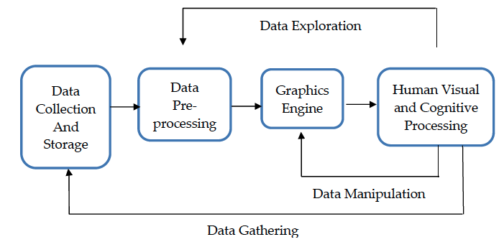

*Figure 2:* The Four Stages of The Data Visualisation Process (Ware, 2013)

According to Ware (2013), the four stages of the data visualisation process are:

1. Data Collection and Storage;
2. Data Pre-processing;
3. Graphics Engine; and
4. Human Visual and Cognitive Processing.

Data Collection and Storage

***Cost and Infrastructure***

Data collection and storage is expensive, especially when there is a large amount of data. Microsoft has a colossal number of products and services, which means there will be a huge amount of data to collect and store, from their own financial data to their consumers’ data. Furthermore, there needs to be good infrastructure and sufficient datacentres to store the data collected. This requires a lot of investing into high-tech servers or datacentres.

***Privacy and Security***

According to its Annual Report 2019, Microsoft has encountered breaches of privacy and security in its cloud business, thus the need for data privacy and security is essential and also challenging. This is because Microsoft is a big organisation and has many third-party providers. In addition to consumers’ data, Microsoft has to protect and secure its proprietary data to prevent competitors from gaining a competitive advantage.

Data Pre-processing

Data pre-processing is essentially pre-processing the data before transforming it into something people can understand and analyse. One of the challenges in data pre-processing is ensuring the quality and representation of data, otherwise the data might give misleading results if it is not cleaned. This includes noisy, incomplete or inconsistent data. An example of noisy data for Microsoft would be if the products and services were mixed up across the three operating segments. If this happens, Microsoft will not be able to accurately report its financial performance for each operating segment.

Graphics Engine

The graphics engine is the hardware display and graphics algorithms that show the data visualisation. Microsoft is a big organisation, hence there will be huge datasets. A challenge would be that the graphics engine is unable to handle the huge datasets and will require more sophisticated data visualisation tools and hardware to increase memory and response time.

Human Visual and Cognitive Processing

Human visual and cognitive processing is how humans interpret and visualise data using their own perception and cognitive system. One challenge is that different analysts may have different understanding of how data is presented, analysed or what datasets to use to present the data. Another challenge would be how the reader of the data perceives the data. In Microsoft’s Annual Report 2019, most of the data and statistics were presented in percentages and numbers. It will be difficult for the reader to understand the performance of the company without adequate and impactful data visualisations, such as pie charts or line charts, to make an informed decision.

**QUESTION 1E**

Point 1 – Financial Performance

One interesting point I noted is that Microsoft’s financial performance is reported based on the three Operating Segments – Productivity and Business Processes, Intelligent Cloud, and More Personal Computing. From this reporting, we can easily tell that each reporting segment have an increase in revenue from FY18 to FY19 – Productivity and Business Processes (increase by $5.3 billion, 15%), Intelligent Cloud (increase by $6.8 billion, 21%), and More Personal Computing (increase by $3.4 billion, 8%).

In addition, under each reporting segment, it also breaks down into the various products and services to also show the amount and percentage change from FY17 to FY18 and FY18 to FY19. This is good for the company so we can analyse the performance based on the strategic objectives and operating segments at an instance.

***Recommendations***

However, I would recommend that the company presents the data using a chart instead of sentences to show year-on-year comparisons of each operating segment over three consecutive years. In addition, I will suggest that there is a further breakdown for operating expenses in its operating segments as well.

Point 2 – Geographic Areas

Another interesting point I noted is that the revenue for geographic areas is only presented as “United States” and “Other Countries”. “Other Countries” was consolidated because there were no sales to other countries that were more than 10% of revenue over the past three years. There had been a steady increase in revenue based on the past three years for United States - $51,078 million in FY17, $55,926 million in FY18 and $64,199 million in FY19. In comparison, there was also a steady increase in revenue for “Other Countries” - $54,493 million in FY17, $54,434 million in FY18 and $61,644 million in FY19. Total revenue was $96,571 million in FY17, $110,360 million in FY18 and $125,843 million in FY19.

This is interesting to me as other companies, like Apple, will indicate net sales of the major geographic areas including Americas, Europe, China and Japan. It is not bad for Microsoft to present its data since United States generates most of its income.

***Recommendations***

However, I would still recommend that Microsoft presents a breakdown of “Other Countries”, ranking the major geographical areas. This is to show the amount that Microsoft needs to increase the market share in a particular geographical area or that it could enter into a new geographic market that it has not been exposed to. In addition, I will also recommend including the percentage change year-on-year.

Point 3 – Stock Performance

The third point I noted is the line chart for Microsoft’s stock performance. This is the only data visualisation diagram shown in the entire Annual Report. If I invested $100 in Microsoft in June 2014, I would have a cumulative total return of $359.85 in June 2019 – a total return of 259.85%. In addition, we can also see that the Microsoft stock has outperformed S&P 500 and NASDAQ Computer in June 2019.

We can see clearly from the line chart that there is an upward trend in the cumulative total returns, which is good for the company and its shareholders.

***Recommendations***

I will recommend indicating the percentage difference in stock performance between Microsoft, S&P 500 and NASDAQ Computer for each year.

**REFERENCES**

Corporate Finance Institute. (n.d.). *What is a Mission Statement?* Retrieved from

<https://corporatefinanceinstitute.com/resources/knowledge/strategy/mission-statement/>

Corporate Finance Institute. (n.d.). *What is a Vision Statement?* Retrieved from

<https://corporatefinanceinstitute.com/resources/knowledge/strategy/vision-statement/>

Cupp, D. (2020). *Microsoft’s resolution for 2020 is to empower tech intensity in its*

*customers and partners.* Retrieved from <https://news.microsoft.com/transform/microsofts-resolution-for-2020-is-to-empower-tech-intensity-in-its-customers-and-partners/>

Microsoft. (2019). Annual Report 2019. Retrieved from

<https://www.microsoft.com/investor/reports/ar19/index.html>

Merriam Webster. (n.d.). Empowerment. Retrieved from

[https://www.merriam-webster.com/dictionary/empowermen](https://www.merriam-webster.com/dictionary/empowerment)t

Tay, E. (n.d.). *ANL201 Data visualisation for business (study guide).* Singapore University of

Social Sciences.

Ware, C. (2013). Information Visualization: Perception for Design (Interactive Technologies)

(3rd ed.). Waltham, MA, USA: Elsevier Inc.