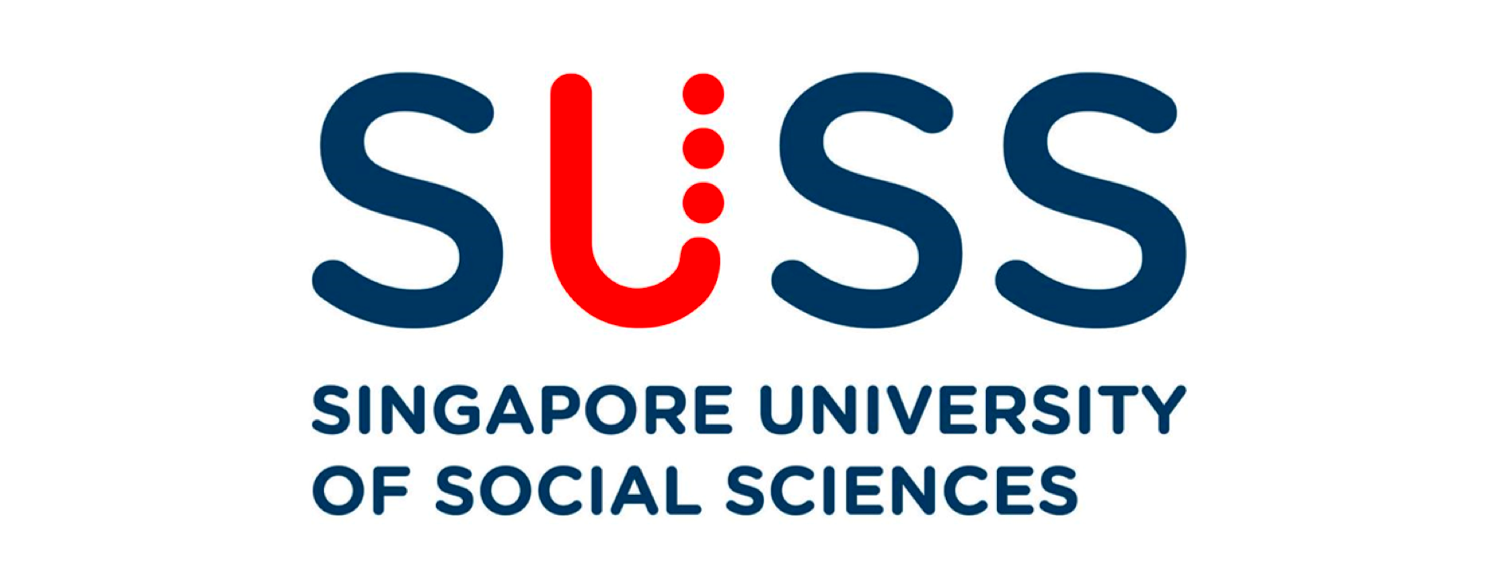

**ANL201**

**Data Visualisation for Business**

**TMA01 – Jan 2021**

**Submitted by:**

|  |  |
| --- | --- |
| Name of Student | PI Number |
| Lee Wei Jie | Q2010884 |

**Submission Date:**

**17 February 2021**

1. Microsoft’s mission was aiming to, with the technologies from Microsoft, give every human being the ability and power to accomplish and reach their desired goals. Microsoft technologies should bring better convenience and efficiency to all its users which in turn, speed up the work processes and achieve more than what was supposed to. Exceeding own limitations to achieve better greatness.
2. Microsoft vision is wanting the customers to be independent with them, work hand in hand together, not dependent on them. Microsoft believes that the next big technology breakthrough will not only come from technology companies, but from traditional businesses, such as retailers and healthcare providers, that are perhaps not as tech intensive. Microsoft understands that not all these companies have the digital capabilities to build technologies that would impact the world.

Thus, Microsoft hopes that they could be the company that would be there for them when the time comes.Together, build the groundbreaking technology, sharing innovative ideas together, creating new business opportunities together and the most importantly, earning the trust of these companies. Ultimately, Microsoft hopes that they could be the company that organisations approach when they build up their digital capabilities in the future.

1. Strategic themes are the identified areas that organisations decide to focus on in order to achieve the vision that was indicated beforehand. In Microsoft's case, the strategic themes are to continue innovating new technology, improve on customer trust, focus on environmental and corporate social responsibility, and work on the company’s culture.

Microsoft’s first strategic theme is to continue their innovation on technology. Such as Github, where engineers could develop their own software and version control it. Azure, an intelligent cloud service created to build, test and deploy applications on Microsoft. As well as Dynamics 365, an business applications that organisations use for resource planning as well as customer relationship management. Not forgetting Microsoft 365, that is adopted by almost every company.

The strategic theme is to improve the customer trust by focusing on these three pillars: privacy, cybersecurity and building a responsible AI. Ensuring customers have full control of their data privacy, Microsoft promises transparency in their privacy practices, offers meaningful privacy choices, as well as responsibly store and manage users data. On top of processing authentications and scanning emails for malware and phishing. To improve cybersecurity, Microsoft is looking into partnering with both tech and the public sector to address new threats. Working together with both government and non-government organisations, as well as other technologies companies, to promote a safe and secure digital world. Building AI responsibly by understanding the objectives and what AI should do. Hence counter society toughest challenges and at the same time, keeping in mind the unintended consequences of building AI.

The third strategic theme is to improve on environmental and corporate social responsibility. Microsoft is so invested in this that they have a Regulatory and Public Policy Committee to oversee this. Some initiatives include, powering the datacentre using renewable energy. Microsoft aims to increase the amount of renewable energy to seventy percent. Providing the opportunity for younger people, including females and minorities, to pick up digital skills by investing heavily on companies that provide coding classes such as Code.org. Extend support for the non-profit sector by donating or providing discounts on softwares and services.

The final strategic theme is to ensure Microsoft’s employee views are aligned with the company’s culture. Microsoft ensures this by practicing customer obsession, getting the employees to listen to the customers then innovate and meet their needs. Operate as one company, ensure that the goal is identical to provide the best solutions for customers. Diversify the company by hiring more minorities such as African Americans and Hispanic and promoting more women to the vice president role. Furthemore, by introducing an allyship program to further strengthen the connection between growth mindset culture, diversity and inclusive workforce.

1. The four stages of data visualisation process: data collection and storage, data pre- processing, graphic engine, and human visual and cognitive process.

The first stage is the Data collection and storage stage. Some possible challenges faced in this stage could be the high cost of collecting data and the concern in data security when storing the data. Microsoft understands the importance of customer’s data privacy, thus why they supported the European Union’s General Data Protection Regulation (GDPR) and expanded it to all their customers to ensure data security is enforced.

The second stage is the Data pre-processing stage. Some possible challenges include, missing data, incorrect data type and data inconsistency. Analysts need to ensure that all the data is cleaned up properly as this could affect the subsequent stages of data visualisation. Microsoft infused AI with Microsoft 365 to enable automation, prediction, translation and insight capabilities. With Microsoft 365, missing data could be filled up and wrong data types could be identified and rectified automatically.

The third stage is the Graphic engine stage. The possible challenges could be the software that the analyst used was not integrated and compatible with the software of the audience which causes difficulty in viewing the visualisation. However, this would not pose a huge challenge for Microsoft as their technologies are so widely adopted and recognizable by many organisations today. In 2019, Office 365 alone has 180 million commercial users. Microsoft had more than 13 million users daily and Windows 10 is active on more than 900 million devices.

The final stage is the Human visual and cognitive process. Possible challenges include audience and analyst having different perceptions on the visualisation. The story that the analyst illustrated might be different from what the audience perceived. Microsoft hopes to align this issue by democratizing AI infrastructure, tools and services with Azure Cognitive Services. Hopefully, with this, developers are able to perceive the same point of view presented by the analyst.

1. Microsoft is a software company that generates revenue by offering a wide range of cloud-based technology such as Azure and Dynamics 365. In my opinion, overall in 2019 Microsoft did well with few worthy highlights. Such as, increasing office commercial revenue by 13 percent as well as server product and cloud services revenue by 25%.

One interesting point I notice is that Microsoft investested more in intelligent cloud from 2017 to 2019, however the return on investment (ROI) decreased or remained stagnant. For instance, from year 2017 to 2018, Microsoft operating income increased by 26% from 9,127 (millions) to 11,524 (millions). On the other hand the revenue only increased by 18%, from 27,407 (millions) to 32,219 (millions). I did a simple calculation on ROI by dividing revenue to operating expenses, which gave me ROI of 3 for 2017 and ROI of 2.8 for 2018. Judging from the ROI, the result of increased investment was not ideal with the decrease of 0.2 in ROI. In 2019, the operating expenses increased by 21% from 2018, which leads to the increase of revenue by 21%. Although there is improvement in the revenue, the ROI for 2019 was identical as 2018.

Across the three years, the increase in revenue under the intelligent cloud was mainly contributed by Azure growth in revenue by 91% between 2017 to 2018 and 72% between 2018 to 2019. On the flipside, operating expenses of intelligent cloud increased by 7% due to investment in commercial sales capacity and cloud engineering between 2017 to 2018. Likewise, between 2018 to 2019, operating income increased by 22% due to investment in commercial sales capacity, in cloud and AI engineering, and GitHub.

I do understand that intelligent cloud services is an aspect that Microsoft is looking into expanding further. However, this might be a concern for Microsoft as there is a decrease in their ROI since 2017, which represents that the investment made was not as effective as before. The increase in investment should generate more subscriptions as better interface and new features were released. I would highly recommend Microsoft to heavily consider the amount to invest on intelligent cloud service in 2020. If possible, revise the amount allocated for intelligent cloud services and refrain from investing more than 2019 amount. The main focus could be on improving the sales of cloud service, such as premium window license for Windows Server, to organisations or improvement on the existing features.

The second interesting point I notice is the amount Microsoft spends on sales and marketing. Although in 2019 the marketing and sales expenses decreased significantly, revenue continued to maintain at a healthy level. Comparing the changes between 2017 and 2018 Microsoft spends 13% more on sales and marketing, increasing the operating expense of sales and marketing to 17,469(millions), 16% of revenue earned. On the other hand, changes between 2018 to 2019 on sales and marketing expenses only increased by 4% to 18,213(millions), 14% of revenue. We can see the improvement in the percentage change, between 2017 to 2018 and 2018 to 2019, 13% increase and 4% increase respectively. Percentage of revenue decreased healthily by two points, from 16% in 2018 to 14% in 2019.

The increase of sales and marketing expenses from 2017 to 2018 was mainly contributed by Linkedin expenses, inclusive of amortization to acquired intangible assets, as well as investment in commercial sales capacity. The increase in sales and marketing expenses from 2018 to 2019 mainly contributed from the increase in investment in commercial sales capacity, Linkedin and GitHub.

Although the sales and marketing expenses decreased, it does not affect the overall revenue of Microsoft and this is a good sign for the company. Which means that Microsoft would not need to rely heavily on marketing as I believe, Microsoft is already a well established name. Comparing from 2018 to 2019, Microsoft overall revenue increased by 14%. I would say Microsoft did well in decreasing the sales and marketing expenses for 2019. I would recommend Microsoft to continue what they were doing with the sales and marketing expenses and if possible, further decrease the expenses. Perhaps, Microsoft could look into adding advertising features on Linkedin which would allow organisations to list their advertisement. This could benefit the company profitably.

Ultimately, the annual report of Microsoft looks promising and very attractive to many investors and shareholders. Hopefully with the mission identified by Microsoft, it could lead the organisation to their target goal in 2020 and continue to excel in their expertise field and create more remarkable technology for the planet.