ANL201 – Data Visualisation for Business

TMA – Tutor Marked Assignment

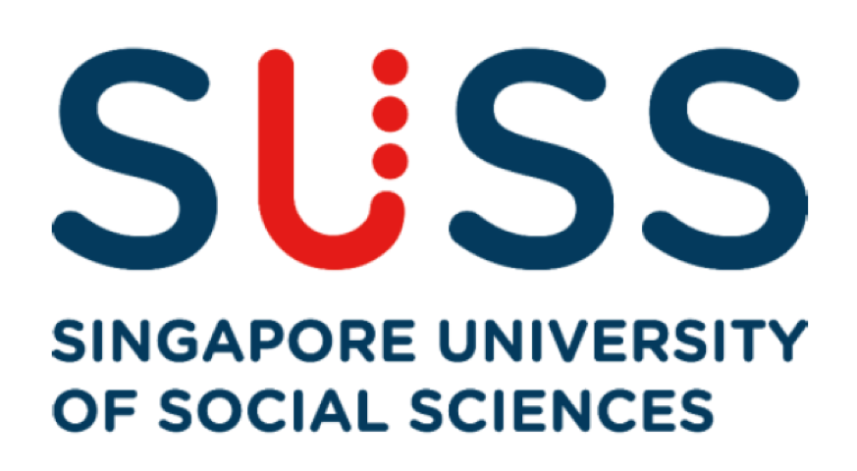

Name: Neo Yi Bin

Student PI No: J1970070

Submission Date: 17th February 2021

**Question 1**

1. A mission statement is a short sentence of why an organisation exists. In Microsoft’s Mission statement, it suggested that its business and products enable people and companies to be responsible and take ownership so that they are able accomplish more. By taking ownership, this will improve work productivity.
2. In my opinion, Microsoft’s vision for 2020 would be hoping for more companies in every industry to be able to venture into digital innovation by developing new technological strategy with their existing business model, and continue to improve and create new business models. Due to the advancing of computing experiences, business can improve its overall customers experiences to meet customers’ needs and expectations while using Microsoft’s products.

I think Microsoft will continue to improve on its products and services to provide its customers a better working experience and continue to help individuals and business to discover that they can be creative, innovative and improve teamwork. Microsoft will continue to make improvement on its digital hub such as Microsoft Teams so that users are able to know that they can be creative.

In my view, Microsoft is also looking into future possible collaborations and partnerships with companies so that these companies. It is trying to promote and encourage organizations to venture into digitising business-critical functions in case if a disaster occurs. In return, this creates chances for Microsoft to gain more customers and further improve its customers’ needs and experiences with existing customers.

1. Strategic theme in a business is a short phrase which help the company to organise their operational plans to achieve their business goals. There are four types of strategic themes: Financial, Customer, Learning and Growth and Internal

Strategic Theme #1: Financial – Increase Revenue

Microsoft make its revenue by proposing many varieties of cloud-based services to people and businesses globally. This includes licensing of software products, creating new designs, produce and sell its products. To reach its global market, online advertisement also helped to generate more revenue.

Strategic Theme #2: Customer – Promote “Tech intensity”.

In the shareholders’ letter, it mentioned that “One of the great privileges of my job is seeing our customers’ tech intensity in action around the world”. This suggested that Microsoft is hoping that its cloud service provider, Azure will be used by everyone globally for building its own exclusive technology solutions to compete and grow in the market.

Strategic Theme #3: Learning and Growth – To attract and retain the best employee.

Microsoft hires talented individuals globally. To do that, Microsoft attract these talents by offering an extraordinary working environment, impressive customer connection, abundance of resources. Employee will have a chance to get to experience a fulfilling career progression, with attractive incentives.

Strategic Theme #4: Internal – Focus on Research and Development (R&D)

With R&D, it allows Microsoft to have its own product which enables Microsoft to have some advantages when customers start to compare Microsoft’s products with other brands. When Microsoft produces its own product, they have a full control to decide any further implementation and modification of the product.

1. Stage 1: Data Collection and Storage. This initial stage is the collection and storage of raw data from various of interest. As mentioned in the shareholder letter, it stated that “by 2030, 50 billion connected devices will be coming online.” This suggested that the data stored in these large amount of connected devices will be run by Microsoft’s own data centre in support for cloud-based services. It will be expensive because Microsoft will need an expertise to store these data and enable them to run efficiently. Moreover, storing so many data in the storage might lead to data underutilised or data unused.

Stage 2: Data Pre-processing. This stage is to transform raw data to data which people can understand them. One of the challenges faced would be as these raw data are huge, it is costly and time consuming to analyse these data. In these data sets, some data might be missing in the data set due to data entry errors. These data entry errors are also known as Noise Data. It will create bias results if this missing data is being deleted away. It becomes irrelevant to the data set which may affect the result of the data analysis.

Stage 3: Graphics Engine. This stage is where the display hardware and the graphics algorithms produce Data Visualisation on screen. As Microsoft is dealing with millions of users and data, challenges faced would be making graphical data to simple and omitted many important information. For example: if a paint supplier company were to plot graphics using Microsoft Graphs according to colour code, individuals with colour blindness will not be able to interpret the chart by its colour. Moreover, blind people cannot see so plotting graphs on Microsoft Graphs is irrelevant for them.

Stage 4: Human Visual and Cognitive Processing is the human perception and cognitive systems that are involved in interpreting and visualising data. Challenges are people with visual processing issue will have difficulties to visualise graphics data. For an individual who suffers from dementia will not be able to perform cognitive processing because they have slow memory and processing.

1. The first interesting point is that Microsoft has led digital transformation globally. Digital Transformation is the implementation of technology to reach out to its stakeholders, shareholders, and customers globally, by bringing value-added service and beneficial impact such as improving overall performance with its products and services. This point is interesting because in every industry, companies have their own business model. Companies will need to find out how they are able to make use of digital transformation to allow business activities to be more efficient. For example: if a company is holding a meeting with at least 20 people, which requires booking of venue and the booking slot availability. It will not be ideal for 20 people if there are at different location to meet in the meeting room because people might end up being late. However, with Microsoft Team, it provides more flexibility because participants do not have to rush for meetings. Conferences and meetings were pre-scheduled, and it can be easily access at any location with the use of any mobile electronic devices such laptops, tablets, and mobile phones. Therefore, this is a good point and I would recommend that company should make use of the products availability and choose the suitable one so that business can operate in a more efficient manner and increase work productivity.

The second interesting point is Cooperate Social Responsibility. This means that Microsoft is contributing back to the community by helping them directly and indirectly, with the use of technology. Examples are making housing more affordable for the community and working towards being carbon neutral. This point is interesting because Microsoft is trying to work towards being eco-friendly. This is a good point because with the help of technology, it created awareness about our environmental health. The emittance of greenhouse gases into the environment will reduce significantly. Therefore, this is a good point and I would recommend that company can collaborate with Microsoft in organising an environmental campaign to raise awareness about cooperate social responsibility so that everyone play their part in reducing environmental footprints, making Earth a sustainable planet.