

**ANL201**

**Data Visualization for Business**

**Tutor Marked Assignment (TMA)**

**January 2021 Presentation**

|  |  |
| --- | --- |
| **Student Name(s)** | **SUSS PI Number** |
| Ooi ZhongChi | Y1771731 |

Tutorial Group: T02

Submission Date: 17 February 2021 (Wednesday), 2355hrs.

Declaration Statement:

*“I declare that this assignment is my own work, unless otherwise acknowledge or credited by appropriate referencing. I have read and abide by the SUSS Honour Code and I am aware of the penalties associated with plagiarism and collusion listed in the SUSS Student Handbook.”*

**Question 1**

1. Microsoft’s Mission statement is to enable all organisations in the world and every person to achieve more through the different technology platforms provided by Microsoft. Microsoft hopes to ensure that the technology provided by them will always provide benefits to the world, make organisation more productive, competitive, effective and efficient. Through this, they hope that it will help to improve education and healthcare and amplify human ingenuity (Microsoft, n.d.).
2. In my opinion, Microsoft’s vision for 2020 is to enable businesses and people in the world to realise and reach their full potential though the use of Microsoft technology platforms and tools.

By visioning to enable businesses and people in the world, Microsoft wants to reach out to the global market focusing not only on individual consumers but also to organisations out there. Microsoft wants to seize opportunity to partner organisations regardless of industries and fields and work alongside by earning customer’s trust to enhance digital capability through innovation and new opportunities. While partnering with organisations to move with technology, Microsoft also aims to instil commitment to deepen partnership in ensuring customers are successful and at the same time be socially responsible in reducing carbon emission to build a sustainable world (Microsoft, n.d.).

1. Strategic Themes are the high-level business strategies that organisation must work towards in order to achieve its ultimate vision. Strategic themes put together activities that are independent and focus on resources and efforts of different functional groups that are essentially important (Tan, 2021, p. SU1-17).

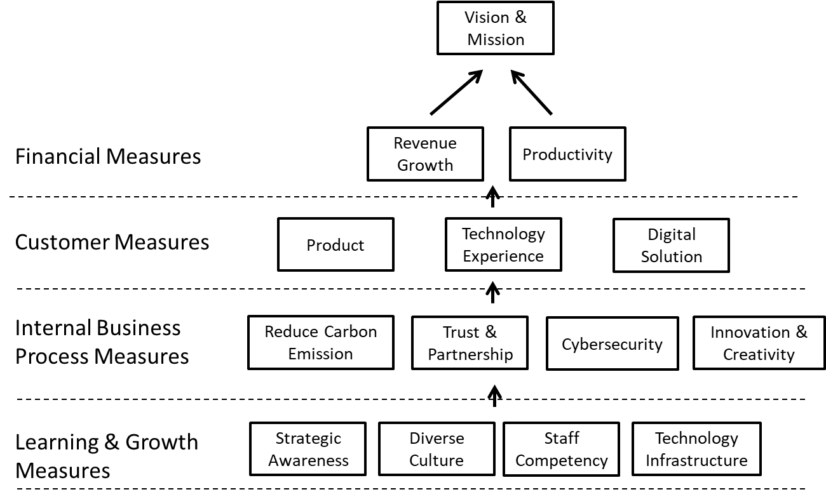

The above strategy map shows how strategically Microsoft can achieve its vision and mission through the learning and growth measures, internal business process measures, customer measures and financial measures (Tan, 2021, p. SU1-25 – SU1-26).

For the learning and growth measures, it has four strategic themes. They are strategic awareness, diverse culture, staff competency and technology infrastructure. The staff must be aware of the company strategies in order to align to Microsoft’s goals and values. This will enable work to be more meaningful for staff when they can relate to it. Work contribution can happen when there is alignment to company vision and mission. The next strategic theme is diverse culture. As mentioned in the case study, Microsoft embrace diverse culture in order to accommodate to it broad diversify customer base and provide its service to all (Microsoft, n.d.). Following that, staff has to be competent to meet the needs of the customers. Technology infrastructure needs to be able to provide staff with the necessary resources in order to complete their jobs. With the strategic themes defined under learning and growth measures, it can lead to the internal business process measures.

Under the internal business process measures, there are four strategic themes identified from the case study. They are reducing carbon emission, trust and partnership, cybersecurity and innovation and creativity. Firstly, Microsoft aims to reduce carbon emission starting from them and hopes to help the world to reduce carbon emission to build a more sustainable planet. Next, Microsoft hopes to build deeper partnership with their customer by earning their trust to enhance the customer experience of using Microsoft Technology. Cybersecurity is important in today’s world in order to ensure data security and protection. This will help to relieve customer’s concern with data security while using Microsoft’s product (Microsoft, n.d.). To maintain competitive advantage, Microsoft has to stay innovative in the market to meet the needs of the customers. With the strategic themes defined under internal business process measures, it can lead to the customer measures.

Under the customer measures, there are three strategic themes identified from the case study. They are products, technology experience and digital solution. Firstly, it is to produce products that suit the requirements and needs of the customers. Different products are launched for diversify customers base around the world that is being served by Microsoft. For example, Dynamics 365 allows organisation to create digital feedback loops by using Artificial Intelligence (AI) applications and Power Platform that enables anyone in an organization to start building an intelligent workflow or app that is non-existent. With the diversified products created by Microsoft, it can help to enhance positive technology experience and provide timely digital solution for businesses and people in the world (Microsoft, n.d.). With the strategic themes defined under customer measures, it can lead to the financial measures.

Under the financial measures, there are two strategic themes identified from the case study. They are revenue growth and productivity. With good products and customers partnership, Microsoft can expect revenue growth along the years. In 2019, Microsoft earned more than $125 billion in revenue (Microsoft, n.d.). The good foundation of having strong learning and growth as well as internal business process measures can help to increase workplace productivity which can result in customers’ satisfaction and therefore, resulting in growth in revenue for re-patronising.

1. The four basic stages in the data visualisation process are data storage and collection, followed by data pre-processing which involved data to be transformed into understandable data, then followed by graphics engine where the graphics algorithms and display produce and lastly, human visual and cognitive processing which involved cognitive system and human perceptual in visualising and interpreting and data (Tan, 2021, p. SU2-3 – SU2-4).

The challenge during the data collection and storage is to ensure that the data collected are relevant and meaningful to achieve its purpose. By ensuring data collected are relevant, it is also a challenge to ensure that the data are stored securely and safely. From the case, Microsoft mentioned that there is an increase in the data volume as it is expected to have 50 billion connected devices coming online by 2030 (Microsoft, n.d.). With the increase of stored data, the challenge here is to ensure that the data are being managed securely. Additionally, Microsoft also has to collect data that are relevant and meaningful for the technology that they wish to developed.

The challenge during the data pre-processing stage is to ensure that the transformed data is meaningful and understandable. From the case, Dynamic 365 was developed by Microsoft to allow any organisation to create digital feedback loops. This requires data to be extracted from one system and use it to produce optimised outcomes. The challenge here is to ensure that the pre-processing of the data is meaning and can be understandable to create effective digital feedback loops. The Open Data Initiative that has been launched also requires data to be enriched and exchanged across system to enable provision of unparalleled business insight (Microsoft, n.d.). If the data pre-processing was not conducted properly, the insights provided may not be helpful to organisations.

The challenge during the graphic engine stage is to ensure that the system can support the technology tools developed by Microsoft. If the system is unable to support the technology tool, it will not be practical for the customers to purchase. For example, Microsoft developed the Power Platform allows anyone in an organization to build intelligent app or workflow where none exists (Microsoft, n.d.). The challenge is to ensure that the system that can support Power Platform is commonly used among organisation and not something which requires additional resources and effort to put together before being able to use Power Platform. It is important for Microsoft to ensure that system can support the Power Platform.

The challenge during the human visual and cognitive processing is to ensure that the data can be easily processed and interpreted by people. With this, Microsoft needs to develop different visualisation tools to meet the usage of their customers. So as to speak, Microsoft’s customers are able to select the visualisation tools most suitable for their target audience to understand and interpret the data visually. For example, Microsoft’s LinkedIn enable integration with their Microsoft Graphs, Dynamic 365 and Microsoft 365 (Microsoft, n.d.). As such, the challenge is to innovate and integrate visualisation tools while optimising the data allowing people to easily understand it. This will enhance the experiences of the customers at the same time.

1. In general, the overall revenue increased in Microsoft 2019 Annual Report. Interestingly, Microsoft’s growth has been increasing steadily over the years which resulted in increasing revenue despite Microsoft being a technology based company, with many comparable competitors in the market. It is not easy to stay competitive and being one of the leading technology companies which provides products and services that meets the demand of its customers. This will requires substantial effort to understand the economy and the needs of its customers. I think Microsoft have done really well to keep on innovating and coming up with new products and services to remain the top of the customer’s choice. Nevertheless, with increasing revenue, the operating expenses over the years have also increased. This is unavoidable with rapid changing landscape in which Microsoft have to restructure to stay abreast to keep up with the changing environment. More and new research and development will be required to come up with new initiatives which would result in additional expenses incurred. Despite the high expenses incurred, Microsoft is still able to earn substantial revenue to cover the expenses (Microsoft, n.d.). Revenue growth is good for the company as this means that the company is growing and expanding. Apart from this, they are on their way to achieve their mission of enable all organisations in the world and every person to achieve more. In order to sustain the growth and excel, Microsoft needs to continue gathering leading data that will provide them with foresight to improve or create new products that benefits consumers to keep up with the advancement of technology. Microsoft can also consider to lower expenses by streamlining processes to sustain and boost revenue.

Another interesting point we noted from Microsoft’s 2019 Annual Report is the launch of LinkedIn platform. LinkedIn has expanded from a being a professional networking platform to integrate as job portal and even learning platform. This platform is relatively creative where it allows the individual to not only use this as a professional platform, but also able to digitise their resume into LinkedIn profile, discuss business ideas online, search for jobs or companies can use this as a platform to headhunt or look for new hires based on their profiles and references (Arruda, 2014). Besides a networking platform, LinkedIn now also launched Lynda, a LinkedIn Learning platform that allows individual to learn anytime and anywhere. Lynda have wide range of resources such as online video tutorials, classes or courses that individuals can subscribed based on their interest area (Lynda, n.d.). This is something innovative which breaks away from the usual norm of utilising a job portal. Presently, LinkedIn has gained its popularity in recent years where most students and professionals will create a professional profile to network using this platform. This being said, it is not surprised that the LinkedIn revenue increased 28% in 2019 for Microsoft (Microsoft, n.d.). It is no doubt that the launch of the LinkedIn platform benefitted Microsoft and is good to the company. However, there is no a perfect system. Microsoft has to continue maintaining the platform and upgrade based on new market trends and think of how to enhance the platform in order to meet the future needs of the users. Otherwise, other competitors may launch similar platform and soon takeover LinkedIn in no time when the system obsolete.

Take the gaming product line of Microsoft, their gaming revenue increased 10% mainly driven by Xbox software and services. Despite having many competitors out in the market such as Nintendo (Switch) and Sony (PlayStation), Microsoft is still able to keep its gaming line on par with these new products. Microsoft innovates by looking for opportunity to enhance gaming experience to gamers. In the past, Xbox was just a console that users play games by connecting to the TV. Gradually, Microsoft enables Xbox users to interact and play games with other gamers across various platforms such as PC, console (Xbox) and mobile. There are also services such as Xbox Game Pass and Mixer allowing gamers to subscribe to their game pass with access to over hundreds of high quality games which are updated and made available in devices. Microsoft subsequently moves towards an approach which they want to enable gamers to play games with people and devices that they want (Microsoft, n.d.). Similarly, this is also a good point of Microsoft. They constantly try to improve and upgrade to enhance the gaming experiences of the users. For instances, they have launched their new Xbox Series X in 2020 which provides better processing speed, graphics and bigger storage space. This enhances the gaming experience for the users (Shepherd, 2021). Similar to LinkedIn, Microsoft has to continue maintaining the gaming system and upgrade based on new market trends to meet the future needs of the users. Otherwise, it will soon be taken over by other competitors in gaming industry such as Nintendo and Sony.

In conclusion, these are some of the interesting points from the Microsoft 2019 Annual Report based on my opinion which resonate well with me. Microsoft is a capable technology company with ability to innovate and launch different line of products ranging from personal to commercial. Despite having diverse products and services, Microsoft can still emerge as one of the top provider in many different industries. Success never comes easy, to continue progressing, Microsoft has to constantly seek improvement and new ideas.

References

Arruda, W. (2014, August 19). The 5 Most Important LinkedIn Features You Aren't Using Correctly. Retrieved February 12, 2021, from <https://www.forbes.com/sites/williamarruda/2014/08/19/the-5-most-important-linkedin-features-you-arent-using-correctly/?sh=dd97f34682c0>

Lynda. (n.d.). About us. Retrieved February 12, 2021, from <https://www.lynda.com/aboutus/>

Microsoft. (n.d.). Microsoft 2019 Annual Report. Retrieved February 12, 2021, from <https://www.microsoft.com/investor/reports/ar19/index.html>

Shepherd, H. (2021, February 2). Xbox series X vs Xbox one X: Is it worth upgrading to Microsoft's next-Gen console?. Retrieved February 12, 2021, from <https://www.techradar.com/sg/news/xbox-series-x-vs-xbox-one-x>

Tan, J. (2021). *ANL201 Data Visualisation (Study Guide)*. Singapore: Singapore University of Social Sciences.