

**ANL201**

**Data Visualisation for Business**

**Tutor-Marked Assignment**

**January 2021 Presentation**

**SUSS PI No. : E1871675**

**Siti Norlela Binte Samuri**

**Submission Date : 17-Feb-2021**

**Question 1 (a)**

Mission Statement

Every organisation has a mission statement that sets out the reason behind their existence. This statement brings the organisation towards accomplishing their goals within the period of 5 years to 10 years. According to Satya Nadella, the Chief Executive Officer of Microsoft, the organisation’s mission statement is “to empower every person and every organization on the planet to achieve more” (Microsoft, 2019).

Within this statement, it can be narrowed to three crucial components. The first component would be empowerment which Microsoft’s products offers. Each of the products are design to ensure that the users are equipped to fulfil their needs. Secondly, the users targeted are made up of individuals or businesses no matter where they are as accessibility will not be an issue. Lastly, these individuals will not only achieve their expected goals but with Microsoft, they will achieve beyond what was expected (Gregory, 2019). Combined, these three components set out the objectives and their approach to reach those objectives.

**Question 1(b)**

Vision Statement

On top of the mission statement, a vision statement will enable the organisation to have a clear path to which it wishes to position itself beyond the foreseeable future. It works hand in hand with the mission statement while setting out a long-term goal for the organisation where it remains unhinged for more than a decade.

While it is not clearly stated in the Shareholder Letter, the CEO has made it clear that what Microsoft has to offer since they were founded in 1975. Thus, we can infer that their corporate vision is “to help people and businesses throughout the world realize their full potential” (Microsoft, 2019).

This vision statement mirrors the mission statement but clearly defines the desired future position. Microsoft has positioned itself amongst the global providers where its businesses and products provides the platform and tools for the global market to expand and grow. However, the future position should remain the same, as Microsoft will maintain its dominance in the enterprise technology by ensuring that it is undoubtedly the driver for the global market to attain its full potential, presently or in the future. In their vision, they set three ambitions that for the year.

1. *Reinvent productivity and business processes*

For them to maintain their dominance in the global market, they will ensure that their products are always evolving to meet the needs and empower the users. They believe that their products will give the digital solution to every organisation no matter their size.

1. *Build the intelligent cloud and intelligent edge platform*

They also envision partnering with organisations to be the platform for these organisations to digitally transform their businesses. Microsoft believe that their cloud business is going to bring about a global-scale transformation and their ability to convert data into AI gives them the competitive edge.

1. *Create more personal computing.*

They expect their products will provide a more personal experience for the users where the users are able to interact intuitively with the technology in a more engaging and dynamic ways.

**Question 1(c)**

Strategic Themes

The vision and mission statements encompass the essence of the organisation’s existence and gives the public an overview of what it desires to be and to achieve. With the guidance of these statements, the organisation will set out a strategy map to materialise these statements within the short-term period of about 3 to 5 years. The strategy map will consist of various strategic objectives which will create the foundation and each of these objectives are interlinked to one another through a theme that will reveal a shared understanding of what these objectives are and actions to focus on. Consequently, these strategic themes are often similar amongst businesses such as business growth, customer intimacy and operational effectiveness (Perry, 2011). Under these themes, the strategic objectives can also be further classified under Financial Perspective, Customer Perspective, Internal Business Processes and Learning & Growth.

According to the Shareholder Letter, there are four strategic themes that the Microsoft focused on. In each theme, it is also mentioned the different strategic objectives and plans that it has executed or is looking to execute.

1. *Business Growth - Technology Breakthroughs and Progress*

Microsoft businesses and products revolves around technology and therefore it is crucial that the first strategic theme laid out by the CEO is the technology breakthroughs and progress. They invented and reinvented, acquired and perfected their products to ensure that these products are one step ahead of the advancements surrounding them. For instance, they acquired new businesses such as GitHub where it ensured that through the Financial Perspective, the strategic objective of business growth is achieved where it has contributed to the increase in revenue in intelligent cloud by 21%. Under the Customer Perspective, the strategic objective of increasing users’ satisfaction is achieved through understanding the needs of the users such as that of their Outlook apps on iOS and Android where it has reached more than a 100 million users (Microsoft, 2019).

1. *Customer Intimacy - Trust*

While it is important that the technology is kept up to date with the current changes, trust also plays a crucial role in all of its strategic objectives. Without the consumer’s trust, a product or business holds no value. Within this theme, Microsoft sets out the three pillars to gain consumer’s confidence i.e. privacy, cybersecurity and responsible AI. Most of these strategic objectives in this theme revolve around the Customer Perspective. For instance, they set out to be the first few supporters of the European Union’s General Data Protection Regulation (GDPR) and ensured that their global consumer’s privacy is protected as they continue to advocate for new privacy laws. They also invested heavily in cybersecurity through collaborations with non-governmental organizations as well as the government globally. In terms of responsible AI, they have created awareness through programmes such as the AI for Good Initiative where ethical issues are being addressed to ensure that the technology is used responsibly (Microsoft, 2019).

1. *Sustainability - Environmental and Corporate Social Responsibility*

Other than the obligations as a trustworthy technological supplier, Microsoft also play its part in ensuring that they are running their business with an obligation to be responsible to the effects they have on society as well as the environment. Their strategic objectives under this theme are mostly affecting the Learning & Growth component as it is widely on sustainability and social impact. One of their strategic objectives mentioned is the reduction in carbon emission to the point that they want to achieve a reduction of 75% by 2030. They engineered pilot products that are environmentally friendly such as the carbon neutral Xbox consoles. They also created solutions for a more sustainable planet such as AI for Earth where environmental data can be studied to better understand the challenges ahead and readily equip them on ways to combat such challenges. In terms of their Corporate Social Responsibility, they are paving ways to provide solutions for affordable housing in the community near their headquarters i.e. Puget Sound region. They also funded an organization (Code.org) which enables young individuals from all backgrounds with digital skills (Microsoft, 2019).

1. *Diversity & Inclusivity - Culture*

Microsoft operates on a global scale, therefore in the public eye, their employees are their first and foremost advocates to live by their vision and mission. Therefore, surrounding these strategic objectives laid out in the letter, it entails mostly on Learning & Growth and Customer Perspective. They ensure that the employee’s satisfactions are met by placing importance on the physical, emotional as well as financial well-being of their employees and families. In terms of employment opportunity, they strategized to embrace diversity in the workplace by looking into the employment mix be it by gender or race throughout the different management levels. Furthermore, they ensure that customer’s satisfaction is met as their diverse needs are not limited by what the organisation can to offer as their diverse team is highly likely to understand their customers better.

Overall, Microsoft’s strategic themes and objectives are mostly within the mix of Customer Perspective and Learning & Growth. This is likely due to the fact that they are pioneers and dominant in their field.

**Question 1(d)**

Challenges in the Stages of Data Visualisation Process

1. *Data Collection and Storage*

The primary stage of Data Visualisation Process is the Data Collection and Storage stage where data are collected from the difference sources and then stored for processing. In general, data are often voluminous, and the storage of such data may pose as a challenge. For small companies, we often look for storage solution in the form of hard drive or perhaps even cloud using servers that are readily available with a small fee. For Microsoft, being the provider of such servers, they cannot turn to a small hard drive to store their data, they have datacentres. Their Azure global structure is massive, comprised of 160+ physical data centres that are linked by one of the largest interconnected networks on the planet (Microsoft, 2021). Therefore, the integrity and security of such data stored in one of these data centres are of the upmost importance to users as well as Microsoft. Therefore, to ensure that such data are protected physically and are also accessible at any point of time, they have invested in the expansion and upgrades of the data centres to run on renewable energy and to ensure that these data centres have back up electricity (Roach, 2020).

1. *Data Pre-processing*

When data collected are stored securely, the next stage to look upon is Data Pre-Processing which involves the transformation of data into useful information. While most data collected at the point of inception may be deemed useful, not all data would be required to be included as it may not serve the purpose of information one wishes to present. Therefore, these extra data may be a clutter or duplicate and would be required to be extracted out from the batch. To process a whole batch in order to remove such unwanted data would be time-consuming and may not be the most effective way. Therefore, it is important to first ensure that the storage in which the data are kept has a trigger or flagging feature to ensure that the data collected are within the scope of what is required. For instance, using Microsoft Excel, the data collected may be coded to ensure that it fits the criteria such as using data validation and drop-down list. When cleaning up the data, flag functions can be used such that data can be simplified to 1 and 0 and those not within the scope or are incomplete are considered invalid (Rajasekaran, 2018). Finally, when data has been processed, look for anomalies in the data collected through the summary such as total value is unreal such that a data was input wrongly.

1. *Graphics Engine*

The graphics engine is made up of the display hardware and the graphics algorithms where data can be realised on a screen. The vulnerability of the graphics rendering engine is a challenge faced when interactive scalability remains unresolved (Andres, 2015). When data input is large, the graphics engine may not be able to produce the intended visualisation even after it has been processed, perhaps due to hardware freeze for an extended period of time or system just crashed. For Microsoft Windows, it depends on the processor and the computer model, whether it has been updated or there’s simply too much data being stored. Many elements play a role in the graphics engine functioning as it should be. For Microsoft Outlook for iOS and Android, it limits the storage of emails to ensure efficiency of the application.

1. *Human Visual and Cognitive Processing*

With technological advancements, the sizes of the screen have played an influence on the products purchased. The human visual and cognitive processing is limited to what the eyes can see. Therefore, it is a challenge to cater the interface of any visual application to everyone’s need. The Surface Duo phone is an example of what is set by the majority standard, where the size of their screen is in trend with other brands. Their user interface has mix review but given that it is much like any windows on a personal laptop, users will find it easier to transition to the “mini” portable laptop. However, there may be resolution, sizing or colour adjustment issues when it comes to an interface that does not match well with the application and this may render a misreading of data where it may overwhelm the users perceptual and cognitive capacities (Rajasekaran, 2018).

**Question 1(e)**

1. *LinkedIn*

In the Shareholder Letter, LinkedIn was mentioned to be the most comprehensive solution for human resource management. It offers both free and paid services to ensure talents are able to stay connected to recruiters. However, it was also mentioned that it faces competition from other similar platforms and larger companies focused on only talent management and human resource services. It was acquired by Microsoft in 2016 for a purchase price of $26.9 billion.

LinkedIn operating loss increase $63 million from 2017 to $987 Million in 2018 as mentioned in “Fiscal Year 2018 Compared with Fiscal Year 2017”. There is no mention of such losses in “Fiscal Year 2019 Compared with Fiscal Year 2018” but it was mentioned that overall gross margin increased due both LinkedIn and Office 365 Commercial improvements. The financial report also repeated mention the 28% increase in revenue. It is quite hard to deduce if LinkedIn was profitable in 2019 as information is either blurred by the combinations of businesses in a segment i.e. Productivity and Business Processes or that there is no readily available individually segmented financial information.

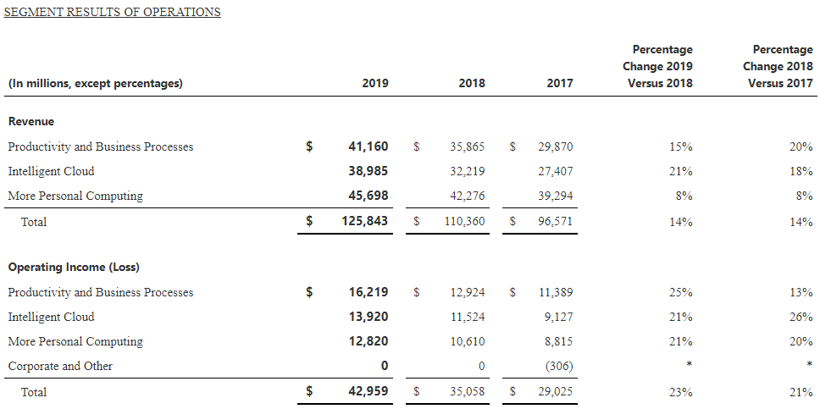**Figure 1: Segment Results of Operations**

Rather than writing paragraphs of information, the data could have been better shown in a detailed “Segment Results of Operations” where the breakdown of the major business is highlighted within the same table. However, it would seem to be a strategic move not to cast such information openly so as to ensure LinkedIn’s survival. If LinkedIn did not perform well in 2019, and that the information is publicly available, then it may affect the future prospects of what LinkedIn may offer. Microsoft may have a long-term strategy to position LinkedIn and current losses may be soon overturned once their strategy materialises.

1. *Dividend vs. Earnings per share vs. Cashflow*

An interesting point is the dividend declared versus the earnings per share. As seen in “Summary Results of Operations”, the earnings per share has increased from 2017 to 2019, cumulatively about 55% from $3.25 in $5.06. However, it is interesting to note that the declared dividends seen in “Stockholders’ Equity Statement” have only increased about 18% from $1.56 and $1.84. As an investor, it would be quite alarming to see the difference between the two especially when the cashflow is in excess of $11 billion 2019 as compared to $7 billion in 2017.

At the start of the Shareholder Letter, they stated that out of the $50 billion in cashflow, $30 billion were paid out to shareholders. However, there are some inconsistency that I am unable to verify between the figures stated in the “Financial Review” (Figure 2) and “Stockholders’ Equity Statements” (Figure 3). There is no index to assist in finding this information. The notes do not provide much information as well.

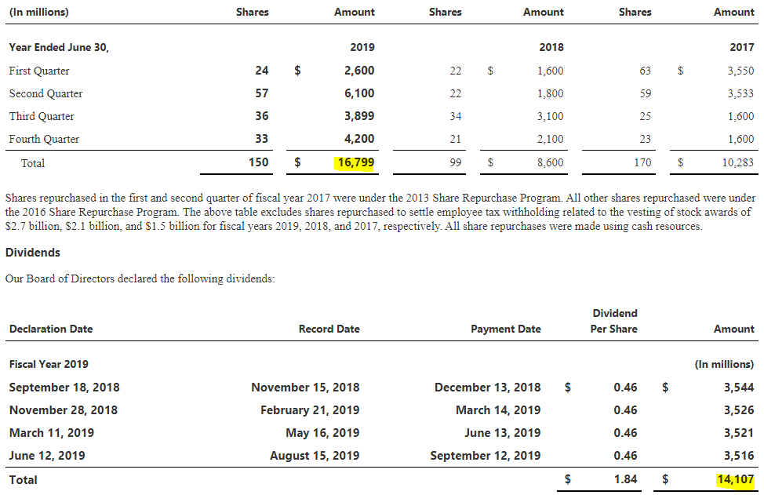**Figure 2: Financial Review**

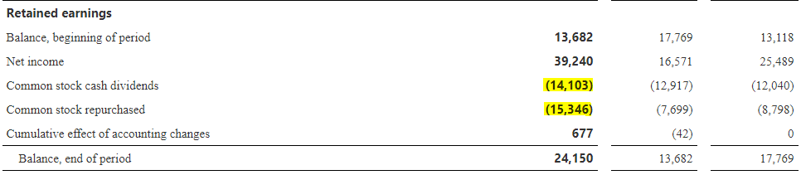

**Figure 3: Stockholders Equity Statements**

It would be better, given that Microsoft is a tech giant, that they would invest more on an interactive Financial Report where we are able to navigate between the data provided. For instance, instead of index notation, they could provide something like a hyperlink to directly take the user to the connected data or notes to have easier access across the long taxing pages of its annual report. As a user of the financial report, such as shareholders, reading such report is not going to be easy and thus it may give Microsoft a disadvantage. Most companies such as Google provides PDF in Pages where it is easier for users to jump from one header to another without the need to scroll tirelessly.

Reference

Microsoft (2019, October 16th) *Annual Report 2019, Shareholder Letter*. Retrieved from: (<https://www.microsoft.com/investor/reports/ar19/index.html>

Gregory, L (2019, February 24th) *Microsoft’s Mission Statement & Vision Statement (An Analysis)*. Retrieved from: <http://panmore.com/microsoft-corporation-vision-statement-mission-statement-analysis#:~:text=Microsoft's%20corporate%20vision%20is%20%E2%80%9Cto,can%20use%20for%20their%20development>

Perry G. S. (2011) *Strategic Themes – How Are They Used and WHY?* Retrieved from: <https://balancedscorecard.org/wp-content/uploads/2019/08/BSI-strategic-themes%E2%80%93how-are-they-used-and-why.pdf>

Microsoft (2021) *Azure global infrastructure*. Retrieved from: <https://azure.microsoft.com/en-gb/global-infrastructure/>

Roach J. (2020, July 27th) *Microsoft tests hydrogen fuel cells for backup power at data centers*. Retrieved from: <https://news.microsoft.com/innovation-stories/hydrogen-datacenters/#:~:text=Microsoft%20tests%20hydrogen%20fuel%20cells%20for%20backup%20power%20at%20datacenters,-July%2027%2C%202020&text=In%20a%20worldwide%20first%20that,consecutive%20hours%2C%20Microsoft%20announced%20Monday>.

Rajasekaran C. (2018, June 12th) *Data Pre-processing: Why do we care?* Retrieved from: <https://medium.com/@chitu_rk/data-pre-processing-why-do-we-care-567a518c308c>

Andres, F. et al. (2015, October). Challenges and Opportunities with Big Data Visualization. Retrieved from: <https://www.researchgate.net/publication/286242973_Challenges_and_Opportunities_with_Big_Data_Visualization>