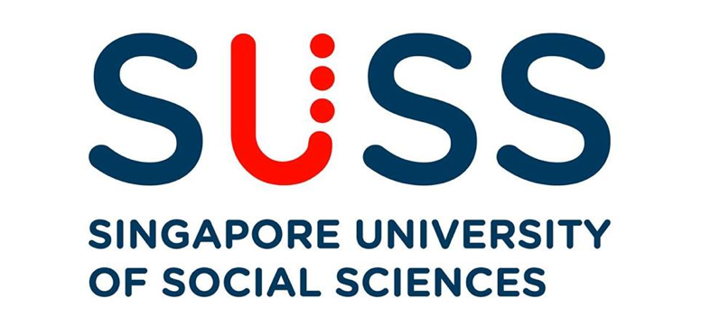

**ANL201**

**Data Visualisation For Business**

**Tutor-Marked Assignment**

|  |  |
| --- | --- |
| **Name** | **PI. Number** |
| **Soon Yue Jun Austin** | **Y1780516** |

**Tutor: : Kumar Munish**

**Tutorial Group: T02**

**Date of Submission: 17 Feb 2021**

**Word Count:1921 words**

**Question 1a**

Microsoft's mission statement is “ **to empower every person and every organization on the planet to achieve more**.” This provides us with a reason for the existence of Microsoft. This means that through its platforms and tools Microsoft hopes that organizations regardless of industry and size can build their digital capabilities to become more efficient, productive, competitive and effective.

**Question 1b**

A Vision Statements sets out the desired future state of organisation (Singapore University of Social Sciences, 2021). In the shareholder letter, the CEO states that “Today, every company is a technology company”. He believes that the next big technology breakthrough will come from partners. He also states Microsoft’s desire to interconnect its three ambitions of 1) Reinvent productivity and business process 2) Build the intelligent cloud and intelligent edge platform 3) Create more personal computing

With that in mind a possible vision statement could be “ **To partner with every technology company to innovate the best products and services that will create a seamless experience**” *Every company is a technology company. This means that Microsoft seeks to be alongside every company to build its digital capabilities akin to a technology company.

Furthermore, the aforementioned vision statement aligns with its mission statement. The mission statement provides us with insights on the qualifiers of “best products and services” which is to create products and services that are “efficient”, “productive”, “competitive” and “effective to its users.

Overall, the shareholder annual letter places a huge emphasis on partnerships with different organisation in different industries such as healthcare, education, Food & Beverages, Manufacturing, Automotive, and Grocery.

**Question 1c**

The definition of Strategic Themes is to create a shared understanding of what Strategic Objectives are and actions to focus on (Singapore University of Social Sciences, 2021).

In view of that, four strategic themes are being identified which are 1) Technological Breakthroughs, 2) Reliable and Trustworthiness, 3) Uphold Environment and Corporate Social Responsibility 4) Customer and Employee Centric Culture

**1) Technological Breakthroughs**

Technological breakthroughs are one of the key pillars of Microsoft ‘s strategy towards its desired end state of innovating the best service and products. For example, in the field of application and infrastructure Microsoft is investing to innovate the most complete toolchains for developers. Another example would be that during the COVID-19 pandemic, Microsoft teams have been a great solution to communicate at the safety of our homes efficiently and effectively. This also aligns with the mission statement to empower everyone to achieve more.

**2) Reliable and Trustworthiness**

Microsoft needs to gain the trust of those who adopt its products and services. If trust is broken, any technological breakthrough would be futile as the users are not willing to adopt them. With data involved, privacy issues will come to the table. Thus, Microsoft has to ensure that users' privacy would be protected. To do so Microsoft has to allocate resources in cybersecurity. For example, Microsoft has been focusing on security innovations on products and services across Azure, Dynamic365, and Microsoft 365. In 2019, three services were introduced namely Microsoft Threat Protection, Azure Sentinel, and Azure Confidential Computing. Users need to trust that Microsoft will protect their data and capable of defending against any emerging cyber threats. Another strategy that Microsoft has to build trust is that they have spearheaded initiatives that would protect the user’s privacy. For example, Microsoft pushed for more detailed government regulation on facial recognition technology.

**3) Uphold Environment and Corporate Social Responsibility**

Microsoft needs to foster a sustainable future through innovative products and services. For example, internally, Microsoft is committed to building the most sustainable data center. Externally, Microsoft is working with different partners to use technology to efficiently reduce their environmental footprints. In terms of corporate social responsibility, Microsoft has been seeking out opportunities to use technology to provide everyone with opportunities to achieve more. For example, Microsoft is the largest donor of Code.org that enables students from all over the world can learning coding skills.

**4) Vibrant Workforce and Customer-Centric Culture**

Microsoft realise that to innovate the best products and service, a vibrant workforce and customer-centric culture must be rooted in its organisation. For example, Microsoft has provided industry-leading work benefits to its employee. Microsoft also ensures that the workplace is more diverse such as increasing the number of women corporate vice president by 152% and including more African American/Black and Hispanic/Latinx employees in non-retail roles by 54%. Such a vibrant and diverse workforce will be in a great position to serve diverse customers globally. Microsoft adopts strong customer-centric culture because it believes it is the key to achieving the “best” products and services. Their customer-obsessed culture can be seen as they are actively listening to customers’ needs and creating products and services alongside them.

**Question 1d**

As seen below, the four stages of visualisation are 1) Data Collection and Storage 2) Data pre-processing 3) Graphics Engine 4) Human Visual and Cognitive Processing.

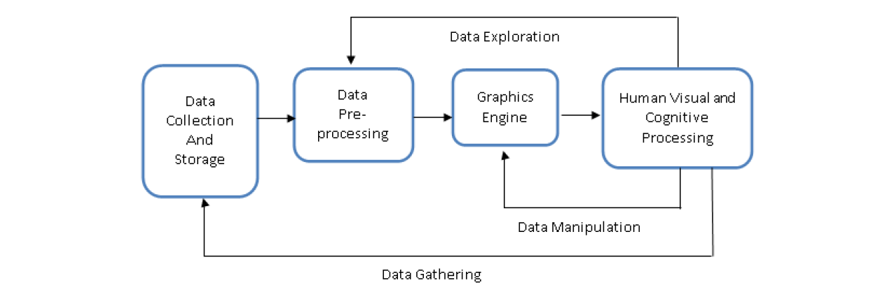

Figure 1.1: 4 Stages of Visualisation

**Challenges faced in Data Collection and Storage: Privacy**

One of the possible challenges is privacy. Microsoft has numerous huge data centers across the globe storing data from those that use their products and services. For example, in January 2020, it was revealed that a database of 250 million Microsoft customer records over the duration of 14 years has been founded to be exposed online and accessible to anyone on the net (Winder, 2020). This includes personal data such as email address, IP address, and even geographical location being exposed to the public. Thus, Microsoft needs to ensure every step of the data collection and storage is secured and only accessible to the relevant personnel.

**Challenges faced in Data Pre-processing: Data Inconsistency**

One of the biggest challenges is data inconsistency. Microsoft has products and services spanning across different industries and sectors globally. It will be a challenge for Microsoft to process all the different data into a clean and standardise format to work on. For example, in the annual report, Microsoft state that their AI for Earth program has collected massive environmental data sets. However, as a scale of temperature, certain regions adopt “Fahrenheit” while certain regions use “Degree”. Thus, Microsoft needs to take note that data could differ to due regional format, different numerical units, and invalid data type in the pre-processing stage.

**Challenges faced in Graphics Engine: Tough to select meaningful variables**

The display algorithms need to be able to produce and discover the meaningful relationship between selected variables. This is an important step for users to make sense of the data and take actionable steps. However, this requires a certain degree of competence in manipulating the data and failure to do so will lead to poor execution of visualisation.

**Challenges faced in Human Visual and cognitive processing: Cultural Context**

Based on the nature of the data, the data displayed must be visually optimised. More importantly, the visualisations must be easy for the user to accurately grasp the key points. However, one needs to be careful of cultural context. For example, a “Thumbs up” symbol might signal positive reinforcement, but some might take it to be an offensive sign in Australia (Jones, 2020 ). While it is challenging, as a global company, Microsoft needs to be ensured that the visualisation of data must be contextual to the culture they are serving in.

**Question 1e**

**First Interesting Point: Microsoft is placing their focus on Cloud Services**

The first interesting point is that Microsoft is placing their focus on its high-growth cloud-based services and tools. One such example is Microsoft Azure which is a cloud service that offers professionals to manage applications.

***Why it is interesting?***

I believe that it is interesting because it provides us with the assurance that Microsoft is on the right track to grow in the long term as they double down on their intelligent cloud and intelligent edge platform. Historically Microsoft rise to prominence as its window systems dominate the operating system of personal computers. Yet ironically, they missed the huge chance to do so in the mobile operating system as market share was gobbled up by Google’s Android and Apple’s IOS. This shows that Microsoft has learned from its mistakes and now gaining a foothold early in potentially high growth sectors.

***Good strategy or Bad Strategy?***

I believe that it is a good strategy that one of Microsoft’s primary focuses is on cloud services. In 2019, its intelligent cloud revenue increased 21% to 6.8 billion, while Azure revenue growth surge to 72% (as compared to 2018). The growth of revenue in “Intelligent cloud” (21%) outpaces its other revenue generator of “Productivity and Business process (15%)” and “Personal Computing(8%)”. This is important because Windows revenue (More personal computing) which used to be the core of Microsoft in the past, is facing slow growth. This can be seen from its revenue that has only increased 877 million or 4% in 2019. This is positive reinforcement that Microsoft has picked the correct strategy and is benefiting from it. But more importantly, it provides us with insights that Microsoft is actively searching for “white spaces” that have high growth potential.

***Recommendation:***

While Microsoft has done an excellent job by hopping onto cloud services early, they are still behind the market leader – Amazon Web Services (AWS). Thus, Microsoft needs to continue to innovate and optimise its web services with the consumer in mind to catch up with AWS. For example, its ecosystem is not huge and only offers several Linux options, unlike Amazon which has an extensive partner ecosystem (Gartner, 2019).

***Second Interesting Point: Is Xbox a fit in Microsoft’s business-orientated strategy?***

In 2019, Gaming’s revenue is $11,386 Million which contributes to 9.04% of the total revenue.

***Why it is interesting?***

From the annual report, we can see that the core customer group that Microsoft focuses on is companies and enterprises. From a business perspective, Xbox looks like a mismatch in its new business-focused strategy.

***Good or bad strategy?***

In terms of revenue, it is no doubt a strong driver and it was a strategic move to capitalise on the thriving gaming industry. However, there is room for greater synergy.

***Recommendations***

One recommendation that Microsoft can fit the gaming sector into its business-focused strategy is to implement gaming technology in training products and services. For example, gamification could be used to make learning more efficient and productive.

***Third interesting point: Microsoft wants to create More Personal Computing***

In 2019, the More Personal Computing category which deals with Business to Consumers (B2C) attributed to 36.31% of the total revenue. In the annual report, Microsoft states that it wants to create “More Personal Computing” to achieve its vision.

***Why it is interesting?***

Firstly, this makes us wonder why and how Microsoft will expand its More Personal Computing.

***Good or bad strategy?***

Even though Microsoft's primary focus is B2B, I believe that it is a good strategy that Microsoft is placing increasing importance on the B2C market again. This can be seen from its record-breaking acquisition of LinkedIn. They understand that they need to avoid over-reliance and diversify.

***Recommendations***

I believe the missing puzzle that Microsoft is lacking is a shopping platform to circle up its eco-system. Under More Personal Computing, Microsoft currently has the hardware (Surface), Software(Windows), Gaming (Xbox), LinkedIn (Socials) but Microsoft is lacking a shopping platform. One possible acquisition would be Fiverr. Fiverr is a freelance service marketplace for business, and it fits perfectly with Microsoft’s business-orientated branding. Imagine if Microsoft can integrate Fiverr into LinkedIn and provide more job opportunities for professionals, I am certain that it would empower them to achieve more.

**References**

Gartner. (2019). Solution Comparison for AWS, GCP and Microsoft Azure Native Cost Optimization Tools. Retrieved 17 February 2021, from <https://www.gartner.com/en/documents/3976223/solution-comparison-for-aws-gcp-and-microsoft-azure-nati>

Jones, M. (2020). 10 Common Hand Gestures That Are Rude in Other Countries. Retrieved 17 February 2021, from <https://www.rd.com/article/common-hand-gestures-rude-in-other-countries/>

Microsoft. (2019). *Microsoft 2019 Annual Report.* Retrieved 17 February 2021, from <https://www.microsoft.com/investor/reports/ar19/index.html>.

Singapore University of Social Sciences (2021). *ANL201 Study Unit 1_2021.* Retrieved 17 February from <https://canvas.suss.edu.sg/courses/31564/files/5433883?module_item_id=394592>

Singapore University of Social Sciences (2021). *ANL201 Study Unit 2_2021.* Retrieved 17 February from <https://canvas.suss.edu.sg/courses/31564/files/5389670?module_item_id=381972>

Winder, D. (2020). *Microsoft Security Shocker As 250 Million Customer Records Exposed Online.* Retrieved 17 February 2021, from <https://www.forbes.com/sites/daveywinder/2020/01/22/microsoft-security-shocker-as-250-million-customer-records-exposed-online/?sh=23988bf54d1b>