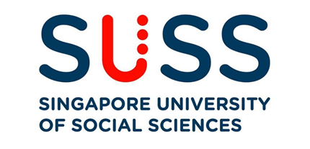

**ANL201**

**DATA VISUALISATION FOR BUSINESS**

**Tutor Marked Assignment**

Submitted by:

|  |  |
| --- | --- |
| **Name** | **PI No.** |
| Chen Junkai | B2071032 |

Tutorial Group: ­­­­­­­­­­­­ T02

Instructor’s Name: Dr. Munish Kumar

Submission Date: 17/02/2021

An Analysis of Microsoft Business

In this paper, we first discussed Microsoft’s mission and vision statements, and subsequently, we moved on to understand the four strategic themes that Microsoft has by elaborating on each of the themes. Next, we highlighted the challenges in each of the four stages of the data visualization process and concluding the paper with two interesting pointers that could be derived from Microsoft’s 2019 Annual Report by elucidating on the effects of the pointers and making relevant recommendations.

**Question 1(a)**

It is Microsoft's mission to ‘*empower every individual and organization on the planet to achieve more*’ and it is the reason for their existence (see Figure 1). They do so by enabling organizations, regardless of their scale and industry, to innovate and succeed through using Microsoft tools and platforms. The experience of empowerment allows everyone, this includes businesses, educators, and the 2 billion first-line workers globally, to feel assured, competent, and in control.

Furthermore, Microsoft views their mission as a tremendous opportunity and take it upon their shoulders to make sure that the technology they created would bring about positive impact to the people and the planet we inhabit in, consistently. Their tools and platforms supported small businesses, multinationals, governments, and non-profit organizations to be more effective, productive, and competitive. Consequently, improving education outcomes and healthcare, magnifying human ingenuity, and enabling people everywhere to reach their fullest potential.

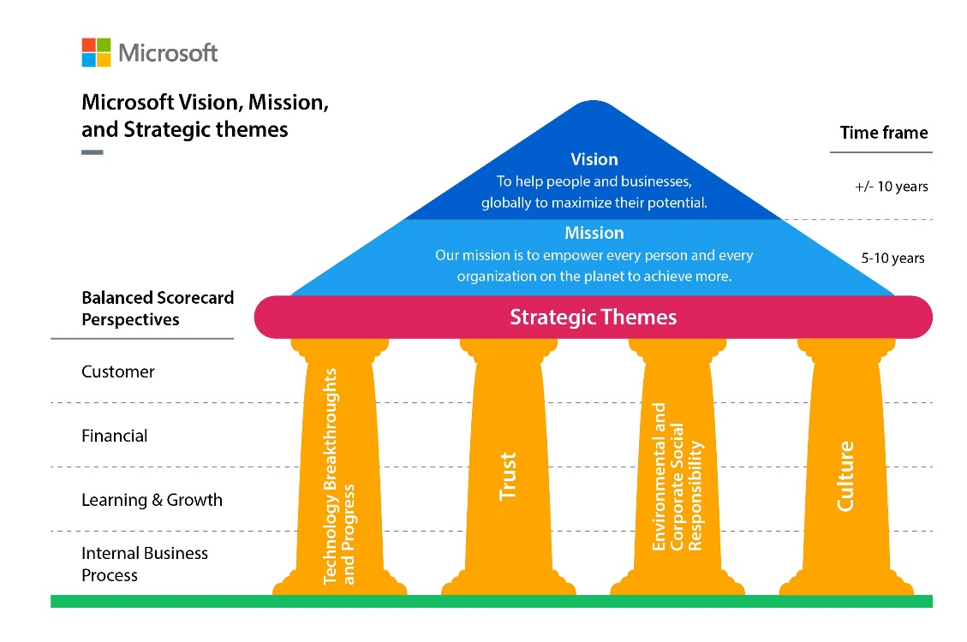

*Figure 1*. Microsoft Vision, Mission and Strategic themes. Adapted from “Strategic Themes – How are they used and why?” by S. Perry, 2011. (https://balancedscorecard.org/wp-content/uploads/2019/08/BSI-strategic-themes%E2%80%93how-are-they-used-and-why.pdf.)

**Question 1(b)**

A vision statement seeks to express the desired state of an organization in the future. Microsoft's vision for 2020 would be to help people and businesses, globally to maximize their potential in my perspective (see Figure 1).

In my opinion, Microsoft wants to assist their customers and partners to be successful in their ways and this is shown by their commitment towards their customer success. In the shareholder’s letter, CEO Satya Nadella cited examples of how Microsoft has empowered the global audience (e.g. rural South Africa, Australia, Japan, and Detroit) through using its tools and platforms currently and I thought Microsoft would continue to provide the tools and platforms required for businesses to face the future challenges ahead.

Furthermore, I thought it is Microsoft's intent for businesses and people to be the best version of themselves. Microsoft does so by working in tandem with customers and partners to transform their businesses and enable them to achieve more than what they could imagine and envision. One such example is in the seaside city of Ise in Japan, a restaurant employee named Akiyoshi Shinobu who used to wait on tables taught herself machine learning to digitally transform her workplace.

**Question 1(c)**

**Introduction**

For Microsoft to accomplish its vision and thrive, it would need key high-level business strategies such as strategic themes. Strategic themes are pillars of excellence for the entire organization which outlines distinct focal points to look into to realize its vision (Perry, 2011). Moreover, strategic themes are intended to foster a common interpretation of the strategic objectives and the actions that would lead to measurable outcomes. Also, strategic themes divide an organization's strategy into different specific themes (see diagram 1). The four strategic themes that Microsoft embraces are technology breakthroughs and progress (1), Trust (2), environmental and corporate social responsibility (3), and culture (4).

**Strategic Theme 1 – Technology Breakthroughs and Progress**

Computing is becoming an integral part of every place and everything in the world and the age of intelligent cloud and intelligent edge is pushing the next course of innovation. Intelligent experiences and systems that were once inconceivable are now made possible. Microsoft is innovating to empower its customers in 5 different areas to help them transform digitally. These 5 areas are applications and infrastructure (1), Data and AI (2), business applications (3), modern workplace (4), and gaming (5).

In applications and infrastructure, Microsoft has recently bought over GitHub which has an audience of 40 million developers currently and it has helped them accelerate growth. Besides, to meet the customer's requirement of operational sovereignty and regulatory needs, Microsoft is establishing Azure as the world’s computer. Notably, 95% of Fortune 500 companies are relying on Azure for their mission-critical workloads.

In data and AI, as big data is increasing and is expected to double by 2030, Azure is the only cloud that has limitless data and analytics capabilities that handle the massive increase in data. Microsoft recognized that AI is the key for all applications moving forward and that is why they are normalizing Azure Cognitive services to enable developers to do more in their applications and they have updated Azure Machine Learning.

In business applications, Microsoft has placed their emphasis on Dynamics 365 that allows organizations to generate digital feedback loops that extract data from one system to enhance the outcome of another which empower business to be AI-focused. Microsoft Power Platforms equip an individual to build an intelligent application or workflow even if there is no existing precedent, and LinkedIn boasts to be the talent management solution to interact with the talents they hire. Also, LinkedIn plays an important role to attract, retain, and develop the best talent in the competitive work climate.

In the modern workplace, Microsoft 365 empower all individuals by offering an integrated, secure experience, and besides, Microsoft Teams achieved a breakthrough in obtaining more than 13 million active users daily. Lastly, in gaming, Microsoft has projects such as Project x Cloud that elevate gamers' gaming experience to the next level and Microsoft Game Stack seeks to empower game developers by providing them the tools to build cloud first games.

**Strategic Theme 2 -Trust**

Microsoft define responsibility as earning and sustaining the trust of the customers and partner they empower and this extend to their commitment of shared victory and wealth. Microsoft do so by having a business model that is in line with their customers success and do not play the role of competitor to earn their trust. The three pillars to Microsoft approach of trust are privacy (1), cybersecurity (2), and responsible AI (3).

Microsoft believes that privacy is a basic human right, and it uses two approaches to ensure privacy is adhered to in their practices: they believed that consumers should have their data and making sure that the services and products offered are created with privacy by design throughout. Microsoft defines clear privacy principles by committing to adopt transparent privacy practices, providing purposeful privacy alternatives, and managing the stored and processed data responsibly.

Microsoft understands that cybersecurity is a key consideration for all consumers in the current “zero trust” environment as such it has made cybersecurity the second strategic theme. Microsoft safeguards consumers by scrutinizing signals, processing authentication, and scan emails for malware and phishing monthly which also draw insights to spark security innovation across all their products and services.

Lastly, Microsoft adopts a principled approach in building responsible artificial intelligence (AI) and asked difficult questions such as ‘what should computers do?’ In the hands of an innovator, AI could solve issues and pressing challenges in society as such Microsoft started new programs such as AI for Good initiative. Concurrently, Microsoft also sees the importance to keep a lookout for the unintended outcomes that artificial technology might cause. An example is the use of facial recognition technology, which is an extremely powerful AI, and it calls for both the public and private sectors to come out with standards to regulate acceptable use to prevent the abuse of the technology.

**Strategic Theme 3 -Environmental and Corporate Social Responsibility**

Microsoft promotes a sustainable future by placing an emphasis on advancing environmental and social causes. As an organization, they understand that to tackle macro challenges such as climate change, Microsoft cannot do it alone. Microsoft, a global technology organization, is in an ideal position to influence and expedite digital transformations that could result in a low carbon future. The examples of these initiatives are enforcing an internal carbon tax to reduce their carbon footprints, focusing to make sure that their data centers are sustainable by powering them with renewable energy, and partnership programs with organizations to empower young people, in the female and underrepresented minorities, to acquire digital skills that are relevant for the future.

**Strategic Theme 4 -Culture**

Microsoft sees the importance to prioritize physical, emotional, and financial well-being of the people Microsoft hire and their family. They expressed this through providing a benefit structure that is industry-leading and the different incentive for the various life circumstances.

Microsoft is customer obsessed which they first understand and then innovate to meet their clients unarticulated needs. To do that, they would need a diverse and inclusive workforce to meet the requirement of the diverse customer worldwide. Microsoft have introduced a series of workplace inclusiveness initiatives and also attempt to address the issue of gender parity in workplaces. Microsoft CEO thinks that cultural transformation could only occur if there is continuous learning, renewal and the courage to confront existing mindsets.

**Question 1(d)**

**Introduction**

The four stages of data visualization are data collection and storage (1), data pre-processing and transformation (2), graphics engine (3), and human visual and cognitive processing (4) (see Figure 3). I would be elucidating the challenges faced in each of the stages in data visualization and illustrate with the case presented.

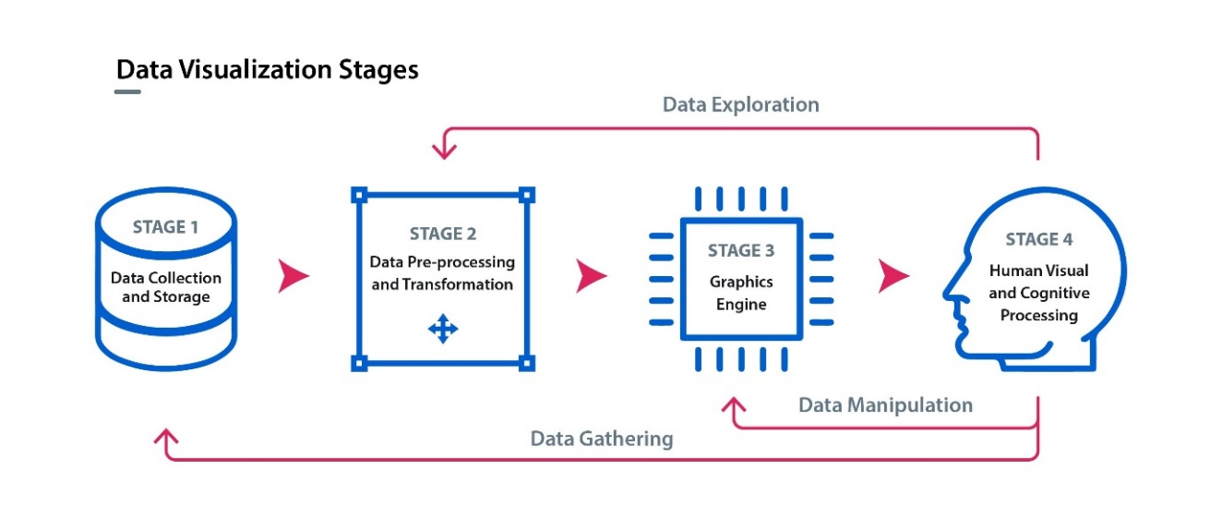

*Figure 3*. Adapted from Information visualization: Perception for Design *(Interactive Technologies)* (3rd ed.)*.* Waltham, MA, USA: Elsevier Inc. Ware, (2013).

**Growth Rate in Data Collection and Storage**

The key challenge for data collection and storage is the growth rate issue brought about by the ever-increasing amount of data. Data explosion poses growth rate challenges as organizations and businesses are struggling to find ways to manage the exponential increase in data in the long term (Espinosa et al, 2019). The challenge is that the sheer amount of data that has been collected is far exceeding our ability to create relevant systems to manipulate the data effectively and analyzing it to extrapolate relevant meanings for decision making.

According to Microsoft's annual report 2019, the projected number of connected devices online is estimated to be 50 billion by 2030, and the variety, velocity, and volume of data would significantly increase. Microsoft understands these challenges and has sought to address these concerns by having limitless data and analytics capabilities across their customers' data estate through their products Azure Data Factory and Azure SQL Data Warehouse.

**Data Validation in Data Pre-processing**

In data pre-processing the challenge would be to validate the data and Espinosa et al (2019) pointed out that the current data validation is typically focussed on missing data and outliers and they suggested that there could be a systematic approach to data validation and cleansing as the variety of data is always increasing. Furthermore, Microsoft also raised the concern of the variety, velocity, and volume of data to be doubled in 2030, which meant there are higher importance and challenge for complex data to be validated and cleanse before the data could be transformed into information in the analysis process.

**Interactivity Scalability in Graphics Engine**

In a graphic engine, interactive data visualization could help us understand the data insights faster and clearer. However, querying big data and complex algorithms might disrupt smooth interaction which the display hardware used to visualize their data might either freeze for an extended period or crash (Agrawal et al, 2015). Microsoft Power BI platform seeks to address this challenge by hosting 25 million models on their service and processing 12 million queries each hour.

**Perceptual Scalability in Human Visual and Cognitive Processing**

In the human visual and cognitive processing stage, the challenge would the perceptual scalability of big data. Agrawal et al, (2015) suggested that visualizing every data point could potentially lead to overplotting and that could overwhelm the human cognitive and perceptual capacities to perceive meaningful information. Microsoft has developed Azure Cognitive services to address the perceptual scalability challenge through the use of artificial intelligence to enable developers to see, hear, respond, translate and reason into their application. They also enhanced their machine learning capabilities so that the machine could be trained to learn the massive amount of data to generate unparallel business insight.

**Question 1(e)**

**Observation 1: Premise**

Gender parity and an inclusive work environment have become key themes in many workplaces. This is especially so in the technology sector which has been dominated by the male population (see Figure 4). According to Byrne, (2017), although the technology sector earned the reputation as one of the workplaces that people wanted to work in, the sector lacked in one area -gender parity. Therefore, it is interesting to observe and understand how Microsoft is tackling this issue that the technology sector grapples with.

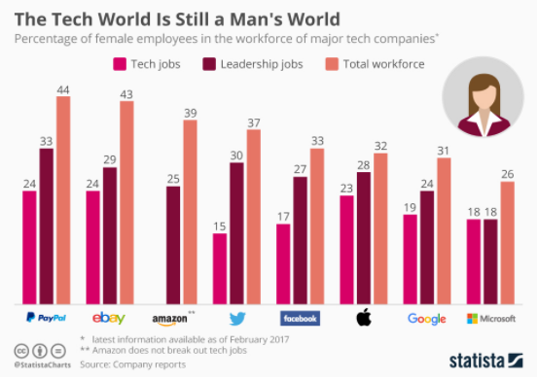

*Figure 4*. The Tech Word Is Still a Man’s World by (Byrne, 2017). (https://www.weforum.org/agenda/2017/08/women-in-tech-gender-parity/)

**Observation 1: Gender Parity and Inclusive Work Culture in Microsoft**

Microsoft aimed to nurture and cultivate an inclusive and diverse workplace culture by first increasing the number of women corporate vice presidents by 152%, and the number of African American/Black and Hispanic/Latinx employees in nonretail roles by 54%. At the board level, 38% of Microsoft directors are nominated for election at the 2019 annual shareholders meeting and 2 out of 4 board committees would be chaired by women (see Figure 5). These are some of the areas that Microsoft attempted to achieve gender parity and an inclusive work environment to combat the gender stereotype. It is interesting to see the approach that Microsoft has taken to increase the number of women in key leadership positions as women tend to have unequal opportunities when it comes to promotion or be considered in positions of authority. 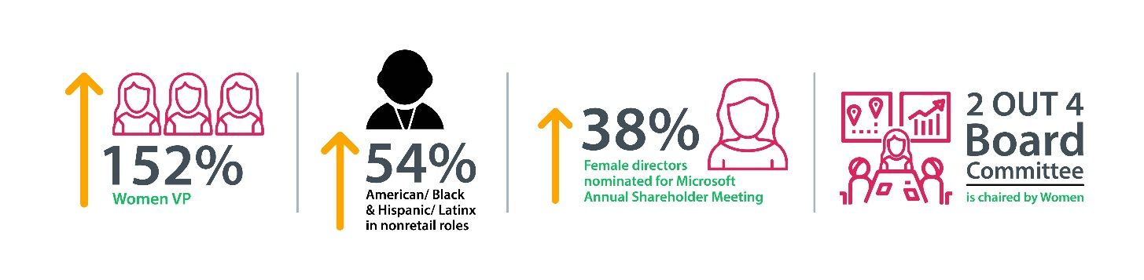*Figure 5*. Infographics of Microsoft Gender Parity and Inclusive Culture Initiatives.

**Observation 1: Effects of Gender Parity and Inclusive Work Culture in Microsoft**

The measures implemented to create an inclusive workplace are beneficial to Microsoft in my perspective. Diversity in the workplace would allow people from different backgrounds, experiences, and attitudes to spark creativity and innovation as they bring their different perspectives to the organization. Productivity could also improve which could result in business profitability in the long term.

Furthermore, a study by Zenger and Folkman, (2019) has revealed that women are rated better than men in 17 out of 19 key leadership capabilities. What this meant is that there is a lot of untapped leadership talent that is lost due to gender biases in the workplace. In my opinion, this is a positive step for Microsoft in creating a workplace that has less gender discrimination and inclusion.

**Observation 1: Recommendations**

The recommendations that I would suggest to Microsoft is to embrace gender parity and inclusive work culture as a paradigm shift in the future workplace more than just a numbers game (Tans, 2020). Microsoft should take note that gender parity and inclusive work cultures are not targets to meet as this could lead to people within Microsoft to reach for the bare minimum requirement to satisfy this target. Gender parity and inclusive work culture is just a starting point for other future conversations to make Microsoft the employer of choice. Moreover, other cultural shifts such as disability inclusion, bringing in people from lower socio-economic backgrounds, LGBTQ+ equality, and others could be potential area that Microsoft could look into.

Microsoft could also consider running sentiment analysis on the issue of gender parity and inclusive work culture to measure and understand the effectiveness of the initiatives they have undertaken. However, since the demographics of the Microsoft workforce is currently male-dominated, the variables of the analysis need to be carefully chosen so that the result of the analysis is representative of the sentiments on the ground.

**Observation 2: Changing Trend in Revenue Sources**

It is observed in the segment results of operations table that the percentage changes in revenue sources have decreased for productivity and business processes from 20% in 2017-2018 to 15% in 2018-2019 while it has increased for the intelligent cloud from 18% in 2017-2018 to 21% in 2018-2019, while more personal computing remains the same at 8% (see Figure 6). This is an interesting observation as it could suggest the changing trend in consumer purchasing behaviors in Microsoft products and services. There could potentially be a demand for an intelligent cloud in the future and a reduced demand in productivity and business processes products which could affect the way Microsoft allocates its resources to in the future.

**Observation 2: Effect of Changing Trend in Revenue Sources**

This observation is beneficial to Microsoft as they could strategically shift the focus of their business to place more emphasis on the research and development in the intelligent cloud technology such that Microsoft could be the trailblazers to step into the next phase of innovation before their competitors catch up. It is also favorable for Microsoft to anticipate demand so that as an organization they could keep themselves relevant to consumers and partners.

**Observation 2: Recommendations**

The recommendation that I would suggest to Microsoft is to invest their resources in terms of talent allocation, financial and research, and development into the intelligent cloud as the financial data seemed to suggest that it could potentially be the primary source of revenue in the next few years. Within the organization, Microsoft could think of retraining the employees in the productivity and business processes division to repurpose some of these existing talents to meet the needs of Microsoft in the future.

Microsoft could also consider doing competitor analysis to find understand the type of offerings that their competitors are providing. First, Microsoft could do a SWOT analysis to identify a potential advantage and to understand the competitive landscape. Parker (2019) has done a SWOT analysis of the Microsoft business that they could consider looking into (see Figure 6).

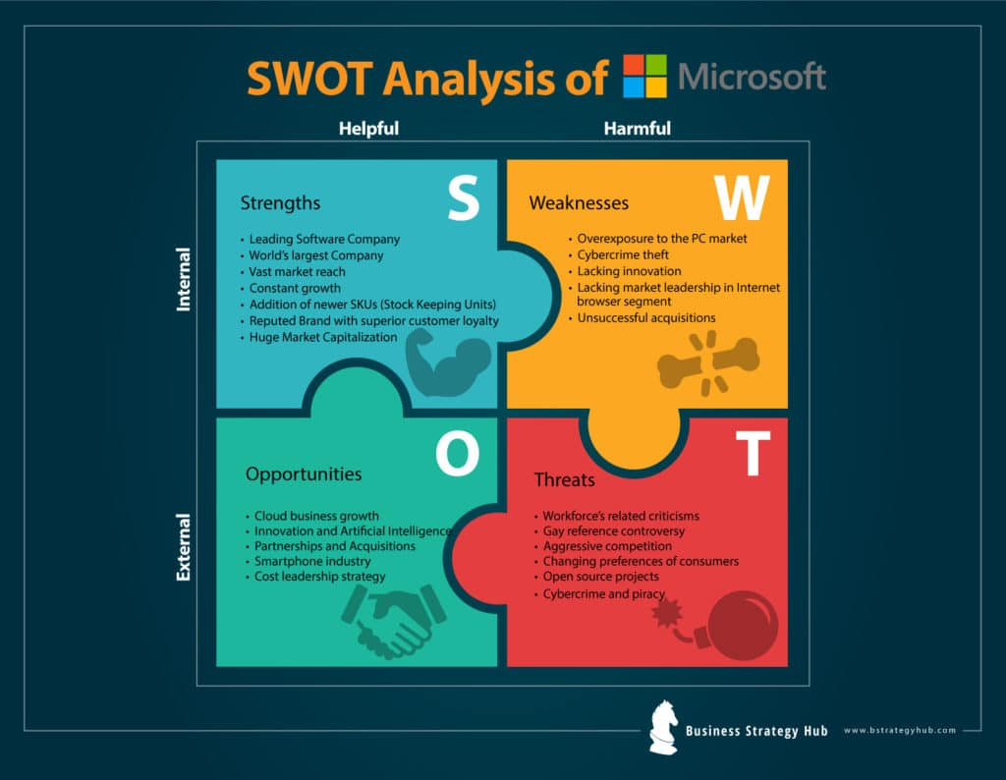

*Figure 6*. Microsoft SWOT Analysis 2019 | SWOT Analysis of Microsoft by Parker (2019). (https://bstrategyhub.com/swot-analysis-of-microsoft/.)

Another competitor analysis that Microsoft could also look into is Porter’s five forces framework look into assess the industry and market via the five elements: new entrants, buyers, suppliers, substitutes, and competitive rivalry. Dudovskiy (2019) analyzed Microsoft's business in detail the areas that Microsoft can look into. For example, there is a large number of competitors in the productivity and business segment such as Apple, Facebook, Google, IBM, and Slack to name a few.

**Observation 3: Microsoft interest the Gaming industry**

It is observed that in the table of revenue for the external customer (page 85) in the gaming product increase from 18,000 to 21 million from 2017 to 2019. This is an interesting observation in my opinion as to why would Microsoft a corporate giant be interested in the already saturated gaming market? An individual would not associate gaming with Microsoft as a business. Besides, Thurrott (2000) also questioned Microsoft's ability to meet the quality demands of the lower-volume enterprise market.

**Observation 3: Effects of Microsoft in the Gaming Industry**

This is beneficial to Microsoft as a business as they could diversify into other sources of revenue and the reason that Microsoft stepped into the gaming industry is that they developed DirectX technology in 1995. Microsoft stepped into the gaming industry so that could also leverage their existing DirectX technology and go into an untapped business opportunity.

**Observation 3: Recommendations**

The recommendation I would suggest to Microsoft is to look into gamification and could spearhead them into other industries by rethinking and relooking at the existing technology they have. Microsoft could consider gamification as a strategy to look into.

References

Agrawal, R. Kadadi, A. Dai, X.F. Andres, F. (2015). Challenges and Opportunities with Big Data Visualization. 10.1145/2857218.2857256. Retrieved from https://www.researchgate.net/publication/286242973_Challenges_and_Opportunities_with_Big_Data_Visualization.

Byrne, C. (2017). 4 Charts that Show Tech is still a Man’s World. *World Economic Forum*. Retrieved from https://www.weforum.org/agenda/2017/08/women-in-tech-gender-parity/.

Dudovskiy, J. (2019). Microsoft Porter’s Five Forces Analysis. Business Research Methodology. Retrieved from https://research-methodology.net/microsoft-porters-five-forces-analysis-4-2/.

Espinosa, J.A. Kaisler, S. Armour, F. Money, W.H. (2019). Big Data Redux: New Issues and Challenges Retrieved from Moving Forward https://scholarspace.manoa.hawaii.edu/bitstream/10125/59546/0106.pdf

Parker, B. (2019). Microsoft SWOT Analysis 2019 | SWOT Analysis of Microsoft. *Business Strategy Hub*. Retrieved from https://bstrategyhub.com/swot-analysis-of-microsoft/.

Perry, S. (2011). Strategic Themes – How are they used and why? *Balanced Scorecard Institute*. Retrieved from https://balancedscorecard.org/wp-content/uploads/2019/08/BSI-strategic-themes%E2%80%93how-are-they-used-and-why.pdf.

Tans, G. (2020). Why Workplace Diversity and Inclusion should not be a Numbers Game. *World Economic Forum*. Retrieved from https://www.weforum.org/agenda/2020/01/diversity-inclusion-gender-accessibility-workplace-culture/.

Thurrott, P (2000) Microsoft to Enter Gaming Industry with X-Box. *ITProToday*. Retrieved from https://www.itprotoday.com/cloud-computing/microsoft-enter-gaming-industry-x-box

Ware, C. (2013). Information Visualization: Perception for Design (Interactive Technologies) (3rd ed.). Waltham, MA, USA: Elsevier Inc.

Zenger, J and Folkman, J. (2019). Research: Women Score Higher Than Men in Most Leadership Skills. Harvard Business Review. Retrieved from https://hbr.org/2019/06/research-women-score-higher-than-men-in-most-leadership-skills.