

**ANL201**

**Data Visualisation for Business**

**Tutor-Marked Assignment**

**January 2021 Presentation**

**Submitted by:**

|  |  |
| --- | --- |
| **Name** | **PI No.** |
| Chew Kin Kiong | J1870459 |

**Instructor’s Name:** Dr. Kumar Munish

**Submission Date:** 17/02/2021

**Table of Contents**

1 Answer 1(a) 3

2 Answer 1(b) 3

3 Answer 1(c) 4

4 Answer 1(d) 5

5 Answer 1(e) 6

References 12

**List of Figures**

Figure 1: Four Stages of Data Visualisation Process (Ware, 2004) 6

Figure 2: Financial Highlights for Year Ended June 30 7

Figure 3: Summary Results of Operations for 2018 & 2019 9

Figure 4: Summary Results of Operations for 2017 & 2018 10

Figure 5: Stock Performance 11

**List of Tables**

Table 1: Financial Highlights for Year Ended June 30 7

Table 2: Summary Results of Operations for 2018 & 2019 9

Table 3: Summary Results of Operations for 2017 & 2018 10

# Answer 1(a)

The mission statement of a company is a short sentence that says how to get to where we want to go. It is put in such a way which is easy for stakeholders such as customers, suppliers, employees, to understand its purpose of what, why and how they can all do together to benefit them (Chen, 2020). For Microsoft, it’s mission statement is “ to empower every person and every organization on the planet to achieve more” refers to how Microsoft can help and enable each individual and each organization at every corner of the world by using its technology to increase their output more than what they can get compared to when working without using Microsoft products and services as a productivity and innovation tool.

# Answer 1(b)

A vision statement paints a broad picture of what the business wants to be in the future (Hofstrand, 2016). In 2009, Microsoft developed a Technology Education and Literacy in Schools (TEALS) Program targeting at students who are studying in several hundreds of high schools in the US, and British Columbia of Canada. The Program helps to build and grow computer science programs in a sustainable manner by connecting the volunteers from Microsoft and other firms. The teachers of the programs are then organised into teams to teach those computer science courses of TEALS to students. In 2019, Microsoft celebrated the 10-year anniversary of the Program. In my opinion, Microsoft has achieved its vision for year 2020 by teaching and equipping the aforementioned high school students with the technological know-how over the last 10-year period to prepare for the current technological demand. Such is the foresight of Microsoft in formulating the vision back ten years ago.

# Answer 1(c)

Strategic themes can be defined as the key business strategies that are designed at the top-level management level which form the foundation for the model of the business organisation. (Perry, 2011)

For fiscal year 2019, Microsoft’s strategic themes can be viewed under each of four perspectives in a Balanced ScoreCard. They are the financial perspective, customer perspective, internal business perspective and learning & growth perspective.

In the financial perspective, the strategic themes are how Microsoft Corporation reaped a record of US$125 billion in revenue, US$43 billion in operating income and distributed in excess of US$30 billion to shareholders. Its commercial cloud business ranked the largest in the world generating beyond $38 billion in revenue with gross margin rising to 63 percent.

In the customer perspective, the strategic themes surround how Microsoft emphasises on strengthening to offer trust, privacy, cybersecurity and responsible AI to increasing demand of end users. Besides, Microsoft also enhances its commitment to improving environmental conditions by further reducing the carbon emissions of its data centers to enhance air quality for the well beings on health for the people on the planet. On the corporate social responsibility aspect, Microsoft in partnership with its employees donated or offered relevant software or services to help transform non-profit organisations through technology to increase productivity.

On internal business process perspective, the strategic themes include how Microsoft inculcates in its employees on customer centric by actively listening to customers and taking their feedback seriously and translate them through innovation to meet customers’ unwritten needs. Over the last five years, it boosts the number of female corporate vice presidents by about one and a half times or 152% as well as raised the number of non-white employees in non-retail positions by about half or 54% in support of diversity and inclusion policy in the workplace.

On learning and growth perspective, the strategic themes consist of how Microsoft continues to innovate with technological breakthroughs in culture, technology in its products such as Azure cloud, acquisition of GitHub for developers, expanding its capabilities in relational database services for cloud analytics. The business applications are Dynamics 365 platform, Microsoft 365 and Microsoft Teams for the workplace as well as Gaming for the entertainment sector.

The above outlines the strategic themes of each of the four perspectives of the Balanced ScoreCard in support of the mission and vision statements of Microsoft Corporation to achieve spectacular financial performance.

# Answer 1(d)

According to (Ware, 2004), there are four stages in the data visualization process which are data collection and storage, data pre-processing, graphics engine and human visual & cognitive processing along with three feedback loops as shown in Figure 1. At the data collection and storage stage, the accounting data collected by an untrained person may come in different date and time or currency format making it difficult for storage and future retrieval. Survey questionnaires used to gather feedback from users of Microsoft products may contain missing values or errors due to unwillingness to cooperate but give wrong answers. At the pre-processing stage, the financial data of Microsoft are transformed into visualization for presentation into a graphical form for easy understanding. In the process, some finer details of the data may be compromised such as outliers are not compensated. The graphics engine is a software used by application programs to draw pictures and images on computer monitors. For example, Microsoft gaming products use graphic engines to reproduce data into 3D animation or human characters. In the case of financial reports, financial data are displayed as bar charts for earnings comparison over different time periods. The challenge faced at the graphic engine stage is the high processing speed and large memory space required for gaming to reproduce graphic images for financial report charts and video at high resolution for seamless visual comfort. The fourth is the human visual and cognitive processing stage. Human visual perception refers to the ability of our brain to form images with what our eyes see. While cognitive processing refers the brain focusing and putting all the information seen by the eyes together and using it to operate a hand held game controller (Eagleman, 2018) in the case of Microsoft gaming product. The challenge faced is on how to produce gaming content at very high visual resolution and speed for immersive gaming to retain attention of players.

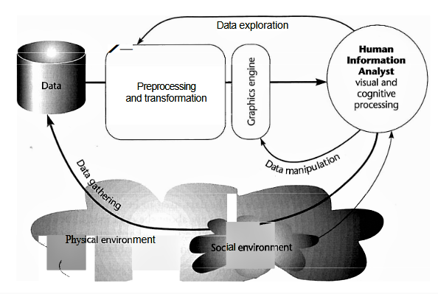

Figure 1: Four Stages of Data Visualisation Process (Ware, 2004)

# Answer 1(e)

The first point extracted from data in the Microsoft’s 2019 annual report thought to be interesting is the financial highlights for fiscal year 2015 to 2019 ended June 30 is shown in Table 1. The data are pre-processed for the fiscal year positioning which has been re-arranged from left to right. The original financial highlights were in numbers organised in a table format makes visual and cognitive processing uncomfortable. This does not reflect well on the company as shareholders may find it difficult to understand. The data in the table were subsequently transformed into line chart in Figure 3. The line chart type is chosen as it shows the financial performance trend for each fiscal year as well as performance comparison across all fiscal years. This chart presentation is user friendly, easy and quick for the Microsoft management to understand which is helpful for adjusting or devising new business plans for the following years.



Table 1: Financial Highlights for Year Ended June 30

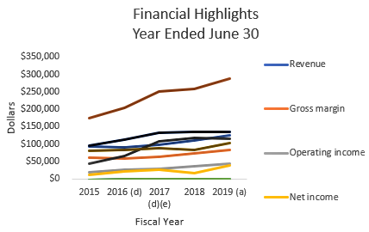

Figure 2: Financial Highlights for Year Ended June 30

Another interesting point from the data in the Microsoft’s 2019 annual report is the summary results of operations again are organised in table format showing the fiscal year 2017 to 2019 along with percentage change between current and preceding year comparing the financial performance between 2018 & 2019 as well as 2017 & 2018. This also makes visual and cognitive processing challenging. The original data for fiscal year in table format were stripped and broken down into two tables with each showing the performance for fiscal year 2018 & 2019 in Table 2 and 2017 & 2018 in Table 3 respectively. The fiscal year positioning was pre-processing with the fiscal year re-arranged from left to right for 2018 & 2019 and 2017 & 2018 together with their respective percentage change data which are subsequently transformed into bar charts in Figure 4 and Figure 5. The bar chart is used to display the comparison of year on year financial performance and the change in performance between two consecutive years.

|  |  |  |  |  |  |  |  |
| --- | --- | --- | --- | --- | --- | --- | --- |
| SUMMARY RESULTS OF OPERATIONS | | | | | | | |
|  |  |  |  |  |  |  |  |
| Descriptions | |  |  |  | 2018 | 2019 | Change (%) |
| Revenue |  |  |  |  | $110,360 | $125,843 | 14% |
| Gross margin | |  |  |  | 72,007 | 82,933 | 15% |
| Operating income | |  |  |  | 35,058 | 42,959 | 23% |
| Net income | |  |  |  | 16,571 | 39,240 | 137% |
| Diluted earnings per share | | |  |  | 2.13 | 5.06 | 138% |
| Non-GAAP operating income | | |  |  | 35,058 | 42,959 | 23% |
| Non-GAAP net income | | |  |  | 30,267 | 36,830 | 22% |
| Non-GAAP diluted earnings per share | | | |  | 3.88 | 4.75 | 22% |
| (In millions, except percentages and per share amounts) | | | | |  |  |  |

Table 2: Summary Results of Operations for 2018 & 2019

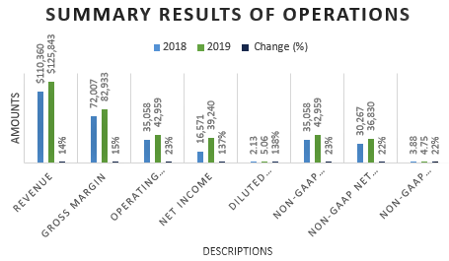

Figure 3: Summary Results of Operations for 2018 & 2019

|  |  |  |  |  |  |  |  |
| --- | --- | --- | --- | --- | --- | --- | --- |
| SUMMARY RESULTS OF OPERATIONS | | | | | | | |
|  |  |  |  |  |  |  |  |
| Descriptions | |  |  |  | 2017 | 2018 | Change (%) |
| Revenue |  |  |  |  | $96,571 | $110,360 | 14% |
| Gross margin | |  |  |  | 62,310 | 72,007 | 16% |
| Operating income | |  |  |  | 29,025 | 35,058 | 21% |
| Net income | |  |  |  | 25,489 | 16,571 | -35% |
| Diluted earnings per share | | |  |  | 3.25 | 2.13 | -34% |
| Non-GAAP operating income | | |  |  | 29,331 | 35,058 | 20% |
| Non-GAAP net income | | |  |  | 25,732 | 30,267 | 18% |
| Non-GAAP diluted earnings per share | | | |  | 3.29 | 3.88 | 18% |
| (In millions, except percentages and per share amounts) | | | | |  |  |  |

Table 3: Summary Results of Operations for 2017 & 2018

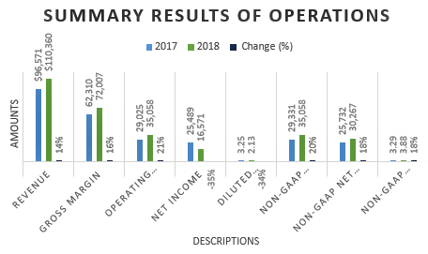

Figure 4: Summary Results of Operations for 2017 & 2018

Another point which is found interesting is the stock performance chart in Figure 5. The legend is placed inside the chart causing distraction to the stock performance chart due to our visual and cognitive processing ability. I would recommend positioning the legend on the right which makes it more easier to relate with each line chart. Also, the wordings under the chart title can be changed to become the x-axis title to reduce cluttering and the y-axis should be labelled too . Different colours can be added to each line chart for better visualisation effect.

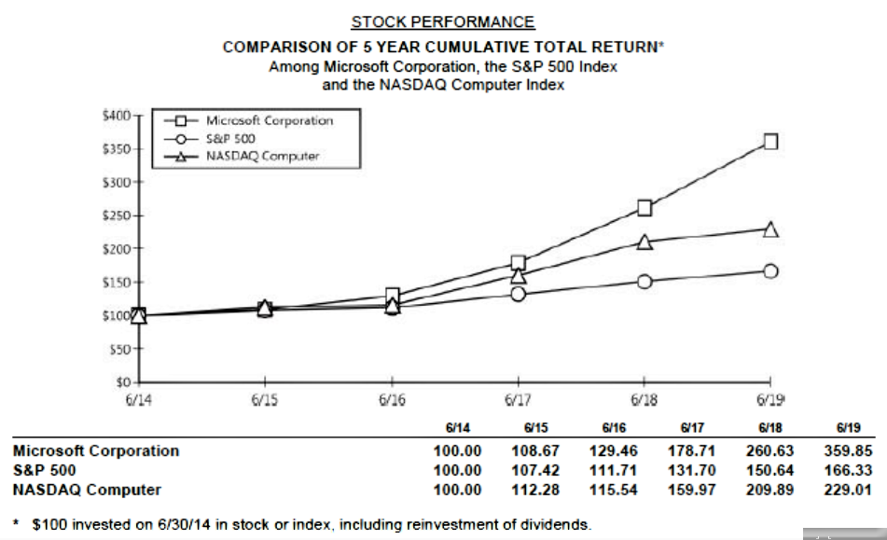

Figure 5: Stock Performance

**---- END OF ASSIGNMENT ----**

# References

Chen, J. (2020, Dec 6). *Mission Statement*. Retrieved from Investopedia: https://www.investopedia.com/terms/m/missionstatement.asp

Eagleman, D. (2018, March 1). *Cognitive Processing: What It Is and Why It’s Important*. Retrieved from BrainCheck: https://braincheck.com/articles/cognitive-processing-what-it-is-why-important/

Hofstrand, D. (2016, August). *Vision and Mission Statements -- a Roadmap of Where You Want to Go and How to Get There*. Retrieved from Iowa State University AG Decision Maker: https://www.extension.iastate.edu/agdm/wholefarm/html/c5-09.html

Perry, G. S. (2011). *Strategic Themes - How Are They Used and Why?* Retrieved from Balanced Scorecard Institute: https://balancedscorecard.org/wp-content/uploads/2019/08/BSI-strategic-themes%E2%80%93how-are-they-used-and-why.pdf

Ware, C. (2004). *Information Visualisation - Perception for Design, Second Edition, Pg 4.* Morgan Kaufmann. Retrieved from https://www.researchgate.net/profile/Colin_Ware/publication/224285723_Information_Visualization_Perception_for_Design_Second_Edition/links/53ce92780cf24377a65dd024/Information-Visualization-Perception-for-Design-Second-Edition.pdf