Title: Using Text Mining and Topic Modelling to understand success factors in Renewable Energy Projects

**Authors:** Munish Kumar1,2 and Janine Ng2

1ERCE Singapore, 2Singapore University of Social Sciences

*Corresponding author. Email: mkumar@erce.energy

**Abstract:** Renewable energy like solar, wind, geothermal and hydrogen are means by which corporations and government hope to mitigate the effect of climate change. However, literature is rife with examples of renewable energy projects not being able to deliver as promised, with difficulties like energy transportation and subpar financial outcomes. Yet, the sector has experienced exponential growth in recent years, with new projects being continually sanctioned, resulting in perceptions that renewable energy projects are generally successful. This paper aims to rank and discuss the main contributing factors to this trend and understand how this impacts perception of success. This will be done using data science techniques like text mining and topic modeling, which will be applied to a collection of 86 peer reviewed scientific research data which specifically discuss “renewable energy project success”. The papers selected encompass policy, economics, technology and engineering. Our results indicated that “softer” non-financial factors were more prevalent success factors, but that financial considerations were not far behind.

**One-Sentence Summary:** This paper aims to determine and rank success factors in renewable energy projects

As climate concerns increase, corporations and governments are seen to make increasing investments in renewable energy (RE) technologies in such diverse areas as solar, wind, hydrogen and biomass. The expectation with such renewable technology is that harmful greenhouses gases are reduced, along with other forms of pollution. There is also a secondary consideration driven more by an economic mindset; as fossil fuels become increasing scarce, energy producers are only able to meet the growing demand at an ever-increasing cost. In either scenario however, an increase in contribution of renewable resources into the energy mix is a positive step.

However, several critical challenges still exist, and which reduces the efficacy of widespread RE adoption. First, RE tends to be a less reliable form of energy, due to the unpredictability associated with the natural environment. For instance, it was reported that in India, despite its RE footprint growing by ~20% from 2015-2020, ~15-20% of (wind and solar) projects underperformed during 2019-2020, primarily due to adverse weather conditions [1]. A mitigant to this is to use technology like batteries, but this adds capital and operational expenditures (CAPEX/ OPEX) to projects that are sometimes already financially stressed. Another challenge associated with RE adoption has to do with its effect on legacy electrical grids; without a proper understanding of import capacity limits and load factors, RE can cause a deterioration of power factors and in fact escalate costs for operators [2].

The above are just snippets of issues associated with RE, its challenging path to commerciality and why widespread adoption is sometimes problematic. Despite this, investment in RE continues to build. (need some links). This is indeed puzzling. Since RE cannot be easily/cheaply stored, transported, has sub optimal production (at times) and is expensive to build, maintain and implement, what are the key motivating factors that are driving private and public sector stakeholders to sanction or fund RE projects? What would be the metric by which a successful RE project is defined? Is it purely perception driven or are there sound financials? Literature itself is extremely polarized on this, with some authors arguing that economic, financial and technical metrics are key, [3, 4, 5], while others argue that political will, behavioral and social aspects are sufficient, if not more important [6, 7, 8, 9].

**Scope & Methods:** This paper will attempt to understand and rank key determinants in RE project success. Given both the polarization of opinion as well as sheer volume of discourse in academic literature in this area, this question lends itself quite readily to methods in data science related to ‘Text Mining’ and ‘Topic Modeling’ (TM+TM) [10, 11].

Both are part of the Natural Language Processing (NLP) set of tools and will be used to understand the patterns present in unstructured data sources like words, phrases, sentences, and strings of text. NLP algorithms transform unstructured text formats into structured data, enabling unsupervised machine learning processes to be applied. The algorithms automate procedures of categorising, clustering, tagging, and classifying texts, and can extract information on sentiment, topics or intent, all with the goal to uncover hidden structures or commonalities binding the text [10].

For this paper, NLP is implemented using Latent Dirichlet Allocation (LDA) and Non-Negative Matrix Factorization (NNMF). LDA uses statistics to identify hidden structures within text, while NNMF utilizes linear algebra. By applying weightages to individual words based on their similarities, each algorithm can cluster the family of words into a topic [12, 13]. A key assumption in LDA is that each text block contains ‘*k*’ number of topics, represented by the word distribution [14].

The algorithms are applied to a collated collection of 86 scientific articles with the terms “renewable energy success” present as a subject matter. The selection of scientific articles was based on the criteria that (a) each research article should explain factors of success in renewable energy projects, and (b) the understanding of success was from each article’s own definition of success. We have not analysed veracity of the financial metrics, like return on investment, nor have we considered technical outcomes like the output capacity and facility uptime. Rather, we will only discuss said success factors within the socio-economic sphere (with considerations to policy, economics and technology readiness) across global datasets.

In order to avoid extended processing times and to ensure that longer articles (with higher word counts) do not unnecessarily skew the evaluation, only text from the abstract and conclusion sections were analysed, the assumption being that they are the most succinct and distilled form of information pertaining to the article. The working hypothesis is that, while brief on detail, these 2 text blocks still contain sufficiently insights to arrive at a meaningful conclusion. Each article is briefly checked to ensure the relevancy to the main question being addressed. Pre-processed, the total word count from these 86 articles was ~76,311 words.

***Data Preparation and Preliminary Exploration:*** A complete flow chart highlighting the NLP process is given in Figure 1. Note that a modified stop word dictionary was created to remove words such as “renewable”, “energy” and “success”, as these would be high frequency words affecting the resulting distribution of words. The process of “tokenization” and “lemmatization” is as done in other NLP processes [15]. The output of this process was visualized using a word cloud where the top 10 most frequent words were highlighted; indeed, a preliminary assessment of the word cloud indicated that the randomly selected articles were suitable for use in the next stage of analysis (Figure 2). Post-processed, the final output is a database of ~40,263 words, or 47% of the original dataset.

Figure 1: Flow chart highlighting text processing stages applied to the scientific articles in question.

Figure 2: Top 10 words with highest frequency.

**Topic Modelling with LDA:** The LDA algorithm is implemented via the use of 2 open-source python libraries, namely “Gensim” and “Mallet” (“MAchine Learning for LanguagE Tootlkit”) (hereafter referred to as ‘Gensim LDA’ and ‘Mallet LDA’ respectively). The former creates a unique dictionary like structure where each word is given a unique id and frequency count of occurrence and also doubles as a visualization library. Mallet is used complementarily to Gensim for coherence analysis. Coherence here is a measure of effectiveness of the topic model. A coherence score measures the degree of sematic similarity between the top scoring words in each topic and also facilitates decisions relating to the optimal value of ‘*k’* (the number of topics). As ‘k varies, so too does the coherence score, with higher coherence scores generally representing better model.

Figure 3 shows the coherence score obtained, as a function of the number of topics. The graph shows that the coherence scores do not varying much between the ranges of 5 to 7 and thereafter decrease. In order to demine topic distinctiveness and prevalence, an intertopic distance map (Figure 4, left) is used, with each bubble representing a topic. Through the use of multidimension reduction scaling (PCA/t-sne), topic’s probability distribution can be visualized to determine the degree of overlap or similarity. Bubble size is a measure of the topic prevalence. From the visualisation, we observe that (a) topics 1-3 and 3-2 overlap very slightly, while topic 4 and 5 are uniquely distinct. For the former, the overlap is statistically insignificant and thus, the 5 topics can be considered distinct enough to take this work forward. Furthermore, topic 1 appears to be the most prevalent topic, constituting 29.9% of the tokens. Figure 4 (right) is a sequence of stack bar graphs with the most prevalent words per topic. In the example shown in the image, the top 3 words to appear under topic 1 are “policy”, “technology”, “industry”, “government” and “environmental”, and are highlighted by the blue bars. However, in topic modelling, the relevance of a word is very important, as it leads to the topic being more obvious. This is where a relevancy metric, , is useful [16].

where is the probability of word w in topic k and is the lift in term’s probability within a topic to its marginal probability across the entire corpus. A lower λ gives more importance to the term , which gives more importance to topic exclusivity. Given in Figure 5 is the effect of reducing by 48%; the word “policy” remains unchanged, but interestingly, words like “industry” and “technology” swap places. Additionally, gone are the words “government” and “environmental” from the top 5 words within the topic, replaced instead with words like “firm” and “adoption”. For this work, we find that λ = 1 is suitable for the modelling. (QN: IS THIS CORRECT?)

Figure 3: Coherence score as a function of topic number; generally, past 5 topics, the score does not vary significantly.

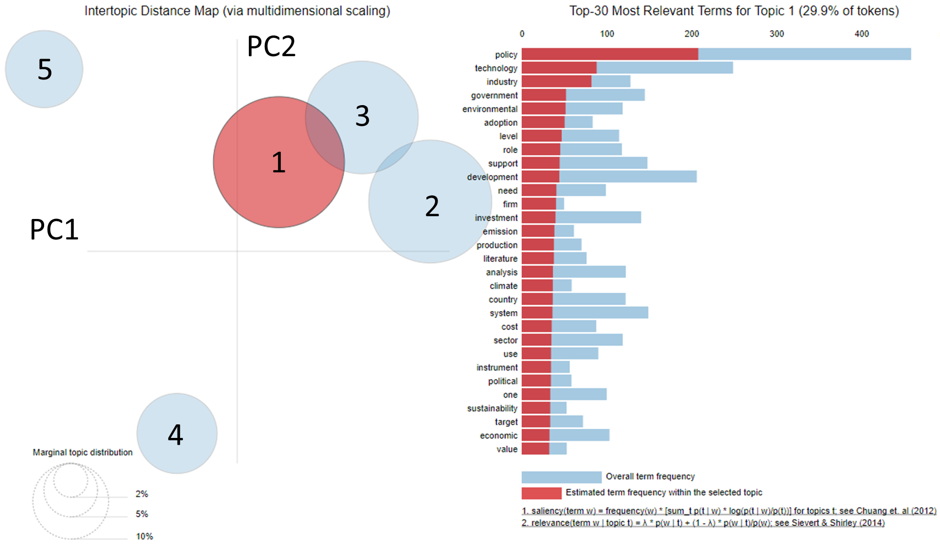

Figure 4: Topic Visualization using a Bubble map and the corresponding top 30 terms in each topic

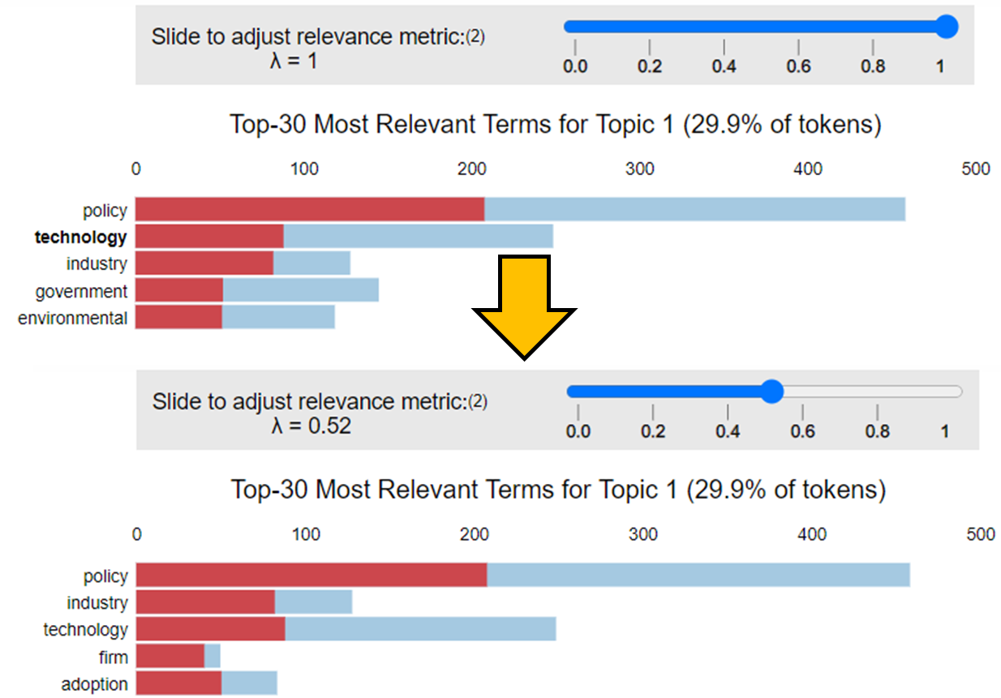

Figure 5: Topic Visualization using a Bubble map and the corresponding top 30 terms in each topic

**Topic Modelling with NNMF:** As another machine learning tool, NNMF is useful as it is able to dimensionally reduce the text data and create topics by grouping words with higher coherence [13]. It does this through a vector multiplication of “*W*” columns and “*H*” rows, with “*W*” representing the weightage of each word in a sentence (‘words-topics’ matrix) and “*H*” represents the words in each column (‘topics-documents’ matrix). The product, “*V*” is referred to as the ‘words-documents’ matrix. In factorizing “*V*” for uses in topic modeling, we are breaking down the corpus into “*W*” and “*H*”. As this approach is based on linear algebraic optimization, the outcome would be an approach that is independent of the probabilistic method utilized by LDA.

**Results:** Given in Table 1 are the top 10 keywords per topic rank, sorted in order of importance. Each of the algorithms presents a slightly different result, although common repetitive words do occur as an output of each algorithm. It is interesting to note the order of the words themselves and how each algorithm places importance on different words.

As an example, the results of the Gensim LDA within Rank 1 has sorted words: 'policy', 'investment', 'community', 'financial', 'performance', 'investor', 'system', 'institutional', 'technology' and 'measure'. These words are plotted in Figure 6 as a function of word count (light blue) and weightage (dark blue. In comparing the words “investment” to “technology”, the algorithm has determined that despite the former having a much lower word count, its importance is greater (i.e. it is more relevant given its exclusivity) and has thus weighted it more, and ranked it higher.

Figure 6: Weightage and frequency of top 10 words in Topic 1

However, there is also a need to consider the words collectively to get a sense of whether topics can be categorised as being more ‘quantitative’ or ‘qualitative’. In this example, words like 'financial', 'performance' and ‘investor’ imply quantification, and thus, a subtopic of “financial performance” seems reasonable. This step is perhaps the most subjective step of this entire process. The human element of interpreting, understanding, and applying a judgement as to the most suitable subtopic, based on ones understanding of the words, is something that is key to this process. Good topic models therefore require (apriori) that the modeler have some background knowledge of the subject matter.

We repeat this process of (a) considering each line of output, (b) observing for the ranking of the words with respect to count and weightages, (c) determining key words that help categorise the output as either ‘quantitative’ or ‘qualitative’, and (d) deciding on a subtopic for each of the 3 algorithms.

We next consider all subtopics collectively and then generalise them into several key concepts, which than becomes the final topic model to be discussed in later sections. Generalisation removes some of the bias that may come about from subtopic selection and allows for comparisons between the outputs of the algorithms. The last step was to combine the three methods to give an averaged, ranked topic score.

Table 1: **Top 10 significand words per algorithm, proposed categorization, subtopic and key concept selection**

|  |  |  |  |  |  |
| --- | --- | --- | --- | --- | --- |
| Algorithm | Topic Rank | Top 10 Words Weighted and Ranked | Category | Sub-Topic | Main Topic |
| Gensim LDA | 1 | 'policy', 'investment', 'community', **'financial', 'performance',** 'investor', 'system', 'institutional', 'technology', 'measure' | Quantitative | Financial Performance | Fiscal (Policy/ Terms) |
| 2 | 'policy', 'technology', 'industry', **'government'**, 'environmental', 'adoption', 'level', 'role', 'support', 'development' | Qualitative | Environmental Technologies Policies | Government (Policy) |
| 3 | 'policy', **'stakeholder' , 'community'**, 'development', 'process', 'local', 'management', 'support', 'government', 'technology' | Qualitative | Community Development Policies | Community (Support/ Involvement) |
| 4 | '**technology'**, 'policy', 'system', 'development', **‘community'**, **'traceability'**, 'group', **'social'**, 'support', 'case' | Quantitative-Qualitative | Technology and social policies | Technology (Development) & Social (Policy) |
| 5 | **'state'**, 'policy', 'technology', **'investor'**, 'expansion', **'government'**, 'plant', 'country', 'electricity', **'community'** | Quantitative | Technological Policies and investors | Public-Private (Corisking/ Perception) |
| Mallet  LDA | 1 | sector', **'policy'**, 'electricity', 'development', 'country', 'source', **'production'**, 'support', **'data'**, 'emission' | Qualitative | Energy policies | Government (Policy) |
| 2 | technology', **'financial'**, 'impact', **'performance', 'cost', 'measure',** 'plant', 'adoption', 'system', 'importance' | Quantitative | Financial performance | Fiscal (Policy/ Terms) |
| 3 | **policy', 'technology'**, 'investment', 'industry', **'environmental'**, 'investor', 'role', 'potential', **'framework'**, 'change' | Quantitative-Qualitative | Technology investment policies | Technology (Development) & Social (Policy) |
| 4 | **stakeholder'**, 'process', **'social'**, 'management', **'community'**, 'model', **'relationship'**, 'literature', **'analysis'**, 'sustainable' | Quantitative | Stakeholder Perception | Public-Private (Corisking/ Perception) |
| 5 | **community'**, 'local', 'system', 'government', **'development'**, 'support', **'transition'**, 'policy', **'national'**, 'state' | Qualitative | Community Involvement | Community (Support/ Involvement) |
| Non-  Negative Matrix Factorization | 1 | **environmental'**, **'mix'**, 'state', **'government'**, 'country', 'development', 'technology', 'industry', 'sector', **'policy'** | Qualitative | Country Environmental policies | Government (Policy) |
| 2 | **process**', 'development', 'technology', **'management'**, 'program', **'partnership'**, 'social', **'beneficiary'**, 'local', **'community'** | Quantitative | Technology development | Public-Private (Corisking/ Perception) |
| 3 | **influence', 'green',** 'satisfaction', **'relationship'**, 'proposed', **'network',** **'twomode',** 'method', 'retrofit', 'stakeholder' | Qualitative | Stakeholder Relationship Satisfaction | Community (Support/ Involvement) |
| 4 | market', 'retail', 'portfolio', 'policy', 'performance', **'financial',** 'technology', 'preference', **'investor', 'investment'** | Quantitative | Investor preference | Fiscal (Policy/ Terms) |
| 5 | **expansion', 'fit',** 'power', 'state', 'price', 'promotion', 'electricity', **'capacity', 'plant', 'system'** | Quantitative-Qualitative | Energy systems | Technology (Development) & Social (Policy) |

(I think we need to report the correlation values here)

**Discussion and Implications:** In order from most important to least, the analysis presented above ranked the following success factors for RE projects: (1) Government (Policy), (2) Fiscal (Policy/Terms), (3) Community (Support/ Involvement), (4) Public-Private (Corisking) and (5) Technology (Development) & Social (Policy). In looking at the results, aside from (2), all the other results speak of non-financial factors as being more important in RE project success. However the fact that ‘Fiscal (Policy/Terms)’ ranked high in the list indicates that financial considerations are very important to decision makers.

(I think each of these sections would benefit from a negative example)

*Government (Policy):* In the articles analyzed in this study, we learn that Government (policy) is a broad but overarching theme for almost every paper analysed. The topic address a gamut of strategies, including (but not limited to) financial, research and development, infrastructure, consumer adoption rates, socio-economical acceptance of RE, and overall development of the sector. We learn that government involvement is important as a signaling mechanism to producers, of the strategy towards domestic energy resilience. Governments also act as financial buffers through subsidies and grants (tying this quite closely to the “Fiscal (Policy/Terms)” success factor), which according to the International Energy Agency, has amounted to US$180 billion in 2020 [17].

External to our articles, we find specific examples of this signaling mechanism when we look to the Unites States of America (USA), where State Energy Programs[1] or the 2005 Energy Policy Act[2] has contributed to RE usage growing by 42% from 2010 to 2020 [18, 19]. The introduction of energy legislation, legal consequence and government financing support has thus allowed renewables to become the fastest-growing energy source in the USA, making up close to 20% of total energy source [20, 21]. In Singapore, given its small size and interdependence to the global community, government policies tend to contain a geopolitical element e.g. development of a shared regional power grid [22] or the “SUN Cable” project between Singapore to Australia [23], to more local centric solutions like research and development in space-saving energy storage technologies. At the national level, the government has set a mandate to increase solar usage by 7 times from its measured 2019 usage [24]. In land-scare Singapore, private sector involvement comes in the form of infrastructure construction and maintenance. The construction costs are borne by the government entirely (TENGAH reference, HDB reference. Is SUNSEAP given attractive PPAs?).

The results of the analysis not only pointed to positive involvement of financial support but also the impact of the absence of government financing. Debt-ridden economies, or countries that are dealing with socio-economic crisis will naturally have failed RE initiatives, simply because they are not a priority.

*Fiscal (Policy/Terms):* The topic of “Fiscal (Policy/Terms)” found quite a close correlation with “Government (Policy)” because governments provide subsidy as well as regulate free-markets in which mechanisms like carbon pricing would operate (London School of Economics and Political Science, 2017). Our analysis also points to policy linkages across carbon tax, fossil fuel subsidies removal and electricity pricing reforms as mechanistic ways for national energy policies to pave the way for RE success (The World Bank, 2021, United Nations, 2016).

*Community (Support/ Involvement):* The articles analysed in this study point to community participation as gaining prominence in project success. Traditional top-down executive-run projects are less effective due to their inability to identify and meet the community’s needs. Two examples of how collaborative approaches to decision making are effective would be from Nepal [25] and rural areas in Indonesia [26]. In both cases, we learn that active participation and collaboration has promoted positive engagement (with the authorities and private sector), a greater sense of ownership from the community (resulting in increasing acceptance and utilisation of the solution), improved livelihoods, and has provided alternative perspectives (local knowledge) which resulted in timely completion of the project (example here of NON success where there was no community engagement – what happens then?).

Public-Private (Corisking/ Perception): We learnt that this topic can be linked to behavioral finance and decision sciences, where perceived impressions towards the RE industry can affect investment decisions. In a way, it is a measure of confidence, be it towards state of technology (present or future), policy bodies, institutions, and investor experience.

Technology (Development) & Social (Policy): (Think about this)

**Limitations of Study and Conclusions:** This study adopted text mining and topic modelling methods to identify common topics related to successful RE projects, in current scientific research. This study has that financial factors alone are not guarantees of success in RE projects. In fact, we learn that there are a series of non-financial factors at play as well. Results from the LDA and NNMF model show that aside from financial viability, energy policies, government intervention, community engagement and investor perceptions were strong determinants in driving RE project success.

We discuss that government financial support contributes greatly to renewable energy adoptions and carbon pricing strategies can be adopted by nations lacking financial resources. Community involvement from project development to implementation is also critical for the long term sustainability of renewable energy implementations. High engagement of the community through the training of locals to take up leadership positions benefits the projects and also boosts the overall livelihoods of the community. Lastly, investor confidence in policies and technologies also impacts decision making. The psychological study of cognitive and behavioural attitudes can also be further expounded to understand investor behaviour. The results show that increasing study on attitudes, social norms and personal norms of investors have the potential to optimize the renewable energy sector and mitigate climate change

This study has limitations that should be addressed in future research. Firstly, it is constrained by its query phrase search. If relevant articles do not have any of the query phrases “renewable energy success” in their subject, they will not be included in the dataset, which may result in data inconsistency or data bias. Secondly is the data size which is relatively small with only 86 research articles. Future studies should include a larger dataset to determine the robustness of the utilized method. Thirdly, personal bias in analysing the keywords of each topic are ever present. Beyond the scope of this work is the use of other predictive models to identify the fit of key topics, with additional statistics used to estimate the accuracy of concepts assigned to the keywords of each topic.

Given the complexity of the RE sector, the study demonstrates that holistic approaches be considered, beyond the technical or financial consideration. Indeed, looking at RE through a social science lens can provide alternative perspectives, to create a more balanced discourse in supporting the global climate change agenda. Future extension of a social perspective in RE research can support future policies and systems that can propel sustainable transformations.

# **References**

|  |  |
| --- | --- |
| [1] | S. Jai, "Indian renewable firms underperformed but credit quality intact: Moody's," [Online]. Available: https://www.business-standard.com/article/companies/indian-renewable-firms-underperformed-but-credit-quality-intact-moody-s-121030901082_1.html#:~:text=%22About%2015%2D20%20per%20cent,the%20underperformance%20respectively%2C%E2%80%9D%20says%20Abhishek. |
| [2] | T. Kealy, "Does an embedded wind turbine reduce a company’s electricity bill? Case study of a 300 kW wind turbine in Ireland.," *Journal of Business Ethics,* vol. 145, no. 2, pp. 417-428, 2015. |
| [3] | . S. Jacobsson and A. Johnson, "The diffusion of renewable energy technology: An analytical framework and key issues for research," *Energy Policy,* vol. 28, no. 9, pp. 625-640, 2000. |
| [4] | A. Jagadeesh, "Wind energy development in Tamil Nadu and Andhra Pradesh, India institutional dynamics and barriers — A case study.," *Energy Policy,* vol. 28, no. 3, pp. 157-168, 2000. |
| [5] | G. Shrimali, S. Goel, S. Srinivasan and D. Neslon, "Solving India’s renewable energy financing challenge: Which federal policies can be most effective?," CPI-ISB Series, 2014. |
| [6] | G. A. Bradshaw and J. G. Borchers, "Uncertainty as information: Narrowing the science-policy gap.," *Conservation Ecology,* vol. 4, no. 1, 2000. |
| [7] | J. West, I. Bailey and M. Winter, "Renewable energy policy and public perceptions of renewable energy: A cultural theory approach," *Energy Policy,* vol. 38, no. 10, pp. 5739-5748, 2010. |
| [8] | A. Masini and E. Menichetti, "Investment Decisions in the Renewable Energy Sector: An Analysis of Non-Financial Drivers," *Technological Forecasting and Social Change,* vol. 80, no. 3, pp. 510-524, 2013. |
| [9] | R. Maqbool, Y. Rashid, S. Sultana and Y. Sudong, "Identifying the critical success factors and their relevant aspects for renewable energy projects; An empirical perspective.," *Journal of Civil Engineering and Management,* vol. 24, no. 3, pp. 223-237, 2018. |
| [10] | D. Ramage, E. Rosen, J. Chuang, C. D. Manning and D. A. McFarland, "Topic modeling for the social sciences," *NIPS 2009 workshop on applications for topic models: text and beyond,* vol. 5, pp. 1-4, 2009. |
| [11] | M. W. Bickel, "Reflecting trends in the academic landscape of sustainable energy using probabilistic topic modeling," *Energy, Sustainability and Society,* vol. 9, no. 49, 2019. |
| [12] | S. Kapadia, "Topic Modeling in Python: Latent Dirichlet Allocation (LDA)," April 2019. [Online]. Available: https://towardsdatascience.com/end-to-end-topic-modeling-in-python-latent-dirichlet-allocation-lda-35ce4ed6b3e0. |
| [13] | S. Mifrah and E. H. Benlahmar, "Topic modeling coherence: A comparative study between LDA and NMF models using COVID’19 corpus," *International Journal of Advanced Trends in Computer Science and Engineering,* vol. 9, no. 4, pp. 5756-5761, 2020. |
| [14] | S. Prabhakaran, "Topic Modeling with Gensim (Python)," 2018. [Online]. Available: https://www.machinelearningplus.com/nlp/topic-modeling-gensim-python/. |
| [15] | S. Bird, E. Klein and E. Loper, Natural Language Processing with Python: Analyzing Text with the Natural Language Toolkit, O'Reilly Media, Inc, 2009. |
| [16] | C. Sievert and K. E. Shirley, "LDAvis: A method for visualizing and interpreting topics," in *Proceedings of the Workshop on Interactive Language Learning, Visualization, and Interfaces*, Baltimore, Maryland, USA, 2014. |
| [17] | International Energy Agency, "Energy Subsidies - Topics," [Online]. Available: https://www.iea.org/topics/energy-subsidies. |
| [18] | Office of Energy Efficiency and Renewable Energy, "Weatherization and Intergovernmental Programs Office State Energy Program," [Online]. Available: https://www.energy.gov/eere/wipo/about-state-energy-program. [Accessed February 2022]. |
| [19] | S. Sundaram, "The Sustainability of Solar PV Governance: A Comparative International Perspective," in *Solar Photovoltaic Technology Production*, 2016, pp. 47-74. |
| [20] | U.S. Department of Energy, "Federal agency use of renewable electric energy," 2021. [Online]. Available: https://www.energy.gov/eere/femp/federal-agency-use-renewable-electric-energy. |
| [21] | Center for Climate and Energy Solutions., "Renewable energy," 2021. [Online]. Available: https://www.c2es.org/content/renewable-energy/. |
| [22] | The Ministry of Energy and Mines of the Lao People’s Democratic Republic, Ministry of Energy of the Kingdom of Thailand, Ministry of Energy, Green Technology and Water of Malaysia, and Ministry of Trade and Industry of the Republic of Singapore, "LAO PDR, MALAYSIA, SINGAPORE, THAILAND: Joint Statement of the Lao PDR, Thailand, Malaysia and Singapore Power Integration Project (LTMS PIP)," 2014. [Online]. Available: https://policy.asiapacificenergy.org/node/2574. [Accessed 2022]. |
| [23] | J. Gordonnat and J. Hunt, "Subsea cable key challenges of an intercontinental power link: case study of Australia–Singapore interconnector.," *Energy Transitions,* vol. 4, no. 2, pp. 169-188, 2020. |
| [24] | A. Tan, "Singapore to ramp up solar energy production to power 350,000 homes by 2030.," Straits Times, Singapore, 2019. |
| [25] | J. Butchers, S. Williamson and J. Booker, "Micro-hydropower in Nepal: Analysing the project process to understand drivers that strengthen and weaken sustainability," *Sustainability,* vol. 13, no. 3, p. 1582, 2021. |
| [26] | W. Hermawati and I. Rosaira, "Key success factors of renewable energy projects implementation in rural areas of Indonesia," *STI Policy and Management Journal,* vol. 2, no. 2, p. 111, 2017. |

**Acknowledgments:** Munish Kumar would like to thank ERCE for peer review of this work.

1. The State Energy Program provides both financial and technical assistance for energy projects that are coherent with nationwide green energy goals.
2. The Act (passed by congress) established a legal requirement for federal agencies to derive at least 7.5% of energy consumption from renewable sources.