Title: Using Text Mining and Topic Modelling to understand success factors in Renewable Energy Projects

**Authors:** Munish Kumar1,2 and Janine Ng2

1ERCE Singapore, 2Singapore University of Social Sciences

*Corresponding author. Email: mkumar@erce.energy

**Abstract:** Renewable energy (solar, wind, geothermal and hydrogen) are means by which corporations and government hope to mitigate the effect of climate change. However, literature is rife with examples of renewable energy projects not being able to deliver as promised, with difficulties like energy transportation, energy output and subpar financial outcomes. Yet, the sector has experienced exponential growth in recent years, with new projects being continually sanctioned, resulting in perceptions that renewable energy projects are generally successful. This paper aims to utilize the method of text mining and topic modeling to probe this perception further. Indeed, this method will be used to rank, understand, and discuss contributing factors to this perception, by applying said technique to a collection of 100 peer reviewed scientific research data which specifically discuss “renewable energy project success”. The papers selected encompass policy, economics, technology and engineering. Our results indicated that “softer” non-financial factors were more prevalent success factors, but that financial considerations were not far behind.

**One-Sentence Summary:** This paper aims to determine and rank success factors in renewable energy projects

As climate concerns increase, corporations and governments are seen to make increasing investments in renewable energy (RE) technologies in such diverse areas as solar, wind, hydrogen and biomass. The expectation with such renewable technology is that harmful greenhouses gases are reduced, along with other forms of pollution. There is also a secondary consideration driven more by an economic mindset; as fossil fuels become increasing scarce, energy producers are only able to meet the growing demand at an ever-increasing cost. In either scenario however, an increase in contribution of renewable resources into the energy mix is a positive step.

However, several critical challenges still exist, and which reduces the efficacy of widespread RE adoption. First, RE tends to be a less reliable form of energy, due to the unpredictability associated with the natural environment. For instance, it was reported that in India, despite its RE footprint growing by ~20% from 2015-2020, ~15-20% of (wind and solar) projects underperformed during 2019-2020, primarily due to adverse weather conditions (Jai, n.d.). A mitigant to this is to use technology like batteries, but this adds capital and operational expenditures (CAPEX/ OPEX) to projects that are sometimes already financially stressed. Another challenge associated with RE adoption has to do with its effect on legacy electrical grids; without a proper understanding of import capacity limits and load factors, RE can cause a deterioration of power factors and in fact escalate costs for operators (Kealy, 2015).

The above are just snippets of issues associated with RE, its challenging path to commerciality and why widespread adoption is sometimes problematic. Despite this, investment in RE continues to build (Inchauspe, Ripple, & Truck, 2016). This is indeed puzzling. Since RE cannot be easily/cheaply stored, transported, has sub optimal production (at times) and is expensive to build, maintain and implement, what are the key motivating factors that are driving private and public sector stakeholders to sanction or fund RE projects? What would be the metric by which a successful RE project is defined? Is it purely perception driven or are there sound financials? Literature itself is extremely polarized on this, with some authors arguing that economic, financial and technical metrics are key, (Jacobsson & Johnson, 2000; Jagadeesh, 2000; Shrimali, Goel, Srinivasan, & Neslon, 2014), while others argue that political will, behavioral and social aspects are sufficient, if not more important (Bradshaw & Borchers, 2000; West, Bailey, & Winter, 2010; Masini & Menichetti, 2013; Maqbool, Rashid, Sultana, & Sudong, 2018).

**Scope & Methods:** This paper will attempt to understand and rank key determinants in RE project success. Given both the polarization of opinion as well as sheer volume of discourse in academic literature in this area, this question lends itself quite readily to methods in data science related to ‘Text Mining’ and ‘Topic Modeling’ (TM+TM) (Ramage, Rosen, Chuang, Manning, & McFarland, 2009; Bickel, 2019).

Both are part of the Natural Language Processing (NLP) set of tools and will be used to understand the patterns present in unstructured data sources like words, phrases, sentences, and strings of text. NLP algorithms transform unstructured text formats into structured data, enabling unsupervised machine learning processes to be applied. The algorithms automate procedures of categorising, clustering, tagging, and classifying texts, and can extract information on sentiment, topics or intent, all with the goal to uncover hidden structures or commonalities binding the text (Ramage, Rosen, Chuang, Manning, & McFarland, 2009).

For this paper, NLP is implemented using Latent Dirichlet Allocation (LDA) and Non-Negative Matrix Factorization (NNMF). LDA uses statistics to identify hidden structures within text, while NNMF utilizes linear algebra. By applying weightages to individual words based on their similarities, each algorithm can cluster the family of words into a topic (Kapadia, 2019; Mifrah & Benlahmar, 2020). A key assumption in LDA is that each text block contains ‘*k*’ number of topics, represented by the word distribution (Prabhakaran, 2018).

The algorithms are applied to a collated collection of 100 scientific articles with the terms “renewable energy success” present as a subject matter. The selection of scientific articles was based on the criteria that (a) each research article should explain factors of success in renewable energy projects, and (b) the understanding of success was from each article’s own definition of success. We have not analysed veracity of the financial metrics, like return on investment, nor have we considered technical outcomes like the output capacity and facility uptime. Rather, we will only discuss said success factors within the socio-economic sphere (with considerations to policy, economics and technology readiness) across global datasets. Below displays the breakdown of the 100 scientific articles and their source. The most popular journals are the Energy Policy followed by Sustainability and Energy. The majority ‘Others’ category is a combination of all individual articles from various journal types.

Figure 1: Breakdown of dataset, the sources of journal articles

In order to avoid extended processing times and to ensure that longer articles (with higher word counts) do not unnecessarily skew the evaluation, only text from the abstract and conclusion sections were analysed, the assumption being that they are the most succinct and distilled form of information pertaining to the article. The working hypothesis is that, while brief on detail, these 2 text blocks still contain sufficiently insights to arrive at a meaningful conclusion. Each article is briefly checked to ensure the relevancy to the main question being addressed. Pre-processed, the total word count from these 100 articles was ~76,311 words.

***Data Preparation and Preliminary Exploration:*** A complete flow chart highlighting the NLP process is given in Figure 1. Note that a modified stop word dictionary was created to remove words such as “renewable”, “energy” and “success”, as these would be high frequency words affecting the resulting distribution of words. The process of “tokenization” and “lemmatization” is as done in other NLP processes (Bird, Klein, & Loper, 2009). The output of this process was visualized using a word cloud where the top 10 most frequent words were highlighted; indeed, a preliminary assessment of the word cloud indicated that the randomly selected articles were suitable for use in the next stage of analysis (Figure 2). Post-processed, the final output is a database of ~40,263 words, or 47% of the original dataset.

Figure 2: Flow chart highlighting text processing stages applied to the scientific articles in question.

Figure 3: Top 10 words with highest frequency.

**Topic Modelling with LDA:** The LDA algorithm is implemented via the use of 2 open-source python libraries, namely “Gensim” and “Mallet” (“MAchine Learning for LanguagE Tootlkit”) (hereafter referred to as ‘Gensim LDA’ and ‘Mallet LDA’ respectively). The former creates a unique dictionary like structure where each word is given a unique id and frequency count of occurrence and also doubles as a visualization library. Mallet is used complementarily to Gensim for coherence analysis. Coherence here is a measure of effectiveness of the topic model. A coherence score measures the degree of sematic similarity between the top scoring words in each topic and also facilitates decisions relating to the optimal value of ‘*k’* (the number of topics). As ‘k varies, so too does the coherence score, with higher coherence scores generally representing better model.

Figure 3 shows the coherence score obtained, as a function of the number of topics. The graph shows that the coherence scores do not varying much between the ranges of 5 to 7 and thereafter decrease. In order to demine topic distinctiveness and prevalence, an intertopic distance map (Figure 4, left) is used, with each bubble representing a topic. Through the use of multidimension reduction scaling (PCA/t-sne), topic’s probability distribution can be visualized to determine the degree of overlap or similarity. Bubble size is a measure of the topic prevalence. From the visualisation, we observe that (a) topics 1-3 and 3-2 overlap very slightly, while topic 4 and 5 are uniquely distinct. For the former, the overlap is statistically insignificant and thus, the 5 topics can be considered distinct enough to take this work forward. Furthermore, topic 1 appears to be the most prevalent topic, constituting 29.9% of the tokens. Figure 4 (right) is a sequence of stack bar graphs with the most prevalent words per topic. In the example shown in the image, the top 3 words to appear under topic 1 are “policy”, “technology”, “industry”, “government” and “environmental”, and are highlighted by the blue bars. However, in topic modelling, the relevance of a word is very important, as it leads to the topic being more obvious. This is where a relevancy metric, , is useful (Sievert & Shirley, 2014).

where is the probability of word w in topic k and is the lift in term’s probability within a topic to its marginal probability across the entire corpus. A lower λ gives more importance to the term , which gives more importance to topic exclusivity. Given in Figure 5 is the effect of reducing by 48%; the word “policy” remains unchanged, but interestingly, words like “industry” and “technology” swap places. Additionally, gone are the words “government” and “environmental” from the top 5 words within the topic, replaced instead with words like “firm” and “adoption”. For this work, we find that λ = 1 is suitable for the modelling. (QN: IS THIS CORRECT?)

Figure 5: Coherence score as a function of topic number; generally, past 5 topics, the score does not vary significantly.

**1**

**4**

**2**

**3**

**5**

Figure 6: Topic Visualization using a Bubble map and the corresponding top 10 terms in each topic

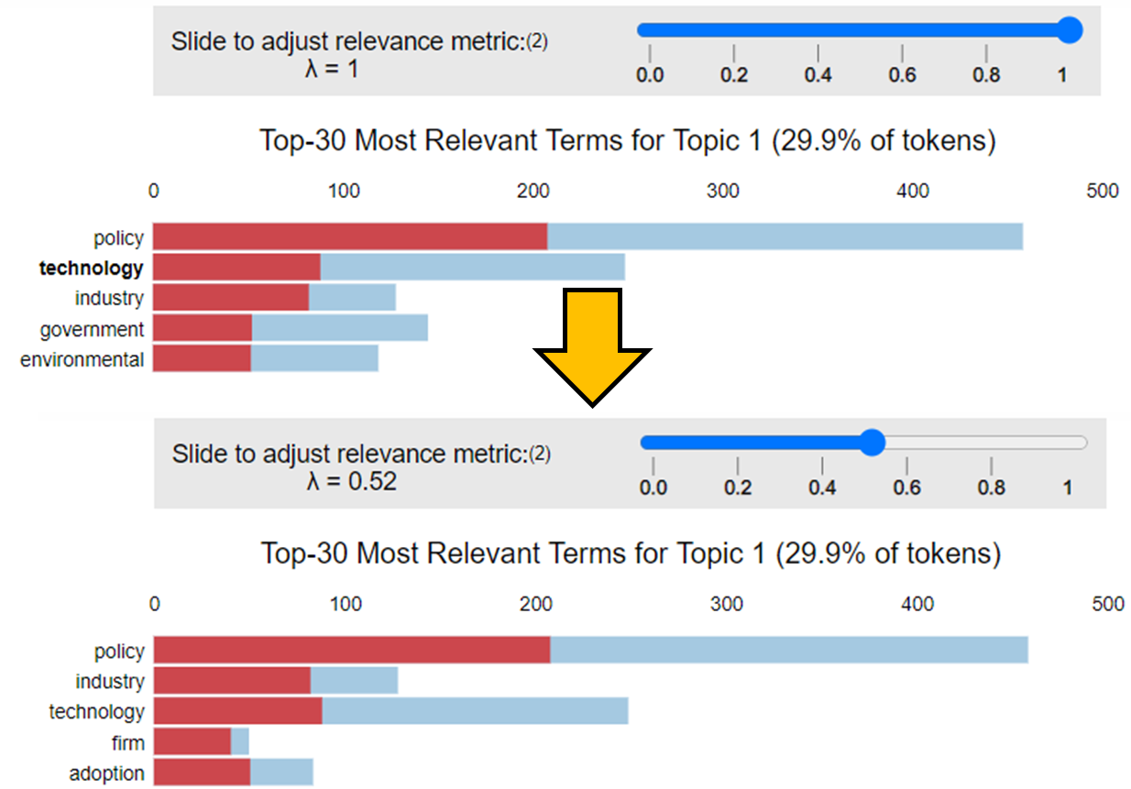

10

10

10

Figure 7: Topic Visualization using a Bubble map and the corresponding top 30 terms in each topic

**Topic Modelling with NNMF:** As another machine learning tool, NNMF is useful as it is able to dimensionally reduce the text data and create topics by grouping words with higher coherence (Mifrah & Benlahmar, 2020). It does this through a vector multiplication of “*W*” columns and “*H*” rows, with “*W*” representing the weightage of each word in a sentence (‘words-topics’ matrix) and “*H*” represents the words in each column (‘topics-documents’ matrix). The product, “*V*” is referred to as the ‘words-documents’ matrix. In factorizing “*V*” for uses in topic modeling, we are breaking down the corpus into “*W*” and “*H*”. As this approach is based on linear algebraic optimization, the outcome would be an approach that is independent of the probabilistic method utilized by LDA.

**Results:** Given in Table 1 are the top 10 keywords per topic rank, sorted in order of importance. Each of the algorithms presents a slightly different result, although common repetitive words do occur as an output of each algorithm. It is interesting to note the order of the words themselves and how each algorithm places importance on different words.

As an example, the results of the Gensim LDA within Rank 1 has sorted words: 'policy', 'investment', 'community', 'financial', 'performance', 'investor', 'system', 'institutional', 'technology' and 'measure'. These words are plotted in Figure 6 as a function of word count (light blue) and weightage (dark blue. In comparing the words “investment” to “technology”, the algorithm has determined that despite the former having a much lower word count, its importance is greater (i.e. it is more relevant given its exclusivity) and has thus weighted it more, and ranked it higher.

Notably, the topic number is assigned randomly in each model, thus results from topic 0 in Mallet is not related to topic 0 results from Gensim.

Figure 6: Weightage and frequency of top 10 words in Topic 1 – Gensim

Figure 7: Weightage and frequency of top 10 words in Topic 1 – Mallet LDA

Figure 7: Weightage and frequency of top 10 words in Topic 1 – NMF

However, there is also a need to consider the words collectively to get a sense of whether topics can be categorised as being more ‘quantitative’ or ‘qualitative’. In this example, words like 'financial', 'performance' and ‘investor’ imply quantification, and thus, a subtopic of “financial performance” seems reasonable. This step is perhaps the most subjective step of this entire process. The human element of interpreting, understanding, and applying a judgement as to the most suitable subtopic, based on ones understanding of the words, is something that is key to this process. Good topic models therefore require (apriori) that the modeler have some background knowledge of the subject matter.

We repeat this process of (a) considering each line of output, (b) observing for the ranking of the words with respect to count and weightages, (c) determining key words that help categorise the output as either ‘quantitative’ or ‘qualitative’, and (d) deciding on a subtopic for each of the 3 algorithms.

We next consider all subtopics collectively and then generalise them into several key concepts, which than becomes the final topic model to be discussed in later sections. Generalisation removes some of the bias that may come about from subtopic selection and allows for comparisons between the outputs of the algorithms. The last step was to combine the three methods to give an averaged, ranked topic score.

Table 1: **Top 10 significand words per algorithm, proposed categorization, subtopic and key concept selection**

The graphs below also depict the breakdown of the number of articles in each topic.

Figure 8: **Number of documents in each topic – LDA Gensim**

Figure 9: **Number of documents in each topic – LDA Mallet**

Figure 10: **Number of documents in each topic – NMF**

**# with our rank**  score – rank the discussion accordingly

***Discussion and Implications:*** In order from most important to least, the analysis presented above ranked the following success factors for RE projects: (1) Government (Policy), (2) Fiscal (Policy/Terms), (3) Community (Support/ Involvement), (4) Public-Private (Corisking) and (5) Technology (Development) & Social (Policy). In looking at the results, aside from (2), all the other results speak of non-financial factors as being more important in RE project success. However the fact that ‘Fiscal (Policy/Terms)’ ranked high in the list indicates that financial considerations are very important to decision makers.

***Government (Policy****):* In the articles analyzed in this study, we learn that Government (policy) is a broad but overarching theme for almost every paper analysed. The topic address a gamut of strategies, including (but not limited to) financial, research and development, infrastructure, consumer adoption rates, socio-economical acceptance of RE, and overall development of the sector. We learn that government involvement is important as a signaling mechanism to producers, of the strategy towards domestic energy resilience. Governments also act as financial buffers through subsidies and grants (tying this quite closely to the “Fiscal (Policy/Terms)” success factor), which according to the International Energy Agency, has amounted to US$180 billion in 2020 (International Energy Agency, n.d.).

External to our articles, we find specific examples of this signaling mechanism when we look to the Unites States of America (USA), where State Energy Programs[1] or the 2005 Energy Policy Act[2] has contributed to RE usage growing by 42% from 2010 to 2020 (Office of Energy Efficiency and Renewable Energy, n.d.; Sundaram, 2016). The introduction of energy legislation, legal consequence and government financing support has thus allowed renewables to become the fastest-growing energy source in the USA, making up close to 20% of total energy source (U.S. Department of Energy, 2021; Center for Climate and Energy Solutions., 2021).

In Singapore, given its small size and interdependence to the global community, government policies tend to contain a geopolitical element e.g. development of a shared regional power grid (The Ministry of Energy and Mines of the Lao People’s Democratic Republic, Ministry of Energy of the Kingdom of Thailand, Ministry of Energy, Green Technology and Water of Malaysia, and Ministry of Trade and Industry of the Republic of Singapore, 2014) or the “SUN Cable” project between Singapore to Australia (Gordonnat & Hunt, 2020), to more local centric solutions like research and development in space-saving energy storage technologies. At the national level, the government has set a mandate to increase solar usage by 7 times from its measured 2019 usage (Tan, 2019). In land-scares Singapore, private sector involvement comes in the form of infrastructure construction and maintenance. The construction costs are borne by the government entirely. Power Purchasing Agreement (PPA) are also popular contracts that allow organizations to transition towards solar energy without upfront payments. The agreement entails organizations lease their rooftops and purchase the energy generated at a cheaper price than regular energy. Industry leader, Sembcorp Singapore singed a 25-year PPA with the National Water Agency, PUB to create one the world’s largest floating solar farm in the Tengah Reservoir. Sembcorp also signed PPA with notable firms like Singapore Airlines to increase their solar-powered energy. Sunseap is also a leading developer that provides zero-cost solar installations through their solar PPAs. Sunseap has secured tenders by Facebook for Housing Development Board (HDB) to increase solar energy usage in public housing (Alley, 2020).

The results of the analysis not only pointed to positive involvement of financial support but also the impact of the absence of government financing. Debt-ridden economies, or countries that are dealing with socio-economic crisis will naturally have failed RE initiatives, simply because green energy are not a priority. In Ghana where goals towards 10% RE penetration rate of electricity by 2020 are failing. They have only achieved a 0.5% penetration rate since 2006, and failure was contributed to the lack of clarity in the RE policies, absence of technical regulation, legislative instruments, and regulatory assessment. Ghana’s Energy Act was not regularly assessed and updated to ensure effectiveness in meeting their targets. Even when there are policies present, the ability to execute and review the policy to ensure that the nation meets their objectives is something that hinders development of RE projects. Subsequently, as investors lose confidence in government’s ability to meet their energy goals, less investments will be given to the project which leads to failure in hitting RE targets (AsareObeng-Darko, 2019). The lack of enforcing regulations is coupled with the lack of scientific and technical expertise and high cost of capital for technologies and development, which all in all contributes to a large barrier of success for RE projects in developing nations like Ghana (Rogers Kipkoech, Takase, & Afrifa, 2022).

***Fiscal (Policy/Terms):***The topic of “Fiscal (Policy/Terms)” found quite a close correlation with “Government (Policy)” because governments provide subsidy as well as regulate free-markets in which mechanisms like carbon pricing would operate (London School of Economics and Political Science, 2017). Our analysis also points to policy linkages across carbon tax, fossil fuel subsidies removal and electricity pricing reforms as mechanistic ways for national energy policies to pave the way for RE success (The World Bank, 2021, United Nations, 2016). In Singapore, Carbon tax was introduced in 2019 at $5 per tonne of emissions. During the latest budget, it was announced that taxes will be increased to $25 per tonne in 2024 and aimed to reach $80 per tonne in 2030. Businesses would also receive a 5% relief of taxable emissions. Singapore also aims to issues up to $35 billion bonds for green projects by 2030 to support green infrastructure projects. (Wong, 2022). Singapore is the greenest country in Asia and is on track to achieving their 2030 emission targets, their policies that discourage non-RE energy sources and incentives RE usage have gotten them the success. Fiscal policies encourage success of RE since capital costs for technology and infrastructure are very high. Hence, PPAs and government financial intervention are crucial as they help with financing RE development.

In Europe, Feed-in Tariffs (FIT), Feed-in Premiums (FIP), loan guarantees, soft loans, investment grant and tax incentives are key financial schemes for RE development in Europe. FITs have been the most significant positive influence on the development and profitability of photovoltaic solar energy, specifically in Germany, Spain, Italy and France. According to the International Energy Agency (IEA), FITs represent 61% of total subsidies for solar energy technology in Europe (Milanés-Montero , Arroyo-Farrona, & Pérez-Calderón, 2018). Tariffs are pricing instruments where governments set funding for RE technologies. In a nutshell, these fiscal regulations encourage investment in REs and make adoption more financially manageable.

The instability of fiscal policies and tariffs or the lack of will cause a reverse effect. In Romania, a change in legislation that introduced a 1.5% property tax on wind turbine infrastructure negatively impacted the wind farm operations and growth of energy resource (Năsulea, 2014). The result of new taxes reduced the predicted profits of wind energy projects, which led to devastating impact on further development plans. In another example, Spain is the second largest producer of wind energy in Europe and the industry was growingly stable due its legislations and regulation. However, changes in tariff conditions caused a downturn in the installment of wind projects (Bueno-Lorenzo, Ángeles Moreno , & Usaola, 2013). The financial crisis as well as debt laden Europe forced the government to cut spending on subsidies for RE projects. Thus, it is evident that fiscal policies can have both positive and negative implications to the industry.

***Community (Support/ Involvement):*** The articles analysed in this study point to community participation as gaining prominence in project success. Traditional top-down executive-run projects are less effective due to their inability to identify and meet the community’s needs. Two examples of how collaborative approaches to decision making are effective would be from Nepal (Butchers, Williamson, & Booker, 2021) and rural areas in Indonesia (Hermawati & Rosaira, 2017). In both cases, we learn that active participation and collaboration has promoted positive engagement (with the authorities and private sector), a greater sense of ownership from the community (resulting in increasing acceptance and utilisation of the solution), improved livelihoods, and has provided alternative perspectives (local knowledge) which resulted in timely completion of the project.

On the flip side, many promising renewable energy initiatives are likely to fail due to community approval. in the case of Ontario Canada, the success of wind projects was largely determined by public support, however when stakeholders who believe that their viewpoints have not been taken into account usually express strong displeasure to the project. Early public participation in decision-making process also effectively eliminated opposition (Jami & Walsh , 2016). Less popular biomass energy developments in the UK are also being opposed by the public due to the la perceived risks of a power plant such as unpleasant smells and noise to the local environment, lack of proper communication and understanding of the project and mistrust towards officials. Public acceptance by the local community was key in receiving planning permission. Therefore, it is in all developers interests to include the community as one of their crucial stakeholders in any development project (Upretia & Horst, 2003). Consultations with the community should go beyond a minimal level. Rather, listening, acknowledging, respecting, and valuing the community’s voice will allow developers to identify more appropriate and successful RE ventures

***Public-Private (Corisking/ Perception):*** We learnt that this topic can be linked to behavioral finance and decision sciences, where perceived impressions towards the RE industry can affect investment decisions. In a way, it is a measure of confidence, be it towards state of technology (present or future), policy bodies, institutions, and investor experience. Private sectors are essentially profit-driven and focused on return on investments and achieving corporate objectives. However, the public concerns are more complicated, as they are driven by legislation, regulations, political opinion, risk minimization and social value maximization (Jones, 1994). Public and private corporation and alliance can have mutual added value. Private partners can profit and increase brand awareness while public can cut costs and retain quality of services using their expertise and financial abilities (Martins, Marques, & Cruz, 2011). Therefore, strong ties between both is key to advancing renewables (IRENA, 2019).The International Renewable Energy Agency (IRENA) highlighted the need for regulatory frameworks to support renewable energy installations, as well as the need for better coordination among parties ranging from government officials to private and public corporations to workers and civil society (IRENA, 2019). Both private and community-based investors need nondiscriminatory market access and locally adapted instruments to participate in energy transition. Government policies can facilitate the private sectors transitions and assist in investments of RE projects.

Within the context of developing the industry efficiently through building partnerships for the purpose of meeting environmental concerns, Public-private Partnerships (PPP) are popular models for joint projects that facilitate collaboration between public and private sectors. They are long term agreements between both government and private agencies for the provision of public services, in which private sectors carries major project risks and management responsibilities (World Bank, 2012). Typically for RE PPP, private companies are responsible for design, construction, financing, operation management and maintenance while the public sector is responsible for distribution of energy through the national power company. Revenues for the private party must be secured with strong public incentives or policies such as PPA or FITs to ensure their interest to invest. It is reported that in countries such as USA, China, South Africa, and India, where there are active policies that support renewable energy, there is also higher amounts of investment (Cedrick & Long, 2017). This depicts that robust policy can increase confidence of market actors, reduces regulatory risks and thus attracts more investors for large RE projects and reduces cost of capital (Jager & Rathmann, 2008). Langniss, Helby, & Mitchell (1999) adds on to mention that in policy making in that “mitigating risk is certainly an alternative to raising the level of compensation”. Thus, investor perceptions and confidence of the risks involved can be equally important to the financial prospects of a project.

In the case of Philippines and Indonesia, FIT schemes were deployed at the same time, but Philippines yielded better results of 1,381 MW of installed RE capacity compared to Indonesia with only 36.8 MW within the same period. One of the explanations for this disparity of quality of governance, such as government effectiveness, regulation quality and legislation rules (World Bank, 2017) Philippines performed better because of extensive market-based reforms that privatize a large portion of their power generation, all transmission operations and majority of distribution. The Philippines established an autonomous regulatory agency, the Energy Regulatory Commission, which reduced subsidies but implemented performance-based regulatory mechanisms. The results of privatization and result based industry is growth in investor trust, which boosted their FIT due to better governance and market-friendly regulations. This allowed RE to rise rapidly in Philippines (Guild, 2019).

Whereas in Indonesia, the costs of FIT schemes were largely borne by the national utility system, Peusahaan Listrik Negara (PLN). The PLN has monopoly on energy, which allows them to determine the payment that private players receive, while also reduces the competitiveness of independent power producers for energy market share. The research by Guild (2019) further questions transparency and honesty of the PLN in their partnerships with independent players and commitment towards RE. Indonesia’s policy-makers had also change their FIT policies frequently, leading to unpredictability, all of which lowered investor trust (Guild, 2019). Therefore, best practice in policies and political economic governance impacting the private sector can explain the effectiveness of FIT policies and be determinants of RE project success.

***Technology (Development) & Social (Policy):*** Finally, even when there are government policies, community support and the collaboration from the private sector, a lack of technology and skills required for RE will cause project failure, there would be the will but not the means to develop projects. There is also the talent aspect of the project, where RE expertise and qualified skills are critical to project success. People development in RE is important as education and training gaps is one of the barriers of success in renewable energy development. In research on global supply of RE education, which studies the IRENA Renewable Energy Learning Partnership (IRELP) data, findings show that there is (1) shortage of education and training in developing nations, (2) mismatch in real life applicability of education curriculum, (3) mismatch between education resources and industry demand and (4) students are moving towards online training for collaboration and learning. These issues contribute to a critical shortage of skilled human resource that hinders the RE market development. Therefore, responding to the changes in demand for skills is crucial and investing into education, up-skilling, re-training is required, transnational networks is crucial. Skill strategies for RE are needed to address these issues, governments and RE sector should collaborate to provide relevant training and education to develop programs. Social dialogues between industry stakeholders are therefore useful, both in identifying skill gaps in the sector and ensuring sufficient education is accessible (Malamatenios, 2016).

In the US, Madison Area Technical College launched an academy that provided training for educators in RE technologies. The program provides high school and college teachers and staff access to equipment and relevant lessons to teach their students through programs in training centers used by the National Alternative Fuel Training Consortium (NAFTC). The educational academies are programmed to expose educators to relevant industry practices. Madison college established a few academies that focused on Solar Electrics, Science Technology, Engineering and Mathematics (STEM) and wind energies. The results were positive as over 96% of attendees indicated a growth in interest for renewable energy. The long-term impact discovered was enhanced classroom lessons, modified curriculum, new lab lessons, new courses and equipment and more hands-on experience (Walz & Shoemaker, 2017). Although there is no direct relation with the program and meeting RE skill shortages, such programs develops the industry as a whole when more students become interested in the sector and educational curriculum gets updated with relevant industry practices.

To build up upon unequal education and training opportunities distribution in developing countries, IRELP shows that courses are concentrated in Europe (41%), North America (33%), while there are less courses in developing areas such as Asia (12%), Latin America (7%), Africa (3%) and Oceania (3%) (Lucas, Pinnington, & Cabeza, 2018). Based on figure 11, countries such as latin americ (South America), Africa and Oceania are still the lowest producers of renewable energy, in tandem with their lack of educational courses by IRELP. However, renewable electricity generation in Asia is the larger than Europe and North America in 2019, major contributors are China, India, Japan, Vietnam, Pakistan and South Korea (Besta, 2019). This is likely due to the sheer diversity of the region and large investments in the leading asian countries.

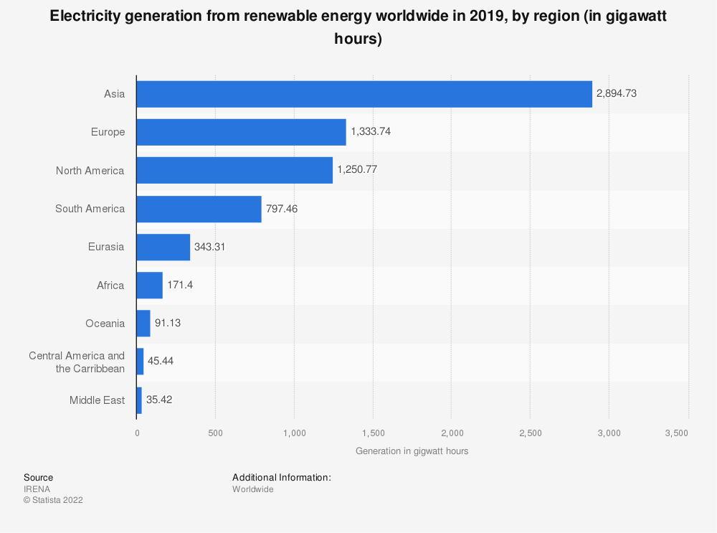

Figure 11: Renewable Energy generation by region **2019**

Source: (Statista, IRENA, 2022)

Other Ideas:

(Think about this – even if there is support from all the above, a lack of technology applicable to the project still causes project failure. In other words the will is there but not the ability to execute. Lack of skill people, lack of training, lack of R&D, - link this to education, link to …..)

I would argue this as having a "balanced" position i.e. that technology does not impede the lives of people. For example, think about windfarms offshore Vs onshore. Another example is fracking oil and gas....it's banned in a lot of countries because it's precieved impact to groundwater as well as siesmic aftershocks...agian you need to read a bit

You can state that topic 1 to 4 are first order effects; topic 5 is 2nd order effect. We talk about world leader (US) vs middle of the pack (Singapore) vs last in line (some county in South America)

**Limitations of Study and Conclusions:** This study adopted text mining and topic modelling methods to identify common topics related to successful RE projects, in current scientific research. This study has that financial factors alone are not guarantees of success in RE projects. In fact, we learn that there are a series of non-financial factors at play as well. Results from the LDA and NNMF model show that aside from financial viability, energy policies, government intervention, community engagement and investor perceptions were strong determinants in driving RE project success.

We discuss that government financial support contributes greatly to renewable energy adoptions and carbon pricing strategies can be adopted by nations lacking financial resources. Community involvement from project development to implementation is also critical for the long term sustainability of renewable energy implementations. High engagement of the community through the training of locals to take up leadership positions benefits the projects and also boosts the overall livelihoods of the community. Lastly, investor confidence in policies and technologies also impacts decision making. The psychological study of cognitive and behavioural attitudes can also be further expounded to understand investor behaviour. The results show that increasing study on attitudes, social norms and personal norms of investors have the potential to optimize the renewable energy sector and mitigate climate change

This study has limitations that should be addressed in future research. Firstly, it is constrained by its query phrase search. If relevant articles do not have any of the query phrases “renewable energy success” in their subject, they will not be included in the dataset, which may result in data inconsistency or data bias. Secondly is the data size which is relatively small with only research articles. Future studies should include a larger dataset to determine the robustness of the utilized method. Thirdly, personal bias in analysing the keywords of each topic are ever present. Beyond the scope of this work is the use of other predictive models to identify the fit of key topics, with additional statistics used to estimate the accuracy of concepts assigned to the keywords of each topic.

Given the complexity of the RE sector, the study demonstrates that holistic approaches be considered, beyond the technical or financial consideration. Indeed, looking at RE through a social science lens can provide alternative perspectives, to create a more balanced discourse in supporting the global climate change agenda. Future extension of a social perspective in RE research can support future policies and systems that can propel sustainable transformations.

# **References**

Jai, S. (n.d.). *Indian renewable firms underperformed but credit quality intact: Moody's*. Retrieved from Business News, Finance News, India News, BSE/NSE News, Stock Markets News, Sensex NIFTY, Latest Breaking News Headlines.: https://www.business-standard.com/article/companies/indian-renewable-firms-underperformed-but-credit-quality-intact-moody-s-121030901082_1.html#:~:text=%22About%2015%2D20%20per%20cent,the%20underperformance%20respectively%2C%E2%80%9D%20says%20Abhishek

Kealy, T. (2015). Does an embedded wind turbine reduce a company’s electricity bill? Case study of a 300 kW wind turbine in Ireland. *Journal of Business Ethics, 145*(2), 417-428. doi:https://doi.org/10.1007/s10551-015-2837-4

Jacobsson, S., & Johnson, A. (2000). The diffusion of renewable energy technology: An analytical framework and key issues for research. *Energy Policy, 28*(9), 625-640. doi:https://doi.org/10.1016/S0301-4215(00)00041-0

Jagadeesh, A. (2000). Wind energy development in Tamil Nadu and Andhra Pradesh, India institutional dynamics and barriers — A case study. *Energy Policy, 28*(3), 157-168. doi:https://doi.org/10.1016/s0301-4215(00)00007-0

Bradshaw, G. A., & Borchers, J. G. (2000). Uncertainty as information: Narrowing the science-policy gap. *Conservation Ecology, 4*(1). doi:https://doi.org/10.5751/es-00174-040107

Ramage, D., Rosen, E., Chuang, J., Manning, C. D., & McFarland, D. A. (2009). Topic modeling for the social sciences. *NIPS 2009 workshop on applications for topic models: text and beyond, 5*, 1-4.

Shrimali, G., Goel, S., Srinivasan, S., & Neslon, D. (2014). *Solving India’s renewable energy financing challenge: Which federal policies can be most effective?* CPI-ISB Series.

West, J., Bailey, I., & Winter, M. (2010). Renewable energy policy and public perceptions of renewable energy: A cultural theory approach. *Energy Policy, 38*(10), 5739-5748.

Masini, A., & Menichetti, E. (2013). Investment Decisions in the Renewable Energy Sector: An Analysis of Non-Financial Drivers. *Technological Forecasting and Social Change, 80*(3), 510-524.

Maqbool, R., Rashid, Y., Sultana, S., & Sudong, Y. (2018). Identifying the critical success factors and their relevant aspects for renewable energy projects; An empirical perspective. *Journal of Civil Engineering and Management, 24*(3), 223-237.

Bickel, M. W. (2019). Reflecting trends in the academic landscape of sustainable energy using probabilistic topic modeling. *Energy, Sustainability and Society, 9*(49).

Bird, S., Klein, E., & Loper, E. (2009). *Natural Language Processing with Python: Analyzing Text with the Natural Language Toolkit.* O'Reilly Media, Inc.

Kapadia, S. (2019, April). *Topic Modeling in Python: Latent Dirichlet Allocation (LDA)*. Retrieved from https://towardsdatascience.com/end-to-end-topic-modeling-in-python-latent-dirichlet-allocation-lda-35ce4ed6b3e0

Prabhakaran, S. (2018). *Topic Modeling with Gensim (Python)*. Retrieved from https://www.machinelearningplus.com/nlp/topic-modeling-gensim-python/

Sievert, C., & Shirley, K. E. (2014). LDAvis: A method for visualizing and interpreting topics. *Proceedings of the Workshop on Interactive Language Learning, Visualization, and Interfaces.* Baltimore, Maryland, USA.

Mifrah, S., & Benlahmar, E. H. (2020). Topic modeling coherence: A comparative study between LDA and NMF models using COVID’19 corpus. *International Journal of Advanced Trends in Computer Science and Engineering, 9*(4), 5756-5761.

International Energy Agency. (n.d.). *Energy Subsidies - Topics*. Retrieved from https://www.iea.org/topics/energy-subsidies

U.S. Department of Energy. (2021). *Federal agency use of renewable electric energy*. Retrieved from https://www.energy.gov/eere/femp/federal-agency-use-renewable-electric-energy

Center for Climate and Energy Solutions. (2021). *Renewable energy*. Retrieved from https://www.c2es.org/content/renewable-energy/

Tan, A. (2019). *Singapore to ramp up solar energy production to power 350,000 homes by 2030.* Singapore: Straits Times. Retrieved from https://www.straitstimes.com/singapore/environment/solar-energy-to-meet-4-of-singapores-energy-demand-by-2030-up-from-less-than-1

Office of Energy Efficiency and Renewable Energy. (n.d.). *Weatherization and Intergovernmental Programs Office State Energy Program*. Retrieved February 2022, from https://www.energy.gov/eere/wipo/about-state-energy-program

Sundaram, S. (2016). The Sustainability of Solar PV Governance: A Comparative International Perspective. In *Solar Photovoltaic Technology Production* (pp. 47-74).

The Ministry of Energy and Mines of the Lao People’s Democratic Republic, Ministry of Energy of the Kingdom of Thailand, Ministry of Energy, Green Technology and Water of Malaysia, and Ministry of Trade and Industry of the Republic of Singapore. (2014). *LAO PDR, MALAYSIA, SINGAPORE, THAILAND: Joint Statement of the Lao PDR, Thailand, Malaysia and Singapore Power Integration Project (LTMS PIP).* Retrieved 2022, from https://policy.asiapacificenergy.org/node/2574

Gordonnat, J., & Hunt, J. (2020). Subsea cable key challenges of an intercontinental power link: case study of Australia–Singapore interconnector. *Energy Transitions, 4*(2), 169-188.

Butchers, J., Williamson, S., & Booker, J. (2021). Micro-hydropower in Nepal: Analysing the project process to understand drivers that strengthen and weaken sustainability. *Sustainability, 13*(3), 1582.

Hermawati, W., & Rosaira, I. (2017). Key success factors of renewable energy projects implementation in rural areas of Indonesia. *STI Policy and Management Journal, 2*(2), 111.

Inchauspe, J., Ripple, R. D., & Truck, S. (2016). The Dynamics of Returns on Renewable Energy Companies: A State-Space Approach. *Energy Economics, Vol. 48, 2015*, 22.

Wong, L. (2022). *Speech: D. Advance Our Green Transition*. Retrieved from Ministry of finance: https://www.mof.gov.sg/singaporebudget/budget-2022/budget-statement/d-advance-our-green-transition

Alley, A. (2020, October 6). *Facebook signs 100MW PPA with Singapore's Sunseap for rooftop solar project*. Retrieved from Data Centre Dynamics: https://www.datacenterdynamics.com/en/news/facebook-signs-100mw-ppa-singapores-sunseap-rooftop-solar-project/

Jami, A. A., & Walsh , P. R. (2016). Wind Power Deployment: The Role of Public Participation in the Decision-Making Process in Ontario, Canada. *Renewable Energy*.

Upretia, B. R., & Horst, D. v. (2003). National renewable energy policy and local opposition in the UK:the failed development of a biomass electricity plant. *Biomass and Energy 26 (2004) 61-69*.

AsareObeng-Darko, N. (2019). Why Ghana will not achieve its renewable energy target for electricity. Policy, legal and regulatory implications. *Energy Policy*, 128:75-83.

Rogers Kipkoech, Takase, M., & Afrifa, E. K. (2022). Renewable Energies in Ghana in Relation to Market Condition, the Environment, and Food Security. *Journal of Renewable Energy*.

Milanés-Montero , P., Arroyo-Farrona, A., & Pérez-Calderón, E. (2018). Assessment of the Influence of Feed-In Tariffs on the Profitability of European Photovoltaic Companies. *Sustainability*.

Bueno-Lorenzo, M., Ángeles Moreno , M., & Usaola, J. (2013). Analysis of the imbalance price scheme in the Spanish electricity market: A wind power test case. *Energy Policy 62*, 1010-1019.

Năsulea, C. (2014). The Effects of Fiscal Policy Instability on Wind Energy Resource Development in Romania. *Economics and Sociology, Vol. 7, No 3,* , 51-59.

IRENA. (2019). *Strong Ties Between Public and Private Sectors Key to Accelerating Renewables .*

Jones, B. D. (1994). *Reconceiving decision-making in democratic politics: attention, choice, and public policy,.* London: The University of Chicago Press.

Martins, A. C., Marques, R. C., & Cruz, C. O. (2011). Public-Private Partnerships for Wind Power Generation: The Portuguese Case. *Energy Policy*.

World Bank. (2012). Public-Private Partnerships: Reference Guide. *World Bank Institute and Public-Private Infrastructure Advisory Facility .*

Cedrick, B. Z., & Long, W. (2017). Investment Motivation in Renewable Energy: A PPP Aproach. *Energy Procedia*, 229-238.

Jager, D. d., & Rathmann, M. (2008). *Policy instrument design to reduce financing costs in renewable energy technology projects.*

Langniss, O., Helby, P., & Mitchell, C. (1999). *inancing Renewable Energy Systems.* Stuttgart.

Guild, J. (2019). Feed-in-tariffs and the politics of renewable energy in Indonesia and the Philippines. *Asia & the Pacific Policy Studies Volume 6*, 417-431.

World Bank. (2017). *worldbank*. Retrieved from Worldwide governance indicators: http://info.worldbank.org/governance/wgi/#home

Lucas, H., Pinnington, S., & Cabeza, L. (2018). Education and training gaps in the renewable energy sector. *Solar Energy, Volume 173*, 449-455.

**Acknowledgments:** Munish Kumar would like to thank ERCE for peer review of this work.

1. The State Energy Program provides both financial and technical assistance for energy projects that are coherent with nationwide green energy goals.
2. The Act (passed by congress) established a legal requirement for federal agencies to derive at least 7.5% of energy consumption from renewable sources.