**Title:** **Utilisation of Artificial Intelligence based Time-Series Prediction to validate Carbon Containment in Injection Well in Illinois Basin**

**Authors:** Munish Kumara and Kanna Swaminathana

**Affiliations:** aSingapore University of Social Sciences, School of Business, Clementi Rd, #463号, Singapore 599494

bCalifornia Resources Corporation, 900 Old River Rd, Bakersfield, CA 93311, United States

Corresponding author. Email: munishkumar001@suss.edu.sg

**Abstract:**

**One-Sentence Summary:** Applying machine learning and predicative analytics via time series injection information and monitoring data on a carbon capture well to predict well injection rate deltas.

**Keywords (minimum 6):** low-carbon, time-series, neural network, LSTM, carbon capture, injection pressure, monitoring, plume migration

# Introduction

There is no doubt that human activities are one of the main reasons for the increase in amounts of greenhouse gases (GHG) and global warming. Primarily, CO2 levels have increased due to the rapid pace of industrialisation and population growth, which has only picked up pace since the 1960s [1].

The burning of fossil fuels (coal, oil, and natural gas) has resulted in carbon dioxide (CO2), methane (CH4) and nitrous oxide (N2O) generation. A report generated by the United States Environmental Protection Agency (EPA) evaluated the amount of CO2 generated in 2020 to be ~3.11 million metric tons [2]. Such significant quantities, if not better managed, will lead to irreversible environmental consequences.

Carbon Capture Utilisation and Storage (CCUS) is one promising method to deal with the produced CO2 from anthropogenic sources. The idea is to capture CO2 from an emission point source and subsequent sequester it via injection into a suitable geological formation, with the explicit aim to store the CO2 safely, in a state of permanance. CCUS is now being viewed as a key technology to assist in reaching global anthropogenic climate change goals. Typically, CO2 storage is carried out in one of three ways - via injection into virgin saline aquifers; into depleted oil and gas fields; or if used for Enhanced Oil Recovery (EOR) processes. These methods all have different project drivers, risks, and commercial implications. However, what these 3 methods have in common is the requirement that (a) there be a good understanding of the subsurface geological properties and (b) there be some ability to monitor and even predict CO2 behaviour at the well scale, be in during the injection phase or during the shut-in phase.

The uncertainties present in (b) especially necessitate pilot development and validation of the technology. The Illinois Basin - Decatur Project is one such study which aimed to demonstrate the capacity, injectivity, and containment of carbon storage in the Mount Simon Sandstone, which is the main carbon storage resource in the Illinois Basin and the Midwest Region. Injection began in 2009 into the Mount Simon Sandstone at a depth of approximately 7,000 feet (2,100 meters), and continued for a 3 year period, during which over 1 million tonnes of CO2 was injected

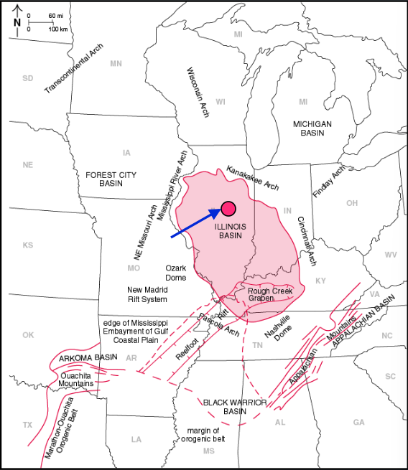

Figure 1: Location map of the Illinois Basin – Decatur Project (IBDP). Image taken from

This paper aims to use time series injection information and monitoring data on a carbon capture well to predict carbon capture well injection rates deltas (D) which is the difference in the injection rate (IR) at time t and time (t-1) i.e.

|  |  |  |
| --- | --- | --- |
|  | $$∆ = {IR}_{t}- {IR}_{t-1}$$ | Equation 1 |

Correlating the change in injection rate to the behaviour of other parameters in the well can be used to provide a checkpoint against carbon migration from the well or other losses during the process. Utilisation of a machine learning (ML) method to predict injection rate deltas based on monitoring well data can be used to validate carbon containment throughout the injection of the well as well.

# Literature Review

Various authors have tried numerous methods to forecast future trends based on past data. Work by De Gooijer and Hyndman [3], for instance, reviewed a series of time-series forecast models over a 25 year period, from 1985 to 2005. Their review highlighted various models being developed and applied in a myriad of scenarios related to finance, statistics and manufacturing, and include methods such as (a) exponential smoothing [4, 5], (b) Autoregressive Integrated Moving Average (ARIMA) [6], (c) seasonal models [7], (d) state space and structural models and the Kalman filter [8], (e) nonlinear models [9], (f) long-range dependence models, including the family of Autoregressive Fractionally Integrated Moving Average (ARFIMA) models [10], (g) Autoregressive Conditional Heteroskedasticity/Generalized Autoregressive Conditional Heteroskedasticity (ARCH/GARCH) models [11], and (h) count data forecasting [12].

In reservoir engineering, the prediction of hydrocarbon or water rates from geological formations is a time-series forecasting problem, with empirical solutions developed by Arps [13], referred to as decline curve analysis (DCA) technique. The method is based on a curve-fit principle, where one would attempt to fit either exponential, hyperbolic or harmonic curve to historical flow production rate as a function of time. Equation 2 shows the general form of the equation

|  |  |  |
| --- | --- | --- |
|  | $$q(t) = \frac{q_{i}}{{(1+bD_{i}t)}^{1/b}}$$ | Equation 2 |

where qi is the initial rate (bbls/day), Di is the initial decline rate (units) and b is the degree of curvature of the line. An exponential curve fit would have b = 0, a hyperbolic curve would have 0 < b < 1 and a harmonic curve would have b = 1. The fitted curve is then used to predict future production rates and cumulative production. This method was originally designed to work with high porosity-permeability reservoirs, and tends to overestimate hydrocarbon recovery from unconventional (low permeability) reservoirs. Thus, various authors have tried to expand on this work [14, 15, 16, 17], but for all intends and purposes, they are mostly just variations of the initial DCA method developed by Arps.

For CCUS, there is little to no available data for time series analysis of wells which have been utilised for CCUS. Ratehr, literature is

carbon capture well machine learning scholar

https://pubs.rsc.org/en/content/articlehtml/2021/ee/d1ee02395k

<https://www.sciencedirect.com/science/article/abs/pii/S0016236122031209>

https://www.sciencedirect.com/science/article/pii/S2212982023000859

## Challenges with XXXXX

# Scope and Methods

During this three-year period, a substantial amount of data was collected.

## Data Collection

**Table 1:** XXXXX

## Removing Duplicates

## Cleaning Data

# Long Short-Term Memory (LSTM)

# Results and Discussion

# Recommendations

# Conclusion

# Bibliography

|  |  |
| --- | --- |
| [1] | R. Lindsey, “Climate Change: Atmospheric carbon dioxide, NOAA Climate.gov,” [Online]. Available: https://www.climate.gov/news-features/understanding-climate/climate-change-atmospheric-carbon-dioxide. [Accessed 25 April 2023]. |
| [2] | United States Environmental Protection Agency, “Sources of Greenhouse Gas Emissions,” 20 Jul 2022. [Online]. Available: from https://www.epa.gov/ghgemissions/sources-greenhouse-gas-emissions. |
| [3] | J. G. D. Gooijer and R. J. Hyndman, “25 years of time series forecasting,” *International Journal of Forecasting,* vol. 22, no. 3, pp. 443-473, 2006. |
| [4] | E. S. Gardner, “Exponential smoothing: The state of the art,” *Journal of Forecasting,* vol. 4, no. 1, pp. 1-28, 1985. |
| [5] | R. D. Snyder, “Recursive Estimation of Dynamic Linear Models,” *Journal of the Royal Statistical Society. Series B (Methodological),* vol. 47, no. 2, p. 272–276, 1985. |
| [6] | R. H. Scumway and D. S. Stoffer, Time Series Regression and ARIMA Models, New York: Springer, 2000. |
| [7] | G. Huyot, K. Chiu, J. Higginson and N. Gait, “Analysis of Revisions in the Seasonal Adjustment of Data Using X-11-Arima Model-Based filters,” *International Journal of Forecasting,* vol. 2, no. 2, pp. 217-229, 1986. |
| [8] | S. H. Babbs and K. B. Nowman, “Kalman filtering of generalized Vasicek term structure models,” *Journal of financial and quantitative analysis,* vol. 34, no. 1, pp. 115-130, 1999. |
| [9] | M. P. F. P. H. &. S. N. R. Clements, “Forecasting economic and financial time-series with non-linear models,” *International journal of forecasting,* vol. 20, no. 2, pp. 169-183, 2004. |
| [10] | B. K. Ray, “Long-range forecasting of IBM product revenues using a seasonal fractionally differenced ARMA model,” *International Journal of Forecasting,* vol. 9, no. 2, pp. 255-269, 1993. |
| [11] | S. J. Taylor, “Forecasting the volatility of currency exchange rates,” *International Journal of Forecasting,* vol. 3, no. 1, pp. 159-170, 1987. |
| [12] | T. R. Willemain, C. N. Smart, J. H. Shockor and P. A. DeSautels, “Forecasting intermittent demand in manufacturing: a comparative evaluation of Croston's method,” *International Journal of Forecasting,* vol. 10, no. 4, pp. 529-538, 1994. |