LAB – 2

INDEX.PHP :

<?php

// Include the Book class

require 'Book.php';

// Start session to store books

session_start();

// Initialize an array to store books if it doesn't exist in session

if (!isset($_SESSION['books'])) {

$_SESSION['books'] = [];

}

$error = '';

// Process the form submission

if ($_SERVER['REQUEST_METHOD'] == 'POST') {

$title = $_POST['title'] ?? '';

$author = $_POST['author'] ?? '';

$year = $_POST['year'] ?? '';

// Attempt to create a new Book object and catch any exceptions

try {

$book = new Book($title, $author, $year);

$_SESSION['books'][] = $book; // Add the book to the session array

} catch (Exception $e) {

$error = $e->getMessage(); // Capture the error message

}

}

?>

<!DOCTYPE html>

<html lang="en">

<head>

<meta charset="UTF-8">

<meta name="viewport" content="width=device-width, initial-scale=1.0">

<title>Book Management System</title>

</head>

<body>

<h1>Book Management System</h1>

<!-- Display error message if something goes wrong -->

<?php if (!empty($error)): ?>

<p style="color: red;"><?php echo $error; ?></p>

<?php endif; ?>

<!-- Book entry form -->

<form method="POST">

<label>Title:</label>

<input type="text" name="title" value="<?php echo htmlspecialchars($title ?? ''); ?>"><br><br>

<label>Author:</label>

<input type="text" name="author" value="<?php echo htmlspecialchars($author ?? ''); ?>"><br><br>

<label>Year:</label>

<input type="text" name="year" value="<?php echo htmlspecialchars($year ?? ''); ?>"><br><br>

<button type="submit">Add Book</button>

</form>

<h2>List of Books</h2>

<!-- Call the static method to display books -->

<?php Book::displayBooks($_SESSION['books']); ?>

</body>

</html>

BOOK.PHP :

<?php

class Book {

private $title;

private $author;

private $year;

// Constructor to initialize the book object

public function __construct($title, $author, $year) {

if (empty($title) || empty($author) || empty($year)) {

throw new Exception("All fields are required.");

}

if (!is_numeric($year) || $year < 0) {

throw new Exception("Invalid year.");

}

$this->title = $title;

$this->author = $author;

$this->year = $year;

}

// Getters for each attribute

public function getTitle() {

return $this->title;

}

public function getAuthor() {

return $this->author;

}

public function getYear() {

return $this->year;

}

// Static method to display all books in a table

public static function displayBooks($books) {

if (empty($books)) {

echo "<p>No books have been added yet.</p>";

} else {

echo "<table border='1'>

<tr>

<th>Title</th>

<th>Author</th>

<th>Year</th>

</tr>";

foreach ($books as $book) {

echo "<tr>

<td>" . htmlspecialchars($book->getTitle()) . "</td>

<td>" . htmlspecialchars($book->getAuthor()) . "</td>

<td>" . htmlspecialchars($book->getYear()) . "</td>

</tr>";

}

echo "</table>";

}

}

}

?>

SO HERE YOU CAN SEE THE OUTPUT:

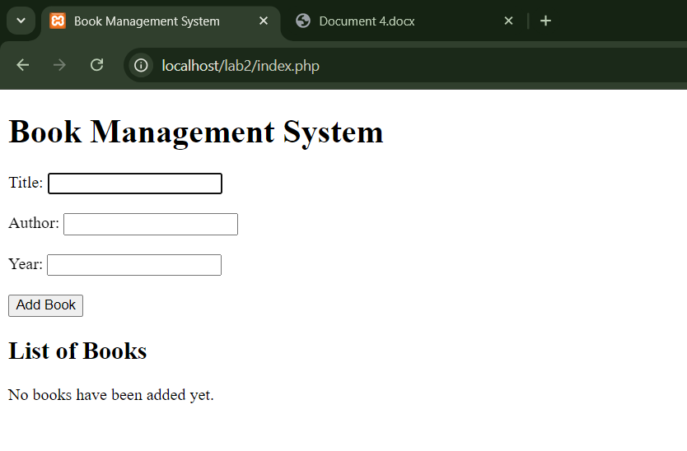

AND HERE YOU CAN SEE IF WE ARE ADDING THE EMPTY DATA FIELDS THEN ITS SHOWING A MESSEGE AT THE TOP OF IT:

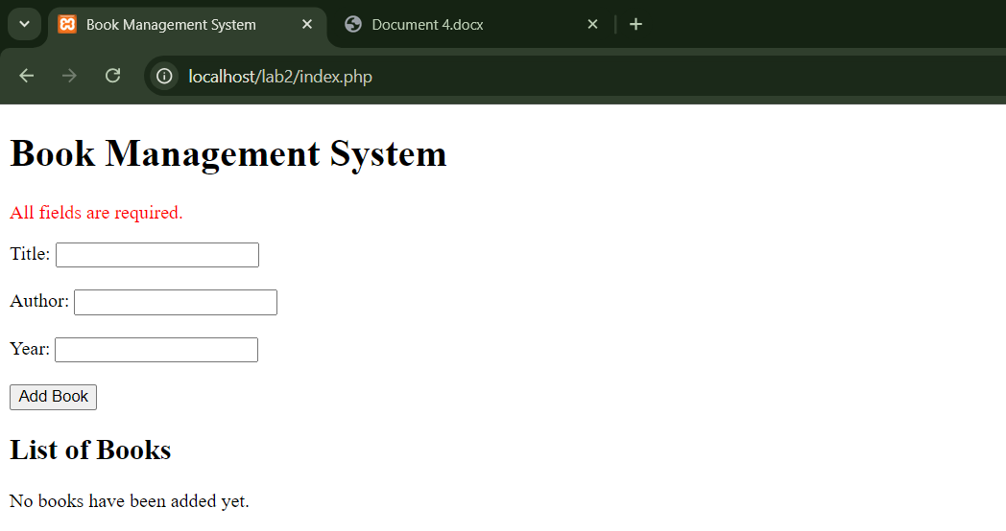

WHEN WE ARE ADDING THE DATA THEN IT WOULD SHOW US THE DATA IN A TABLE LIKE THIS BELOW:

