LegalEase:AI-PoweredLegalDocument Generator

1. Brainstorming & Ideation Phase

Problem
documents are cLegal ostly and need legal expertise. Entrepreneurs, freelancers and landlords need a simple way to create reliable legal content.

Idea
LegalEase uses Generative AI to create customizable, editable legal documents (contracts, NDAs, lease agreements) from user inputs, with export to .TXT, .DOCX and .PDF.

Scenarios
- Scenario 1: Startup founder generates an Employment Contract, edits it, adds a logo and downloads a branded PDF.
- Scenario 2: Freelancer generates an NDA by giving parties, confidentiality scope and effective date.
- Scenario 3: Landlord generates a residential lease agreement and downloads it as .DOCX.

Why Gemini 1.5 Pro
- Long context window (up to 1 million tokens)
- Structured prompting with multi-part content
- Fast generation and suited to formal legal drafting
- Generates clauses dynamically from user inputs

Requirement Analysis Phase

Functional Requirements
- Accept document type, parties, terms and effective date
- Generate a structured legal document using Gemini
- Editable text preview
- Export as .TXT, .DOCX and .PDF with logo, terms table and footer
- POST /generate backend endpoint

Non-Functional Requirements
- Secure handling of data (API key in .env)
- Professional formatting standards
- Responsive, user-friendly UI
- Modular and scalable architecture

Input Table
Input | Purpose | Example
Document Type | Type of legal document | Freelance Work Contract
Parties Involved | Names and roles | Jane Doe (Service Provider), TechNova Inc. (Client)
Terms & Conditions | Clauses separated by semicolons | Payment within 7 days of invoice; ...
Effective Date | Date agreement is valid | April 15, 2025

Libraries
pip install fastapi uvicorn streamlit python-docx fpdf Pillow requests google-generativeai python-dotenv

3. Project Design Phase

Architecture
User Interface (Streamlit) → FastAPI Backend (main.py) → Document Generator (gemini_generator.py) → Gemini API → Formatted Output (.txt, .docx, .pdf).

Component | Role
Frontend | Streamlit: input, preview, editing, downloads
Backend | FastAPI: routes input to Gemini and returns content
AI Core | Gemini integration for content generation
Formatting Modules | DOCX, PDF and TXT generators

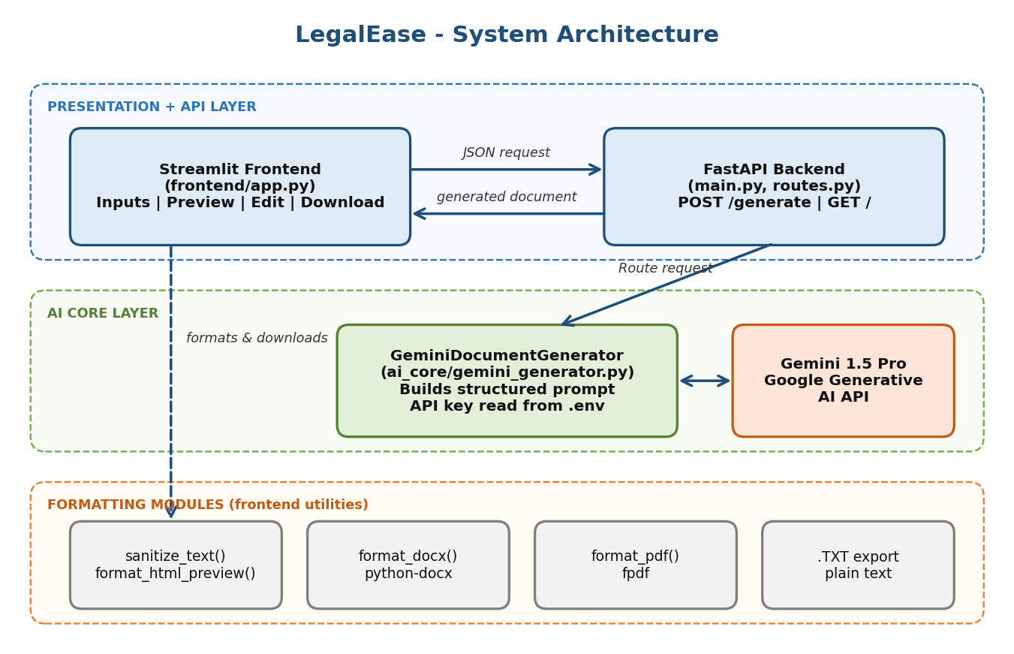

Flow Diagram
Step-by-step flow of the application from user input to document download.
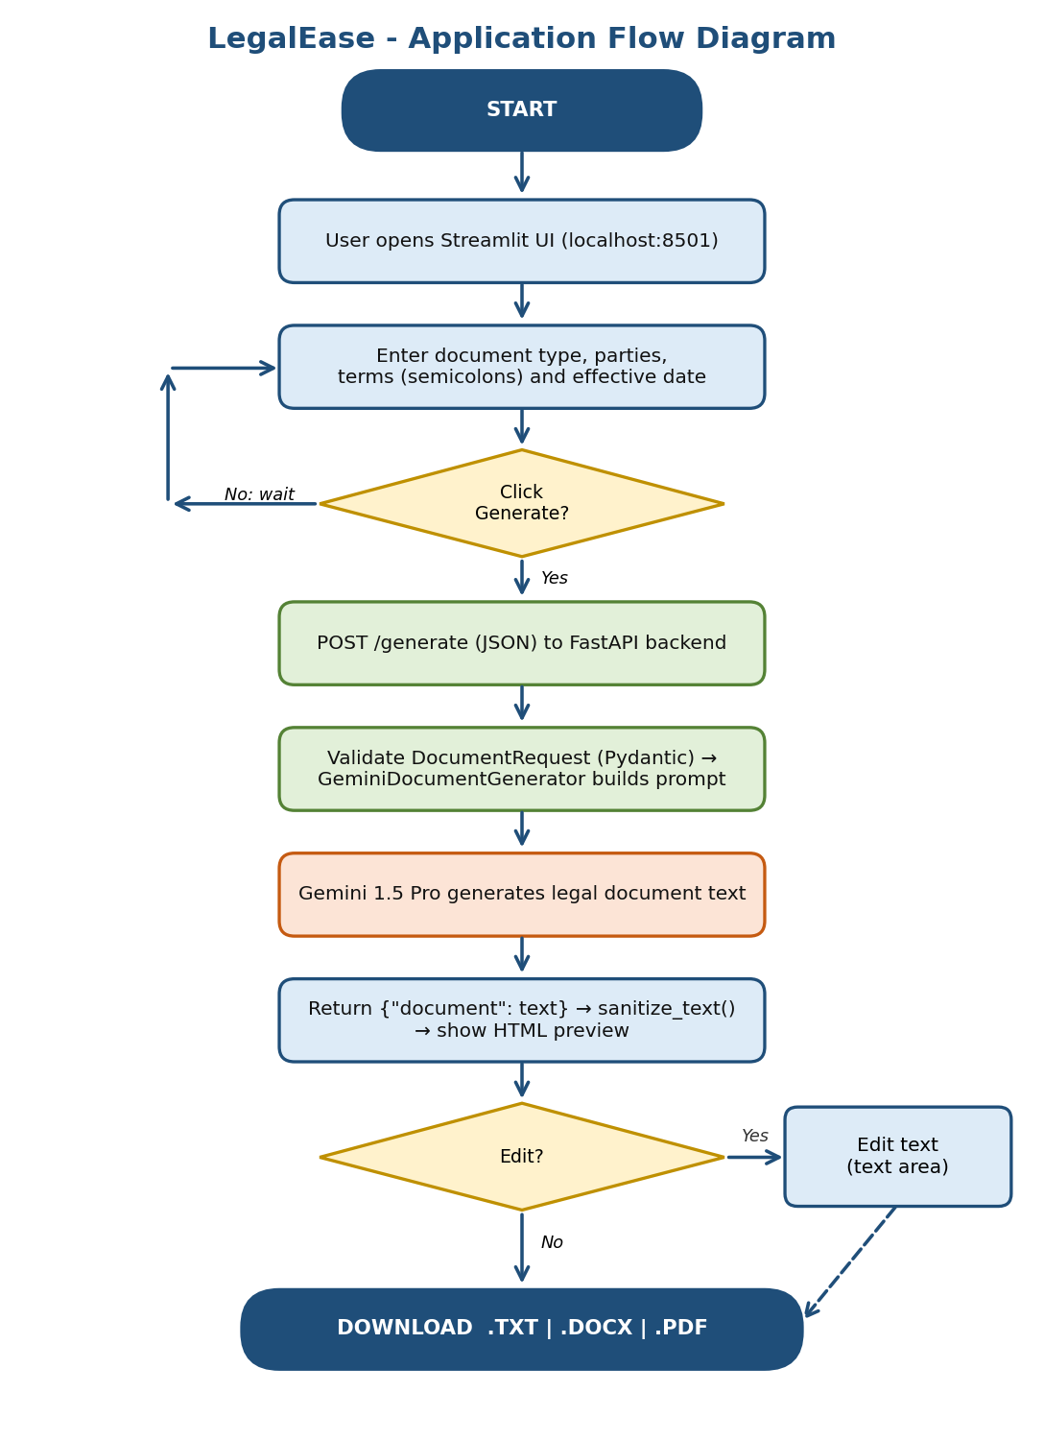

API Design
POST /generate accepts JSON and returns the generated document. GET / is the health check.
Request: {"document_type": "...", "parties": "...", "terms": "...", "dates": "..."}
Response: {"document": "<generated legal text>"}

UI Design
- Centered logo (st.columns) and title
- Inputs: text_input (type, date), text_area (parties, terms)
- Buttons: Generate Document, Click to Edit Document, Download TXT / DOCX / PDF
- Dark-themed scrollable HTML preview

Folder Structure
LEGALEASE/
├── ai_core/ (gemini_generator.py, generator.py)
├── docs/
├── frontend/ (app.py)
├── Image/ (Logo.png, inverseLogo.png)
├── legalEaseAPI/ (main.py, routes.py)
├── .env config.py requirements.txt run.sh

4. Project Planning Phase
Activity | Key Tasks | Milestone
1. Model Selection & Architecture | Select Gemini 1.5 Pro, define architecture, set up .env | Milestone 1
2. Core Functionalities | Generation, editable preview, export, FastAPI backend | Milestone 2
3. main.py & API Logic | FastAPI app, DocumentRequest model, /generate route | Milestone 3
4. Frontend with Streamlit | Inputs, layout with logo, preview, export options | Milestone 4
5. Deployment | requirements.txt, local run, cloud options | Milestone 5
6. Conclusion | End-to-end and multi-input testing | Final testing

5. Project Development Phase

gemini_generator.py
genai.configure(api_key=os.getenv("GEMINI_API_KEY"))
self.model = genai.GenerativeModel(model_name)

def generate_document(self, document_type, parties, terms, dates):
prompt = (...) # structured prompt with type, parties, date, terms
response = self.model.generate_content(prompt)
return response.text

main.py
Creates the FastAPI app, includes the router from routes.py and defines the root route (/) that returns a welcome message.

routes.py
class DocumentRequest(BaseModel):
document_type: str; parties: str; terms: str; dates: str

@router.post("/generate")
def generate_legal_document(request: DocumentRequest):
response = gemini_generator.generate_document(...)
return {"document": response}

app.py
Collects inputs, posts them to http://localhost:8000/generate, sanitizes the response, shows the HTML preview, provides an edit text area (st.session_state) and three download buttons.

Core Functions
Function | Purpose
sanitize_text(text) | Removes special characters and typographic quotes
format_docx(text, doc_type) | python-docx: logo, titles, terms table, footer
format_pdf(text, doc_type) | FPDF: header/footer, bold headings, bullet terms
format_html_preview(text) | Stylized HTML blocks for preview

6. Project Testing Phase

Test Setup
uvicorn legalEaseAPI.main:app --reload
# http://127.0.0.1:8000
streamlit run frontend/app.py
# http://localhost:8501

Sample Input
Field | Value
Document Type | Freelance Work Contract
Parties | Jane Doe (Service Provider), TechNova Inc. (Client)
Terms | Work delivered by May 15, 2025; Payment within 7 days; Client retains IP rights; Confidentiality at all times
Effective Date | April 15, 2025

Test Cases
# | Test Case | Expected | Result
1 | Backend health check (GET /) | Welcome message | Pass
2 | Generate document | Structured legal text | Pass
3 | HTML preview | Dark scrollable card | Pass
4 | Edit document | Edits reflected in downloads | Pass
5 | Download .TXT | Plain text file | Pass
6 | Download .DOCX | Logo, terms table, footer | Pass
7 | Download .PDF | Logo and footer on all pages | Pass
8 | NDA / Lease / Employment inputs | Relevant document for each | [Update]

Checklist
- Proper layout with logo and footer
- Clean formatting of bullet points
- Correct embedding of terms in the document

7. Project Documentation Phase

Setup Guide
- Install Python 3.10+ and pip
- Create and activate virtual environment: venv\scripts\activate
- Install dependencies: pip install -r requirements.txt
- Create .env with the Gemini API key
- Start backend (Uvicorn) and frontend (Streamlit)

.env
GEMINI_API_KEY=your_api_key_here
Do not upload the real .env file to GitHub.

Usage Guide
- Open http://localhost:8501
- Enter document type, parties, terms (use semicolons) and date
- Click Generate Document, review the preview, edit if needed
- Download as .TXT, .DOCX or .PDF

Deployment Notes
Local deployment first (FastAPI + Streamlit). Cloud options: Render, Railway, Deta, Fly.io or VPS for the backend and Streamlit Community Cloud for the frontend. All project files should be uploaded to GitHub.

8. Project Demonstration Phase

Demo Steps
- Start backend and frontend
- Enter the sample Freelance Work Contract details
- Click Generate Document
- Show the preview and edit the text
- Download and open the .TXT, .DOCX and .PDF files

Output Summary
Format | Output
.TXT | Plain text version
.DOCX | Word document with logo on front page, terms table and footer
.PDF | Branded PDF with logo and footer on all pages

Conclusion
LegalEase makes legal document creation simple, accessible and editable for people without a legal background. Future scope: deeper contract analysis, legal database integration and personalized recommendations.

