PROJECT REPORT
Object Oriented Programming Lab (CSL-210)


PROJECT TITLE:
BS(CS) – 2A
Group Members
Name | Enrollment
- MUNEEZA AHMED | 02-134242-023
- SHEHNEEZ ARIF | 01-134242-035

Submitted to:
Ma’am Mehwish Saleem

BAHRIA UNIVERSITY KARACHI CAMPUS
Department of Computer Science

ABSTRACT:

The Eye Clinic Management System is a desktop-based application developed using Java Swing and MySQL to streamline the administrative processes in an eye clinic. This system offers functionalities such as doctor and patient registration, appointment booking and cancellation, and record viewing through a user-friendly graphical interface. A login module ensures secure access, and key actions are logged for tracking purposes. The system uses object-oriented programming concepts, including abstraction and inheritance, to maintain clean and reusable code. It significantly reduces manual effort, increases data accuracy, and improves the overall efficiency of clinic operations. The project lays a solid foundation for future enhancements like role-based access, online appointment booking, and notification systems.

INTRODUCTION:
The Eye Clinic Management System is a Java-based desktop application designed to simplify and automate various administrative tasks in an eye clinic. The system allows for the registration of doctors and patients, booking and cancellation of appointments, and viewing of registered entities. It provides a user-friendly graphical interface (GUI) using Swing and connects to a MySQL database to store and retrieve data.

PROBLEM STATEMENT:
Managing clinic operations manually, including scheduling, maintaining doctor availability, and recording patient details, is time-consuming and error-prone. The need arises for a digital system that can:
- Maintain accurate records of doctors and patients.
- Enable quick booking and cancellation of appointments.
- Log clinic activities for accountability.
- Provide a professional and accessible user interface for clinic staff.

METHODOLOGY:
This system was built using:
- Java Swing for the GUI.
- JDBC (Java Database Connectivity) to interact with a MySQL database.
- Object-Oriented Programming (OOP) principles with inheritance and abstraction.
- Event-driven programming for user interactions.
- A Login module to restrict access to authorized users.
- Logging mechanisms to maintain a record of key events in the system.
Steps:
- Designing the GUI for both login and main clinic dashboard.
- Implementing classes for Person, Doctor, and Patient.
- Setting up a database with appropriate tables.
- Writing methods to handle database CRUD operations.
- Integrating user actions with backend logic.
- Testing for correct functionality and error handling.

PROJECT SCOPE:
- Registration of new doctors and patients.
- Appointment booking and cancellation.
- Viewing lists of doctors, patients, and appointments.
- Basic login authentication for users.
- Activity logging for key operations.
Out of scope: Advanced reporting, billing, multi-user support, and online integration are not part of the current version.

CODE:
EyeClinicSystem.java
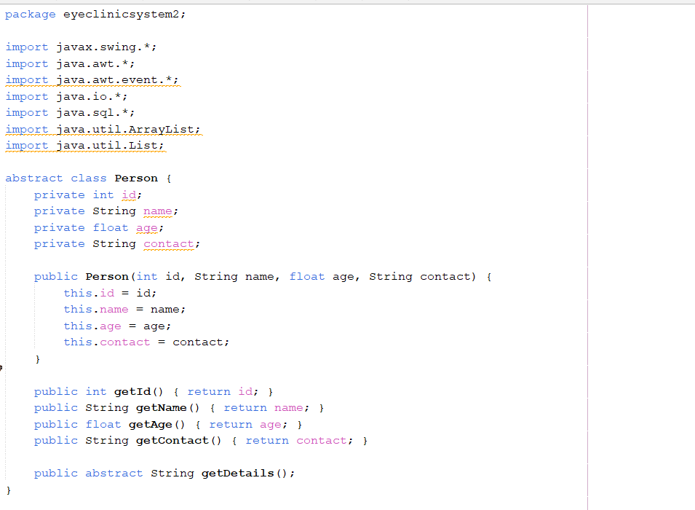
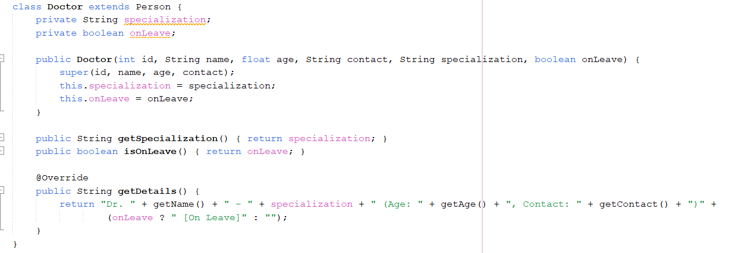
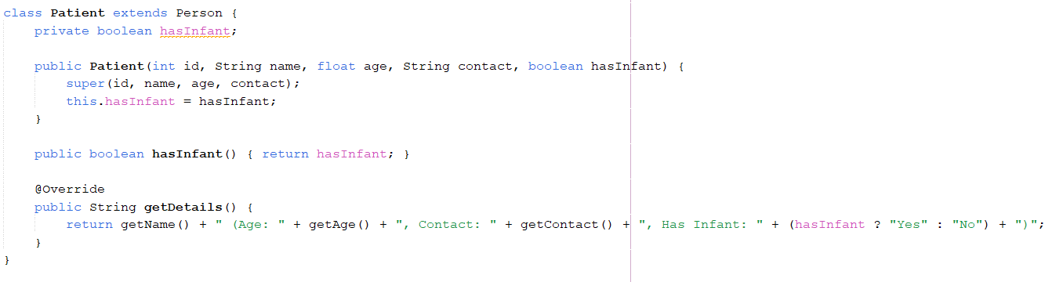
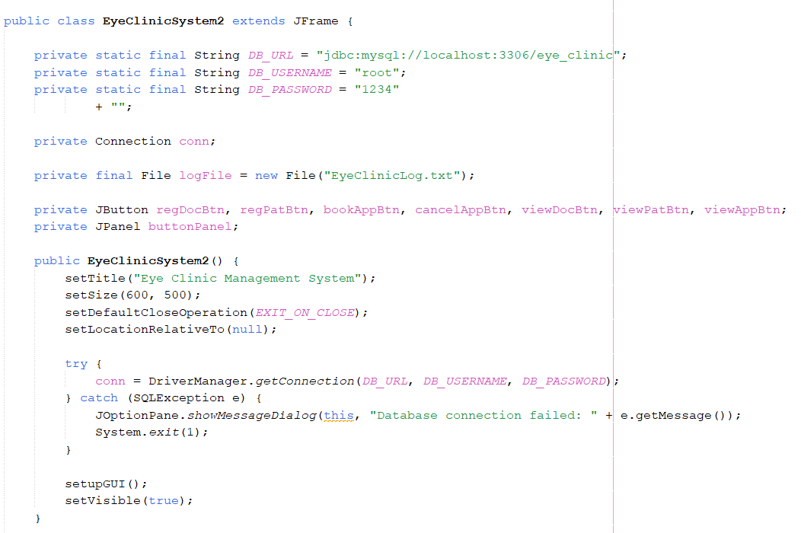
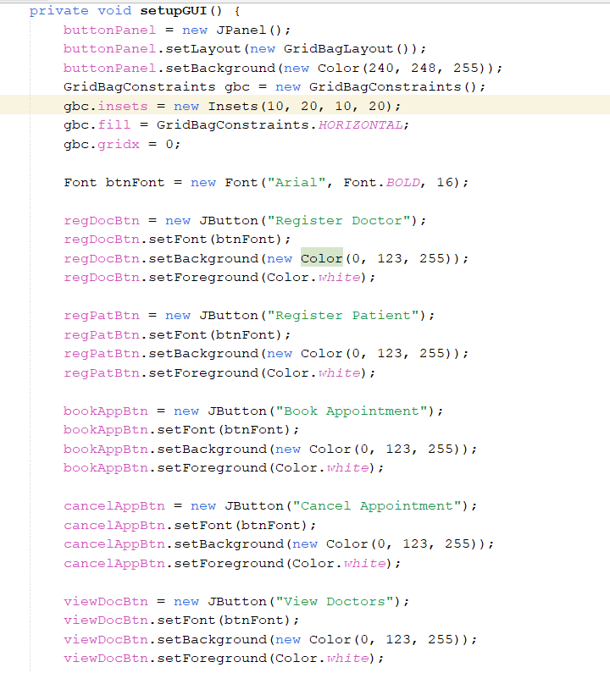
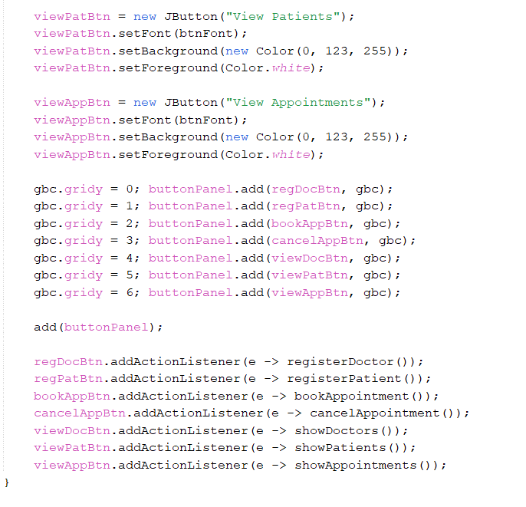
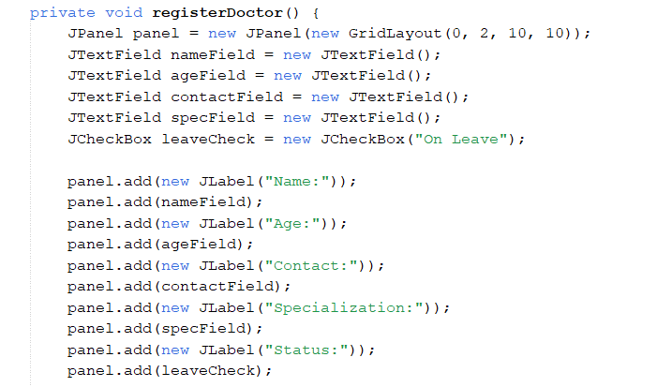
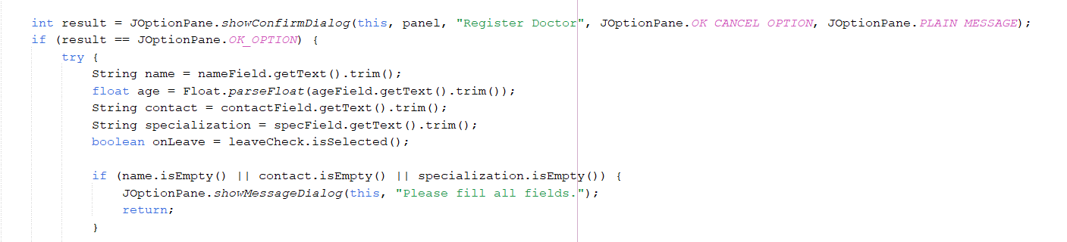
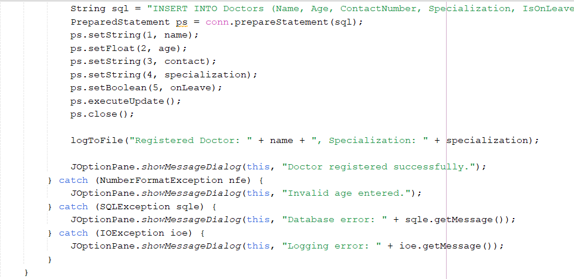
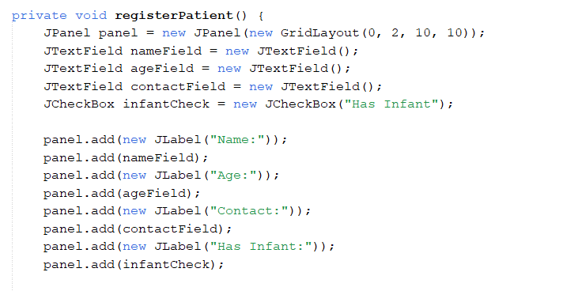
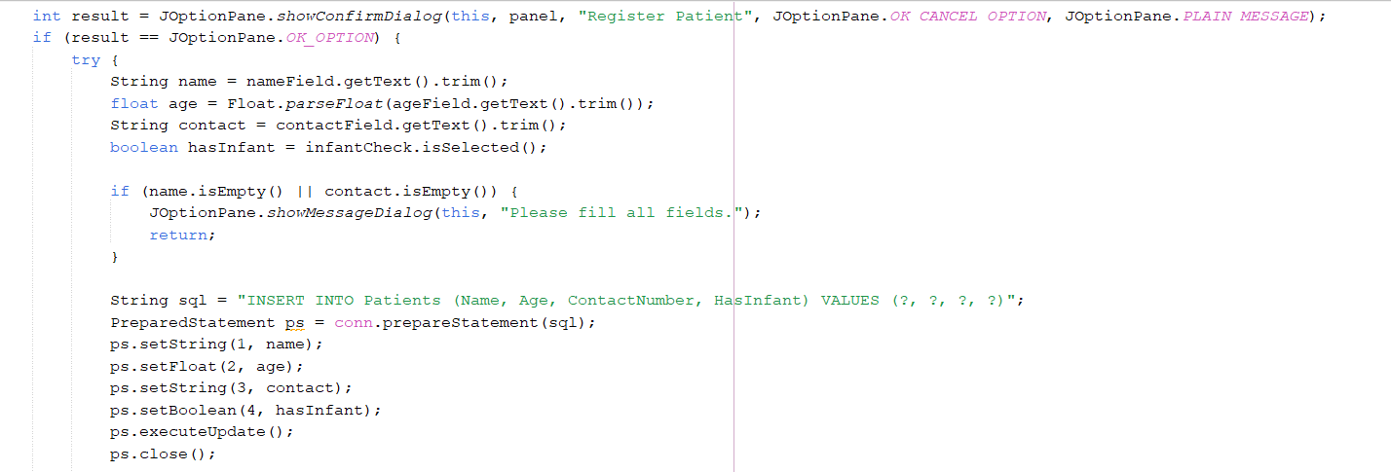
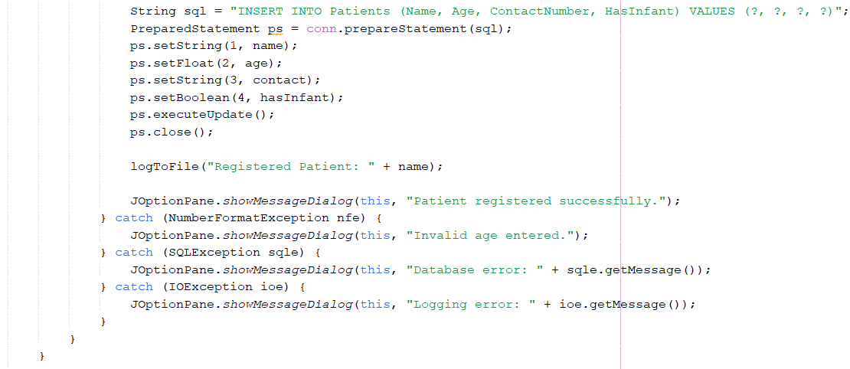
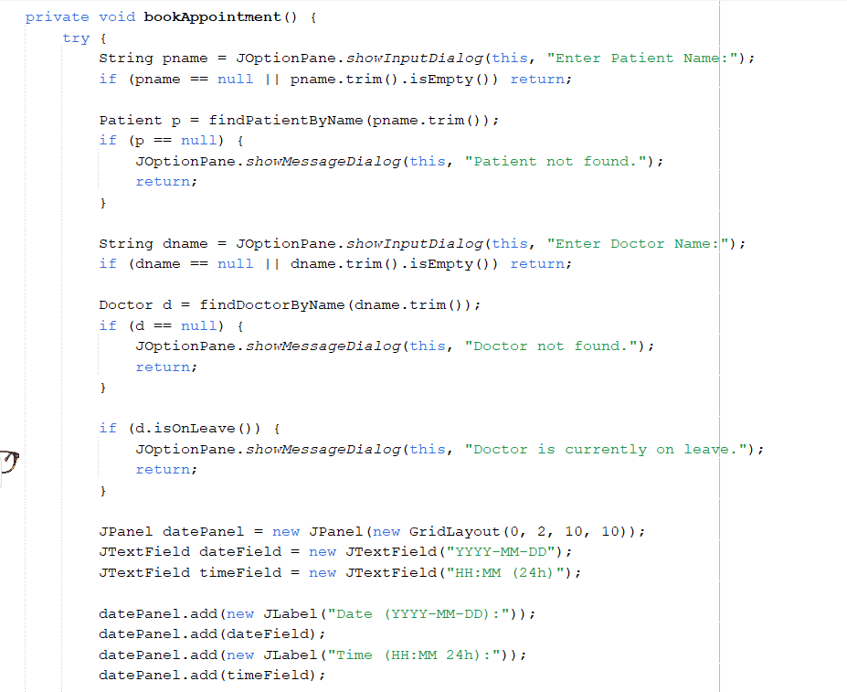
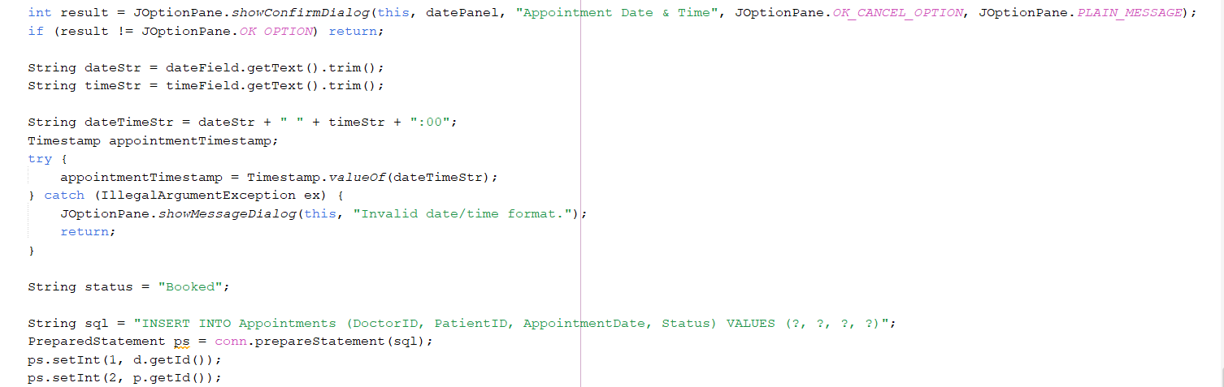
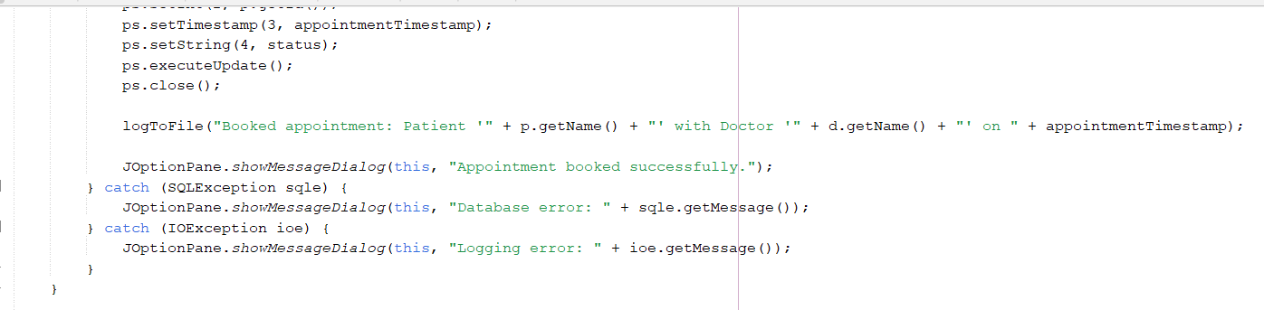
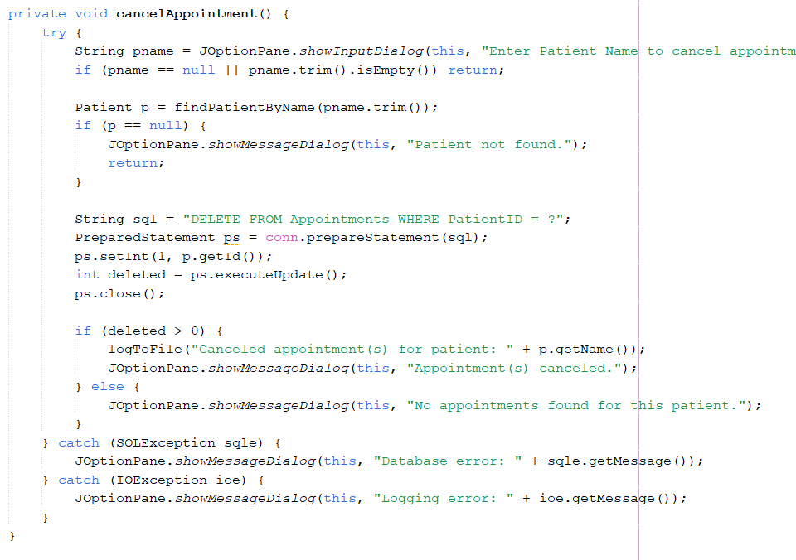
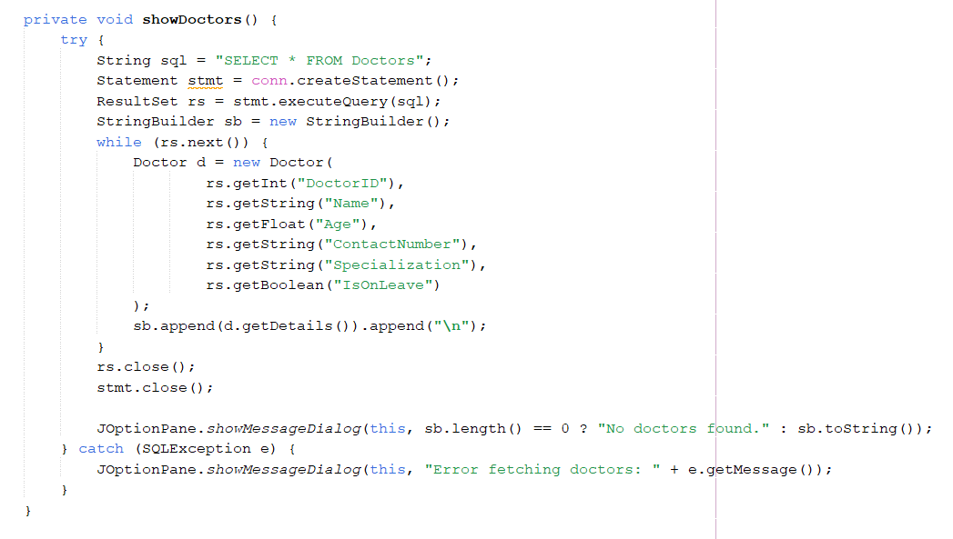
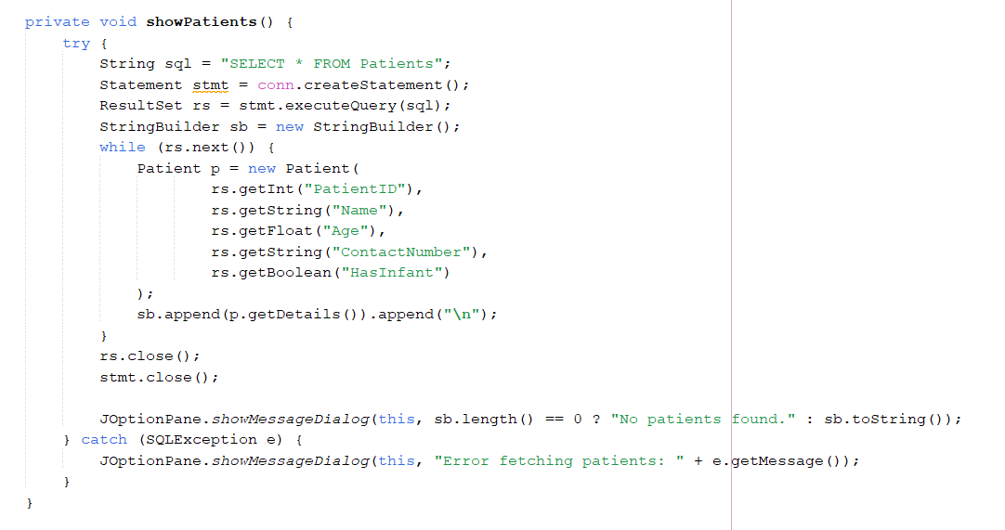
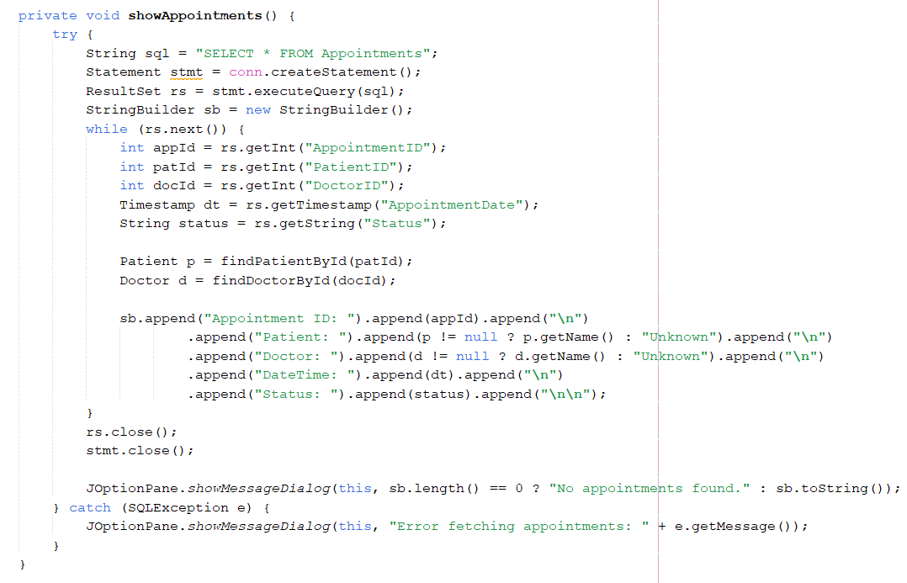
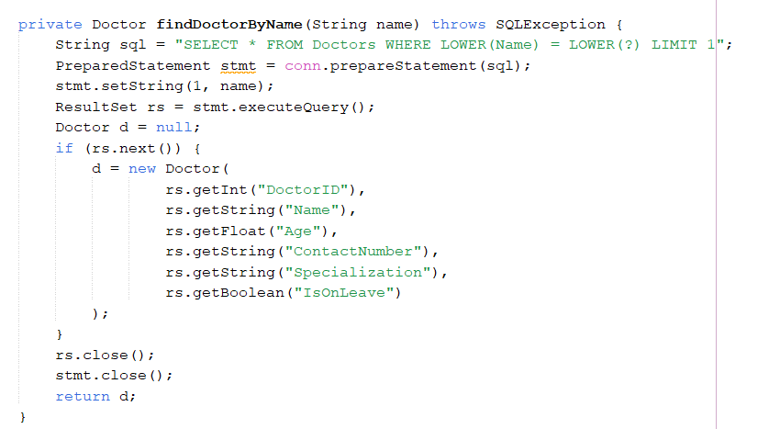
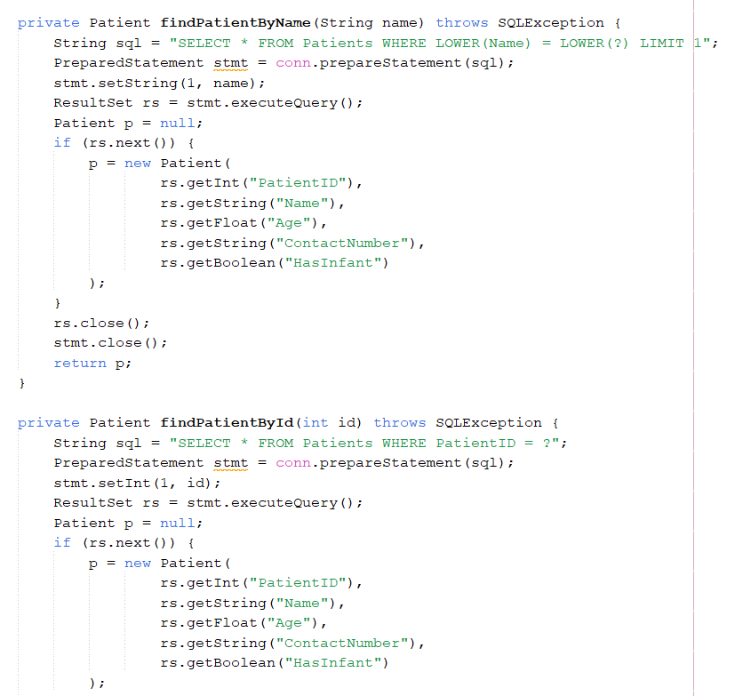
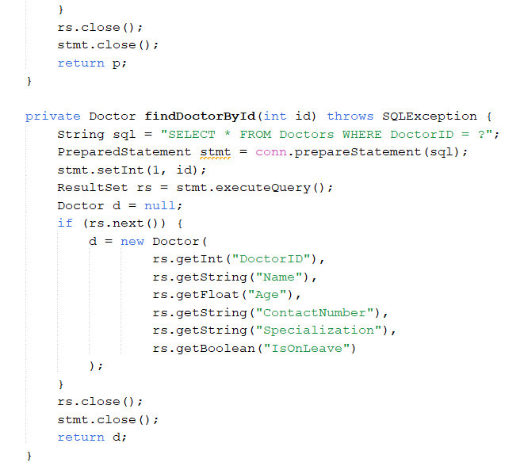
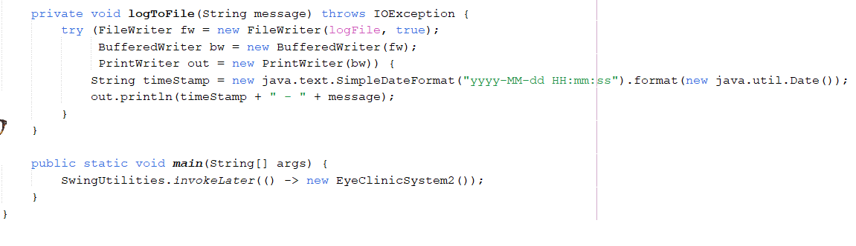

LoginFrame.java
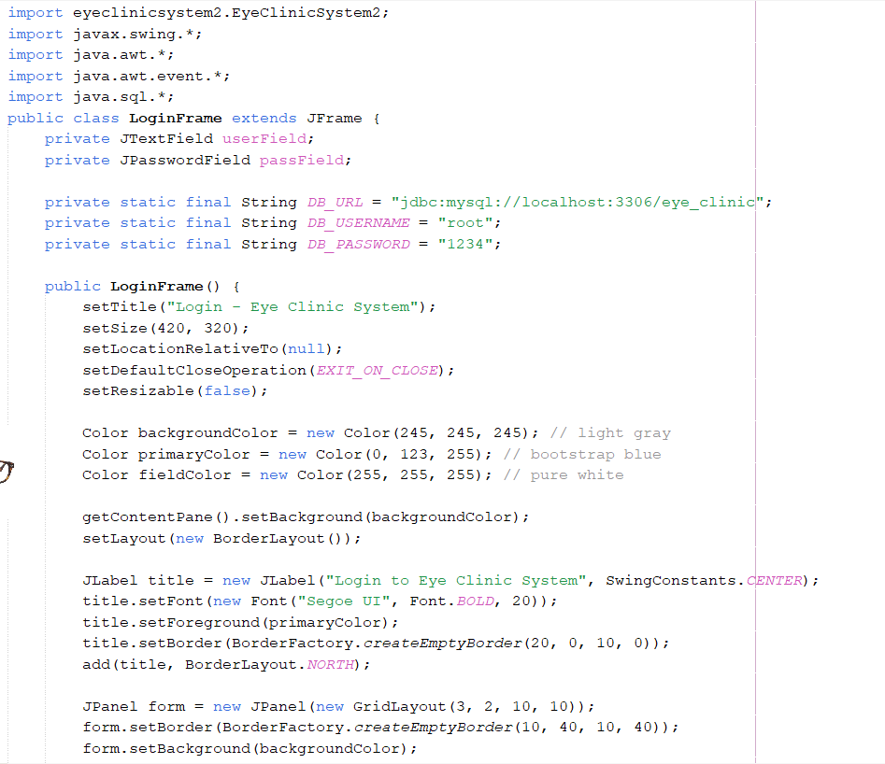
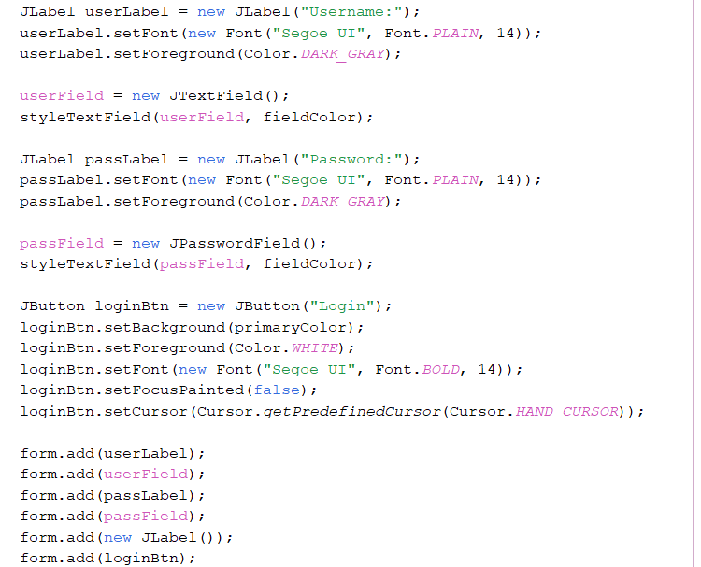
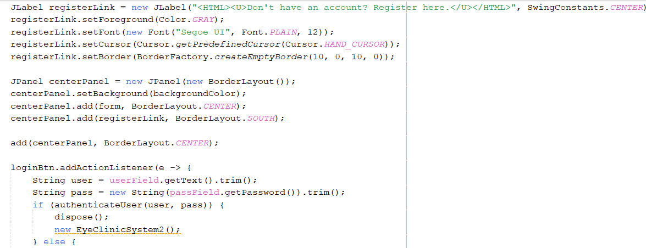
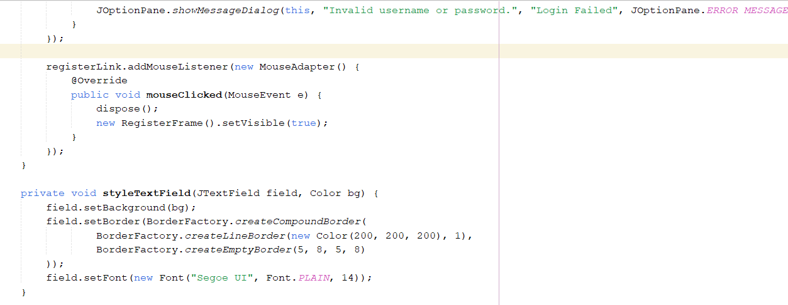
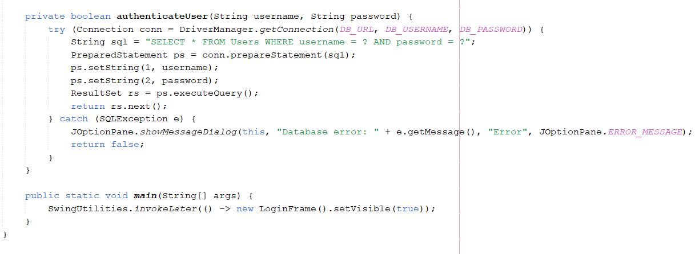

RegisterFrame.java
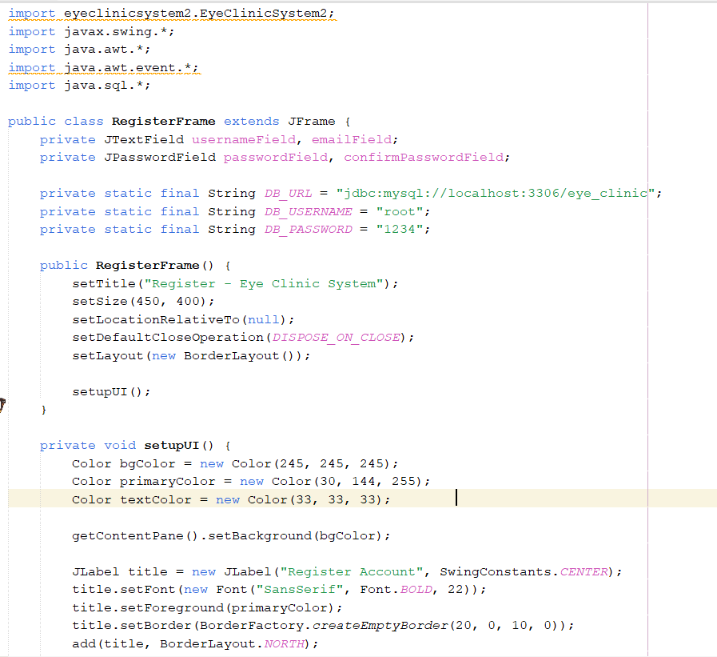
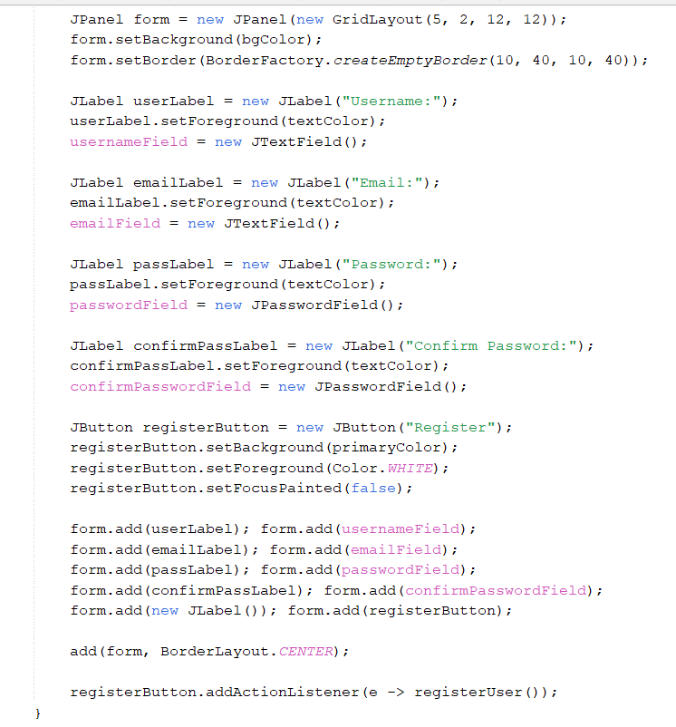
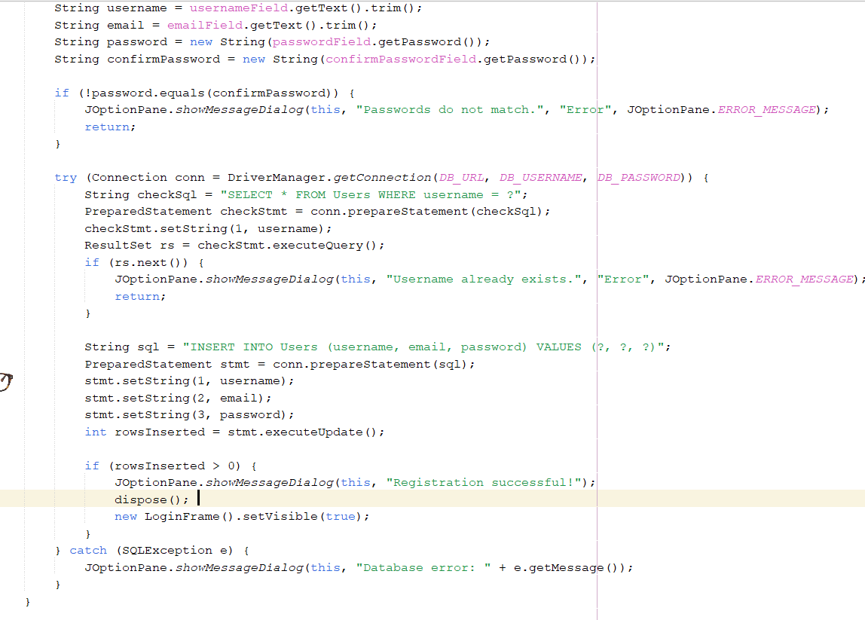
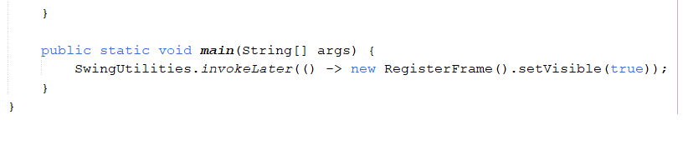

OUTPUT:
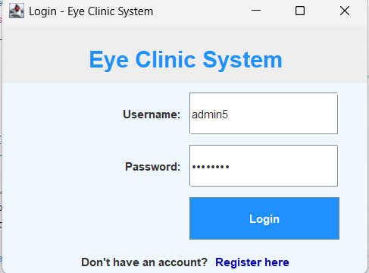
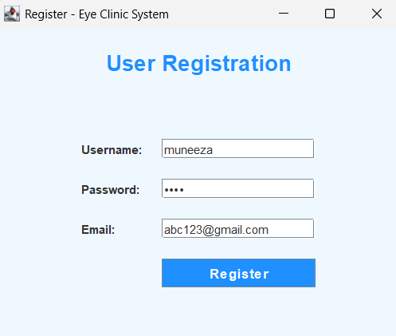
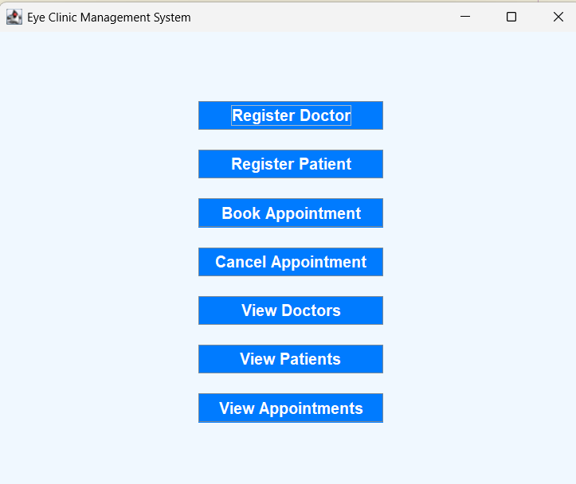
Register Doctor/Patient
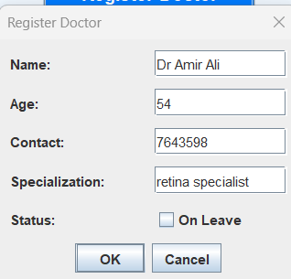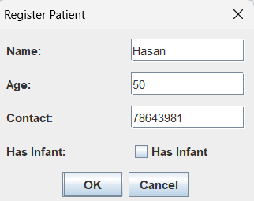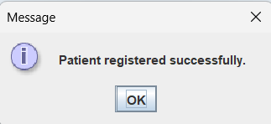

View doctors
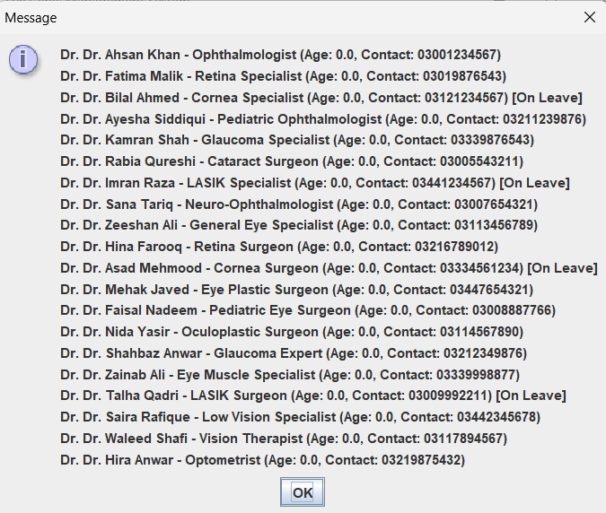

View Patients
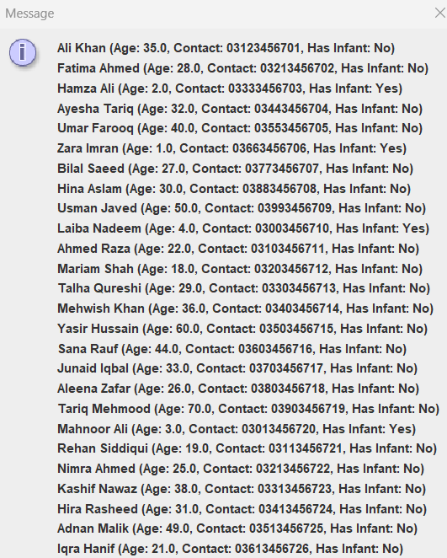

View Appointments
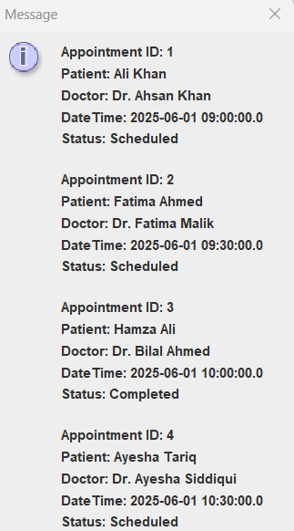

FUTURE DEVELOPMENT:
The system can be improved by:
- Adding multi-user support with roles (Admin, Receptionist, Doctor).
- Online appointment booking integration.
- Email/SMS notifications for appointments.
- Exporting data to PDF or Excel.
- Analytics for clinic performance.
- Password management and encryption.

CONCLUSION:
The Eye Clinic Management System successfully addresses common administrative challenges in managing a clinic. It combines the strengths of a structured backend with a user-friendly interface. Though basic in its current form, the system provides a strong foundation for further enhancements and real-world deployment..

