# Effects of expected and unexpected uncertainty on cue processing

Clara Muñiz-Diez1, Sandra Lagator2, Mark Haselgrove2, and Tom Beesley1

1Department of Psychology, Lancaster University

2School of Psychology, The University of Nottingham

# Author Note

Clara Muñiz-Diez  http://orcid.org/0000-0001-5192-0462

Sandra Lagator  http://orcid.org/0000-0001-6060-2941

Mark Haselgrove  http://orcid.org/0000-0001-8981-1181

Tom Beesley  http://orcid.org/0000-0003-2836-2743

The programs of the experiments presented here, the data and the full code for the writing this manuscript are freely available on www.github.com/munizdiezclara/UNM_draft. This study was supported by the ESRC grant Known unknowns and unknown unknowns (ES/W013215/1).

Correspondence concerning this article should be addressed to Clara Muñiz-Diez, Department of Psychology, Lancaster University, Lancaster, UK, Email: c.muniz-diez@lancaster.ac.uk

# Abstract

Learning influences the overt attention that is paid to stimuli in two main ways: first, stimuli which are reliable predictors of an outcome are paid more attention than unreliable stimuli; and second, stimuli associated with uncertain outcomes capture more attention than stimuli associated with certain outcomes. Past studies have shown that these two phenomena can be demonstrated within the same experiment, but strikingly, the increase in attention due to uncertainty does not necessarily translate into subsequent better learning. We investigate this paradox by examining stimulus processing in three experiments that included predictive and non-predictive cues, trained under different conditions of uncertainty. In Experiment 1, we established a recognition memory test that could detect differences in stimulus processing from a previous learning task. In Experiment 2, this test revealed that recognition memory was similar after learning with certain and uncertain stimulus-outcome contingencies. In Experiment 3, uncertain contingencies were introduced after a period of learning with certain contingencies. During the subsequent memory test, this training resulted in better memory than training with certain contingencies throughout the learning phase. These results suggest the importance of drawing a distinction between expected and unexpected uncertainty on stimulus processing. The implications of these results for attentional models of learning are discussed.

*Keywords*: Associative Learning, Attention, Uncertainty, Predictiveness, Cue processing

# Effects of expected and unexpected uncertainty on cue processing

# 3. Experiment 2

The purpose of Experiment 2 was to examine differences in recognition memory in a learned predictiveness procedure under certain and uncertain cue-outcome contingency conditions. Two groups were trained, one with a perfect contingency between the predictive cues and their paired outcome (Group Certain) - replicating the training from Experiment 1 - and one with a contingency of 0.8 between the predictive cues and their paired outcome (Group Uncertain). After this training, we tested the memory for cues in both groups using the memory test procedure that was most successful in Experiment 1, namely Test 2 (where targets were paired with foils from different cues). We also used the “High” similarity stimuli from Experiment 1, since it was only using these stimuli that a difference in memory performance between predictive and non-predictive stimuli was established.

The design of Experiment 2 is shown in Table 1. Previous experiments have established that for uncertain contingencies, participants spend longer attending to (looking at) all cues compared to attention to cues in certain contingencies (Beesley et al., 2015; Easdale et al., 2019; Walker et al., 2022). Experiment 2 therefore aimed to test whether uncertain contingencies, where it is well established that there is a high level of attention to cues, result in an improvement in the processing of these stimuli. As such, we predicted that memory would be better, overall, for the cues in group Uncertain compared to group Certain. Finally, on the basis of the results of Experiment 1, we anticipate seeing superior memory scores for the predictive than the non-predictive cues in group Certain.

Table 1

Design of Experiment 2

| Group | Training | Test |
| --- | --- | --- |
| Certain | AX - O1  AY - O1  BX - O2  BY - O2 | A vs *b*/*x*/*y*  B vs *a*/*x*/*y*  X vs *a*/*b*/*y*  Y vs *a*/*b*/*x* |
| Uncertain | 0.8 AX - O1 / 0.2 AX - O2  0.8 AY - O1 / 0.2 AY - O2  0.8 BX - O2 / 0.2 BX - O1  0.8 BY - O2 / 0.2 BY - O1 | A vs *b*/*x*/*y*  B vs *a*/*x*/*y*  X vs *a*/*b*/*y*  Y vs *a*/*b*/*x* |

*Note*. Uppercase letters A, B, X, and Y represent the cues presented during training. O1 and O2 represent the outcomes presented in training. Lowercase letters a, b, x, and y represent the foils that are similar to the (corresponding upper-case letter) cues presented in the training phase. The numbers before the trials define the proportion of trials of that type that were presented.

## 3.1 Methods

### 3.1.1 Participants

98 participants were recruited through Prolific. The sample consisted of 34 women, 63 men and one non-binary person, with 20 different nationalities. The mean age was 32.1 calculated for the 95 participants that reported their age (range 18 - 71). Pre-screening of participants in Prolific ensured that they had normal or corrected to normal vision, fluency in English language, and had not participated in previous studies from our lab. Participants were rewarded with £2.70 for their participation in the study. Participants were randomly allocated to either the Certain or Uncertain condition. Four participants were excluded due to failing the comprehension check before the test (three in group Certain and one in group Uncertain). Post-hoc calculations using G*Power 3.1 (Faul et al., 2007) revealed that this sample size had a power of .99 to detect an effect size of ηp2 = .08 that was observed for the *group x predictiveness* interaction reported in Figure 3.

## 3.2 Results

Since participants in the uncertain condition received trials in which the “correct” outcome was switched on 20% of the trials,even if participants in group Uncertain were to always select the most probable outcome (O1 when A is present and O2 when B is present), it would result in an accuracy score of 80%. Thus, we calculated the proportion of probable responses (PPR): for the Uncertain group, on each trial, the score was 0 when participants chose the less probable outcome (i.e., O2 for A and O1 for B) and 1 when they chose the most probable outcome (i.e., O1 for A and O2 for B). For the certain condition, this equates to a standard accuracy score.

Figure 1 shows the mean PPR across blocks for each group. Participants in the Certain group showed a higher PPR through training than the Uncertain group, reaching a PPR of about 0.85 on block 8. The Uncertain group showed consistently lower PPR, that reached approximately 0.7 in block 8.

Figure 1

PPR on the training phase of Experiment 2.

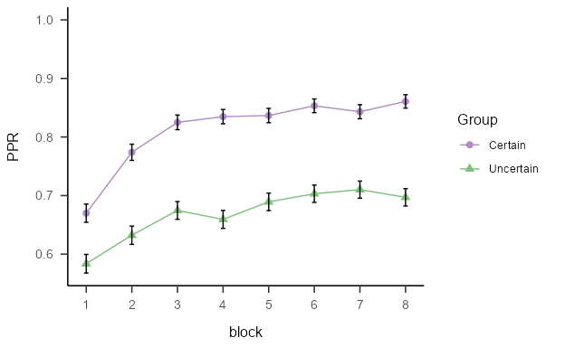

*Note*. Mean proportion of probable responses (±SEM) during the training phase of Experiment 2, for groups trained with certain and uncertain contingencies.

A mixed model ANOVA of individual PPR scores found significant both the main effect of *group*, *F*(1, 92) = 19.35, *p* < .001, = .17, BF10 = 626.48 ± 4.28%, and of *block*, *F*(5.51, 507.20) = 21.58, *p* < .001, = .19, BF10 = 6.2x1022 ± 1.48%. There was no interaction effect between these factors, *F*(5.51, 507.20) = 1.36, *p* = .233, = .01, BF10 = 0.05 ± 6.97%. These results indicate that the training increased the PPR for both groups, as the effect of block was significant, with the Certain group showing a consistently higher PPR than Uncertain group.

Figure 2 shows the accuracy results from the recognition memory test. Accuracy for non-predictive cues was lower than for the predictive cues in the Certain group, but this difference was not present in the Uncertain group. Also, accuracy was similar in both groups.

Figure 2

Accuracy on the test phase of Experiment 2.

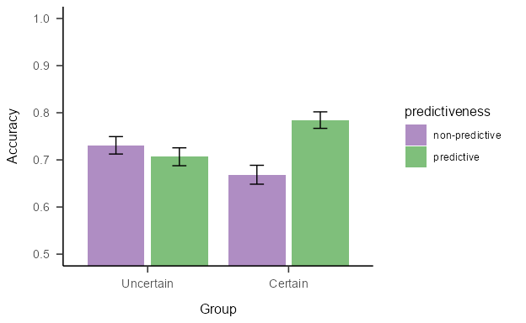

*Note*. Mean accuracy (±SEM) during the test phase of Experiment 2, for groups trained with certain and uncertain contingencies.

A mixed model ANOVA with the between subjects-factor *group* (Uncertain vs Certain) and the within-subjects factor *predictiveness*, found no significant effect of the main effects (*group*: *F*(1, 92) = 0.05, *p* = .831, < .01, BF10 = 0.21 ± 4.15%; *predictiveness*: *F*(1, 92) = 2.86, *p* = .094, = .03, BF10 = 0.5 ± 2.99%), but a significant *group x predictiveness* interaction, *F*(1, 92) = 6.69, *p* = .011, = .07, BF10 = 4.66 ± 8.25%. Simple main effects analysis showed a significant effect of predictiveness in the group Certain, *F* (1, 45) = 6.537, *p* = 0.028, $\\eta^2_p$ = 0.127, BF10 = 5.75 ± 2.51%, but not on the Uncertain group, *F* (1, 47) = 0.636, *p* = 0.858, $\\eta^2_p$ = 0.013, BF10 = 0.27 ± 3.75%. These analyses suggest that group Certain were more accurate at remembering predictive than non-predictive cues, whereas group Uncertain does not show this difference.

Memory scores, calculated as the product of the accuracy score (1 or 0) with the confidence rating given, can be seen in Figure 3. The memory scores for non-predictive cues was lower than for the predictive cues in the Certain group. This difference was notably attenuated in the Uncertain group, and there was no indication of higher memory scores in the uncertain group relative to the Certain group.

Figure 3

Memory scores during the Test of Experiment 2.

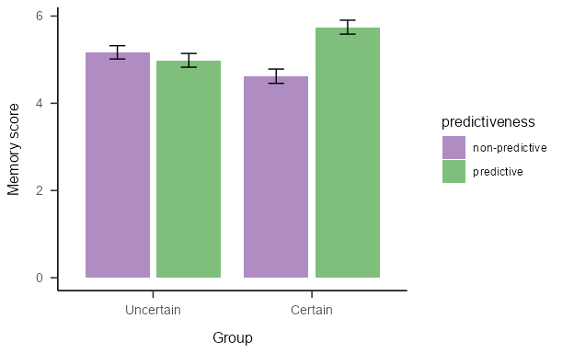

*Note*. Mean memory scores (±SEM) during the Test phase of Experiment 2 for predictive and non-predictive trials in the Certain and Uncertain groups.

The mixed model ANOVA find significant the *group x predictiveness* interaction, *F*(1, 92) = 7.54, *p* = .007, = .08, BF10 = 3.95 ± 11.95%, but no main effects of *group*: *F*(1, 92) = 0.06, *p* = .801, < .01, BF10 = 0.25 ± 2.16%, nor of *predictiveness*,*F*(1, 92) = 3.90, *p* = .051, = .04, BF10 = 0.74 ± 3.59%. Simple main effects showed a significant effect of *predictiveness* on Certain group, *F*(1, 45) = 8.75, *p* = 0.01, $\\eta^2_p$ = 0.163, but not on group Uncertain, *F*(1, 47) = 0.396, *p* = 1, $\\eta^2_p$ = 0.008. Again, memory score analysis suggests better memory for predictive cues than for non-predictive cues in group Certain, whereas this difference is not present in group Uncertain. The lack of a main effect of the group suggest that overall memory was similar in both groups.

## 3.3 Discussion

Experiment 2 aimed to examine the effect of uncertainty on recognition memory for predictive and non-predictive cues. The Uncertain group of participants were exposed to a probabilistic relationship between the predictive cues and their respective outcomes, while the Certain group received deterministic relationships. We hypothesised that the previously observed effect of uncertainty on overt attention (e.g., Beesley et al., 2015) would lead to better memory for cues in that condition. However, in a final recognition memory test, the two groups showed a similar overall level of recognition memory for the cues. There was an effect of cue-predictiveness in group Certain with better recognition memory for the predictive than the non-predictive cues (replicating the results of Experiment 1). However, there was no effect of cue-predictiveness in group Uncertain, with evidence to suggest memory for predictive and non-predictive cues was equivalent. This latter result is consistent with previous studies (Beesley et al., 2015; Easdale et al., 2019) that have shown that attention (in those cases measured by eye-gaze dwell times), under certain training, decreased for non-predictive cues but not for predictive cues. That decrease in attention could be responsible for the worse memory performance for the non-predictive cues, compared with the predictive cues, in the certain group.

A central distinction made in Easdale et al. (2019) was that between *expected-* and *unexpected-uncertainty*. In those experiments, participants who experienced a sustained period with uncertain compounds (as is the case in our “uncertain group” in Experiment 2) learnt more slowly about new contingencies, compared to a group that received a sudden and unexpected change in the contingencies. Thus, it may be the case that the current uncertain condition does not promote higher recognition memory, overall, because participants have come to expect a certain level of uncertainty and are no longer engaging in an exploratory mode of cue-processing. Of course, the expected levels of high attention to cues under these uncertain conditions presents a paradox for learning and attention research: why does a high level of attention not translate to better learning and memory for those cues? We return to this point in the general discussion. Nevertheless, this analysis of the findings in terms of expected and unexpected uncertainty suggests that a more acute period of uncertainty may (re)engage a mode of exploratory attentional processing for the cues, which would result in better memory of those cues. Experiment 3 tested this hypothesis.

# 4. Experiment 3

Experiment 3 aimed to examine whether the introduction of uncertainty, following a period of certain training (i.e., unexpected uncertainty), would lead to an increase in cue-processing (better recognition memory). The design of Experiment 3 can be seen in Table 2. The experiment consisted of three groups. Groups Certain Long and Certain Short received training that was similar to the Certain condition from Experiment 2, experiencing a protracted period of certain contingencies between the cue compounds and the outcomes throughout the training phase, differing only in the amount of training trials experienced by each of them. Group Uncertain first experienced the same certain contingencies experienced by the certain groups, before the contingencies were changed to uncertain for a short period before the recognition memory test. Our prediction was that, if the introduction of unexpected uncertainty promotes greater levels of exploratory attention, then we should see better recognition memory performance in this uncertain condition, compared to the certain condition.

Table 2

Design of Experiment 3

| Group | Stage 1 | Stage 2 | Test |
| --- | --- | --- | --- |
| Certain Long | AX - O1  AY - O1  BX - O2  BY - O2 | AX - O1  AY - O1  BX - O2  BY - O2 | A vs *b*/*x*/*y*  B vs *a*/*x*/*y*  X vs *a*/*b*/*y*  Y vs *a*/*b*/*x* |
| Certain Short | AX - O1  AY - O1  BX - O2  BY - O2 |  | A vs *b*/*x*/*y*  B vs *a*/*x*/*y*  X vs *a*/*b*/*y*  Y vs *a*/*b*/*x* |
| Uncertain | AX - O1  AY - O1  BX - O2  BY - O2 | 0.8 AX - O1 / 0.2 AX - O2  0.8 AY - O1 / 0.2 AY - O2  0.8 BX - O2 / 0.2 BX - O1  0.8 BY - O2 / 0.2 BY - O1 | A vs *b*/*x*/*y*  B vs *a*/*x*/*y*  X vs *a*/*b*/*y*  Y vs *a*/*b*/*x* |

*Note*. Uppercase letters A, B, X, and Y represent the cues presented during training. O1 and O2 represent the outcomes presented in training. Lowercase letters a, b, x, and y represent the foils that are similar to the (corresponding upper-case letter) cues presented in the training phase. The numbers before the trials define the proportion of trials of that type that were presented.

Group Certain Short received the same certain contingencies as the other two conditions in Stage 1 but did not experience Stage 2; they received a shorter training phase than the other two conditions. If the onset of the uncertainty leads to greater cue-processing, then we should also see better cue-memory in the Uncertain condition compared to the Certain Short condition. The inclusion of this condition is important because longer training with the certain contingencies in the “Certain Long” condition could *decrease* cue processing, which would be an alternative explanation of any difference in cue processing we observe between Group Uncertain and Group Certain Long. If this is the case, we should see equivalent recognition memory in the Certain Short and Uncertain conditions, and poorer recognition memory in the Certain Long condition. Therefore, the addition of this third condition allowed us to make stronger inferences about the causal relationship between the onset of uncertainty and cue-processing.

## 4.1 Methods

### 4.1.1 Participants

180 participants were recruited through Prolific. The mean age of the 175 participants that reported their age was 32.8 (range 18 - 74), with 60 women, 119 men, and one non-binary person, and 33 different nationalities. Participants were randomly allocated to each condition. Eight participants were excluded on the basis of failing the comprehension check before the test, six in group Uncertain, one in group Certain Short, and one in group Certain Long. Also, 39 participants were excluded due to a low PPR (< 0.75) on the last block of Stage 1, five in group Certain Long, seven in group Certain Short and 19 in group Uncertain. Thus, the results below are for the remaining 136 participants. Post-hoc calculations using G*Power 3.1 (Faul et al., 2007) revealed that this sample size had a power of .79 to detect an effect size of ηp2 = .05 that was observed for the group main effect reported in Figure 6.

## 4.2 Results

Figure 4 shows the mean PPR for each group across the ten blocks of training. All participants showed a similar increase in PPR in stage 1, reaching a PPR of around 0.95 on block 6. In Stage 2, group Certain showed a similar PPR to block 6, but the Uncertain group showed a decrease in PPR to a level of around 0.85.

Figure 4

PPR on the training phase of Experiment 3.

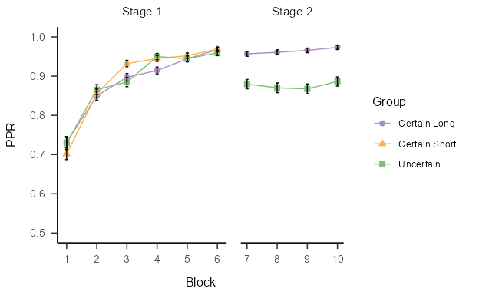

*Note*. Mean proportion of probable responses (±SEM) during the training phase of Experiment 3, plotted against the ten blocks of trials, for each Group.

The Stage 1 data were analysed with a mixed-model ANOVA (with the degrees of freedom corrected by Greenhouse-Geisser when the sphericity assumption was not fulfilled), with the between-subjects factor of *group* (Certain Long, Certain Short, and Uncertain), and the within-subjects factor of *block* (1-6). This revealed a significant effect of *block*, *F*(3.26, 433.37) = 116.94, *p* < .001, = .47, BF10 = 6.1x1086 ± 1.31%. There was no effect of *group*, *F*(2, 133) = 0.08, *p* = .923, < .01, BF10 = 0.05 ± 1.9%, and no interaction effect, *F*(6.52, 433.37) = 1.21, *p* = .296, = .02, BF10 = 0.02 ± 10.93%.

The data from Stage 1 and 2 were analysed with a mixed model ANOVA (using the Greenhouse-Geisser correction when needed), with the between-subjects factor of *group* (Certain Long vs Uncertain) and the within-subjects factor of *block* (1-10). There was no effect of *group*, *F*(1, 86) = 3.38, *p* = .070, = .04, BF10 = 0.71 ± 2.17%, but there was a significant effect of *block*, *F*(5.51, 507.20) = 21.58, *p* < .001, = .19, BF10 = 2.4x1056 ± 1.02%, and a significant *group x block* interaction, *F*(4.26, 366.35) = 5.82, *p* < .001, = .06, BF10 = 166961.66 ± 3.61%. Simple main effects showed a significant effect of condition on blocks 7 to 10, *F*(1, 86) > 17.079, *p* < 0.000829, BF10 = 261.11 ± 0%, but not in block 1 to 0, *F*(1, 86), < 1.238, *p* > 1, BF10 = 0.15 ± 0.03%.

Taken together, these results indicate that the training in Stage 1 increased the PPR for all groups in the same fashion, while in Stage 2, the Certain Long group showed a consistently higher PPR than the Uncertain group.

Figure 5 shows the accuracy results from the recognition memory test. Accuracy for non-predictive cues was lower than for the predictive cues in both Certain Long and Certain Short groups, but this difference was attenuated in the Uncertain group. Also, accuracy was higher in the Uncertain group compared with the other two.

Figure 5

Accuracy on the test phase of Experiment 3.

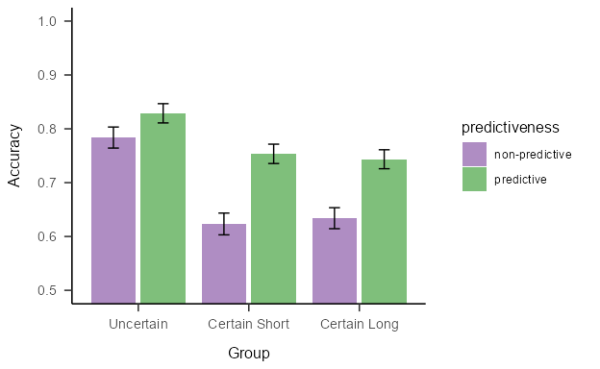

*Note*. Mean accuracy (±SEM) during the test phase of Experiment 3, across the three groups.

There was a significant main effect of the *group*, *F*(2, 133) = 5.95, *p* = .003, = .08, BF10 = 10.36 ± 5.44%, and a main effect of *predictiveness*: *F*(1, 133) = 28.48, *p* < .001, = .18, BF10 = 99424.34 ± 3.12%. The *group x predictiveness* interaction was not significant, *F*(2, 133) = 1.90, *p* = .154, = .03, BF10 = 0.34 ± 8.49%. Bonferroni corrected pairwise comparisons showed significant differences between the group Uncertain and the mean on the groups Certain Long and Certain Short, *t*(133) = 3.449, *p* < .001, BF10 = 362.82 ± 0%, but not between the groups Certain Long and Certain Short, *t*(133) = 0.01, *p* = 1, BF10 = 0.15 ± 0.07%. These results indicate that all groups were more accurate at recognising predictive cues than non-predictive cues. Furthermore, group Uncertain was overall more accurate than Certain Long and Certain Short groups.

Figure 6 shows the recognition memory data for the three conditions. Memory for non-predictive cues was lower than for predictive cues in all groups, but this difference was notably attenuated in the Uncertain group. Interestingly, the memory for the cues in the Uncertain group was higher, overall, than in the Certain Long and Certain Short groups.

Figure 6

Memory scores on the Test of Experiment 3.

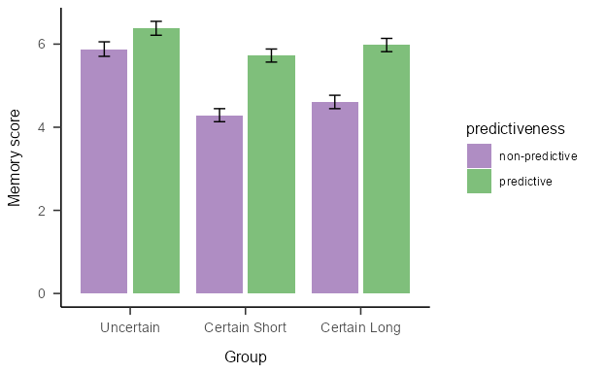

*Note*. Mean memory scores (±SEM) during the Test of Experiment 2 for predictive and non-predictive trials across the three groups.

A mixed model ANOVA, including the between-subjects factor *group* (Certain Long, Certain Short, Uncertain), and the within-subjects factor *predictiveness* (predictive vs non-predictive) showed a significant main effect of the *group*, *F*(2, 133) = 3.68, *p* = .028, = .05, BF10 = 0.19 ± 11.16%, of *predictiveness*, *F*(1, 133) = 46.39, *p* < .001, = .26, BF10 = 847.56 ± 0%, and of the *group x predictiveness* interaction, *F*(2, 133) = 3.15, *p* = .046, = .05, BF10 = 0.19 ± 11.16%. However, is worth noting that the Bayesian analysis indicated moderate evidence in favour of the null hypothesis for this interaction. Bonferroni corrected post-hoc comparisons on the group factor showed that group Uncertain differed significantly from the average of the Certain groups, *t*(133) = 2.624, *p* = .01, BF10 = 18.21 ± 0%, but memory scores for the two Certain groups did not differ the one from the other, *t*(133) = 0.732, *p* = 1, BF10 = 0.22 ± 0.05%, with the Bayesian evidence suggesting that memory performance was the same in these two groups. Furthermore, simple main effects showed a significant effect of *predictiveness* on group Certain Long, , *F*(1, 50) = 27.98, *p* > .001, = .36, BF10 = 4781.12 ± 1.13%, and on group Certain Short, *F*(1, 47) = 21.59, *p* > .001, = .32, BF10 = 802.61 ± 1.95%, but not on Uncertain group, *F*(1, 36) = 4.28, *p* = .138, = .11, BF10 = 1.35 ± 2.16%. These results suggest that memory for predictive cues was better than for non-predictive cues in both Certain Long and Certain Short groups, but not on group Uncertain. Also, those participants that experienced an unexpected period of uncertainty showed generally better memory than the Certain groups.

## 4.3 Discussion

Experiment 3 examined the effect of unexpected uncertainty on recognition memory. The “Uncertain” group of participants first experienced a period of training with certain contingencies, before receiving a second period with uncertain contingencies. Participants that were exposed to this unexpected uncertainty showed a higher level of recognition memory for the cues than participants that received only certain training. An important difference between Experiment 2 and 3 is that in Experiment 2, the Certain and Uncertain groups had a similar recognition memory for the cues, whereas in the current experiment, the Uncertain group showed better cue-recognition. We interpret this difference to be a consequence of the expectancy of uncertainty: in Experiment 3, but not Experiment 2, uncertainty is suddenly introduced after a sustained period of certain training.

These results suggest that introducing a period of unexpected uncertainty results in enhanced cue processing and are consistent with previous results (Easdale et al., 2019) that showed that unexpected uncertainty enhanced learning. Easdale et al. used a training phase with participants learning about either certain or uncertain contingencies. Participants showed better attention to uncertain cues. However, when those cues were subsequently trained under new contingencies, it was participants in the certain condition that learned about these more rapidly, compared to those participants in the uncertain condition. Easdale et al. suggested that the transition from certain to uncertain contingencies brought about a state of “unexpected uncertainty” which promoted new learning. Experiment 3 shows more directly that a period of unexpected uncertainty leads to superior cue processing and stronger memory representations.

Beesley, T., Nguyen, K. P., Pearson, D., & Le Pelley, M. E. (2015). Uncertainty and predictiveness determine attention to cues during human associative learning. *Quarterly Journal of Experimental Psychology*, *68*(11), 2175–2199. <https://doi.org/10.1080/17470218.2015.1009919>

Easdale, L. C., Le Pelley, M. E., & Beesley, T. (2019). The onset of uncertainty facilitates the learning of new associations by increasing attention to cues. *Quarterly Journal of Experimental Psychology*, *72*(2), 193–208. <https://doi.org/10.1080/17470218.2017.1363257>

Faul, F., Erdfelder, E., Lang, A.-G., & Buchner, A. (2007). Statistical power analyses using G*Power 3.1: Tests for correlation and regression analyses. *Behavior Research Methods*, *39*, 175–191.

Walker, A. R., Navarro, D. J., Newell, B. R., & Beesley, T. (2022). Protection from uncertainty in the exploration/exploitation trade-off. *Journal of Experimental Psychology: Learning, Memory, and Cognition*, *48*, 547–568. <https://doi.org/10.1037/xlm0000883>