acc&rat_with_congruence

# Exp 2

## Accuracy

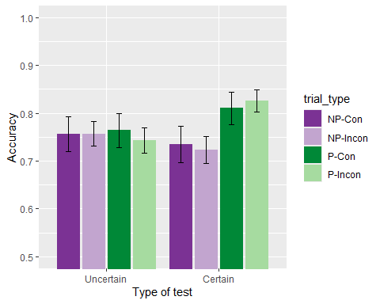

There were no significant differences, *group*: *F*(1, 66) = 0.20, *p* = .656, < .01, BF10 = 0.23 ± 0.85%; *predictiveness*: *F*(1, 66) = 2.26, *p* = .138, = .03, BF10 = 0.51 ± 3.72%; *congruence*: *F*(1, 66) = 0.05, *p* = .823, < .01, BF10 = 0.15 ± 8.82%; *group x predictiveness*, *F*(1, 66) = 2.65, *p* = .108, = .04, BF10 = 0.94 ± 2.76%; *predictiveness x congruence*: *F*(1, 66) = 0.00, *p* = .961, < .01, BF10 = 0.2 ± 4.27%; *group x congruence*: *F*(1, 66) = 0.10, *p* = .749, < .01, BF10 = 0.18 ± 3.55%; *group x predictiveness x congruence*: *F*(1, 66) = 0.22, *p* = .643, < .01, BF10 = 0.25 ± 6.32%.

## Just correct ratings

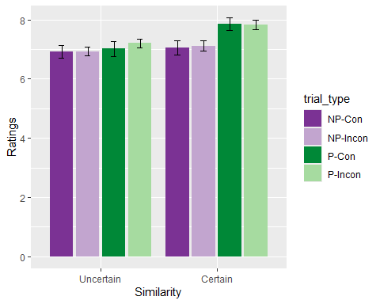

There was a significant effect of *predictiveness*: *F*(1, 63) = 4.95, *p* = .030, = .07, BF10 = 2.71 ± 1.02%, and a marginally significant effect of the *group x predictiveness* interaction, *F*(1, 63) = 3.73, *p* = .058, = .06, BF10 = 1.85 ± 1.91% but no other significant differences, *group*: *F*(1, 63) = 0.38, *p* = .541, < .01, BF10 = 0.44 ± 0.77%; *congruence*: *F*(1, 63) = 0.70, *p* = .406, = .01, BF10 = 0.15 ± 0.97%; ; *predictiveness x congruence*: *F*(1, 63) = 0.20, *p* = .653, < .01, BF10 = 0.21 ± 2.85%; *group x congruence*: *F*(1, 63) = 0.77, *p* = .382, = .01, BF10 = 0.22 ± 2.33%; *group x predictiveness x congruence*: *F*(1, 63) = 0.12, *p* = .729, < .01, BF10 = 0.33 ± 19.24%. Simple main effects indicate a marginal effect of predictiveness in group Certain, *F* (1, 127) = 5.151, *p* = .05, $\\eta^2_p$ = .039, but not in group Uncertain, *F* (1, 138) = .029, *p* = 1, $\\eta^2_p$ > .001.

# Exp 3

## Accuracy

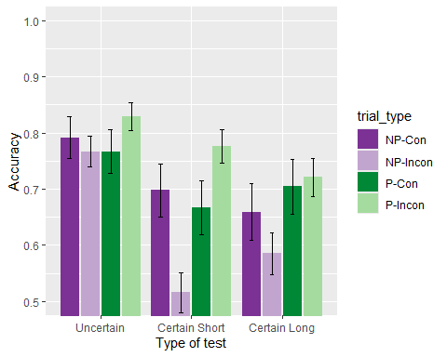

There are significant differences due to the *group*: *F*(2, 73) = 4.57, *p* = .014, = .11, BF10 = 3.32 ± 1.08%, *predictiveness*: *F*(1, 73) = 9.86, *p* = .002, = .12, BF10 = 8.72 ± 1.75%, and of the *predictiveness x congruence* interaction, *F*(1, 73) = 8.47, *p* = .005, = .10, BF10 = 29.87 ± 2.82%. All other effects and interactions were non significant: *congruence*: *F*(1, 73) = 0.85, *p* = .360, = .01, BF10 = 0.14 ± 0.74%; *group x predictiveness*, *F*(2, 73) = 1.61, *p* = .207, = .04, BF10 = 0.27 ± 1.98%; *group x congruence*: *F*(2, 73) = 1.17, *p* = .317, = .03, BF10 = 0.1 ± 3.67%; *group x predictiveness x congruence*: *F*(2, 73) = 1.56, *p* = .217, = .04, BF10 = 0.64 ± 12.13%. Pairwise comparisons of the effect of condition show differences of the Uncertain group with the Certain groups, *t* (73) = 3.019, *p* = .003, BF10 = 540.89 ± 0%, but not between them, *t* (73) = .069, *p* = 1, BF10 = 0.16 ± 0.06%. The simple main effects showed an effect in predictiveness in the incongruent trials, *F* (1, 75) = .044, *p* = 1, $\\eta^2_p$ = .001, but not on the congruent trials, *F* (1, 75) = 13.459, *p* = 1, $\\eta^2_p$ = .001.

## Just correct ratings

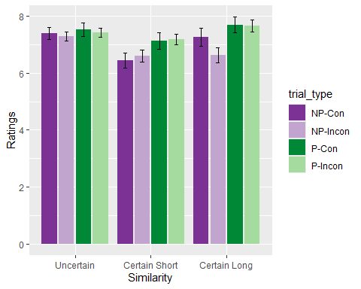

There was a significant effect *predictiveness*, *F*(1, 69) = 15.71, *p* < .001, = .19, BF10 = 100.05 ± 0.95%, and of the *group x predictiveness* interaction, *F*(2, 69) = 3.44, *p* = .038, = .09, BF10 = 1.97 ± 2.67%, but no significant effect of the *group*, *F*(2, 69) = 1.11, *p* = .336, = .03, BF10 = 0.34 ± 0.49%. A simple main effects analysis showed a significant effect of *predictiveness* on the Certain Short group, *F* (1, 20) = 10.672, *p* = .036, $\\eta^2_p$ = .348, marginally significant on the Certain Long group, *F*(1, 20) = 9.134, *p* = .063, $\\eta^2_p$ = .314, but not significant on the Uncertain group, *F* (1, 29) = 0.167, *p* = 1, $\\eta^2_p$ = .006. No other effect was significant, *congruence*: *F*(1, 73) = 0.85, *p* = .360, = .01, BF10 = 0.14 ± 0.74%; *predictiveness x congruence* interaction, *F*(1, 73) = 8.47, *p* = .005, = .10, BF10 = 29.87 ± 2.82%; *group x predictiveness*, *F*(2, 73) = 1.61, *p* = .207, = .04, BF10 = 0.27 ± 1.98%; *group x congruence*: *F*(2, 73) = 1.17, *p* = .317, = .03, BF10 = 0.1 ± 3.67%; *group x predictiveness x congruence*: *F*(2, 73) = 1.56, *p* = .217, = .04, BF10 = 0.64 ± 12.13%.