acc&rat_with_congruence

# Exp 2

## Accuracy

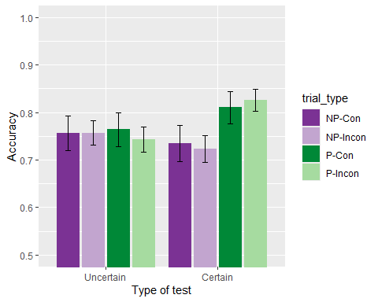

There were no significant differences, *group*: *F*(1, 66) = 0.20, *p* = .656, < .01, BF10 = 0.23 ± 1.5%; *predictiveness*: *F*(1, 66) = 2.26, *p* = .138, = .03, BF10 = 0.49 ± 0.94%; *congruence*: *F*(1, 66) = 0.05, *p* = .823, < .01, BF10 = 0.13 ± 1.39%; *group x predictiveness*, *F*(1, 66) = 2.65, *p* = .108, = .04, BF10 = 0.84 ± 8.81%; *predictiveness x congruence*: *F*(1, 66) = 0.00, *p* = .961, < .01, BF10 = 0.19 ± 3.52%; *group x congruence*: *F*(1, 66) = 0.10, *p* = .749, < .01, BF10 = 0.19 ± 5.68%; *group x predictiveness x congruence*: *F*(1, 66) = 0.22, *p* = .643, < .01, BF10 = 0.27 ± 6.72%.

## Just correct ratings

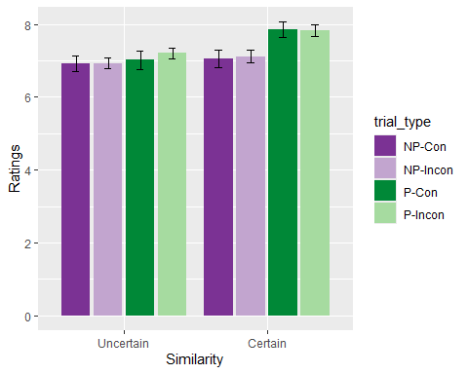

There was a significant effect of *predictiveness*: *F*(1, 63) = 4.95, *p* = .030, = .07, BF10 = 2.73 ± 1.04%, and a marginally significant effect of the *group x predictiveness* interaction, *F*(1, 63) = 3.73, *p* = .058, = .06, BF10 = 2.05 ± 5.68% but no other significant differences, *group*: *F*(1, 63) = 0.38, *p* = .541, < .01, BF10 = 0.43 ± 0.5%; *congruence*: *F*(1, 63) = 0.70, *p* = .406, = .01, BF10 = 0.15 ± 1.34%; ; *predictiveness x congruence*: *F*(1, 63) = 0.20, *p* = .653, < .01, BF10 = 0.22 ± 5.63%; *group x congruence*: *F*(1, 63) = 0.77, *p* = .382, = .01, BF10 = 0.23 ± 2.22%; *group x predictiveness x congruence*: *F*(1, 63) = 0.12, *p* = .729, < .01, BF10 = 0.3 ± 8.51%. Simple main effects indicate a no effect of predictiveness in group Certain, *F* (1, 32) = 4.124, *p* = 0.1025, $\\eta^2_p$ = 0.114, nor in group Uncertain, *F* (1, 34) = 0.057, *p* = 15, $\\eta^2_p$ = 0.002.

## Memory score

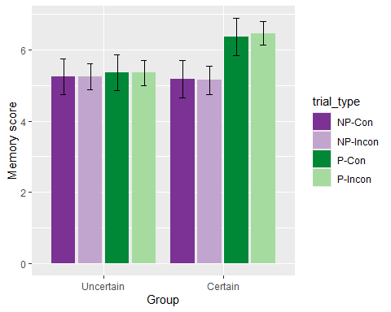

There was a significant effect of *predictiveness*, *F*(1, 66) = 6.01, *p* = .017, = .08, BF10 = 9.92 ± 1.53%, and a significant *group x predictiveness* interaction, *F*(1, 66) = 4.18, *p* = .045, = .06, BF10 = 4.04 ± 3.63%. There were no other significant effects or interactions, *group*: *F*(1, 66) = 1.05, *p* = .309, = .02, BF10 = 0.4 ± 0.75%; *congruence*: *F*(1, 66) = 0.01, *p* = .925, < .01, BF10 = 0.13 ± 1.39%; *predictiveness x congruence*: *F*(1, 66) = 0.02, *p* = .896, < .01, BF10 = 0.19 ± 4.55%; *group x congruence*: *F*(1, 66) = 0.02, *p* = .902, < .01, BF10 = 0.19 ± 10.46%; *group x predictiveness x congruence*: *F*(1, 66) = 0.03, *p* = .852, < .01, BF10 = 0.27 ± 6.04%. Simple main effects showed a significant effect of *predictiveness* on Certain group, *F*(1, 32) = 6.775, *p* = 0.028, $\\eta^2_p$ = 0.175, but not on group Uncertain, *F*(1, 34) = 0.13, *p* = 1, $\\eta^2_p$ = 0.004.

# Exp 3

## Accuracy

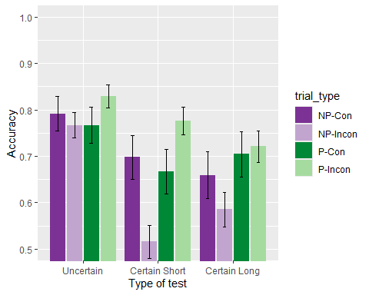

There are significant differences due to the *group*: *F*(2, 73) = 4.57, *p* = .014, = .11, BF10 = 3.23 ± 2.66%, *predictiveness*: *F*(1, 73) = 9.86, *p* = .002, = .12, BF10 = 8.55 ± 0.87%, and of the *predictiveness x congruence* interaction, *F*(1, 73) = 8.47, *p* = .005, = .10, BF10 = 27.38 ± 3.74%. All other effects and interactions were non significant: *congruence*: *F*(1, 73) = 0.85, *p* = .360, = .01, BF10 = 0.14 ± 1.15%; *group x predictiveness*, *F*(2, 73) = 1.61, *p* = .207, = .04, BF10 = 0.27 ± 2.71%; *group x congruence*: *F*(2, 73) = 1.17, *p* = .317, = .03, BF10 = 0.1 ± 2.36%; *group x predictiveness x congruence*: *F*(2, 73) = 1.56, *p* = .217, = .04, BF10 = 0.59 ± 5.31%. Pairwise comparisons of the effect of condition show differences of the Uncertain group with the Certain groups, *t* (73) = 3.019, *p* = .003, BF10 = 540.89 ± 0%, but not between them, *t* (73) = .069, *p* = 1, BF10 = 0.16 ± 0.06%. The simple main effects showed an effect in predictiveness in the incongruent trials, *F* (1, 75) = 0.044, *p* = 1, $\\eta^2_p$ = 5.85^{-4}, but not on the congruent trials, *F* (1, 75) = 13.459, *p* = 9.06^{-4}, $\\eta^2_p$ = 0.152.

## Just correct ratings

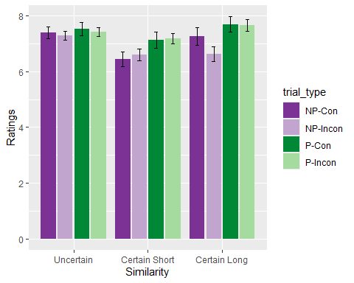

There was a significant effect *predictiveness*, *F*(1, 69) = 15.71, *p* < .001, = .19, BF10 = 101.72 ± 1.3%, and of the *group x predictiveness* interaction, *F*(2, 69) = 3.44, *p* = .038, = .09, BF10 = 1.86 ± 4.91%, but no significant effect of the *group*, *F*(2, 69) = 1.11, *p* = .336, = .03, BF10 = 0.34 ± 0.45%. A simple main effects analysis showed a significant effect of *predictiveness* on the Certain Long group, *F* (1, 21) = 8.528, *p* = 0.024, $\\eta^2_p$ = 0.289, and on the Certain Short group, *F* (1, 23) = 11.17, *p* = 0.009, $\\eta^2_p$ = 0.327, but not significant on the Uncertain group, *F* (1, 29) = 0.068, *p* = 1, $\\eta^2_p$ = 0.002. No other effect was significant, *congruence*: *F*(1, 73) = 0.85, *p* = .360, = .01, BF10 = 0.14 ± 1.15%; *predictiveness x congruence* interaction, *F*(1, 73) = 8.47, *p* = .005, = .10, BF10 = 27.38 ± 3.74%; *group x predictiveness*, *F*(2, 73) = 1.61, *p* = .207, = .04, BF10 = 0.27 ± 2.71%; *group x congruence*: *F*(2, 73) = 1.17, *p* = .317, = .03, BF10 = 0.1 ± 2.36%; *group x predictiveness x congruence*: *F*(2, 73) = 1.56, *p* = .217, = .04, BF10 = 0.59 ± 5.31%.

## Memory score

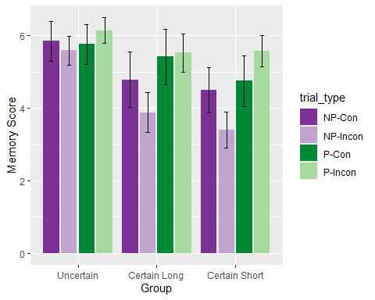

There was a significant main effect of *group* , *F*(2, 73) = 3.70, *p* = .029, = .09, BF10 = 2.09 ± 0.85%, and of *predictiveness*, *F*(1, 73) = 17.72, *p* < .001, = .20, BF10 = 800.42 ± 1.4%, as well as a *predictiveness x congruence* interaction, *F*(1, 73) = 8.33, *p* = .005, = .10, BF10 = 15.69 ± 2.7%. The significant *group x predictiveness* interaction was marginally significant, *F*(2, 73) = 2.58, *p* = .082, = .07, BF10 = 1.02 ± 5.21%. No other effects or interactions were significant, *congruence*: *F*(1, 73) = 1.63, *p* = .205, = .02, BF10 = 0.15 ± 0.75%; *group x congruence*: *F*(2, 73) = 1.19, *p* = .309, = .03, BF10 = 0.09 ± 3.63%; *group x predictiveness x congruence*: *F*(2, 73) = 0.89, *p* = .417, = .02, BF10 = 0.28 ± 4.11%. Simple main effects showed a significant effect of *predictiveness* on Certain Long group, *F*(1, 21) = 9.298, *p* = 0.018, $\\eta^2_p$ = 0.307, and on Certain Short, *F*(1, 23) = 10.02, *p* = 0.012, $\\eta^2_p$ = 0.303, but not on group Uncertain, *F*(1, 29) = 1.263, *p* = 0.81, $\\eta^2_p$ = 0.042. Also, there was a significant effect of predictiveness on incongruent trials, *F*(1, 75) = 17.617, *p* = 1.468^{-4}, $\\eta^2_p$ = 0.19, but not on congruent trials, *F*(1, 75) = 0.896, *p* = 0.694, $\\eta^2_p$ = 0.012.