acc&rat_with_congruence

# Exp 2

## Accuracy

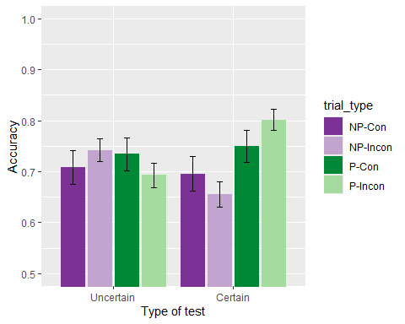

There was a significant *group x predictiveness* interaction, *group x predictiveness*, *F*(1, 92) = 5.16, *p* = .025, = .05, BF10 = 3.28 ± 5.36%; but no other significant differences, *group*: *F*(1, 92) = 0.03, *p* = .862, < .01, BF10 = 0.18 ± 0.91%; *predictiveness*: *F*(1, 92) = 3.23, *p* = .075, = .03, BF10 = 0.69 ± 0.8%; *congruence*: *F*(1, 92) = 0.00, *p* = .967, < .01, BF10 = 0.11 ± 1.36%; *predictiveness x congruence*: *F*(1, 92) = 0.04, *p* = .852, < .01, BF10 = 0.16 ± 3.49%; *group x congruence*: *F*(1, 92) = 0.07, *p* = .799, < .01, BF10 = 0.18 ± 12.05%; *group x predictiveness x congruence*: *F*(1, 92) = 3.47, *p* = .066, = .04, BF10 = 0.87 ± 18.13%. Simple main effects analysis showed a significant effect of predictiveness in the group Certain, *F* (1, 45) = 6.537, *p* = 0.028, $\\eta^2_p$ = 0.127, but not on the Uncertain group, *F* (1, 47) = 0.636, *p* = 0.858, $\\eta^2_p$ = 0.013.

## Just correct ratings

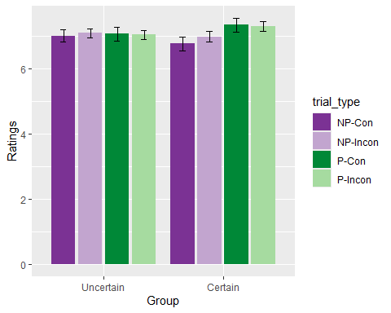

There were no significant effects or interactions, *group*: *F*(1, 88) = 0.05, *p* = .831, < .01, BF10 = 0.29 ± 3%; *predictiveness*: *F*(1, 88) = 0.24, *p* = .627, < .01, BF10 = 0.13 ± 1.54%; *congruence*: *F*(1, 88) = 0.62, *p* = .432, < .01, BF10 = 0.12 ± 1.51%; *group x predictiveness*: *F*(1, 88) = 3.09, *p* = .082, = .03, BF10 = 1.34 ± 5.65%; *predictiveness x congruence*: *F*(1, 88) = 0.11, *p* = .741, < .01, BF10 = 0.15 ± 14.02%; *group x congruence*: *F*(1, 88) = 0.11, *p* = .743, < .01, BF10 = 0.15 ± 5.78%; *group x predictiveness x congruence*: *F*(1, 88) = 0.06, *p* = .801, < .01, BF10 = 0.21 ± 13.39%.

## Memory score

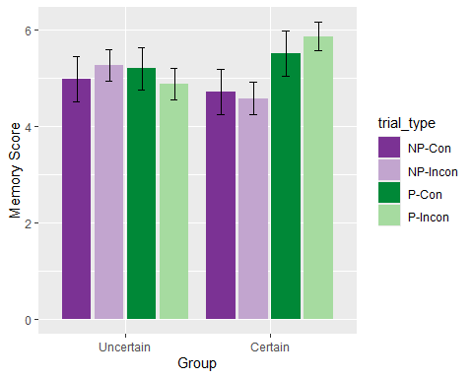

There was a significant effect of *predictiveness*, *F*(1, 92) = 4.24, *p* = .042, = .04, BF10 = 2.12 ± 1.31%, and a significant *group x predictiveness* interaction, *F*(1, 92) = 5.81, *p* = .018, = .06, BF10 = 9.53 ± 8.6%. There were no other significant effects or interactions, *group*: *F*(1, 92) = 0.04, *p* = .836, < .01, BF10 = 0.24 ± 0.61%; *congruence*: *F*(1, 92) = 0.13, *p* = .718, < .01, BF10 = 0.12 ± 1.21%; *predictiveness x congruence*: *F*(1, 92) = 0.03, *p* = .861, < .01, BF10 = 0.17 ± 3.9%; *group x congruence*: *F*(1, 92) = 0.17, *p* = .677, < .01, BF10 = 0.16 ± 2.38%; *group x predictiveness x congruence*: *F*(1, 92) = 2.43, *p* = .122, = .03, BF10 = 0.46 ± 14.61%. Simple main effects showed a significant effect of *predictiveness* on Certain group, *F*(1, 45) = 8.75, *p* = 0.01, $\\eta^2_p$ = 0.163, but not on group Uncertain, *F*(1, 47) = 0.396, *p* = 1, $\\eta^2_p$ = 0.008.

# Exp 3

## Accuracy

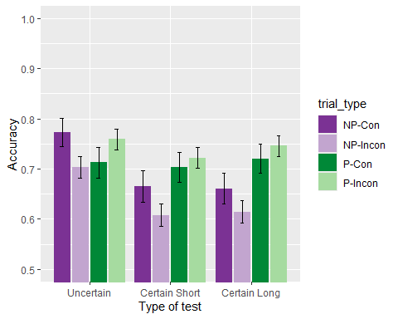

There was a significant main effect of the *predictiveness*: *F*(1, 169) = 14.18, *p* < .001, = .08, BF10 = 84.03 ± 2.13%, a significant *group x predictiveness* interaction, *F*(2, 169) = 3.87, *p* = .023, = .04, BF10 = 1.18 ± 22.46%, and the *predictiveness x congruence* interaction, *F*(1, 169) = 6.02, *p* = .015, = .03, BF10 = 6.21 ± 4.47%. All other effects and interactions were non significant: *group*: *F*(2, 169) = 1.80, *p* = .168, = .02, BF10 = 0.24 ± 0.68%; *congruence*: *F*(1, 169) = 1.21, *p* = .273, < .01, BF10 = 0.12 ± 0.73%; *group x congruence*: *F*(2, 169) = 0.05, *p* = .954, < .01, BF10 = 0.03 ± 2.19%; *group x predictiveness x congruence*: *F*(2, 169) = 0.15, *p* = .864, < .01, BF10 = 0.1 ± 23.18%. Simple main effects showed an effect in predictiveness in the Certain Long group, *F* (1, 58) = 13.452, *p* = 0.001599, $\\eta^2_p$ = 0.188, and on the Certain Short group, *F* (1, 58) = 7.046, *p* = 0.03, $\\eta^2_p$ = 0.108, but not the Uncertain group, *F* (1, 53) = 0.455, *p* = 1, $\\eta^2_p$ = 0.009. Also, the simple main effects for the other significant interaction showed an effect in predictiveness in the incongruent trials, *F* (1, 171) = 15.919, *p* = 0.0001958, $\\eta^2_p$ = 0.085, but not on the congruent trials, *F* (1, 171) = 0.47, *p* = 0.988, $\\eta^2_p$ = 0.003.

## Just correct ratings

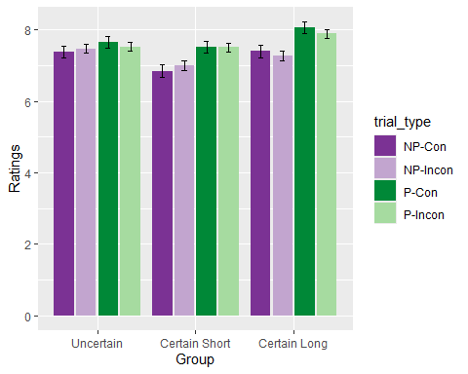

There was a significant effect *predictiveness*, *F*(1, 160) = 17.02, *p* < .001, = .10, BF10 = 55120.66 ± 1.21%. No other effect was significant, *group*: *F*(2, 160) = 1.54, *p* = .217, = .02, BF10 = 0.22 ± 0.63%; *congruence*, *F*(1, 169) = 1.21, *p* = .273, < .01, BF10 = 0.12 ± 0.73%; *group x predictiveness*: *F*(2, 160) = 2.87, *p* = .060, = .03, BF10 = 1.1 ± 3.83%; *predictiveness x congruence*: *F*(1, 169) = 6.02, *p* = .015, = .03, BF10 = 6.21 ± 4.47%; *group x congruence*: *F*(2, 169) = 0.05, *p* = .954, < .01, BF10 = 0.03 ± 2.19%; *group x predictiveness x congruence*: *F*(2, 169) = 0.15, *p* = .864, < .01, BF10 = 0.1 ± 23.18%. Is worth noting that the *group x predictiveness* interaction is marginally significant, and that the simple main effects found significant the effect of *predictiveness* in the group Certain Long, *F*(1, 58) = 13.85, *p* = 0.001347, $\\eta^2_p$ = 0.193, and in the group Certain Short, *F*(1, 58) = 9.255, *p* = 0.012, $\\eta^2_p$ = 0.138, but not in the group Uncertain, *F*(1, 53) = 1.471, *p* = 0.693, $\\eta^2_p$ = 0.027.

## Memory score

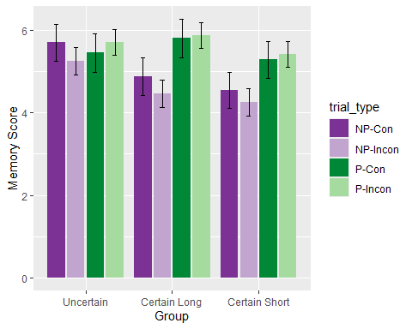

There was a significant effect of *predictiveness*, *F*(1, 169) = 25.74, *p* < .001, = .13, BF10 = 2267452.7 ± 1.52%, as well as a significant *group x predictiveness* interaction, *F*(2, 169) = 4.78, *p* = .010, = .05, BF10 = 12.68 ± 2.12% and a significant *predictiveness x congruence* interaction, *F*(1, 169) = 4.15, *p* = .043, = .02, BF10 = 1.05 ± 4.19%. No other main effects or interactions were significant, *group*: *F*(2, 169) = 1.65, *p* = .195, = .02, BF10 = 0.28 ± 0.54%; *congruence*: *F*(1, 169) = 1.73, *p* = .190, = .01, BF10 = 0.13 ± 2.01%; *group x congruence*: *F*(2, 169) = 0.11, *p* = .893, < .01, BF10 = 0.03 ± 2.02%; *group x predictiveness x congruence*: *F*(2, 169) = 0.09, *p* = .911, < .01, BF10 = 0.06 ± 6.34%. Simple main effects showed a significant effect of *predictiveness* on Certain Long group, *F*(1, 58) = 19.849, *p* = 0.0001164, $\\eta^2_p$ = 0.255, and on Certain Short, *F*(1, 58) = 11.426, *p* = 0.003, $\\eta^2_p$ = 0.165, but not on group Uncertain, *F*(1, 53) = 0.904, *p* = 1, $\\eta^2_p$ = 0.017. Also, there was a significant effect of predictiveness on both incongruent trials, *F*(1, 171) = 22.973, *p* = 0.0000071, $\\eta^2_p$ = 0.118, and congruent trials, *F*(1, 171) = 7.101, *p* = 0.016, $\\eta^2_p$ = 0.04.