acc&rat_with_congruence

# Exp 2

## Accuracy

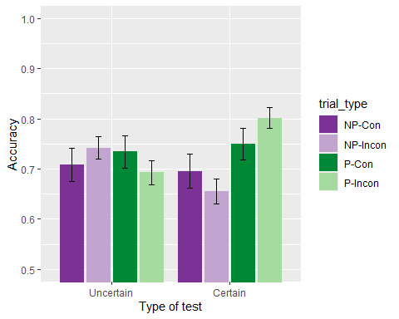

There was a significant *group x predictiveness* interaction, *group x predictiveness*, *F*(1, 92) = 5.16, *p* = .025, = .05, BF10 = 3.36 ± 2.43%; but no other significant differences, *group*: *F*(1, 92) = 0.03, *p* = .862, < .01, BF10 = 0.18 ± 3.45%; *predictiveness*: *F*(1, 92) = 3.23, *p* = .075, = .03, BF10 = 0.75 ± 6.34%; *congruence*: *F*(1, 92) = 0.00, *p* = .967, < .01, BF10 = 0.11 ± 1.11%; *predictiveness x congruence*: *F*(1, 92) = 0.04, *p* = .852, < .01, BF10 = 0.27 ± 40.4%; *group x congruence*: *F*(1, 92) = 0.07, *p* = .799, < .01, BF10 = 0.14 ± 13.57%; *group x predictiveness x congruence*: *F*(1, 92) = 3.47, *p* = .066, = .04, BF10 = 1.16 ± 9.78%. Simple main effects analysis showed a significant effect of predictiveness in the group Certain, *F* (1, 45) = 6.537, *p* = 0.028, $\\eta^2_p$ = 0.127, but not on the Uncertain group, *F* (1, 47) = 0.636, *p* = 0.858, $\\eta^2_p$ = 0.013.

## Just correct ratings

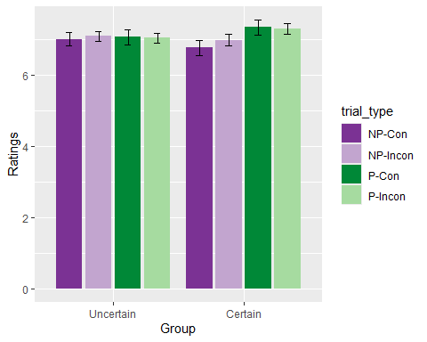

There were no significant effects or interactions, *group*: *F*(1, 88) = 0.05, *p* = .831, < .01, BF10 = 0.32 ± 2.88%; *predictiveness*: *F*(1, 88) = 0.24, *p* = .627, < .01, BF10 = 0.12 ± 1.03%; *congruence*: *F*(1, 88) = 0.62, *p* = .432, < .01, BF10 = 0.13 ± 1.57%; *group x predictiveness*: *F*(1, 88) = 3.09, *p* = .082, = .03, BF10 = 1.32 ± 5.55%; *predictiveness x congruence*: *F*(1, 88) = 0.11, *p* = .741, < .01, BF10 = 0.18 ± 5.43%; *group x congruence*: *F*(1, 88) = 0.11, *p* = .743, < .01, BF10 = 0.16 ± 5.81%; *group x predictiveness x congruence*: *F*(1, 88) = 0.06, *p* = .801, < .01, BF10 = 0.2 ± 12.37%.

## Memory score

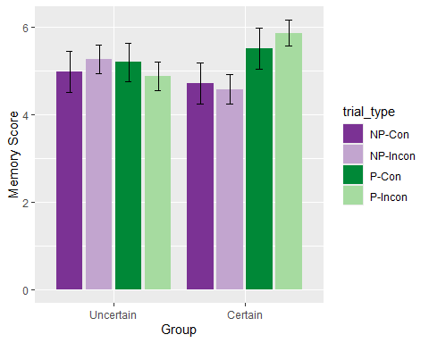

There was a significant effect of *predictiveness*, *F*(1, 92) = 4.24, *p* = .042, = .04, BF10 = 2.14 ± 2.45%, and a significant *group x predictiveness* interaction, *F*(1, 92) = 5.81, *p* = .018, = .06, BF10 = 12.09 ± 10.35%. There were no other significant effects or interactions, *group*: *F*(1, 92) = 0.04, *p* = .836, < .01, BF10 = 0.24 ± 0.68%; *congruence*: *F*(1, 92) = 0.13, *p* = .718, < .01, BF10 = 0.12 ± 4.75%; *predictiveness x congruence*: *F*(1, 92) = 0.03, *p* = .861, < .01, BF10 = 0.15 ± 2.75%; *group x congruence*: *F*(1, 92) = 0.17, *p* = .677, < .01, BF10 = 0.16 ± 3%; *group x predictiveness x congruence*: *F*(1, 92) = 2.43, *p* = .122, = .03, BF10 = 0.53 ± 9.45%. Simple main effects showed a significant effect of *predictiveness* on Certain group, *F*(1, 45) = 8.75, *p* = 0.01, $\\eta^2_p$ = 0.163, but not on group Uncertain, *F*(1, 47) = 0.396, *p* = 1, $\\eta^2_p$ = 0.008.

# Exp 3

## Accuracy

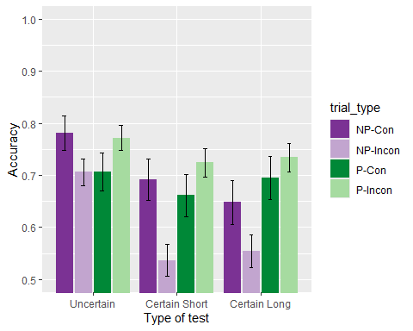

There was a significant main effect of the *predictiveness*: *F*(1, 103) = 9.39, *p* = .003, = .08, BF10 = 5.32 ± 1.52%, a significant *group x predictiveness* interaction, *F*(2, 103) = 3.08, *p* = .050, = .06, BF10 = 0.8 ± 2.35%, and the *predictiveness x congruence* interaction, *F*(1, 103) = 12.39, *p* < .001, = .11, BF10 = 428.64 ± 4.4%. All other effects and interactions were non significant: *group*: *F*(2, 103) = 2.70, *p* = .072, = .05, BF10 = 0.7 ± 2.03%; *congruence*: *F*(1, 103) = 3.13, *p* = .080, = .03, BF10 = 0.22 ± 2.65%; *group x congruence*: *F*(2, 103) = 0.70, *p* = .500, = .01, BF10 = 0.07 ± 2.43%; *group x predictiveness x congruence*: *F*(2, 103) = 0.33, *p* = .722, < .01, BF10 = 0.13 ± 7.1%. Simple main effects showed an effect in predictiveness in the Certain Long group, *F* (1, 31) = 10.252, *p* = 0.009, $\\eta^2_p$ = 0.249, but not on the Certain Short group, *F* (1, 33) = 5.414, *p* = 0.078, $\\eta^2_p$ = 0.141, nor the Uncertain group, *F* (1, 39) = 0.382, *p* = 1, $\\eta^2_p$ = 0.01. Also, the simple main effects for the other significant interaction showed an effect in predictiveness in the incongruent trials, *F* (1, 105) = 16.446, *p* = 1.926^{-4}, $\\eta^2_p$ = 0.135, but not on the congruent trials, *F* (1, 105) = 0.756, *p* = 0.774, $\\eta^2_p$ = 0.007.

## Just correct ratings

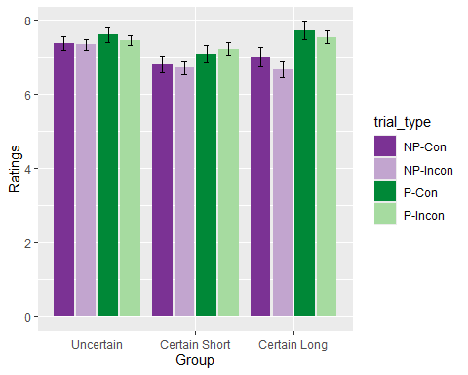

There was a significant effect *predictiveness*, *F*(1, 96) = 12.95, *p* < .001, = .12, BF10 = 423.57 ± 1.43%, and a significant main effect of *congruence*, *F*(1, 103) = 3.13, *p* = .080, = .03, BF10 = 0.22 ± 2.65%. No other effect was significant, *group*: *F*(2, 96) = 1.11, *p* = .335, = .02, BF10 = 0.23 ± 1.34%; *group x predictiveness*: *F*(2, 96) = 2.67, *p* = .074, = .05, BF10 = 0.8 ± 5.85%; *predictiveness x congruence*: *F*(1, 103) = 12.39, *p* < .001, = .11, BF10 = 428.64 ± 4.4%; *group x congruence*: *F*(2, 103) = 0.70, *p* = .500, = .01, BF10 = 0.07 ± 2.43%; *group x predictiveness x congruence*: *F*(2, 103) = 0.33, *p* = .722, < .01, BF10 = 0.13 ± 7.1%. Is worth noting that the *group x predictiveness* interaction is marginally significant, and that the simple main effects found significant the effect of *predictiveness* in the group Certain Long, *F*(1, 31) = 15.127, *p* = 0.001488, $\\eta^2_p$ = 0.328, but not in the group Certain Short, *F*(1, 33) = 3.429, *p* = 0.219, $\\eta^2_p$ = 0.094, nor in the group Uncertain, *F*(1, 39) = 0.74, *p* = 1, $\\eta^2_p$ = 0.019.

## Memory score

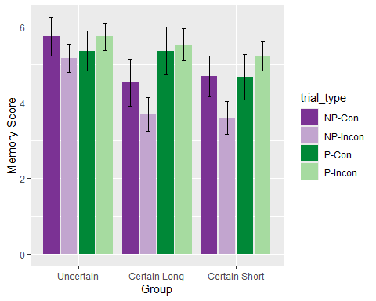

There was a significant effect of *predictiveness*, *F*(1, 103) = 16.56, *p* < .001, = .14, BF10 = 803.45 ± 2.8%, and of *congruence*, *F*(1, 103) = 4.65, *p* = .033, = .04, BF10 = 0.26 ± 1.21%, as well as a significant *group x predictiveness* interaction, *F*(2, 103) = 3.97, *p* = .022, = .07, BF10 = 5.22 ± 2.42% and a significant *predictiveness x congruence* interaction, *F*(1, 103) = 12.86, *p* < .001, = .11, BF10 = 120.49 ± 5.75%. The main effect of *group* was marginally significant, *F*(2, 103) = 2.91, *p* = .059, = .05, BF10 = 0.99 ± 0.55%. No other interactions were significant, *group x congruence*: *F*(2, 103) = 0.45, *p* = .636, < .01, BF10 = 0.06 ± 2.91%; *group x predictiveness x congruence*: *F*(2, 103) = 0.44, *p* = .643, < .01, BF10 = 0.14 ± 12.63%. Simple main effects showed a significant effect of *predictiveness* on Certain Long group, *F*(1, 31) = 15.794, *p* = 0.001179, $\\eta^2_p$ = 0.338, and on Certain Short, *F*(1, 33) = 6.577, *p* = 0.045, $\\eta^2_p$ = 0.166, but not on group Uncertain, *F*(1, 39) = 0.79, *p* = 1, $\\eta^2_p$ = 0.02. Also, there was a significant effect of predictiveness on incongruent trials, *F*(1, 105) = 20.46, *p* = 3.22^{-5}, $\\eta^2_p$ = 0.163, but not on congruent trials, *F*(1, 105) = 0.254, *p* = 1, $\\eta^2_p$ = 0.002.