Untitled

# Exp 1

## Test1

### Accuracy

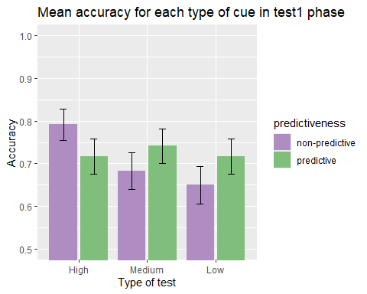

Except for those that did the very subtle test, all subjects had lower accuracy for the non predictive vs the predictive targets. However, there are no significant effects: *similarity* : *F*(2, 87) = 0.87, *p* = .425, = .02, BF10 = 0.17 ± 0.59%; *predictiveness*: *F*(1, 87) = 0.23, *p* = .635, < .01, BF10 = 0.18 ± 2.5%; *similarity x predictiveness*: *F*(2, 87) = 1.72, *p* = .185, = .04, BF10 = 0.17 ± 0.59%.

###Just correct ratings

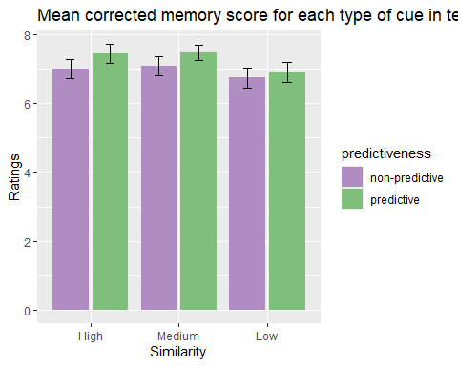

In this first test, there was a significant effect of the predictiveness, *F*(1, 82) = 4.70, *p* = .033, = .05, BF10 = 1.15 ± 1.19%, but not of the *similarity*, *F*(2, 82) = 0.86, *p* = .428, = .02, BF10 = 0.25 ± 0.48%, nor of the *similarity x predictiveness* interaction, *F*(2, 82) = 0.43, *p* = .653, = .01, BF10 = 0.25 ± 0.48%.

##Test2

### Accuracy

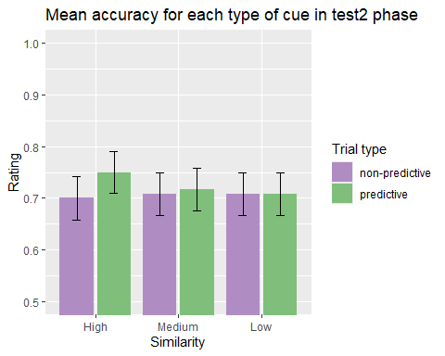

There are no significant differences due to any effect or interaction in accuracy in the second test, *similarity* : *F*(2, 87) = 0.05, *p* = .952, < .01, BF10 = 0.09 ± 0.93%; *predictiveness*: *F*(1, 87) = 0.26, *p* = .613, < .01, BF10 = 0.18 ± 1%; *similarity x predictiveness*: *F*(2, 87) = 0.16, *p* = .850, < .01, BF10 = 0.12 ± 6.67%.

###Just correct ratings

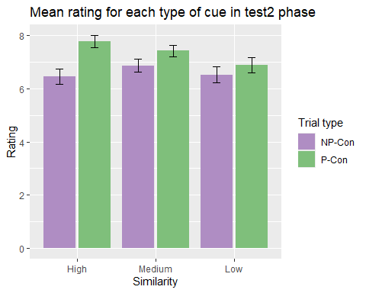

When the confidence ratings for the correct options were analysed, there was a clear effect of predictiveness, *predictiveness*: *F*(1, 83) = 13.67, *p* < .001, = .14, BF10 = 54.86 ± 4.28%. The rest of the main effects and interactions were not significant: *similarity* : *F*(2, 83) = 0.62, *p* = .538, = .01, BF10 = 0.19 ± 0.51%; *similarity x predictiveness*: *F*(2, 83) = 1.37, *p* = .259, = .03, BF10 = 0.31 ± 2.73%.

#### Group Low

There was no differences due to *predictiveness* in group Low similarity, *t*(28) = -1.01, *p* = .320, *d* = -0.19, BF10 = 0.31 ± 0.03%.

#### Group Medium

For group Medium, there was also no effect of *predictiveness*, *t*(28) = -1.59, *p* = .122, *d* = -0.30, BF10 = 0.61 ± 0.03%.

#### Group High

For group High there was a significant effect of *predictiveness*, *V* = 21, *p* < .001, BF10 = 95.78 ± 0%.

# Exp 2

## Accuracy

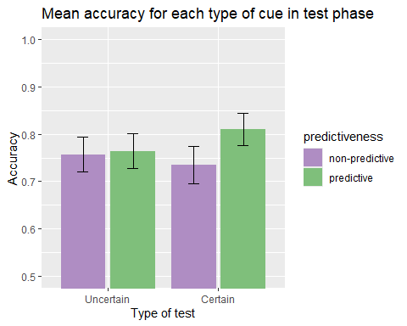

There were no significant differences, *group*: *F*(1, 66) = 0.07, *p* = .789, < .01, BF10 = 0.24 ± 1.18%; *predictiveness*: *F*(1, 66) = 1.43, *p* = .235, = .02, BF10 = 0.34 ± 0.89%; *group x predictiveness*, *F*(1, 66) = 0.98, *p* = .325, = .01, BF10 = 0.4 ± 3.09%.

## Just correct ratings

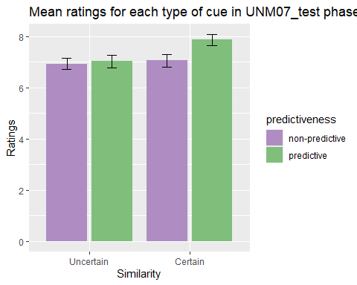

There was no significant effect of the *group*, *F*(1, 65) = 0.98, *p* = .325, = .01, BF10 = 0.45 ± 1.49%, nor *predictiveness*, *F*(1, 65) = 1.39, *p* = .243, = .02, BF10 = 0.33 ± 1.26%, neither of the *group x predictiveness* interaction, *F*(1, 65) = 1.85, *p* = .178, = .03, BF10 = 0.45 ± 1.49%. It is worth mentioning that the effect of predictiveness is very close to significance and that the bayesian evidence is anecdotal.

# Exp 3

## Accuracy

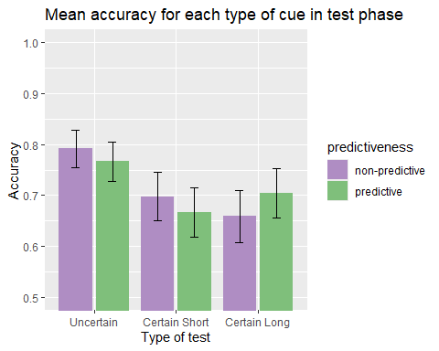

There were no significant differences, *group*: *F*(2, 73) = 2.19, *p* = .119, = .06, BF10 = 0.64 ± 0.73%, *predictiveness*: *F*(1, 73) = 0.01, *p* = .910, < .01, BF10 = 0.18 ± 3.83%, *group x predictiveness*: *F*(2, 73) = 0.56, *p* = .576, = .02, BF10 = 0.64 ± 0.73%.

## Just correct ratings

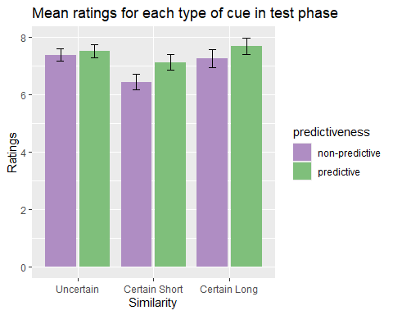

There was a significant effect *predictiveness*, *F*(1, 73) = 8.70, *p* = .004, = .11, BF10 = 4.74 ± 1.2%, but no significant effect of the *group*, *F*(2, 73) = 1.64, *p* = .201, = .04, BF10 = 0.49 ± 0.73% nor of the *group x predictiveness* interaction, *F*(2, 73) = 2.13, *p* = .126, = .06, BF10 = 0.54 ± 6.51%.